Supplementary Materials for

Atomistic Evidence of Nucleation Mechanism for the Direct Graphite-to-Diamond Transformation

Duan Luo†, Liuxiang Yang†, Hongxian Xie, Srilok Srinivasan, Jinshou Tian, Subramanian Sankaranarayanan, Ilke Arslan, Wenge Yang*, Ho-kwang Mao*, Jianguo Wen*

Correspondence to: yangwg@hpstar.ac.cn (W.G.Y.), maohk@hpstar.ac.cn (H.K. M.), jwen@anl.gov (J.G.W.)
†D.L. and L.Y. contributed equally to this work.

This PDF file includes:

Supplementary Fig. 1 to 6

Supplementary Figures

Fig. S1. Possible pathways for hexagonal graphite-to-diamond transition.
In hexagonal graphite, carbon atoms are arranged in planar honeycomb sheets with AB stacking, which hinders direct transformation into diamond due to the lack of matching carbon atoms at honeycomb centers with carbon atoms in adjacent layers. Therefore, extensive theoretical research suggests that the direct transformation of AB-stacked hexagonal graphite (HG) to hexagonal diamond (HD) or cubic diamond (CD) must first undergo a sliding process to form an intermediate phase, including either orthorhombic graphite (OG) with AB’ stacking or rhombohedral graphite (RG) with ABC stacking, followed by boat or chair buckling to form sp³ bonds. When the transformation goes through OG, (001) honeycomb planes in HG is perpendicular to corrugated densest planes (001) planes in HD and (111) in CD. In case of RG, (001) honeycomb planes in HG is parallel to (111) in CD.

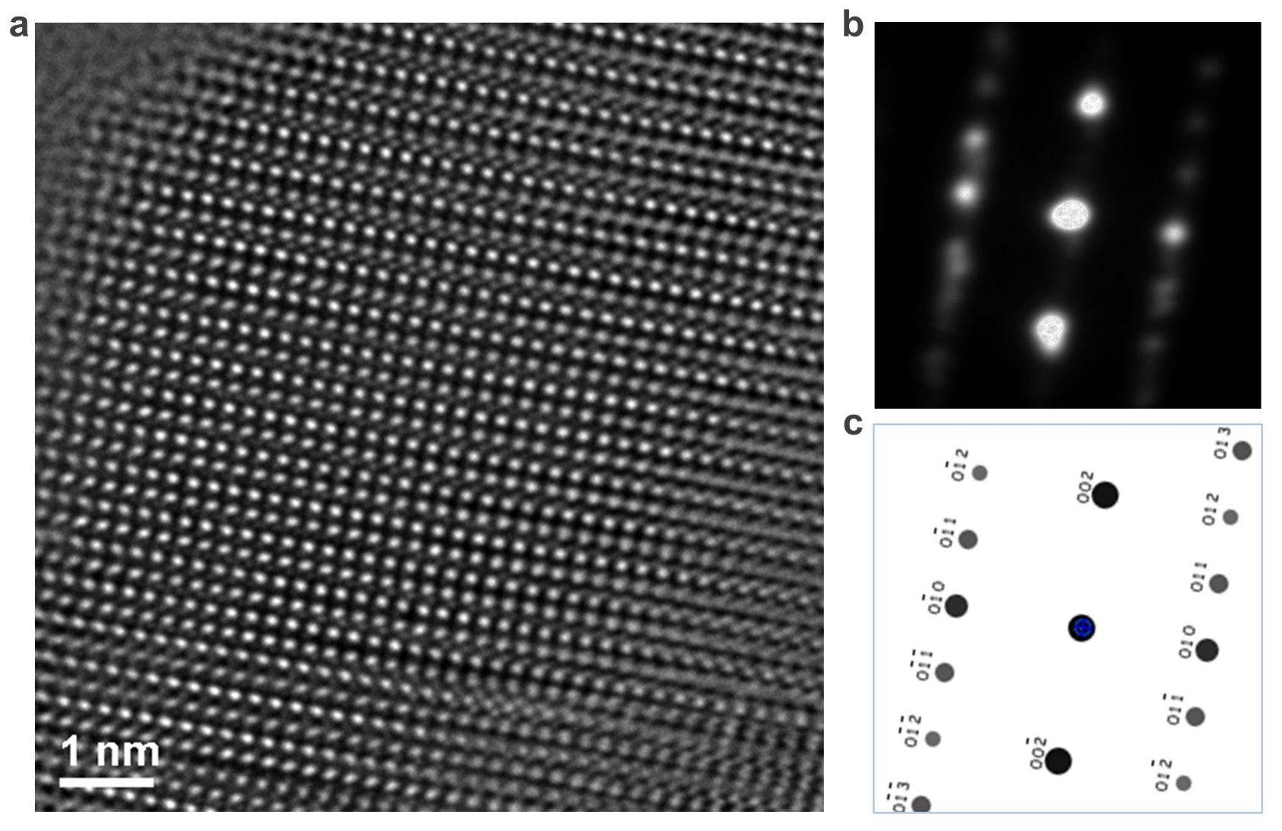

Fig. S2. High-quality single-phase HD from recovered HPHT at 1400 K samples. a, TEM image of [100]; b, Selected area electron diffraction (SAED) of [100]_{HD}; c, Simulated electron diffraction of [100]_{HD}., which matches with the diffraction pattern in b.

Fig. S3. 6-fold symmetry diffraction pattern. a, HRTEM image of nanoscale HD nuclei embedded in the graphite matrix. b, The FFT pattern from the OG in a shows a diffraction pattern matching with [310]_{OG} instead of [1$\overline{1}$0]_{HG}. c, the FFT pattern from the HD in a has a 6-fold symmetry with a 0.218 nm lattice spacing indexed by [001]_{HD}. d, [001] diffraction pattern of a HD structure; e, [001] diffraction pattern of a HG structure; f, [111] diffraction pattern of a CD structure. g, EELS spectra of HD and distorted graphite OG near the nanodiamond.

Fig. S4. Interfaces between nono-diamond and graphite matrix. a, TEM image of graphite-diamond interfaces; b, FFT pattern from the OG area. Note the first-order diffraction spots lie in the middle of the zero-order diffraction spots. In contrast (also see Fig. S5f), the first-order diffraction spots are aligned with the zero-order diffraction spots in the case of HG; c, FFT pattern from the HD nanodiamond area, showing that the (002)_{HG} is more or less parallel to (001)_{HD} (~4 degree off). Two (002)_{HG} arcs indicated by yellow arrow heads reflect the bent graphitic planes where nanodiamond are found.

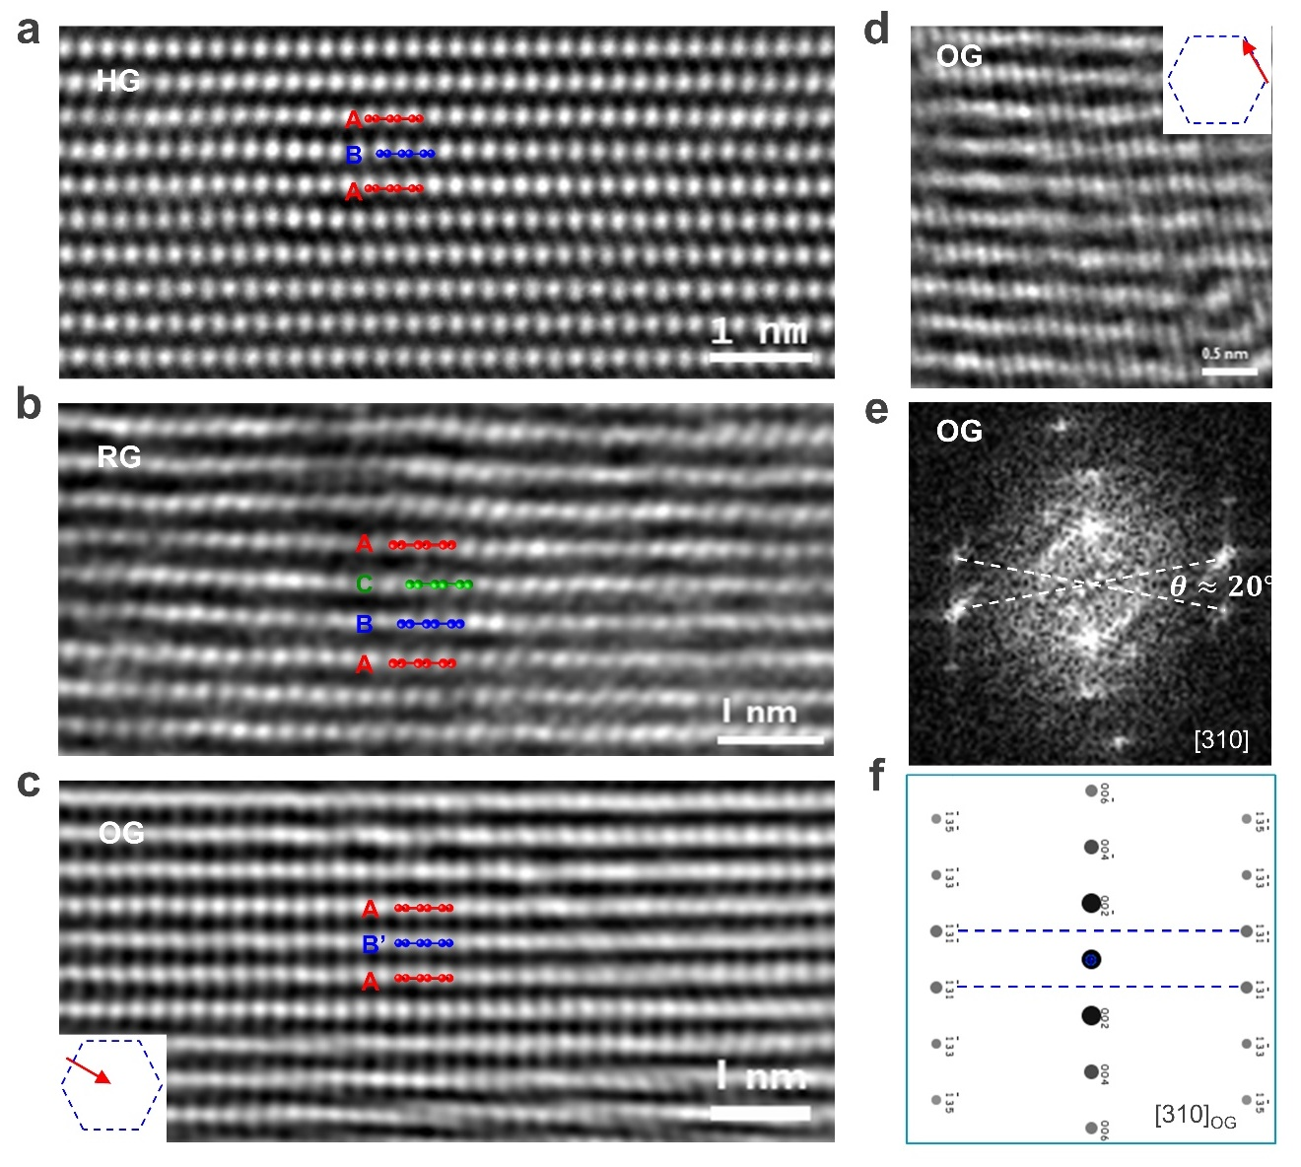

Fig. S5. High-resolution TEM images of graphite structures. a, HG with AB stacking; b, RG with ABC stacking; c, OG with AB’ stacking; d-e, HRTEM image and [310] diffraction of OG show AB’ stacking instead of AA stacking.

Fig. S6. The enthalpy landscape and pathway for concerted HGOGHD transformation.

