PBPK-based exposure response modeling of enzalutamide and its active metabolite N-desmethyl enzalutamide, for the prediction of progression-free survival rates in prostate cancer patients
Authors

¹College of Pharmacy, Chungnam National University, Daejeon 34134, Republic of Korea.
† These authors contributed equally to this work as the first authors
* These authors contributed equally to this work as the corresponding authors

Correspondence

Jung-woo Chae, College of Pharmacy, Chungnam National University, Daejeon 34134, Republic of Korea.
Email: jwchae@cnu.ac.kr

Hwi-yeol Yun, College of Pharmacy, Chungnam National University, Daejeon 34134, Republic of Korea.
Email: hyyun@cnu.ac.kr

Soyoung Lee, College of Pharmacy, Chungnam National University, Daejeon 34134, Republic of Korea.
Email: sy.lee@cnu.ac.kr

- PBPK model development and evaluation of Enzalutamide and N-desmethyl enzalutamide
The whole-body PBPK models of Enzalutamide and N-desmethyl enzalutamide were developed and evaluated using a total of 8 clinical data. A summary of these clinical data and the corresponding references are listed in Table S1. Results of the evaluation steps for the model development are listed in Table S2.
- PBPK population simulation for E-R model of Enzalutamide and N-desmethyl enzalutamide
The PBPK based E-R models for predicts OS and PFS of Enzalutamide and N-desmethyl enzalutamide were developed and evaluated using a total of 4 clinical. A summary of these clinical data and the corresponding references are listed in Table S3. Results of the PBPK population simulation are listed in Table S4.

Table S1. List of clinical studies (with dose regimens, characteristics and subject demographics, and references) used for the development and evaluation of the PBPK model of Enzalutamide and N-desmethyl enzalutamide
Compound | number | Dose regimen | Population | Age  [year] | Weight  [kg] |  | Height  [cm] |  | BMI  [kg/m²] |  | Number of subjects | Race | Reference/ Clinical trial number
ENZ | 1_A | 160mg (sd) | Healthy | 42.4  (26-59) | 87.4  (74-102) |  | 180  (167-192) |  | 27.1  (24.3-33.3) |  | 6 (A) | Caucasian | [1] / NCT01901133
ENZ | 1_B | 160mg (sd) | Healthy | 51.3  (37-63) | 90.8  (77-102) |  | 181  (171-192) |  | 27.6  (24-32.2) |  | 8 (B) | Caucasian | [1]/ NCT01901133
ENZ | 2 | 160mg (sd) | Healthy | 54.6  (47-66) | 80.5  (69-101) |  | 172  (169-176) |  | 27.2  (23.9-33.7) |  | 8 | Caucasian | [1]/ NCT02138162
ENZ | 3 | 160mg (sd) | Healthy | 28.5  (24-36) | 64.2  (55.4-77.5) |  | 171.6  (165-180) |  | 21.5  (19.9–24.0) |  | 14 | Asian | [2]/ CTR20150635
ENZ | 4 | 30,60,150,240,360 (sd)  30,60,150,240,360 (qd) | CRPC | 68  (44-93) | 93.9 |  |  |  |  |  | 18 (sd)  140 (qd) | Caucasian | [3]/ NCT00510718
ENZ | 5 | 160mg (qd) | CRPC | 71  (54-83) | 82.9  (58-108) |  |  |  | 28.1  (20.5-31.0) |  | 14 | Caucasian | [3]/ NCT01911728
ENZ | 6 | 160mg (qd) | HNPC | 73  (48-86) |  |  |  |  | 26.2  (20.8-39.7) |  | 67 | Caucasian | [4]/ NCT01302041
ENZ | 7 | 160mg (qd) | CRPC | 69  (41-92) |  | 84.2 |  |  |  |  | 680 | Caucasian | [5]/ NCT00974311
NDE | 1_A | 160mg (sd) | Healthy | 42.4  (26-59) |  | 87.4  (74-102) |  | 180  (167-192) |  | 27.1  (24.3-33.3) | 6 (A) | Caucasian | [1]/ NCT01901133
NDE | 1_B | 160mg (sd) | Healthy | 51.3  (37-63) |  | 90.8  (77-102) |  | 181  (171-192) |  | 27.6  (24-32.2) | 8 (B) | Caucasian | [1]/ NCT01901133
NDE | 2 | 160mg (sd) | Healthy | 54.6  (47-66) |  | 80.5  (69-101) |  | 172  (169-176) |  | 27.2  (23.9-33.7) | 8 | Caucasian | [1]/ NCT02138162
NDE | 3 | 160mg (sd) | Healthy | 28.5  (24-36) |  | 64.2  (55.4-77.5) |  | 171.6  (165-180) |  | 21.5  (19.9–24.0) | 14 | Asian | [2]/ CTR20150635
NDE | 5 | 160mg (qd) | CRPC | 71  (54-83) |  | 82.9  (58-108) |  |  |  | 28.1  (20.5-31.0) | 14 | Caucasian | [3]/ NCT01911728
NDE | 6 | 160mg (qd) | HNPC | 73  (48-86) |  |  |  |  |  | 26.2  (20.8-39.7) | 67 | Caucasian | [4]/ NCT01302041
NDE | 7 | 160mg (qd) | CRPC | 69  (41-92) |  | 84.2 |  |  |  |  | 680 | Caucasian | [5]/ NCT00974311
NDE | 8 | 160mg (sd) | Healthy | 28  (20-51) |  | 73.4  (66-83) |  |  |  | 23.6  (21-25) | 13 | Caucasian | [6]/ NCT01913379
ENZ, Enzalutamide; NDE, N-desmethyl enzalutamide; sd, Single dose; qd, once daily;Healthy, healty male volunteers; CRPC, Castration prostate cancer patients; HNPC, Hormone naïve prostate cancer patients; A, Healthy male matched with mild groups in study; B, Healthy male matched with moderate groups in study.

Table S2. Observation and prediction of C_{max}​ and AUC_{last} values and ratios for enzalutamide and active metaboltie from PBPK model by clinical study
Compound | Study number /  Dose regimen | C_{max,obs}  (ug/mL) | C_{max,pred}  (ug/mL) | C_{max} raito  (sim/obs) | AUC_{last,obs}  (ug*h/mL) | AUC_{last,pred}  (ug*h/mL) | AUC_{last} ratio  (sim/obs)
ENZ | 1_A / 160 mg (sd) | 2.90 | 2.78 | 0.96 | 544.23 | 293.94 | 0.54
ENZ | 1_B / 160 mg (sd) | 3.48 | 2.68 | 0.77 | 500.69 | 301.14 | 0.60
ENZ | 2 / 160 mg (sd) | 3.84 | 3.06 | 0.80 | 719.06 | 299.94 | 0.42
ENZ | 3 / 160 mg (sd) | 5.37 | 4.06 | 0.76 | 350.26 | 303.80 | 0.87
ENZ | 4 / 30 mg (sd) | 0.33 | 0.34 | 1.03 | 20.14 | 22.32 | 1.11
ENZ | 4 / 60 mg (sd) | 1.63 | 1.08 | 0.66 | 52.12 | 45.15 | 0.74
ENZ | 4 / 150 mg (sd) | 2.85 | 2.84 | 1.00 | 144.88 | 106.81 | 0.74
ENZ | 4 / 240 mg (sd) | 4.90 | 3.42 | 0.70 | 215.31 | 161.61 | 0.75
ENZ | 4 / 360 mg (sd) | 6.62 | 4.58 | 0.69 | 304.71 | 206.03 | 0.68
ENZ | 4 / 30mg (qd) | 2.87 | 2.96 | 0.96 | 4456.95 | 4196.77 | 0.94
ENZ | 4 / 60 mg(qd) | 5.24 | 5.94 | 1.13 | 7606.12 | 8368.41 | 1.1
ENZ | 4 / 150 mg(qd) | 13.32 | 13.63 | 1.02 | 20327.96 | 18634.47 | 0.92
ENZ | 4 / 240 mg(qd) | 18.36 | 19.49 | 1.06 | 28889.08 | 27762.74 | 0.96
ENZ | 4 / 360 mg(qd) | 22.87 | 24.83 | 1.09 | 33578.59 | 33481.84 | 1.00
ENZ | 5 / 160 mg(qd) | 15.90 | 16.57 | 1.04 | 8379.99 | 8123.30 | 1.03
ENZ | 6 / 160 mg(qd) | 12.18 | 13.33 | 1.09 | 45619.18 | 49970.02 | 1.10
ENZ | 7 / 160 mg(qd) | 10.71 | 16.16 | 1.51 | 92265.16 | 145313.94 | 1.57
NDE | 1_A / 160mg(sd) | 0.61 | 0.48 | 0.79 | 314.24 | 237.94 | 0.76
NDE | 1_B / 160mg(sd) | 0.56 | 0.45 | 0.80 | 292.10 | 244.26 | 0.84
NDE | 2 / 160mg(sd) | 0.70 | 0.47 | 0.67 | 402.58 | 239.09 | 0.59
NDE | 3 / 160mg(sd) | 1.07 | 0.67 | 0.63 | 448.25 | 247.06 | 0.55
NDE | 5 / 160 mg(qd) | 12.24 | 12.12 | 0.99 | 7288.53 | 7376.86 | 1.01
NDE | 6 / 160 mg(qd) | 12.67 | 12.21 | 0.96 | 43604.18 | 44558.95 | 1.02
NDE | 7 / 160 mg(qd) | 11.49 | 11.79 | 1.03 | 89268.37 | 123999.40 | 1.39
NDE | 8 / 160mg(sd) | 0.86 | 0.55 | 0.64 | 384.79 | 236.51 | 0.61
ENZ, Enzalutamide; NDE, N-desmethyl enzalutamide; sd, Single dose; qd, once daily;Healthy, healty male volunteers; A, Healthy male matched with mild groups in study; B, Healthy male matched with moderate groups in study.

Table S3. List of clinical studies (with dose regimens, characteristics and subject demographics, and references) used for the development and evaluation of the E-R model of Enzalutamide and N-desmethyl enzalutamide
Outcome | Dose | Population | Number of subjects | Age  [year] | Weight  [kg] | Height  [cm] | BMI  [kg/m²] | Race | Reference
OS | 120mg | CRPC | 18 | 78.7  (58-86) |  |  |  | Asian | [7]
OS | 160mg | CRPC | 63 | 77.9  (55-92) |  |  |  | Asian | [7]
OS | 120mg | mCRPC, mHSPC | 28 | 80  (69-90) |  |  | 28.4  (23-38) | Caucasian | [8]
OS | 160mg | mCRPC, mHSPC | 25 | 80  (68-88) |  |  | 26.2  (20-36) | Caucasian | [8]
OS | Placebo | mCRPC | 399 | 69  (49-89) |  |  |  | Caucasian | [9]
OS | 160mg | mCRPC | 800 | 69  (41-92) |  |  |  | Caucasian | [9]
OS | Placebo | mCRPC | 801 | 71  (42-93) | 83.1  (34-160) |  | 27.5  (15-51) | Caucasian | [10]
OS | 160mg | mCRPC | 867 | 72  (43-93) | 82.8  (49-162) |  | 27.5  (18-47) | Caucasian | [10]
PFS | 120mg | mCRPC, mHSPC | 28 | 80  (69-90) |  |  | 28.4  (23-38) | Caucasian | [8]
PFS | 160mg | mCRPC, mHSPC | 25 | 80  (68-88) |  |  | 26.2  (20-36) | Caucasian | [8]
PFS | Placebo | mCRPC | 399 | 69  (49-89) |  |  |  | Caucasian | [9]
PFS | Placebo | mCRPC | 800 | 71  (42-93) | 83.1  (34-160) |  | 27.5  (15-51) | Caucasian | [10]
PFS: Progression-free survival; OS: Overall survival; mCRPC: Metastatic castration prostate cancer; mHSPC: Metastatic hormone sensitive prostate cancer.

Table S4. PK parameters from PBPK Population PK simulation results for average value by study
Study | Number of subjects | C_{avg,ss,enz}  (95% CI)  [ug/mL] | C_{avg,ss,nde}  (95% CI)  [ug/mL] | C_{max,ss,enz}  (95% CI)  [ug/mL] | C_{max,ss,nde}  (95% CI)  [ug/mL] | $${\text{AUC}}_{τ,ss,enz}$$(95% CI)  [ug*h/mL] | $${\text{AUC}}_{τ,ss,nde}$$(95% CI)  [ug*h/mL]
Boerrigter E, et al.  (120mg) | 28 | 13.0  (3.8-28.4) | 11.5  (5.8-30.0) | 14.7  (5.5-30.6) | 11.6  (5.8-30.1) | 310.9  (90.0-681.0) | 277.1  (140.2-720.1)
Boerrigter E, et al. (160mg) | 25 | 14.6  (4.7-29.4) | 16.3  (5.6-59.5) | 16.8  (6.6-31.2) | 16.4  (5.6-59.7) | 351.4  (112.1-706.6) | 392.0  (134.2 1428.6)
Tszuki S, et al.  (120mg) | 18 | 10.8  (4.7-25.6) | 7.8  (4.6-11.7) | 12.7  (6.4- 27.7) | 7.9  (4.6- 11.8) | 258.2  (112.8- 615.0) | 187.8  (110.1 281.0)
Tszuki S, et al.  (160mg) | 63 | 13.1  (3.1-31.5) | 9.0  (5.0-14.5) | 15.4  (5.3-34.5) | 9.0  (5.1-14.5) | 313.4  (75.4-755.9) | 215.8  (121.2-348.2)
AFFIRM  (160mg) | 200 | 14.2  (3.1-32.9) | 10.7  (5.4-21.8) | 16.1  (4.6-34.5) | 10.7  (5.4-21.8) | 341.2  (74.8-788.6) | 256.9  (130.3-522.7)
PREVAIL  (160mg) | 200 | 15.5  (3.7-40.1) | 13.0  (5.2-27.8) | 17.6  (5.4-42.4) | 13.0  (5.2-27.8) | 373.2  (88.3-961.3) | 312.3  (123.9-666.7)

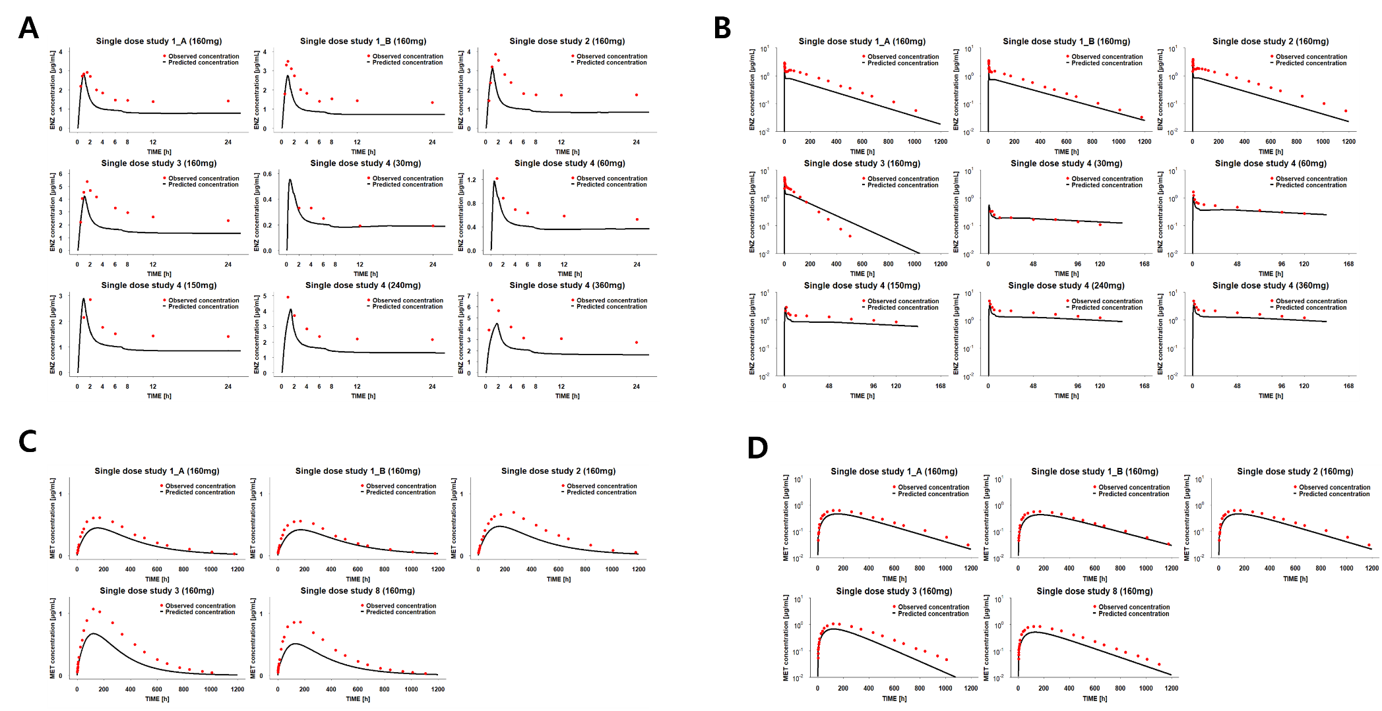
Figure S1. The prediction of the developed PBPK model on PK of (A) Enzalutamide (linear scale), (B) Enzalutamide (log scale), (C) N-desmethyl enzalutamide (linear scale) (D) N-desmethyl enzalutamide (log scale). Solid line, prediction data; red circle, observed data; ENZ, Enzalutamide; MET, N-desmethyl enzalutamide.

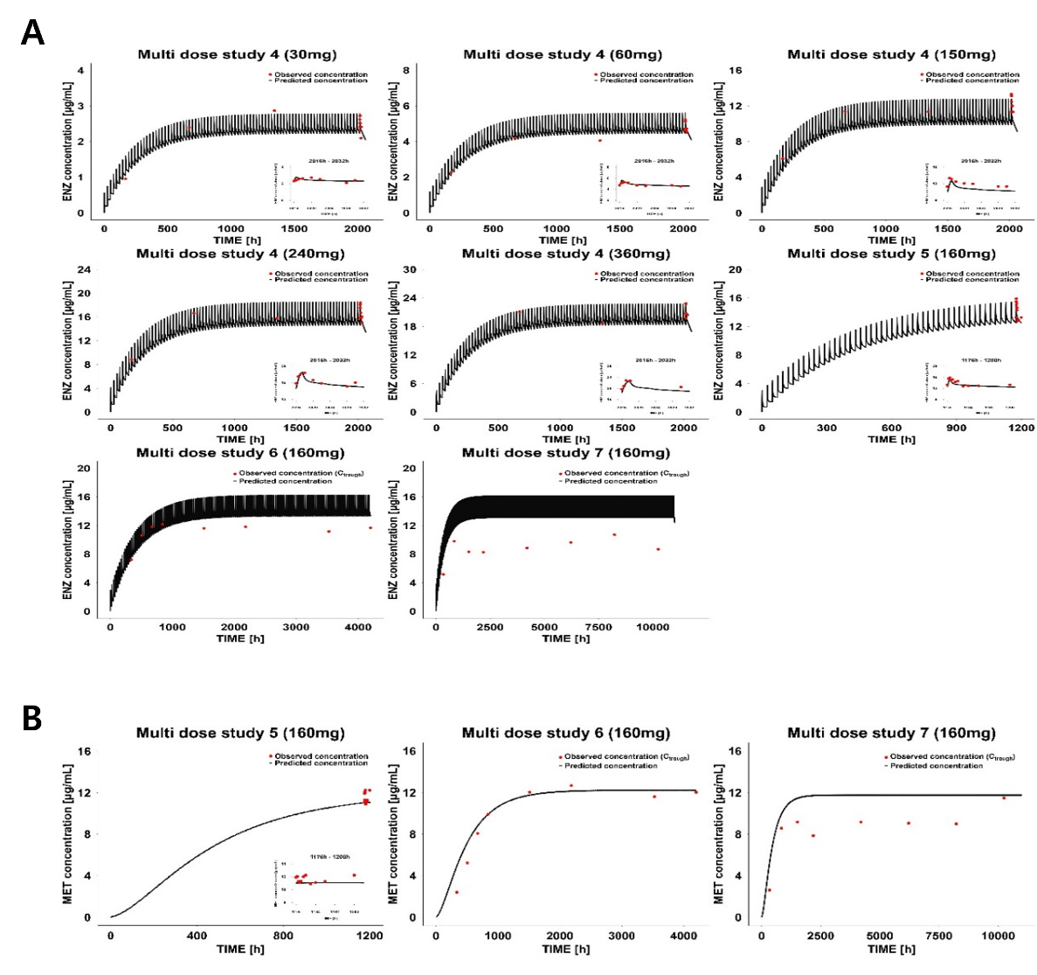
Figure S2. The prediction of the developed PBPK model on PK of (A) Enzalutamide (linear scale), (B) N-demethyl enzalutamide (linear scale). Solid line, prediction data; red circle, observed data; ENZ, Enzalutamide; MET, N-desmethyl enzalutamide

- Sensitivity analysis for PBPK model of Enzalutamide and N-desmethyl enzalutamide
The sensitivity of the final models to single parameter values was assessed to measure which input parameters have the most impact on the output curves. Parameters were included in the analysis if they were optimized, if they were associated with optimized parameters, or if they might have strong variations due to calculation methods.
In the present study, the sensitivity (S) for the AUC_{last} to the input parameters was measured. Sensitivity was calculated as the ratio of the relative change in AUC_{last} to the relative variation of the input parameter, as described in the equation below:
$\begin{aligned}S=\frac{∆AUC}{∆P}×\frac{P}{AUC}\#(1\end{aligned}$)
where $∆P$ is the relative change in the input parameter P and ΔAUC is the corresponding relative change in the AUC_{last} that is calculated as the difference between the values in the original simulation (original input parameter [P]) and the new simulation (varied input parameter [P+$∆P]$). A sensitivity of −1.0 implies that a 10% increase in the input parameters leads to a 10% decrease in the AUC value.
The sensitivity of the PBPK model to single parameters was calculated as the relative change of the predicted AUC_{last} following a once a daily at 175 days oral dose of 160 mg of Enzalutamide. Sensitivity analysis was carried out using a relative parameter perturbation of 10% (variation range, 0.1; 2 step). The following parameters were tested for the sensitive analysis. lipophilicity, solubility, fraction unbound, specific intestinal permeability, dissolution time and shape and CL for enzyme reactions were included in the analysis. Results of the sensitivity analysis are presented in Figure S3; the analysis revealed that the PK of Enzalutamide is mainly sensitive to the fraction unbound in plasma of Enzalutamide, lipophilicity (LogP) of Enzalutamide, intrinsic clearance by CYP2C8 of Enzalutamide, and dissolution shape. And N-desmethyl enzalutamide is mainly sensitive to the fraction unbound in plasma of N-desmethyl enzalutamide, total hepatic clearance of N-desmethyl enzalutamide, lipophilicity (LogP) of Enzalutamide, and intricsic clearance by CYP2C8 of Enzalutamide.
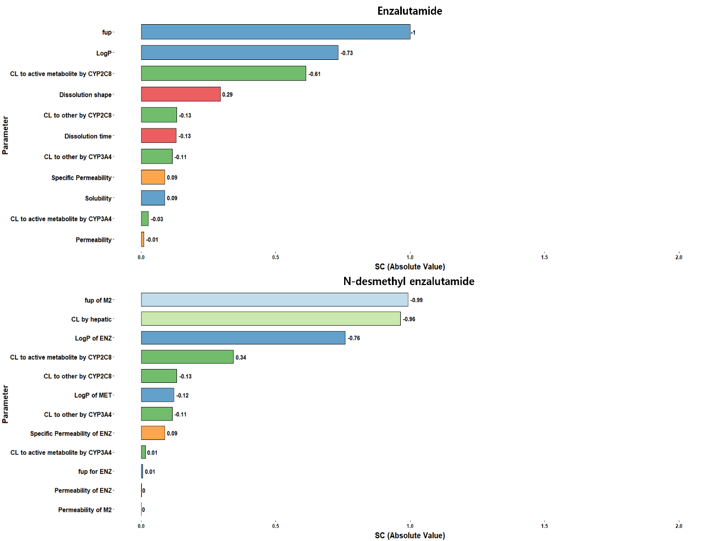
Figure S3. Sensitivity analysis of the developed PBPK model of Enzalutamide (upper) and N-desmethyl enzalutamide (lower) to single parameters, calculated as the change of AUC_{last} following a once a daily oral dose at 175 days of Enzalutamide 160mg. fup, fraction unbound in plasma; LogP, lipophilicity; CL, clearance; active metabolite, N-desmethyl enzalutamide; MET, N-desmethyl enzalutamide; M2, N-desmethyl enzalutamide

Reference
- Krauwinkel W, Noukens J, van Dijk J, et al. A comparison of the pharmacokinetics and safety of enzalutamide in subjects with hepatic impairment and matched healthy subjects. J Clin Pharm Ther. 2017;42(3):268-75.
- Liu YM, Wu P, Fukushi R, Yamada S, Chen Q. Pharmacokinetics and Safety of Enzalutamide in Healthy Chinese Male Volunteers. Clin Ther. 2019;41(2):261-8.
- XTANDI®: Clinical Pharmacology and Biopharmaceutics Review(s). https://www.accessdata.fda.gov/drugsatfda_docs/nda/2012/203415Orig1s000ClinPharmR.pdf Accessed Oct 11, 2024.
- Therapeutic Goods Administration. AusPAR Attachment 2: Extract from the Clinical Evaluation Report for Enzalutamide. Canberra: Commonwealth of Australia; 2016. Accessed 11 Oct 2024 Available from: https://www.tga.gov.au/sites/default/files/auspar-enzalutamide-160323.pdf Accessed Oct 11, 2024.
- Gibbons JA, Ouatas T, Krauwinkel W, et al. Clinical Pharmacokinetic Studies of Enzalutamide. Clin Pharmacokinet. 2015;54(10):1043-55.
- Gibbons, Jacqueline A, et al. “Pharmacokinetic Drug Interaction Studies with Enzalutamide.” Clinical pharmacokinetics vol. 2015;54(10): 1057-69.
- Tsuzuki S, Nakanishi S, Tamaki M, et al. Initial dose reduction of enzalutamide does not decrease the incidence of adverse events in castration-resistant prostate cancer. PLoS One. 2021;16(10):e0258160.
- Boerrigter E, Overbeek JK, Benoist GE, et al. A Prospective Randomised Trial to Determine the Effect of a Reduced Versus Standard Dose of Enzalutamide on Side Effects in Frail Patients with Prostate Cancer. Eur Urol Oncol. 2024;7(6):1376-83.
- Scher HI, Fizazi K, Saad F, et al. Increased survival with enzalutamide in prostate cancer after chemotherapy. N Engl J Med. 2012;367(13):1187-97.
- Beer TM, Armstrong AJ, Rathkopf DE, et al. Enzalutamide in metastatic prostate cancer before chemotherapy. N Engl J Med. 2014;371(5):424-33.

