Table S1 Sequence information for qRT-PCR primers.
β-actin | human | F: 5' AAG GTG ACA GCA GTC GGT T 3'  R: 5' TGT GTG GAC TTG GGA GAG G 3'
 | mouse | F: 5' CCT CTA TGC CAA CAC AGT 3'  R: 5' AGC CAC CAA TCC ACA CAG 3'
CD69 | human | F: CTAAAACGATACGCAGGTAGAG  R: CTTTGCCATTTGACCACTT
 | mouse | F: GTACGAGAAGTTGGAATCATCTG  R: GTTGTGGTGGAGAAGAAGTAACAT
CD103 | human | F: CCAGGAGAAAGGCATCCAAG  R: GGGGAGTTGATGACTGTCGTAAG
 | mouse | F: GTACGAGAAGTTGGAATCATCTG  R: GTTGTGGTGGAGAAGAAGTAACAT
PINK1 | human | F: GGAGGAGCCTGTCTTTGTTGTGA  R: CCGTTGAGTGCCGTGTTCTTATT
PRKN | Human | F: CCAGCAATGTCACCATCAAAG  R: GCGTGTCCACTCAGTCTG
BNIP3 | human | F: AACAGCAGCAATGGCAATGAT  R: TGTGGATGGAGGATGAGGATG
BNIP3L | human | F: CTAAAACGATACGCAGGTAGAG  R: CTTTGCCATTTGACCACTT
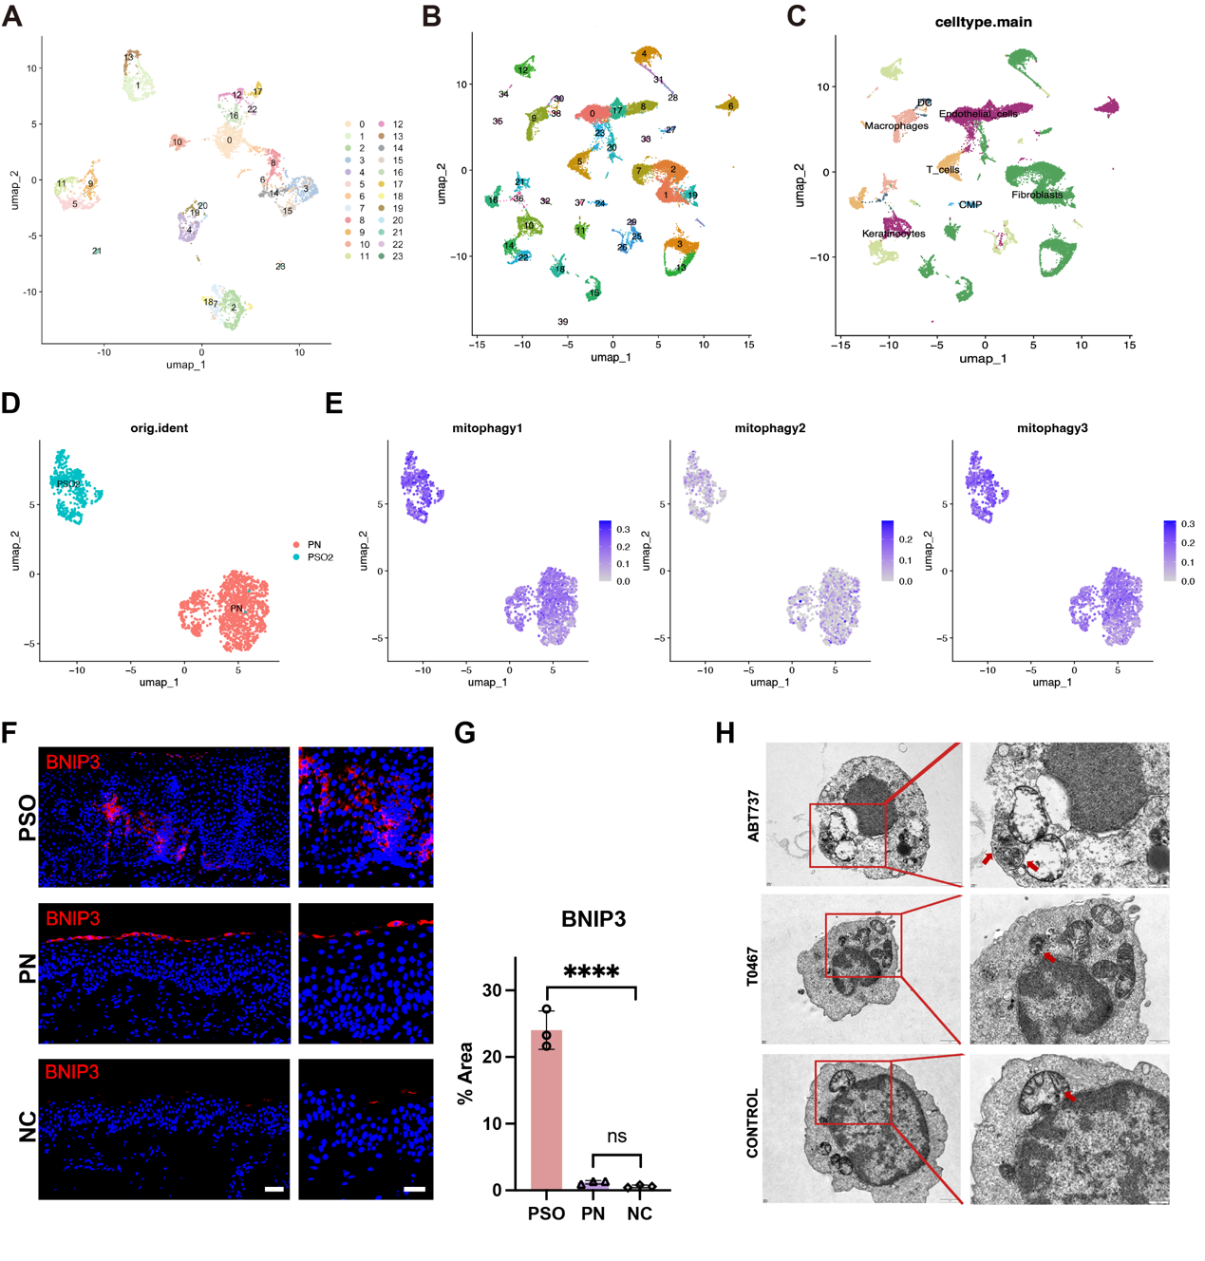
Figure 1. Single-cell transcriptomic landscape of psoriatic lesions and morphological validation of enhanced mitophagy. A) UMAP embedding of the scRNA-seq data exclusively from psoriasis lesions, displaying the unbiased unsupervised clustering. B) Integrated UMAP embedding of scRNA-seq data combining samples from psoriatic lesions, non-lesional skin, and healthy normal controls. C) UMAP plot showing the annotation of the major distinct cell lineages across the integrated dataset, including T cells, Macrophages, Dendritic cells (DC), Keratinocytes, Fibroblasts, and Common myeloid progenitors (CMP). D) UMAP plot depicting the distribution of cells colored by their specific sample origin. E) UMAP feature plots illustrating the calculated module scores for three distinct mitophagy-related gene signatures (mitophagy1, mitophagy2, and mitophagy3) across the single-cell landscape. Darker blue indicates higher enrichment scores. F) Representative immunofluorescence (IF) images evaluating the in-situ expression of the mitophagy receptor protein BNIP3 in skin tissues from psoriasis (PSO), psoriatic non-lesion skin (PN), and normal control (NC) patients. Scale bars: 50 μm, enlarged scale bar: 20 μm. G) Quantitative analysis of the BNIP3 fluorescence-positive area percentage from panel (F). Data are presented as mean ± SEM. ns, not significant; **** P < 0.0001. H) Representative transmission electron microscopy images of human primary CD8⁺ T cells treated with mitophagy activators T0467 and ABT737.

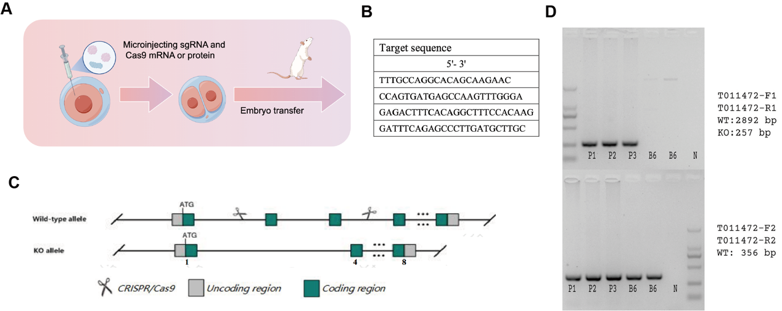
Figure S2 Generation and genotyping of the [Insert Gene Name, e.g., Pink1] mutant mouse model using the CRISPR/Cas9 system. A) Schematic illustration of the CRISPR/Cas9-mediated gene editing workflow. Specifically designed sgRNAs and Cas9 mRNA/protein were microinjected into fertilized mouse zygotes, which were subsequently transferred into pseudopregnant surrogate females for embryonic development. B) The 5' to 3' target sequences of the single guide RNAs (sgRNAs) utilized to direct Cas9 cleavage at the targeted genomic loci. C) Schematic representation of the genomic editing strategy for the wild-type (WT) and knockout (KO) alleles. D) Representative agarose gel electrophoresis of PCR genotyping products from founder mice/progeny (P1–P3) and wild-type C57BL/6 (B6) controls. The top gel displays amplification using the primer pair F1/R1, yielding a 257 bp specific band for the KO allele (the 2892 bp WT band is beyond standard amplification/extension time here). The bottom gel shows amplification using the primer pair F2/R2, yielding a 356 bp band specific to the WT allele. The simultaneous presence of both the 257 bp KO band and the 356 bp WT band in samples P1, P2, and P3 confirms their heterozygous (+/-) genotype. 'N' represents the negative template control (water).

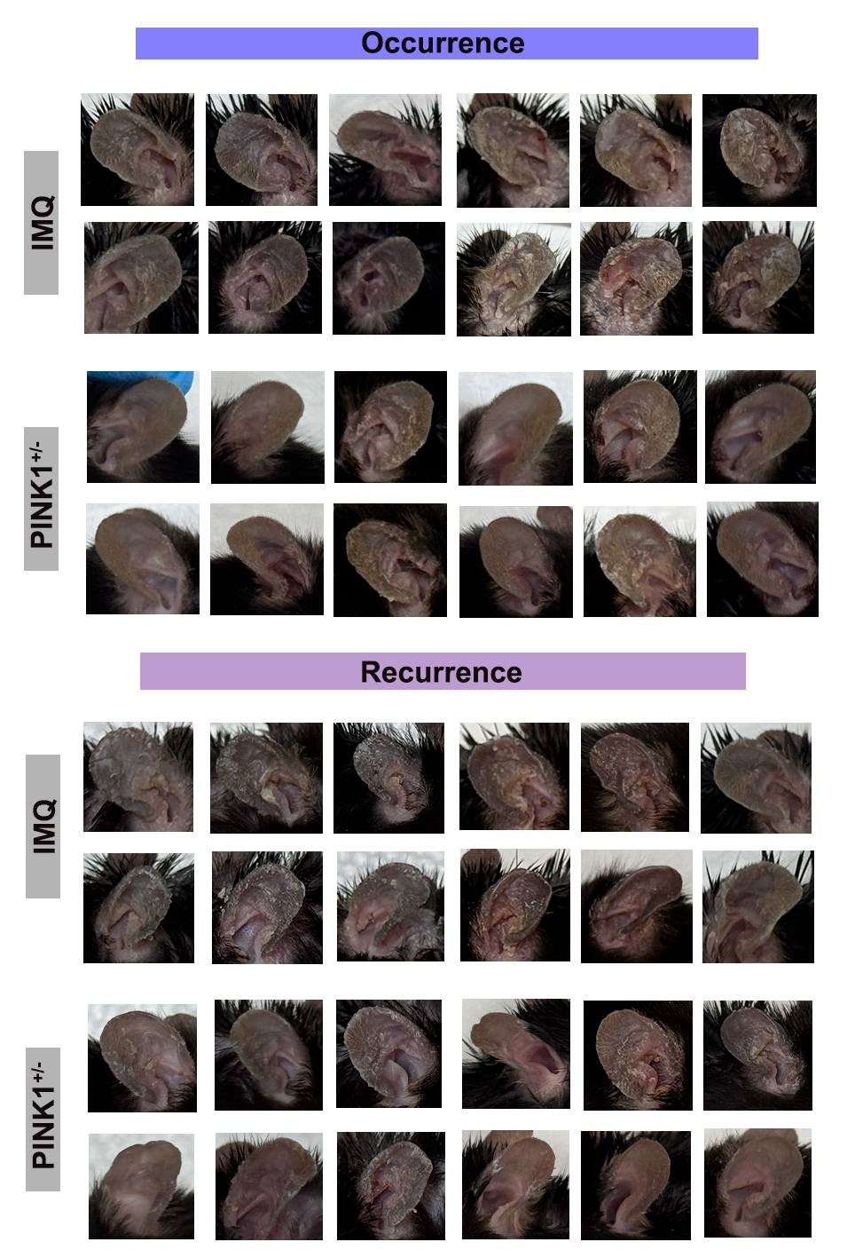
Figure S3. Attenuation of IMQ-induced psoriasis-like lesion in Pink1^{+/-} mice. Macroscopic images of ear skin from multiple biological replicates of wild-type and Pink1^{+/-} mice during the occurrence (top) and recurrence (bottom) phases.

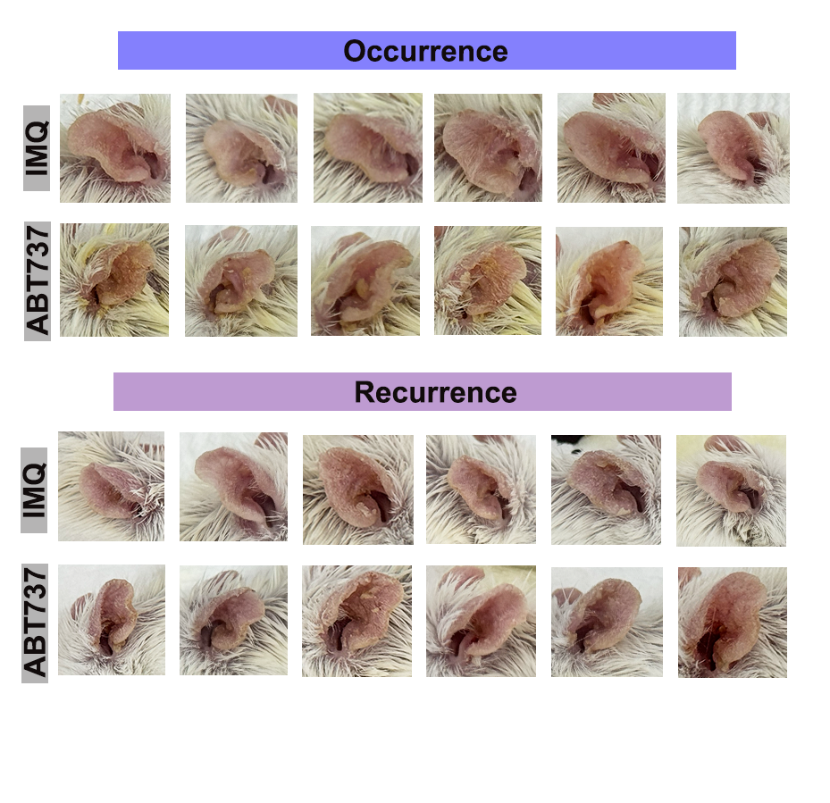
Figure S4. Exacerbation of IMQ-induced psoriasis-like lesion by ABT737. Macroscopic images of ear skin from multiple biological replicates of Control (IMQ) and ABT737-treated mice during the occurrence (top) and recurrence (bottom) phases.

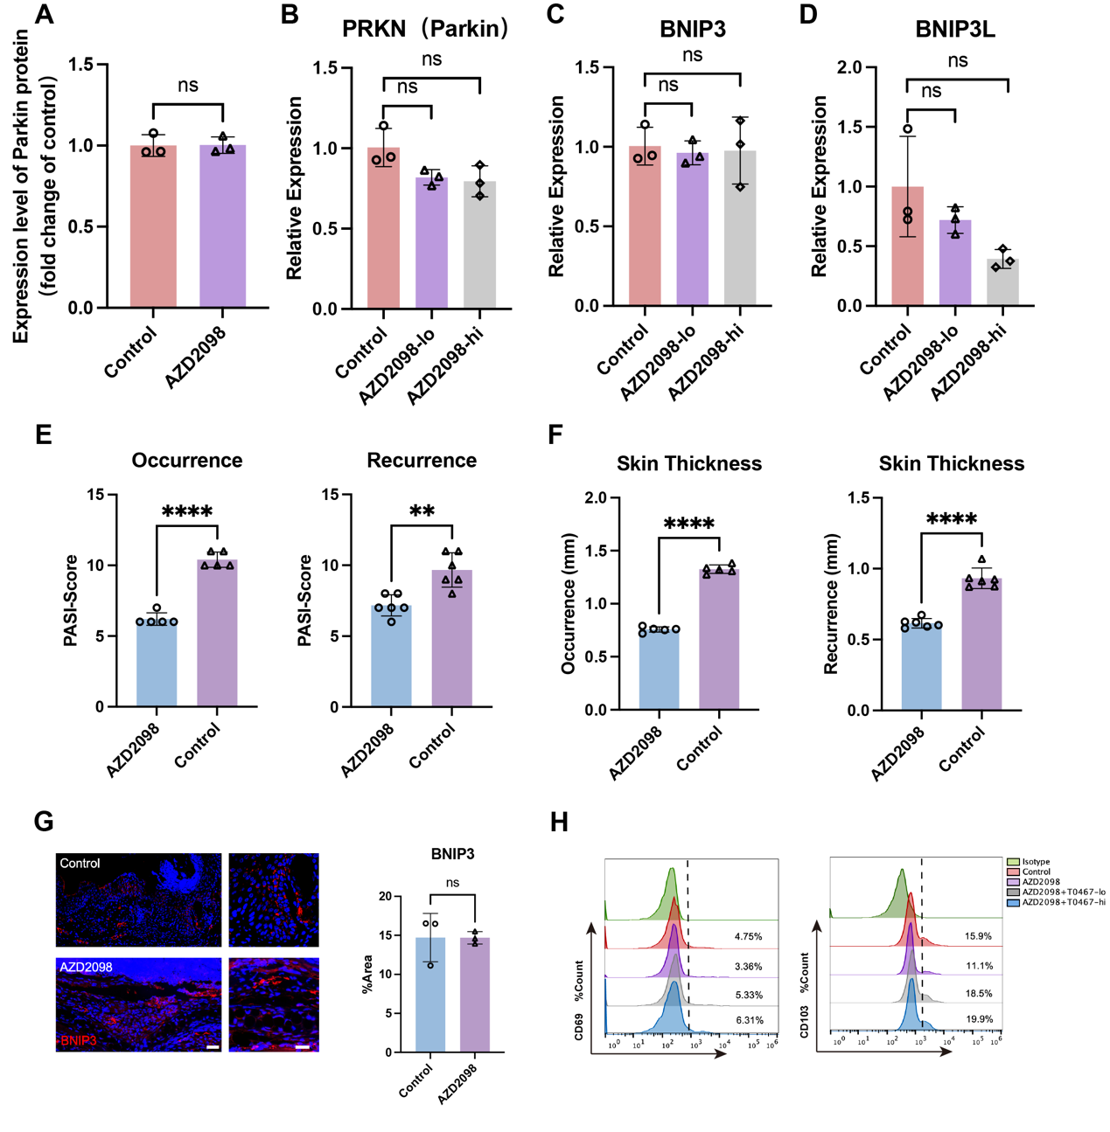
Figure S5. Pharmacological inhibition of CCR4 exerts specific effects on mitophagy and significantly ameliorates psoriasis-like lesions. A) Quantitation of Parkin protein expression levels in primary CD8⁺ T cells treated with or without the CCR4 inhibitor AZD2098. B–D) Relative mRNA expression levels of alternative mitophagy-related genes, including PRKN (encoding Parkin) (B), BNIP3 (C), and BNIP3L (D), in cells treated with low-dose AZD2098 (AZD2098-lo), or high-dose AZD2098 (AZD2098-hi). Expression was measured via qRT-PCR and normalized to the control group. E, F) Clinical evaluation of imiquimod (IMQ)-induced psoriasis-like lesion in mice. PASI scores (E) and ear skin thickness (F) were evaluated and compared between AZD2098-treated and Control groups during both the initial occurrence phase and the subsequent recurrence phase. G) Representative immunofluorescence images (left) and corresponding quantitative analysis (right) of BNIP3 protein expression in the lesion of Control and AZD2098-treated mice. Scale bars: 50 μm, enlarged scale bar: 20 μm. (H) Phenotypic rescue using the PINK1 activator T0467. Representative flow cytometry histograms of CD69 and CD103 in CD8⁺ T cells treated with AZD2098 alone or in combination with low/high doses of T0467. Data are presented as mean ± SEM. ns, not significant; **P < 0.01, **** P < 0.0001.

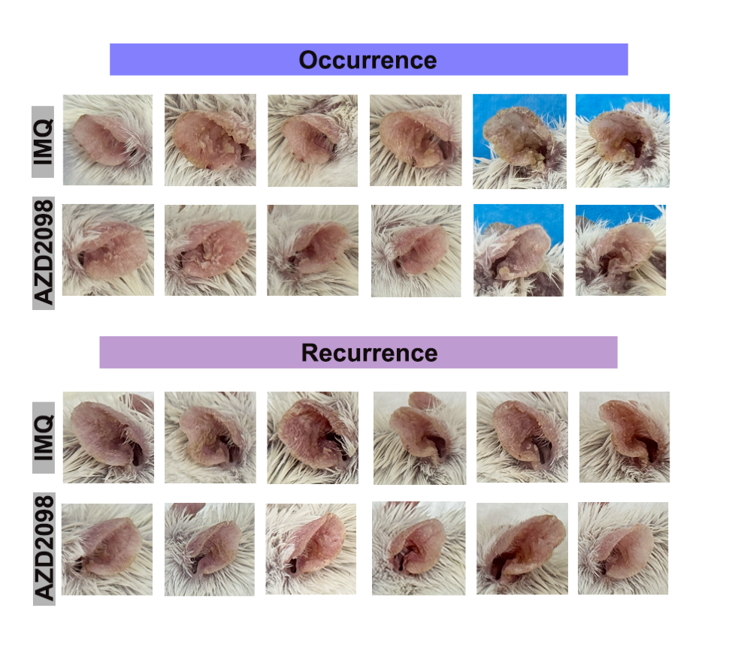
Figure S6. Attenuation of IMQ-induced psoriasis-like lesion by AZD2098.
Macroscopic images of ear skin from multiple biological replicates of Control (IMQ) and AZD2098-treated mice during the occurrence (top) and recurrence (bottom) phases.

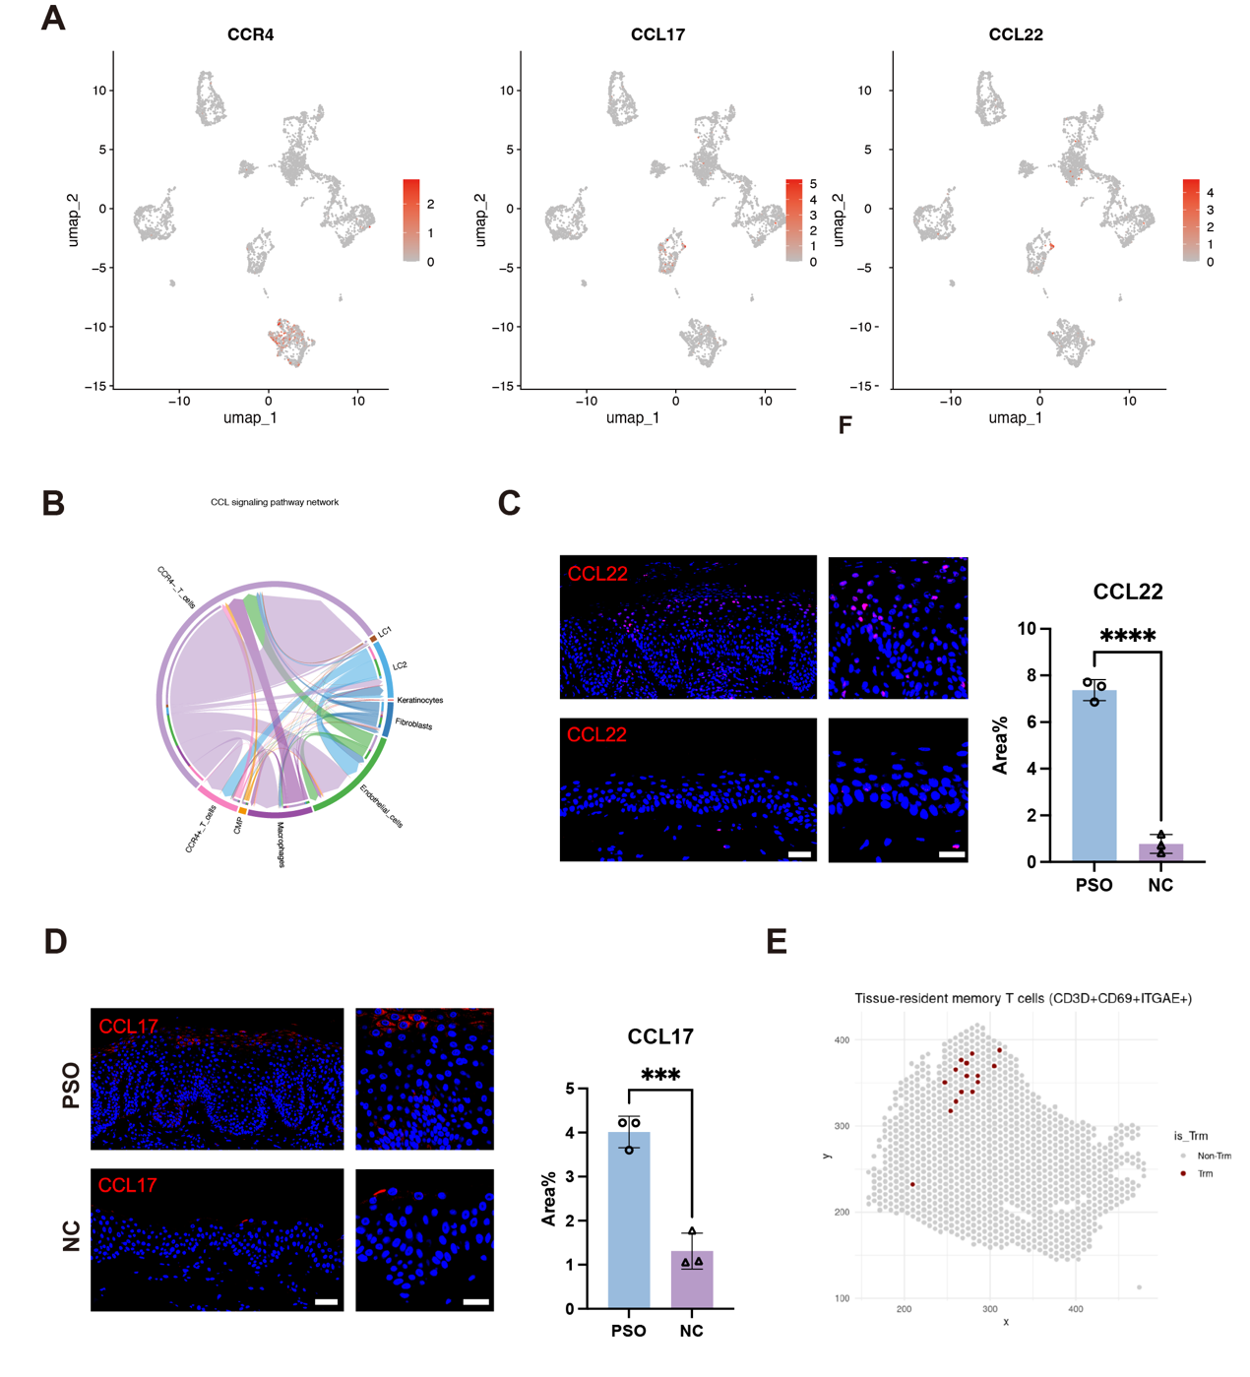
Figure S7. Expression landscape of the CCL17/22-CCR4 axis and spatial mapping of TRM cells in the psoriatic skin microenvironment. A) UMAP feature plots illustrating the single-cell transcriptomic expression distribution and levels of CCR4, CCL17, and CCL22. B) Circos plot depicting the inferred cell-cell communication networks among diverse cell populations, highlighting the intricate signaling interactions, particularly those mediated by the CCL17/CCL22 signaling pathways. C-D) Representative immunofluorescence images (left) and statistical quantification of the fluorescence-positive area percentage (right) for the chemokine CCL22(C) and CCL17(D) in skin tissues from psoriasis (PSO) patients and normal controls (NC). Scale bars: 50 μm, enlarged scale bar: 20 μm. **** P < 0.0001. *** P < 0.001. E) Spatial transcriptomics mapping demonstrating the specific anatomical distribution and localization of TRM within the psoriatic skin section. All quantitative data are presented as mean ± SEM.
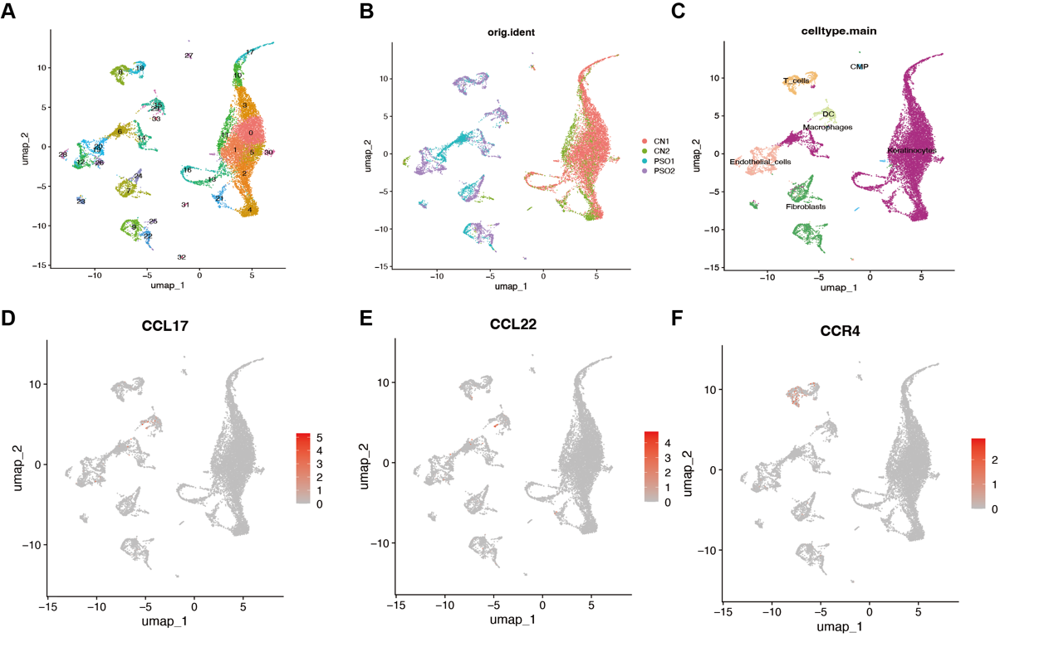
Figure S8 Cellular Origins of CCR4, CCL17, and CCL22 Unveiled by Single-cell Transcriptomics. (D-I) Validation of findings through analysis of public databases.

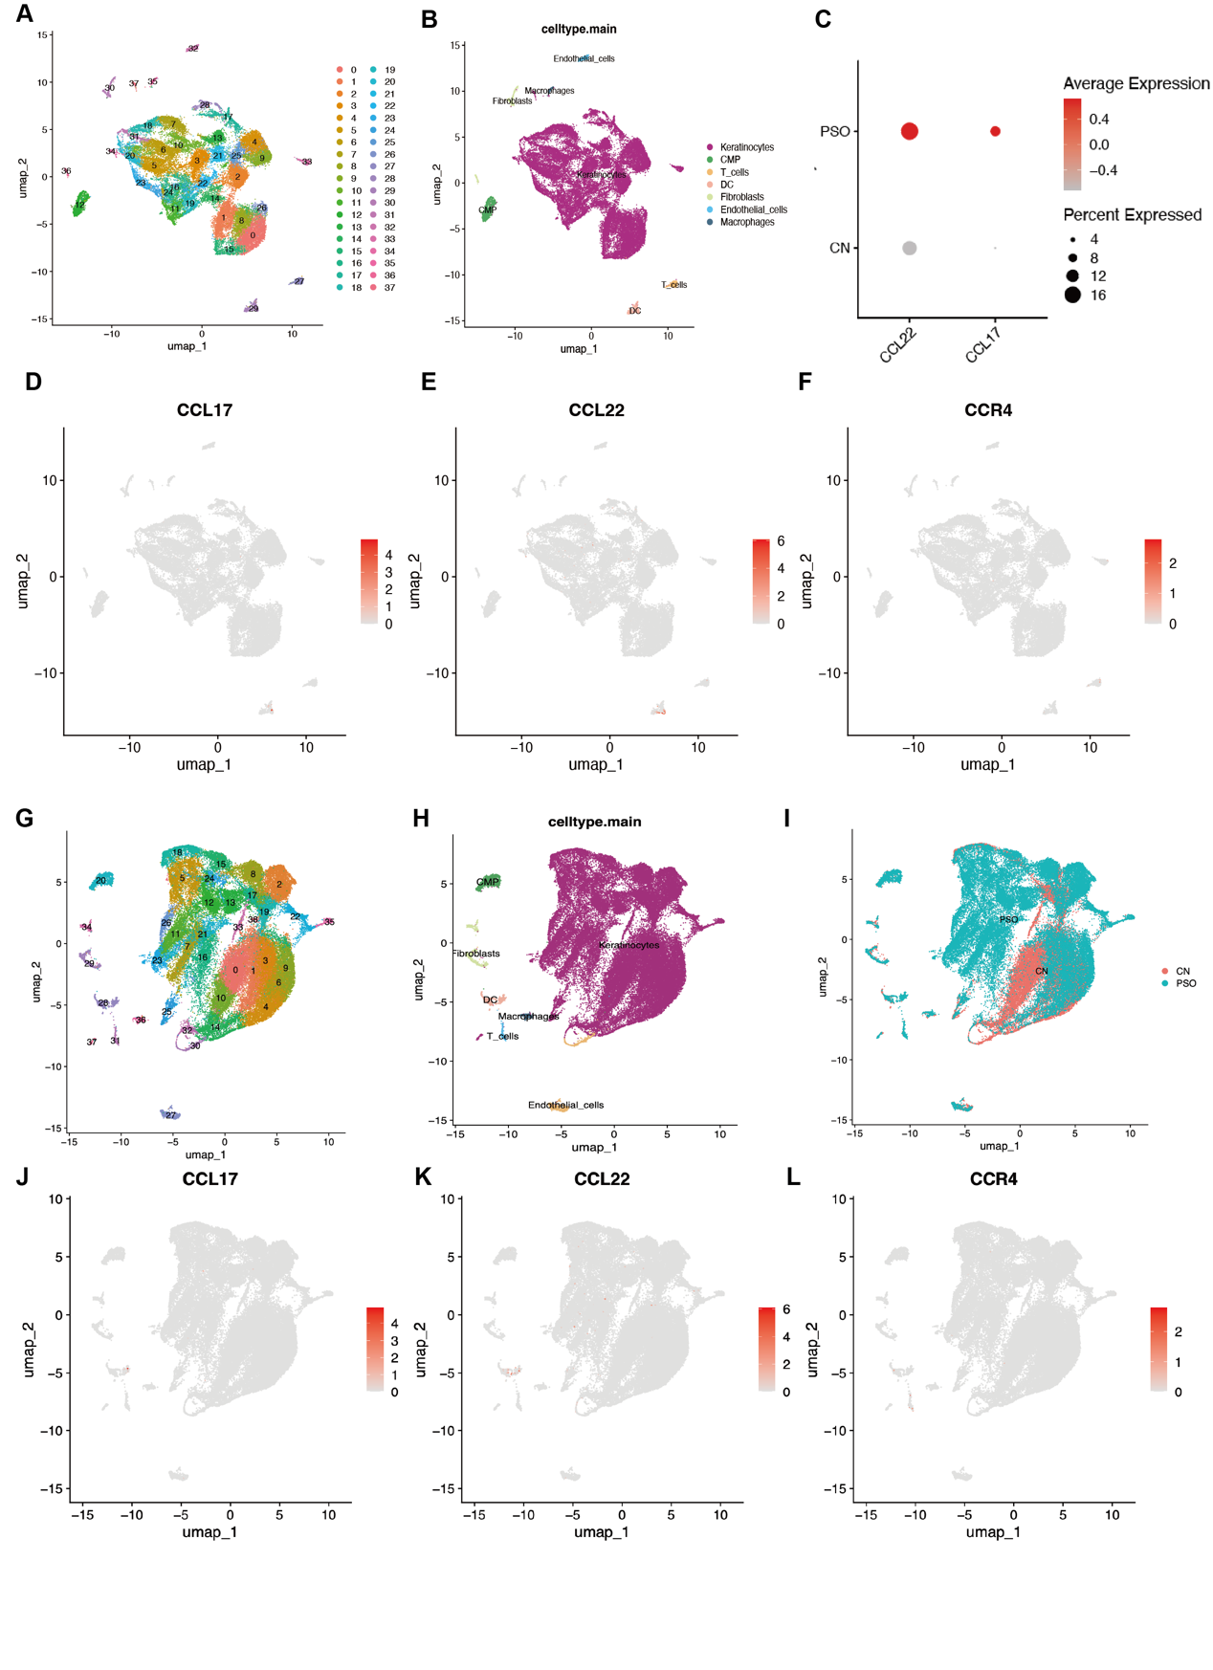
Figure S9 Cellular Origins of CCR4, CCL17, and CCL22 Unveiled by Single-cell Transcriptomics. (A-B, D-F) Analysis reveals that CCR4 originates from T cells, while CCL22 and CCL17 is broadly present in DC. (C) Dotplot depicting the increased expression of detailed genes for CCL22 and CCL17 in psoriasis. (G-L) Validation of findings in psoriasis lesions and normal skin through analysis of public databases.

