Supplementary Table S1. Multivariable Cox regression analysis of IRC-assessed PFS and overall survival (Model 2, excluding BMI)
Variable | IRC-assessed PFS HR  (95% CI) | P value | OS HR (95% CI) | P value
Lipid-lowering therapy, yes vs no | 0.716 (0.517-0.991) | 0.044 | 0.520 (0.345-0.782) | 0.002
Treatment arm, sunitinib vs toripalimab plus axitinib | 1.561 (1.176-2.071) | 0.002 | 1.234 (0.892-1.707) | 0.203
Age, per year | 1.006 (0.991-1.022) | 0.434 | 1.015 (0.996-1.035) | 0.116
Sex, female vs male | 1.039 (0.741-1.456) | 0.825 | 1.255 (0.864-1.825) | 0.234
ECOG performance status, 1 vs 0 | 1.035 (0.769-1.393) | 0.82 | 1.168 (0.827-1.648) | 0.379
IMDC risk group, 1 vs 0 | 0.682 (0.476-0.976) | 0.036 | 0.455 (0.309-0.671) | <0.001
Interval from diagnosis to randomization, per month | 0.987 (0.980-0.995) | 0.001 | 0.992 (0.984-1.000) | 0.038
Number of metastatic sites, per site increase | 1.065 (0.935-1.213) | 0.341 | 1.069 (0.920-1.242) | 0.386
Hazard ratios (HRs) and 95% confidence intervals (CIs) were estimated using multivariable Cox proportional hazards models (Model 2), which excluded BMI from the adjustment variables.
HR < 1 indicates a lower risk of progression or death for PFS and a lower risk of death for OS.

Supplementary Table S2. Interaction analysis between lipid-lowering therapy use and BMI for survival outcomes
Outcome | Variable | HR (95% CI) | P value
IRC-assessed PFS | Lipid-lowering therapy (Yes vs No) | 0.582 (0.371–0.913) | 0.019
 | BMI group (≥ median vs < median) | 0.880 (0.640–1.210) | 0.431
 | Lipid-lowering therapy × BMI group | 1.690 (0.929–3.075) | 0.086
OS | Lipid-lowering therapy (Yes vs No) | 0.635 (0.430–0.939) | 0.023
 | BMI group (≥ median vs < median) | 0.841 (0.630–1.122) | 0.239
 | Lipid-lowering therapy × BMI group | 1.527 (0.904–2.580) | 0.113
BMI was dichotomized according to the median value. Interaction terms between lipid-lowering therapy use and BMI group were included in Cox proportional hazards models. HR < 1 indicates a lower risk of progression or death for PFS and a lower risk of death for OS. P values for interaction correspond to the statistical significance of the interaction term.

Supplementary Table S3. Characteristics of lipid-lowering therapy use among users
Variable | Lipid-lowering therapy users, n = 113
Statin use, n (%) | 91 (80.5)
Non-statin or non–statin-classified lipid-lowering therapy, n (%) | 22 (19.5)
Combination lipid-lowering therapy, n (%) | 19 (16.8)
Statin dose, median (IQR), mg/day | 20 (10–20)
Abbreviations: IQR, interquartile range.
Lipid-lowering therapy use was defined based on recorded oral medication use during the study period and was not restricted to baseline use.
Statin dose was summarized among statin users with available dose information.

Supplementary Table S4. Post hoc association between baseline TG and survival outcomes among lipid-lowering therapy users stratified by treatment group
Treatment group | Outcome | HR (95% CI), TG >=1.7 vs <1.7 mmol/L | Log-rank P value
Toripalimab + Axitinib | IRC-assessed PFS | 3.21 (1.29-8.03) | 0.009
Toripalimab + Axitinib | OS | 1.90 (0.64-5.68) | 0.242
Sunitinib | IRC-assessed PFS | 0.43 (0.20-0.94) | 0.030
Sunitinib | OS | 0.29 (0.10-0.85) | 0.016
Baseline TG was dichotomized using the clinical cutoff of 1.7 mmol/L. HRs compare TG >=1.7 mmol/L with TG <1.7 mmol/L among lipid-lowering therapy users within each treatment group. P values were calculated using the log-rank test. These analyses were post hoc and were not adjusted for multiple comparisons.

Supplementary Table S5. Covariate balance before and after IPTW stratified by treatment group
Treatment group | Covariate | SMD before IPTW | SMD after IPTW | Balance after IPTW
Toripalimab + Axitinib | Age | 0.366 | 0.085 | Balanced
Toripalimab + Axitinib | Female sex | 0.04 | 0.015 | Balanced
Toripalimab + Axitinib | BMI | 0.317 | 0.044 | Balanced
Toripalimab + Axitinib | ECOG PS 1 | 0.009 | 0.005 | Balanced
Toripalimab + Axitinib | Diagnosis-to-randomization interval | 0.051 | 0.004 | Balanced
Toripalimab + Axitinib | Number of metastatic sites | 0.251 | 0.064 | Balanced
Sunitinib | Age | 0.271 | 0.028 | Balanced
Sunitinib | Female sex | 0.109 | 0.013 | Balanced
Sunitinib | BMI | 0.404 | 0.062 | Balanced
Sunitinib | ECOG PS 1 | 0.076 | 0.054 | Balanced
Sunitinib | Diagnosis-to-randomization interval | 0.006 | 0.045 | Balanced
Sunitinib | Number of metastatic sites | 0.031 | 0.011 | Balanced
Table note:
Standardized mean differences were calculated to assess baseline covariate balance between patients with and without lipid-lowering therapy before and after inverse probability of treatment weighting within each treatment group. Stabilized IPTW was estimated using age, sex, BMI, ECOG performance status, diagnosis-to-randomization interval, and number of metastatic sites. An absolute standardized mean difference less than 0.10 was considered indicative of adequate balance. Abbreviations: BMI, body mass index; ECOG, Eastern Cooperative Oncology Group; IPTW, inverse probability of treatment weighting; LLT, lipid-lowering therapy; SMD, standardized mean difference.

Supplementary Table S6. IPTW-adjusted Cox regression analyses of lipid-lowering therapy and survival outcomes stratified by treatment group
Treatment group | Outcome | IPTW-adjusted HR  (95% CI) | P value
Toripalimab + Axitinib | IRC-assessed PFS | 0.62 (0.38–1.04) | 0.068
Toripalimab + Axitinib | Overall survival | 0.48 (0.26–0.88) | 0.018
Sunitinib | IRC-assessed PFS | 0.91 (0.61–1.36) | 0.641
Sunitinib | Overall survival | 0.72 (0.42–1.25) | 0.246
Table note:
Hazard ratios (HRs) and 95% confidence intervals (CIs) were estimated using IPTW-weighted Cox proportional hazards models. IPTW was calculated based on baseline covariates to balance differences between patients with and without lipid-lowering therapy.
Abbreviations: CI, confidence interval; HR, hazard ratio; IRC, independent review committee; OS, overall survival; PFS, progression-free survival.

Supplementary Table S7. Logistic regression analysis of ORR and DCR according to lipid-lowering therapy
Outcome | Group | OR (95% CI) | P value
ORR | Toripalimab plus Axitinib | 1.273 (0.671–2.417) | 0.460
DCR | Toripalimab plus Axitinib | 1.447 (0.476–4.401) | 0.515
ORR | Sunitinib | 0.976 (0.478–1.991) | 0.947
DCR | Sunitinib | 1.794 (0.625–5.150) | 0.278
Table note:
Abbreviations: ORR, objective response rate; DCR, disease control rate; IRC, independent review committee; CI, confidence interval. Odds ratios were estimated using logistic regression models comparing lipid-lowering therapy use versus no use.

Supplementary Table S8. Post hoc analyses according to lipid-lowering therapy class and lipid biomarkers
Analysis | Population | IRC-assessed PFS | OS
LLT class | LLT users (n=113) | — | —
Statin vs non-statin | LLT users | No stable difference | No stable difference
Baseline TC | Overall and LLT users | No consistent association | No consistent association
TG ≥1.7 vs <1.7 mmol/L | Toripalimab + axitinib LLT users | HR 3.21 (1.29–8.03); P=0.009 | HR 1.90 (0.64–5.68); P=0.242
TG ≥1.7 vs <1.7 mmol/L | Sunitinib LLT users | HR 0.43 (0.20–0.94); P=0.030 | HR 0.29 (0.10–0.85); P=0.016
Table note:
LLT, lipid-lowering therapy; TC, total cholesterol; TG, triglycerides; IRC, independent review committee; PFS, progression-free survival; OS, overall survival; HR, hazard ratio; CI, confidence interval. TG subgroup analyses compared TG >=1.7 mmol/L with TG <1.7 mmol/L among lipid-lowering therapy users within each treatment group. P values for TG analyses were calculated using the log-rank test. These analyses were post hoc and were not adjusted for multiple comparisons.

Supplementary Figure 1. Multivariable Cox regression analysis of survival outcomes (Model 2)
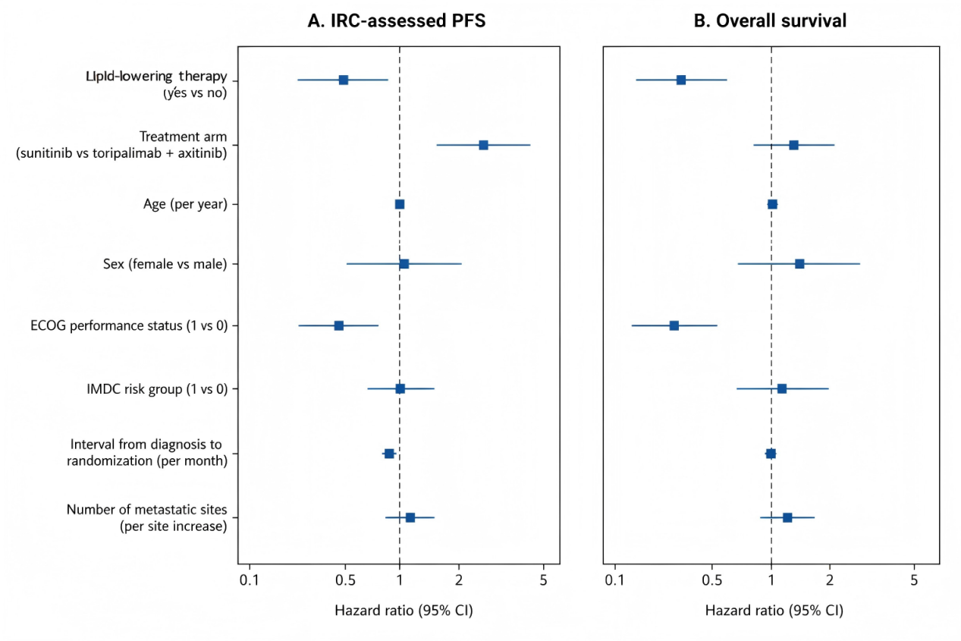
Forest plots of multivariable Cox regression analyses for progression-free survival (PFS) and overall survival (OS) (Model 2, excluding BMI). Hazard ratios (HRs) are shown on a logarithmic scale, with the vertical line indicating HR = 1.0.

