Supplementary Material 1
Supplementary figures and tables
Joint Associations of the Atherogenic Index of Plasma and Estimated Glucose Disposal Rate with Incident Cardio-Renal-Metabolic Multimorbidity: A Prospective Cohort Study in UK Biobank and CHARLS
Contents
Supplementary Figure S1. Participant selection in UK Biobank and CHARLS
Supplementary Figure S2. CRMM cumulative incidence by joint AIP-eGDR phenotype in UK Biobank and CHARLS
Supplementary Figure S3. Joint AIP-eGDR phenotypes and incident CRMM across UK Biobank subgroups
Supplementary Figure S4. Joint AIP-eGDR phenotypes and incident CRMM across CHARLS subgroups
Table S1. Hypertension and outcome ascertainment in CHARLS
Table S2. Baseline characteristics by joint AIP-eGDR phenotype in UK Biobank
Table S3. Baseline characteristics by joint AIP-eGDR phenotype in CHARLS
Table S4. Joint AIP-eGDR phenotypes and incident CRMM in both cohorts
Table S5. Piecewise associations of AIP and eGDR with incident CRMM
Table S6. Exploratory discrimination and reclassification metrics in CHARLS
Table S7. Additive interaction between AIP and eGDR in UK Biobank
Table S8. Additive interaction between AIP and eGDR in CHARLS
Table S9. Coarse transition-specific associations in UK Biobank
Table S10. Detailed transition-specific associations in UK Biobank
Table S11. Coarse CRMM transition routes in UK Biobank
Table S12. Detailed CRMM transition routes in UK Biobank
Table S13. Sensitivity analysis additionally adjusted for family history in UK Biobank
Table S14. Sensitivity analysis additionally adjusted for glucose-lowering and antihypertensive medications
Table S15. Fine-Gray competing-risk analysis for incident CRMM in UK Biobank
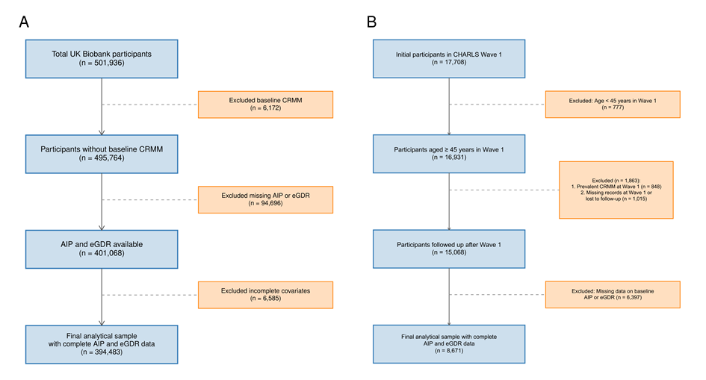
Supplementary Figure S1. Participant selection in UK Biobank and CHARLS.
(A) UK Biobank participant selection; (B) CHARLS participant selection.
Abbreviations: AIP, atherogenic index of plasma; CHARLS, China Health and Retirement Longitudinal Study; CRMM, cardio-renal-metabolic multimorbidity; eGDR, estimated glucose disposal rate; UKB, UK Biobank.
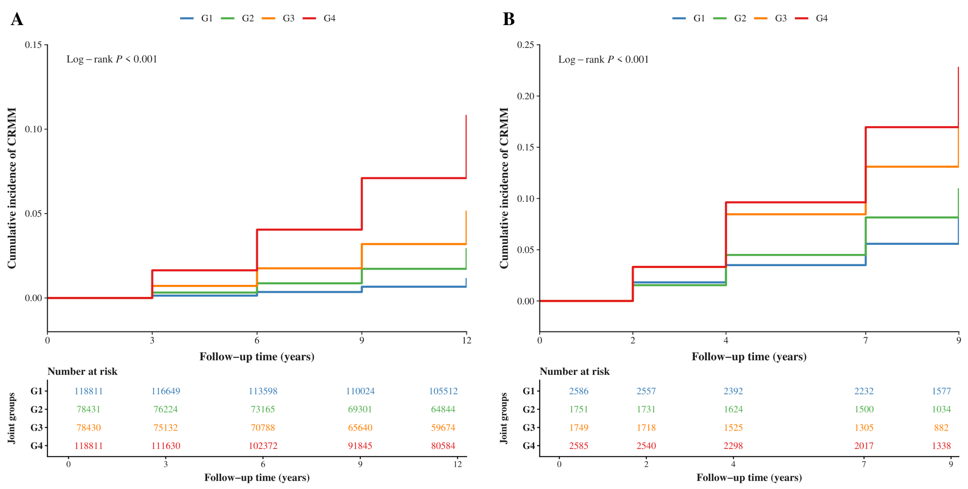
Supplementary Figure S2. CRMM cumulative incidence by joint AIP-eGDR phenotype in UK Biobank and CHARLS.
Abbreviations: AIP, atherogenic index of plasma; CHARLS, China Health and Retirement Longitudinal Study; CRMM, cardio-renal-metabolic multimorbidity; eGDR, estimated glucose disposal rate; G1, low AIP/high eGDR (reference); G2, high AIP/high eGDR; G3, low AIP/low eGDR; G4, high AIP/low eGDR; UKB, UK Biobank.
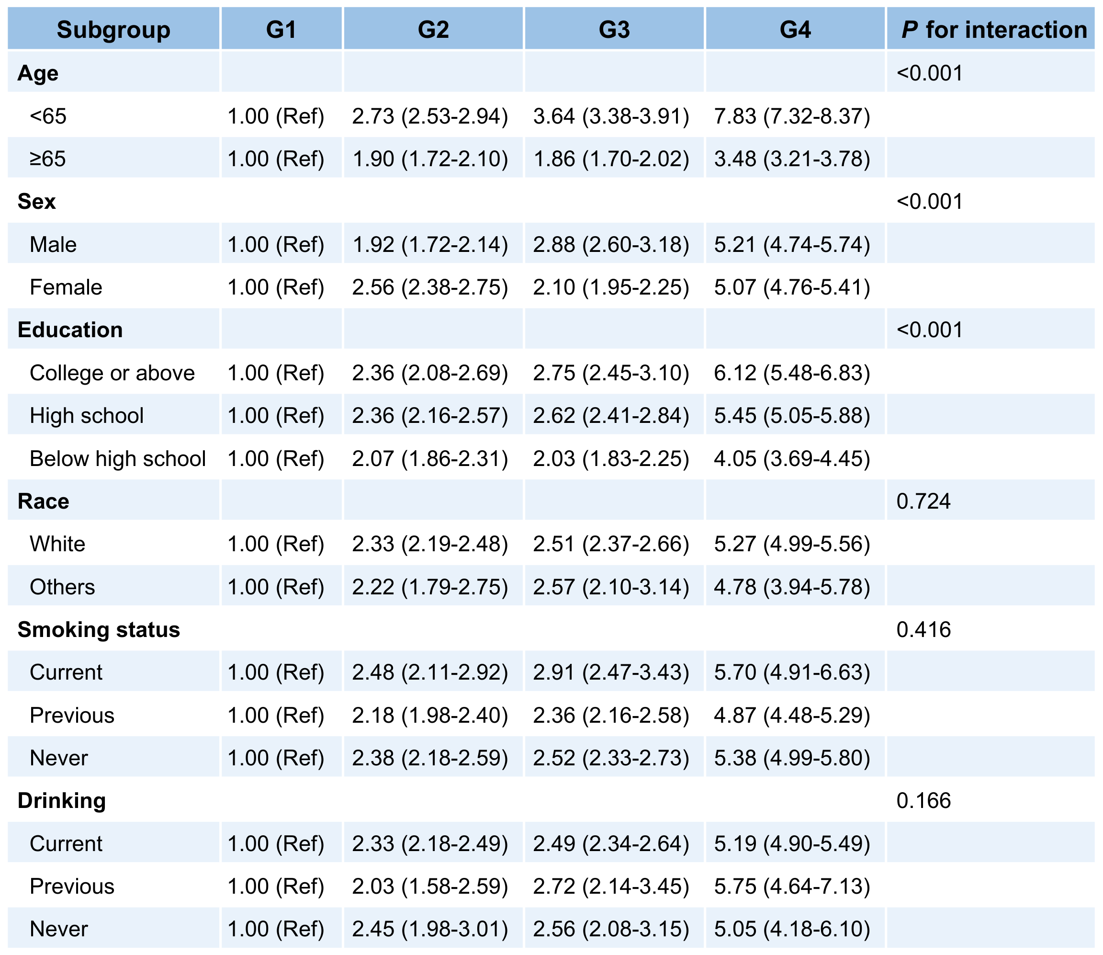
Supplementary Figure S3. Joint AIP-eGDR phenotypes and incident CRMM across UK Biobank subgroups. Hazard ratios are presented with G1 (low AIP, high eGDR) as the reference group. G2, high AIP/high eGDR; G3, low AIP/low eGDR; G4, high AIP/low eGDR
Abbreviations: AIP, atherogenic index of plasma; CI, confidence interval; CRMM, cardio-renal-metabolic multimorbidity; eGDR, estimated glucose disposal rate; HR, hazard ratio; UKB, UK Biobank.
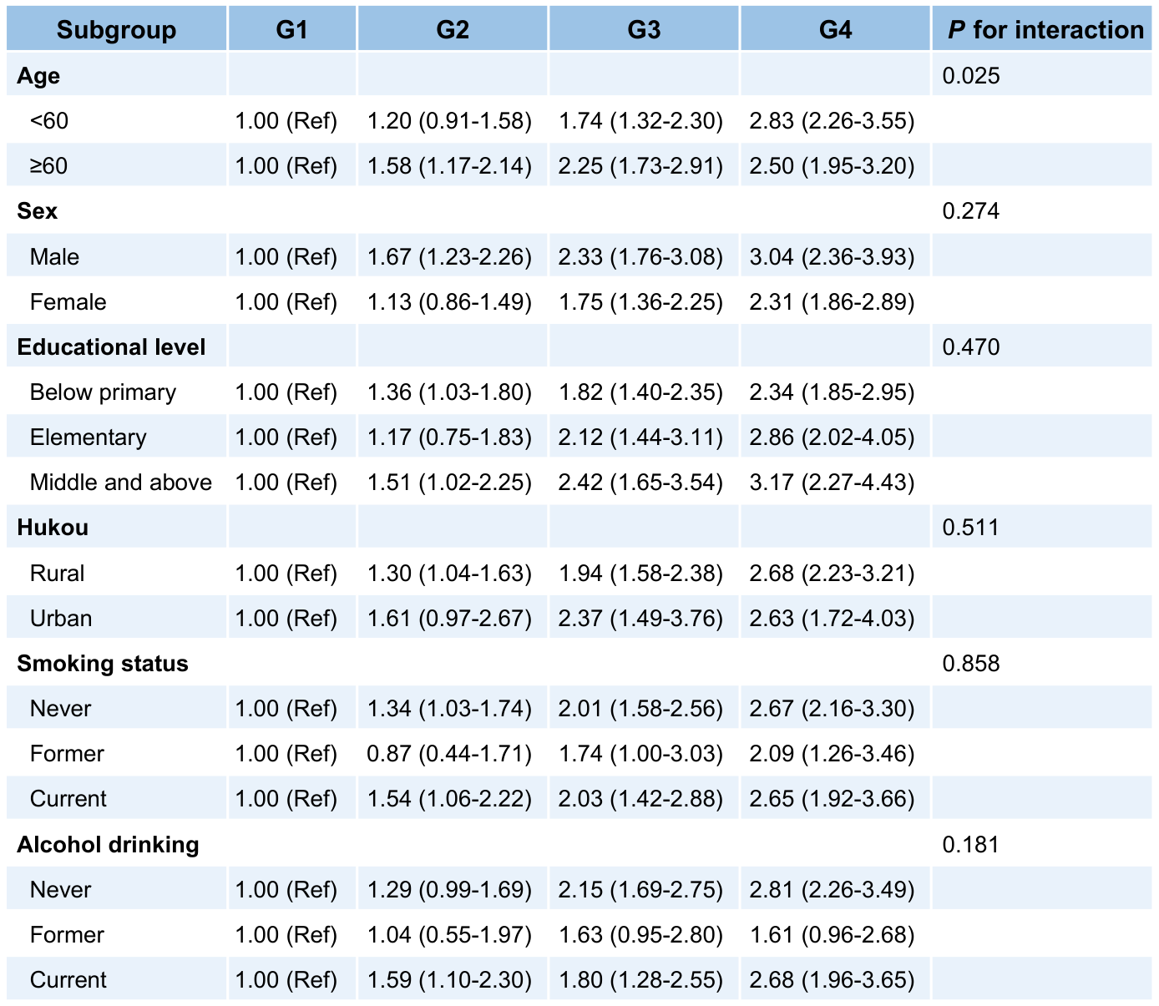
Supplementary Figure S4. Joint AIP-eGDR phenotypes and incident CRMM across CHARLS subgroups.
Abbreviations: AIP, atherogenic index of plasma; CHARLS, China Health and Retirement Longitudinal Study; CI, confidence interval; CRMM, cardio-renal-metabolic multimorbidity; eGDR, estimated glucose disposal rate; HR, hazard ratio. Hukou denotes household registration (rural vs urban) in Harmonized CHARLS variable r1rural2.
Table S1. Hypertension and outcome ascertainment in CHARLS.
Condition | Definition and ascertainment
Hypertension | Self-reported physician-diagnosed hypertension, antihypertensive medication use, systolic blood pressure ≥ 140 mmHg, or diastolic blood pressure ≥ 90 mmHg.
Cardiovascular disease (CVD) | Self-reported physician-diagnosed heart attack or stroke, ascertained at each follow-up wave through the standard CHARLS health questionnaire.
Type 2 diabetes | Self-reported physician diagnosis, fasting glucose ≥ 7.0 mmol/L, or HbA1c ≥ 6.5% at follow-up.
Chronic kidney disease (CKD) | Self-reported physician-diagnosed kidney disease or eGFR <60 mL/min/1.73 m² derived from serum creatinine at follow-up.
Note. In CHARLS, the 2011 wave was used as baseline and participants were followed through 2020. Incident CRMM was defined as the first follow-up time at which at least two of CVD, T2D, and CKD were present; participants with prevalent CRMM at baseline were excluded, whereas participants with zero or one component disease remained eligible. The eGFR-based CKD component is an operational study definition; a single eGFR <60 mL/min/1.73 m² does not by itself establish persistence for at least 3 months. Hypertension and CVD definitions for UK Biobank are described in the main Methods.
Abbreviations: CHARLS, China Health and Retirement Longitudinal Study; CKD, chronic kidney disease; CRMM, cardio-renal-metabolic multimorbidity; CVD, cardiovascular disease; eGFR, estimated glomerular filtration rate; HbA1c, glycated hemoglobin; ICD-10, International Classification of Diseases, 10th Revision; T2D, type 2 diabetes.
Table S2. Baseline characteristics by joint AIP-eGDR phenotype in UK Biobank.
Characteristic | Overall | G1 | G2 | G3 | G4 | P-value
Age, years, mean (SD) | 56.48 (8.09) | 53.94 (8.07) | 54.87 (8.13) | 59.00 (7.32) | 58.41 (7.54) | <0.001
Townsend deprivation index, mean (SD) | -1.36 (3.05) | -1.47 (2.99) | -1.25 (3.13) | -1.45 (3.01) | -1.27 (3.09) | <0.001
Sleep duration, hours, mean (SD) | 7.15 (1.10) | 7.14 (1.02) | 7.15 (1.11) | 7.15 (1.09) | 7.17 (1.17) | <0.001
Waist circumference, cm, mean (SD) | 90.16 (13.35) | 80.71 (10.05) | 89.90 (9.15) | 90.15 (12.30) | 99.77 (12.40) | <0.001
HbA1c, %, mean (SD) | 5.44 (0.58) | 5.28 (0.36) | 5.37 (0.38) | 5.45 (0.57) | 5.63 (0.79) | <0.001
LDL-C, mmol/L, mean (SD) | 3.57 (0.86) | 3.41 (0.77) | 3.79 (0.85) | 3.47 (0.85) | 3.66 (0.92) | <0.001
CRP, mg/L, mean (SD) | 2.58 (4.32) | 1.83 (3.84) | 2.61 (4.14) | 2.61 (4.58) | 3.30 (4.57) | <0.001
AIP score, mean (SD) | 0.03 (0.30) | -0.22 (0.16) | 0.25 (0.18) | -0.18 (0.15) | 0.29 (0.19) | <0.001
eGDR, mg·kg⁻¹·min⁻¹, mean (SD) | 8.44 (2.42) | 10.87 (0.98) | 10.09 (0.84) | 6.77 (1.13) | 6.01 (1.33) | <0.001
Sex, n (%) |  |  |  |  |  | <0.001
Male | 181,310 (46.0) | 28,570 (24.0) | 38,352 (48.9) | 35,299 (45.0) | 79,089 (66.6)
Female | 213,173 (54.0) | 90,241 (76.0) | 40,079 (51.1) | 43,131 (55.0) | 39,722 (33.4)
Race, n (%) |  |  |  |  |  | <0.001
White | 373,998 (94.8) | 112,975 (95.1) | 73,881 (94.2) | 73,978 (94.3) | 113,164 (95.2)
Others | 20,485 (5.2) | 5,836 (4.9) | 4,550 (5.8) | 4,452 (5.7) | 5,647 (4.8)
Educational level, n (%) |  |  |  |  |  | <0.001
College or above | 128,720 (32.6) | 47,068 (39.6) | 26,492 (33.8) | 23,577 (30.1) | 31,583 (26.6)
High school / equivalent | 199,923 (50.7) | 58,743 (49.4) | 40,224 (51.3) | 39,666 (50.6) | 61,290 (51.6)
Below high school | 65,840 (16.7) | 13,000 (10.9) | 11,715 (14.9) | 15,187 (19.4) | 25,938 (21.8)
Smoking status, n (%) |  |  |  |  |  | <0.001
Current | 41,617 (10.5) | 10,645 (9.0) | 11,408 (14.5) | 6,274 (8.0) | 13,290 (11.2)
Previous | 136,667 (34.6) | 36,438 (30.7) | 24,353 (31.1) | 28,947 (36.9) | 46,929 (39.5)
Never | 216,199 (54.8) | 71,728 (60.4) | 42,670 (54.4) | 43,209 (55.1) | 58,592 (49.3)
Alcohol intake, n (%) |  |  |  |  |  | <0.001
Current | 364,085 (92.3) | 110,964 (93.4) | 71,085 (90.6) | 73,267 (93.4) | 108,769 (91.5)
Previous | 13,684 (3.5) | 3,476 (2.9) | 3,294 (4.2) | 2,171 (2.8) | 4,743 (4.0)
Never | 16,714 (4.2) | 4,371 (3.7) | 4,052 (5.2) | 2,992 (3.8) | 5,299 (4.5)
Family history of CMD, n (%) |  |  |  |  |  | <0.001
Yes | 304,508 (83.0) | 88,688 (79.3) | 58,714 (80.7) | 62,606 (85.9) | 94,500 (86.3)
No | 62,532 (17.0) | 23,092 (20.7) | 14,083 (19.3) | 10,302 (14.1) | 15,055 (13.7)
Lipid-lowering medication, n (%) |  |  |  |  |  | <0.001
Yes | 39,468 (10.0) | 2,190 (1.8) | 3,570 (4.6) | 9,570 (12.2) | 24,138 (20.3)
No | 355,015 (90.0) | 116,621 (98.2) | 74,861 (95.4) | 68,860 (87.8) | 94,673 (79.7)
Hypertension, n (%) |  |  |  |  |  | <0.001
Yes | 186,607 (47.3) | 4,029 (3.4) | 411 (0.5) | 75,214 (95.9) | 106,953 (90.0)
No | 207,876 (52.7) | 114,782 (96.6) | 78,020 (99.5) | 3,216 (4.1) | 11,858 (10.0)
Incident CRMM during follow-up, n (%) |  |  |  |  |  | <0.001
No | 371,194 (94.1) | 117,032 (98.5) | 75,592 (96.4) | 73,785 (94.1) | 104,785 (88.2)
Yes | 23,289 (5.9) | 1,779 (1.5) | 2,839 (3.6) | 4,645 (5.9) | 14,026 (11.8)
Note: Values are presented as mean (SD) or n (%). P values were derived from Kruskal-Wallis tests for continuous variables and chi-square tests for categorical variables. Race was self-reported and categorized as White or Other; the Other category included Asian, Black, Mixed, Chinese, and other reported ethnic groups. Family-history data were available for 367,040 participants and were used in a sensitivity analysis rather than the primary fully adjusted model.
G1, low AIP/high eGDR (reference); G2, high AIP/high eGDR; G3, low AIP/low eGDR; G4, high AIP/low eGDR.
Table S3. Baseline characteristics by joint AIP-eGDR phenotype in CHARLS.
Characteristic | Overall | G1 | G2 | G3 | G4 | P-value
Age, years, mean (SD) | 58.94 (9.20) | 57.74 (8.90) | 56.96 (8.57) | 61.65 (9.78) | 59.64 (8.97) | <0.001
Night sleep duration, hours, mean (SD) | 6.35 (1.88) | 6.36 (1.82) | 6.31 (1.90) | 6.27 (1.95) | 6.44 (1.87) | 0.024
LDL cholesterol, mg/dL, mean (SD) | 116.47 (34.82) | 113.45 (31.31) | 115.20 (35.74) | 118.05 (32.39) | 119.27 (38.64) | <0.001
hs-CRP, mg/L, mean (SD) | 2.58 (7.05) | 2.36 (7.31) | 2.50 (7.71) | 2.76 (7.82) | 2.74 (5.60) | <0.001
AIP score, mean (SD) | -0.01 (0.33) | -0.28 (0.16) | 0.20 (0.21) | -0.25 (0.15) | 0.28 (0.27) | <0.001
eGDR, mg·kg⁻¹·min⁻¹, mean (SD) | 9.33 (2.27) | 11.34 (0.90) | 11.13 (1.03) | 7.63 (1.23) | 7.26 (1.50) | <0.001
Sex, n (%) |  |  |  |  |  | <0.001
Male | 4,042 (46.6) | 1,304 (50.4) | 802 (45.8) | 826 (47.2) | 1,110 (42.9)
Female | 4,629 (53.4) | 1,282 (49.6) | 949 (54.2) | 923 (52.8) | 1,475 (57.1)
Educational level, n (%) |  |  |  |  |  | <0.001
Below primary | 4,199 (48.4) | 1,245 (48.1) | 798 (45.6) | 920 (52.6) | 1,236 (47.8)
Elementary | 1,921 (22.2) | 575 (22.2) | 377 (21.5) | 390 (22.3) | 579 (22.4)
Middle school or above | 2,551 (29.4) | 766 (29.6) | 576 (32.9) | 439 (25.1) | 770 (29.8)
Marital status, n (%) |  |  |  |  |  | <0.001
Married | 7,618 (87.9) | 2,321 (89.8) | 1,586 (90.6) | 1,452 (83.0) | 2,259 (87.4)
Others | 1,053 (12.1) | 265 (10.2) | 165 (9.4) | 297 (17.0) | 326 (12.6)
Hukou, n (%) |  |  |  |  |  | <0.001
Rural | 7,250 (83.6) | 2,266 (87.6) | 1,479 (84.5) | 1,460 (83.5) | 2,045 (79.1)
Urban | 1,421 (16.4) | 320 (12.4) | 272 (15.5) | 289 (16.5) | 540 (20.9)
Smoking status, n (%) |  |  |  |  |  | <0.001
Never | 5,299 (61.1) | 1,507 (58.3) | 1,067 (60.9) | 1,065 (60.9) | 1,660 (64.2)
Former | 723 (8.3) | 185 (7.2) | 120 (6.9) | 164 (9.4) | 254 (9.8)
Current | 2,649 (30.6) | 894 (34.6) | 564 (32.2) | 520 (29.7) | 671 (26.0)
Alcohol drinking, n (%) |  |  |  |  |  | <0.001
Never | 5,298 (61.1) | 1,508 (58.3) | 1,128 (64.4) | 1,017 (58.1) | 1,645 (63.6)
Former | 685 (7.9) | 174 (6.7) | 114 (6.5) | 157 (9.0) | 240 (9.3)
Current | 2,688 (31.0) | 904 (35.0) | 509 (29.1) | 575 (32.9) | 700 (27.1)
Lipid-lowering medication, n (%) |  |  |  |  |  | <0.001
Yes | 378 (4.4) | 34 (1.3) | 45 (2.6) | 80 (4.6) | 219 (8.5)
No | 8,293 (95.6) | 2,552 (98.7) | 1,706 (97.4) | 1,669 (95.4) | 2,366 (91.5)
Incident CRMM, n (%) |  |  |  |  |  | <0.001
Yes | 1,185 (13.7) | 196 (7.6) | 179 (10.2) | 271 (15.5) | 539 (20.9)
No | 7,486 (86.3) | 2,390 (92.4) | 1,572 (89.8) | 1,478 (84.5) | 2,046 (79.1)
Note: Values are presented as mean (SD) or n (%). P values were derived from Kruskal-Wallis tests for continuous variables and chi-square tests for categorical variables. Hukou denotes registered household status (rural vs urban) from Harmonized CHARLS (r1rural2), rather than current geographic residence alone.
G1, low AIP/high eGDR (reference); G2, high AIP/high eGDR; G3, low AIP/low eGDR; G4, high AIP/low eGDR.
Abbreviations: AIP, atherogenic index of plasma; CHARLS, China Health and Retirement Longitudinal Study; eGDR, estimated glucose disposal rate; hs-CRP, high-sensitivity C-reactive protein; LDL-C, low-density lipoprotein cholesterol.
Table S4. Joint AIP-eGDR phenotypes and incident CRMM in both cohorts.
Characteristic (participants, n) | Crude model | Crude model | Crude model | Model 1 | Model 1 | Model 1 | Model 2 | Model 2 | Model 2
 | HR (95% CI) | P value | P for trend | HR (95% CI) | P value | P for trend | HR (95% CI) | P value | P for trend
UK Biobank
AIP
Low AIP (n = 197,241) | 1.00 (Ref) | - |  | 1.00 (Ref) | - |  | 1.00 (Ref) | -
High AIP (n = 197,242) | 2.84 (2.76-2.92) | <0.001 | <0.001 | 2.35 (2.28-2.42) | <0.001 | <0.001 | 2.31 (2.24-2.38) | <0.001 | <0.001
eGDR
High eGDR (n = 197,242) | 1.00 (Ref) | - |  | 1.00 (Ref) | - |  | 1.00 (Ref) | -
Low eGDR (n = 197,241) | 4.57 (4.42-4.72) | <0.001 | <0.001 | 2.93 (2.84-3.03) | <0.001 | <0.001 | 2.54 (2.46-2.63) | <0.001 | <0.001
Joint groups
G1: Low AIP + High eGDR (n = 118,811) | 1.00 (Ref) | - |  | 1.00 (Ref) | - |  | 1.00 (Ref) | -
G2: High AIP + High eGDR (n = 78,431) | 2.53 (2.38-2.68) | <0.001 |  | 2.20 (2.07-2.33) | <0.001 |  | 2.33 (2.19-2.47) | <0.001
G3: Low AIP + Low eGDR (n = 78,430) | 4.36 (4.13-4.60) | <0.001 |  | 2.75 (2.60-2.91) | <0.001 |  | 2.51 (2.38-2.66) | <0.001
G4: High AIP + Low eGDR (n = 118,811) | 9.33 (8.88-9.81) | <0.001 | <0.001 | 5.82 (5.53-6.12) | <0.001 | <0.001 | 5.24 (4.97-5.52) | <0.001 | <0.001
CHARLS
AIP
Low AIP (n = 4,335) | 1.00 (Ref) | - |  | 1.00 (Ref) | - |  | 1.00 (Ref) | -
High AIP (n = 4,336) | 1.57 (1.39-1.76) | <0.001 | <0.001 | 1.59 (1.41-1.78) | <0.001 | <0.001 | 1.48 (1.31-1.66) | <0.001 | <0.001
eGDR
High eGDR (n = 4,337) | 1.00 (Ref) | - |  | 1.00 (Ref) | - |  | 1.00 (Ref) | -
Low eGDR (n = 4,334) | 2.38 (2.10-2.69) | <0.001 | <0.001 | 2.23 (1.97-2.53) | <0.001 | <0.001 | 2.06 (1.82-2.33) | <0.001 | <0.001
Joint groups
G1: Low AIP + High eGDR (n = 2,586) | 1.00 (Ref) | - |  | 1.00 (Ref) | - |  | 1.00 (Ref) | -
G2: High AIP + High eGDR (n = 1,751) | 1.37 (1.12-1.68) | 0.002 |  | 1.39 (1.13-1.70) | 0.002 |  | 1.34 (1.10-1.64) | 0.005
G3: Low AIP + Low eGDR (n = 1,749) | 2.29 (1.90-2.75) | <0.001 | <0.001 | 2.11 (1.75-2.54) | <0.001 | <0.001 | 1.99 (1.65-2.40) | <0.001 | <0.001
G4: High AIP + Low eGDR (n = 2,585) | 3.03 (2.57-3.56) | <0.001 | <0.001 | 2.89 (2.45-3.41) | <0.001 | <0.001 | 2.58 (2.18-3.05) | <0.001 | <0.001
Abbreviations: AIP, atherogenic index of plasma; eGDR, estimated glucose disposal rate; CRMM, cardio-renal-metabolic multimorbidity; HR, hazard ratio; CI, confidence interval.
P for trend was calculated by modeling the corresponding binary exposure or ordinal joint phenotype as a continuous variable. Crude model: unadjusted. Model 1: adjusted for age and sex. Model 2 in UK Biobank: adjusted for age, sex, race, Townsend deprivation index, education, smoking, alcohol intake, sleep duration, lipid-lowering medication use, LDL-C, and CRP. Model 2 in CHARLS: adjusted for age, sex, education, marital status, hukou, alcohol intake, smoking, sleep duration, lipid-lowering medication use, LDL-C, and hs-CRP.
Table S5. Piecewise associations of AIP and eGDR with incident CRMM.
 | Marker | Threshold  point | Below threshold | Below threshold | Above threshold | Above threshold | P for  nonlinearity | P for  LRT
 |  |  | HR (95% CI) | P value | HR (95% CI) | P value
UK Biobank | AIP | 0.34883559 | 6.790 (6.330-7.270) | <0.001 | 3.160 (2.790-3.590) | <0.001 | <0.001 | <0.001
 | eGDR | 10.2700700836 | 0.7600 (0.7600-0.770) | <0.001 | 0.520 (0.490-0.560) | <0.001 | <0.001 | <0.001
CHARLS | AIP | -0.4020222692 | 0.710 (0.150-3.430) | 0.672 | 2.150 (1.800-2.580) | <0.001 | 0.570 | 0.204
 | eGDR | 11.1466462498 | 0.810 (0.790-0.840) | <0.001 | 1.110 (0.990-1.240) | 0.078 | 0.001 | <0.001
Abbreviations: AIP, atherogenic index of plasma; CHARLS, China Health and Retirement Longitudinal Study; CI, confidence interval; eGDR, estimated glucose disposal rate; HR, hazard ratio; LRT, likelihood-ratio test. Segment-specific HRs are reported per one-unit increase in the corresponding continuous marker; eGDR is expressed in mg·kg⁻¹·min⁻¹.
Table S6. Exploratory discrimination and reclassification metrics in CHARLS.
Model | 9-year AUC | IDI (95% CI) | P value | NRI (95% CI) | P value
Basic model | 0.6553 | - | - | - | -
Basic model + AIP | 0.6763 | 0.0077 (0.0039-0.0128) | <0.001 | 0.213 (0.147-0.280) | <0.001
Basic model + eGDR | 0.6779 | 0.0227 (0.0154-0.0311) | <0.001 | 0.391 (0.333-0.450) | <0.001
Basic model + AIP + eGDR | 0.6857 | 0.0253 (0.0182-0.0356) | <0.001 | 0.385 (0.328-0.453) | <0.001
Table S7. Additive interaction between AIP and eGDR in UK Biobank.
Interaction index | Crude model | P value | Model 1 | P value | Model 2 | P value
RERI | 3.440 (2.904-3.989) | <0.001 | 1.870 (1.514-2.231) | <0.001 | 1.400 (1.063-1.741) | <0.001
AP | 0.368 (0.324-0.411) | <0.001 | 0.321 (0.270-0.368) | <0.001 | 0.266 (0.211-0.319) | <0.001
SI | 1.705 (1.573-1.845) | <0.001 | 1.635 (1.490-1.792) | <0.001 | 1.494 (1.357-1.641) | <0.001
Note: UKB, UK Biobank; AIP, atherogenic index of plasma; eGDR, estimated glucose disposal rate; CRMM, cardio-renal-metabolic multimorbidity; RERI, relative excess risk due to interaction; AP, attributable proportion due to interaction; SI, synergy index; CI, confidence interval.
Crude model: unadjusted. Model 1: adjusted for age and sex. Model 2: adjusted for age, sex, race, Townsend deprivation index, education, smoking, alcohol intake, sleep duration, lipid-lowering medication use, LDL-C, and CRP.
Table S8. Additive interaction between AIP and eGDR in CHARLS.
Interaction index | Crude model | P value | Model 1 | P value | Model 2 | P value
RERI | 0.363 (-0.349-1.075) | 0.315 | 0.387 (-0.292-1.068) | 0.262 | 0.240 (-0.396-0.875) | 0.457
AP | 0.113 (-0.129-0.317) | 0.315 | 0.127 (-0.112-0.330) | 0.262 | 0.086 (-0.171-0.303) | 0.457
SI | 1.248 (0.830-1.827) | 0.315 | 1.291 (0.845-1.929) | 0.262 | 1.217 (0.768-1.875) | 0.457
Crude model: unadjusted. Model 1: adjusted for age and sex. Model 2: adjusted for age, sex, education, marital status, hukou, alcohol intake, smoking status, sleep duration, lipid-lowering medication use, LDL-C, and hs-CRP.
Abbreviations: AIP, atherogenic index of plasma; AP, attributable proportion due to interaction; CHARLS, China Health and Retirement Longitudinal Study; CI, confidence interval; CRMM, cardio-renal-metabolic multimorbidity; eGDR, estimated glucose disposal rate; RERI, relative excess risk due to interaction; SI, synergy index.
Table S9. Coarse transition-specific associations in UK Biobank.
Transition | Exposure | HR (95% CI) | P value
From no CRMM to Dual comorbidity | AIP | 2.24 (2.18-2.31) | <0.001
From no CRMM to Dual comorbidity | eGDR | 2.43 (2.35-2.52) | <0.001
From no CRMM to Death | AIP | 1.00 (0.98-1.03) | 0.813
From no CRMM to Death | eGDR | 1.12 (1.10-1.15) | <0.001
From Dual comorbidity to Triple comorbidity | AIP | 1.40 (1.29-1.53) | <0.001
From Dual comorbidity to Triple comorbidity | eGDR | 1.53 (1.37-1.70) | <0.001
From Dual comorbidity to Death | AIP | 0.82 (0.78-0.87) | <0.001
From Dual comorbidity to Death | eGDR | 0.90 (0.84-0.97) | 0.004
From Triple comorbidity to Death | AIP | 0.94 (0.83-1.07) | 0.351
From Triple comorbidity to Death | eGDR | 1.12 (0.94-1.34) | 0.203
Note. Transition combines the source and destination states in the Markov diagram. Values are presented as HR (95% CI). Dual comorbidity denotes any two of cardiovascular disease, type 2 diabetes, and chronic kidney disease; triple comorbidity denotes all three conditions. UK Biobank is abbreviated as UKB in file names.
Models were adjusted for age, sex, race, Townsend deprivation index, education, smoking, alcohol intake, sleep duration, lipid-lowering medication use, LDL-C, and CRP. AIP compares high versus low AIP; eGDR compares low versus high eGDR.
Abbreviations: AIP, atherogenic index of plasma; CI, confidence interval; CKD, chronic kidney disease; CRMM, cardio-renal-metabolic multimorbidity; CVD, cardiovascular disease; eGDR, estimated glucose disposal rate; HR, hazard ratio; T2D, type 2 diabetes; UKB, UK Biobank.
Table S10. Detailed transition-specific associations in UK Biobank.
Transition | Exposure | HR (95% CI) | P value
From no CRMM to CVD & T2D | AIP | 2.87 (2.74-3.00) | <0.001
From no CRMM to CVD & T2D | eGDR | 3.08 (2.93-3.24) | <0.001
From no CRMM to CVD & CKD | AIP | 1.42 (1.36-1.49) | <0.001
From no CRMM to CVD & CKD | eGDR | 1.60 (1.52-1.69) | <0.001
From no CRMM to T2D & CKD | AIP | 3.76 (3.41-4.14) | <0.001
From no CRMM to T2D & CKD | eGDR | 3.90 (3.48-4.36) | <0.001
From no CRMM to Death | AIP | 1.00 (0.98-1.03) | 0.813
From no CRMM to Death | eGDR | 1.12 (1.10-1.15) | <0.001
From CVD & T2D to Triple comorbidity | AIP | 1.23 (1.10-1.37) | <0.001
From CVD & T2D to Triple comorbidity | eGDR | 1.27 (1.11-1.46) | <0.001
From CVD & T2D to Death | AIP | 0.84 (0.77-0.92) | <0.001
From CVD & T2D to Death | eGDR | 0.85 (0.76-0.94) | 0.002
From CVD & CKD to Triple comorbidity | AIP | 1.71 (1.41-2.06) | <0.001
From CVD & CKD to Triple comorbidity | eGDR | 1.58 (1.28-1.97) | <0.001
From CVD & CKD to Death | AIP | 0.89 (0.82-0.97) | 0.008
From CVD & CKD to Death | eGDR | 1.06 (0.97-1.17) | 0.206
From T2D & CKD to Triple comorbidity | AIP | 0.83 (0.69-1.00) | 0.048
From T2D & CKD to Triple comorbidity | eGDR | 1.29 (0.99-1.66) | 0.055
From T2D & CKD to Death | AIP | 1.03 (0.81-1.32) | 0.794
From T2D & CKD to Death | eGDR | 0.89 (0.67-1.18) | 0.408
From Triple comorbidity to Death | AIP | 0.94 (0.83-1.07) | 0.351
From Triple comorbidity to Death | eGDR | 1.12 (0.94-1.34) | 0.203
Note. Transition combines the source and destination states in the Markov diagram. Values are presented as HR (95% CI). Dual comorbidity denotes any two of cardiovascular disease, type 2 diabetes, and chronic kidney disease; triple comorbidity denotes all three conditions. UK Biobank is abbreviated as UKB in file names.
Models were adjusted for age, sex, race, Townsend deprivation index, education, smoking, alcohol intake, sleep duration, lipid-lowering medication use, LDL-C, and CRP. AIP compares high versus low AIP; eGDR compares low versus high eGDR.
Abbreviations: AIP, atherogenic index of plasma; CI, confidence interval; CKD, chronic kidney disease; CRMM, cardio-renal-metabolic multimorbidity; CVD, cardiovascular disease; eGDR, estimated glucose disposal rate; HR, hazard ratio; T2D, type 2 diabetes; UKB, UK Biobank.
Table S11. Coarse CRMM transition routes in UK Biobank.
Path | From | To | N | Percent
t1 | No CRMM | Dual | 23,289 | 5.9%
t2 | Dual | Triple | 3,308 | 14.2%
t3 | No CRMM | Death | 33,742 | 8.6%
t4 | Dual | Death | 5,854 | 25.1%
t5 | Triple | Death | 1,448 | 43.8%
Values are presented as n (%), with the denominator defined by the source state for each transition. The no-CRMM state includes participants with zero or one component disease. Dual, any two of CVD, T2D, and CKD; Triple, all three component diseases.
Table S12. Detailed CRMM transition routes in UK Biobank.
Path | From | To | N | Percent
t1 | No CRMM | CM | 12,487 | 3.2%
t2 | No CRMM | CR | 8,233 | 2.1%
t3 | No CRMM | RM | 2,569 | 0.7%
t4 | CM | Triple | 2,020 | 16.2%
t5 | CR | Triple | 613 | 7.4%
t6 | RM | Triple | 675 | 26.3%
t7 | No CRMM | Death | 33,742 | 8.6%
t8 | CM | Death | 2,815 | 22.5%
t9 | CR | Death | 2,603 | 31.6%
t10 | RM | Death | 436 | 17.0%
t11 | Triple | Death | 1,448 | 43.8%
Values are presented as n (%), with the denominator defined by the source state for each transition. The no-CRMM state includes participants with zero or one component disease. CM, CVD+T2D; CR, CVD+CKD; RM, T2D+CKD; Triple, all three component diseases.
Table S13. Sensitivity analysis additionally adjusted for family history in UK Biobank, n = 367,040.
 |  | Crude model | Crude model | Model 1 | Model 1 | Model 2 | Model 2
Characteristic | Participants, n | HR (95% CI) | P value | HR (95% CI) | P value | HR (95% CI) | P value
AIP
Low AIP | 184,688 | 1.00 (Ref) | - | 1.00 (Ref) | - | 1.00 (Ref) | -
High AIP | 182,352 | 2.87 (2.79-2.96) | <0.001 | 2.38 (2.31-2.45) | <0.001 | 2.31 (2.24-2.38) | <0.001
eGDR
High eGDR | 184,577 | 1.00 (Ref) | - | 1.00 (Ref) | - | 1.00 (Ref) | -
Low eGDR | 182,463 | 4.55 (4.40-4.70) | <0.001 | 2.93 (2.83-3.03) | <0.001 | 2.49 (2.40-2.58) | <0.001
AIP and eGDR
Low AIP + High eGDR | 111,780 | 1.00 (Ref) | - | 1.00 (Ref) | - | 1.00 (Ref) | -
High AIP + High eGDR | 72,797 | 2.54 (2.38-2.70) | <0.001 | 2.21 (2.08-2.35) | <0.001 | 2.31 (2.18-2.46) | <0.001
Low AIP + Low eGDR | 72,908 | 4.31 (4.07-4.56) | <0.001 | 2.73 (2.57-2.89) | <0.001 | 2.45 (2.31-2.59) | <0.001
High AIP + Low eGDR | 109,555 | 9.32 (8.86-9.81) | <0.001 | 5.84 (5.53-6.15) | <0.001 | 5.13 (4.86-5.41) | <0.001
Abbreviations: UKB, UK Biobank; AIP, atherogenic index of plasma; eGDR, estimated glucose disposal rate; CRMM, cardio-renal-metabolic multimorbidity; HR, hazard ratio; CI, confidence interval.
Crude model: unadjusted. Model 1: adjusted for age and sex.
Model 2: adjusted for age, sex, race, Townsend deprivation index, education, smoking, alcohol intake, sleep duration, lipid-lowering medication use, LDL-C, CRP, and family history of cardiometabolic disease.
Table S14. Sensitivity analysis additionally adjusted for glucose-lowering and antihypertensive medications, n = 392,835.
 |  | Crude model | Crude model | Model 1 | Model 1 | Model 2 | Model 2
Characteristic | Participants, n | HR (95% CI) | P value | HR (95% CI) | P value | HR (95% CI) | P value
AIP
Low AIP | 196,702 | 1.00 (Ref) | - | 1.00 (Ref) | - | 1.00 (Ref) | -
High AIP | 196,133 | 2.84 (2.76-2.93) | <0.001 | 2.35 (2.28-2.42) | <0.001 | 2.27 (2.20-2.34) | <0.001
eGDR
High eGDR | 196,511 | 1.00 (Ref) | - | 1.00 (Ref) | - | 1.00 (Ref) | -
Low eGDR | 196,324 | 4.56 (4.42-4.71) | <0.001 | 2.93 (2.83-3.03) | <0.001 | 2.29 (2.21-2.37) | <0.001
AIP and eGDR
Low AIP + High eGDR | 118,523 | 1.00 (Ref) | - | 1.00 (Ref) | - | 1.00 (Ref) | -
High AIP + High eGDR | 77,988 | 2.54 (2.39-2.69) | <0.001 | 2.21 (2.08-2.34) | <0.001 | 2.42 (2.28-2.57) | <0.001
Low AIP + Low eGDR | 78,179 | 4.37 (4.13-4.61) | <0.001 | 2.75 (2.60-2.91) | <0.001 | 2.34 (2.21-2.48) | <0.001
High AIP + Low eGDR | 118,145 | 9.35 (8.89-9.82) | <0.001 | 5.82 (5.53-6.13) | <0.001 | 4.81 (4.56-5.07) | <0.001
Abbreviations: UKB, UK Biobank; AIP, atherogenic index of plasma; eGDR, estimated glucose disposal rate; CRMM, cardio-renal-metabolic multimorbidity; HR, hazard ratio; CI, confidence interval.
Crude model: unadjusted. Model 1: adjusted for age and sex.
Model 2: adjusted for age, sex, race, Townsend deprivation index, education, smoking, alcohol intake, sleep duration, lipid-lowering medication use, LDL-C, CRP, glucose-lowering medication use, and antihypertensive medication use.
Table S15. Fine-Gray competing-risk analysis for incident CRMM in UK Biobank, n = 394,483.
 |  | Crude model | Crude model | Model 1 | Model 1 | Model 2 | Model 2
Characteristic | Participants, n | SHR (95% CI) | P value | SHR (95% CI) | P value | SHR (95% CI) | P value
AIP
Low AIP | 197,241 | 1.00 (Ref) | - | 1.00 (Ref) | - | 1.00 (Ref) | -
High AIP | 197,242 | 2.80 (2.72-2.88) | <0.001 | 2.34 (2.27-2.41) | <0.001 | 2.31 (2.24-2.39) | <0.001
eGDR
High eGDR | 197,242 | 1.00 (Ref) | - | 1.00 (Ref) | - | 1.00 (Ref) | -
Low eGDR | 197,241 | 4.42 (4.28-4.57) | <0.001 | 2.90 (2.81-3.00) | <0.001 | 2.53 (2.44-2.62) | <0.001
AIP and eGDR
Low AIP + High eGDR | 118,811 | 1.00 (Ref) | - | 1.00 (Ref) | - | 1.00 (Ref) | -
High AIP + High eGDR | 78,431 | 2.50 (2.36-2.66) | <0.001 | 2.20 (2.07-2.33) | <0.001 | 2.35 (2.21-2.50) | <0.001
Low AIP + Low eGDR | 78,430 | 4.23 (4.00-4.46) | <0.001 | 2.73 (2.58-2.89) | <0.001 | 2.51 (2.37-2.65) | <0.001
High AIP + Low eGDR | 118,811 | 8.98 (8.55-9.43) | <0.001 | 5.75 (5.46-6.05) | <0.001 | 5.23 (4.96-5.52) | <0.001
Abbreviations: AIP, atherogenic index of plasma; CHARLS, China Health and Retirement Longitudinal Study; CI, confidence interval; CRMM, cardio-renal-metabolic multimorbidity; eGDR, estimated glucose disposal rate; SHR, subdistribution hazard ratio; UKB, UK Biobank. Fine-Gray models treated death before CRMM as a competing event.
Crude model: unadjusted Fine-Gray model. Model 1: Fine-Gray model adjusted for age and sex. Model 2: Fine-Gray model adjusted for age, sex, race, Townsend deprivation index, education, smoking, alcohol intake, sleep duration, lipid-lowering medication use, LDL-C, and CRP. Non-CRMM death was treated as the competing event in all models.

