Supplementary material
1. DEHpyrDGA(7): ¹H-NMR (300 MHz, CDCl₃, δ): 4.38 (s, 2H), 4.29 (s, 2H), 3.49 (t, J = 6.8 Hz, 2H), 3.41 (t, J = 6.7 Hz, 2H), 3.28 (m, 2H), 3.10 (d, J = 7.5 Hz, 2H), 1.94 (p, J = 6.4 Hz, 2H), 1.85 (p, J = 6.2 Hz, 2H), 1.67 (m, 1H), 1.57 (m, 1H), 1.25 (br m, 16H), 0.87 (br m, 12H). ¹³C-NMR (151 MHz, CDCl₃, δ): 169.60, 167.73, 69.86, 69.41, 50.24, 48.09, 45.97, 45.67, 38.08, 36.82, 30.69, 30.63, 28.97, 28.96, 28.84, 28.83, 26.32, 24.04, 23.97, 23.93, 23.21, 23.14, 14.20, 14.15, 11.09, 10.78, 10.77. IR (NaCl, film) ν_{max} (cm⁻¹): 2959 (s, CH, aliphatic), 2929 (s, CH, aliphatic), 2871 (s, CH, aliphatic), 2859 (s, CH, aliphatic), 1654 (s, C=O), 1455 (m, C-N), 1422 (m, C-N), 1123 (m, C-O). HRMS-MALDI TOF/TOF (m/z): [M + H]⁺(calc.) = 411.35874; [M + H]⁺(exp.) = 411.35913. Overall yield = 78%.
¹H NMR spectrum of DEHpyrDGA(7) (300 MHz, CDCl₃, δ, nt = 128, d1 = 3)
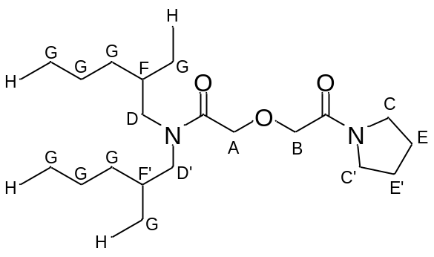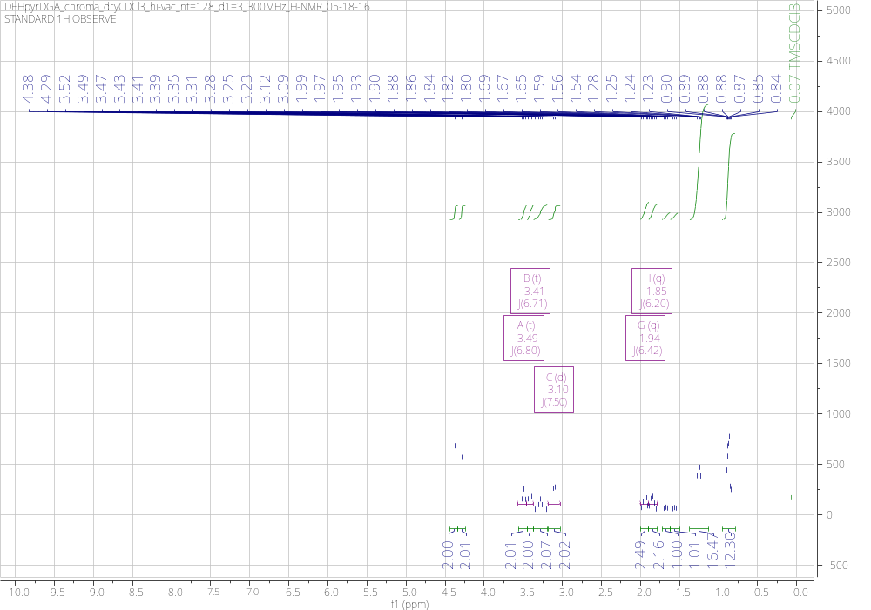
¹³C NMR spectrum of DEHpyrDGA(7) (151 MHz, CDCl₃, δ, nt = 1000)
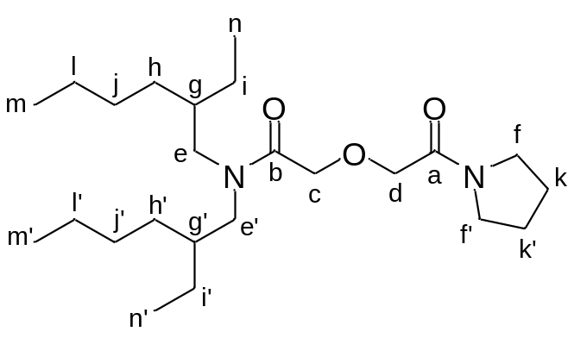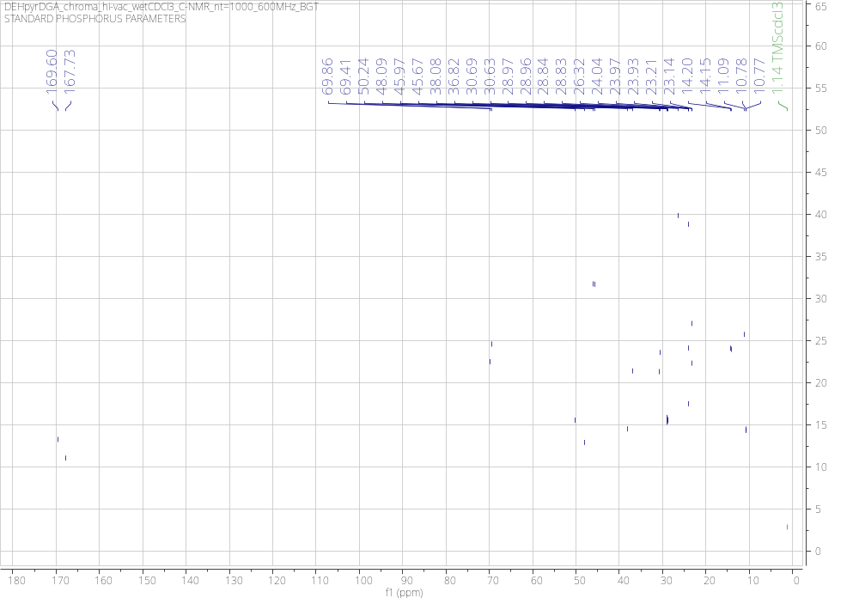

IR spectrum of DEHpyrDGA(7) (NaCl, film, 16 scans)
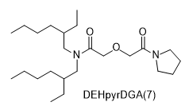

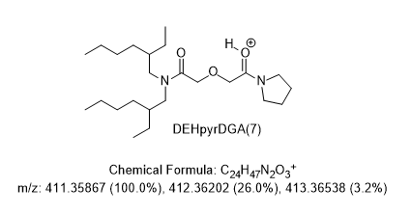
MALDI Mass Spectrum of DEHpyrDGA(7) (calibration is H+ form, 0.9 ppm error)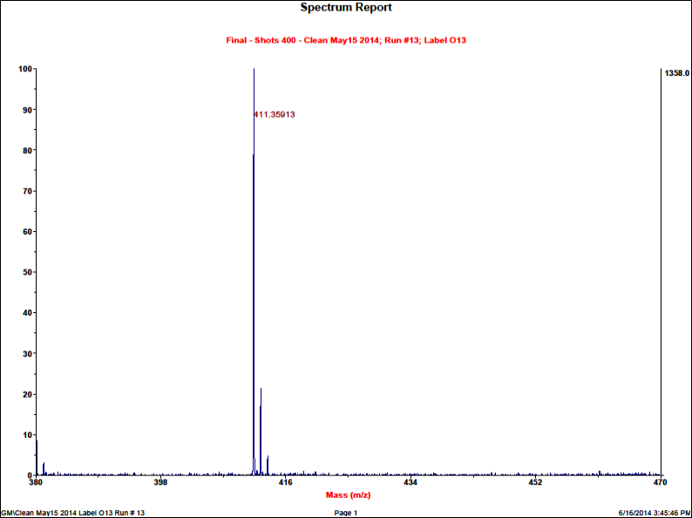

2. DEHpipDGA(8): ¹H-NMR (400 MHz, CDCl₃, δ): 4.32 (s, 2H), 4.32 (s, 2H), 3.54 (m, 2H), 3.40 (m, 2H), 3.27 (m, 2H), 3.08 (d, J = 7.5 Hz, 2H), 1.64 (br m, 4H), 1.55 (br m, 4H), 1.24 (br m, 16H), 0.88 (m, 12H). ¹³C-NMR (101 MHz, CDCl₃, δ): 169.46, 167.24, 69.93, 69.39, 50.16, 48.06, 46.07, 42.97, 38.07, 36.79, 30.66, 30.62, 28.96, 28.82, 26.53, 25.69, 24.60, 23.93, 23.20, 23.13, 14.20, 14.15, 11.08, 10.76. IR (NaCl, film) ν_{max} (cm⁻¹): 2957 (s, CH, aliphatic), 2931 (s, CH, aliphatic), 2870 (s, CH, aliphatic), 2856 (s, CH, aliphatic), 1653 (s, C=O), 1461 (m, C-N), 1443 (m, C-N), 1119 (m, C-O). HRMS-MALDI TOF/TOF (m/z): [M + H]⁺(calc.) = 425.37444; [M + H]⁺(exp.) = 425.37466. Overall yield = 75%.
¹H NMR spectrum of DEHpipDGA(8) (400 MHz, CDCl₃, δ, nt = 128, d1 = 3)
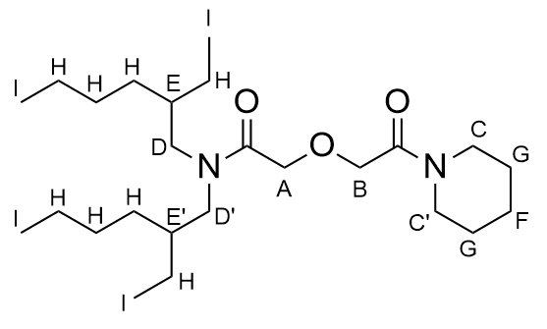
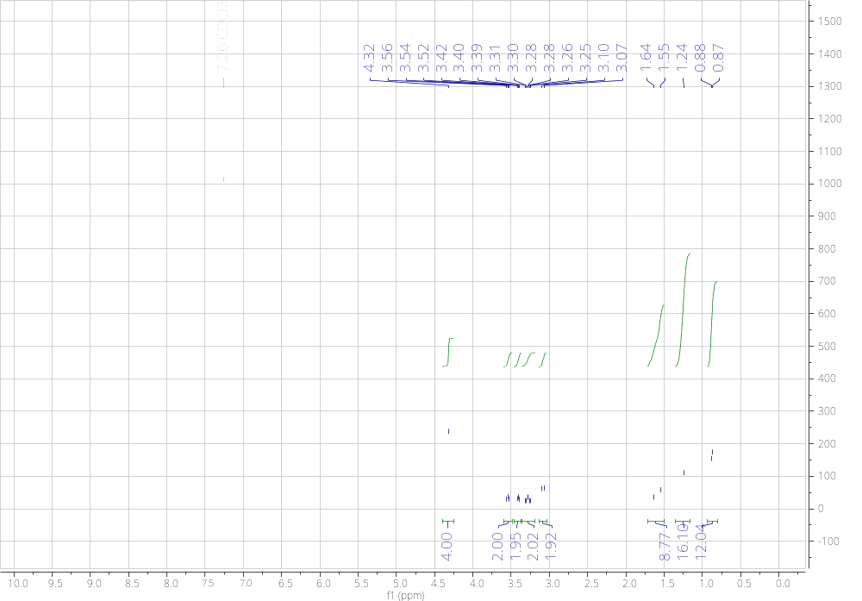

¹³C NMR spectrum of DEHpipDGA(8) (101 MHz, CDCl₃, δ, nt = 512)
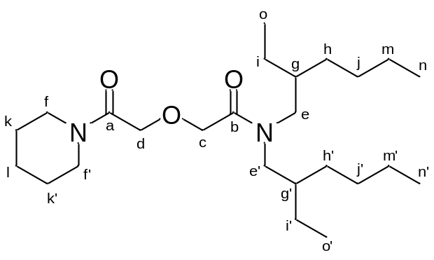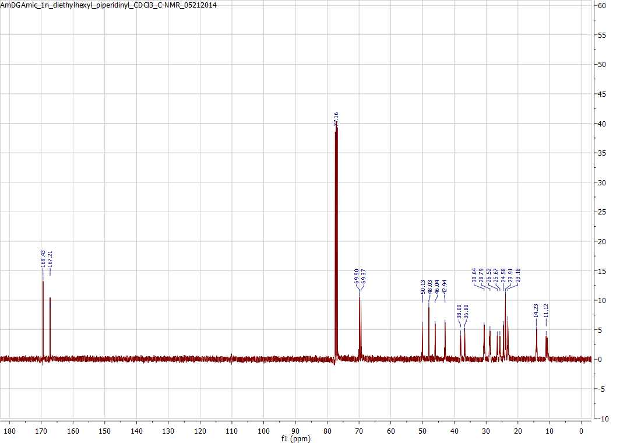

IR spectrum of DEHpipDGA(8) (NaCl, film, 16 scans)
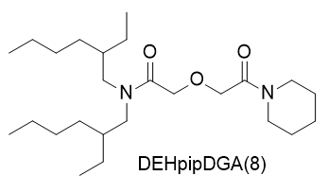
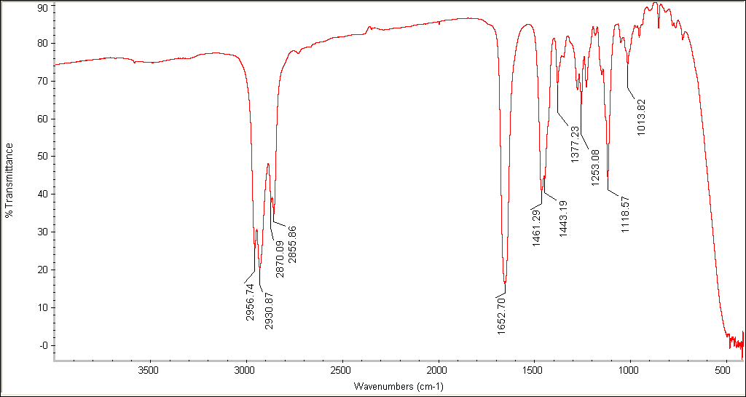

MALDI Mass Spectrum of DEHpipDGA(8) (calibration is H+ form, 0.5 ppm error)
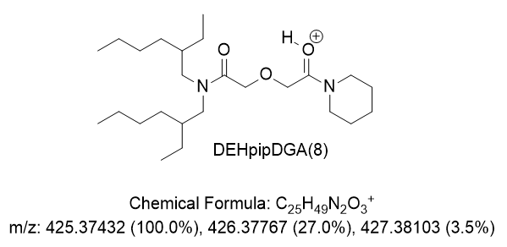
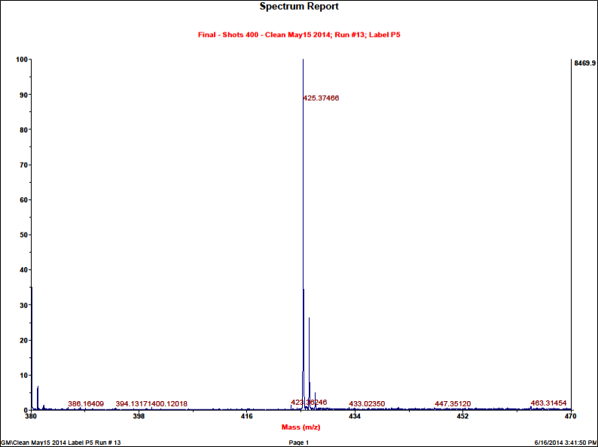

3. DEHmorDGA(9): ¹H-NMR (300 MHz, CDCl₃, δ): 4.31 (s, 2H), 4.29 (s, 2H), 3.68 (m, 4H), 3.61 (m, 4H), 3.27 (m, 2H), 3.05 (d, J = 7.5 Hz, 2H), 1.66 (m, 1H), 1.56 (m, 1H), 1.27 (m, 16H), 0.88 (m, 12H). ¹³C-NMR (101 MHz, CDCl₃, δ): 169.23, 167.63, 70.30, 69.22, 66.98, 50.15, 48.20, 45.77, 42.25, 38.12, 36.81, 30.67, 28.94, 28.80, 23.95, 23.22, 23.14, 14.21, 14.17, 11.07, 10.81. IR (NaCl, film) ν_{max} (cm⁻¹): 2957 (s, CH, aliphatic), 2924 (s, CH, aliphatic), 2868 (s, CH, aliphatic), 2854 (s, CH, aliphatic), 1653 (s, C=O), 1457 (m, C-N), 1438 (m, C-N), 1108 (m, C-O). HRMS-MALDI TOF/TOF (m/z): [M + H]⁺(calc.) = 427.35374; [M + H]⁺(exp.) = 427.35373. Overall yield = 32%.
¹H NMR spectrum of DEHmorDGA(9) (300 MHz, CDCl₃, δ, nt = 128, d1 = 3)
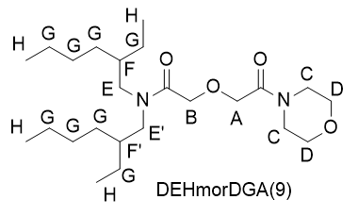
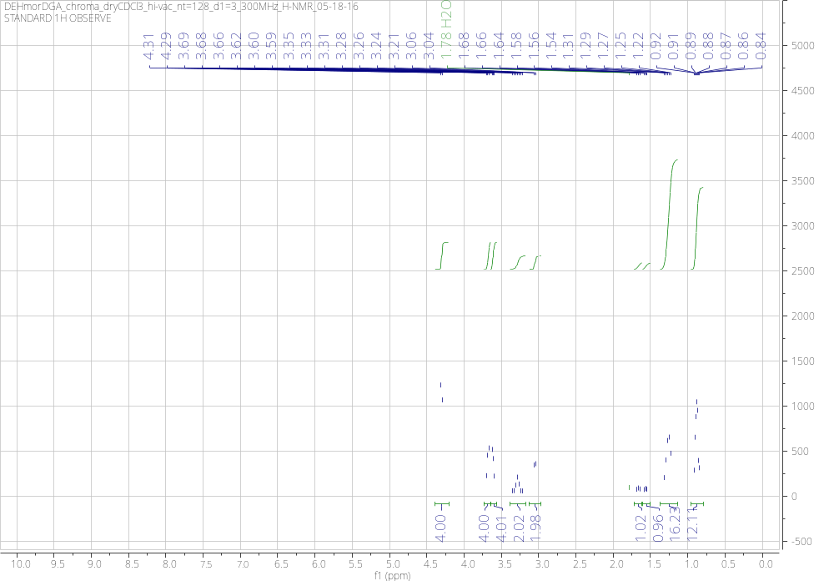

¹³C NMR spectrum of DEHmorDGA(9) (101 MHz, CDCl₃, δ, nt = 1024, d1 = 1)
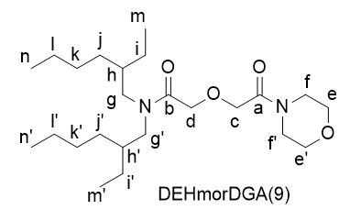
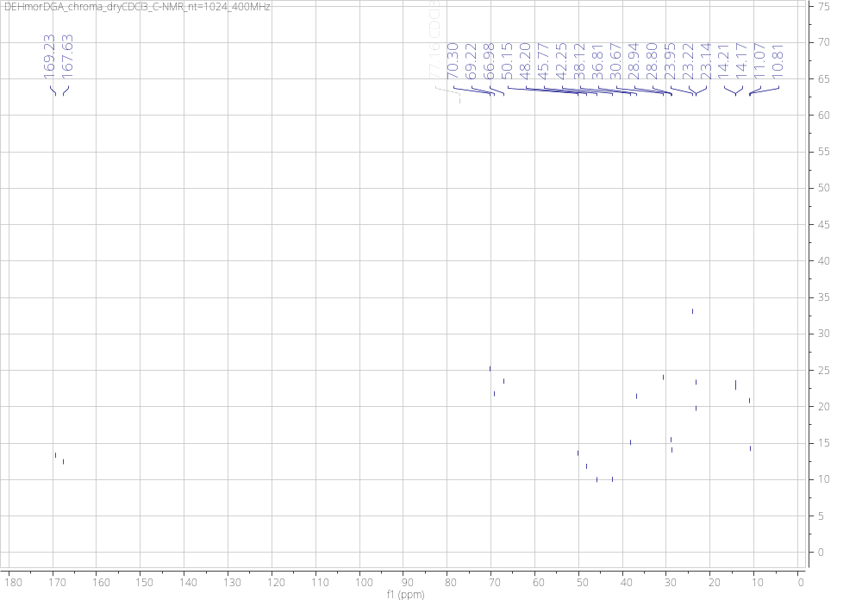

IR spectrum of DEHmorDGA(9) (NaCl, film, 16 scans)
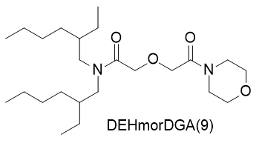

MALDI Mass Spectrum of DEHmorDGA(9) (calibration is H+ form, 0.02 ppm error)
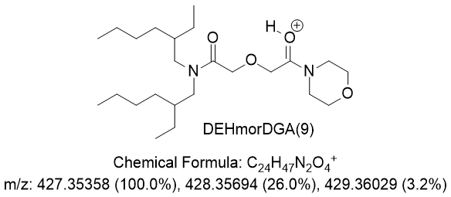
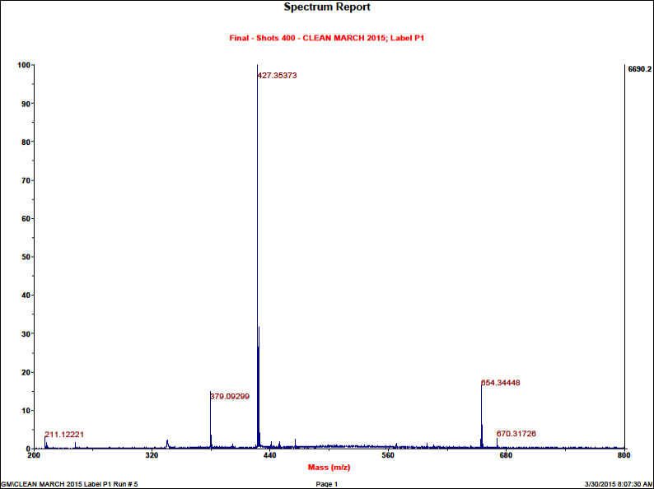

4. DMOpyrDGA(10): ¹H-NMR (400 MHz, CDCl₃, δ): 4.31 (s, 2H), 4.26 (s, 2H), 3.49 (t, J = 6.8 Hz, 2H), 3.41 (t, J = 6.7 Hz, 2H), 3.31 (m, 2H), 3.18 (m, 2H), 1.93 (p, J = 6.4 Hz, 2H), 1.85 (p, J = 6.3 Hz, 2H), 1.51 (br m, 4H), 1.37 (br m, 4H), 1.28 (br m, 6H), 1.14 (br m, 6H), 0.90 (d, J = 6.2 Hz, 6H), 0.87 (d, J = 2.3 Hz, 6H), 0.85 (d, J = 2.3 Hz, 6H). ¹³C-NMR (75.5 MHz, CDCl₃, δ): 168.34, 167.65, 69.85, 69.14, 45.91, 45.61, 45.20, 44.12, 39.31, 39.23, 37.23, 37.16, 36.10, 34.62, 31.05, 30.97, 28.00, 26.26, 24.72, 23.99, 22.77, 22.68, 22.66, 19.64. IR (NaCl, film) ν_{max} (cm⁻¹): 2962 (s, CH, aliphatic), 2921 (s, CH, aliphatic), 2871 (s, CH, aliphatic), 2856 (s, CH, aliphatic), 1653 (s, C=O), 1449 (m, C-N), 1136 (m, C-O). HRMS-MALDI TOF/TOF (m/z): [M + H]⁺(calc.) = 467.42134; [M + H]⁺(exp.) = 467.42172. Overall yield = 66%.
¹H NMR spectrum of DMOpyrDGA(10) (300 MHz, CDCl₃, δ, nt = 256, d1 = 1)
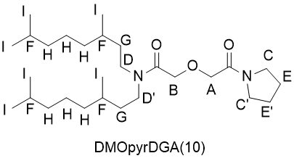
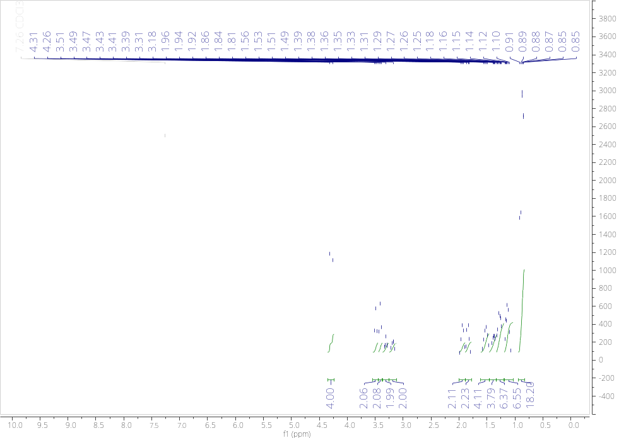
¹³C NMR spectrum of DMOpyrDGA(10) (75.5 MHz, CDCl₃, δ, nt = 512, d1 = 1)
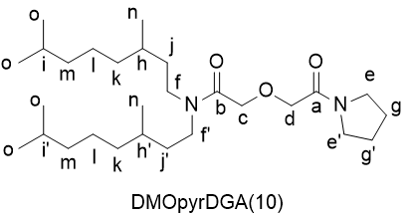
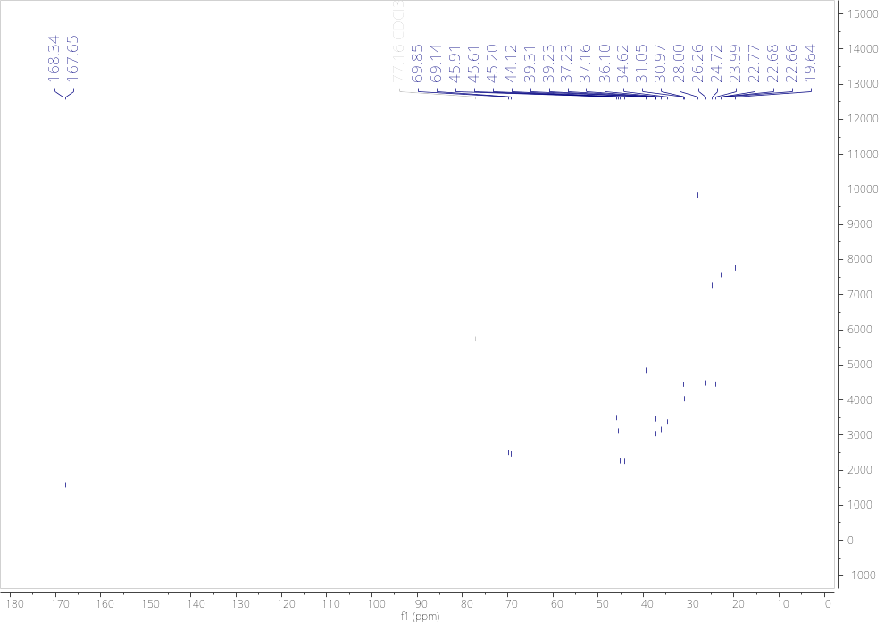

IR spectrum of DMOpyrDGA(10) (NaCl, film, 16 scans)
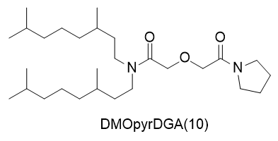

MALDI Mass Spectrum of DMOpyrDGA(10) (calibration is H+ form, 0.8 ppm error)
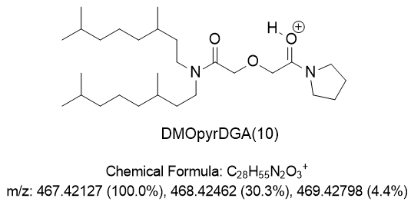
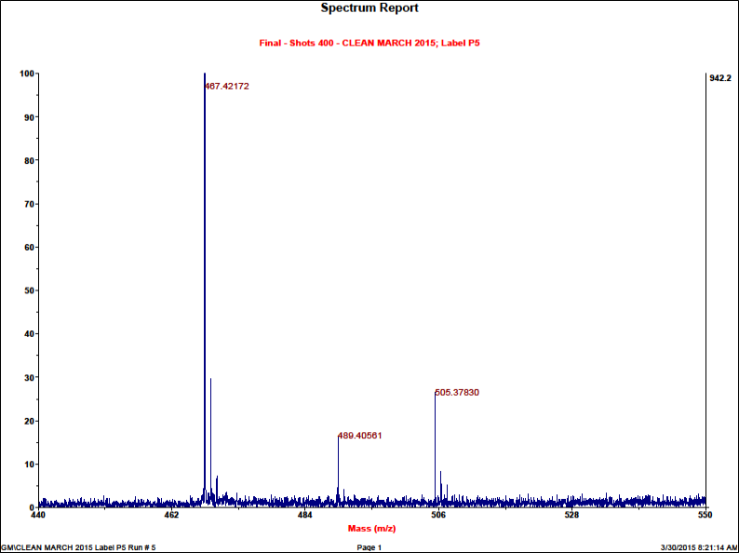

5. DMOpipDGA(11): ¹H-NMR (400 MHz, CDCl₃, δ): 4.35 (s, 2H), 4.31 (s, 2H), 3.54 (m, 2H), 3.41 (m, 2H), 3.32 (m, 2H), 3.17 (m, 2H), 1.56 (br m, 10H), 1.39 (br m, 4 H), 1.29 (br m, 6H), 1.14 (br m, 6H), 0.90 (d, J = 6.1 Hz, 6H), 0.87 (d, J = 2.4 Hz, 6H), 0.85 (d, J = 2.4 Hz, 6H). ¹³C-NMR (101 MHz, CDCl₃, δ): 168.35, 167.27, 70.05, 69.26, 46.12, 45.25, 44.21, 42.99, 39.39, 39.31, 37.30, 37.23, 36.19, 34.71, 31.14, 31.05, 28.08, 26.56, 25.70, 24.79, 24.62, 22.83, 22.74, 22.72, 19.70. IR (NaCl, film) ν_{max} (cm⁻¹): 2948 (s, CH, aliphatic), 2926 (s, CH, aliphatic), 2859 (s, CH, aliphatic), 1652 (s, C=O), 1458 (m, C-N), 1115 (m, C-O). HRMS-MALDI TOF/TOF (m/z): [M + H]⁺(calc.) = 481.43637; [M + H]⁺(exp.) = 481.43475. Overall yield = 55%.
¹H NMR spectrum of DMOpipDGA(11) (300 MHz, CDCl₃, δ, nt = 128, d1 = 1)
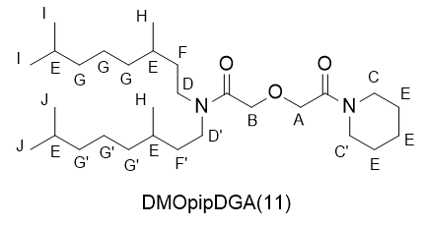
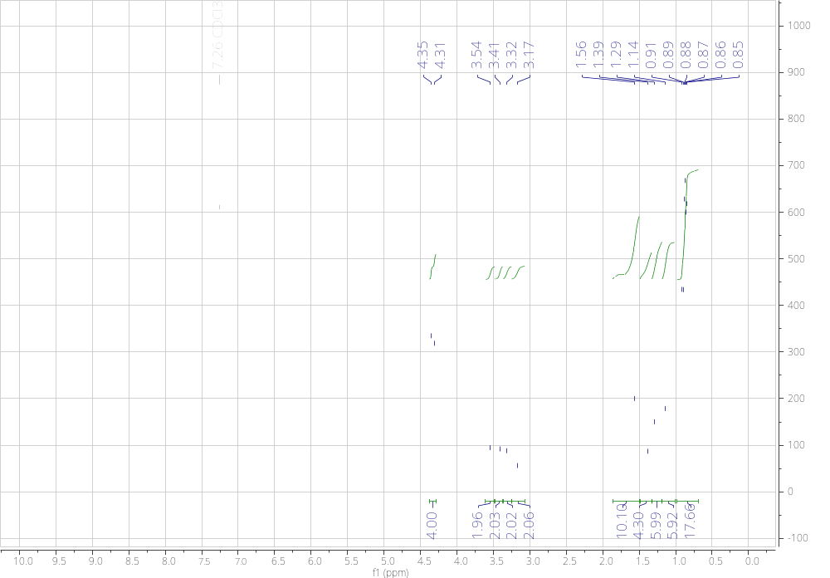

¹³C NMR spectrum of DMOpipDGA(11) (101 MHz, CDCl₃, δ, nt = 512, d1 = 3)
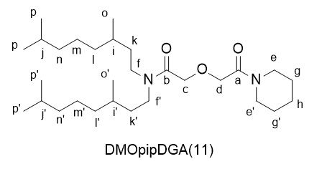
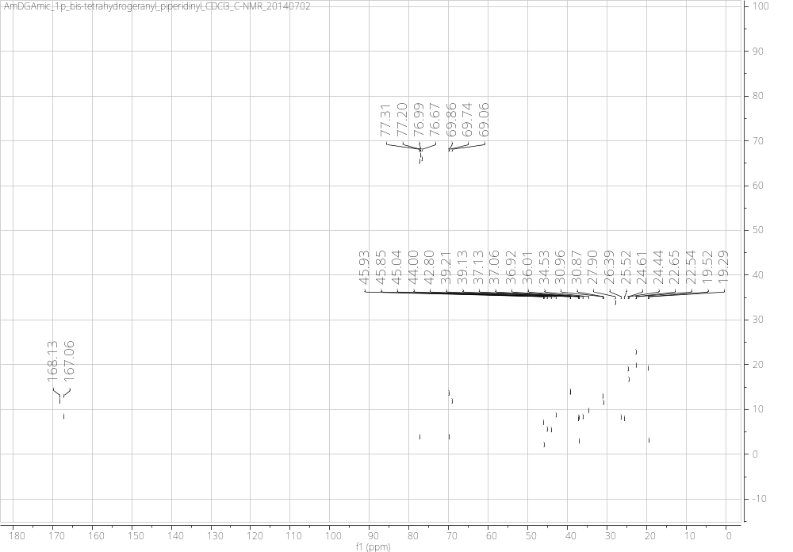

IR spectrum of DMOpipDGA(11) (NaCl, film, 16 scans)
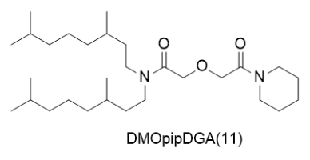
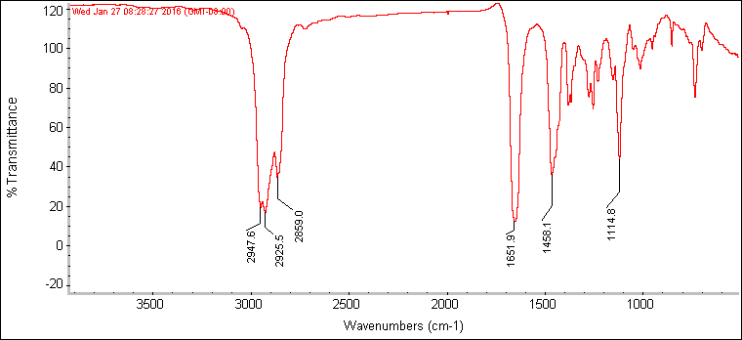

MALDI Mass Spectrum of DMOpipDGA(11) (calibration is H+ form, 4.8 ppm error)
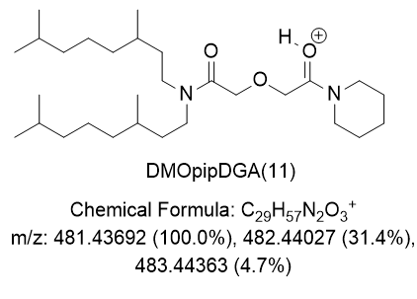
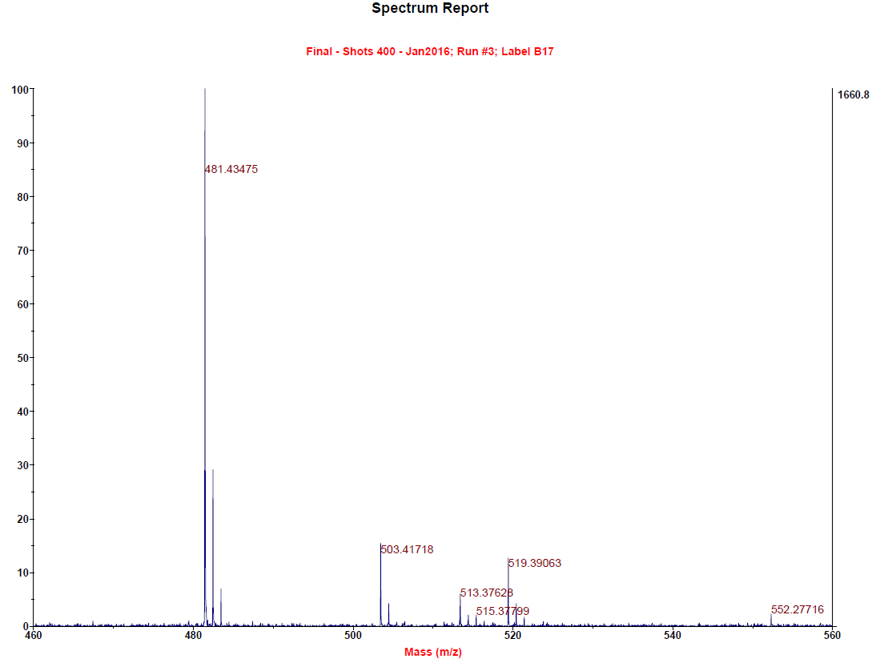

6. DMOmorDGA(12): ¹H-NMR (400 MHz, CDCl₃, δ): 4.34 (s, 2H), 4.28 (s, 2H), 3.69 (m, 4H), 3.61 (m, 4H), 3.32 (m, 2H), 3.14 (m, 2H), 1.53 (br m, 4H), 1.39 (br m, 4H), 1.28 (br m, 6H), 1.14 (br m, 6H), 0.91 (d, J = 6.4 Hz, 6H), 0.88 (d, J = 3.7 Hz, 6H), 0.86 (d, J = 3.7 Hz, 6H). ¹³C-NMR (101 MHz, CDCl₃, δ): 168.09, 167.61, 70.39, 69.04, 66.97, 45.80, 45.16, 44.25, 42.25, 39.38, 39.31, 37.27, 37.21, 36.15, 34.73, 31.15, 31.06, 28.08, 24.78, 22.82, 22.72, 19.70. IR (NaCl, film) ν_{max} (cm⁻¹): 2956 (s, CH, aliphatic), 2929 (s, CH, aliphatic), 2864 (s, CH, aliphatic), 1653 (s, C=O), 1462 (m, C-N), 1439 (m, C-N), 1113 (m, C-O). HRMS-MALDI TOF/TOF (m/z): [M + H]⁺(calc.) = 483.41634; [M + H]⁺(exp.) = 483.41568. Overall yield = 62%.
¹H NMR spectrum of DMOmorDGA(12) (400 MHz, CDCl₃, δ, nt = 128, d1 = 3)
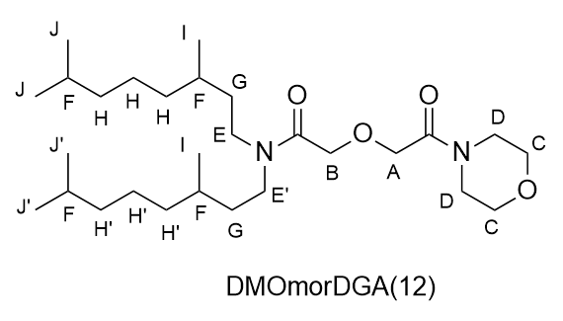
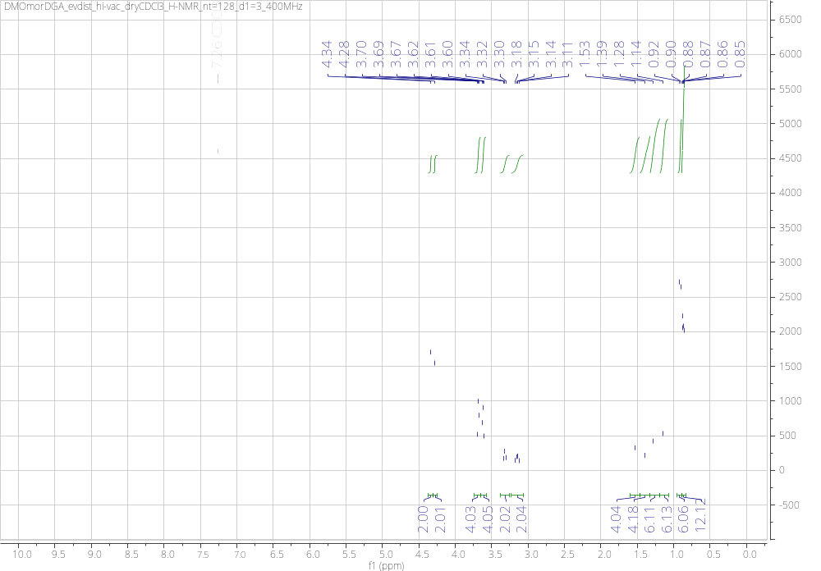

¹³C NMR spectrum of DMOmorDGA(12) (101 MHz, CDCl₃, δ, nt = 1024, d1 = 1)
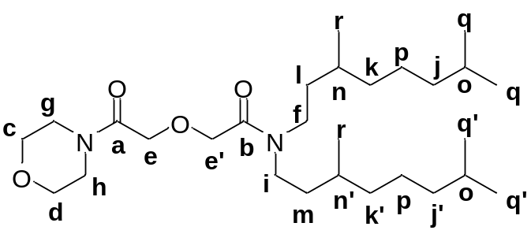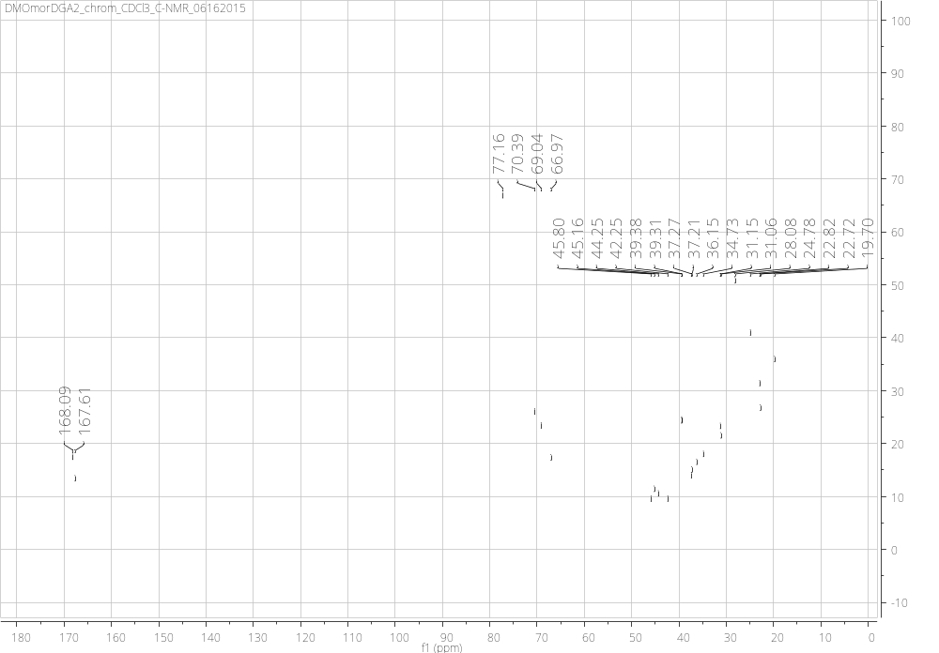

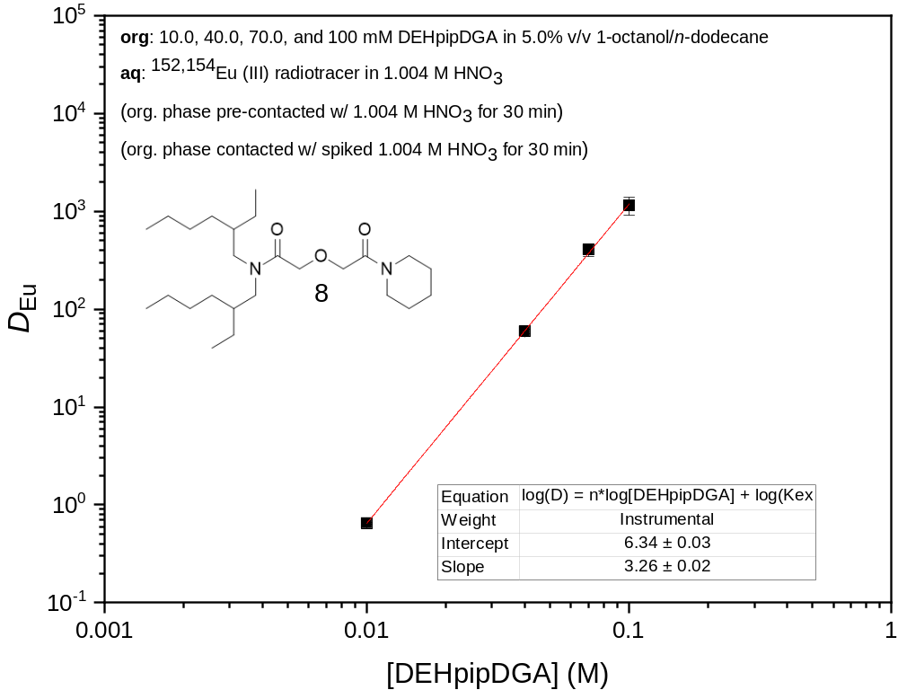
SI Fig. 1 The partitioning of Eu(III) metal between 1.004 M HNO₃ and varying [DEHpipDGA] in 5.0% v/v 1-octanol/n-dodecane
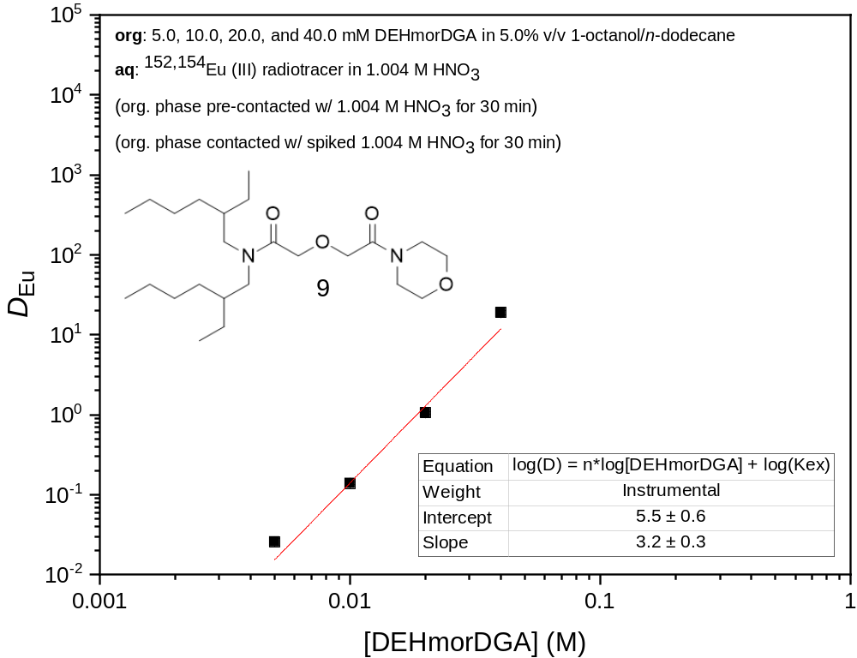
SI Fig. 2 The partitioning of Eu(III) metal between 1.004 M HNO₃ and varying [DEHmorDGA] in 5.0% v/v 1-octanol/n-dodecane
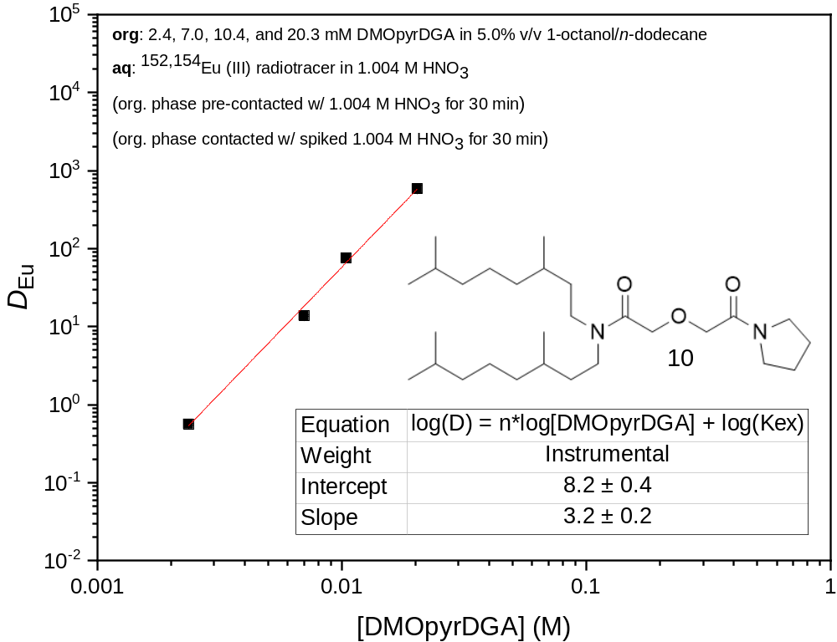
SI Fig. 3 The partitioning of Eu(III) metal between 1.004 M HNO₃ and varying [DMOpyrDGA] in 5.0% v/v 1-octanol/n-dodecane
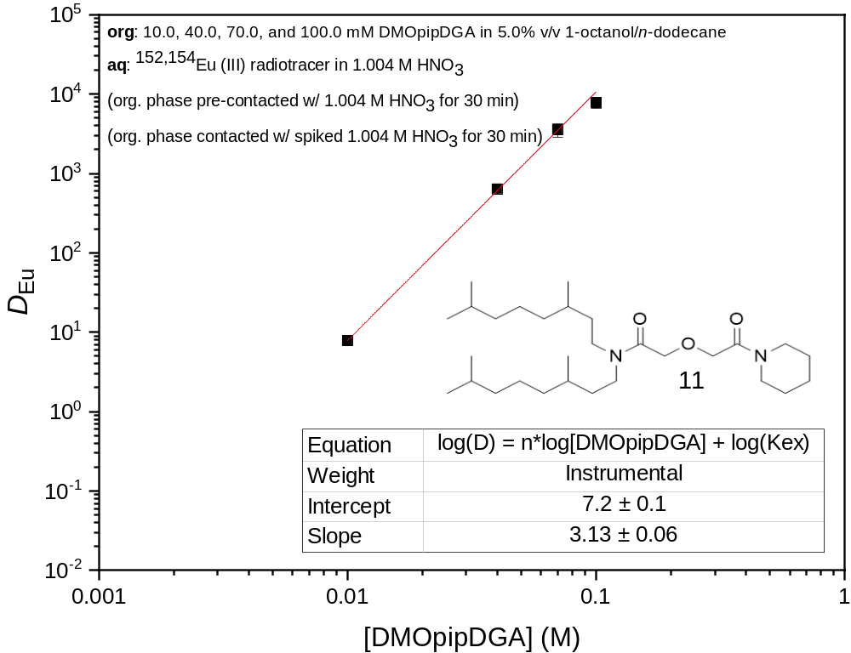
SI Fig. 4 The partitioning of Eu(III) metal between 1.004 M HNO₃ and varying [DMOpipDGA] in 5.0% v/v 1-octanol/n-dodecane
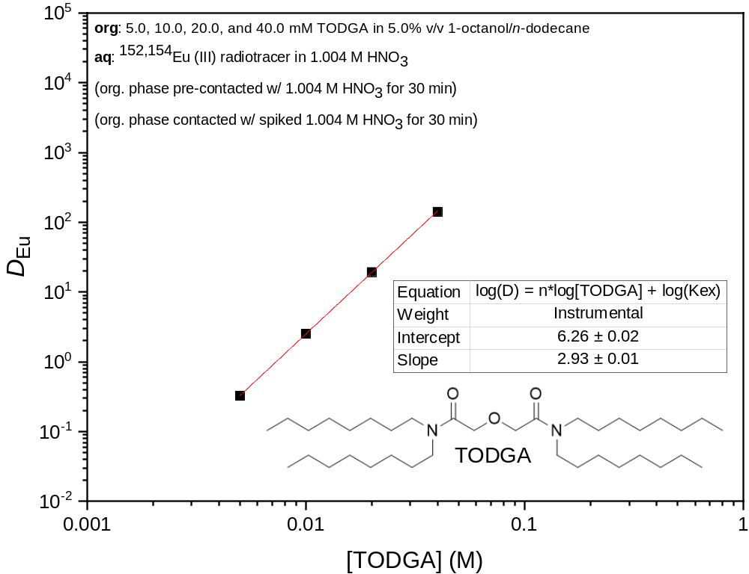
SI Fig. 5 The partitioning of Eu(III) metal between 1.003 M HNO₃ and varying [TODGA] in 5.0% v/v 1-octanol/n-dodecane
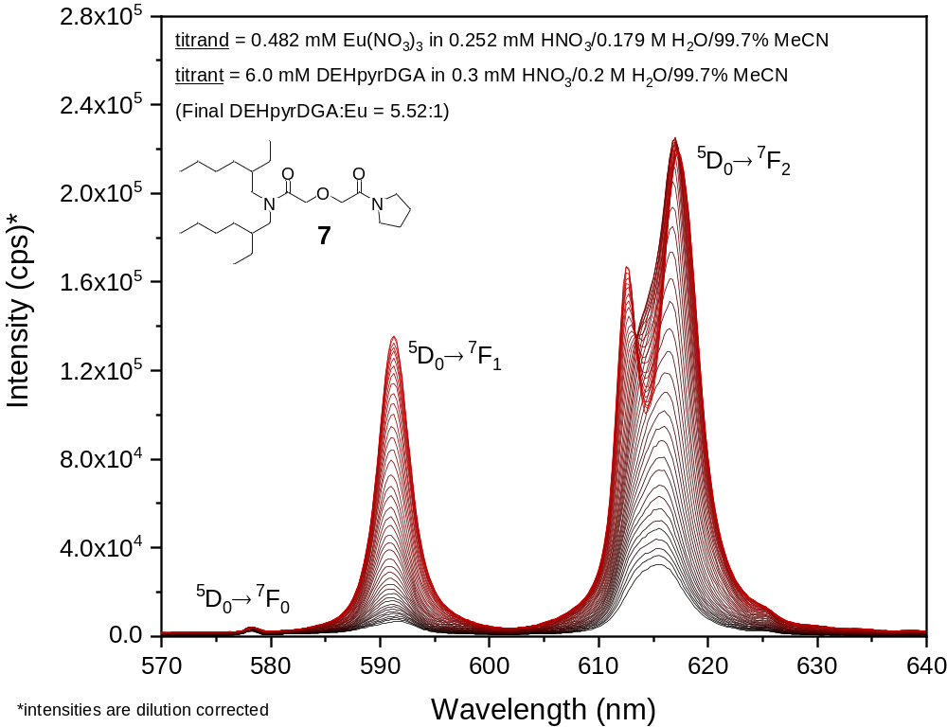
SI Fig. 6 Emission spectra of Eu(III) with increasing concentration of the ligand N,N-bis(2-ethylhexyl)-N'-pyrrolidinyldiglycolamide (DEHpyrDGA) in acetonitrile (black line = beginning; red line = end)

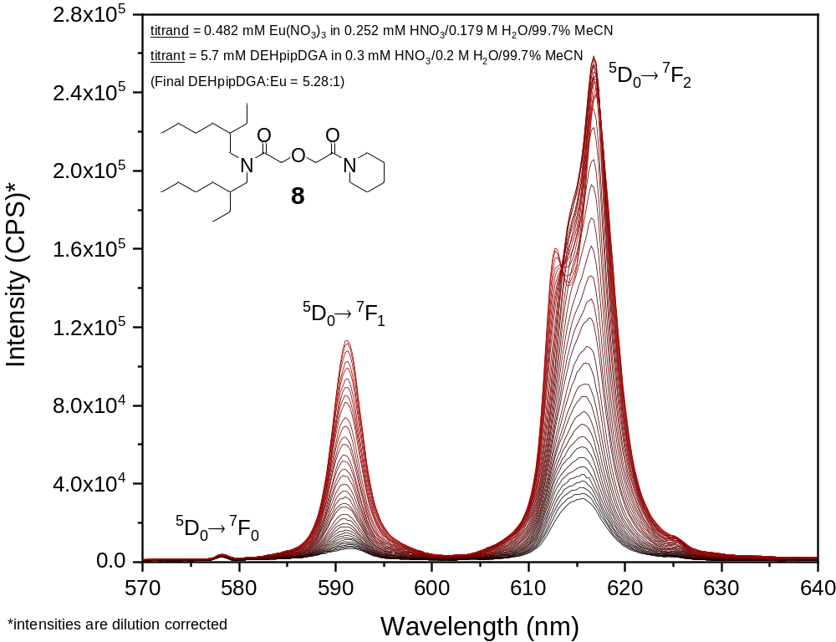
SI Fig. 7 Emission spectra of Eu(III) with increasing concentration of the ligand N,N-bis(2-ethylhexyl)-N'-piperidinyldiglycolamide (DEHpipDGA) in acetonitrile (black line = beginning; red line = end)

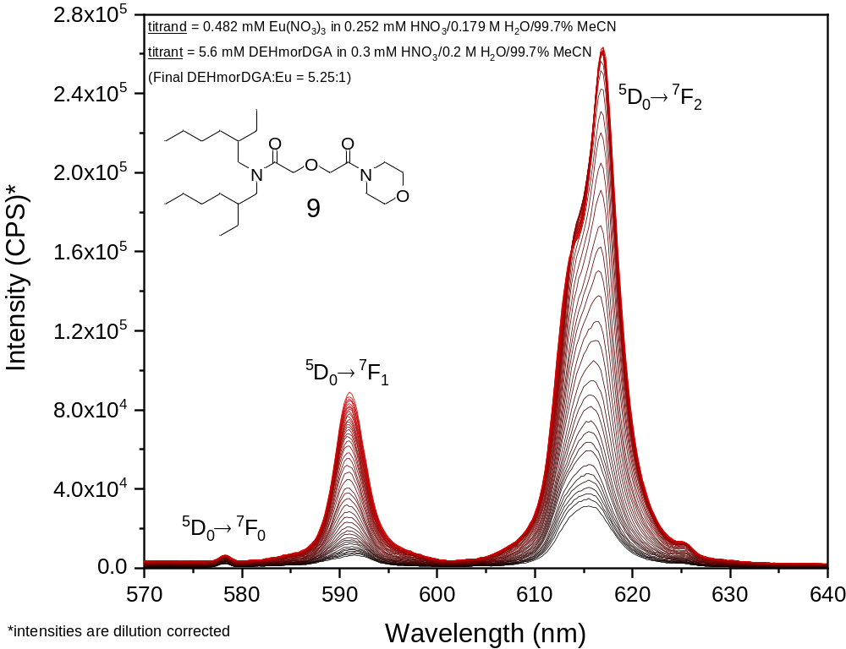
SI Fig. 8 Emission spectra of Eu(III) with increasing concentration of the ligand N,N-bis-(2-ethylhexyl)-N'-morpholinodiglycolamide (DEHmorDGA) in acetonitrile (black line = beginning; red line = end)

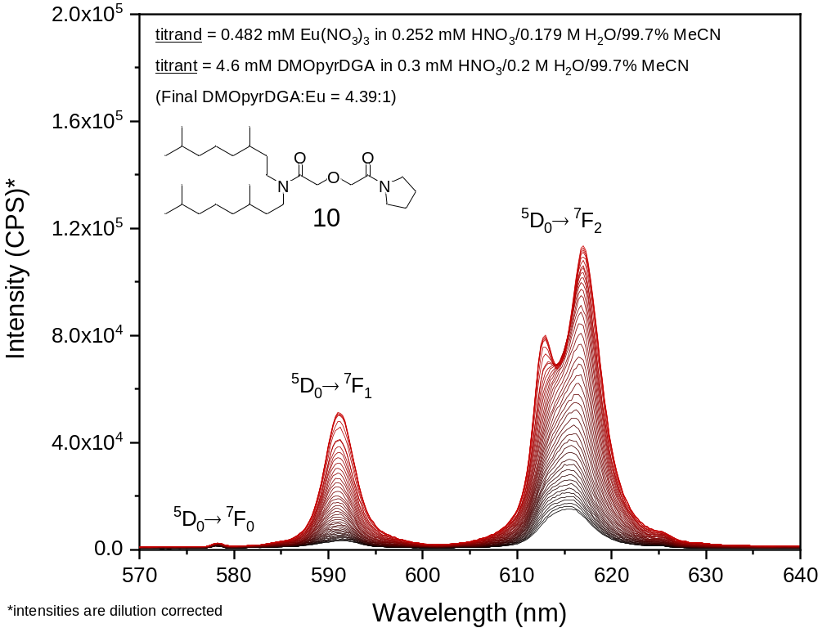
SI Fig. 9 Emission spectra of Eu(III) with increasing concentration of the ligand N,N- bis(3,7-dimethyloctyl)-N'-pyrrolidinyldiglycolamide (DMOpyrDGA) in acetonitrile (black line = beginning; red line = end)

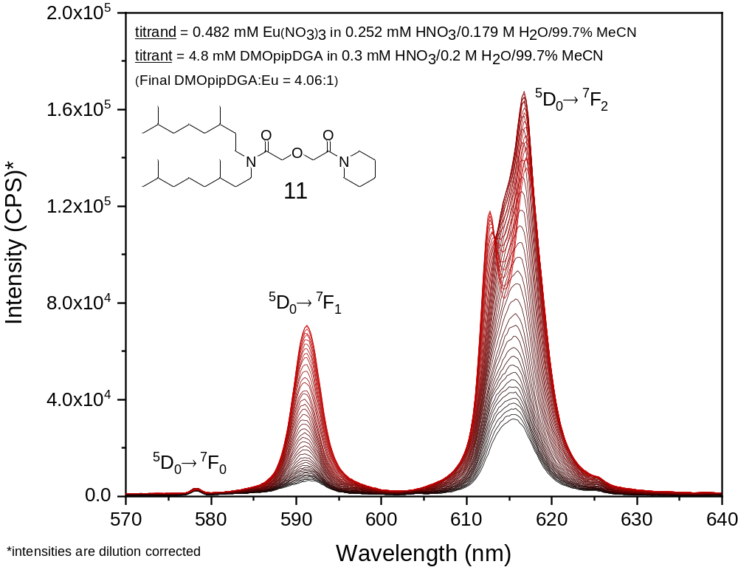
SI Fig. 10 Emission spectra of Eu(III) with increasing concentration of the ligand N,N-bis(3,7-dimethyloctyl)-N'-piperidinyldiglycolamide (DMOpipDGA) in acetonitrile (black line = beginning; red line = end)

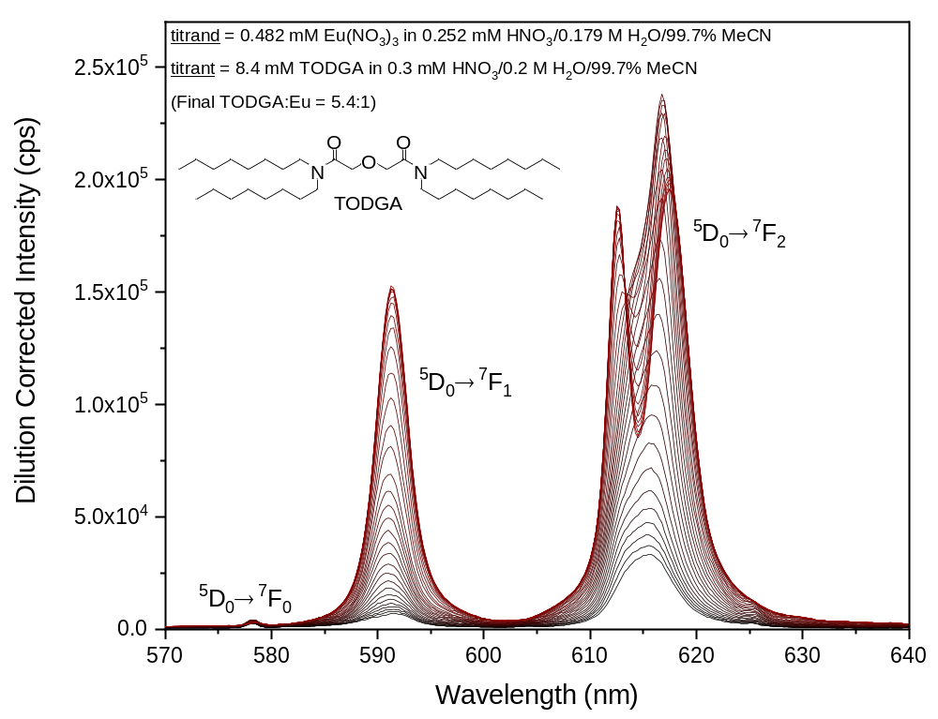
SI Fig. 11 Emission spectra of Eu(III) with increasing concentration of the ligand N,N,N',N'-tetraoctyldiglycolamide (TODGA) in acetonitrile (black line = beginning; red line = end)

