Supplementary Information
Genome and Transcriptome Sequencing of Novel Pseudomonas sp. NLX-4 Strain Involved in Bio-restoration of Over Exploited Mining Sites
Yanwen Wu,^{1,2,5#} Ayyappa Kumar Sista Kameshwar,^{2#} Bo Zhang,³ Feifei Chen,⁴ Wensheng Qin,² Miaojing Meng,¹ Jinchi Zhang^{1*}

¹ Co-innovation Center for Sustainable Forestry in Southern China, Jiangsu Province Key Laboratory of Soil and Water Conservation and Ecological Restoration, Nanjing Forestry University, 159 Longpan Road, Nanjing, Jiangsu 210037, China.
² Department of Biology, Lakehead University, 955 Oliver Road, Thunder Bay, Ontario, P7B 5E1, Canada.
³ Department of Biology, University of Miami, Coral Gables, FL 33124, USA.
⁴ Co-innovation Center for Sustainable Forestry in Southern China, Jiangsu Province Key Laboratory for Prevention and Management of Invasive Species, Nanjing Forestry University, 159 Longpan Road, Nanjing, Jiangsu 210037, China.
⁵ Learning Support Team, St Margaret's School, Victoria, BC, V8X 3P7, Canada (current address)
*Corresponding author: zhang8811@njfu.edu.cn
#Y.W. and AKSK Contributed equally

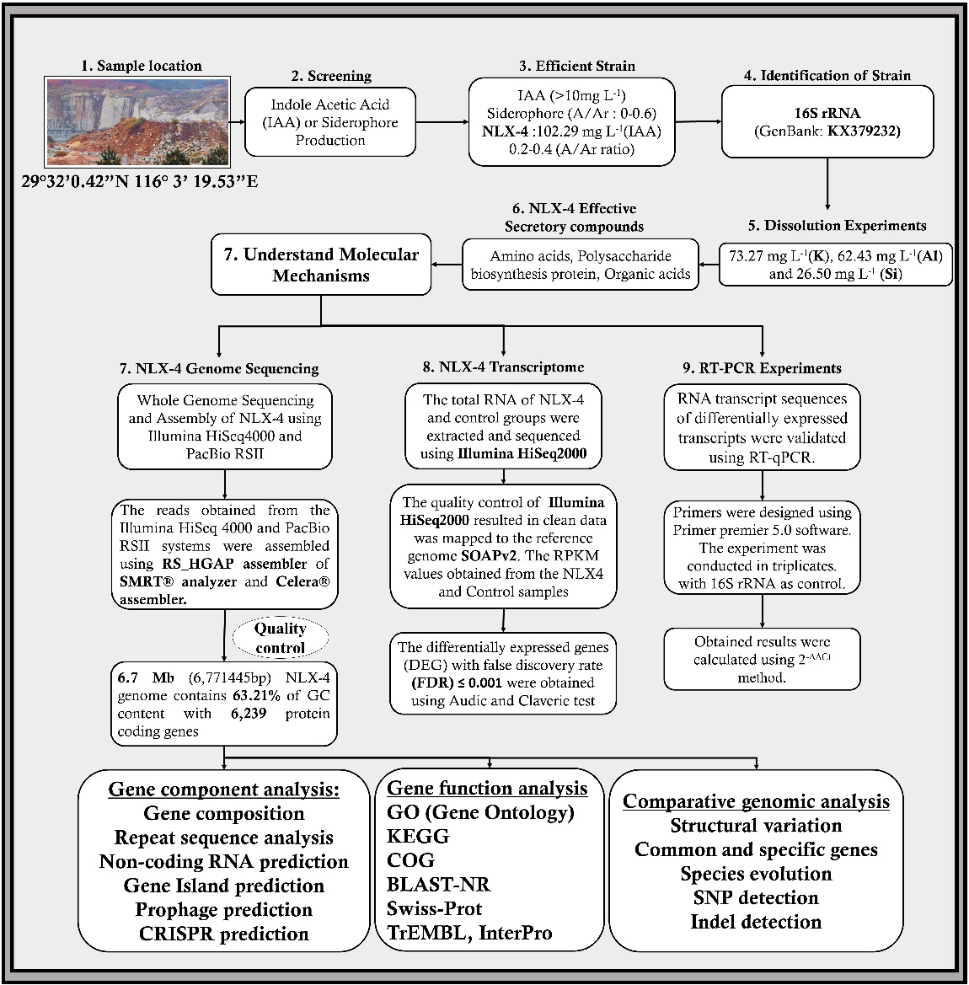
Fig. S1 Step-wise pipeline of experiments implemented in our study 1) rock sampling, 2) screening of bacteria, 3) isolating efficient strain, 4) identification of strain, 5) silicate rock-dissolution experiments, 6) NLX-4 strain’s effective secretory compounds, 7) NLX-4 whole genome sequencing, 8) NLX-4 genome-wide transcriptome and 9) qRT-PCR experiment.

Table S1 Indoleacetic acid and siderophore productions of the tested strains
Strain | IAA (mgL⁻¹) | Siderophore
NLX-1 | 80.49 | ++++
NLX-2 | 0 | +++
NLX-3 | 66.12 | +++++
NLX-4 | 102.29 | ++++
NLX-5 | 75.15 | -
NLX-6 | 42.25 | +++++
NLX-7 | 75.36 | ++++
NLX-8 | 45.76 | ++++
NLX-9 | 9.95 | +++
NLX-10 | 0 | -
NLX-11 | 68.37 | -
NLX-12 | 83.6 | ++++
NLX-13 | 0.83 | +
NLX-14 | 106.84 | +++
NLX-15 | 0 | +
NLX-16 | 0 | -
NLX-17 | 55.92 | +++++
NLX-18 | 81.21 | ++++
NLX-19 | 110.48 | +++
NLX-20 | 13.29 | ++
NLX-21 | 20.36 | -
NLX-22 | 59.7 | ++++
Note: Lower A/Ar ratio represents more siderophore productions. A/Ar: 0-0.2 (+++++); 0.2-0.4 (++++); 0.4-0.6 (+++); 0.6-0.8 (++); 0.8-1.0 (+); no production (-).

Table S2 The contents of the NLX-4 metabolites associated with rock dissolution.
Time  (days) | Exo-polysaccharide  (g L⁻¹) | Amino acid  (g L⁻¹) | Oxalic acid  (mg L⁻¹) | Citric acid  (mg L⁻¹) | Tartaric acid  (mg L⁻¹) | Malic acid (mg L⁻¹)
0 | 0 | 0 | 0 | 0 | 0 | 0
2 | 3.49±0.33 | 14.14±0.49 | 41.99±1.54 | 31.15±1.30 | 364.19±2.63 | 38.88±1.91
5 | 6.88±0.20 | 24.06±1.86 | 65.70±2.45 | 47.84±1.63 | 569.41±10.40 | 74.15±1.05
9 | 8.21±0.22 | 35.25±1.98 | 78.20±2.58 | 64.22±2.37 | 690.08±7.26 | 91.68±2.00
12 | 9.09±0.25 | 43.96±1.87 | 70.57±3.01 | 59.45±0.80 | 777.38±8.71 | 123.68±6.43
15 | 12.12±0.78 | 74.70±2.60 | 49.57±2.42 | 44.77±0.72 | 956.98±5.53 | 103.32±2.69
22 | 15.45±1.02 | 87.74±1.95 | 31.88±1.14 | 35.99±1.05 | 992.32±5.51 | 84.73±1.36
30 | 13.54±0.14 | 97.47±4.10 | 26.08±1.19 | 32.44±1.11 | 1025.87±5.14 | 75.58±3.51

Table S3 The contents of the bacterial metabolites produced by strain NLX-4 cultured with K-bearing rock samples and K⁺, respectively.
Effective secretory compounds | Treatment
Effective secretory compounds | NLX-4+rock | NLX-4+K⁺(CK)
Polysaccharide (g L⁻¹) | 12.12±0.78*** | 3.22±0.20
Amino acid (g L⁻¹) | 74.70±2.60*** | 48.63±2.85
Oxalic acid (mg L⁻¹) | 49.57±2.42*** | 30.29±2.70
Citric acid (mg L⁻¹) | 44.77±0.72*** | 26.91±1.31
Tartaric acid (mg L⁻¹) | 956.98±5.53*** | 317.12±4.45
Malic acid (mg L⁻¹) | 103.32±2.69*** | 42.65±3.13
Note: ***indicates difference is significant at the 0.001 level.

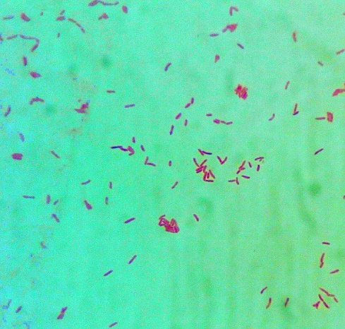
a

b
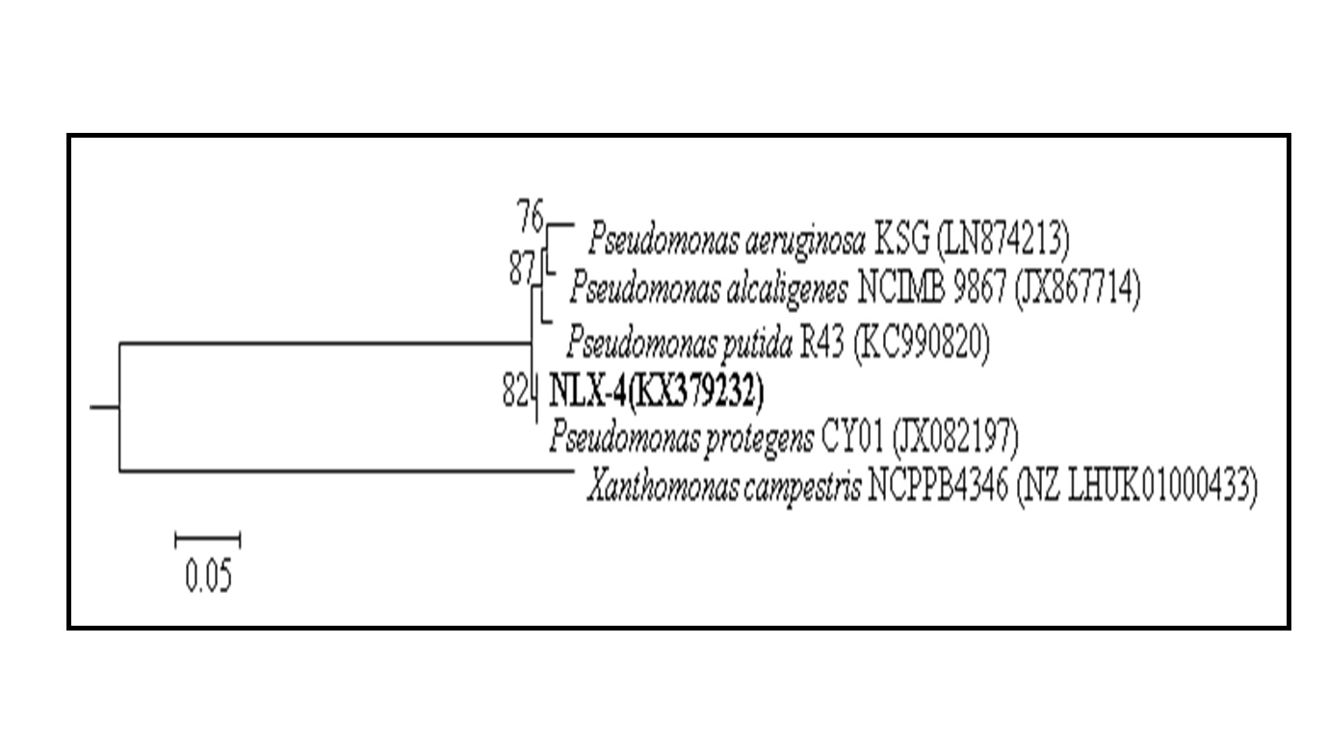
Fig. S2 a) Cell morphologies of strain NLX-4 (×1000); b) Neighbor-joining phylogenetic tree reconstructed based on 16S rDNA sequences, which showed the phylogenetic relationships between strain NLX-4 and related type bacteria. Bootstrap values (expressed as percentages of 1,000 replications) greater than 50% are shown at branch points. The scale bars represent 0.05 substitutions per nucleotide position.

Table S4 Data obtained from Illumina HiSeq4000 and PacBio RSII SMRT sequencing systems.
Illumina HiSeq4000 |  | PacBio RSII SMRT
Sample Name | NLX-4 | Sample Name | NLX-4
Insert Size(bp) | 300 | Polymerase Reads Number | 49,861
Reads Length(bp) | (100:100) | Polymerase Reads Mean Length(bp) | 14,374
Raw Data(Mb) | 904 | Polymerase Reads Bases(bp) | 766,172,465
Adapter (%) | 0.23 | Polymerase Reads Quality | 0.85
Duplication (%) | 8.03 | Subreads Number | 79,379
Total Reads | 9,049,948 | Subreads Mean Length(bp) | 8,991
Filtered Reads (%) | 9.68 | Subreads Bases(bp) | 713,706,632
Low Quality Filtered Reads (%) | 1.39 | Subreads Quality | 0.85
Clean Data(Mb) | 817 | Utilization Ratio | 0.95

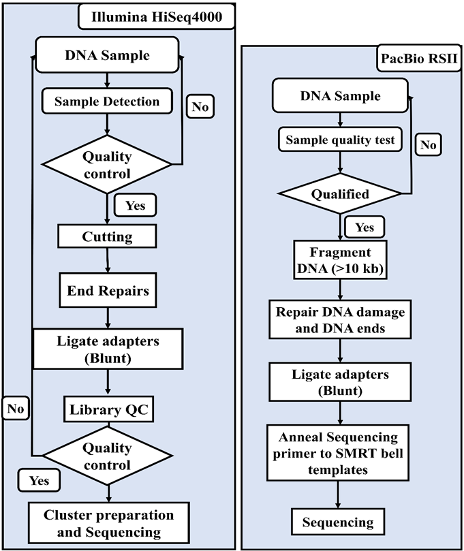
Fig. S3 The sequencing workflow applied for the Illumina HiSeq 4000 and PacBio RSII sequencing systems.
Fig. S4 The analysis workflow applied in this study for the assembly of the NLX-4 genome using hybrid analysis approach implementing the genome sequences obtained from Illumina and PacBio systems.

Fig. S5 The data analysis pipeline used for biological contextualization of the Pseudomonas sp NLX4 strain.

Table S5 Lists the final results obtained from the genome assembly and genome biological contextualization. a) results obtained after the RS_HGAP (SMRT analysis suite) and Celera software pipeline, b) gene prediction using Glimmer, c) ncRNA prediction, d) tandem repeat prediction, e) CRISPR finder and f) biological contextualization (GO, COG, InterPro, KEGG, Swiss-Prot and BLAST-NR.
Assembly Results
a
Assembling result evaluation file
Sample Name | NLX-4
Single Base Quality (#) | 1
Structure Base Quality (#) | 0.9975
Reads Usage Percent (#) | 0.9915
Conclusion | Yes
Assembly result statistics file
Sample Name | NLX-4
Chromosome Number (#) | 1
Total Length (bp) | 6,771,445
N50 Length (bp) | 6,771,445
N90 Length (bp) | 6,771,445
Max Length (bp) | 6,771,445
Min Length (bp) | 6,771,445
GC Content (%) | 63.21
ID-Circular/Linear-Length | Chromosome_1; circular:6771445
K-mer result statistics file
Sample-name | NLX-4
K-mer (#) | 15
Kmer_Num(Mbp) | 228.57
Pk_Depth (#) | 35
Genome Size(Mbp) | 6.52
Genome Depth (#) | 40.75
Repeat result statistic file
Sample Name | NLX-4
Genome Size (#) | 6,771,445
GC (%) | 63.21
Repeat Number (#) | 1,049
Repeat Length (#) | 130,540
Min Length (#) | 25
Max Length (#) | 5,847
Average Length (#) | 124.44
Repeat Rate (%) | 1.93

Results from Glimmer
Sample Name | NLX-4
Gene Number | 6,239
Gene Length | 5,918,817
GC Content | 64.17
% of Genome(Genes) | 87.41
Gene Average Length | 949
Gene Internal Length | 852,628
Gene Internal GC Content | 56.55
% of Genome(internal) | 12.59
b

Method | Type | Number# | Avg_Len | Total_Len | % in Genome
TRNA-NA-Scan | tRNA | 72 | 77 | 5,612 | 0.0829
rRNA_denovo | 5s | 7 | 116 | 812 | -NA-
rRNA_denovo | 16s | 6 | 1,527 | 9,162 | 0.4034
rRNA_denovo | 23s | 6 | 2,890 | 17,340 | -NA-
rRNA_ho | 5S | -NA- | -NA- | -NA- | -NA-
rRNA_ho | 16S | -NA- | -NA- | -NA- | -NA-
rRNA_ho | 23S | -NA- | -NA- | -NA- | -NA-
RNAmmer | sRNA | 17 | 172 | 2,927 | 0.0432
c

d
Type | Number (#) | Repeat Size(bp) | Total Length(bp) | In Genome (%)
TRF | 192 | 6-1,047 | 35,083 | 0.5181
Minisatellite DNA | 90 | 15-63 | 4,597 | 0.0679
Microsatellite DNA  e | 36 | 10-6 | 1,380 | 0.0204
Chr-1 Crispr1 | GGCTGGCGGTTTCGCCTTTACGGCGAGTGGGAC
Chr-1 Crispr2 | CCGTGCCACTCGCTGTAAAAGCGAAACCGCCAGC
Chr-1 Crispr3 | GTCAAACTCGCCACAAAGGCGAAACCGCCAGCGGCCACAC
Chr-1 Crispr4 | CTATCCCGGCCCGACATGGGCCCTGTAGCCCCCTGCGTCTCCTGCGGA

f
Sample | NLX-4
Total | 6239
COG | 5045(80.86%)
GO | 3996(64.04%)
IPR | 5342(85.62%)
KEGG | 4386(70.29%)
NR | 6038(96.77%)
Swiss Prot | 3897(62.46%)
Over all | 6041(96.82%)

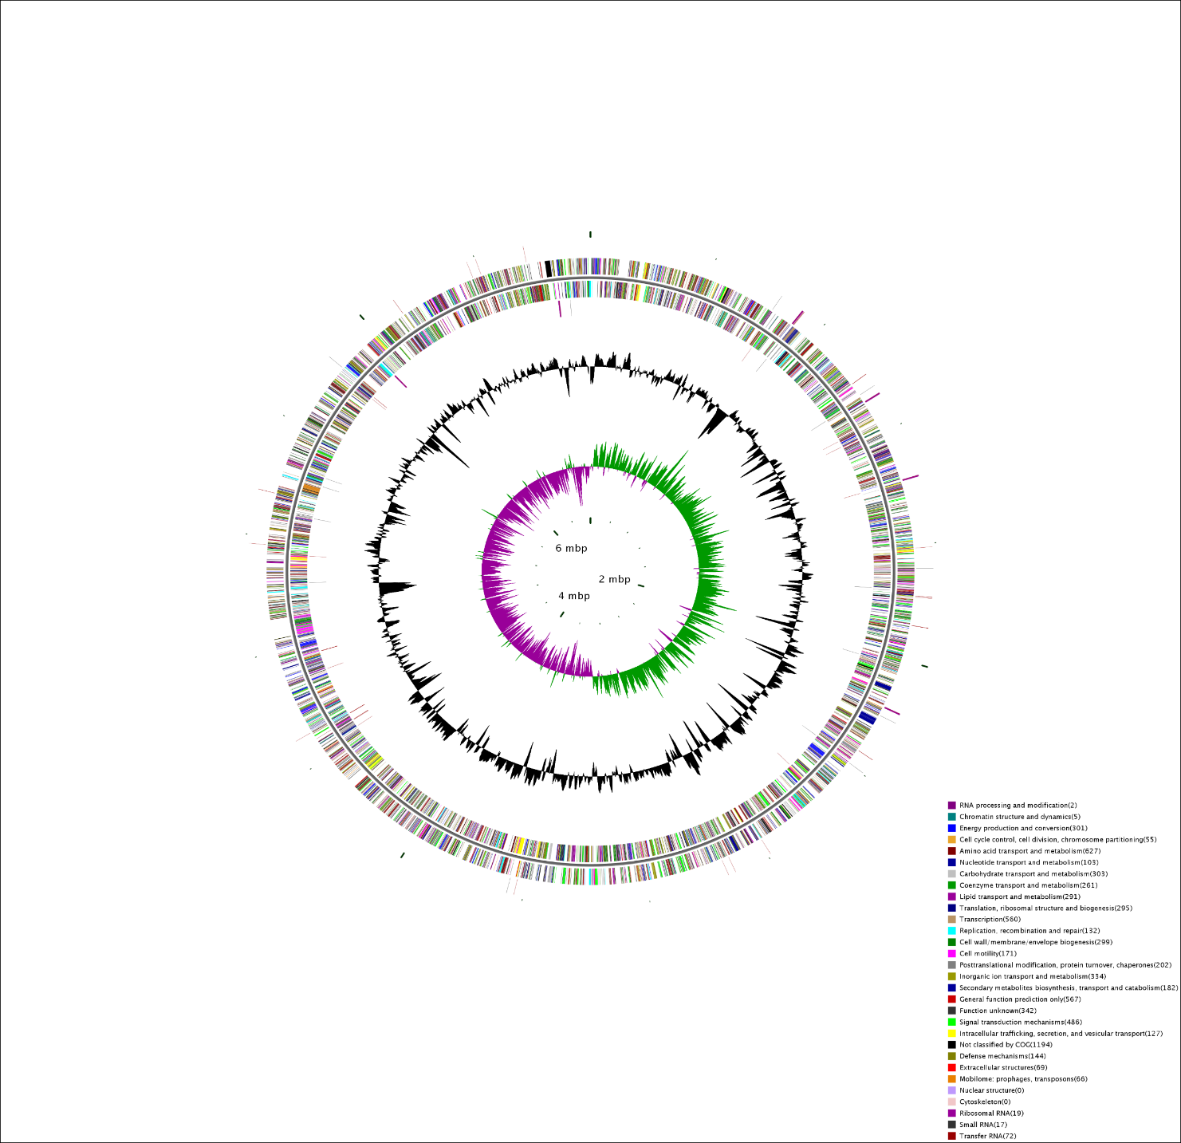
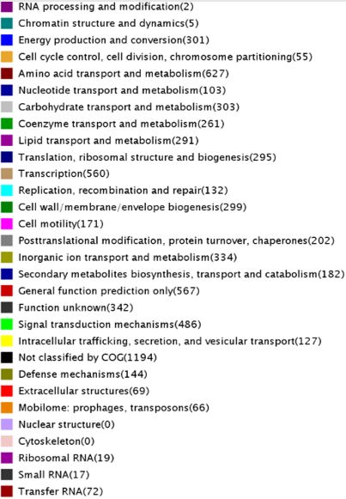
Fig. S6 The GC skewness of the Pseudomonas sp NLX-4 strain and the genome wide distribution of different cellular process.

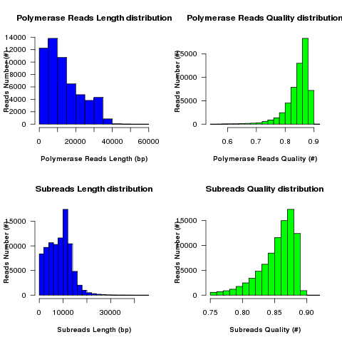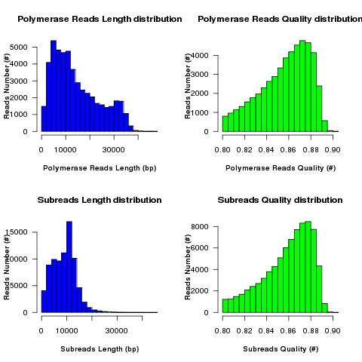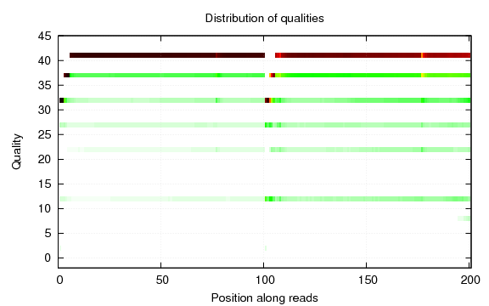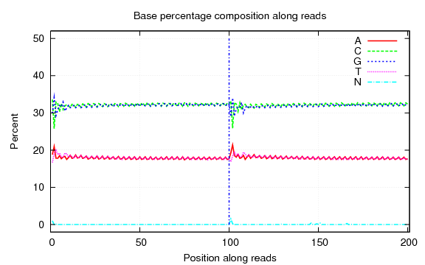
c
b
a
Raw reads
Clean reads
Fig. S7 Shows the distribution and statics of length and mass of the polymerase reads and subreads respectively. a) The results are represented for both raw reads and clean reads respectively; b) base composition of data. On the X axis, 1-90 bp represents the base position of read1, and 91-180 bp represents the base position of read; c) shows the reads base mass distribution.

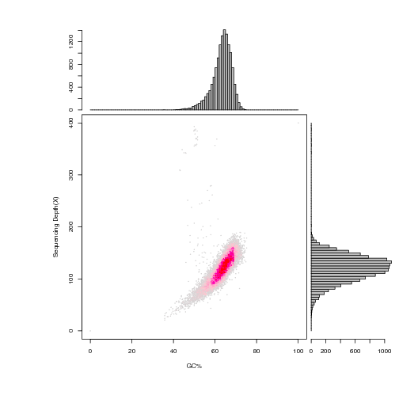
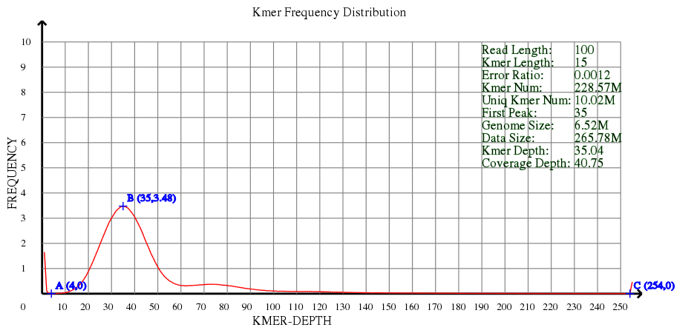
Fig. S8 a) Correlation analysis of GC content and Depth: The abscissa is the GC content, and the ordinate is the average sequencing depth; b) shows the Kmer Analysis Graph where the abscissa is Depth, and the ordinate is the ratio of the frequency at each depth to the total frequency. Without considering the sequencing error rate, the heterozygosity and repetition of the genome.
b
a
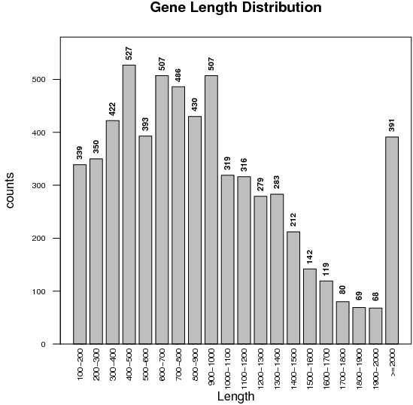

Fig. S9 Gene Prediction glimmers.

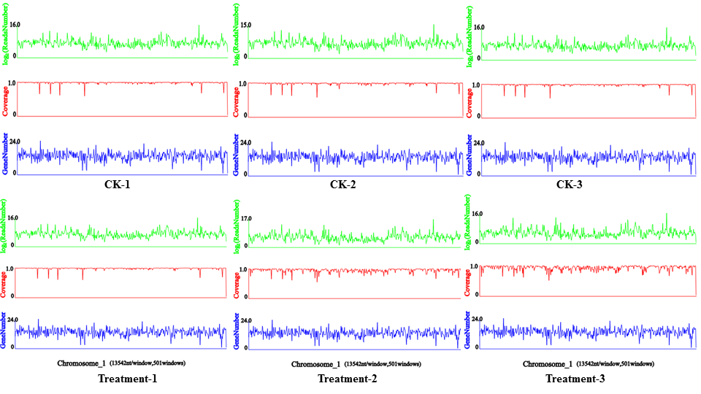
Fig. S10 Birds eye view of the distribution of reads mapped to the reference genome, each figure shows the distribution of genes and also the distribution of reads in the longest 1 chromosome/scaffold.
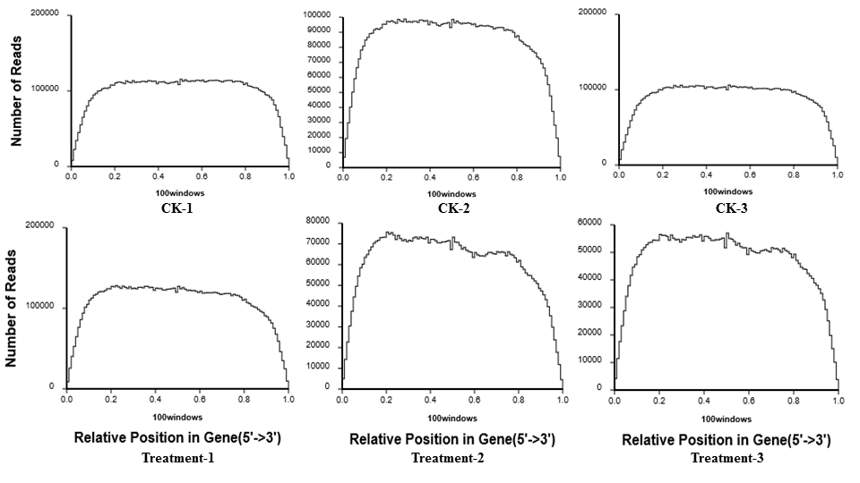
Fig. S11 The results of randomness assessment showing the distribution of reads mapped to the reference genome.

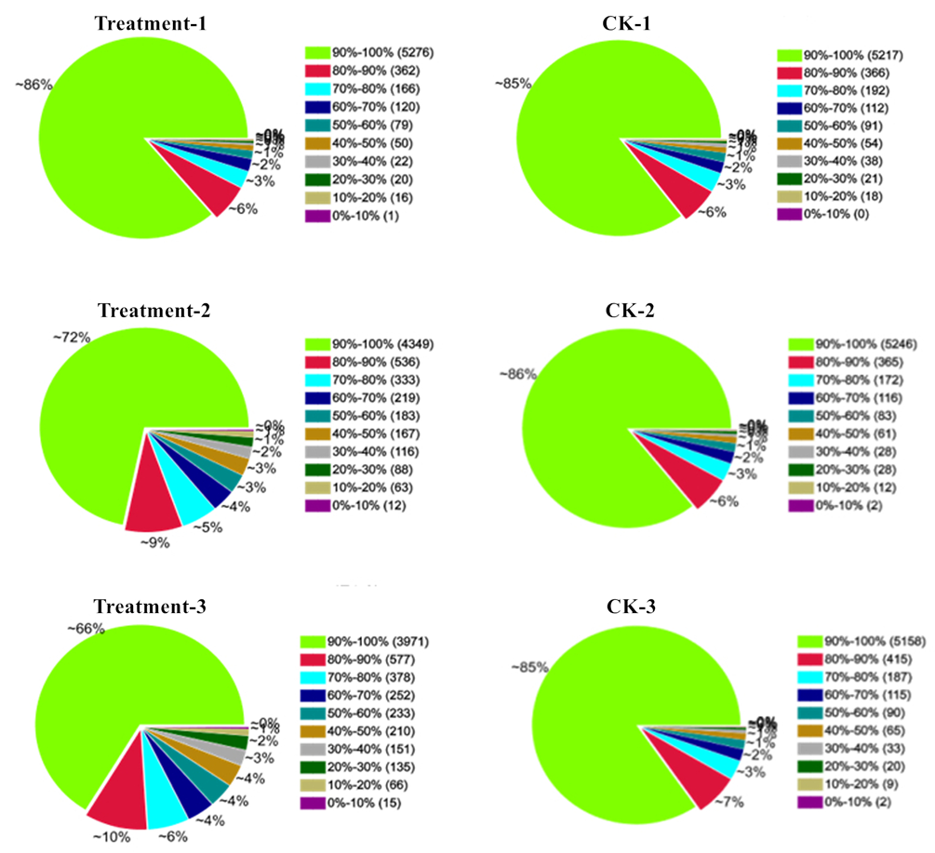
Fig. S12 Distribution of gene’s coverage for individual sequenced samples.
Fig. S13 Correlation analyses of three biological replicates in treatment and CK groups, respectively. The Pearson correction coefficients are shown in the upper right corner of the plot.
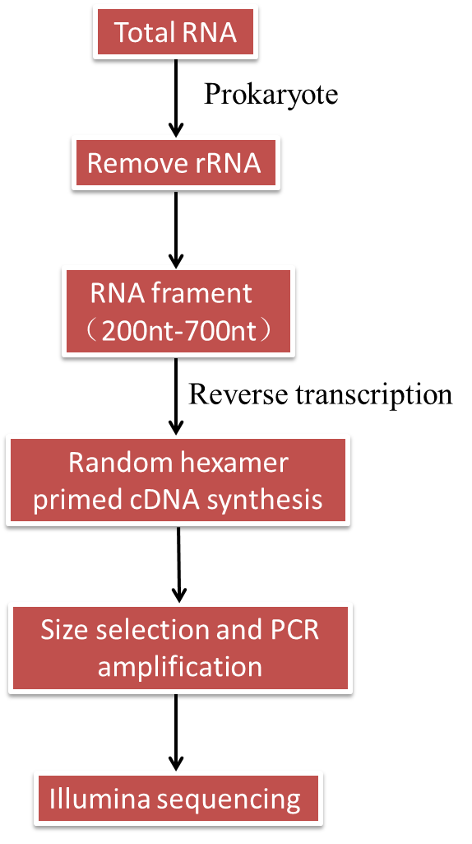
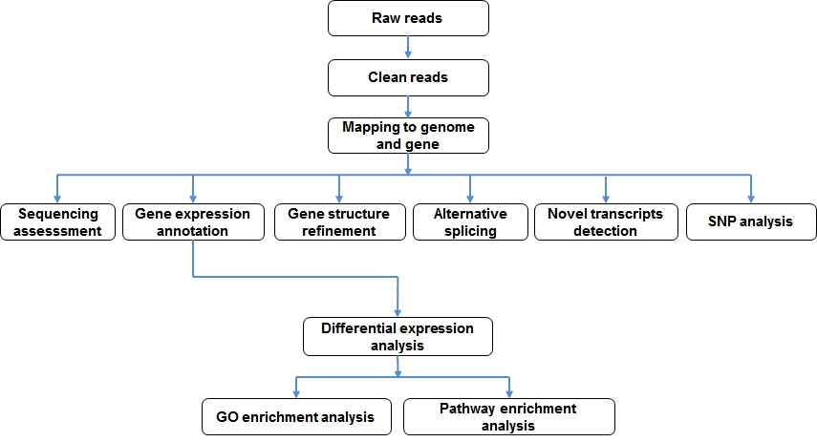
Fig. S14 Detailed workflow implemented for the illumina RNA-Sequencing and the sequencing analysis pipeline for obtaining for the gene annotations.
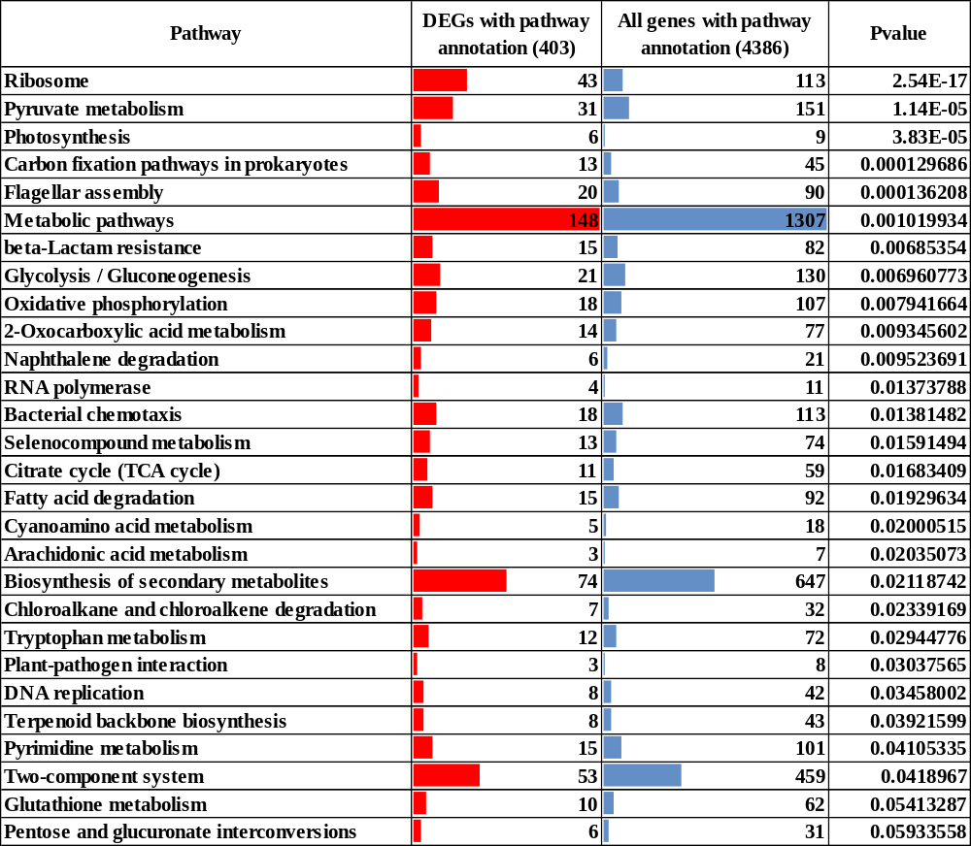

Continued…
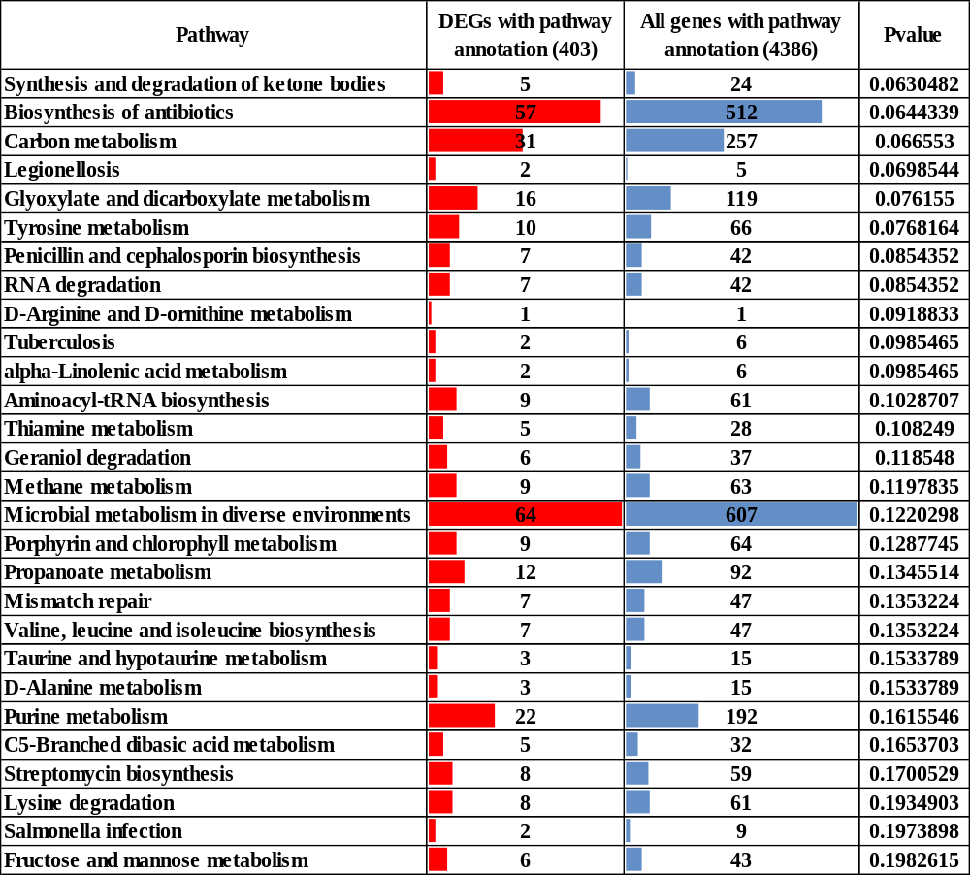
Fig. S15 The enriched and significant KEGG pathways based on their differentially expressed genes and the total number of genes belonging to each pathway.

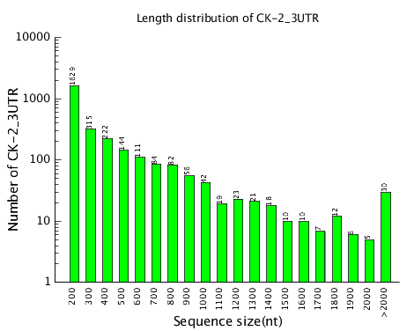
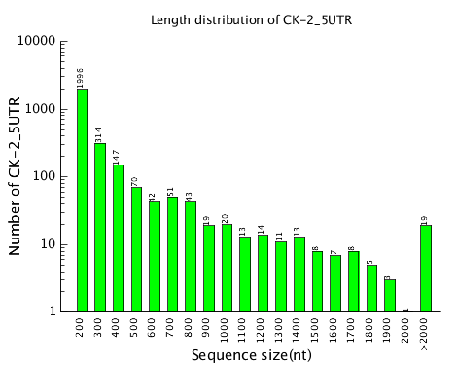
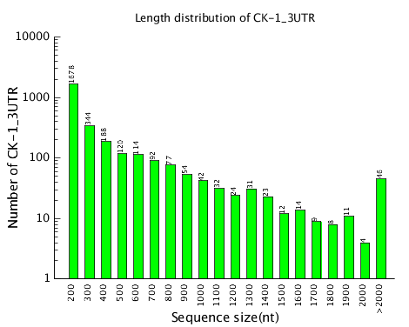
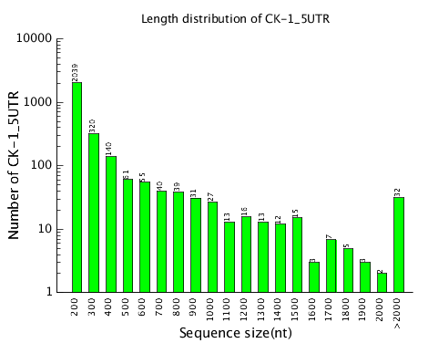
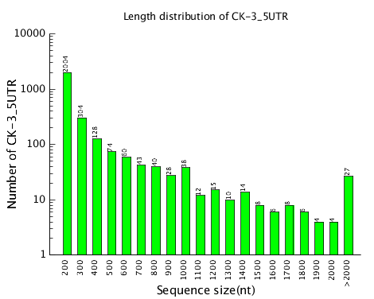
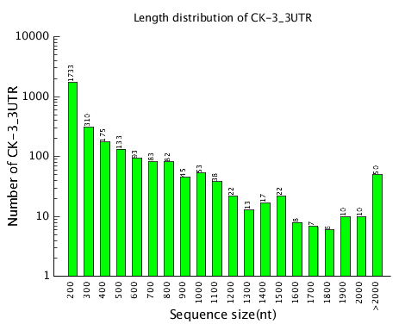
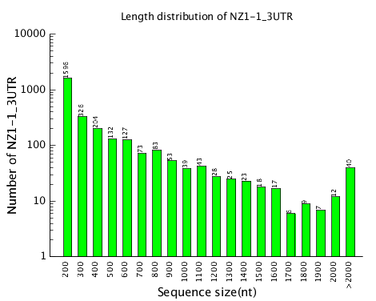
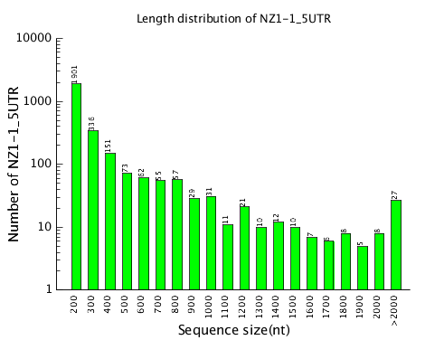
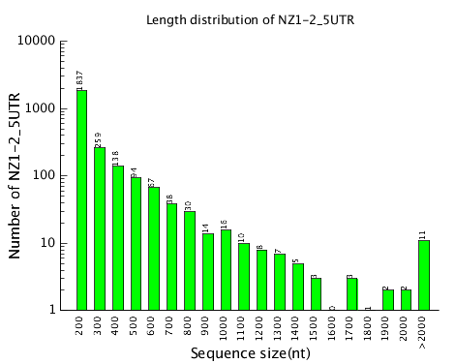
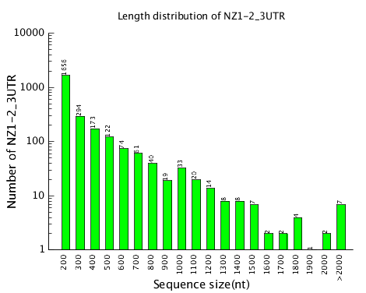
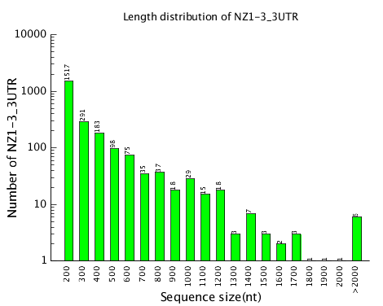
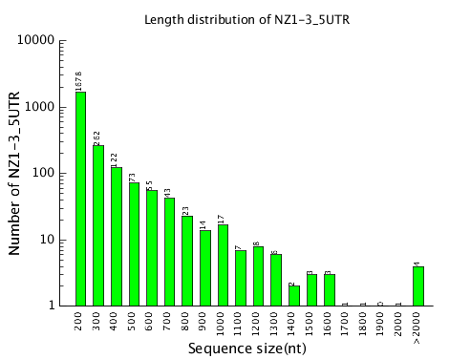
Fig. S16 Shows the distribution of 3’ and 5’ UTR regions in the sequenced samples (control and NLX-4 samples.
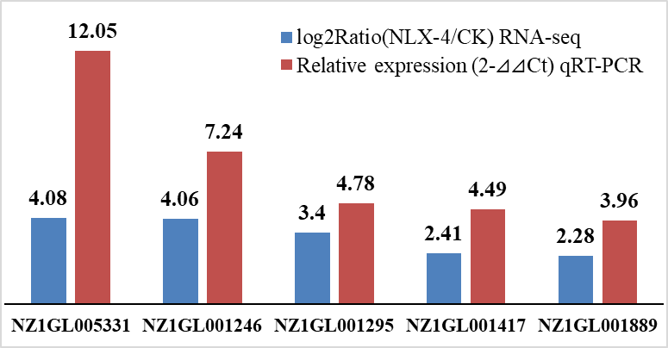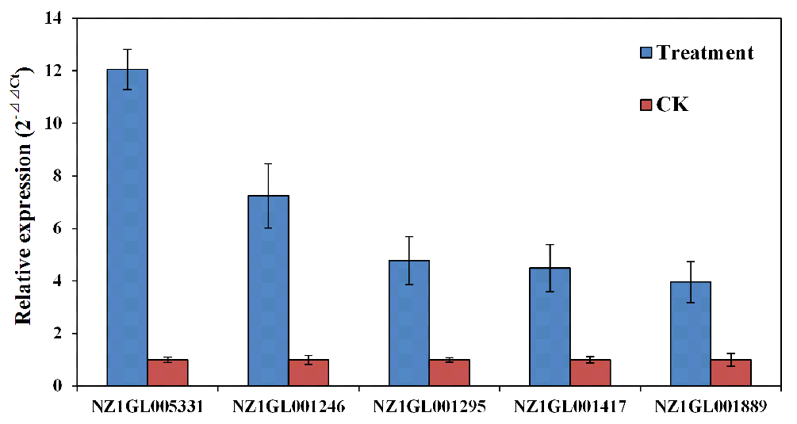
Fig. S17 The qRT-PCR analysis of the specifically selected six differentially expressed genes involved in the rock-dissolution process, selected based on the RNA-Seq results.
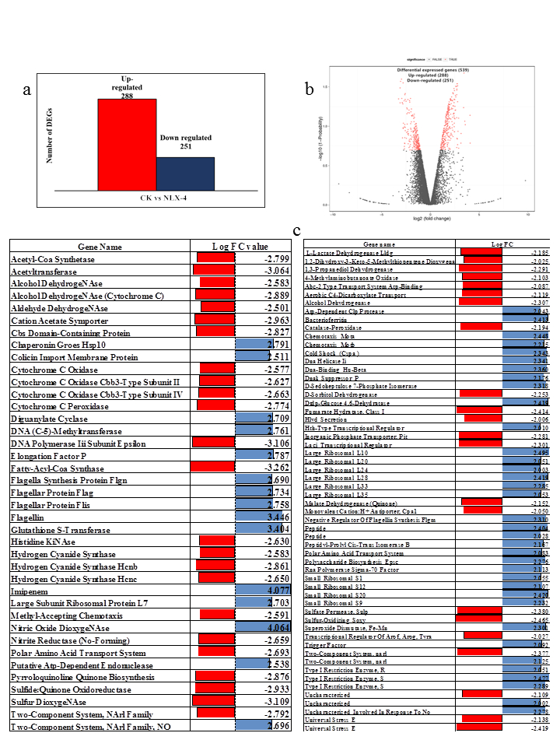
Fig. S18 The differentially expressed genes (DEGs) obtained from transcriptome analysis. a) fold change results b) DEGs both up and down regulated c) volcano plot.

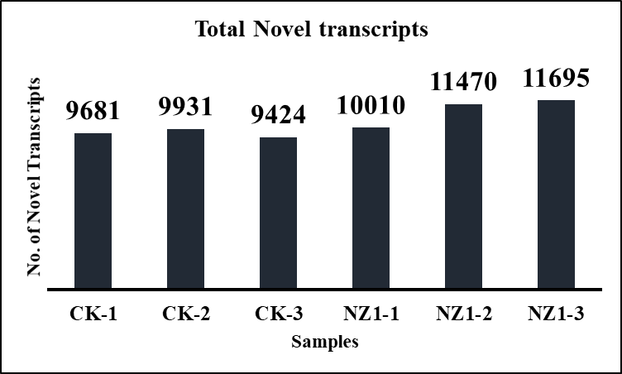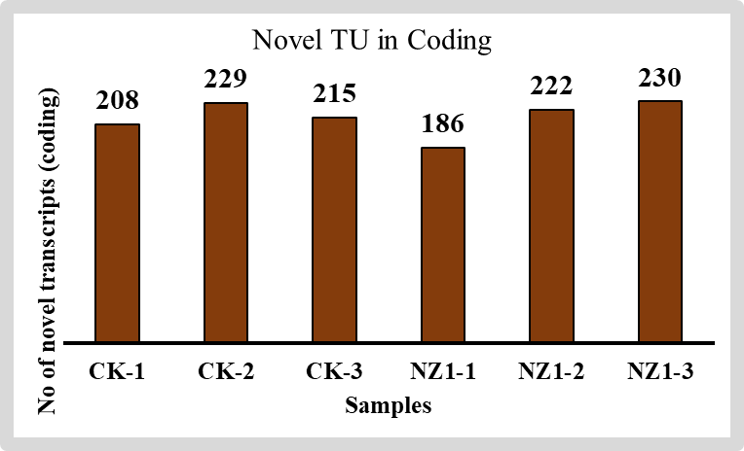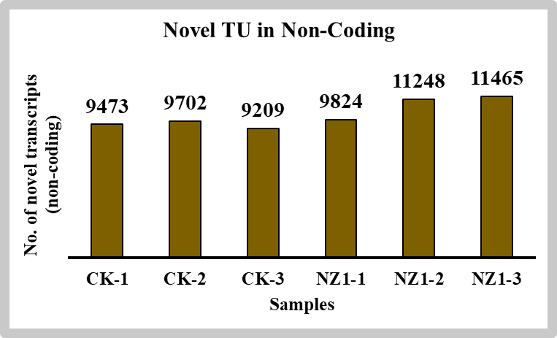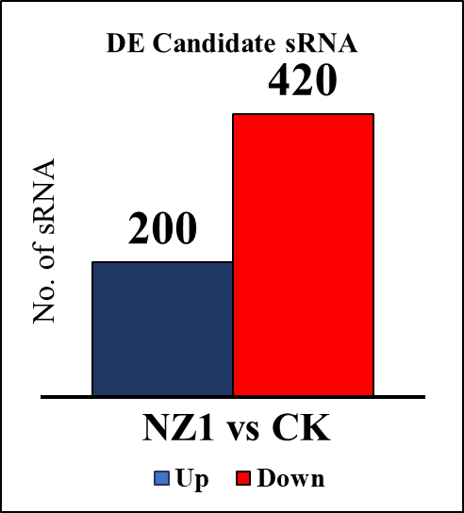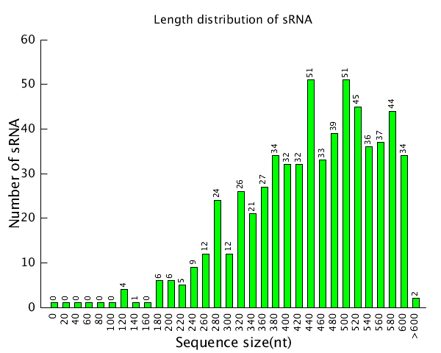
a
c
b

Continued…
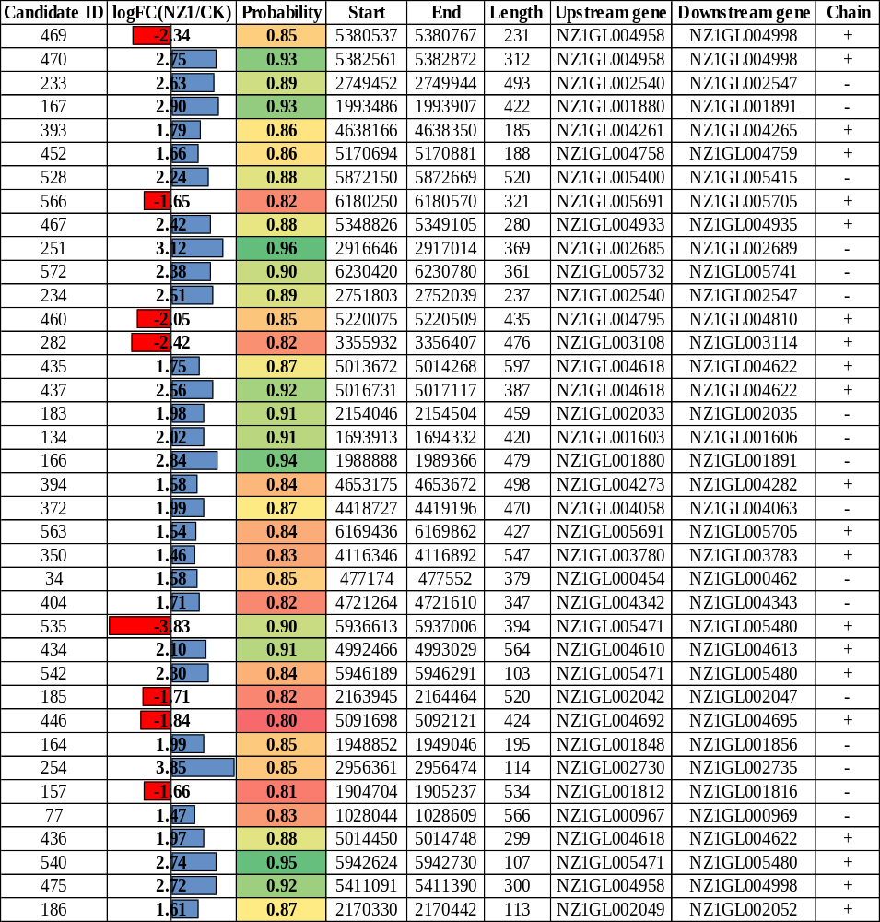
d
Fig. S19 a) Total number of novel transcripts discovered based on the transcriptome data analysis, which includes both novel transcripts in coding and non-coding regions; b) Total number of differentially expressed sRNA in control and treatment samples; c) distribution of the total number of sRNA’s and their length; d) Top differentially expressed sRNA’s represented by its candidate-ID along with its start and ending regions.

