Supplementary Information

Article title: Copeptin and Global Oxidative Imbalance in Interictal Migraine: An Exploratory Matched Case–Control Study

Journal: Acta Neurologica Belgica

Supplementary Table S1. Biomarker levels across controls, episodic migraine, and chronic migraine
Biomarker | Control (n=43) | Episodic migraine (n=24) | Chronic migraine (n=19) | Overall p
TAS | 1.05 (0.85–1.52)ᵃ | 0.76 (0.68–1.01)ᵇ | 0.81 (0.62–0.91)ᵇ | <0.001
TOS | 8.78 (7.71–11.81)ᵃ | 13.42 (10.16–23.29)ᵇ | 12.70 (9.49–22.69)ᵇ | <0.001
OSI | 0.79 (0.56–1.19)ᵃ | 1.69 (1.13–3.24)ᵇ | 1.99 (1.09–2.84)ᵇ | <0.001
Copeptin | 5.29 (2.91–10.36)ᵃ | 12.52 (4.92–15.57)ᵇ | 11.83 (5.48–15.92)ᵇ | 0.001
Data are presented as median (Q1–Q3). Overall comparisons were performed using the Kruskal–Wallis test. Pairwise comparisons were performed using Mann–Whitney U tests with Bonferroni correction. Different superscript letters indicate statistically significant between-group differences after Bonferroni correction; groups sharing the same letter are not significantly different.

Supplementary Table S2. Biomarker levels according to aura status in patients with migraine
Biomarker | Without aura | With aura | p
TAS | 0.816 (0.660–0.917) | 0.735 (0.695–0.917) | 0.635
TOS | 13.065 (10.033–22.694) | 13.868 (10.033–21.924) | 0.807
OSI | 1.788 (1.124–3.089) | 1.865 (1.186–3.155) | 0.796
Copeptin | 12.837 (7.111–15.681) | 7.825 (4.721–15.924) | 0.719
Data are presented as median (Q1–Q3). Comparisons between patients with and without aura were performed using the Mann–Whitney U test. TAS: total antioxidant status; TOS: total oxidant status; OSI: oxidative stress index.

Supplementary Table S3. Spearman correlation analyses within the migraine group
Variables | Spearman’s rho | p
TAS–TOS | 0.021 | 0.893
TAS–OSI | −0.561 | <0.001
TAS–MIDAS grade | −0.083 | 0.599
TAS–Copeptin | 0.118 | 0.453
TAS–VAS | 0.041 | 0.794
TOS–OSI | 0.817 | <0.001
TOS–MIDAS grade | −0.112 | 0.476
TOS–Copeptin | −0.164 | 0.292
TOS–VAS | 0.146 | 0.350
OSI–MIDAS grade | −0.171 | 0.273
OSI–Copeptin | −0.139 | 0.373
OSI–VAS | −0.061 | 0.697
MIDAS grade–Copeptin | 0.072 | 0.646
MIDAS grade–VAS | 0.182 | 0.242
Copeptin–VAS | −0.214 | 0.168
Spearman’s rho correlation coefficients were calculated within the migraine group. TAS: total antioxidant status; TOS: total oxidant status; OSI: oxidative stress index; MIDAS: Migraine Disability Assessment Scale; VAS: Visual Analog Scale.

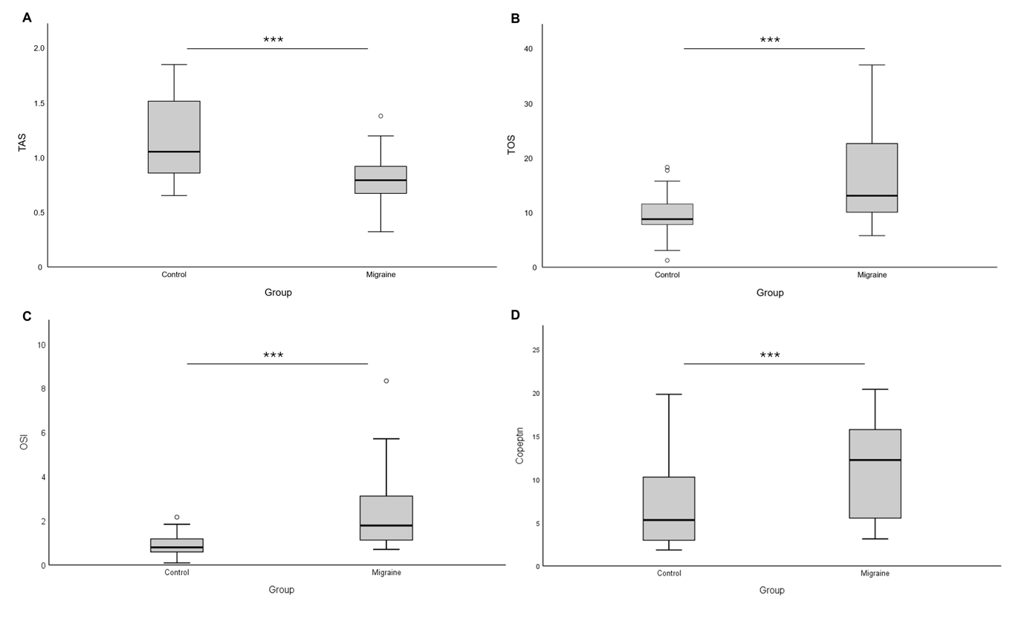 Fig. S1 Boxplot distributions of total antioxidant status (TAS), total oxidant status (TOS), oxidative stress index (OSI), and copeptin levels in patients with migraine and healthy controls. Patients with migraine demonstrated significantly lower TAS levels and significantly higher TOS, OSI, and copeptin levels compared with controls. Horizontal lines within boxes represent medians; boxes represent interquartile ranges; whiskers indicate minimum and maximum values excluding outliers. ***p < 0.001.
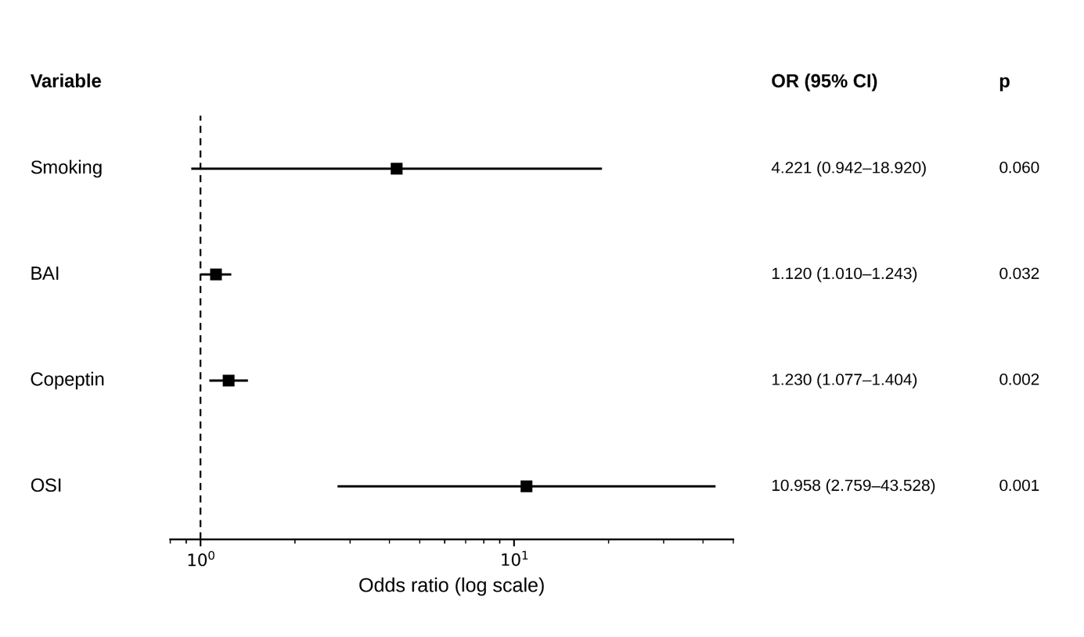
Fig. S2 Forest plot of factors associated with migraine status in the fully adjusted logistic regression model. Odds ratios and 95% confidence intervals are shown for variables included in the multivariable model adjusted for age, sex, smoking status, Beck Depression Inventory (BDI) score, Beck Anxiety Inventory (BAI) score, oxidative stress index (OSI), and copeptin level. The dashed vertical line indicates the reference value (OR=1).

