Supplementary Information

Micro- and Nanometric Characterization of the Celestite Skeleton of Acantharian Species

Rina Fujimaki¹ • Noritoshi Suzuki² • Katsunori Kimoto³ • Yukiko Nagai⁴ • Yuya Oaki¹ • Shinji Shimode⁵ • Takashi Toyofuku⁴ • Hiroaki Imai^{1*}

Address
1: Department of Applied Chemistry, Faculty of Science and Technology, Keio University, 3-14-1 Hiyoshi, Kohoku-ku, Yokohama 223-8522, Japan /E-mail※: hiroaki@applc.keio.ac.jp
2: Department of Earth Science, Graduate School of Science, Tohoku University, 6-3, Aoba, Aramaki, Aoba-ku, Sendai 980-8578, Japan
3: RIGC, Japan Agency for Marine-Earth Science and Technology, Natsushima-cho 2-15, Yokosuka 237-0061, Japan
4: X-star, Japan Agency for Marine-Earth Science and Technology (JAMSTEC), Natsushima-cho 2-15, Yokosuka 237-0061, Japan
5: Manazuru Marine Center for Environmental Research and Education, Graduate School of Environment and Information Sciences, Yokohama National University, 61 Iwa, Manazuru 259-0202, Japan.

Corresponding authors
Hiroaki Imai E-mail address: hiroaki@applc.keio.ac.jp

Figure S1
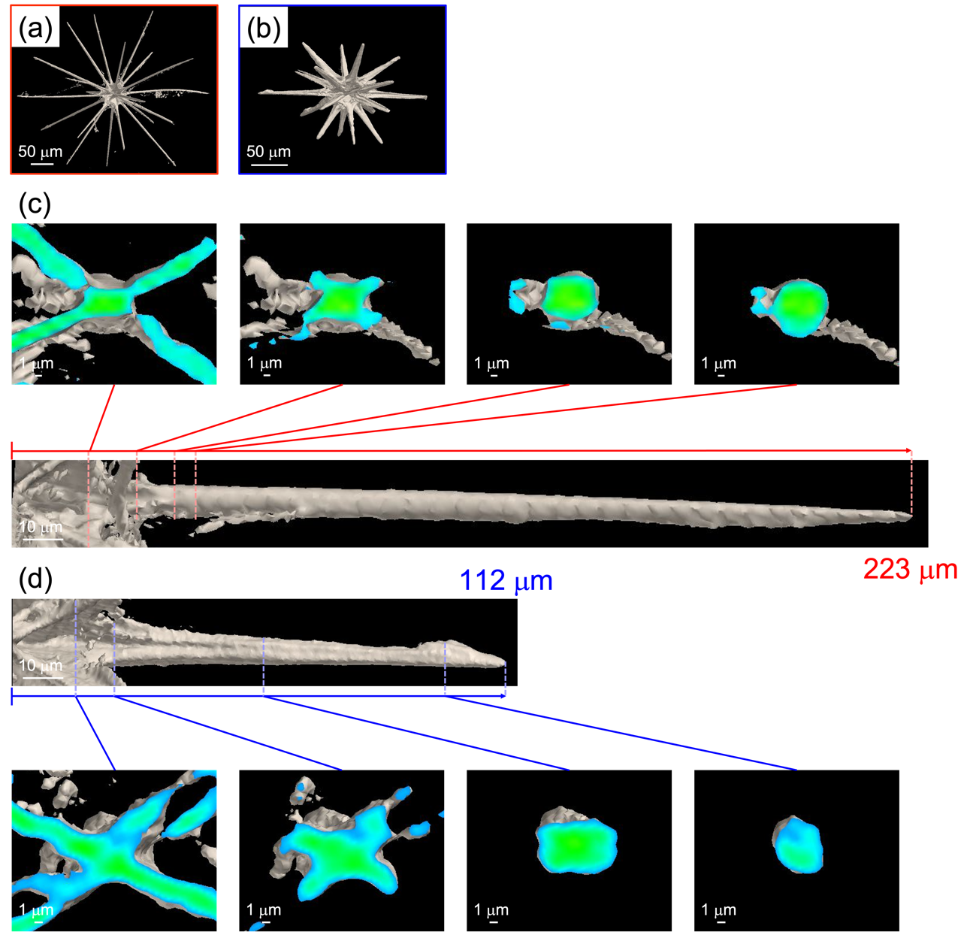
Supplementary Figure 1. The whole microfocus CT images (a, b). Cross-sectional microfocus CT images of equatorial spines of a large individual (c) and a small one (d).

Figure S2
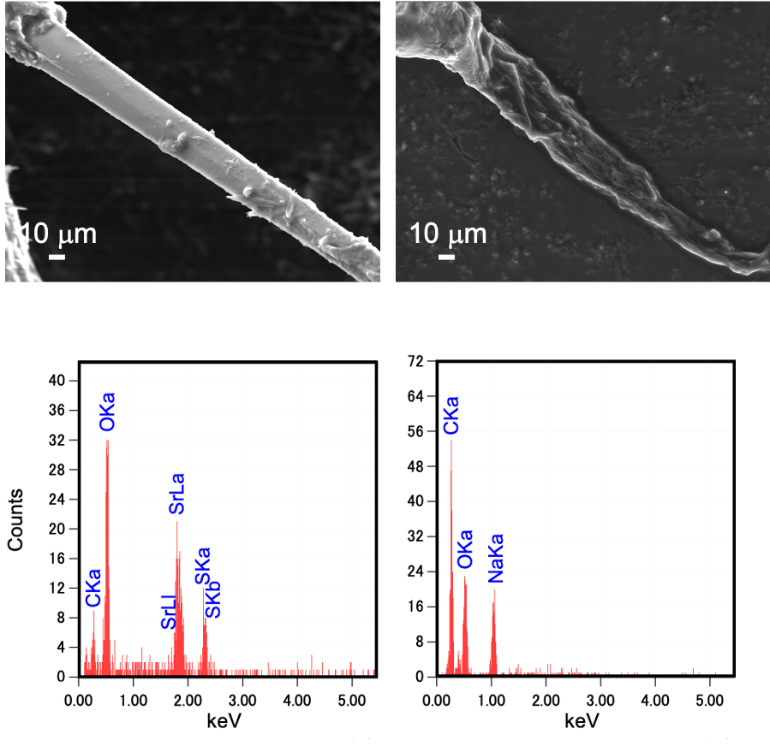
Supplementary Figure 2. SEM images with EDS spectra before and after immersion into an EDTA solution.

Figure S3
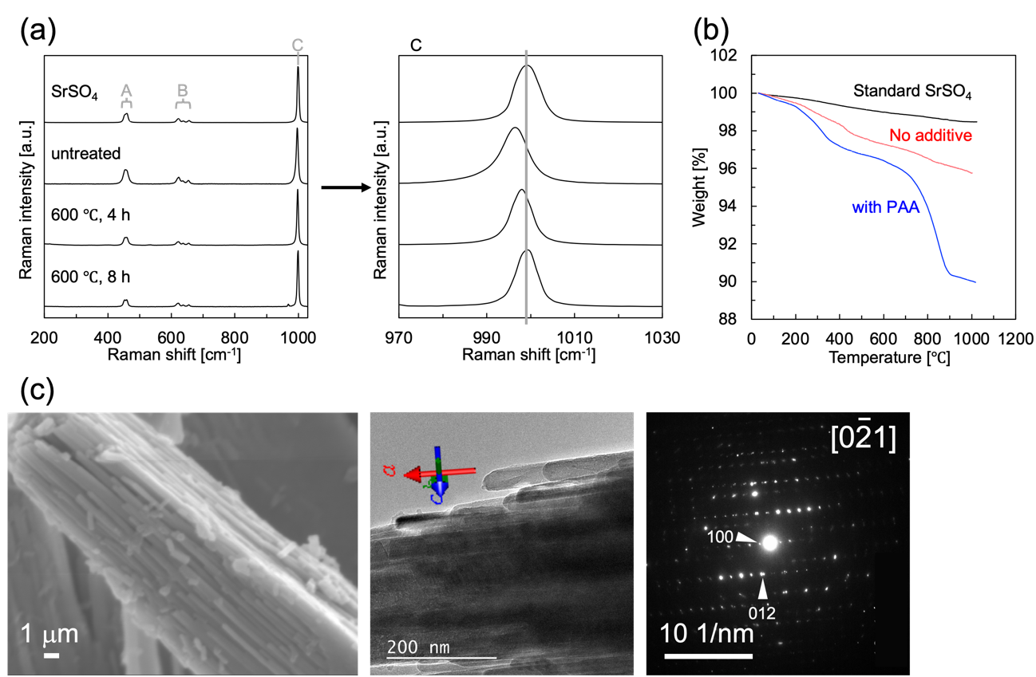
Supplementary Figure 3. Raman spectra of artificailly produced celestite with PAA before and after calcination at 600°C in air (a). Thermogravimetry (TG, Shimadzu DTG-60) was performed to evaluate the organic content. TG curves of artificailly produced celestite with and witout PAA (b). SEM and TEM images with an SAED pattern of artificailly produced celestite mesocrystal with PAA (c). Raman signals A, B, and C are assigned to the S-O symmetric stretching vibration, the S-O double expansion and stretching vibration, and the S-O asymmetric stretching vibration, respectively.
We synthesized celestite using the following procedure. Solutions of Na₂SO₄ (1.0 mol/dm³) and of SrCl₂ (1.0 mol/dm³) were prepared by dissolving analytically pure Na₂SO₄ and SrCl₂·6H₂O into purified water. A certain amount (0.01 wt%) of PAA was dissolved into the SrCl₂ solution under stirring. The Na₂SO₄ solution was added into the mixed aqueous of SrCl₂ and PAA under vigorous stirring at room temperature. After stirring for 10 min, the suspension was kept for 24 h. We recovered precipitates by filtration and subsequent rinse with ethanol.

