Cost-Efficient Large Language Model-Assisted
Title and Abstract Screening for Systematic Reviews: Method Evaluation and Validation

Dimitri Belenki^{a*}, Alexander Astaninª, Dan Baakenª, Heinrich A. M. Leymannª, Felix Meyerª, Blanka Pophofª, Evelyn Weiserª
ª Competence Centre for Electromagnetic Fields, Federal Office for Radiation Protection, Karl-Liebknecht-Straße 33, 03046 Cottbus, Germany
* Corresponding author: Dimitri Belenki (ORCID ID 0000-0002-9004-9849), e-mail: dbelenki@bfs.de

Supplementary Methods
Software

Access to proprietary OpenAI models
To operate proprietary OpenAI models, we used OpenAI API’s "/v1/chat/completions" endpoint and programmed batch API task jobs via the OpenAI Python library (https://github.com/openai/openai-python). The batch API token price is half the token price of on-demand API calls. We chose this option to minimise costs, with generally short waiting times. One caveat with OpenAI API is the usage tier limit which may block batch jobs when a tier-specific daily batch queue token limit is reached. Usage tiers increase with both additional credit deposits and time elapsed since initial payment. To mitigate this restriction at low usage tiers, large batch jobs (thousands of abstracts) were processed in smaller sub-batches.
Development

Agentic design
We used LangChain-Community (v0.3.5) wrappers for search engine and Wikipedia API queries. We initially used the DuckDuckGo search engine API wrapper but encountered rate-limiting during development, and therefore switched to the Google Search API Serper (https://serper.dev; hereafter referred to as Serper).
In agentic workflows, the search functions were exposed to the LLM as callable tools. The LLM was instructed to request a tool call when needed and to provide a search query, with Wikipedia search intended for short queries (≤3 words) and web search for more complex queries. When the LLM requested a search, we executed the corresponding search function and returned the result to the LLM in a subsequent call. This follow-up call repeated the original prompt and appended the search result in LangChain’s chat-history “placeholder” (Supplementary File 1).
The LLM was allowed to request up to three searches per record (or up to two searches within the evaluation step of task-decomposition workflows). Wikipedia results were limited to the top three hits and web search results to the top five and both were truncated at 3,000 characters. Serper web search results typically consisted of short snippets and did not reach this limit. For open-source workflows, the TiAb was re-injected after the search results to reduce the risk that repeated searches would dilute access to the original TiAb in the model’s context window.
Of note, the instructions and eligibility criteria were inserted via the system prompt. In our Ollama setup (context window size parameter num_ctx=8192), we did not observe these instructions being truncated or otherwise obfuscated by appended search results.

LLM response processing
Open-source model responses
Open-source models, particularly smaller ones, did not always reliably execute tool calling in the expected format. To enable uninterrupted processing of thousands of records without discarding valid model outputs, we implemented robust parsing and recovery logic. For example, models occasionally returned a valid JSON response in the message content field rather than in the expected tool_calls field of LangChain’s AIMessage. Our recovery function detected such cases, extracted the JSON payload, and re-parsed it into the expected schema, thereby increasing the rate of successfully parsed outputs.
Proprietary model responses
OpenAI models are generally reliable at tool calling, and we did not encounter tool-call formatting issues. Nevertheless, for consistency across model types, we applied the same parsing and recovery functions to all outputs. These functions operate only on returned text and do not affect model behaviour.
Internal evaluation
SR dataset processing
Ground truth labels were taken from the authors’ EndNote databases. In addition to final inclusion in the review (“include”), we also retained the label “full-text”, denoting records that passed TiAb screening but were excluded at full-text screening.
SR1 [1] contained 3,909 TiAb records. Two records were used as few-shot examples (Inskip et al., 2001 and Ahlbom, 2001 therein) and excluded from evaluation, leaving 3,907 records to screen. The final SR included 147 records, one of which was used as a few-shot example (Inskip et al., 2001) and was therefore excluded from evaluation, leaving 146 included records. A further 492 records had passed TiAb screening but were excluded at full-text screening.
SR6 [2] contained 23,450 TiAb records, including 80 finally included studies and 165 records excluded at full-text screening. To keep runtime manageable, we downsampled the dataset to 5,000 records by randomly removing records labelled “exclude” (sample() in Python/pandas with random_state = 42), while retaining all records labelled “include” and “full-text”.
SR9 [3] contained 12,409 TiAb records, including 56 finally included studies and 841 records excluded at full-text screening. We downsampled the dataset to 5,000 records. To keep the proportion of full-text-screened records comparable across SR datasets, we additionally downsampled the “full-text” subset to 500 by randomly removing the required number of records from the “full-text” and “exclude” labels, as described above.

External validation
SR dataset processing
The workflows selected in the internal evaluation stage were assessed on external SR datasets not used during development or internal evaluation: SR4, SR7, Luukkonen 2025 (Lu2025), Appenzeller‑Herzog 2019 (AZ2019), van Dis 2020 (vD2020) and Leenaars 2020 (Le2020), as well as two datasets derived from Sandner et al. (2024).
Sandner et al. [4] curated four SR datasets [5-8] produced by an overlapping author group. Three addressed highly similar pharmacological treatment questions in COVID‑19, differing mainly by intervention. To avoid overweighting this author collective and clinical context, we concatenated these three SR datasets into a single combined dataset (“Sandner 2024 COVID‑19 disease”, Sa_Covid) and treated the acupuncture/Raynaud’s SR as a separate dataset (“Sandner Raynaud’s”, Sa_Raynauds) due to its distinct PECOS question.
Ground truths for SR4 [9] and SR7 [10] were labelled (“include” and “full-text”) as kindly provided by the authors of these SRs in their EndNote databases. The ground truth for the dataset of Luukkonen 2025 (“include” labels only) was extracted from the paper [11].
The ground truths for the other three primary SRs were obtained from their respective repositories (AZ2019: https://zenodo.org/records/3625931, vD2019: https://osf.io/4d9tu/, Le2020: https://osf.io/t7gyr/). EndNote databases were constructed, deduplicated, and further duplicates in the vD2019 dataset were removed using custom Python jupyter notebooks. Missing abstracts in the Le2020 dataset were retrieved and TiAb deduplicated using custom jupyter notebooks interacting with the National Center for Biotechnology Information (NCBI) E-Utilities API.
SR4 search results contained 1,335 TiAb. We manually removed 9 duplicates, leaving 1,326 TiAb to screen. The dataset included 117 records in the final review, and a further 206 TiAb were excluded after passing the initial TiAb screening step.
SR7 search results contained 3,887 TiAb. The dataset included 13 records in the final review, and a further 243 TiAb were excluded at the full-text screening step.
We reproduced the database search described by Luukkonen et al. [11] and retrieved 985 TiAb records. Luukkonen et al. [11] additionally reported two studies identified via reference-list screening. One of these reference-list studies was included in the final SR and was used here as a few-shot example (Beniashvili et al., 1991). It was therefore excluded from evaluation. Consequently, our Lu2025 evaluation dataset comprised 985 retrieved records, with 53 records labelled as finally included based on Luukkonen et al. [11].
AZ2019 [12] search results contained 3,453 TiAb. After removing 6 duplicates, 3,447 TiAb remained. The dataset included 26 records in the final review, and a further 148 TiAb were excluded at the full-text screening step.
vD2020 [13] search results contained 10,857 records after deduplication by van Dis et al., 2020. After further removal of duplicates, our dataset comprised 10,287 records, consisting of 73 fully eligible TiAb included in the review and a further 635 TiAb excluded at the full-text screening step. To keep the workload manageable, we downsampled the total dataset size to 5,000, and to keep the proportion of full-text-screened records comparable to other SR datasets, we downsampled the number of the full-text-labelled TiAb to 500, by randomly removing the required number of TiAb with the “full-text” and “exclude” labels (sample() in Python/pandas with random_state = 42).
Le2020 [14] search results contained 8,105 TiAb, comprising 659 TiAb included in the final review and a further 748 TiAb excluded at the full-text screening step. After deduplicating the search result files provided by the osf repository (https://osf.io/t7gyr), our dataset contained 8,021 TiAb, comprising 658 TiAb included in the final review and 748 TiAb excluded at the full-text screening step. To keep the workload manageable, we downsampled the total dataset size to 5,000 and to keep the proportion of excluded records comparable to other SR datasets, we downsampled the numbers of the “full-text”– and also of the “include”–labelled TiAb to 500 each, by randomly removing the required number of TiAb with the “include”, “full-text” and “exclude” labels (as above).
Ground truths for the two Sandner et al. [4] derived datasets (Sa_Raynauds and Sa_Covid) were labelled (“include” and “full-text”) as obtained from https://zenodo.org/records/14379735. Notably, Sandner et al. [4] removed all title-only items. Sa_Raynauds comprised 849 TiAb with four records excluded at the full-text screening step and two included in the final review. Sa_Covid comprised 4,794 TiAb from three SRs with 88 records excluded at the full-text screening step and 46 included in the final reviews.
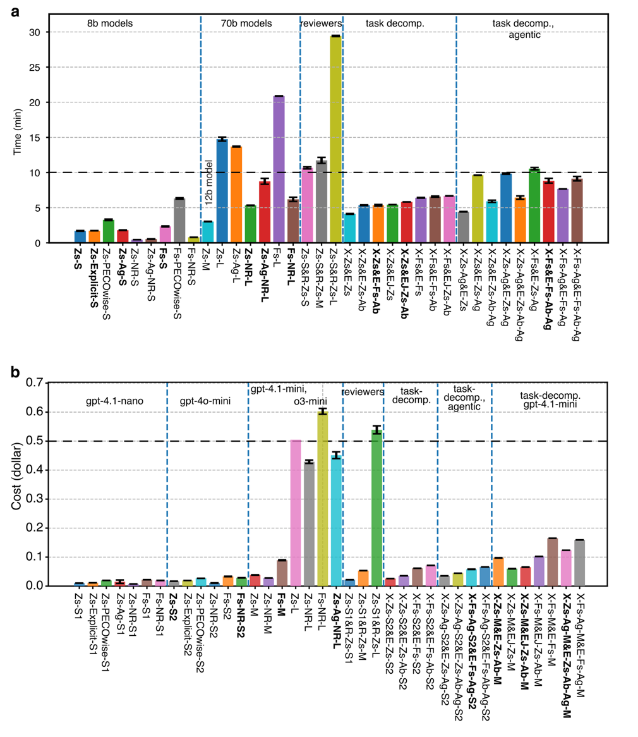
Supplementary Figures

Supplementary Figure S1 | Computational effort of workflows in development.
a,b Mean runtime and cost per workflow (± s.d.) for a, open-source and b, proprietary (OpenAI) LLM workflows. Horizontal black dashed lines denote the pre-specified cut-offs (20 min runtime; US$0.50 per run). Workflows exceeding either cut-off were deprioritized. One repetition of Zs-L (b) generated many errors due to constrained reasoning token allocation, and required reruns with increased allowance of generated tokens (resulting in a total cost of US$1.20). This value was treated as an outlier and excluded; therefore, no s.d. is available.
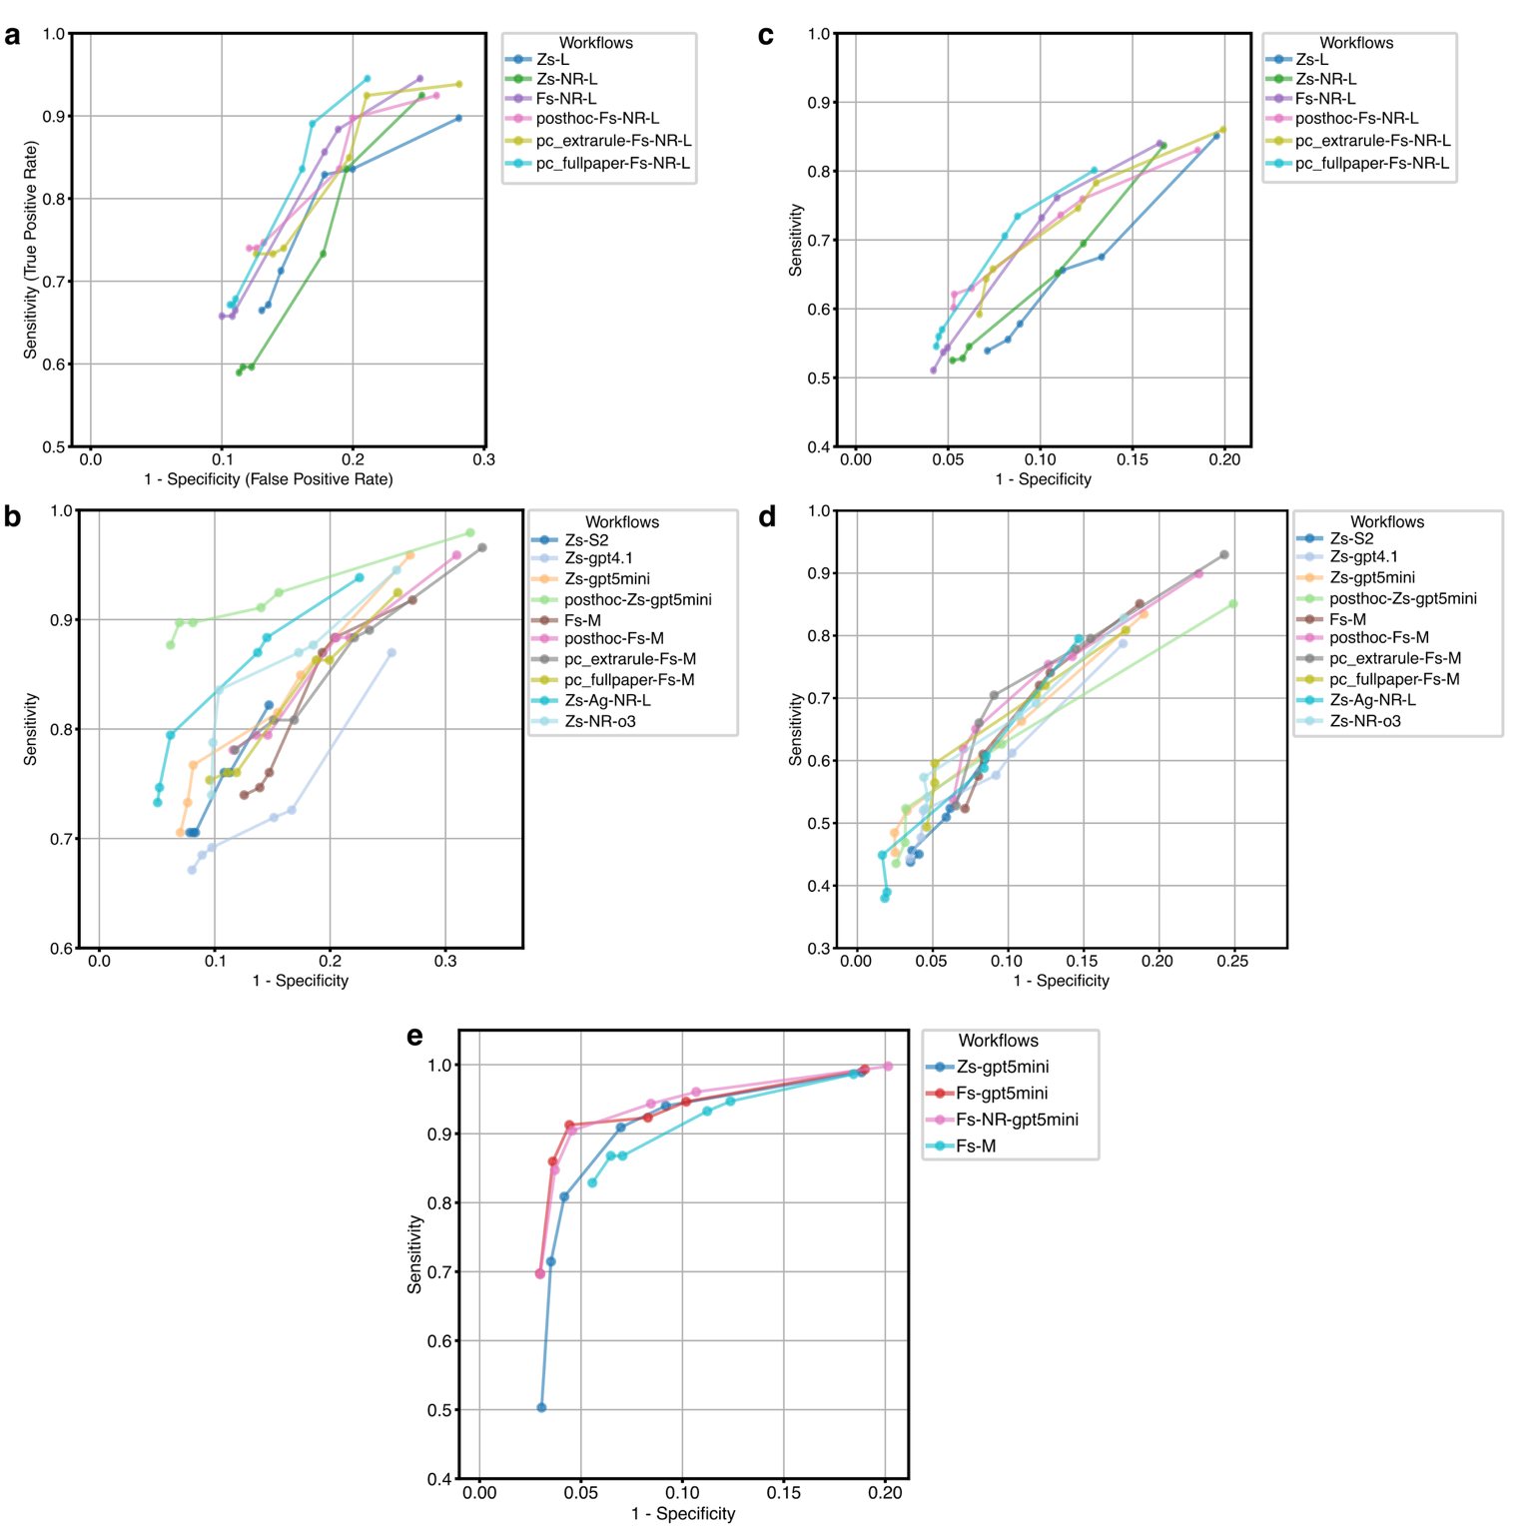

Supplementary Figure S2 | Post hoc analyses of workflow performance on SR datasets.
a,b ROC curves for SR1 using a, open-source workflows and b, proprietary (OpenAI) workflows, using only finally eligible (“include”) SR1 labels as reference. Post hoc variants tested structured and clarified criteria (“posthoc”), an additional conservative instruction (“extrarule”) as well as extended (“fullpaper”) eligibility criteria. An additional zero-shot Llama3.3:70b workflow (Zs-L) with high computational cost was also evaluated (a). Additional OpenAI flagship models (gpt-4.1 and o3-high) were evaluated post hoc (b).
c,d As in a,b, but using full-text–eligible TiAb (“full-text” or “include”) as reference labels.
e ROC curves for post hoc gpt-5-mini extension workflows averaged across SR1, SR6 and SR9 (SR1 evaluations used the post hoc clarified eligibility criteria, as “posthoc” in b).

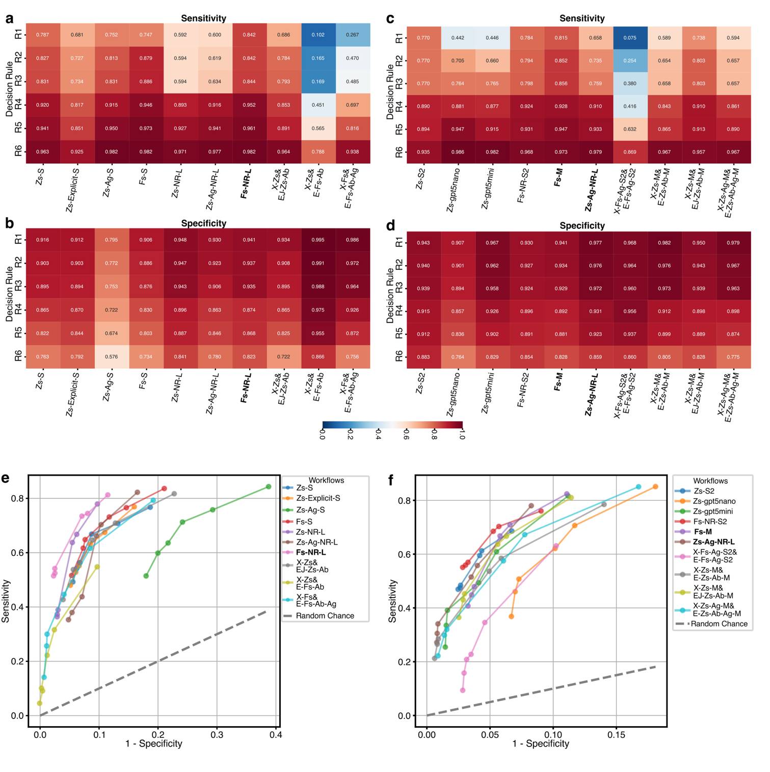
Supplementary Figure S3 | Sensitivity and specificity during internal evaluation on three SR datasets.
a–d Heatmaps of average sensitivity (a,c) and specificity (b,d) across workflows and six decision rules for open-source (a,b) and proprietary (OpenAI; c,d) workflows, evaluated on SR1, SR6 and SR9. Workflows shown in bold were advanced to external validation.
e,f Average ROC curves using full-text–eligible TiAb (SR1, SR6, SR9) as reference labels (“full-text” or “include”) for open-source (e) and proprietary (OpenAI; f) workflows; the dashed line indicates random performance.
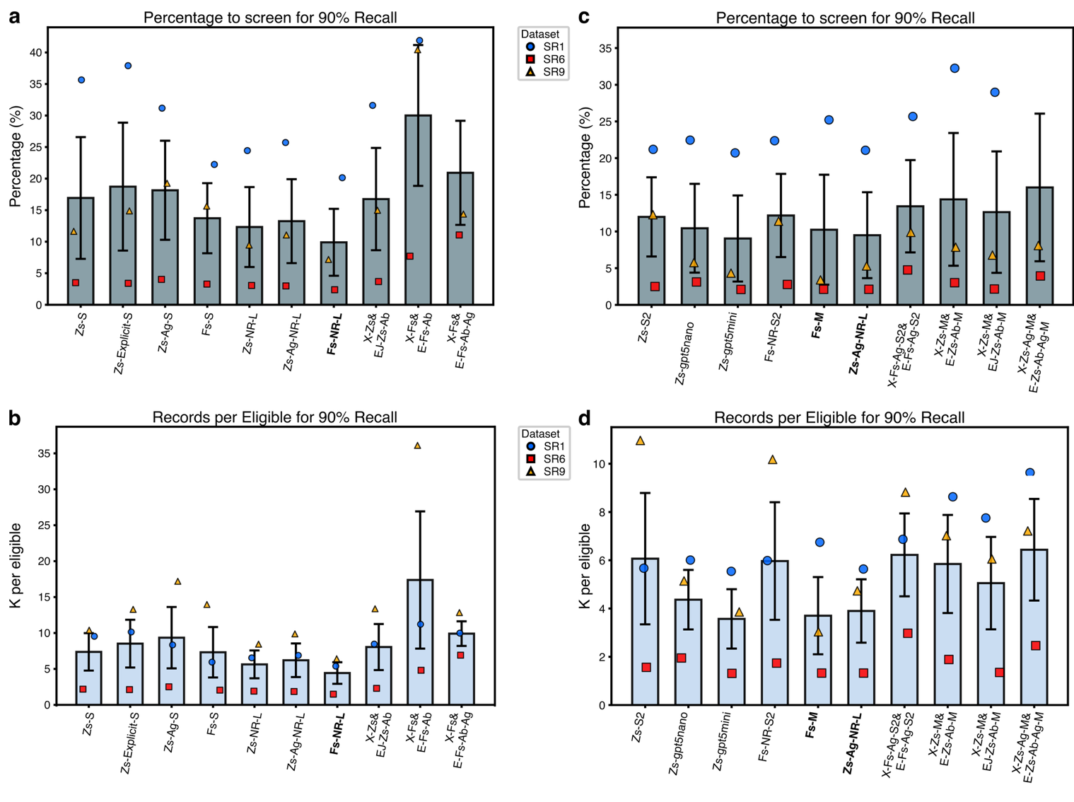Supplementary Figure S4 | Additional performance metrics at 90% recall (decision rule 6).
a–d Results for internal evaluation on SR1, SR6 and SR9 for open-source (a,b) and proprietary (OpenAI; c,d) LLM–based workflows, when ranking records according to their PECOS-wise score (see Methods section ‘PECOS–based ranking score’ in the main paper).
a,c Percentage of ranked title/abstract (TiAb) records that must be screened to achieve 90% recall.
b,d “K per eligible” (number of TiAb records screened per finally eligible included study) at 90% recall.
Bars show mean ± s.e.m. across SR1, SR6 and SR9, with per-dataset values overlaid. Workflows shown in bold were advanced to external validation.

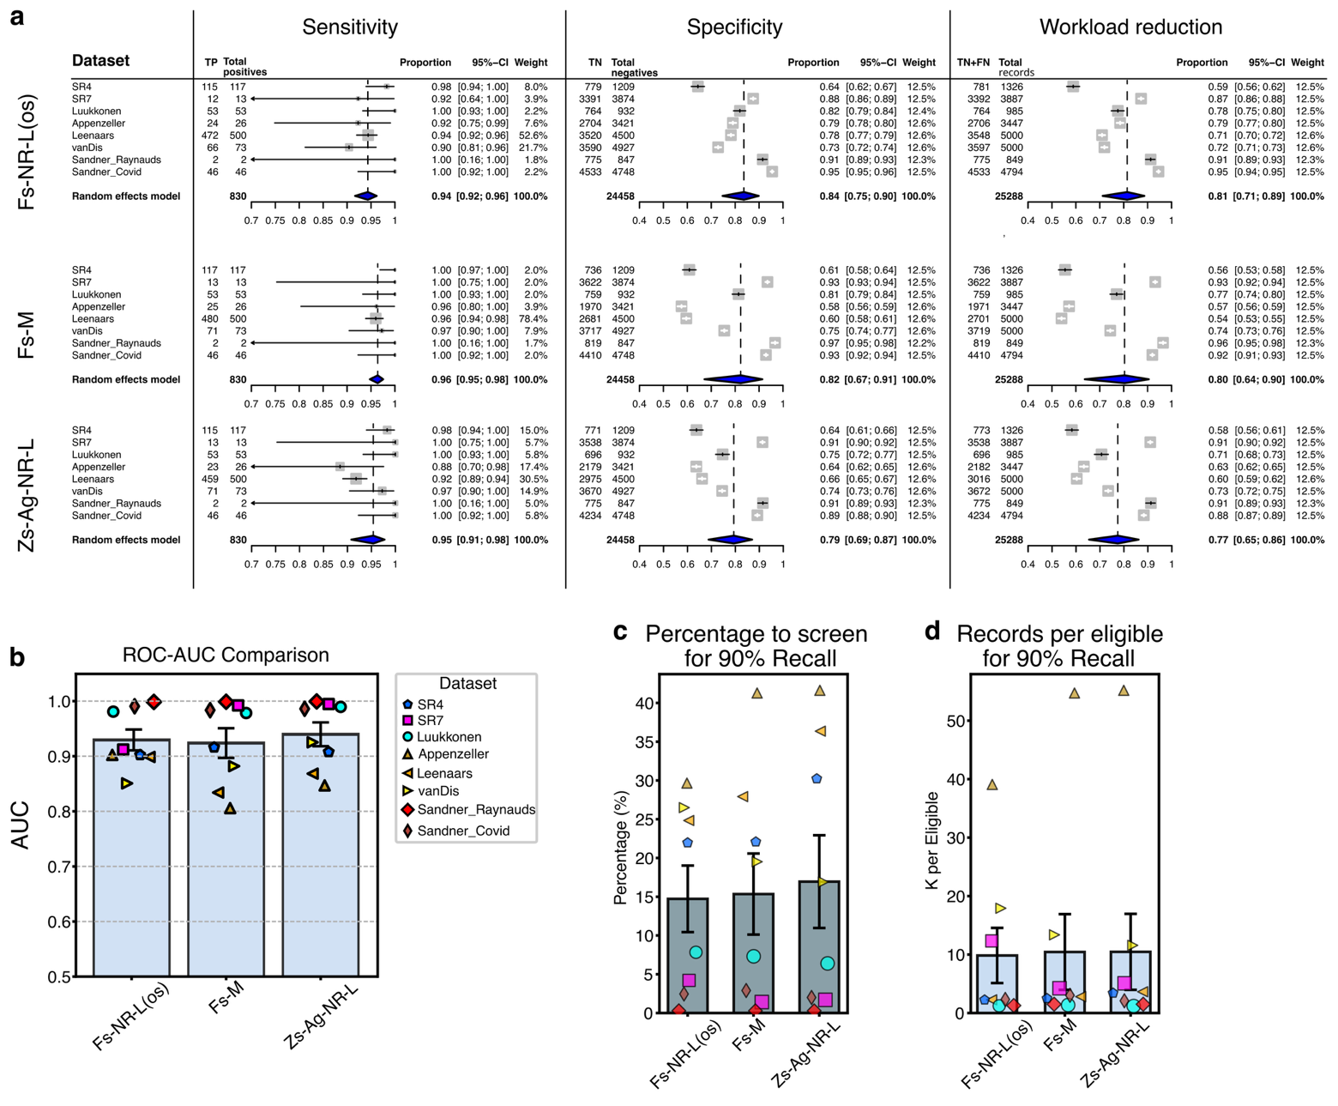Supplementary Figure S5 | External validation performance of contender workflows across eight independent SR datasets.
a Meta-analysis of single proportions (inverse-variance, logit-transformed) for per-dataset estimates by workflow (rows), showing sensitivity, specificity and workload reduction (columns). Pooled estimates with 95% CIs are shown as blue diamonds. Individual-dataset CIs are Clopper–Pearson intervals (Wilson intervals could not be displayed for all datasets). The choice of CI method for individual datasets does not affect the pooled estimates.
b ROC–AUC for each contender workflow across the eight validation datasets (bars show mean ± s.e.m.; points show per-dataset values).
c Percentage of PECOS-wise score-ranked title/abstract (TiAb) records to screen to achieve 90% recall.
d “K per eligible” at 90% recall (number of TiAb records screened per finally eligible included study).
In b–d, bars show mean ± s.e.m. across datasets with per-dataset values overlaid.

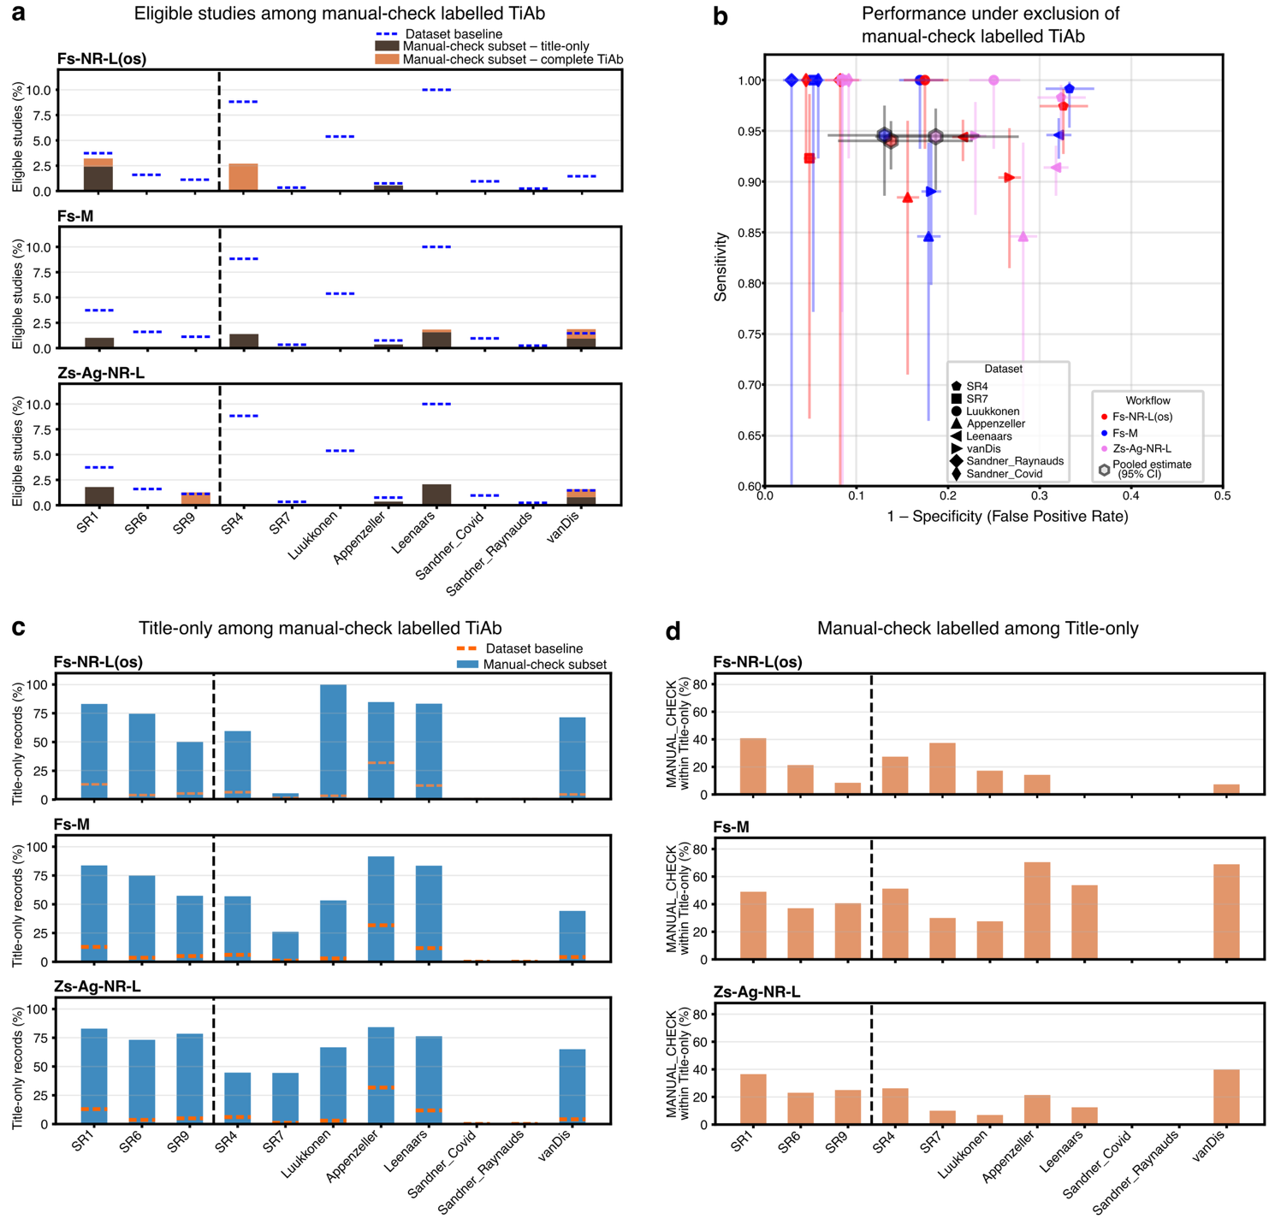Supplementary Figure S6 | Impact and characteristics of title/abstract records labelled “manual check” under decision rule R6.
a Proportion of eligible studies in each dataset (blue dashed lines) compared with their proportion (bars) within the “manual check” subset. “Manual check” bars are subdivided into complete TiAb and title-only records, showing that “manual check” items are depleted of eligible studies overall, and that eligible records within “manual check” are predominantly title-only. Dashed black line separates SR datasets used during internal evaluation from those used in external validation.
b External validation performance after hard exclusion of “manual check”−labelled TiAb (i.e., “manual check” treated as automated exclusion): sensitivity versus False Positive Rate (1 – specificity) with per-dataset estimates and 95% Wilson CIs. Pooled estimates across eight datasets are shown as hexagons, derived from a meta-analysis of single proportions.
c Proportion of title-only records in each dataset (orange dashed lines) compared with their proportion within the “manual check” subset (bars), demonstrating overrepresentation of title-only records among “manual check” items.
d Proportion of title-only records that were labelled “manual check”, shown by dataset and workflow.
Note that Sandner datasets were curated by Sandner et al. (2024) [4] to not contain title-only records.

Supplementary Table S1 | Performance of contender workflows under decision rule R6 with hard exclusion of records labelled “manual check”.
Dataset | Total Records  (N) | Eligible (P) | Workflow ID | TP labelled “include” | Manual check  (N)  [% of total] | TP labelled  “manual check”  [thereof title-only] | Sensitivity  [95% CI] (%) | Specificity  [95% CI] (%) | Workload reduction  [95% CI] (%) | ΔSensitivity  (pp) | ΔWorkload reduction  (pp)
SR1  (RF-EMF and cancer in human  observational studies) | 3907 | 146 | Fs-NR-L(os) | 130 | 249 [6.4] | 8 [6] | 89.0 [82.9 – 93.1] | 81.3 [80.0 – 82.5] | 78.7 [77.3 – 79.9] | -5.5 | +6.4
SR1  (RF-EMF and cancer in human  observational studies) | 3907 | 146 | Fs-M | 131 | 296 [7.6] | 3 [3] | 89.7 [83.7 – 93.7] | 80.6 [79.4 – 81.9] | 78.0 [76.7 – 79.3] | -2.1 | +7.6
SR1  (RF-EMF and cancer in human  observational studies) | 3907 | 146 | Zs-Ag-NR-L | 133 | 223 [5.7] | 4 [4] | 91.1 [85.4 – 94.7] | 83.3 [82.1 – 84.4] | 80.5 [79.2 – 81.7] | -2.7 | +5.7
SR6  (RF-EMF and cognition  in human trials) | 5000 | 80 | Fs-NR-L(os) | 80 | 51 [1.0.] | 0 | 100.0 [95.4 – 100.0] | 92.2 [91.4 – 92.3] | 90.7 [89.9 – 91.5] | 0.0 | +1.0
SR6  (RF-EMF and cognition  in human trials) | 5000 | 80 | Fs-M | 80 | 88 [1.8] | 0 | 100.0 [95.4 – 100.0] | 97.0 [96.4 – 97.4] | 95.4 [94.8 – 96.0] | 0.0 | +1.0
SR6  (RF-EMF and cognition  in human trials) | 5000 | 80 | Zs-Ag-NR-L | 80 | 56 [1.1] | 0 | 100.0 [95.4 – 100.0] | 97.0 [96.5 – 97.5] | 95.5 [94.9 – 96.0] | 0.0 | +1.8
SR9  (RF-EMF and oxidative stress) | 5000 | 56 | Fs-NR-L(os) | 56 | 42 [0.8] | 0 | 100.0 [93.6 – 100.0] | 81.6 [80.5 – 82.7] | 80.7 [79.6 – 81.2] | 0.0 | +0.8
SR9  (RF-EMF and oxidative stress) | 5000 | 56 | Fs-M | 56 | 176 [3.5] | 0 | 100.0 [93.6 – 100.0] | 84.1 [83.0 – 85.1] | 83.1 [82.1 – 84.1] | 0.0 | +3.5
SR9  (RF-EMF and oxidative stress) | 5000 | 56 | Zs-Ag-NR-L | 55 | 79 [1.6] | 1 [0] | 98.2 [90.6 – 99.7] | 86.0 [85.0 – 86.9] | 85.0 [84.0 – 86.0] | -1.8 | +1.6
SR4  (RF-EMF and male animal fertility) | 1326 | 117 | Fs-NR-L(os) | 115 | 37 [2.8] | 1 [0] | 97.4 [92.7 – 99.1] | 67.4 [64.7 – 70.0] | 61.7 [59.0 – 64.3] | -0.8 | +2.8
SR4  (RF-EMF and male animal fertility) | 1326 | 117 | Fs-M | 116 | 72 [5.4] | 1 [1] | 99.2 [95.3 – 99.9] | 66.8 [64.0 – 69.4] | 60.9 [58.3 – 63.5] | -0.8 | +5.4
SR4  (RF-EMF and male animal fertility) | 1326 | 117 | Zs-Ag-NR-L | 115 | 47 [3.5] | 0 | 98.3 [94.0 – 99.5] | 67.7 [65.0 – 70.2] | 61.8 [59.2 – 64.4] | 0.0 | +3.5
SR7  (RF-EMF and  unspecific symptoms in humans) | 3887 | 13 | Fs-NR-L(os) | 12 | 293 [7.5] | 0 | 92.3 [66.7 – 98.6] | 95.1 [94.4 – 95.7] | 94.8 [94.1 – 95.5] | 0.0 | +7.5
SR7  (RF-EMF and  unspecific symptoms in humans) | 3887 | 13 | Fs-M | 13 | 46 [1.2] | 0 | 100.0 [77.2 – 100.0] | 94.7 [93.9 – 95.4] | 94.4 [93.6 – 95.1] | 0.0 | +1.2
SR7  (RF-EMF and  unspecific symptoms in humans) | 3887 | 13 | Zs-Ag-NR-L | 13 | 9 [0.2] | 0 | 100.0 [77.2 – 100.0] | 91.6 [90.6 – 92.4] | 91.3 [90.3 – 92.1] | 0.0 | +0.2
Luukkonen  (LF-EMF and cancer in animals) | 985 | 53 | Fs-NR-L(os) | 53 | 5 [0.5] | 0 | 100.0 [93.2 – 100.0] | 82.5 [79.9 – 84.8] | 78.1 [75.4 – 80.5] | 0.0 | +0.5
Luukkonen  (LF-EMF and cancer in animals) | 985 | 53 | Fs-M | 53 | 15 [1.5] | 0 | 100.0 [93.2 – 100.0] | 83.1 [80.5 – 85.3] | 78.6 [75.9 – 81.0] | 0.0 | +1.5
Luukkonen  (LF-EMF and cancer in animals) | 985 | 53 | Zs-Ag-NR-L | 53 | 3 [0.3] | 0 | 100.0 [93.2 – 100.0] | 75.0 [72.1 – 77.7] | 71.0 [68.1 – 73.7] | 0.0 | +0.3
Appenzeller-Herzog  (Wilson’s disease treatment) | 3447 | 26 | Fs-NR-L(os) | 23 | 184 [5.3] | 1 [1] | 88.5 [71.0 – 96.0] | 84.4 [83.1 – 85.6] | 83.8 [82.6 – 85.0] | -3.9 | +5.3
Appenzeller-Herzog  (Wilson’s disease treatment) | 3447 | 26 | Fs-M | 22 | 842 [24.2] | 3 [3] | 84.6 [66.5 – 93.9] | 82.1 [80.8 – 83.4] | 81.6 [80.3 – 82.9] | -11.5 | +24.4
Appenzeller-Herzog  (Wilson’s disease treatment) | 3447 | 26 | Zs-Ag-NR-L | 22 | 278 [8.1] | 1 [1] | 84.6 [66.5 – 93.9] | 71.8 [70.3 – 73.3] | 71.4 [69.8 – 72.9] | -3.8 | +8.1
Leenaars  (Rheumatoid arthritis  methotrexate treatment) | 5000 | 500 | Fs-NR-L(os) | 472 | 6 [0.1] | 0 | 94.4 [92.0 – 96.1] | 78.4 [77.1 – 79.5] | 71.1 [69.8 – 72.3] | 0.0 | +0.1
Leenaars  (Rheumatoid arthritis  methotrexate treatment) | 5000 | 500 | Fs-M | 473 | 382 [7.6] | 7 [6] | 94.6 [92.3 – 96.3] | 67.9 [66.5 – 69.3] | 61.7 [60.3 – 63.0] | -1.4 | +7.6
Leenaars  (Rheumatoid arthritis  methotrexate treatment) | 5000 | 500 | Zs-Ag-NR-L | 457 | 97 [1.9] | 2 [2] | 91.4 [88.6 – 93.6] | 68.2 [66.9 – 69.6] | 62.3 [60.9 – 63.6] | -0.4 | +1.9
Sandner_Covid  (Covid-19 treatment) | 4794 | 46 | Fs-NR-L(os) | 46 | 0 [0.0] | 0 | 100.0 [92.3 – 100.0] | 95.5 [94.8 – 96.0] | 94.6 [93.9 – 95.2] | 0.0 | 0.0
Sandner_Covid  (Covid-19 treatment) | 4794 | 46 | Fs-M | 46 | 60 [1.3] | 0 | 100.0 [92.3 – 100.0] | 94.1 [93.4 – 94.8] | 93.2 [92.5 – 93.9] | 0.0 | +1.3
Sandner_Covid  (Covid-19 treatment) | 4794 | 46 | Zs-Ag-NR-L | 46 | 78 [1.6] | 0 | 100.0 [92.3 – 100.0] | 90.8 [90.0 – 91.6] | 90.0 [89.1 – 90.8] | 0.0 | +1.6
Sandner_Raynauds  (Acupuncture in Raynaud’s) | 849 | 2 | Fs-NR-L(os) | 2 | 8 [0.9] | 0 | 100.0 [34.2 – 100.0] | 85.6 [83.1 – 87.8] | 85.4 [82.9 – 87.6] | 0.0 | +0.9
Sandner_Raynauds  (Acupuncture in Raynaud’s) | 849 | 2 | Fs-M | 2 | 2 [0.2] | 0 | 100.0 [34.2 – 100.0] | 91.7 [89.7 – 93.4] | 91.5 [89.5 – 93.2] | 0.0 | +0.2
Sandner_Raynauds  (Acupuncture in Raynaud’s) | 849 | 2 | Zs-Ag-NR-L | 2 | 0 [0.0] | 0 | 100.0 [34.2 – 100.0] | 91.5 [89.4 – 93.2] | 91.3 [89.2 – 93.0] | 0.0 | 0.0
vanDis  (Cognitive behavioural therapy) | 5000 | 73 | Fs-NR-L(os) | 66 | 21 [0.4] | 0 | 90.4 [81.5 – 95.3] | 73.3 [72.0 – 74.5] | 72.4 [71.1 – 73.6] | 0.0 | +0.4
vanDis  (Cognitive behavioural therapy) | 5000 | 73 | Fs-M | 65 | 321 [6.4] | 6 [3] | 89.0 [79.8 – 94.3] | 81.8 [80.7 – 82.9] | 80.8 [79.7 – 81.9] | -8.2 | +6.4
vanDis  (Cognitive behavioural therapy) | 5000 | 73 | Zs-Ag-NR-L | 69 | 126 [2.5] | 2 [1] | 94.5 [86.7 – 97.9] | 77.0 [75.8 – 78.2] | 76.0 [74.8 – 77.1] | -2.7 | +2.5
meta-analysis – pooled estimate | 25288 | 830 | Fs-NR-L(os) | 788 | 548 [2.2] | 2 [1] | 94.0 [91.2 – 96.0] | 86.2 [77.3 – 92.0] | 84.1 [73.4 – 91.0] | -0.3 | +2.6
meta-analysis – pooled estimate | 25288 | 830 | Fs-M | 790 | 1741 [6.9] | 17 [13] | 94.6 [88.6 – 97.5] | 86.9 [76.6 – 93.1] | 85.1 [72.8 – 92.4] | -1.8 | +4.7
meta-analysis – pooled estimate | 25288 | 830 | Zs-Ag-NR-L | 777 | 638 [2.5] | 5 [4] | 94.4 [89.2 – 97.2] | 81.3 [72.3 – 87.9] | 79.3 [68.6 – 87.1] | -1.0 | +1.9
Results are shown for the three internal evaluation datasets (SR1, SR6 and SR9) and the eight external validation SR datasets. Per-dataset performance metrics and meta-analytic pooled estimates computed on the eight external validation datasets, were obtained under exclusion of records labelled “manual check” (equivalent to applying a stricter variant of R6 in which records are only included when at least three PECOS components are judged eligible). ΔSensitivity and ΔWorkload-reduction represent the difference between the rule applied here and the original rule R6 (see Tables 3–4 in main text). P: Positives; TP: True positives; pp: percentage points.
References
1. Karipidis K, Baaken D, Loney T, Blettner M, Brzozek C, Elwood M, et al. The effect of exposure to radiofrequency fields on cancer risk in the general and working population: A systematic review of human observational studies - Part I: Most researched outcomes. Environ Int. 2024;191:108983. doi: 10.1016/j.envint.2024.108983.
2. Pophof B, Kuhne J, Schmid G, Weiser E, Dorn H, Henschenmacher B, et al. The effect of exposure to radiofrequency electromagnetic fields on cognitive performance in human experimental studies: Systematic review and meta-analyses. Environ Int. 2024;191:108899. doi: 10.1016/j.envint.2024.108899.
3. Meyer F, Bitsch A, Forman HJ, Fragoulis A, Ghezzi P, Henschenmacher B, et al. The effects of radiofrequency electromagnetic field exposure on biomarkers of oxidative stress in vivo and in vitro: A systematic review of experimental studies. Environ Int. 2024;194:108940. doi: 10.1016/j.envint.2024.108940.
4. Sandner E, Hu B, Simiceanu A, Fontana L, Jakovljevic I, Henriques A, et al., editors. Screening Automation for Systematic Reviews: A 5-Tier Prompting Approach Meeting Cochrane’s Sensitivity Requirement. 2024 2nd International Conference on Foundation and Large Language Models (FLLM); 2024 26-29 Nov. 2024. doi: 10.1109/FLLM63129.2024.10852425.
5. Deng J, Zhou F, Ali S, Heybati K, Hou W, Huang E, et al. Efficacy and safety of ivermectin for the treatment of COVID-19: a systematic review and meta-analysis. QJM. 2021;114(10):721-32. doi: 10.1093/qjmed/hcab247.
6. Deng J, Rayner D, Ramaraju HB, Abbas U, Garcia C, Heybati K, et al. Efficacy and safety of selective serotonin reuptake inhibitors in COVID-19 management: a systematic review and meta-analysis. Clin Microbiol Infect. 2023;29(5):578-86. doi: 10.1016/j.cmi.2023.01.010.
7. Deng J, Zhou F, Hou W, Heybati K, Ali S, Chang O, et al. Efficacy of lopinavir-ritonavir combination therapy for the treatment of hospitalized COVID-19 patients: a meta-analysis. Future Virol. 2021. doi: 10.2217/fvl-2021-0066.
8. Zhou F, Huang E, Zheng E, Deng J. The use of acupuncture in patients with Raynaud's syndrome: a systematic review and meta-analysis of randomized controlled trials. Acupunct Med. 2023;41(2):63-72. doi: 10.1177/09645284221076504.
9. Cordelli E, Ardoino L, Benassi B, Consales C, Eleuteri P, Marino C, et al. Effects of radiofrequency electromagnetic field (RF-EMF) exposure on male fertility: A systematic review of experimental studies on non-human mammals and human sperm in vitro. Environ Int. 2024;185:108509. doi: 10.1016/j.envint.2024.108509.
10. Roosli M, Dongus S, Jalilian H, Eyers J, Esu E, Oringanje CM, et al. The effects of radiofrequency electromagnetic fields exposure on tinnitus, migraine and non-specific symptoms in the general and working population: A systematic review and meta-analysis on human observational studies. Environ Int. 2024;183:108338. doi: 10.1016/j.envint.2023.108338.
11. Luukkonen J, Roivainen P, Nieminen V, Naarala J, Mustafa E, Juutilainen J. Carcinogenicity of extremely low-frequency magnetic fields: A systematic review of animal studies. Environ Res. 2025;279(Pt 2):121819. doi: 10.1016/j.envres.2025.121819.
12. Appenzeller-Herzog C, Mathes T, Heeres MLS, Weiss KH, Houwen RHJ, Ewald H. Comparative effectiveness of common therapies for Wilson disease: A systematic review and meta-analysis of controlled studies. Liver Int. 2019;39(11):2136-52. doi: 10.1111/liv.14179.
13. van Dis EAM, van Veen SC, Hagenaars MA, Batelaan NM, Bockting CLH, van den Heuvel RM, et al. Long-term Outcomes of Cognitive Behavioral Therapy for Anxiety-Related Disorders: A Systematic Review and Meta-analysis. JAMA Psychiatry. 2020;77(3):265-73. doi: 10.1001/jamapsychiatry.2019.3986.
14. Leenaars C, Stafleu F, de Jong D, van Berlo M, Geurts T, Coenen-de Roo T, et al. A Systematic Review Comparing Experimental Design of Animal and Human Methotrexate Efficacy Studies for Rheumatoid Arthritis: Lessons for the Translational Value of Animal Studies. Animals (Basel). 2020;10(6). doi: 10.3390/ani10061047.

