Supplementary material
Supplementary Figure S1. Receiver operating characteristic curves of POD1 biomarkers for detection of anastomotic leakage after Hartmann’s reversal.
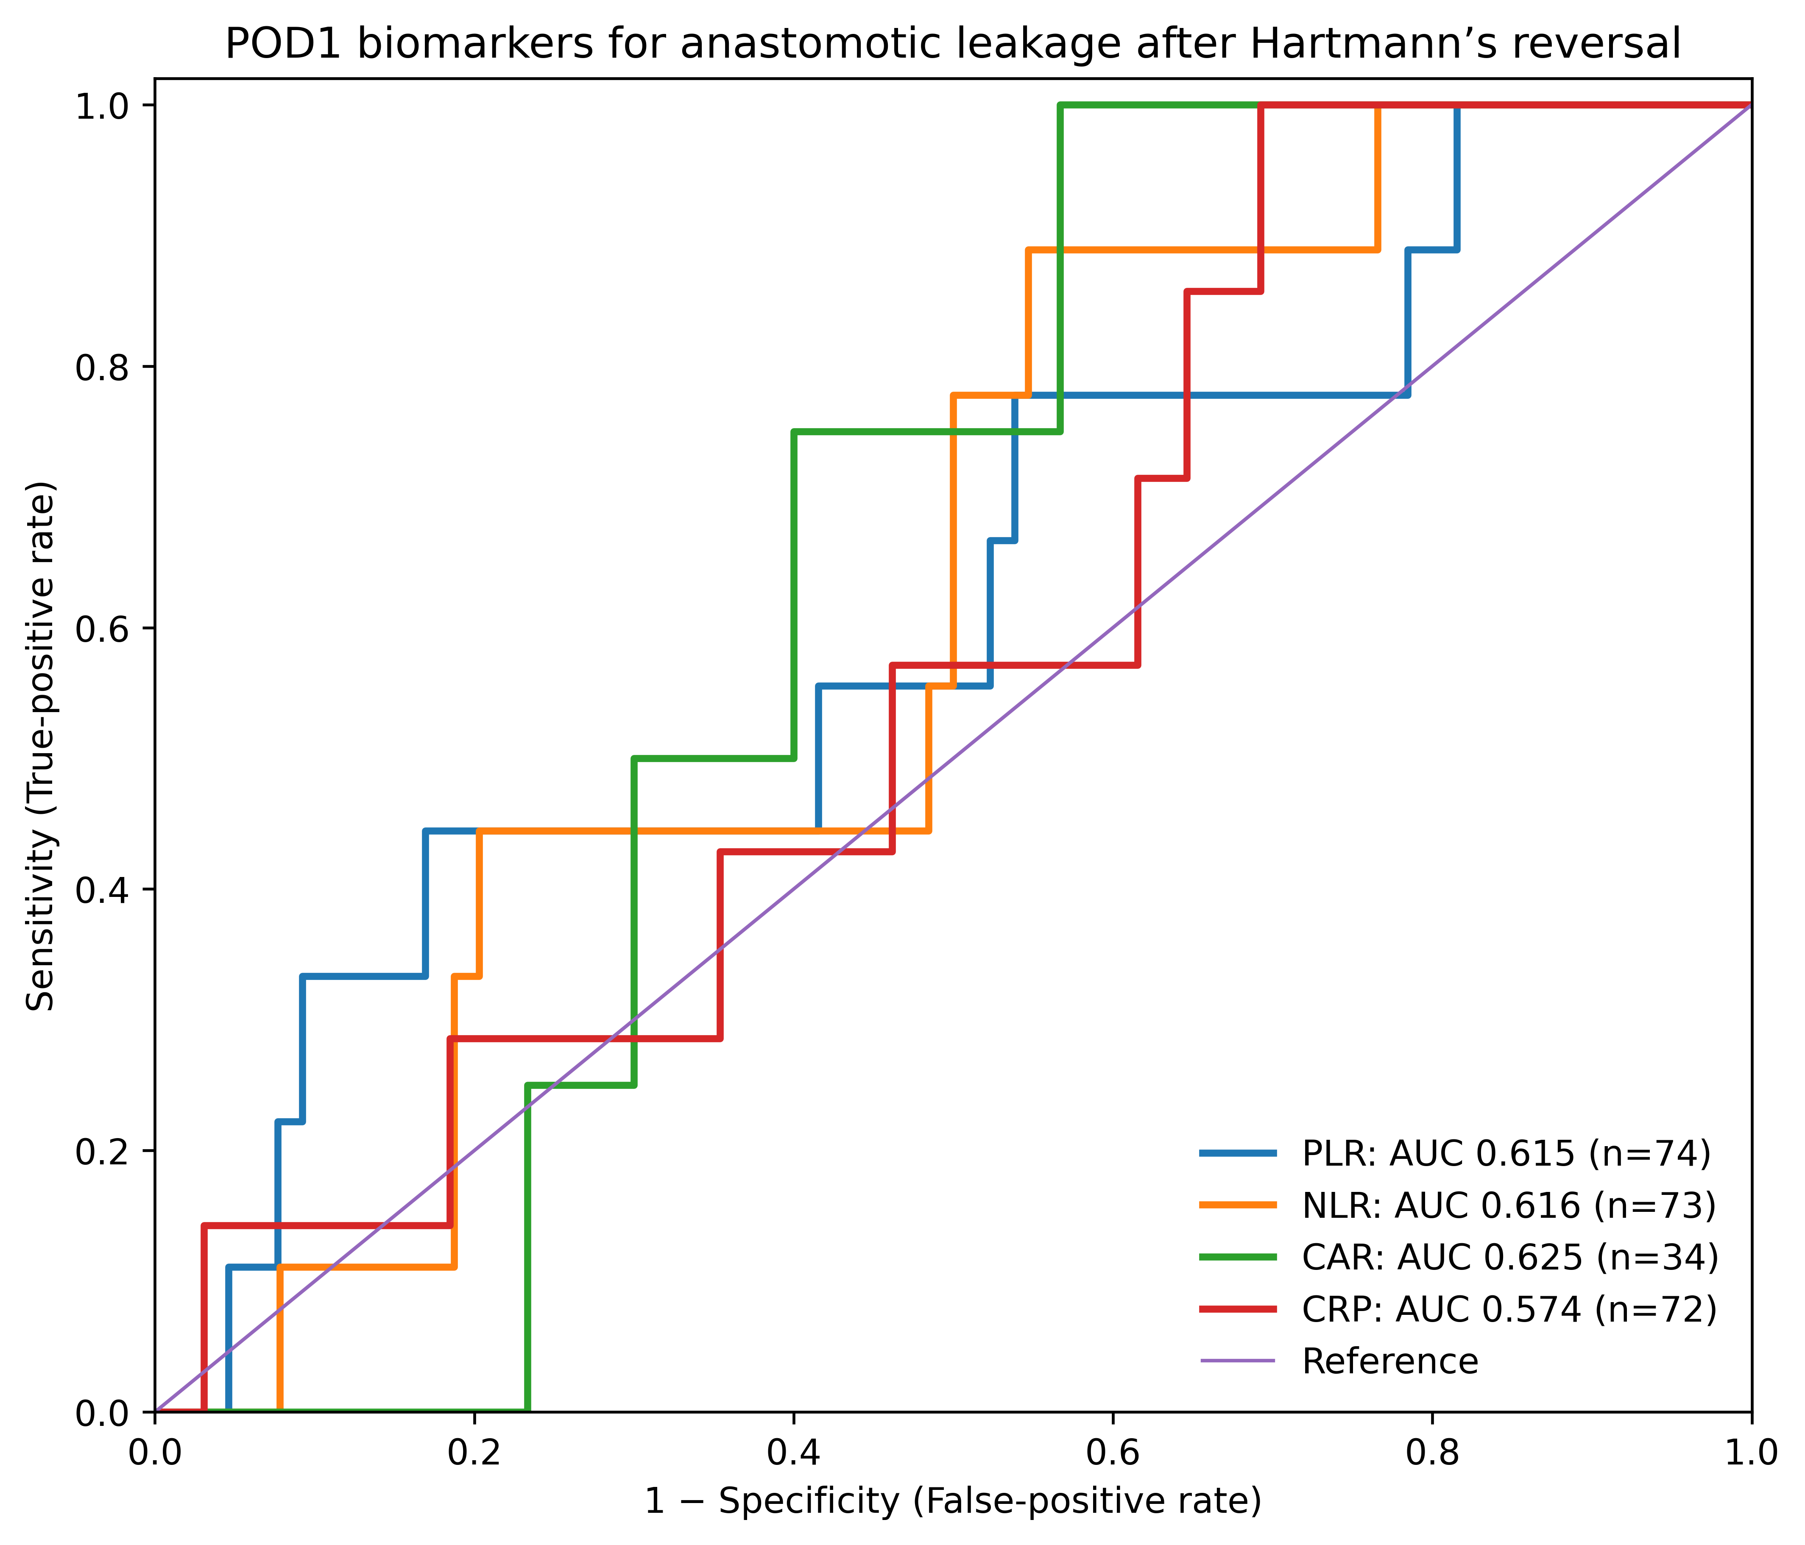

Supplementary Figure S2. Receiver operating characteristic curves of POD5 biomarkers for detection of anastomotic leakage after Hartmann’s reversal.

