Supplementary Information
Table of Contents
- Gut microbiota analyses
- Deviations from preregistration
- Fiber intake
  - Cohort differences
  - Fiber intake and SCFAs and SCFA-producing genera
  - Fiber intake and stress outcomes
- Correlation analyses between SCFA-producing genera and serum and fecal SCFAs
- SCFAs and stress outcomes
  - Fecal SCFAs and cortisol responses to the MAST
  - Fecal SCFAs and the cortisol awakening response
  - SCFAs and AUC outcomes
  - SCFAs and self-reported stress responses to the MAST
  - SCFAs and self-report questionnaires
- SCFA-producing genera and stress outcomes
  - SCFA-producing genera and cortisol responses to the MAST
  - SCFA-producing genera and the cortisol awakening response
  - SCFA-producing genera and self-reported stress responses to the MAST
  - SCFA-producing genera and self-report questionnaires
- Mood-related genera and stress outcomes
  - Mood-related genera and cortisol responses to the MAST
  - Mood-related genera and the cortisol awakening response
  - Mood-related genera and self-reported stress responses to the MAST
  - Mood-related genera and self-report questionnaires
- Microbiome ecosystem-level features and stress outcomes
  - Alpha diversity metrics and cortisol responses to the MAST
  - Alpha diversity metrics and the cortisol awakening response
  - Alpha diversity metrics and self-reported stress responses to the MAST
  - Alpha diversity metrics and self-report questionnaires
  - Principal coordinates analysis of gut microbiome composition
  - Enterotype and cortisol responses to the MAST
  - Enterotype and the cortisol awakening response
  - Enterotype and self-reported stress responses to the MAST
  - Enterotype and self-report questionnaires
- Correlation analyses between serum and fecal SCFAs

- Gut microbiota analyses
Gut microbiota composition was characterized by 16S ribosomal RNA (rRNA) gene amplicon sequencing, following the protocol outlined by Tito et al (1). Briefly, DNA was extracted from fecal samples and the V4 hypervariable region of the 16S rRNA gene was amplified using primers 515F (GTGYCAGCMGCCGCGGTAA) and 806R (GGACTACNVGGGTWTCTAAT). Dual-barcoded sequencing libraries were constructed by incorporating a sample-specific barcode between each primer and its corresponding Illumina adaptor sequence. Prior to sequencing, fragment size selection was carried out with Agencourt AMPure beads (Beckman Coulter, Indianapolis, USA) to exclude fragments shorter than 200 bp. Sequencing was performed on the Illumina MiSeq platform (Illumina, San Diego, USA) using the MiSeq Reagent Kit v2 (500 cycles, 2 × 250 paired-end reads, 15.38% PhiX spike-in).
Raw reads were demultiplexed using sdm within the LotuS pipeline, requiring exact barcode matches with no mismatches permitted. Subsequent sequence processing was performed with the DADA2 pipeline. During quality filtering, forward (R1) and reverse (R2) reads were trimmed to remove primer sequences along with the first 10 adjacent bases, yielding truncated read lengths of 200 bp and 130 bp, respectively. Chimeric sequences were identified and removed, paired reads were merged, and taxonomy was assigned against the RDP training set (rdp_train_set_16).
Enterotypes were assigned by merging the samples from this cohort with all samples from the Flemish Gut Flora Project (FGFP) (2) and clustering them into four community types using Dirichlet Multinomial Mixtures (3), as implemented in the DirichletMultinomial R package (1.40.0). Four clusters were used, consistent with the enterotype partition established in the FGFP reference cohort (4,5). Alpha diversity metrics (observed richness, Shannon index, Simpson index and Dominance) were computed with the microbiome R package (6). Microbial load was quantified using approximately 100 mg of frozen (−80°C) aliquots of non-homogenized fecal material, via flow cytometry, using a protocol adapted from previously published methods (7). Briefly, frozen aliquots (−80 °C) were weighed and brought to a total volume of 100 mL using 0.9% sodium chloride solution (NaCl; Baxter Healthcare SA, Deerfield, USA). After homogenization, the slurries were sequentially diluted at 1:100 and then 1:10 in the same NaCl solution. Next, 1 mL of the microbial cell suspension was stained with 1 μl of SYBR Green I (10,000 × concentrate; diluted 1:100 in dimethyl sulfoxide; Thermo Fisher Scientific, Waltham, USA). The samples were shaded for 20 min of incubation at 37 °C. The flow cytometry analysis was performed using a CytoFlex S (Beckman Coulter, Brea, USA). Fluorescence events were measured using fluorescence channels FITC 525/40 nm combining with Side Scatter Channel SSC-A. In addition, the CytExpert Software was used to gate and separate microbial fluorescence events from background events. Based on the exact weight of the aliquots analyzed, cell counts were converted to microbial loads per gram of fecal material.

Quantitative Microbiome Profiling (QMP) was performed as described by Vandeputte et al. (8) in R version 4.2.1. Briefly, per-genus 16S read counts were corrected for inter-genus differences in 16S rRNA gene copy number, and the corrected counts per sample were rarefied to a sampling depth scaled to the bacterial load of that sample, as measured by flow cytometry. A sample was retained for rarefaction only if its copy-number-corrected read count exceeded a minimum threshold, obtained by dividing a fixed raw-read threshold of 500 reads by the mean 16S rRNA gene copy number across all genera detected in the dataset. In this dataset, one read corresponded to approximately 1.05 × 10⁵ cells/g.
1. Tito RY, Verbandt S, Aguirre Vazquez M, Lahti L, Verspecht C, Lloréns-Rico V, et al. Microbiome confounders and quantitative profiling challenge predicted microbial targets in colorectal cancer development. Nat Med. 2024 May 1;30(5):1339–48. doi:10.1038/S41591-024-02963-2 PubMed PMID: 38689063.
2. Falony G, Joossens M, Vieira-Silva S, Wang J, Darzi Y, Faust K, et al. Population-level analysis of gut microbiome variation. Science. 2016 Apr 29;352(6285):560–4. doi:10.1126/SCIENCE.AAD3503 PubMed PMID: 27126039.
3. Holmes I, Harris K, Quince C. Dirichlet Multinomial Mixtures: Generative Models for Microbial Metagenomics. PLoS One. 2012 Feb 3;7(2):e30126. doi:10.1371/JOURNAL.PONE.0030126 PubMed PMID: 22319561.
4. Pauwels A, Devolder L, Falony G, D’haeseleer M, Nagels G, Van Remoortel A, et al. Deconfounded, quantitative microbiome profiling identifies robust multiple sclerosis markers and clinical covariate associations. Gut Microbes. 2026 Dec 31;18(1). doi:10.1080/19490976.2026.2681876 PubMed PMID: 42246374.
5. Falony G, Joossens M, Vieira-Silva S, Wang J, Darzi Y, Faust K, et al. Population-level analysis of gut microbiome variation. Science. 2016 Apr 29;352(6285):560–4. doi:10.1126/SCIENCE.AAD3503 PubMed PMID: 27126039.
6. Lahti L, Salonen A, Kekkonen RA, Salojärvi J, Jalanka-Tuovinen J, Palva A, et al. Associations between the human intestinal microbiota, Lactobacillus rhamnosus GG and serum lipids indicated by integrated analysis of high-throughput profiling data. PeerJ. 2013;2013(1). doi:10.7717/PEERJ.32 PubMed PMID: 23638368.
7. Vieira-Silva S, Sabino J, Valles-Colomer M, Falony G, Kathagen G, Caenepeel C, et al. Quantitative microbiome profiling disentangles inflammation- and bile duct obstruction-associated microbiota alterations across PSC/IBD diagnoses. Nature Microbiology 2019 4:11. 2019 Jun 17;4(11):1826–31. doi:10.1038/s41564-019-0483-9 PubMed PMID: 31209308.
8. Vandeputte D, Kathagen G, D’Hoe K, Vieira-Silva S, Valles-Colomer M, Sabino J, et al. Quantitative microbiome profiling links gut community variation to microbial load. Nature. 2017 Nov 23;551(7681):507–11. doi:10.1038/NATURE24460;TECHMETA PubMed PMID: 29143816.

- Deviations from preregistration
In our preregistration, we specified that all analyses would be controlled for fiber intake. As reported in the below section, however, fiber intake was not significantly associated with outcomes, except for a timepoint interaction effect for the CAR and AUC_{I} of the CAR. However, these analyses are not corrected for multiple testing and sensitivity analyses including fiber intake as a covariate yielded near identical results, thus the more parsimonious models are presented. Together, this suggests that the observed associations are unlikely to be explained solely by upstream dietary fiber intake and may instead reflect interindividual differences in microbial metabolic activity or host processing of microbial-derived metabolites. The fiber-related interaction should therefore be interpreted with caution, as it was not central to the study hypotheses and did not meaningfully influence the primary associations of interest.
Some of the preregistered genera were not sufficiently detectable in our population and were therefore not included in the analysis. These include: Anaerobutyricum, Eubacterium, Subdoligranulum, Butyrivibrio, Enterococcus, Lachnoclostridium, Sellimonas and Hungatella.

3. Fiber intake
3.1. Cohort differences
Fiber intake was recorded for three days prior to the study visit. Participants in cohort A and C were instructed to adhere to the consumption of a low-fiber diet, while participants in cohort B were given the instructions to adhere to a maximum of 25 grams of fiber/day. Examination of the actual fiber intake, which was averaged over the three days per participant, revealed that the fiber intake was significantly different between cohorts (F(2,215) = 28.20, p < .0001), with post-hoc tests showing significant differences between cohort A (M = 12.09, SD = 5.05) and C (M = 13.78, SD = 7.05; p < 0.001) and between B (M = 7.51, SD = 2.40) and C (p <0.001). Fiber intake was standardized within cohort to account for differences in instructions.
3.2. Fiber intake and SCFAs and SCFA producing-genera
Table S1. Pearson’s correlations between fiber intake and SCFAs.
 | Pearson’s r | p | p_{Holm}
Serum acetate | 0.09 | 0.21 | 1.00
Serum butyrate | 0.08 | 0.24 | 1.00
Serum propionate | 0.14 | 0.041 | 0.25
Total serum SCFAs | 0.15 | 0.029 | NA
Fecal acetate | 0.07 | 0.32 | 1.00
Fecal butyrate | -0.02 | 0.82 | 1.00
Fecal propionate | -0.04 | 0.55 | 1.00
Total fecal SCFAs | 0.004 | 0.95 | NA

Table S2. Pearson’s correlations between fiber intake and SCFA-producing genera.
 | Pearson’s r | p | p_{FDR}
Akkermansia | 0.08 | 0.23 | 0.31
Alistipes | -0.13 | 0.06 | 0.13
Bacteroides | -0.17 | 0.011 | 0.09
Prevotella | 0.13 | 0.06 | 0.13
Propionate-producer composite score | -0.03 | 0.62 | NA
Anaerostipes | 0.08 | 0.23 | 0.31
Coprococcus | 0.02 | 0.79 | 0.79
Faecalibacterium | -0.06 | 0.37 | 0.42
Roseburia | -0.14 | 0.043 | 0.12
Butyrate-producer composite score | -0.04 | 0.61 | NA

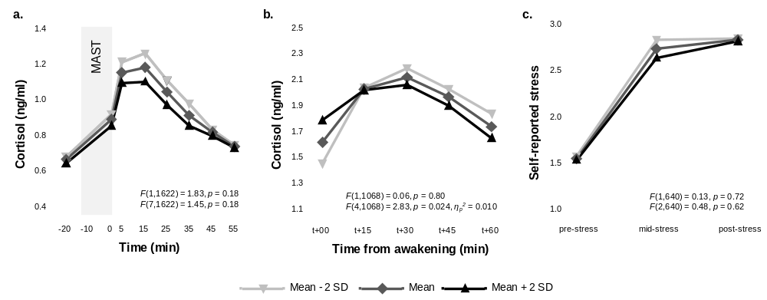
3.3. Fiber intake and stress outcomes

Figure S1. Estimates of cortisol and stressfulness ratings are plotted at different levels of fiber intake (mean and 2 standard deviations below and above the mean) for responses to the MAST (a and c) and the awakening response (b) respectively. Nominal and adjusted p values shown within each graph correspond to the main effect (top) and the interaction effect (bottom).

Table S3. Fixed-effect estimates from a linear mixed-effects model assessing the associations between dietary fiber and MAST AUC_{G}, MAST AUC_{I} (F(1,201)), CAR AUC_{G} and CAR AUC_{I} (F(1,212)) including a random cohort effect.
 | F | Estimate ± SE | p | ƞ_{p}²
MAST AUC_{G} | 2.45 | -0.30 ± 0.19 | 0.12
MAST AUC_{I} | 0.47 | -0.44 ± 0.63 | 0.49
CAR AUC_{G} | 0.53 | -0.11 ± 0.16 | 0.47
CAR AUC_{I} | 5.02 | -6.21 ± 2.77 | 0.026 | 0.023

Table S4. Fixed-effect estimates from a linear mixed-effects model assessing the associations between dietary fiber and PSS and PANAS scores (F(1,212)) including a random cohort effect.
 | F | Estimate ± SE | p
PSS | 0.43 | -0.07 ± 0.11 | 0.51
Positive affect | 0.84 | 1.04 ± 5.19 | 0.84
Negative affect | 0.49 | -0.001 ± 0.002 | 0.49

4. Correlation analyses between SCFA-producing genera and serum and fecal SCFAs
Table S5. Partial Pearson correlation coefficients assessing the associations between butyrate- and propionate-producing genera and their corresponding serum and fecal metabolites.
 |  | Pearson's r | p | p_{Holm} |  | Pearson's r | p | p_{Holm}
Serum propionate |  |  |  |  | Fecal propionate
 | Akkermansia | -0.05 | 0.49 | 0.49 |  | -0.26 | <0.001 | <0.001
 | Alistipes | -0.13 | 0.052 | 0.21 |  | -0.14 | 0.046 | 0.09
 | Bacteroides | -0.12 | 0.09 | 0.26 |  | -0.05 | 0.45 | 0.45
 | Prevotella | 0.11 | 0.12 | 0.26 |  | 0.25 | <0.001 | <0.001
 | Propionate-producer composite score | -0.09 | 0.19 | NA |  | -0.09 | 0.011 | NA
Serum butyrate |  |  |  |  | Fecal butyrate
 | Anaerostipes | 0.08 | 0.27 |  |  | 0.03 | 0.67 | 1.00
 | Coprococcus | 0.11 | 0.09 |  |  | 0.02 | 0.74 | 1.00
 | Faecalibacterium | 0.06 | 0.40 |  |  | 0.13 | 0.07 | 0.21
 | Roseburia | 0.10 | 0.17 |  |  | 0.16 | 0.017 | 0.07
 | Butyrate-producer composite score | 0.12 | 0.07 |  |  | 0.13 | 0.07 | NA
Note. Analyses were adjusted for fiber intake, and additionally for fecal moisture content in models of fecal metabolites. Holm–Bonferroni correction was applied separately within each domain. Sensitivity analyses with additional adjusting for age and BMI revealed similar results.

5. SCFAs and stress outcomes
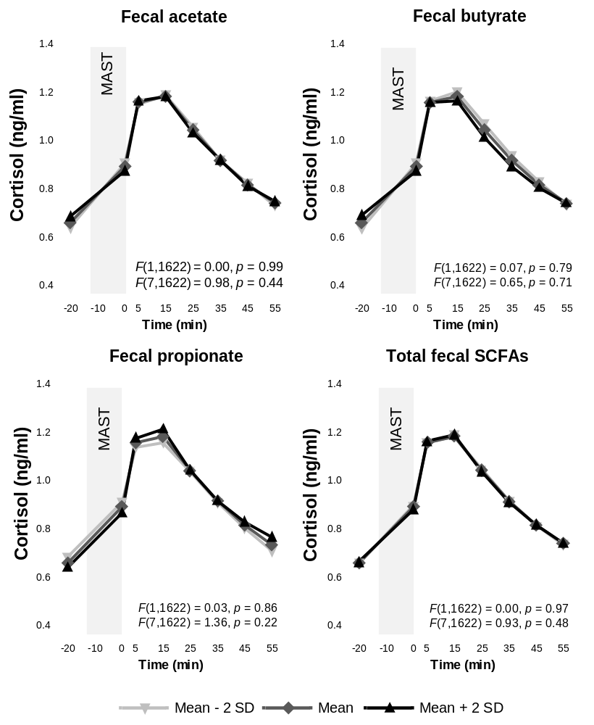
5.1. Fecal SCFAs and cortisol responses to the MAST

Figure S2. Estimates of cortisol are plotted at different levels of fecal SCFA concentrations (mean and 2 standard deviations below and above the mean) for responses to the MAST. Nominal and adjusted p values shown within each graph correspond to the main effect (top) and the interaction effect (bottom). None of the fecal SCFAs were significantly associated with cortisol responses to the MAST.

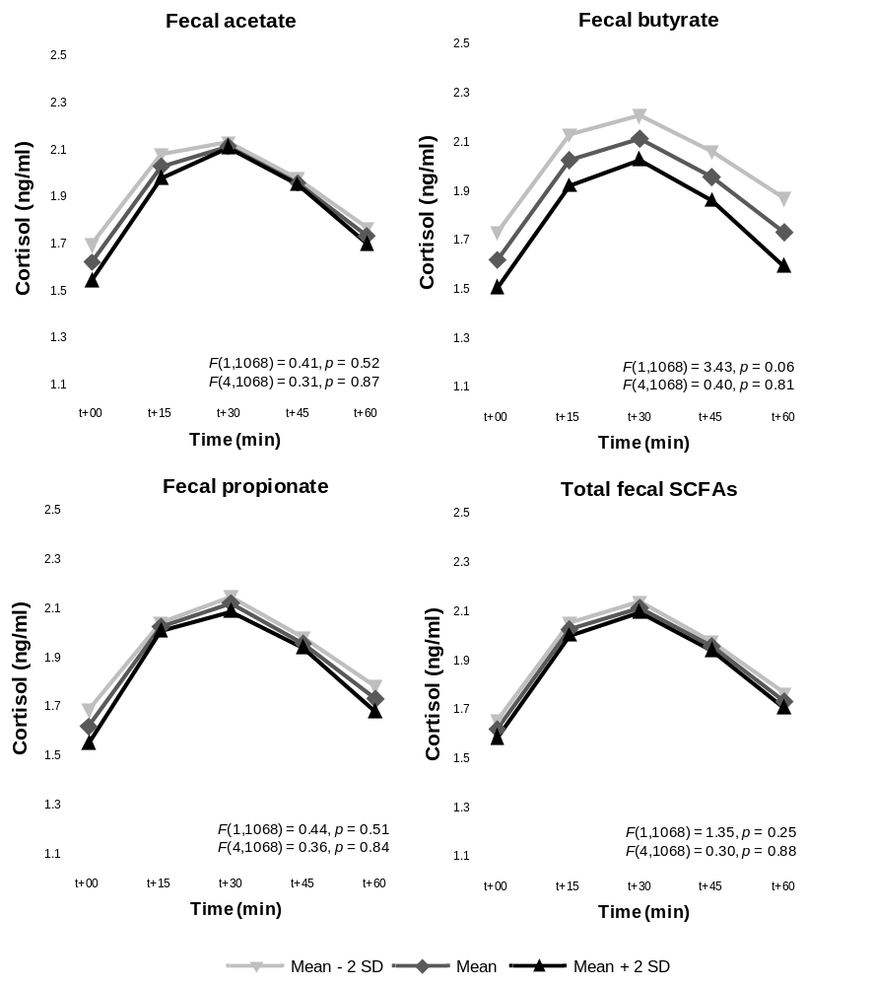
5.2. Fecal SCFAs and the cortisol awakening response

Figure S3. Estimates of cortisol at awakening are plotted at different levels of fecal SCFA concentrations (mean and 2 standard deviations below and above the mean). Nominal and adjusted p values shown within each graph correspond to the main effect (top) and the interaction effect (bottom). None of the fecal SCFAs were significantly associated with the cortisol awakening response.

5.3. SCFAs and AUC outcomes
Table S6. Fixed-effect estimates from a linear mixed-effects model assessing the associations between SCFAs and MAST AUC_{G}, MAST AUC_{I} (F(1,201)), CAR AUC_{G} and CAR AUC_{I} (F(1,212)) including a random cohort effect.
 |  | F | Estimate ± SE | p | p_{Holm} | ƞ_{p}²
MAST AUC_{G}
 | Serum acetate | 0.84 | -0.18 ± 0.20 | 0.36 | 0.36
 | Serum butyrate | 0.86 | -0.18 ± 0.20 | 0.35 | 0.36
 | Serum propionate | 8.99 | -0.56 ± 0.19 | 0.003 | 0.009 | 0.043
 | Total serum SCFAs | 5.42 | -0.21 ± 0.09 | 0.021 | NA | 0.026
 | Fecal acetate | 0.00 | -0.008 ± 0.19 | 0.97
 | Fecal butyrate | 0.15 | -0.07 ± 0.19 | 0.70
 | Fecal propionate | 0.17 | 0.08 ± 0.19 | 0.68
 | Total fecal SCFAs | 0.00 | -0.0006 ± 0.07 | 0.99
MAST AUC_{I}
 | Serum acetate | 0.41 | 0.42 ± 0.65 | 0.52
 | Serum butyrate | 0.05 | -0.14 ± 0.64 | 0.83
 | Serum propionate | 0.71 | -0.53 ± 0.63 | 0.40
 | Total serum SCFAs | 0.04 | -0.06 ± 0.31 | 0.83
 | Fecal acetate | 0.35 | -0.38 ± 0.64 | 0.56
 | Fecal butyrate | 0.45 | -0.42 ± 0.63 | 0.50
 | Fecal propionate | 0.20 | 0.29 ± 0.64 | 0.65
 | Total fecal SCFAs | 0.09 | -0.07 ± 0.23 | 0.77
CAR AUC_{G}
 | Serum acetate | 0.73 | -0.13 ± 0.16 | 0.39 | 0.39
 | Serum butyrate | 3.42 | -0.29 ± 0.16 | 0.07 | 0.10
 | Serum propionate | 11.98 | -0.53 ± 0.15 | 0.001 | 0.002 | 0.054
 | Total serum SCFAs | 9.06 | -0.23 ± 0.08 | 0.003 | NA | 0.041
 | Fecal acetate | 0.23 | -0.08 ± 0.16 | 0.63
 | Fecal butyrate | 2.76 | -0.26 ± 0.16 | 0.10
 | Fecal propionate | 0.30 | -0.09 ± 0.16 | 0.58
 | Total fecal SCFAs | 0.97 | -0.06 ± 0.06 | 0.33
CAR AUC_{I}
 | Serum acetate | 0.19 | -1.23 ± 2.80 | 0.66
 | Serum butyrate | 0.92 | -2.68 ± 2.80 | 0.34
 | Serum propionate | 0.78 | -2.47 ± 2.80 | 0.38
 | Total serum SCFAs | 1.24 | -1.51 ± 1.36 | 0.27
 | Fecal acetate | 0.41 | 1.80 ± 2.80 | 0.52
 | Fecal butyrate | 0.10 | -0.90 ± 2.80 | 0.75
 | Fecal propionate | 0.20 | 1.25 ± 2.80 | 0.66
 | Total fecal SCFAs | 0.08 | 0.29 ± 1.03 | 0.78

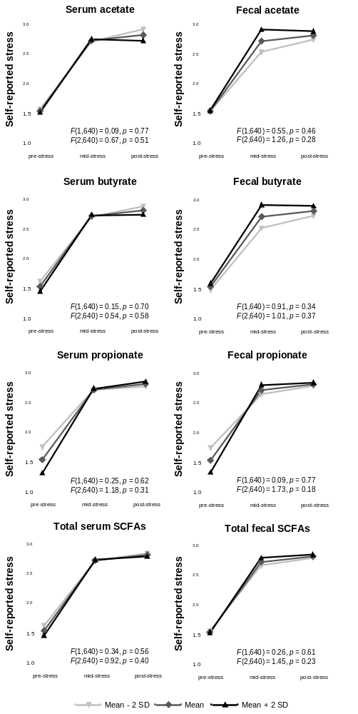
5.4. SCFAs and self-reported stress responses to the MAST
Figure S4. Estimates of stressfulness ratings in response to acute stress are plotted at different levels of SCFA concentrations (mean and 2 standard deviations below and above the mean), representing lowest to highest SCFAs levels. Nominal and adjusted p values shown within each graph correspond to the main effect (top) and the interaction effect (bottom). None of the SCFAs were significantly associated with self-reported stress responses to the MAST.
5.5. SCFAs and self-report questionnaires
Table S7. Fixed-effect estimates from a linear mixed-effects model assessing the associations between SCFAs and PSS and PANAS scores (F(1,212)) including a random cohort effect.
 |  | F | Estimate ± SE | p
PSS
 | Serum acetate | 3.77 | -0.20 ± 0.10 | 0.05
 | Serum butyrate | 0.05 | -0.02 ± 0.10 | 0.83
 | Serum propionate | 0.02 | -0.01 ± 0.10 | 0.90
 | Total serum SCFAs | 1.22 | -0.05 ± 0.052 | 0.27
 | Fecal acetate | 0.14 | -0.04 ± 0.10 | 0.71
 | Fecal butyrate | 0.24 | -0.05 ± 0.10 | 0.63
 | Fecal propionate | 0.75 | -0.09 ± 0.10 | 0.39
 | Total fecal SCFAs | 0.40 | -0.02 ± 0.03 | 0.53
Positive affect
 | Serum acetate | 1.40 | 6.11 ± 5.17 | 0.24
 | Serum butyrate | 2.14 | 7.55 ± 5.16 | 0.15
 | Serum propionate | 0.06 | 1.30 ± 5.19 | 0.80
 | Total serum SCFAs | 1.99 | 3.55 ± 2.51 | 0.16
 | Fecal acetate | 0.12 | 1.80 ± 5.19 | 0.73
 | Fecal butyrate | 0.63 | 4.12 ± 5.19 | 0.43
 | Fecal propionate | 1.48 | 6.29 ± 5.17 | 0.23
 | Total fecal SCFAs | 0.75 | 1.64± 1.90 | 0.39
Negative affect
 | Serum acetate | 0.79 | 0.001 ± 0.001 | 0.38
 | Serum butyrate | 0.80 | 0.001± 0.001 | 0.37
 | Serum propionate | 0.59 | -0.001 ± 0.001 | 0.44
 | Total serum SCFAs | 0.24 | 0.0004 ± 0.0009 | 0.62
 | Fecal acetate | 0.15 | 0.0007 ± 0.001 | 0.70
 | Fecal butyrate | 1.39 | 0.002 ± 0.001 | 0.24
 | Fecal propionate | 1.28 | -0.002 ± 0.001 | 0.26
 | Total fecal SCFAs | 0.02 | 0.0001 ± 0.0007 | 0.87

6. SCFA-producing genera and stress outcomes
6.1. SCFA-producing genera and cortisol responses to the MAST
Table S8. Fixed-effect estimates from a linear mixed-effects model assessing the associations between SCFA-producing genera and cortisol responses to the MAST (main effect: F(1,1606), interaction effect: F(7,1606)) including a random cohort effect.
 | Type | F | Estimate ± SE | p | p_{FDR} | ƞ_{p}²
Akkermansia | Binary | 1.46 | 0.05 ± 0.03 | 0.23 | 0.75
Akkermansia × timepoint |  | 1.30 | 0.06 ± 0.04 | 0.25 | 0.75
Alistipes | Continuous | 5.38 | 0.03 ± 0.019 | 0.021 | 0.25 | 0.003
Alistipes × timepoint |  | 1.08 | -0.02 ± 0.02 | 0.38 | 0.75
Bacteroides | Continuous | 0.03 | 0.002 ± 0.01 | 0.85 | 0.98
Bacteroides × timepoint |  | 1.22 | 0.002 ± 0.02 | 0.29 | 0.75
Prevotella | Binary | 0.30 | -0.04 ± 0.04 | 0.59 | 0.94
Prevotella × timepoint |  | 2.21 | 0.10 ± 0.04 | 0.031 | 0.25 | 0.010
Propionate-producer composite score |  | 4.85 | 0.02 ± 0.009 | 0.028 | NA | 0.003
Propionate-producer composite score × timepoint |  | 1.78 | -0.02 ± 0.01 | 0.09 | NA
Anaerostipes | Continuous | 0.07 | 0.01 ± 0.01 | 0.79 | 0.98
Anaerostipes × timepoint |  | 1.15 | -0.03 ± 0.02 | 0.33 | 0.75
Coprococcus | Continuous | 0.59 | -0.003 ± 0.01 | 0.44 | 0.79
Coprococcus × timepoint |  | 0.22 | -0.01 ± 0.02 | 0.98 | 0.98
Faecalibacterium | Continuous | 0.00 | 0.003 ± 0.01 | 0.98 | 0.98
Faecalibacterium × timepoint |  | 0.60 | -0.01 ± 0.021 | 0.76 | 0.98
Roseburia | Continuous | 2.00 | -0.03 ± 0.01 | 0.16 | 0.75
Roseburia × timepoint |  | 0.69 | 0.01 ± 0.02 | 0.68 | 0.98
Butyrate-producer composite score |  | 0.44 | -0.003 ± 0.006 | 0.51 | NA
Butyrate-producer composite score × timepoint |  | 0.13 | -0.005 ± 0.007 | 0.99 | NA

Table S9. Fixed-effect estimates from a linear mixed-effects model assessing the associations between SCFA-producing genera and MAST AUC_{G} and MAST AUC_{I} (F(1,199)) including a random cohort effect.
 |  | Type | F | Estimate ± SE | p | p_{FDR} | ƞ_{p}²
MAST AUC_{G}
 | Akkermansia | Binary | 1.25 | 0.43 ± 0.39 | 0.27 | 0.71
 | Alistipes | Continuous | 2.08 | 0.40 ± 0.19 | 0.039 | 0.31 | 0.021
 | Bacteroides | Continuous | 0.01 | 0.019 ± 0.19 | 0.92 | 0.92
 | Prevotella | Binary | 0.49 | 0.27 ± 0.39 | 0.48 | 0.77
 | Propionate-producer composite score |  | 4.45 | 0.19 ± 0.09 | 0.036 | NA | 0.022
 | Anaerostipes | Continuous | 0.14 | 0.07 ± 0.19 | 0.70 | 0.89
 | Coprococcus | Continuous | 0.50 | -0.13 ± 0.19 | 0.48 | 0.77
 | Faecalibacterium | Continuous | 0.08 | -0.05 ± 0.19 | 0.78 | 0.89
 | Roseburia | Continuous | 1.43 | -0.22 ± 0.19 | 0.23 | 0.71
 | Butyrate-producer composite score |  | 0.41 | -0.04 ± 0.06 | 0.52 | NA
MAST AUC_{I}
 | Akkermansia | Binary | 2.48 | 2.01 ± 1.28 | 0.12 | 0.23
 | Alistipes | Continuous | 3.93 | 1.27 ± 0.64 | 0.049 | 0.20 | 0.019
 | Bacteroides | Continuous | 0.01 | -0.07 ± 0.63 | 0.91 | 0.91
 | Prevotella | Binary | 3.21 | 2.32 ± 1.29 | 0.07 | 0.20
 | Propionate-producer composite score |  | 8.01 | 0.84 ± 0.29 | 0.005 | NA | 0.038
 | Anaerostipes | Continuous | 3.39 | 1.14 ± 0.62 | 0.07 | 0.20
 | Coprococcus | Continuous | 0.33 | 0.36 ± 0.62 | 0.57 | 0.75
 | Faecalibacterium | Continuous | 0.43 | 0.41 ± 0.62 | 0.51 | 0.75
 | Roseburia | Continuous | 0.03 | -0.10 ± 0.62 | 0.87 | 0.91
 | Butyrate-producer composite score |  | 1.07 | 0.23 ± 0.22 | 0.30 | NA

6.2. SCFA-producing genera and the cortisol awakening response
Table S10. Fixed-effect estimates from a linear mixed-effects model assessing the associations between SCFA-producing genera and the cortisol awakening response (main effect: F(1,1058), interaction effect: (F(4,1058)) including a random cohort effect.
 | Type | F | Estimate ± SE | p
Akkermansia | Binary | 0.00 | -0.01 ± 0.07 | 0.99
Akkermansia × timepoint |  | 0.42 | -0.01 ± 0.09 | 0.79
Alistipes | Continuous | 0.36 | -0.006 ± 0.03 | 0.55
Alistipes × timepoint |  | 1.21 | 0.05 ± 0.04 | 0.30
Bacteroides | Continuous | 1.08 | 0.02 ± 0.03 | 0.30
Bacteroides × timepoint |  | 0.73 | 0.02 ± 0.04 | 0.57
Prevotella | Binary | 1.68 | 0.06 ± 0.07 | 0.20
Prevotella × timepoint |  | 1.10 | -0.01 ± 0.09 | 0.35
Propionate-producer composite score |  | 0.09 | -0.001 ± 0.01 | 0.76
Propionate-producer composite score × timepoint |  | 0.71 | 0.01 ± 0.02 | 0.59
Anaerostipes | Continuous | 0.34 | -0.01 ± 0.03 | 0.56
Anaerostipes × timepoint |  | 1.04 | 0.01 ± 0.04 | 0.38
Coprococcus | Continuous | 0.07 | -0.005 ± 0.03 | 0.79
Coprococcus × timepoint |  | 1.88 | 0.04 ± 0.04 | 0.11
Faecalibacterium | Continuous | 0.06 | -0.02 ± 0.03 | 0.81
Faecalibacterium × timepoint |  | 0.74 | 0.06 ± 0.04 | 0.57
Roseburia | Continuous | 0.30 | 0.008 ± 0.03 | 0.58
Roseburia × timepoint |  | 0.65 | -0.03 ± 0.04 | 0.63
Butyrate-producer composite score |  | 0.15 | -0.005 ± 0.012 | 0.69
Butyrate-producer composite score × timepoint |  | 0.89 | 0.01 ± 0.01 | 0.47

Table S11. Fixed-effect estimates from a linear mixed-effects model assessing the associations between SCFA-producing genera and CAR AUC_{G} and CAR AUC_{I} (F(1,210)) including a random cohort effect.
 |  | Type | F | Estimate ± SE | p
CAR AUC_{G}
 | Akkermansia | Binary | 0.05 | -0.06 ± 0.32 | 0.83
 | Alistipes | Continuous | 0.13 | 0.05 ± 0.15 | 0.72
 | Bacteroides | Continuous | 0.67 | 0.12 ± 0.15 | 0.41
 | Prevotella | Binary | 1.99 | -0.46 ± 0.32 | 0.16
 | Propionate-producer composite score |  | 0.00 | -0.002 ± 0.07 | 0.97
 | Anaerostipes | Continuous | 0.78 | -0.14 ± 0.15 | 0.38
 | Coprococcus | Continuous | 0.00 | 0.01 ± 0.15 | 0.95
 | Faecalibacterium | Continuous | 0.28 | -0.08 ± 0.15 | 0.60
 | Roseburia | Continuous | 0.44 | -0.10 ± 0.15 | 0.51
 | Butyrate-producer composite score |  | 0.51 | -0.04 ± 0.05 | 0.48
CAR AUC_{I}
 | Akkermansia | Binary | 0.00 | 0.26 ± 5.70 | 0.96
 | Alistipes | Continuous | 1.32 | -3.20 ± 2.79 | 0.25
 | Bacteroides | Continuous | 0.06 | -0.71 ± 2.80 | 0.80
 | Prevotella | Binary | 0.42 | -3.75 ± 5.78 | 0.52
 | Propionate-producer composite score |  | 0.72 | -1.13 ± 1.34 | 040
 | Anaerostipes | Continuous | 0.74 | -2.41 ± 2.80 | 0.39
 | Coprococcus | Continuous | 1.10 | -2.93 ± 2.79 | 0.30
 | Faecalibacterium | Continuous | 2.32 | -4.25 ± 2.79 | 0.13
 | Roseburia | Continuous | 0.79 | -2.50 ± 2.81 | 0.37
 | Butyrate-producer composite score |  | 2.38 | -1.53 ± 0.99 | 0.12

6.3. SCFA-producing genera and self-reported stress responses to the MAST
Table S12. Fixed-effect estimates from a linear mixed-effects model assessing the associations between SCFA-producing genera and self-reported stress responses to the MAST (main effect: F(1,634), interaction effect: F(2,634)) including a random cohort effect.
 | Type | F | Estimate ± SE | p | p_{FDR} | ƞ_{p}²
Akkermansia | Binary | 3.14 | 0.23 ± 0.15 | 0.08 | 0.41
Akkermansia × timepoint |  | 0.40 | -0.10 ± 0.17 | 0.67 | 0.89
Alistipes | Continuous | 0.82 | -0.05 ± 0.07 | 0.37 | 0.83
Alistipes × timepoint |  | 4.52 | 0.20 ± 0.08 | 0.011 | 0.09 | 0.014
Bacteroides | Continuous | 0.03 | -0.05 ± 0.07 | 0.86 | 0.93
Bacteroides × timepoint |  | 1.83 | 0.10 ± 0.08 | 0.16 | 0.52
Prevotella | Binary | 1.57 | -0.23 ± 0.15 | 0.21 | 0.56
Prevotella × timepoint |  | 0.73 | 0.21 ± 0.18 | 0.48 | 0.89
Propionate-producer composite score |  | 0.03 | -0.02 ± 0.03 | 0.85 | NA
Propionate-producer composite score × timepoint |  | 1.50 | 0.05 ± 0.04 | 0.22 | NA
Anaerostipes | Continuous | 0.32 | -0.03 ± 0.07 | 0.57 | 0.89
Anaerostipes × timepoint |  | 0.58 | -0.03 ± 0.08 | 0.56 | 0.89
Coprococcus | Continuous | 0.01 | -0.12 ± 0.07 | 0.91 | 0.93
Coprococcus × timepoint |  | 4.77 | 0.23 ± 0.08 | 0.009 | 0.09 | 0.015
Faecalibacterium | Continuous | 0.19 | -0.04 ± 0.07 | 0.66 | 0.89
Faecalibacterium × timepoint |  | 1.92 | 0.11 ± 0.08 | 0.15 | 0.89
Roseburia | Continuous | 0.01 | 0.01 ± 0.07 | 0.93 | 0.93
Roseburia × timepoint |  | 0.24 | -0.04 ± 0.08 | 0.79 | 0.93
Butyrate-producer composite score |  | 0.00 | -0.02 ± 0.02 | 0.98 | NA
Butyrate-producer composite score × timepoint |  | 1.82 | 0.03 ± 0.03 | 0.16 | NA

6.4. SCFA-producing genera and self-report questionnaires
Table S13. Fixed-effect estimates from a linear mixed-effects model assessing the associations between SCFA-producing genera and PSS and PANAS scores (F(1,212)) including a random cohort effect.
 |  | Type | F | Estimate ± SE | p | p_{FDR} | ƞ_{p}²
PSS
 | Alistipes | Continuous | 0.15 | 0.04 ± 0.10 | 0.70
 | Akkermansia | Binary | 0.16 | -0.08 ± 0.22 | 0.69
 | Bacteroides | Continuous | 0.14 | 0.04 ± 0.10 | 0.70
 | Prevotella | Binary | 0.29 | -0.12 ± 0.22 | 0.59
 | Propionate-producer composite score |  | 0.26 | 0.02 ± 0.05 | 0.61
 | Anaerostipes | Continuous | 0.02 | 0.01 ± 0.10 | 0.88
 | Coprococcus | Continuous | 0.56 | -0.08 ± 0.10 | 0.45
 | Faecalibacterium | Continuous | 2.49 | 0.17 ± 0.10 | 0.12
 | Roseburia | Continuous | 0.06 | -0.02 ± 0.10 | 0.80
 | Butyrate-producer composite score |  | 0.07 | 0.01 ± 0.03 | 0.80
Positive affect
 | Alistipes | Continuous | 0.49 | -3.63 ± 5.17 | 0.48
 | Akkermansia | Binary | 0.83 | 9.59 ± 10.53 | 0.36
 | Bacteroides | Continuous | 0.18 | -2.17 ± 5.19 | 0.68
 | Prevotella | Binary | 0.04 | 2.08 ± 10.70 | 0.85
 | Propionate-producer composite score |  | 0.00 | -0.02 ± 2.48 | 0.99
 | Anaerostipes | Continuous | 0.01 | -0.38 ± 5.19 | 0.94
 | Coprococcus | Continuous | 0.31 | -2.85 ± 5.17 | 0.58
 | Faecalibacterium | Continuous | 0.11 | -1.75 ± 5.19 | 0.74
 | Roseburia | Continuous | 0.61 | 4.06 ± 5.20 | 0.44
 | Butyrate-producer composite score |  | 0.00 | -0.12 ± 1.84 | 0.95
Negative affect
 | Alistipes | Continuous | 2.63 | 0.003 ± 0.001 | 0.11 | 0.33
 | Akkermansia | Binary | 0.04 | -0.0007 ± 0.004 | 0.84 | 0.89
 | Bacteroides | Continuous | 1.11 | 0.002 ± 0.001 | 0.29 | 0.47
 | Prevotella | Binary | 0.02 | -0.0005 ± 0.004 | 0.89 | 0.89
 | Propionate-producer composite score |  | 1.03 | 0.0009 ± 0.0009 | 0.31 | NA
 | Anaerostipes | Continuous | 1.96 | 0.002 ± 0.001 | 0.16 | 0.33
 | Coprococcus | Continuous | 2.24 | 0.002 ± 0.001 | 0.14 | 0.33
 | Faecalibacterium | Continuous | 9.16 | 0.005 ± 0.001 | 0.003 | 0.022 | 0.042
 | Roseburia | Continuous | 0.43 | -0.001 ± 0.001 | 0.51 | 0.69
 | Butyrate-producer composite score |  | 3.45 | 0.001 ± 0.0006 | 0.07 | NA

7. Mood-related genera and stress outcomes
7.1. Mood-related genera and cortisol responses to the MAST
Table S14. Fixed-effect estimates from a linear mixed-effects model assessing the associations between mood-related genera and cortisol responses to the MAST (main effect: F(1,1606), interaction effect: F(7,1606)) including a random cohort effect.
 | Type | F | Estimate ± SE | p | p_{FDR} | ƞ_{p}²
Anaerotruncus | Binary | 0.25 | 0.02 ± 0.04 | 0.62 | 0.92
Anaerotruncus × timepoint |  | 0.64 | - | 0.72 | 0.92
Bifidobacterium | Continuous | 1.31 | -0.01± 0.01 | 0.25 | 0.92
Bifidobacterium × timepoint |  | 0.54 | - | 0.80 | 0.92
Butyricicoccus | Continuous | 0.03 | -0.01 ± 0.01 | 0.86 | 0.92
Butyricicoccus × timepoint |  | 0.51 | - | 0.83 | 0.92
Clostridium III | Binary | 3.83 | 0.10 ± 0.04 | 0.05 | 0.73
Clostridium III × timepoint |  | 0.82 | - | 0.57 | 0.92
Clostridium IV | Continuous | 0.87 | 0.01 ± 0.01 | 0.35 | 0.92
Clostridium IV × timepoint |  | 0.69 | - | 0.68 | 0.92
Clostridium XVIII | Continuous | 2.01 | -0.01 ± 0.01 | 0.16 | 0.92
Clostridium XVIII × timepoint |  | 0.68 | - | 0.69 | 0.92
Clostridium XIVa | Continuous | 0.78 | 0.02 ± 0.01 | 0.38 | 0.92
Clostridium XIVa × timepoint |  | 1.20 | - | 0.30 | 0.92
Clostridium XIVb | Continuous | 2.91 | 0.03 ± 0.01 | 0.09 | 0.78
Clostridium XIVb × timepoint |  | 1.59 | - | 0.14 | 0.92
Clostridium sensu stricto | Binary | 0.03 | 0.01 ± 0.03 | 0.87 | 0.92
Clostridium sensu stricto × timepoint |  | 1.27 | - | 0.26 | 0.92
Dialister | Binary | 0.63 | -0.01 ± 0.03 | 0.43 | 0.92
Dialister × timepoint |  | 0.74 | - | 0.64 | 0.92
Eggerthella | Binary | 0.10 | -0.03 ± 0.05 | 0.76 | 0.92
Eggerthella × timepoint |  | 0.35 | - | 0.93 | 0.95
Flavonifractor | Binary | 1.68 | 0.04 ± 0.04 | 0.20 | 0.92
Flavonifractor × timepoint |  | 2.04 | - | 0.047 | 0.73 | 0.009
Fusicatenibacter | Continuous | 1.10 | -0.009 ± 0.01 | 0.29 | 0.92
Fusicatenibacter × timepoint |  | 0.61 | - | 0.75 | 0.92
Gemmiger | Continuous | 0.55 | -0.007 ± 0.02 | 0.46 | 0.92
Gemmiger × timepoint |  | 0.56 | - | 0.79 | 0.92
Holdemanella | Binary | 0.17 | -0.003 ± 0.03 | 0.68 | 0.92
Holdemanella × timepoint |  | 0.86 | - | 0.54 | 0.92
Lactobacillus | Binary | 0.97 | -0.02 ± 0.05 | 0.32 | 0.92
Lactobacillus × timepoint |  | 0.56 | - | 0.79 | 0.92
Odoribacter | Binary | 0.00 | -0.006 ± 0.04 | 0.97 | 0.97
Odoribacter × timepoint |  | 0.44 | - | 0.88 | 0.92
Oscillibacter | Continuous | 4.97 | 0.05 ± 0.01 | 0.026 | 0.73 | 0.003
Oscillibacter × timepoint |  | 0.65 | - | 0.72 | 0.92
Parabacteroides | Continuous | 1.12 | 0.01 ± 0.01 | 0.29 | 0.92
Parabacteroides × timepoint |  | 0.49 | - | 0.85 | 0.92
Ruminococcus | Continuous | 0.44 | -0.01 ± 0.01 | 0.51 | 0.92
Ruminococcus × timepoint |  | 1.90 | - | 0.07 | 0.73
Streptococcus | Binary | 0.07 | 0.02 ± 0.04 | 0.80 | 0.92
Streptococcus × timepoint |  | 0.76 | - | 0.62 | 0.92
Victivallis | Binary | 0.66 | 0.05 ± 0.05 | 0.42 | 0.92
Victivallis × timepoint |  | 0.47 | - | 0.86 | 0.92

Table S15. Fixed-effect estimates from a linear mixed-effects model assessing the associations between mood-related genera and MAST AUC_{G} and MAST AUC_{I} (F(1,199)) including a random cohort effect.
 |  | Type | F | Estimate ± SE | p | p_{FDR} | ƞ_{p}²
MAST AUC_{G}
 | Anaerotruncus | Binary | 0.04 | 0.09 ± 0.47 | 0.85
 | Bifidobacterium | Continuous | 0.48 | -0.13 ± 0.19 | 0.49
 | Butyricicoccus | Continuous | 0.19 | -0.08 ± 0.19 | 0.66
 | Clostridium III | Binary | 2.98 | 0.80 ± 0.46 | 0.09
 | Clostridium IV | Continuous | 0.49 | 0.13 ± 0.19 | 0.48
 | Clostridium XVIII | Continuous | 2.05 | -0.27 ± 0.18 | 0.15
 | Clostridium XIVa | Continuous | 0.93 | 0.18 ± 0.19 | 0.34
 | Clostridium XIVb | Continuous | 2.93 | 0.32 ± 0.19 | 0.09
 | Clostridium sensu stricto | Binary | 0.07 | 0.10 ± 0.38 | 0.79
 | Dialister | Binary | 0.37 | -0.23 ± 0.39 | 0.55
 | Eggerthella | Binary | 0.19 | -0.24 ± 0.57 | 0.67
 | Flavonifractor | Binary | 1.69 | 0.50 ± 0.38 | 0.19
 | Fusicatenibacter | Continuous | 1.09 | -0.20 ± 0.19 | 0.30
 | Gemmiger | Continuous | 0.35 | -0.11 ± 0.19 | 0.55
 | Holdemanella | Binary | 0.23 | -0.19 ± 0.39 | 0.63
 | Lactobacillus | Binary | 1.21 | -0.61 ± 0.56 | 0.27
 | Odoribacter | Binary | 0.00 | 0.002 ± 0.40 | 0.99
 | Oscillibacter | Continuous | 3.86 | 0.37 ± 0.18 | 0.05
 | Parabacteroides | Continuous | 0.89 | 0.18 ± 0.19 | 0.35
 | Ruminococcus | Continuous | 1.27 | -0.21 ± 0.19 | 0.26
 | Streptococcus | Binary | 0.02 | -0.06 ± 0.41 | 0.88
 | Victivallis | Binary | 0.63 | 0.41 ± 0.52 | 0.43
MAST AUC_{I}
 | Anaerotruncus | Binary | 0.14 | 0.58 ± 1.55 | 0.71 | 0.98
 | Bifidobacterium | Continuous | 0.03 | 0.10 ± 0.63 | 0.87 | 0.98
 | Butyricicoccus | Continuous | 0.10 | 0.20 ± 0.63 | 0.75 | 0.98
 | Clostridium III | Binary | 2.33 | 2.33 ± 1.52 | 0.13 | 0.94
 | Clostridium IV | Continuous | 0.28 | 0.33 ± 0.63 | 0.59 | 0.98
 | Clostridium XVIII | Continuous | 0.22 | -0.29 ± 0.62 | 0.64 | 0.98
 | Clostridium XIVa | Continuous | 4.57 | 1.35 ± 0.63 | 0.034 | 0.46 | 0.022
 | Clostridium XIVb | Continuous | 4.19 | 1.28 ± 0.62 | 0.042 | 0.46 | 0.020
 | Clostridium sensu stricto | Binary | 0.01 | -0.11 ± 1.27 | 0.93 | 0.98
 | Dialister | Binary | 0.27 | 0.67 ± 1.29 | 0.60 | 0.98
 | Eggerthella | Binary | 0.96 | -1.85 ± 1.89 | 0.33 | 0.98
 | Flavonifractor | Binary | 1.03 | 1.28 ± 1.27 | 0.31 | 0.98
 | Fusicatenibacter | Continuous | 0.04 | 0.12 ± 0.63 | 0.84 | 0.98
 | Gemmiger | Continuous | 0.22 | 0.30 ± 0.65 | 0.64 | 0.98
 | Holdemanella | Binary | 0.00 | 0.02 ± 1.28 | 0.98 | 0.98
 | Lactobacillus | Binary | 0.13 | -0.67 ± 1.84 | 0.71 | 0.98
 | Odoribacter | Binary | 0.26 | 0.68 ± 1.33 | 0.61 | 0.98
 | Oscillibacter | Continuous | 1.84 | 0.85 ± 0.62 | 0.18 | 0.96
 | Parabacteroides | Continuous | 0.08 | 0.18 ± 0.62 | 0.77 | 0.98
 | Ruminococcus | Continuous | 0.00 | 0.022 ± 0.63 | 0.97 | 0.98
 | Streptococcus | Binary | 1.00 | 1.34 ± 1.34 | 0.32 | 0.98
 | Victivallis | Binary | 0.02 | 0.25 ± 1.71 | 0.88 | 0.98

7.2. Mood-related genera and the cortisol awakening response
Table S16. Fixed-effect estimates from a linear mixed-effects model assessing the associations between mood-related genera and the cortisol awakening response (main effect F(1,1058), interaction effect: F(4,1058)) including a random cohort effect.
 | Type | F | Estimate ± SE | p | p_{FDR} | ƞ_{p}²
Anaerotruncus | Binary | 2.50 | 0.02 ± 0.08 | 0.11 | 0.70
Anaerotruncus × timepoint |  | 1.43 | - | 0.22 | 0.70
Bifidobacterium | Continuous | 0.05 | -0.01 ± 0.03 | 0.83 | 0.96
Bifidobacterium × timepoint |  | 0.87 | - | 0.48 | 0.82
Butyricicoccus | Continuous | 0.33 | -0.01 ± 0.03 | 0.56 | 0.82
Butyricicoccus × timepoint |  | 0.72 | - | 0.58 | 0.82
Clostridium III | Binary | 4.16 | 0.05 ± 0.08 | 0.042 | 0.46 | 0.004
Clostridium III × timepoint |  | 1.47 | - | 0.21 | 0.70
Clostridium IV | Continuous | 0.01 | -0.04 ± 0.03 | 0.94 | 0.98
Clostridium IV × timepoint |  | 3.37 | - | 0.010 | 0.42 | 0.013
Clostridium XVIII | Continuous | 1.99 | -0.04 ± 0.03 | 0.16 | 0.70
Clostridium XVIII × timepoint |  | 2.80 | - | 0.025 | 0.46 | 0.010
Clostridium XIVa | Continuous | 0.12 | -0.04 ± 0.03 | 0.73 | 0.95
Clostridium XIVa × timepoint |  | 1.29 | - | 0.27 | 0.80
Clostridium XIVb | Continuous | 0.39 | -0.01 ± 0.03 | 0.53 | 0.82
Clostridium XIVb × timepoint |  | 0.78 | - | 0.54 | 0.82
Clostridium sensu stricto | Binary | 0.44 | 0.03 ± 0.07 | 0.51 | 0.82
Clostridium sensu stricto × timepoint |  | 0.20 | - | 0.94 | 0.98
Dialister | Binary | 0.06 | -0.002 ± 0.07 | 0.80 | 0.95
Dialister × timepoint |  | 0.74 | - | 0.56 | 0.82
Eggerthella | Binary | 0.71 | -0.09 ± 0.10 | 0.40 | 0.82
Eggerthella × timepoint |  | 2.52 | - | 0.040 | 0.46 | 0.009
Flavonifractor | Binary | 0.08 | -0.02 ± 0.07 | 0.77 | 0.95
Flavonifractor × timepoint |  | 0.21 | - | 0.93 | 0.98
Fusicatenibacter | Continuous | 1.62 | -0.05 ± 0.03 | 0.20 | 0.70
Fusicatenibacter × timepoint |  | 0.79 | - | 0.53 | 0.82
Gemmiger | Continuous | 0.77 | -0.06 ± 0.03 | 0.38 | 0.82
Gemmiger × timepoint |  | 1.07 | - | 0.37 | 0.82
Holdemanella | Binary | 0.00 | -0.03 ± 0.07 | 0.96 | 0.98
Holdemanella × timepoint |  | 0.45 | - | 0.77 | 0.95
Lactobacillus | Binary | 0.69 | 0.11 ± 0.10 | 0.41 | 0.60
Lactobacillus × timepoint |  | 0.88 | - | 0.48 | 0.60
Odoribacter | Binary | 0.80 | 0.01 ± 0.07 | 0.37 | 0.82
Odoribacter × timepoint |  | 1.60 | - | 0.17 | 0.70
Oscillibacter | Continuous | 0.96 | 0.004 ± 0.03 | 0.33 | 0.82
Oscillibacter × timepoint |  | 1.49 | - | 0.20 | 0.70
Parabacteroides | Continuous | 0.18 | 0.005 ± 0.03 | 0.67 | 0.90
Parabacteroides × timepoint |  | 0.68 | - | 0.60 | 0.83
Ruminococcus | Continuous | 0.34 | -0.02 ± 0.03 | 0.56 | 0.82
Ruminococcus × timepoint |  | 1.57 | - | 0.18 | 0.70
Streptococcus | Binary | 1.62 | -0.06 ± 0.07 | 0.20 | 0.70
Streptococcus × timepoint |  | 1.92 | - | 0.10 | 0.70
Victivallis | Binary | 0.00 | 0.01 ± 0.09 | 0.99 | 0.99
Victivallis × timepoint |  | 0.26 | - | 0.90 | 0.98

Table S17. Fixed-effect estimates from a linear mixed-effects model assessing the associations between mood-related genera and CAR AUC_{G} and CAR AUC_{I} (F(1,210)) including a random cohort effect.
 |  | Type | F | Estimate ± SE | p | p_{FDR} | ƞ_{p}²
CAR AUC_{G}
 | Anaerotruncus | Binary | 1.94 | 0.54 ± 0.39 | 0.17 | 0.73
 | Bifidobacterium | Continuous | 0.19 | -0.06 ± 0.15 | 0.66 | 0.86
 | Butyricicoccus | Continuous | 0.10 | 0.04 ± 0.15 | 0.76 | 0.86
 | Clostridium III | Binary | 3.99 | 0.77 ± 0.38 | 0.047 | 0.58 | 0.019
 | Clostridium IV | Continuous | 0.04 | 0.03 ± 0.15 | 0.85 | 0.86
 | Clostridium XVIII | Continuous | 3.79 | -0.30 ± 0.15 | 0.05 | 0.58
 | Clostridium XIVa | Continuous | 0.30 | -0.08 ± 0.15 | 0.59 | 0.86
 | Clostridium XIVb | Continuous | 0.44 | -0.10 ± 0.15 | 0.51 | 0.86
 | Clostridium sensu stricto | Binary | 0.43 | 0.20 ± 0.31 | 0.51 | 0.86
 | Dialister | Binary | 0.09 | 0.09 ± 0.32 | 0.77 | 0.86
 | Eggerthella | Binary | 0.65 | -0.38 ± 0.47 | 0.42 | 0.86
 | Flavonifractor | Binary | 0.11 | -0.10 ± 0.10 | 0.74 | 0.86
 | Fusicatenibacter | Continuous | 2.00 | -0.22 ± 0.15 | 0.16 | 0.73
 | Gemmiger | Continuous | 1.42 | -0.19 ± 0.16 | 0.24 | 0.86
 | Holdemanella | Binary | 0.05 | 0.06 ± 0.32 | 0.83 | 0.86
 | Lactobacillus | Binary | 1.15 | 0.50 ± 0.47 | 0.29 | 0.86
 | Odoribacter | Binary | 0.53 | 0.24 ± 0.33 | 0.47 | 0.86
 | Oscillibacter | Continuous | 0.90 | 0.15 ± 0.15 | 0.35 | 0.86
 | Parabacteroides | Continuous | 0.07 | 0.04 ± 0.15 | 0.80 | 0.86
 | Ruminococcus | Continuous | 0.08 | 0.04 ± 0.15 | 0.78 | 0.86
 | Streptococcus | Binary | 2.32 | -0.50 ± 0.33 | 0.13 | 0.73
 | Victivallis | Binary | 0.03 | 0.07 ± 0.43 | 0.86 | 0.86
CAR AUC_{I}
 | Anaerotruncus | Binary | 0.25 | -3.49 ± 6.99 | 0.62 | 0.91
 | Bifidobacterium | Continuous | 1.43 | -3.34 ± 2.79 | 0.23 | 0.57
 | Butyricicoccus | Continuous | 1.51 | -3.44 ± 2.80 | 0.22 | 0.57
 | Clostridium III | Binary | 0.33 | -3.94 ± 3.94 | 0.57 | 0.91
 | Clostridium IV | Continuous | 0.32 | -1.59 ± 2.80 | 0.57 | 0.91
 | Clostridium XVIII | Continuous | 7.17 | -7.36 ± 2.75 | 0.008 | 0.09 | 0.033
 | Clostridium XIVa | Continuous | 1.70 | -3.65 ± 2.79 | 0.19 | 0.57
 | Clostridium XIVb | Continuous | 0.01 | 0.20 ± 2.82 | 0.94 | 0.96
 | Clostridium sensu stricto | Binary | 0.02 | -0.85 ± 5.63 | 0.88 | 0.96
 | Dialister | Binary | 0.10 | -1.81 ± 5.78 | 0.75 | 0.96
 | Eggerthella | Binary | 0.00 | -0.54 ± 8.41 | 0.95 | 0.96
 | Flavonifractor | Binary | 0.15 | -2.20 ± 5.65 | 0.70 | 0.96
 | Fusicatenibacter | Continuous | 1.99 | -3.94 ± 2.79 | 0.16 | 0.57
 | Gemmiger | Continuous | 7.61 | -7.80 ± 2.83 | 0.006 | 0.09 | 0.035
 | Holdemanella | Binary | 0.00 | 0.30 ± 5.67 | 0.96 | 0.96
 | Lactobacillus | Binary | 3.62 | 15.75 ± 8.28 | 0.06 | 0.33
 | Odoribacter | Binary | 1.03 | -5.96 ± 5.96 | 0.31 | 0.68
 | Oscillibacter | Continuous | 0.04 | -0.58 ± 2.80 | 0.83 | 0.96
 | Parabacteroides | Continuous | 0.57 | -2.11 ± 2.79 | 0.45 | 0.90
 | Ruminococcus | Continuous | 2.66 | -4.53 ± 2.78 | 0.10 | 0.46
 | Streptococcus | Binary | 3.55 | -11.08 ± 5.88 | 0.06 | 0.33
 | Victivallis | Binary | 0.24 | 3.77 ± 7.68 | 0.62 | 0.92

7.3. Mood-related genera and self-reported stress responses to the MAST
Table S18. Fixed-effect estimates from a linear mixed-effects model assessing the associations between mood-related genera and self-reported stress responses to the MAST (main effect: F(1,634), interaction effect: F(2,634)) including a random cohort effect.
 | Type | F | Estimate ± SE | p | p_{FDR} | ƞ_{p}²
Anaerotruncus | Binary | 1.25 | -0.30 ± 0.18 | 0.26 | 0.67
Anaerotruncus × timepoint |  | 1.17 | - | 0.31 | 0.67
Bifidobacterium | Continuous | 0.68 | -0.001 ± 0.07 | 0.41 | 0.67
Bifidobacterium × timepoint |  | 1.06 | - | 0.35 | 0.67
Butyricicoccus | Continuous | 0.13 | -0.0002 ± 0.07 | 0.72 | 0.87
Butyricicoccus × timepoint |  | 1.03 | - | 0.36 | 0.67
Clostridium III | Binary | 0.52 | -0.18 ± 0.18 | 0.47 | 0.68
Clostridium III × timepoint |  | 0.93 | - | 0.40 | 0.67
Clostridium IV | Continuous | 0.64 | -0.06 ± 0.07 | 0.43 | 0.67
Clostridium IV × timepoint |  | 3.91 | - | 0.021 | 0.28 | 0.012
Clostridium XVIII | Continuous | 0.04 | 0.06 ± 0.07 | 0.84 | 0.91
Clostridium XVIII × timepoint |  | 3.29 | - | 0.038 | 0.28 | 0.010
Clostridium XIVa | Continuous | 0.05 | -0.02 ± 0.07 | 0.82 | 0.91
Clostridium XIVa × timepoint |  | 1.38 | - | 0.25 | 0.67
Clostridium XIVb | Continuous | 0.12 | 0.001 ± 0.07 | 0.73 | 0.87
Clostridium XIVb × timepoint |  | 2.07 | - | 0.13 | 0.46
Clostridium sensu stricto | Binary | 2.24 | 0.02 ± 0.14 | 0.13 | 0.46
Clostridium sensu stricto × timepoint |  | 0.41 | - | 0.67 | 0.87
Dialister | Binary | 0.89 | -0.38 ± 0.15 | 0.35 | 0.67
Dialister × timepoint |  | 8.89 | - | 0.0002 | 0.007 | 0.027
Eggerthella | Binary | 0.00 | 0.025 ± 0.22 | 0.95 | 0.95
Eggerthella × timepoint |  | 0.11 | - | 0.89 | 0.94
Flavonifractor | Binary | 1.18 | 0.10 ± 0.14 | 0.28 | 0.67
Flavonifractor × timepoint |  | 2.26 | - | 0.10 | 0.42
Fusicatenibacter | Continuous | 0.79 | 0.001 ± 0.07 | 0.37 | 0.67
Fusicatenibacter × timepoint |  | 1.00 | - | 0.37 | 0.67
Gemmiger | Continuous | 2.88 | 0.09 ± 0.07 | 0.09 | 0.42
Gemmiger × timepoint |  | 0.75 | - | 0.47 | 0.68
Holdemanella | Binary | 4.73 | 0.33 ± 0.14 | 0.030 | 0.28 | 0.007
Holdemanella × timepoint |  | 0.91 | - | 0.41 | 0.67
Lactobacillus | Binary | 2.72 | 0.56 ± 0.21 | 0.10 | 0.42
Lactobacillus × timepoint |  | 3.03 | - | 0.049 | 0.31 | 0.009
Odoribacter | Binary | 0.04 | -0.09 ± 0.09 | 0.84 | 0.91
Odoribacter × timepoint |  | 0.32 | - | 0.73 | 0.87
Oscillibacter | Continuous | 0.07 | -0.08 ± 0.07 | 0.79 | 0.91
Oscillibacter × timepoint |  | 3.41 | - | 0.034 | 0.28 | 0.011
Parabacteroides | Continuous | 0.01 | -0.03 ± 0.07 | 0.94 | 0.95
Parabacteroides × timepoint |  | 0.73 | - | 0.48 | 0.68
Ruminococcus | Continuous | 0.28 | -0.02 ± 0.07 | 0.60 | 0.82
Ruminococcus × timepoint |  | 4.02 | - | 0.018 | 0.28 | 0.013
Streptococcus | Binary | 3.14 | 0.16 ± 0.15 | 0.08 | 0.42
Streptococcus × timepoint |  | 1.37 | - | 0.28 | 0.67
Victivallis | Binary | 1.21 | -0.21 ± 0.20 | 0.27 | 0.67
Victivallis × timepoint |  | 0.36 | - | 0.70 | 0.87

7.4. Mood-related genera and self-report questionnaires
Table S19. Fixed-effect estimates from a linear mixed-effects model assessing the associations between mood-related genera and PSS scores (F(1,210)) including a random cohort effect.
 |  | Type | F | Estimate ± SE | p | p_{FDR} | ƞ_{p}²
PSS
 | Anaerotruncus | Binary | 0.77 | 0.24 ± 0.27 | 0.38 | 0.93
 | Bifidobacterium | Continuous | 0.05 | 0.02 ± 0.11 | 0.83 | 0.99
 | Butyricicoccus | Continuous | 0.03 | 0.02 ± 0.11 | 0.87 | 0.99
 | Clostridium III | Binary | 0.02 | 0.04 ± 0.27 | 0.89 | 0.99
 | Clostridium IV | Continuous | 0.29 | -0.06 ± 0.11 | 0.59 | 0.99
 | Clostridium XVIII | Continuous | 0.00 | 0.0009 ± 0.11 | 0.99 | 0.99
 | Clostridium XIVa | Continuous | 0.24 | 0.05 ± 0.11 | 0.62 | 0.99
 | Clostridium XIVb | Continuous | 3.94 | 0.22 ± 0.11 | 0.049 | 0.88 | 0.018
 | Clostridium sensu stricto | Binary | 2.01 | -0.31 ± 0.22 | 0.16 | 0.88
 | Dialister | Binary | 1.04 | -0.23 ± 0.23 | 0.31 | 0.88
 | Eggerthella | Binary | 1.04 | 0.33 ± 00.33 | 0.31 | 0.88
 | Flavonifractor | Binary | 1.05 | 0.22 ± 0.22 | 0.31 | 0.88
 | Fusicatenibacter | Continuous | 0.31 | 0.06 ± 0.11 | 0.58 | 0.99
 | Gemmiger | Continuous | 0.99 | -0.11 ± 0.11 | 0.32 | 0.88
 | Holdemanella | Binary | 1.50 | 0.27 ± 0.22 | 0.22 | 0.88
 | Lactobacillus | Binary | 0.08 | -0.09 ± 0.32 | 0.78 | 0.99
 | Odoribacter | Binary | 0.09 | 0.07 ± 0.23 | 0.77 | 0.99
 | Oscillibacter | Continuous | 0.02 | -0.01 ± 0.11 | 0.89 | 0.99
 | Parabacteroides | Continuous | 0.01 | -0.01 ± 0.11 | 0.93 | 0.99
 | Ruminococcus | Continuous | 0.00 | 0.003 ± 0.11 | 0.98 | 0.99
 | Streptococcus | Binary | 1.76 | 0.30 ± 0.23 | 0.19 | 0.88
 | Victivallis | Binary | 0.02 | -0.04 ± 0.04 | 0.90 | 0.99

Table S20. Fixed-effect estimates from a linear mixed-effects model assessing the associations between mood-related genera and PANAS scores (F(1,210)) including a random cohort effect.
 |  | Type | F | Estimate ± SE | p | p_{FDR} | ƞ_{p}²
Positive affect
 | Anaerotruncus | Binary | 1.15 | -13.82 ± 13.82 | 0.29
 | Bifidobacterium | Continuous | 0.39 | 3.23 ± 5.19 | 0.53
 | Butyricicoccus | Continuous | 0.31 | 2.88 ± 5.20 | 0.58
 | Clostridium III | Binary | 0.39 | -7.88 ±12.70 | 0.54
 | Clostridium IV | Continuous | 0.91 | 4.93 ± 5.18 | 0.34
 | Clostridium XVIII | Continuous | 0.25 | -2.57 ± 5.18 | 0.62
 | Clostridium XIVa | Continuous | 0.06 | -1.23 ± 5.20 | 0.81
 | Clostridium XIVb | Continuous | 0.25 | -2.63 ± 5.22 | 0.61
 | Clostridium sensu stricto | Binary | 0.60 | -8.03 ± 10.40 | 0.44
 | Dialister | Binary | 0.43 | -7.02 ± 10.69 | 0.51
 | Eggerthella | Binary | 0.64 | 12.40 ± 15.55 | 0.43
 | Flavonifractor | Binary | 0.68 | -8.58 ± 10.39 | 0.41
 | Fusicatenibacter | Continuous | 0.03 | 0.83 ± 5.20 | 0.87
 | Gemmiger | Continuous | 0.04 | -1.09 ± 5.33 | 0.84
 | Holdemanella | Binary | 0.37 | -6.42 ± 10.48 | 0.54
 | Lactobacillus | Binary | 0.48 | 10.65 ± 15.43 | 0.49
 | Odoribacter | Binary | 0.00 | 0.48 ± 10.90 | 0.97
 | Oscillibacter | Continuous | 0.36 | -3.13 ± 5.18 | 0.55
 | Parabacteroides | Continuous | 1.53 | 6.39 ± 5.17 | 0.22
 | Ruminococcus | Continuous | 2.10 | 7.48 ± 5.16 | 0.15
 | Streptococcus | Binary | 0.40 | -6.88 ± 10.94 | 0.53
 | Victivallis | Binary | 0.00 | 0.56 ± 14.20 | 0.97
Negative affect
 | Anaerotruncus | Binary | 0.08 | -0.001 ± 0.005 | 0.77 | 0.86
 | Bifidobacterium | Continuous | 5.02 | 0.004 ± 0.002 | 0.026 | 0.29 | 0.023
 | Butyricicoccus | Continuous | 1.11 | 0.002 ± 0.002 | 0.29 | 0.79
 | Clostridium III | Binary | 0.40 | -0.003 ± 0.003 | 0.53 | 0.86
 | Clostridium IV | Continuous | 0.44 | 0.001 ± 0.002 | 0.51 | 0.86
 | Clostridium XVIII | Continuous | 0.45 | 0.001 ± 0.002 | 0.50 | 0.86
 | Clostridium XIVa | Continuous | 2.12 | 0.003 ± 0.002 | 0.15 | 0.46
 | Clostridium XIVb | Continuous | 3.31 | 0.004 ± 0.002 | 0.07 | 0.46
 | Clostridium sensu stricto | Binary | 0.08 | -0.001 ± 0.001 | 0.78 | 0.86
 | Dialister | Binary | 0.24 | -0.002 ± 0.002 | 0.63 | 0.86
 | Eggerthella | Binary | 0.00 | 0.0004 ± 0.006 | 0.95 | 0.95
 | Flavonifractor | Binary | 0.30 | 0.002 ± 0.004 | 0.58 | 0.86
 | Fusicatenibacter | Continuous | 5.37 | 0.005 ± 0.002 | 0.022 | 0.29 | 0.025
 | Gemmiger | Continuous | 0.77 | 0.002 ± 0.002 | 0.38 | 0.84
 | Holdemanella | Binary | 2.37 | 0.006 ± 0.004 | 0.13 | 0.46
 | Lactobacillus | Binary | 0.12 | -0.002 ± 0.006 | 0.73 | 0.86
 | Odoribacter | Binary | 0.10 | -0.001 ± 0.004 | 0.75 | 0.86
 | Oscillibacter | Continuous | 0.97 | 0.002 ± 0.002 | 0.32 | 0.79
 | Parabacteroides | Continuous | 0.22 | 0.0009 ± 0.002 | 0.64 | 0.86
 | Ruminococcus | Continuous | 2.15 | 0.003 ± 0.002 | 0.14 | 0.46
 | Streptococcus | Binary | 2.12 | 0.006 ± 0.004 | 0.15 | 0.46
 | Victivallis | Binary | 0.04 | -0.001 ± 0.005 | 0.85 | 0.89

8. Microbiome ecosystem-level features and stress outcomes
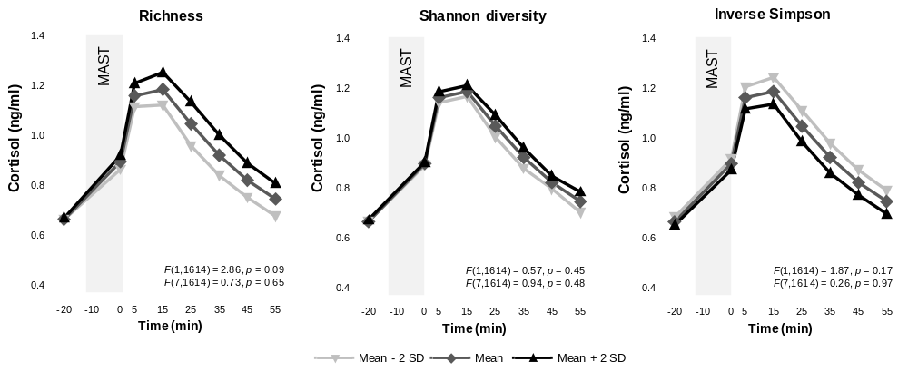
8.1. Alpha diversity and cortisol responses to the MAST

Figure S5. Estimates of cortisol are plotted at different levels of alpha diversity metrics (mean and 2 standard deviations below and above the mean) for responses to the MAST. Nominal and adjusted p values shown within each graph correspond to the main effect (top) and the interaction effect (bottom). None of the alpha diversity metrics were significantly associated with cortisol responses to the MAST.

Table S21. Fixed-effect estimates from a linear mixed-effects model assessing the associations between alpha diversity metrics and MAST AUC_{G} and MAST AUC_{I} (F(1,200)) including a random cohort effect.
 |  | F | Estimate ± SE | p
MAST AUC_{G}
 | Richness | 3.77 | 0.38 ± 0.20 | 0.05
 | Shannon | 0.77 | 0.17 ± 0.19 | 0.38
 | Inverse Simpson | 2.08 | -0.27 ± 0.19 | 0.15
MAST AUC_{I}
 | Richness | 3.31 | 1.17 ± 0.65 | 0.07
 | Shannon | 1.04 | 0.65 ± 0.64 | 0.31
 | Inverse Simpson | 1.64 | -0.80 ± 0.63 | 0.20

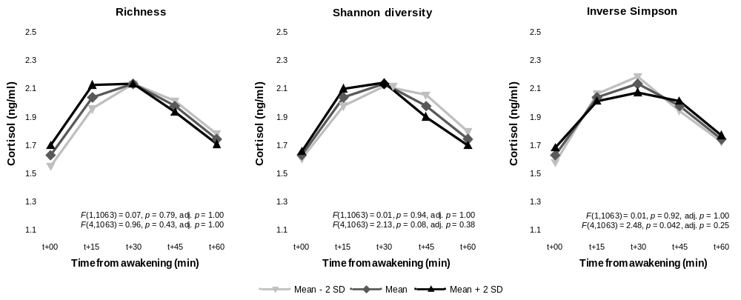
8.2. Alpha diversity metrics and the cortisol awakening response

Figure S6. Estimates of cortisol are plotted at different levels of alpha diversity metrics (mean and 2 standard deviations below and above the mean) for the awakening response. Nominal and adjusted p values shown within each graph correspond to the main effect (top) and the interaction effect (bottom). None of the alpha diversity metrics were significantly associated with the cortisol awakwening response after multiple comparison correction.

Table S22. Fixed-effect estimates from a linear mixed-effects model assessing the associations between mental health-associated genera and CAR AUC_{G} and CAR AUC_{I} (F(1,211)) including a random cohort effect.
 |  | F | Estimate ± SE | p
CAR AUC_{G}
 | Richness | 0.20 | 0.07 ± 0.16 | 0.65
 | Shannon | 0.00 | 0.00007 ± 0.16 | 0.99
 | Inverse Simpson | 0.00 | 0.003 ± 0.16 | 0.99
CAR AUC_{I}
 | Richness | 0.35 | -1.71 ± 2.90 | 0.56
 | Shannon | 0.26 | -1.43 ± 2.82 | 0.61
 | Inverse Simpson | 0.01 | -0.34 ± 2.81 | 0.90

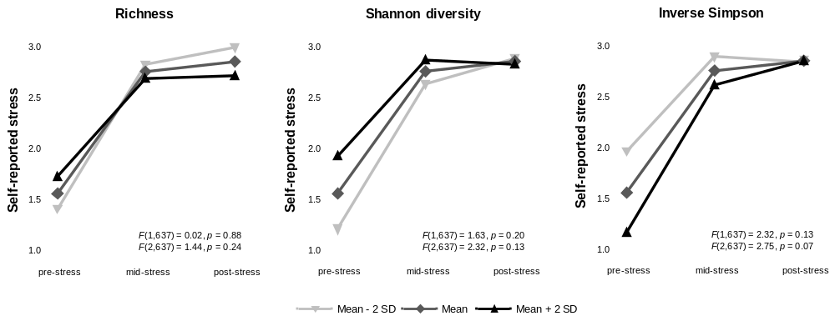
8.3. Alpha diversity metrics and self-reported stress responses to the MAST
Figure S7. Estimates of stressfulness ratings in response to acute stress are plotted at different levels of alpha diversity metrics (mean and 2 standard deviations below and above the mean). Nominal and adjusted p values shown within each graph correspond to the main effect (top) and the interaction effect (bottom). None of the alpha diversity metrics were significantly associated with self-reported stress responses to the MAST.

8.4. Alpha diversity metrics and self-report questionnaires
Table S23. Fixed-effect estimates from a linear mixed-effects model assessing the associations between alpha diversity metrics and PSS scores (F(1,211)) including a random cohort effect.
 |  | F | Estimate ± SE | p
PSS
 | Richness | 2.33 | -0.17 ± 0.11 | 0.13
 | Shannon | 0.66 | -0.09 ± 0.11 | 0.42
 | Inverse Simpson | 0.51 | 0.08 ± 0.11 | 0.48
Positive affect
 | Richness | 0.07 | -1.40 ± 5.31 | 0.79
 | Shannon | 1.97 | -7.25 ± 5.16 | 0.16
 | Inverse Simpson | 2.09 | 7.44 ± 5.15 | 0.15
Negative affect
 | Richness | 0.30 | -0.001 ± 0.002 | 0.58
 | Shannon | 0.58 | 0.001 ± 0.002 | 0.45
 | Inverse Simpson | 0.78 | -0.002 ± 0.002 | 0.38

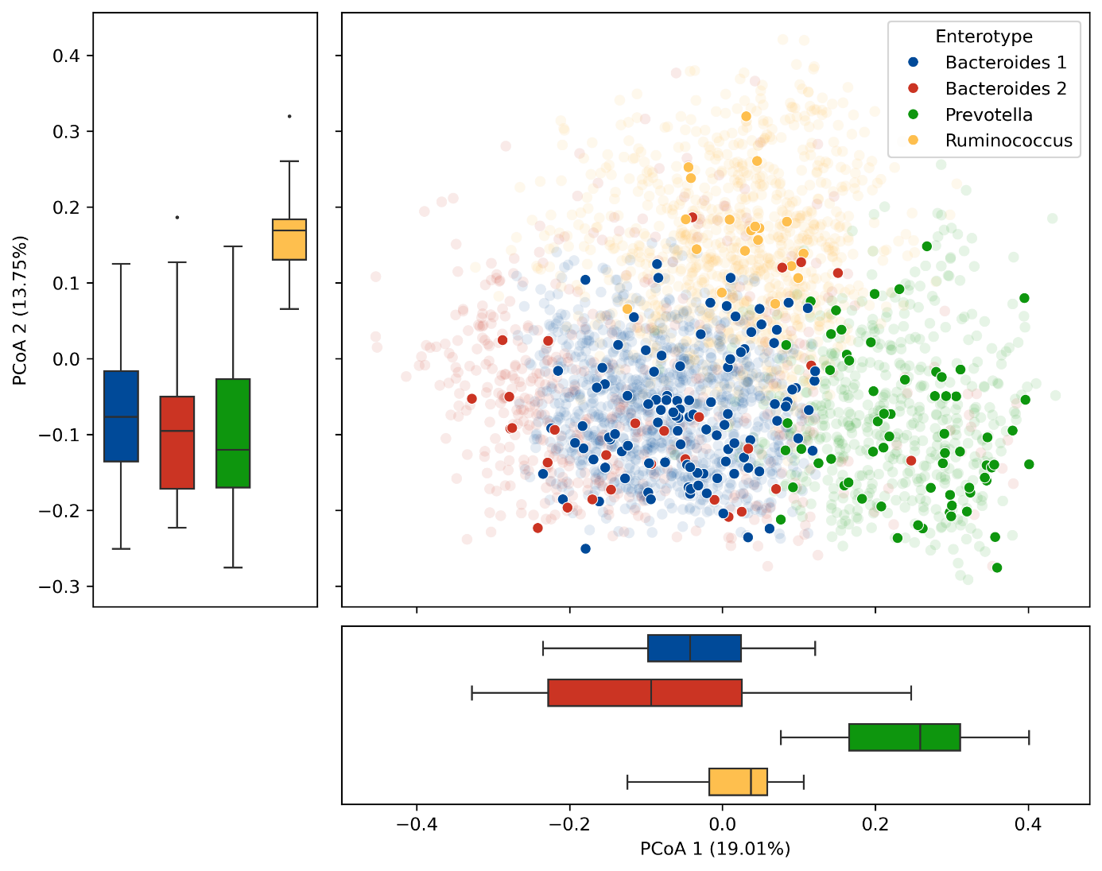
8.5. Principal coordinates analysis of gut microbiome composition
Figure S8. Principal coordinates analysis of gut microbiome composition in the Moodbugs cohort relative to the Flemish Gut Flora Project reference population. Translucent points represent samples from the Flemish Gut Flora Project (FGFP), which were used as a reference backbone for enterotype assignment, whereas opaque points represent Moodbugs samples. Samples are coloured according to enterotype: Bacteroides 1, Bacteroides 2, Prevotella or Ruminococcus. Boxplots show the distributions of Moodbugs samples along PCoA1 and PCoA2 for each enterotype; FGFP samples are not included in these summaries. PCoA1 and PCoA2 explain 19.01% and 13.75% of the variation, respectively.

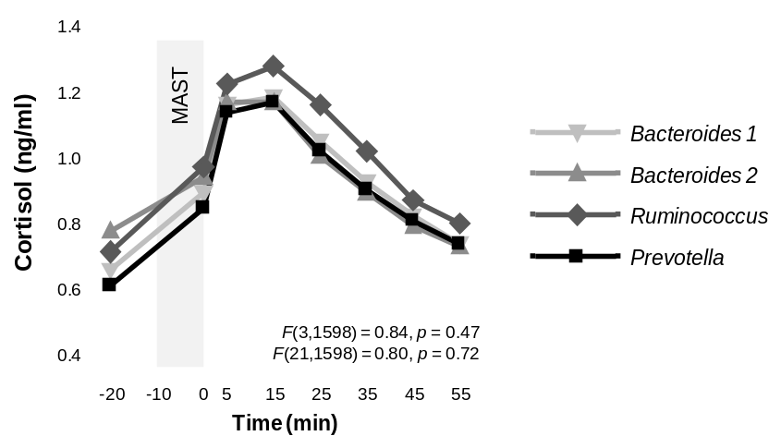
8.6. Enterotype and cortisol responses to the MAST

Figure S9. Estimates of cortisol are plotted by enterotype for responses to the MAST. Nominal and adjusted p values shown within each graph correspond to the main effect (top) and the interaction effect (bottom). No significant differences in cortisol responses to the MAST were found between enterotypes.

Table S24. Estimated marginal means of MAST AUCG and MAST AUCI by enterotype from linear mixed-effects models with a random cohort effect.
 | Enterotype | LS Means  Estimate | SE | 95% CI
MAST AUC_{G}
 | Bacteroides 1 | 11.84 | 0.51 | 10.84, 12.84
 | Bacteroides 2 | 11.70 | 0.67 | 10.38, 13.01
 | Ruminococcus | 12.77 | 0.78 | 11.23, 14.30
 | Prevotella | 11.61 | 0.56 | 10.51, 12.70
MAST AUC_{I}
 | Bacteroides 1 | 36.44 | 1.22 | 34.03, 38.86
 | Bacteroides 2 | 32.44 | 1.87 | 28.75, 36.12
 | Ruminococcus | 37.34 | 2.28 | 32.83, 41.85
 | Prevotella | 36.44 | 1.43 | 33.51, 39.16
Note. Enterotype was not significantly associated with MAST AUC_{G} (F(3, 198) = 0.85, p = 0.47) or MAST AUC_{I} (F(3, 198) = 1.74, p = 0.16).

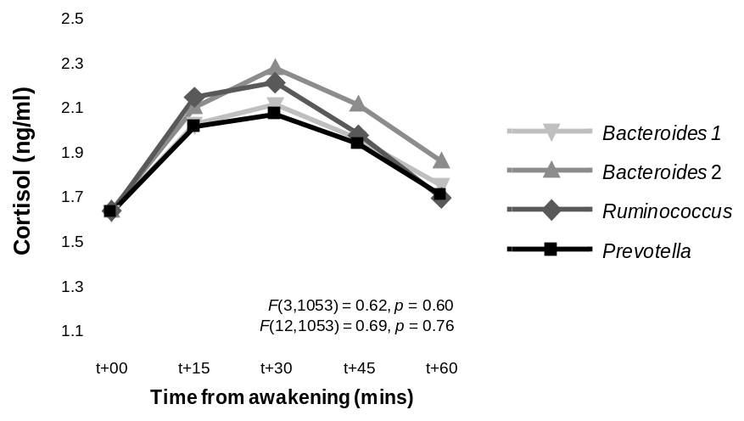
8.7. Enterotype and the cortisol awakening response

Figure S10. Estimates of cortisol are plotted by enterotype for the awakening response. Nominal and adjusted p values shown within each graph correspond to the main effect (top) and the interaction effect (bottom). No significant differences in the cortisol awakening response were found between enterotypes.
Table S25. Fixed-effect estimates from a linear mixed-effects model assessing the associations between enterotype and CAR AUC_{G} and CAR AUC_{I} including a random cohort effect.
 | Enterotype | LS Means  Estimate | SE | 95% CI
CAR AUC_{G}
 | Bacteroides 1 | 13.68 | 1.00 | 11.71, 15.65
 | Bacteroides 2 | 14.28 | 1.06 | 12.18, 16.38
 | Ruminococcus | 14.15 | 1.11 | 11.97, 16.34
 | Prevotella | 13.58 | 1.02 | 11.57, 15.58
CAR AUC_{I}
 | Bacteroides 1 | 129.65 | 9.68 | 110.58, 148.73
 | Bacteroides 2 | 141.93 | 11.66 | 118.95, 164.91
 | Ruminococcus | 140.03 | 12.90 | 114.60, 165.45
 | Prevotella | 131.53 | 10.20 | 111.41, 151.64
Note. Enterotype was not significantly associated with CAR AUC_{G} (F(3, 209) = 0.84, p = 0.47) or CAR AUC_{I} (F(3, 209) = 0.90, p = 0.44).

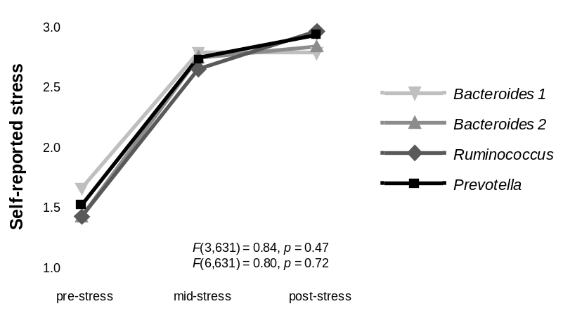
8.8. Enterotype and self-reported stress responses to the MAST

Figure S11. Estimates of self-reported stress are plotted by enterotype for the awakening response. Nominal and adjusted p values shown within each graph correspond to the main effect (top) and the interaction effect (bottom). No significant differences in self-reported stress responses to the MAST were found between enterotypes.
8.9. Enterotype and self-report questionnaires
Table S26. Fixed-effect estimates from a linear mixed-effects model assessing the associations between enterotype and PSS and PANAS scores including a random cohort effect.
 | Enterotype | LS Means  Estimate | SE | 95% CI
PSS
 | Bacteroides 1 | 4.64 | 0.18 | 4.31, 5.01
 | Bacteroides 2 | 4.90 | 0.31 | 4.29, 5.51
 | Ruminococcus | 4.24 | 0.38 | 3.50, 4.99
 | Prevotella | 4.68 | 0.18 | 4.25, 5.11
Positive Affect
 | Bacteroides 1 | 305.96 | 12.34 | 281.64, 330.28
 | Bacteroides 2 | 296.39 | 17.20 | 262.49, 330.29
 | Ruminococcus | 316.07 | 19.99 | 276.67, 355.48
 | Prevotella | 305.96 | 13.71 | 286.43, 340.48
Negative Affect
 | Bacteroides 1 | 1.18 | 0.003 | 1.17, 1.19
 | Bacteroides 2 | 1.17 | 0.006 | 1.16, 1.18
 | Ruminococcus | 1.18 | 0.007 | 1.16, 1.19
 | Prevotella | 1.17 | 0.004 | 1.16, 1.18
Note. Enterotype was not significantly associated with PSS (F(3,209) = 0.66, p = 0.58), positive affect (F(3,209) = 0.43, p = 0.73) or negative affect (F(3,209) = 2.10, p = 0.10).

- Correlations between serum and fecal SCFAs
Table S27. Pearson correlations between serum and fecal SCFAs.
 | Serum butyrate | Serum propionate | Total serum SCFAs | Fecal acetate | Fecal butyrate | Fecal propionate | Total fecal SCFAs
Serum acetate | 0.11  0.11 | 0.17  0.013 | 0.62  <0.0001 | -0.11  0.11 | -0.10  0.14 | -0.12  0.08 | -0.12  0.08
Serum butyrate |  | 0.33  <.0001 | 0.70  <0.0001 | 0.16  0.017 | 0.15  0.032 | 0.07  0.33 | 0.14  0.043
Serum propionate |  |  | 0.73  <0.0001 | -0.05  0.29 | -0.04  0.51 | -0.04  0.55 | -0.06  0.39
Total serum SCFAs |  |  |  | -0.008  0.90 | -0.0004  0.99 | -0.04  0.51 | -0.02  0.77
Fecal acetate |  |  |  |  | 0.79  <.0001 | 0.75  <.0001 | 0.93  <.0001
Fecal butyrate |  |  |  |  |  | 0.67  <.0001 | 0.90  <.0001
Fecal propionate |  |  |  |  |  |  | 0.89  <.0001
Note. Pearson’s r (top) and nominal p-values (bottom) are reported.

