Supplementary Information for
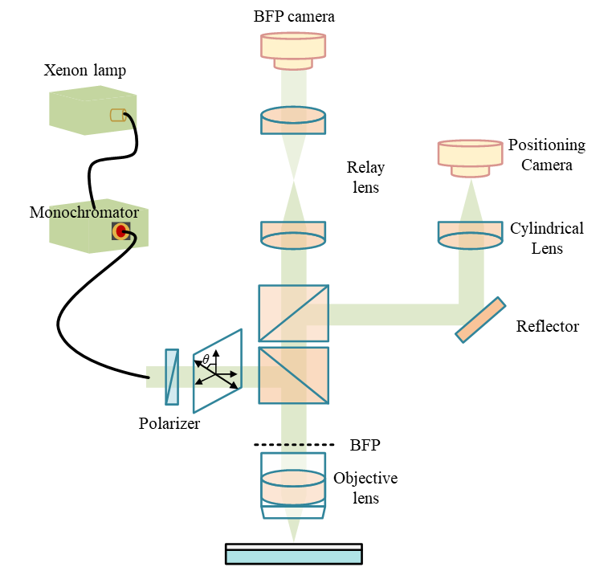
DeepONet-Assisted Angle-Resolved Scattering for Sub-Nanometer in Situ Optical Metrology of Nanowire Geometry
Supplementary. Fig S1 Optical configuration of the in-situ angle-resolved scattering (ARS) measurement system. A xenon lamp coupled with a monochromator provides tunable narrowband illumination, which is delivered into the optical path through fiber coupling. After collimation, the beam sequentially passes through a polarizer and a beam splitter and is then focused onto the sample surface by a high–numerical-aperture (NA ≈ 0.9) objective. The same objective collects the scattered light over a wide angular range and projects the far-field angular distribution onto its back focal plane (BFP). Through angular calibration of the BFP pupil, the radial coordinate is mapped to the scattering polar angle θ, enabling construction of the angle-resolved reflectance $R(θ)$ from the zero-order reflection channel.

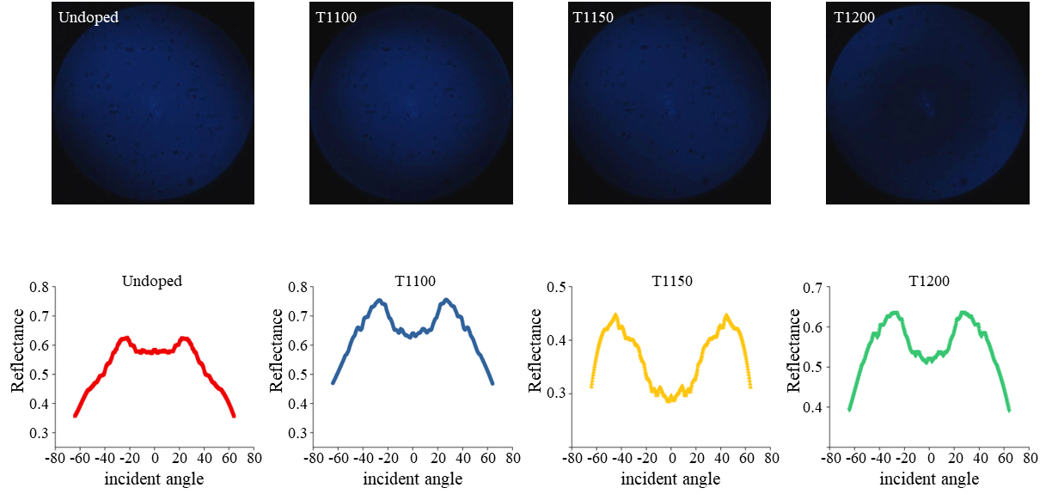
Supplementary. Fig S2 Back focal plane (BFP) images and corresponding angle-resolved reflectance curves of Si-doped GaN nanowire arrays under different doping temperatures. The BFP images of Si-doped GaN nanowire arrays measured under different doping temperature conditions (Undoped, T1100, T1150, and T1200) are shown in the top row. The measurements were performed at a working wavelength of 480 nm. Through angular calibration of the BFP pupil, the radial coordinate of the BFP image was mapped to the scattering polar angle $θ$, enabling conversion of the BFP intensity distribution into the corresponding angle-resolved reflectance $R(θ)$curves shown in the bottom row. For each doping temperature condition, 10 Si-doped GaN nanowire samples with identical fabrication parameters were prepared. Thirty spatial locations were selected on each sample for measurement, resulting in 300 angle-resolved reflectance spectra for each temperature condition.

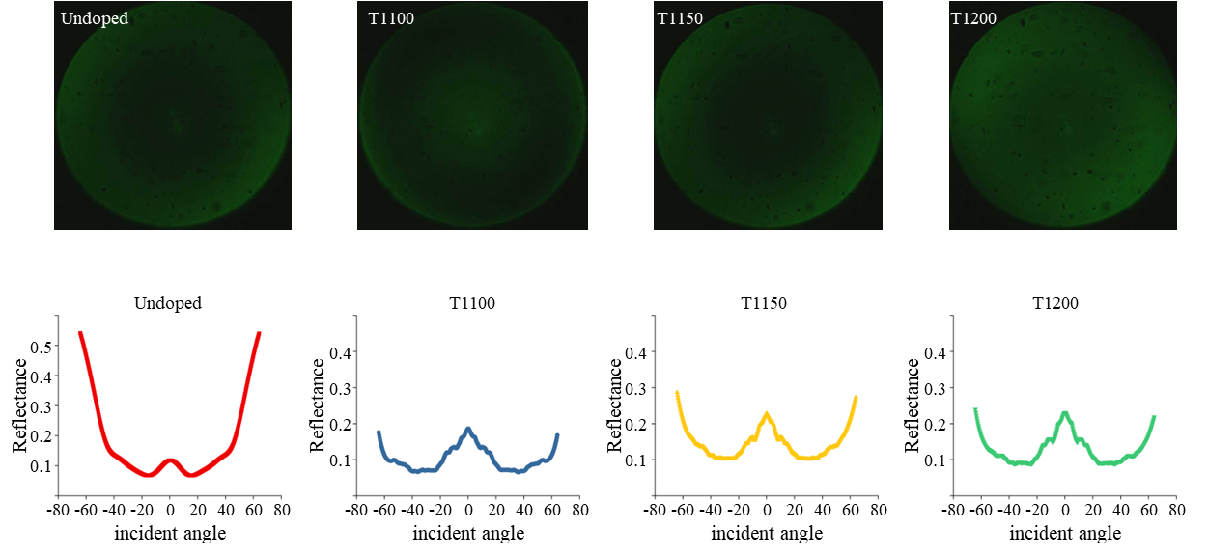
Supplementary Fig S3 BFP images and corresponding angle-resolved reflectance spectra of Si-doped GaN nanowire arrays at 574 nm. Representative back focal plane (BFP) images of Si-doped GaN nanowire arrays measured at a wavelength of 574 nm under different doping temperature conditions (Undoped, T1100, T1150, and T1200) are shown in the top row. The wide-angle scattering distribution collected by the high–numerical-aperture objective is mapped onto the BFP, where the radial coordinate corresponds to the scattering polar angle. Through angular calibration of the BFP pupil, the intensity distribution is converted into angle-resolved reflectance $R(θ)$, and the corresponding reflectance curves are presented in the bottom row. For each doping temperature condition, 10 Si-doped GaN nanowire samples with identical fabrication parameters were prepared. Thirty spatial locations were selected on each sample for measurement, yielding 300 angle-resolved reflectance spectra per temperature condition.

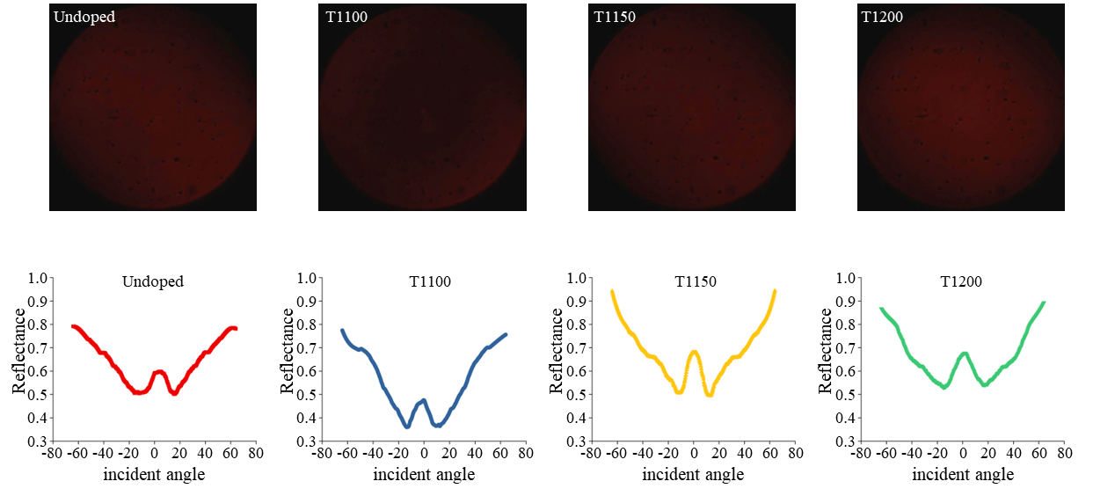
Supplementary Fig S4 Experimental BFP images and extracted angle-resolved reflectance spectra of Si-doped GaN nanowire arrays at 644 nm. Representative back focal plane (BFP) images of Si-doped GaN nanowire arrays measured at a wavelength of 644 nm under different doping temperature conditions (Undoped, T1100, T1150, and T1200) are shown in the top row. The scattered light collected by the high–numerical-aperture objective is mapped onto the BFP, where the radial coordinate corresponds to the scattering polar angle. Through angular calibration of the BFP pupil, the BFP intensity distribution is converted into angle-resolved reflectance $R(θ)$, and the corresponding reflectance curves are shown in the bottom row. These measurements illustrate the angular scattering characteristics of nanowire arrays under different doping conditions and provide experimental spectral data for evaluating the consistency and robustness of the optical metrology framework across multiple wavelengths.

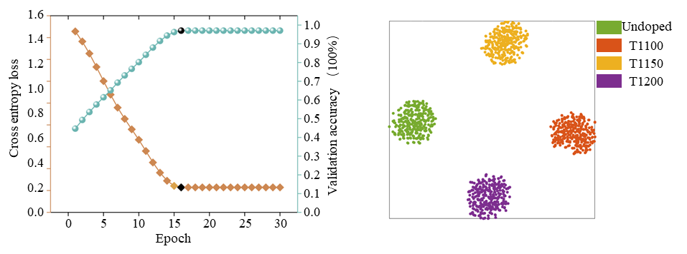
Supplementary Fig S5 Training convergence and t-SNE visualization of angle-resolved reflectance spectra at 480 nm. The left panel shows the evolution of the training and validation loss during DeepONet optimization using the experimental angle-resolved reflectance dataset measured at a wavelength of 480 nm. Both curves gradually converge as the training progresses, indicating stable learning behavior of the operator-learning model. The right panel presents a two-dimensional t-distributed stochastic neighbor embedding (t-SNE) visualization of the spectral features extracted from the $R(θ)$dataset. Data points corresponding to different doping temperature conditions (Undoped, T1100, T1150, and T1200) form distinct clusters in the embedded feature space. This separation indicates that the angle-resolved reflectance spectra at 480 nm contain distinguishable information associated with variations in nanowire growth conditions, supporting the feasibility of using these spectra for subsequent spectral alignment and geometric inversion.

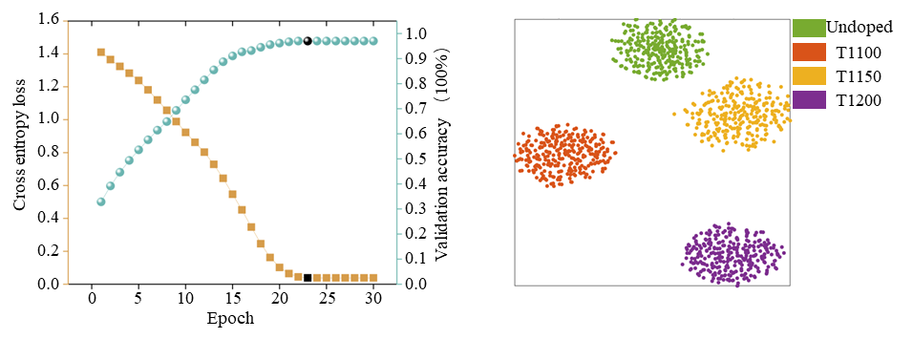
Supplementary Fig S6 Training convergence and t-SNE visualization of angle-resolved reflectance spectra at 644 nm. The left panel shows the evolution of the training and validation loss during DeepONet optimization using the experimental angle-resolved reflectance dataset measured at a wavelength of 644 nm. Both curves gradually converge during training, indicating stable optimization and effective learning of the spectral mapping relationship. The right panel presents a two-dimensional t-distributed stochastic neighbor embedding (t-SNE) visualization of the feature representations derived from the $R(θ)$spectra. Data points corresponding to different doping temperature conditions (Undoped, T1100, T1150, and T1200) form clearly separated clusters in the embedded feature space. This clustering behavior indicates that the angle-resolved reflectance spectra at 644 nm preserves discriminative information related to variations in nanowire growth conditions, further supporting the robustness of the spectral dataset for subsequent spectral alignment and geometric inversion.

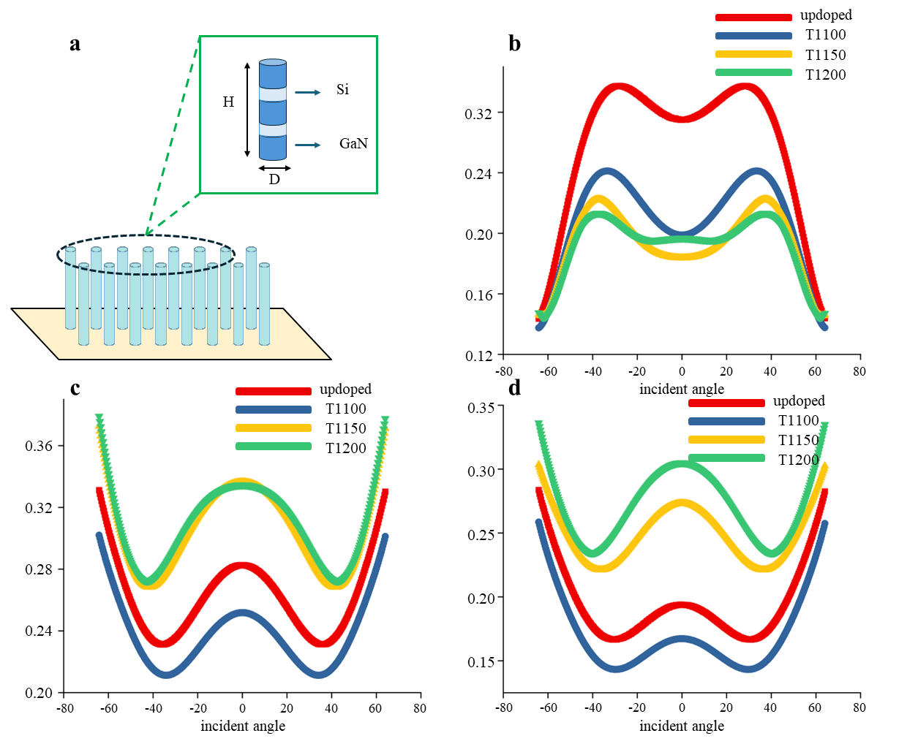
Supplementary Fig. S7 RCWA-simulated angle-resolved reflectance spectra of Si-doped GaN nanowire arrays at different wavelengths. An approximate structural RCWA model was established for the Si-doped GaN nanowire arrays based on the equivalent nanowire geometry used in this work. a–c show the simulated angle-resolved reflectance spectra $R(θ)$at 480, 574, and 644 nm, respectively, under different doping temperature conditions (Undoped, T1100, T1150, and T1200). The simulated spectra reveal distinct wavelength-dependent angular responses to doping-induced structural variation. Among the three wavelengths, the spectra at 574 nm exhibits the clearest separation over the full angular range, whereas the curves at 480 nm and 644 nm show relatively stronger overlap between different temperature conditions. These results indicate that 574 nm provides the highest angular sensitivity to doping-related geometric variation in the present Si-doped GaN nanowire system, supporting its selection as the primary working wavelength for DeepONet-based spectral alignment and subsequent geometric inversion.

