MLC-Seq: de novo Sequencing of Full-Length tRNAs and Quantitative Mapping of Multiple RNA Modifications

Xiaohong Yuan^{1a}, Yue Su^{1a}, Xudong Zhang², Spencer J. Turkel^{1a}, Shundi Shi³, Xuanting Wang³, Eun-Jin Choi^{4a}, Wenzhe Wu^{4a}, Haichuan Liu⁵, Rosa Viner⁵, James J. Russo³, Wenjia Li^{1b}, Xiaoyong Bao^{4a, 4b,4c,4d}, Qi Chen², Shenglong Zhang^{1a*}

Supplementary Information

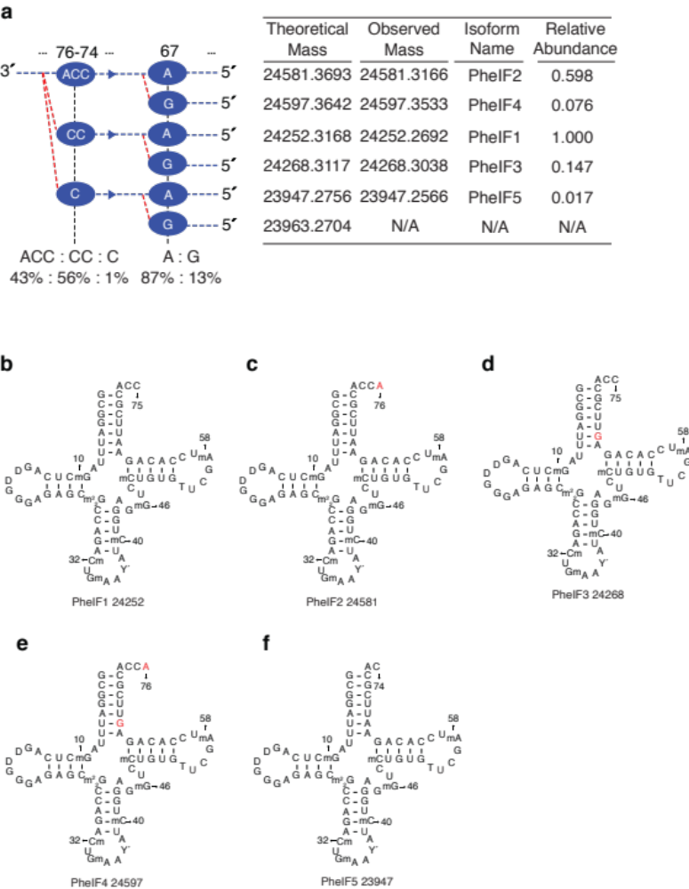
Position | Partial Modification | Mean Ratio (N=3) | Standard Deviation
67 | A : G | 87 : 13 | 0.4 : 0.4

Fig. S1 | Supplementary MLC-Seq results for 5 isoforms of yeast tRNA-Phe. a, The observed branching indicates the truncated 3´-end isoforms and the partial editing position and stoichiometry. The theoretical exact mass and observed monoisotopic mass after acid degradation are presented, along with the relative abundance before acid degradation in a control sample. b, Mean ratio and standard deviation for partial editing at position 67 of the tRNA-Phe.

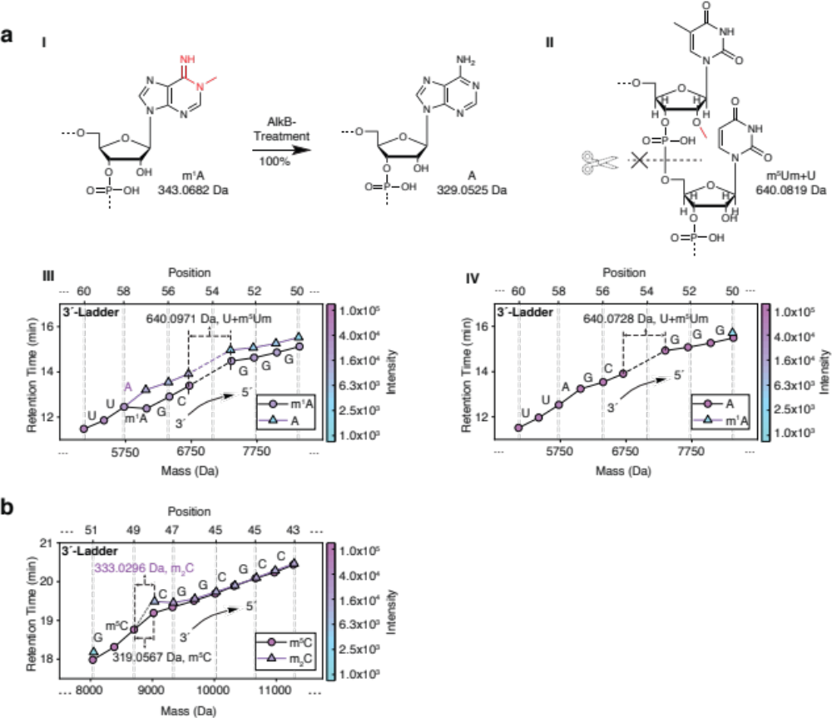
Fig. S2 | Supplementary MLC-Seq results for wild-type tRNA-Glu extracted from mouse liver. a, I, Structural change of m¹A to A at position 57 caused by AlkB treatment and II, 2-methylation blocks the cleavage of phosphodiester bond under acidic condition. A 2-O´-methyl of m⁵Um at position 53 of the tRNA-Glu blocks the acid degradation, causing a small mass gap with a ladder fragment of 640.0819 Da (the mass sum of likely 53m⁵Um and 54U) missing between positions 53 and 54. This mass gap was observed both before (III) and after AlkB-treatment (IV). III-IV, Stoichiometric changes of m¹A at position 57 of the tRNA-Glu after AlkB-treatment. The percentage of m¹A is reduced from 68% to 0% at the position where it is demethylated completely and become 100% A. b, At position 48 of the tRNA-Glu, one methylated m⁵C and one dimethylated C (m₂C) co-exist because (1) there is a new branch starting off at position 48 and (2) the mass difference of ladder fragments between 49 and 48 is 319.0567 matching to m⁵C and 333.0296 matching to dimethylated m₂C.

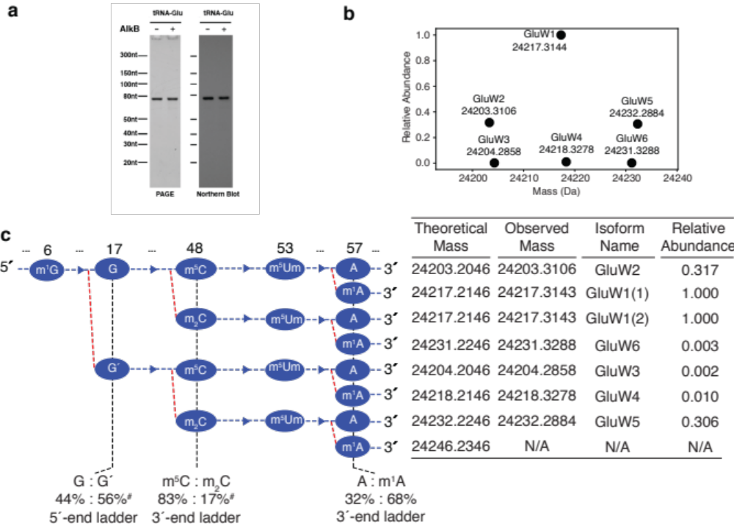
Wild-Type
Position | Partial Modification | Mean Ratio  (N=3) | Standard Deviation
57 | A : m¹A | 32 : 68 | 2.6 : 2.6
AlkB-Treated
17 | G : G´ | 69 : 31 | 4.6 : 4.6
57 | A: m¹A | 100 : 0 | na

Fig. S3 | Supplementary MLC-Seq results for tRNA-Glu extracted from mouse liver. a, Northern blot data on tRNA-Glu. PAGE gel image (left) and Northern blot (right) confirmation of enriched tRNA-Glu from mouse liver. b, In the mass-relative abundance graph observed intact tRNA isoforms (at around 24kDa) before acid degradation. c, Branching indicating all the partial modifications and related intact monoisotopic masses of tRNAs in the mouse live tRNA-Glu sample. The theoretical masses, observed masses, isoform names and the relative abundances of tRNAs are also listed. d, Mean ratio and standard deviation for the partial modification/editing of tRNA-Glu before and after AlkB-treatment. Only the partial modifications are presented. # Mean ratio and standard deviation not calculated due to limited trials for the wild-type tRNA sample.

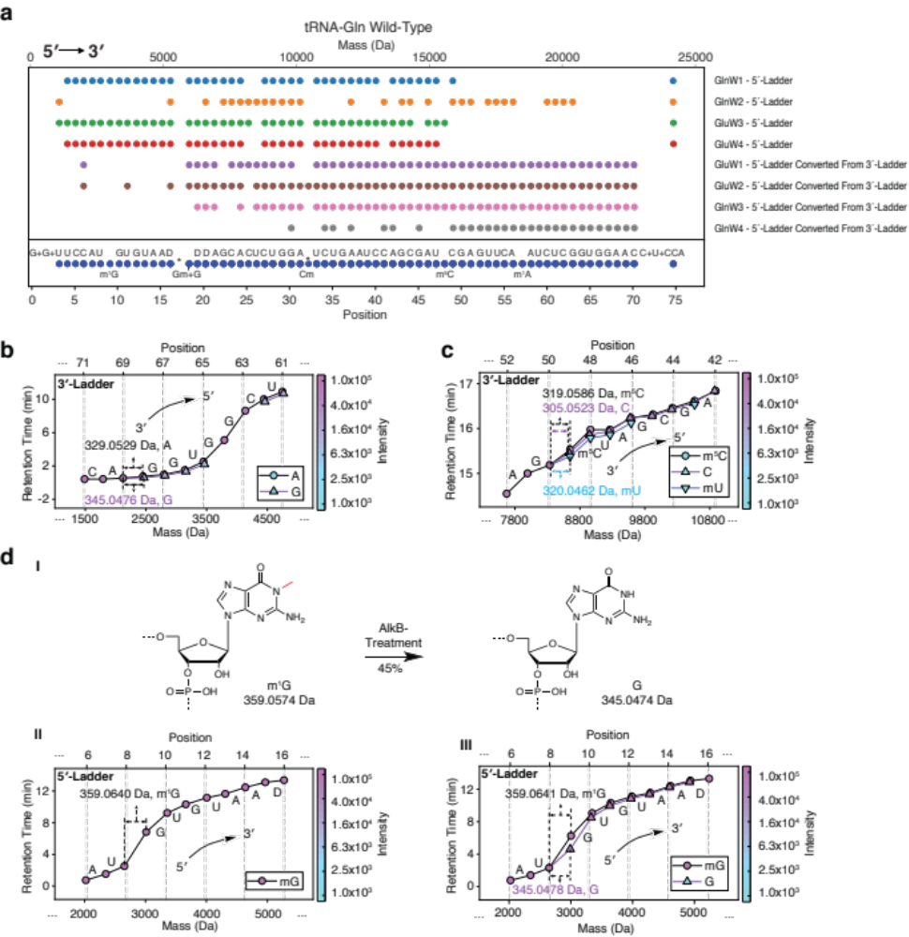
Fig. S4 | MLC-Seq results for tRNA-Gln extracted from mouse liver. a, Ladder complementation of various related tRNA isoforms allows direct sequencing of wild-type tRNA-Gln extracted from mouse liver. None of the four isoforms of tRNA-Gln could provide a perfect MS ladder. After ladder complementation, the missing MS ladder fragments were filled in to generate a perfect MS ladder, allowing for direct sequencing of all 4 tRNA isoforms. All 3′-ladders were converted to 5′- ladders to keep the positions consistent. b, An minor A (3%) to G transition at position 68 of the tRNA-Gln. c, A partial modification of C/m⁵C/mU was observed at position 49 and their ratio is 57%:38%:5%. d, Structural (I) and stoichiometric changes (II-III) of m¹G after AlkB-treatment. The percentage of m¹G at position 9 was reduced from 100% to 55% (with 45% G co-existing at this position) after AlkB-treatment.
*The missing fragment at position 17 is due to 2′-O-Methyl of Gm blocking acid degradation.

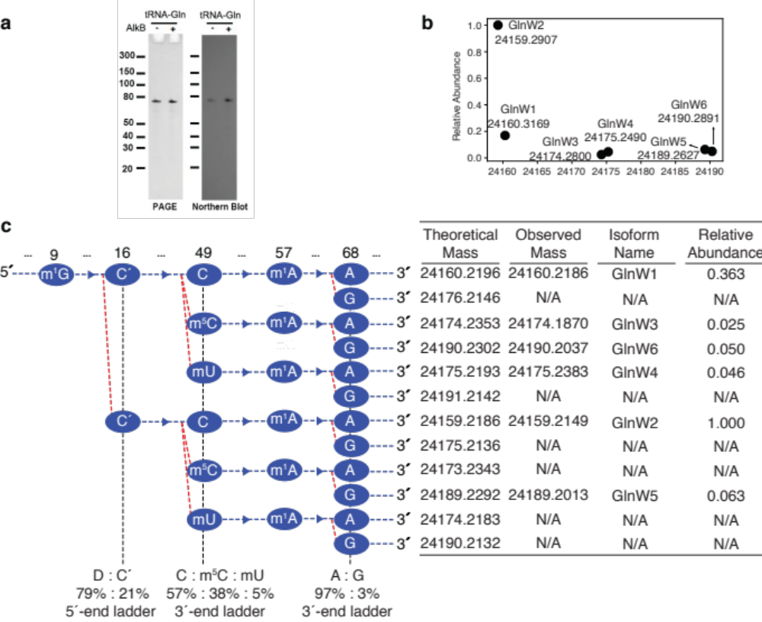
Wild-Type
Position | Partial Modification | Mean Ratio  (N=3) | Standard Deviation
16 | D : C´ | 79 : 21 | 4.2 : 4.2
49 | C : m⁵C : mU | 57 : 38 : 5 | 1.4 : 1.7 : 1.8
68 | A : G | 97 : 3 | 0.4 : 0.4
AlkB-Treated
9 | G : m¹G | 45 : 55 | 2.1 : 2.1
57 | A : m¹A | 99 : 1 | 0.1 : 0.1

Fig. S5 | Supplementary MLC-Seq results for tRNA-Gln extracted from mouse liver. a, Northern blot data on tRNA-Gln. PAGE gel image (left) and Northern blot (right) confirmation of enriched tRNA-Gln from mouse liver. b, In the mass-relative abundance graph observed major intact tRNA isoforms (at around 24kDa) before acid degradation. c, A branching including all the partial modifications and intact masses of tRNAs. The theoretical masses, observed masses, isoform names and the relative abundance of tRNA isoforms are also listed. d, Mean ratio and standard deviation for the partial modification/editing of tRNA-Gln before and after AlkB treatment. Only the partial modification/editing are presented.

