Supplementary information

Climate warming accelerates plastic degradation
and secondary microplastic formation

Li Zhou^{1#}, Xinjie Wang^{1#}, Garance Lefevre¹, Maud Le Bescond¹, Rui-Ying Bao²,
Emmanuel Richaud³, Matthew Macleod⁴, Xinfeng Wei^{1,5}*

- Department of Fibre and Polymer Technology, KTH Royal Institute of Technology, SE–100 44 Stockholm, Sweden
- College of Polymer Science and Engineering, State Key Laboratory of Advanced Polymer Materials, Sichuan University, Chengdu 610065, China
- Laboratoire PIMM, Arts et Métiers Institute of Technology, CNRS Cnam, HESAM Université, Paris, France
- Department of Environmental Science, Stockholm University, Stockholm 106 91, Sweden
- KTH Climate Action Centre, SE–100 44 Stockholm, Sweden

Supplementary Note 1. Plastic films and sample preparation for ageing.
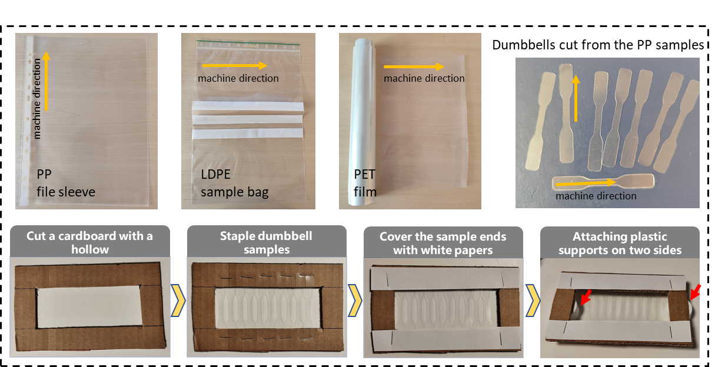
Supplementary Fig. 1. Images of the three commercial plastic films used in this study: a PP file sleeve from Lyreco Sverige AB, LDPE sample bags from Office Depot (Sweden; only the transparent region was used), and PET film (Mylar® A, Synflex Elektro GmbH, Germany). The thickness was 75 µm for PP and PET films and 50 µm for the LDPE film. The orange arrows indicate the machine direction of the films, corresponding to the longitudinal direction of the cut dumbbell specimens. Images to illustrate the procedures for mounting the films onto the sample holder for ageing experiments, where the red arrows point to the location of the two plastic supports. As these films were mainly aimed for indoor applications, we can expect that they do not contain any UV stabilizers.
A custom-designed sample holder made of cardboard was fabricated to secure the specimens during the aging process. A rectangular hollow region (4 cm × 10 cm) was cut in the center of a cardboard sheet (overall dimensions approximately 8 cm × 14 cm). Ten dumbbell-shaped specimens were fastened to the cardboard using staples such that the grip ends were fixed to the holder while the gauge sections were suspended freely within the hollow region. Preliminary trials indicated that the wider grip sections degraded more rapidly than the gauge section due to additional heat accumulation from the cardboard holder under UV exposure. To prevent this, both grip ends of the dumbbell specimens were further covered with white paper to shield them from direct UV irradiation. Moreover, plastic supports (10 mm in height) were attached to both sides of the sheet to elevate the holder. This configuration allowed the gauge sections of the specimens to remain suspended in air rather than in contact with the chamber surface. By minimizing direct heat conduction from the metal base plate of the aging chamber, this design ensured that the specimens experienced a temperature closer to the ambient chamber temperature.
Supplementary Note 2. Calculation of total UV irradiance and simulated number of exposure days
The calculation approach was adapted from the literature [1-3]. The total UV irradiance received during the exposure period was calculated based on the experimental irradiance intensity and exposure duration:
Total irradiance=𝐼×𝑡=60t
where 𝐼 is the irradiance (60 W/m²), and 𝑡 is the exposure time (h).
To estimate the equivalent number of exposure days under average European conditions, a mean annual solar irradiance of approximately 1200 kWh/(m²∙year) was assumed. Of this, 5% was attributed to UV radiation, corresponding to an average UV irradiance of 60 kWh/(m²∙year).
The simulated exposure time in days was then calculated as:
$$Simulated days=\frac{Total irradiance exposed }{Mean Annual European UV irradiance }× 365=0.365t$$
​ 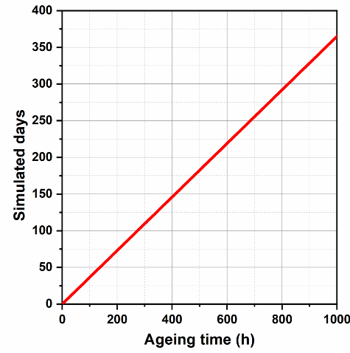
Supplementary Fig. 2. Simulated days plotted as a function of ageing time.
[1] Sørensen L, Groven AS, Hovsbakken IA, Del Puerto O, Krause DF, Sarno A, et al. UV degradation of natural and synthetic microfibers causes fragmentation and release of polymer degradation products and chemical additives. Science of The Total Environment. 2021;755:143170.
[2] Gewert B, Plassmann M, Sandblom O, MacLeod M. Identification of Chain Scission Products Released to Water by Plastic Exposed to Ultraviolet Light. Environmental Science & Technology Letters. 2018;5:272-6.
[3] Sait STL, Sørensen L, Kubowicz S, Vike-Jonas K, Gonzalez SV, Asimakopoulos AG, et al. Microplastic fibres from synthetic textiles: Environmental degradation and additive chemical content. Environmental Pollution. 2021;268:115745.

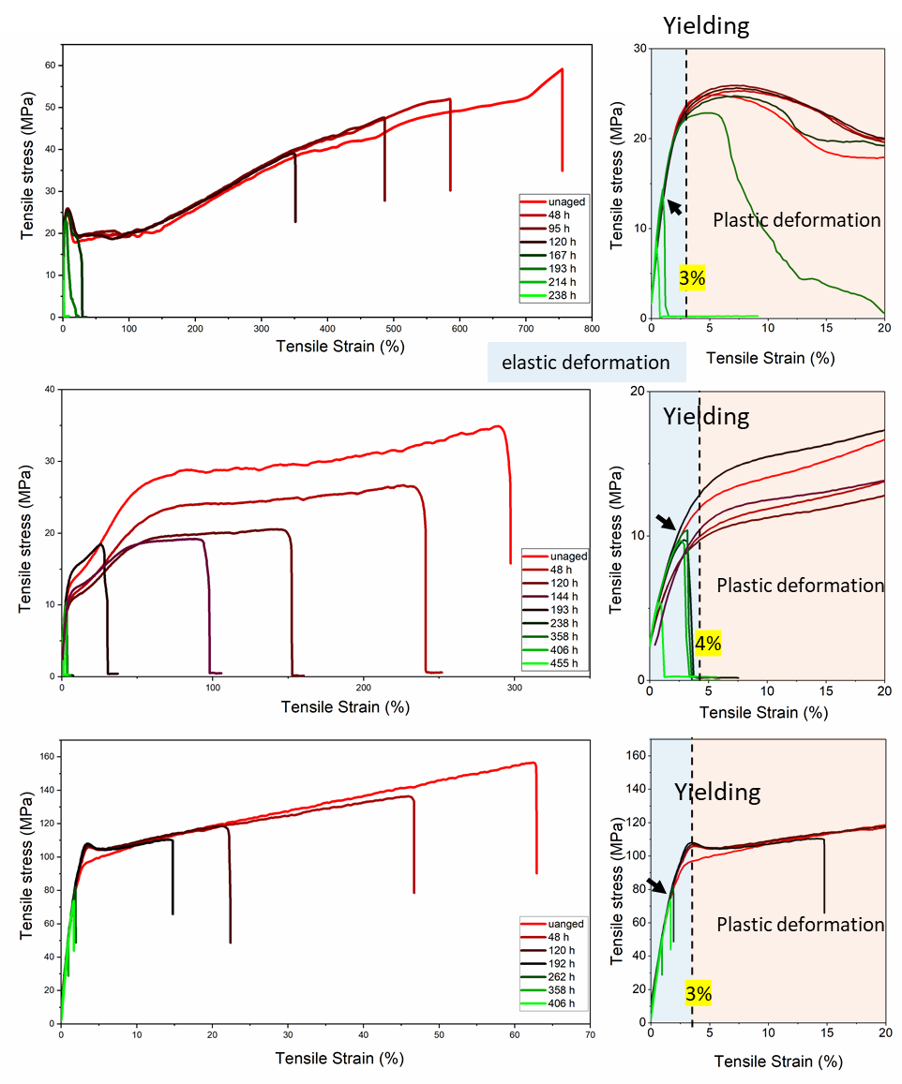
Supplementary Fig. 3. Representative tensile stress–strain curves of PP (top), LDPE (middle), and PET (bottom) samples aged at 50 °C for different durations. The left panels show enlarged views in the strain range of 0–20%. The yield point is indicated; the region before yielding corresponds to elastic deformation, while plastic deformation occurs beyond the yield point. The arrows point out the samples that broke before the yielding point, corresponding to a brittle fracture.

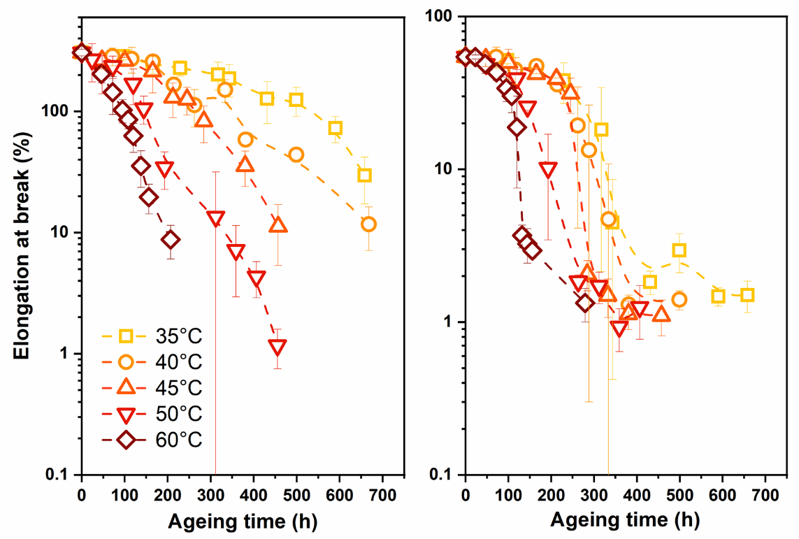
Supplementary Fig. 4. Elongation at break of the LDPE (left) and PET (right) aged at different temperatures.

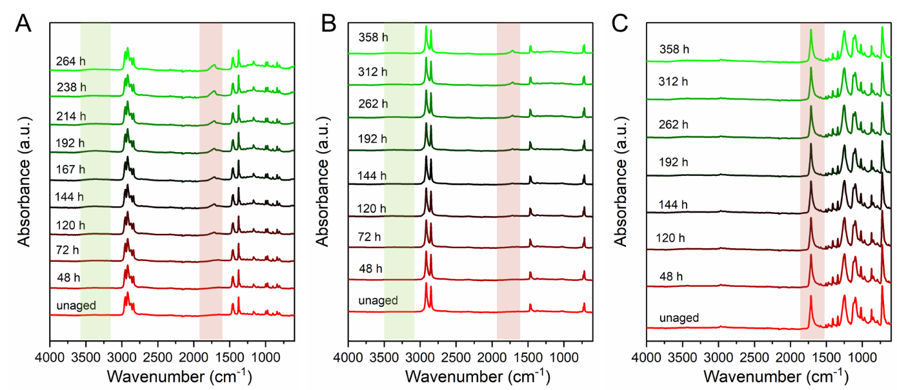

Supplementary Fig. 5. Representative IR spectra of PP (A), LDPE (B), and PET (C) samples aged at 50 °C for different durations. The red shaded region highlights the emergence and growth of carbonyl absorption bands during ageing. The green shaded region highlights the development of a broad hydroxyl band, attributed to hydroxyl-containing oxidation products, particularly carboxylic acids, formed during oxidative degradation.

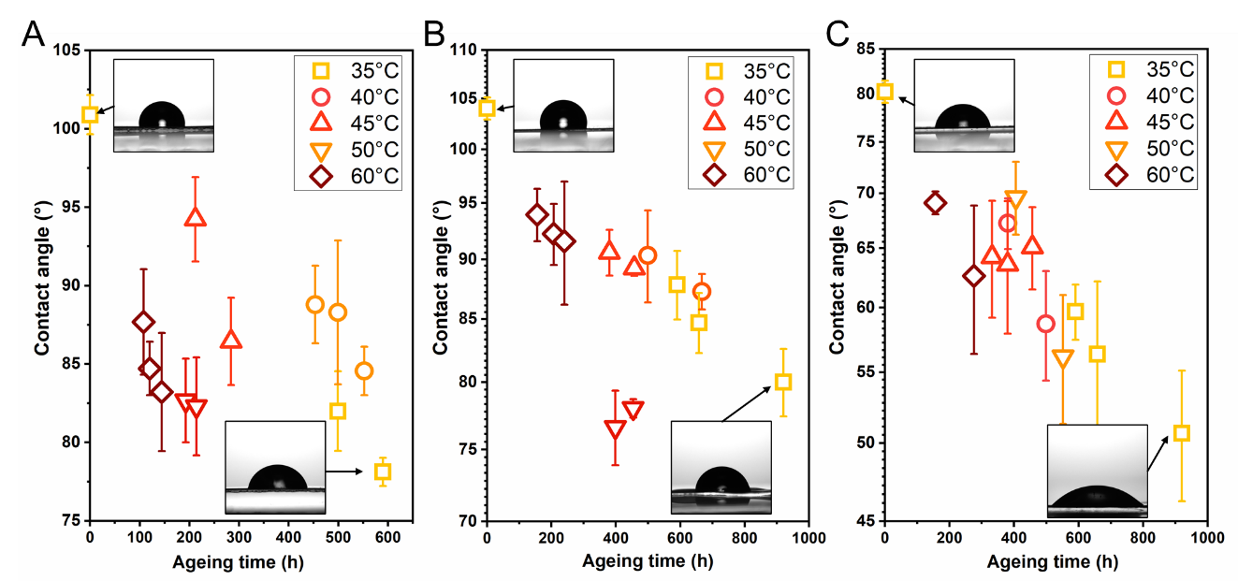
Supplementary Fig. 6: Contact angle of the PP (A), PE (B), and PET (C) films after prolonged ageing under different ageing temperatures. The inserted image shows the image of the water droplet on the unaged film and the one aged for the longest time at 35 ºC.
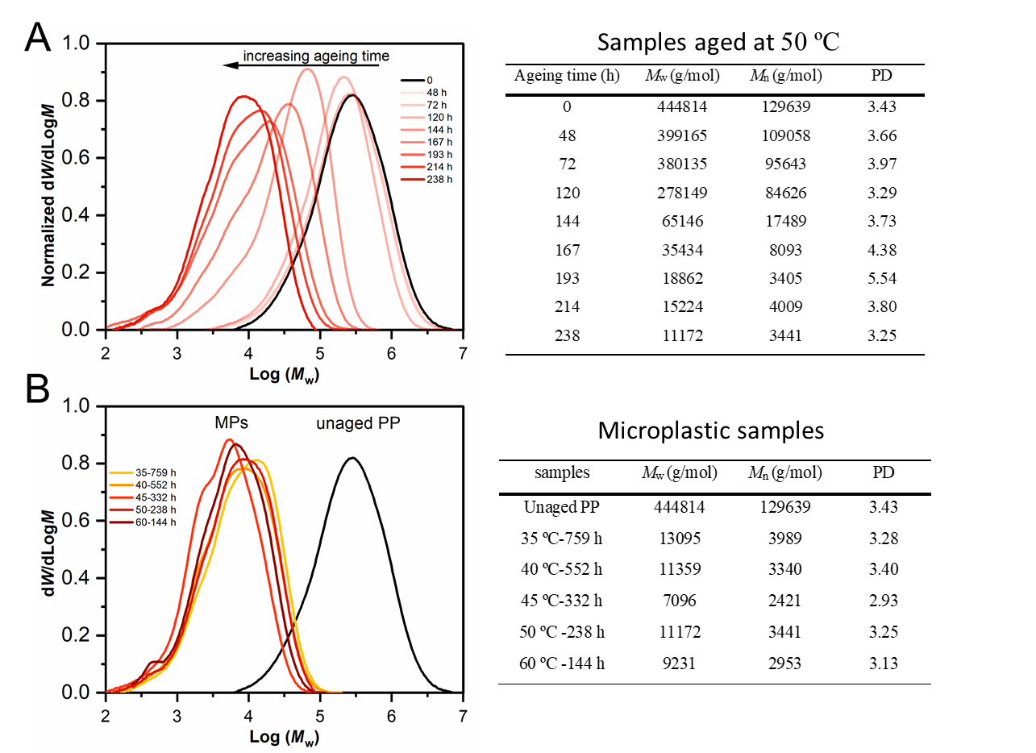
Supplementary Fig. 7. SEC curves (dWf/dlogM) of (A) PP samples aged at 50 °C for different durations and (B) the microplastic samples formed at different ageing temperatures. The inset table summarizes the weight-average molecular weight (M_{w}), number-average molecular weight (M_{n}), and dispersity (PD) of the samples.
Supplementary Fig. 8. Number-average molecular weight (M_{n}) of LDPE samples aged at 50 °C for different durations.

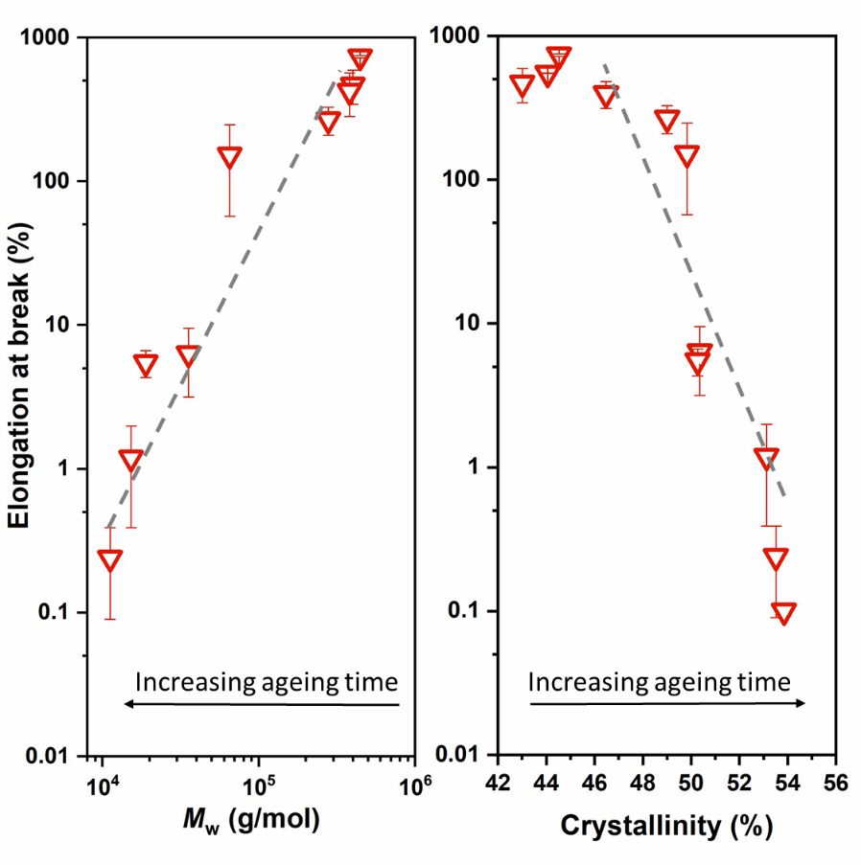
Supplementary Fig. 9. Correlations of elongation at break with molecular weight (M_{w}, right) and crystallinity (left) of PP films aged at 50 °C. Dashed lines are shown to indicate the trends.

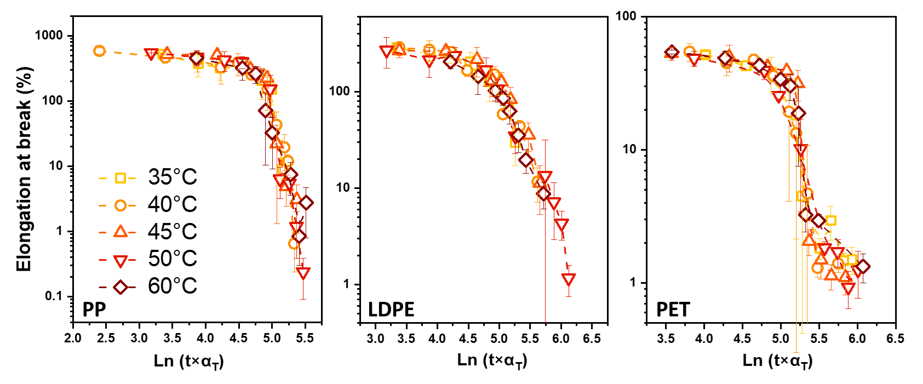
Supplementary Fig. 10. Obtained master curves of the elongation at break of PP, LDPE and PET samples at a reference temperature of 50 °C.

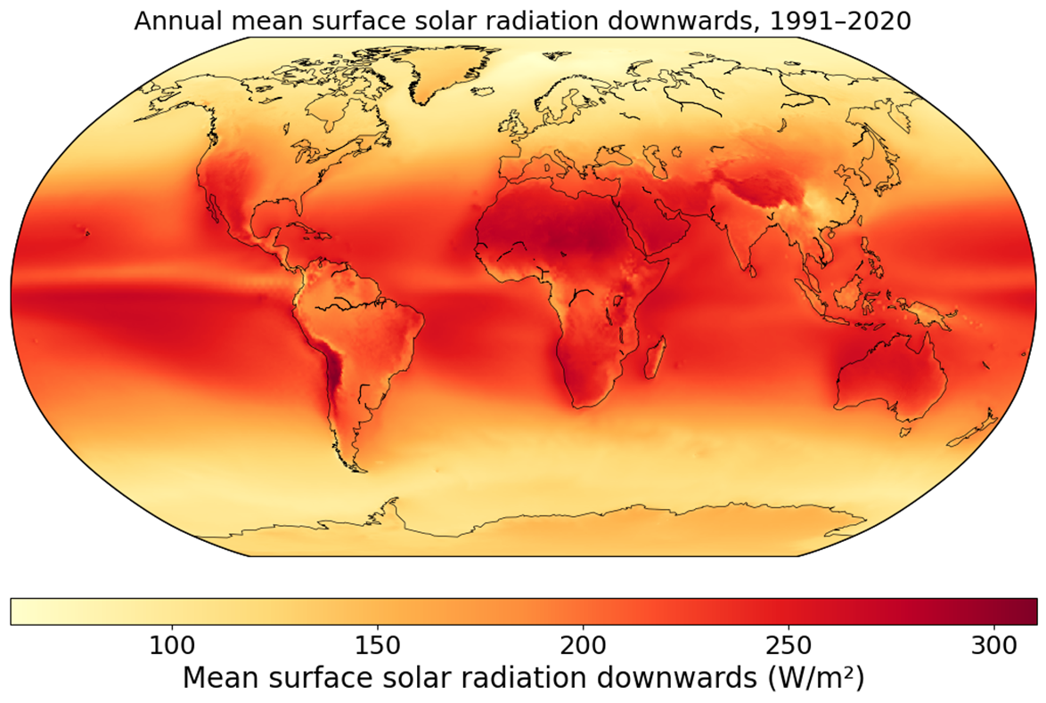

Supplementary Fig. 11. Global distribution of annual mean surface solar radiation over 1991-2020 period. The data were exported from the Copernicus Interactive Climate Atlas, which used the data source of ERA5 (https://atlas.climate.copernicus.eu/atlas ).
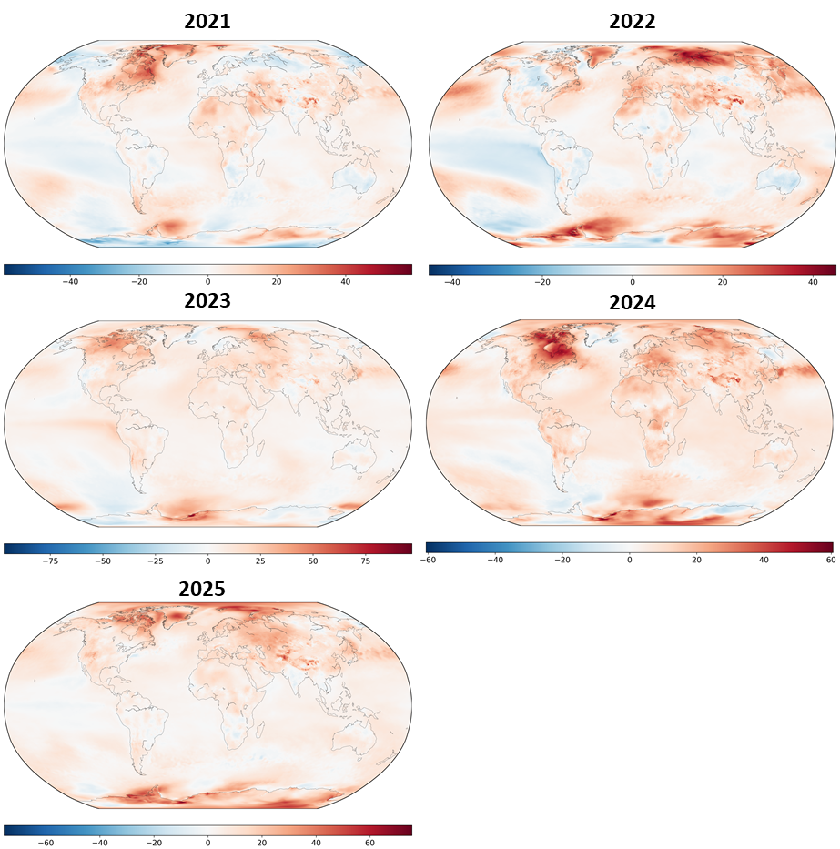
Supplementary Fig. 12. Projected global distribution of the temperature-driven percent change in the UV degradation rate of PP from 2021 to 2025 relative to the 1991–2020 reference period, estimated using the Arrhenius equation.

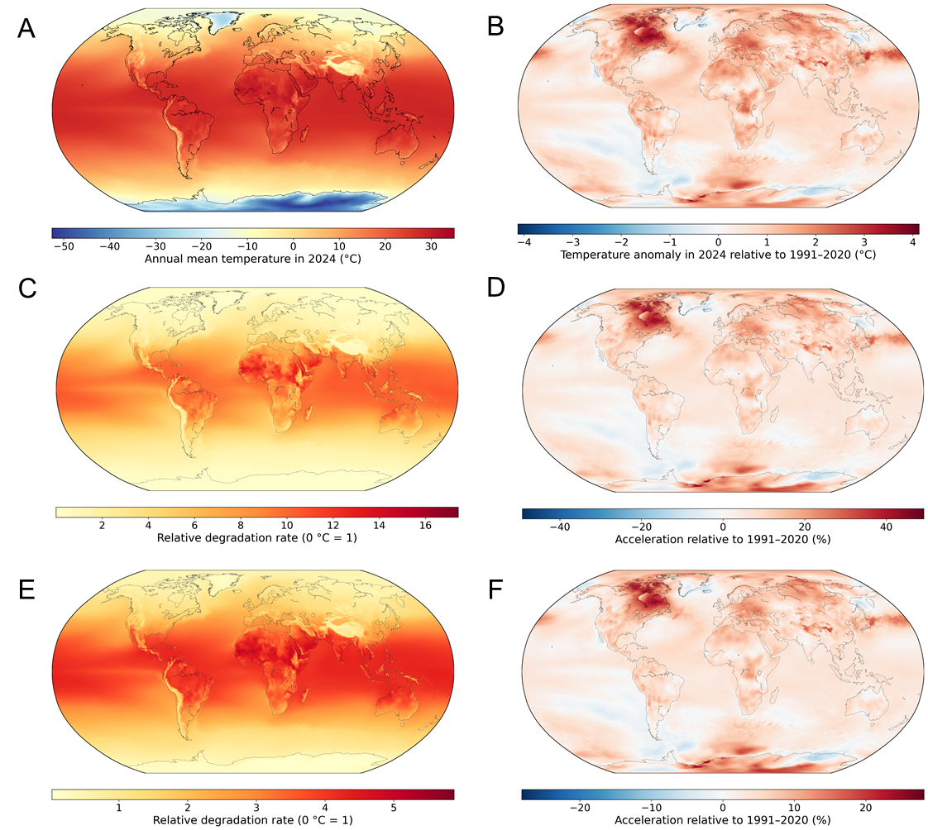

Supplementary Fig. 13. (A) Global distribution of the annual mean temperature in 2024, (B) the temperature anomaly in 2024 relative to the 1991–2020 average, the global distributions of the temperature-driven relative degradation rates of LDPE (C) and PET (E) in 2024, and the percent change in the degradation rates of LDPE (D) and PET (F) relative to the 1991–2020 reference period. Relative degradation rates were expressed relative to the rate at 0 °C (= 1) based on the Arrhenius equation. All calculations were based on annual mean near-surface air temperatures derived from ERA5 monthly data using month-length-weighted averaging. Positive values indicate accelerated degradation, whereas negative values indicate reduced degradation relative to the reference period.

Supplementary Fig. 14. Obtained master curves of the microplastic formation of PP at a reference temperature of 60 °C.

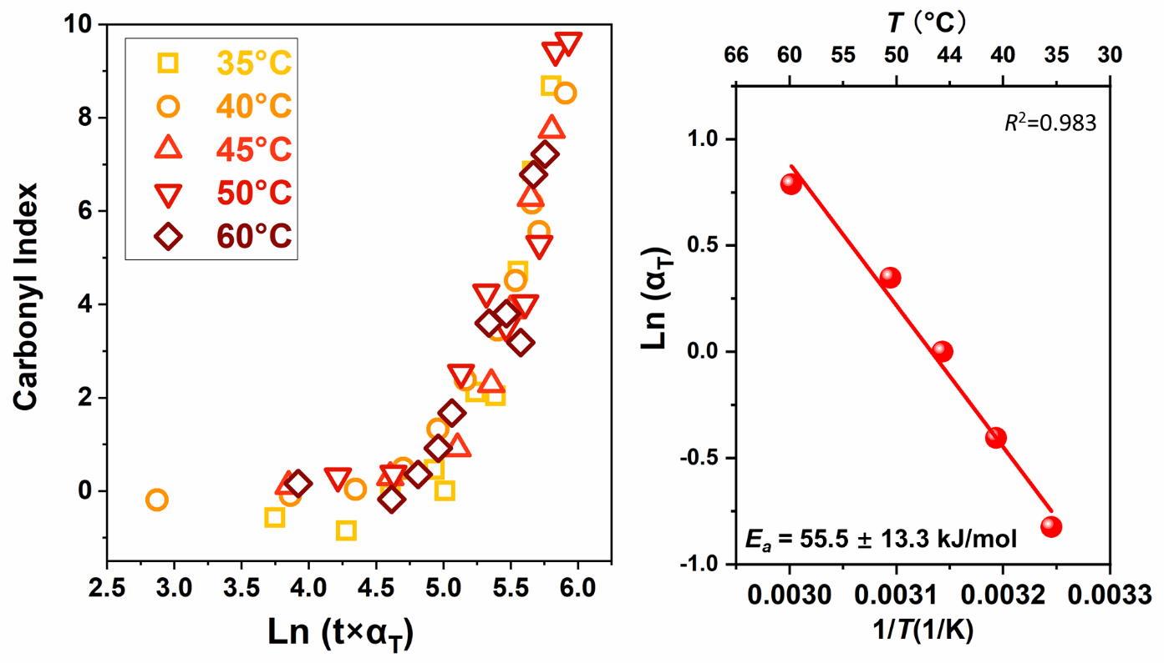
Supplementary Fig. 15. Obtained master curves of the carbonyl index of PP at a reference temperature of 45 °C and the Arrhenius plot of the shift factors.
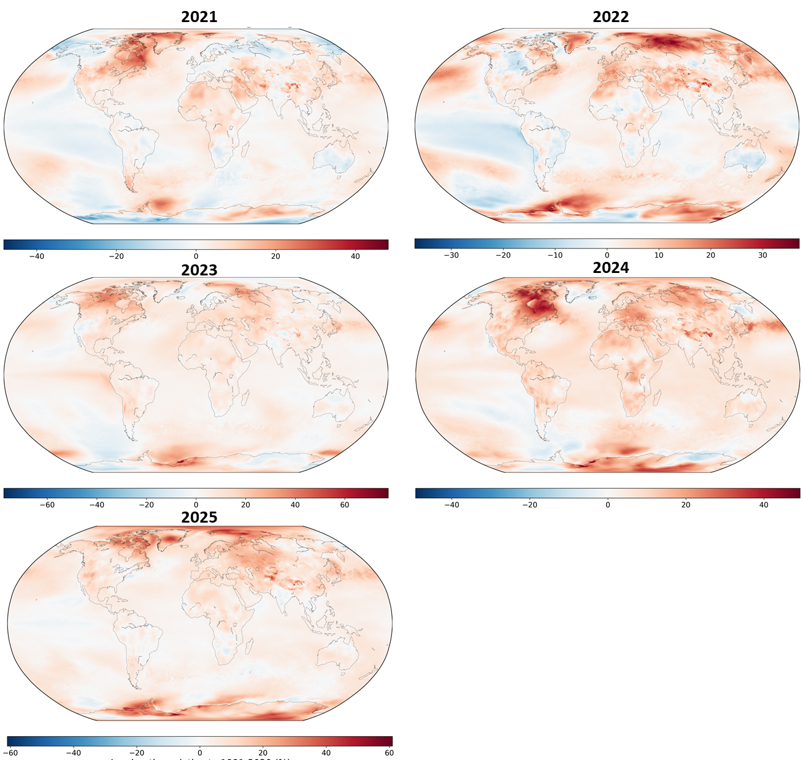

Supplementary Fig. 16. Projected global distribution of the temperature-driven percent change in the microplastic formation rate of PP from 2021 to 2025 relative to the 1991–2020 reference period, estimated using the Arrhenius equation.

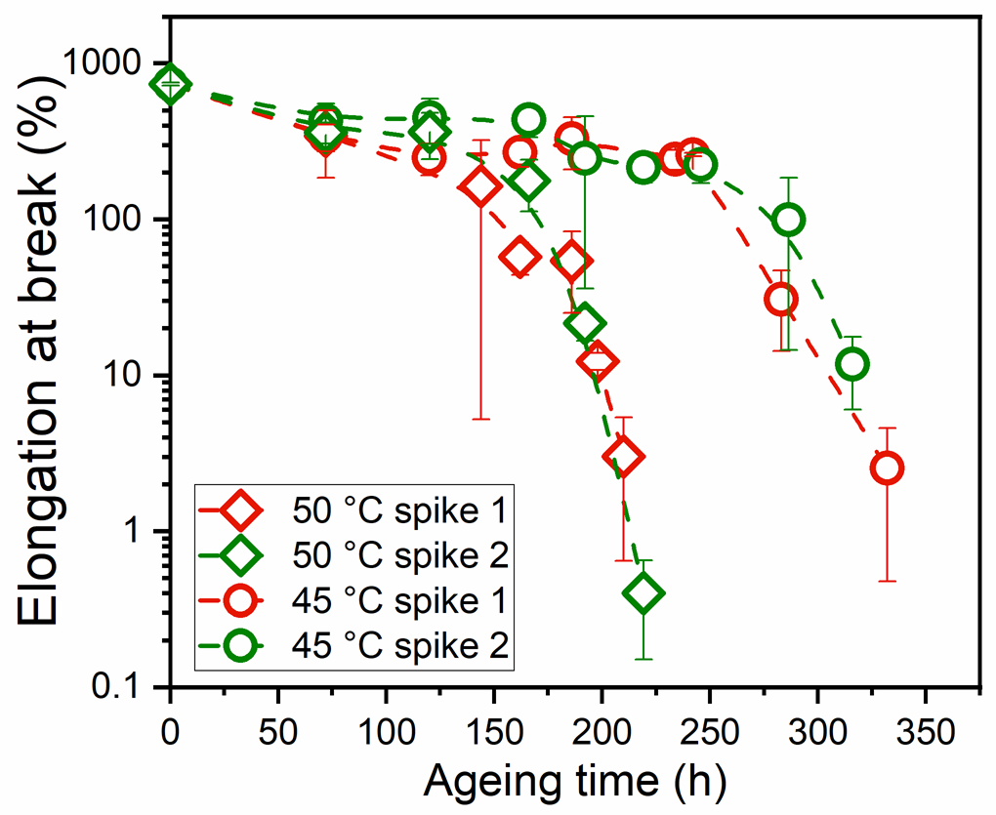
Supplementary Fig. 17. Comparison of the elongation at break of PP from two repeated ageing tests.

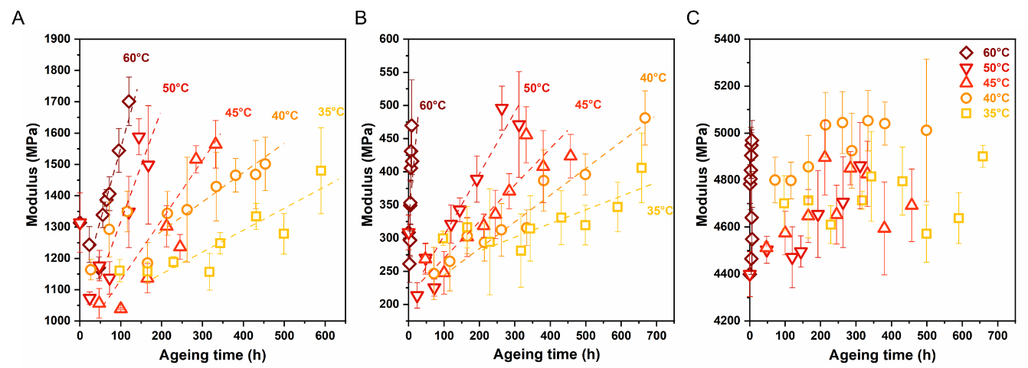
Supplementary Fig. 18. Changes in modulus of PP (A), LDPE (B) and PET (C) during ageing under different temperatures. This shows the increasing trend of modulus with increasing ageing time, and this was mainly due to the increased crystallinity during ageing.

