SUPPLEMENTAL FIGURES and TABLES

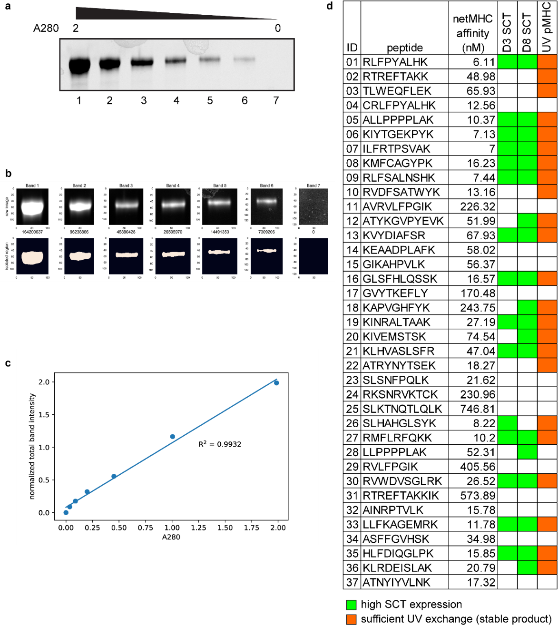

Supplementary Figure 1. SCT yield quantification and a comparison of D3 and D8 SCTs and UV-exchanged pMHCs. a. SDS-PAGE image of WT1 SCTs, titrated across a range of approximately 2.0 to 0 absorbance units (280 nm). b. Manually cropped areas of each band from reference gel (top). Isolated regions of bands identified by Python script (bottom). Integers below the top row represent the relative calculated intensity of each identified band (bottom). c. Scatterplot showing correlation of A280 values and calculated band intensity from SDS-PAGE for each reference band. d. A comparison of D3 and D8 SCTs and UV-exchanged pMHCs on the thirty-seven A*03:01-restricted private neoantigens predicted for a melanoma patient. Relative expression of D3 and D8 SCTs were quantified according to methods outlined in (a-c, see Methods) and then converted into a binary format (based upon yield being above intensity threshold of 0.15) to identify stable/high-yield pMHCs (columns 4 & 5).Stabilization of the UV-exchanged pMHCs for the same peptides was measured via an ELISA assay, also converted into a binary format (ELISA efficiency > 30%) (column 6).
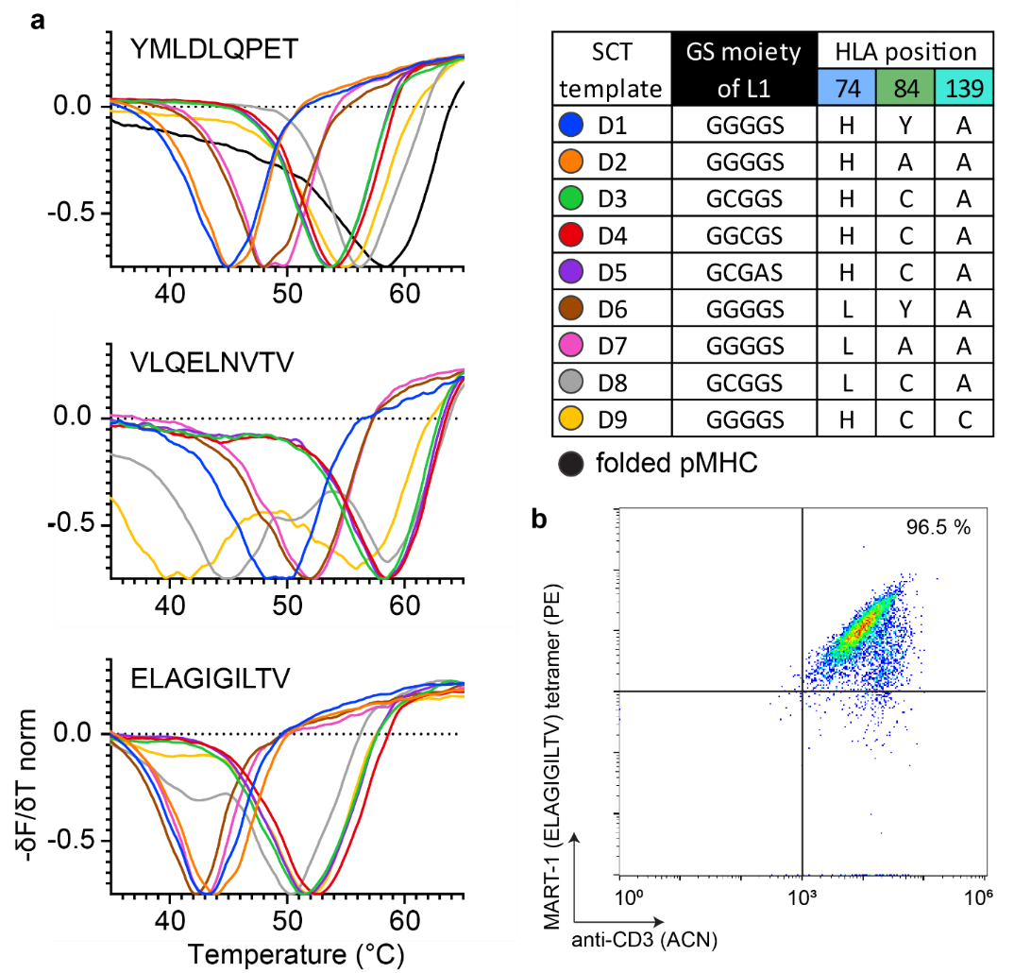
Supplementary Figure 2. Characterization of SCT thermal stability and functional evaluation of SCT tetramer. a. Thermal melting curves of SCTs. The negative of the change in fluorescence over the change in temperature (−δF/δT, first derivative) is measured for all SCT templates made against three peptides of Fig. 2b that expressed at a sufficient yield for purification. Melting curves are representative of a biological triplicate per SCT. b. Capturing of MART1-specific F5 TCR-transduced Jurkat cells with the MART1 epitope presenting SCT tetramers (D3 template).

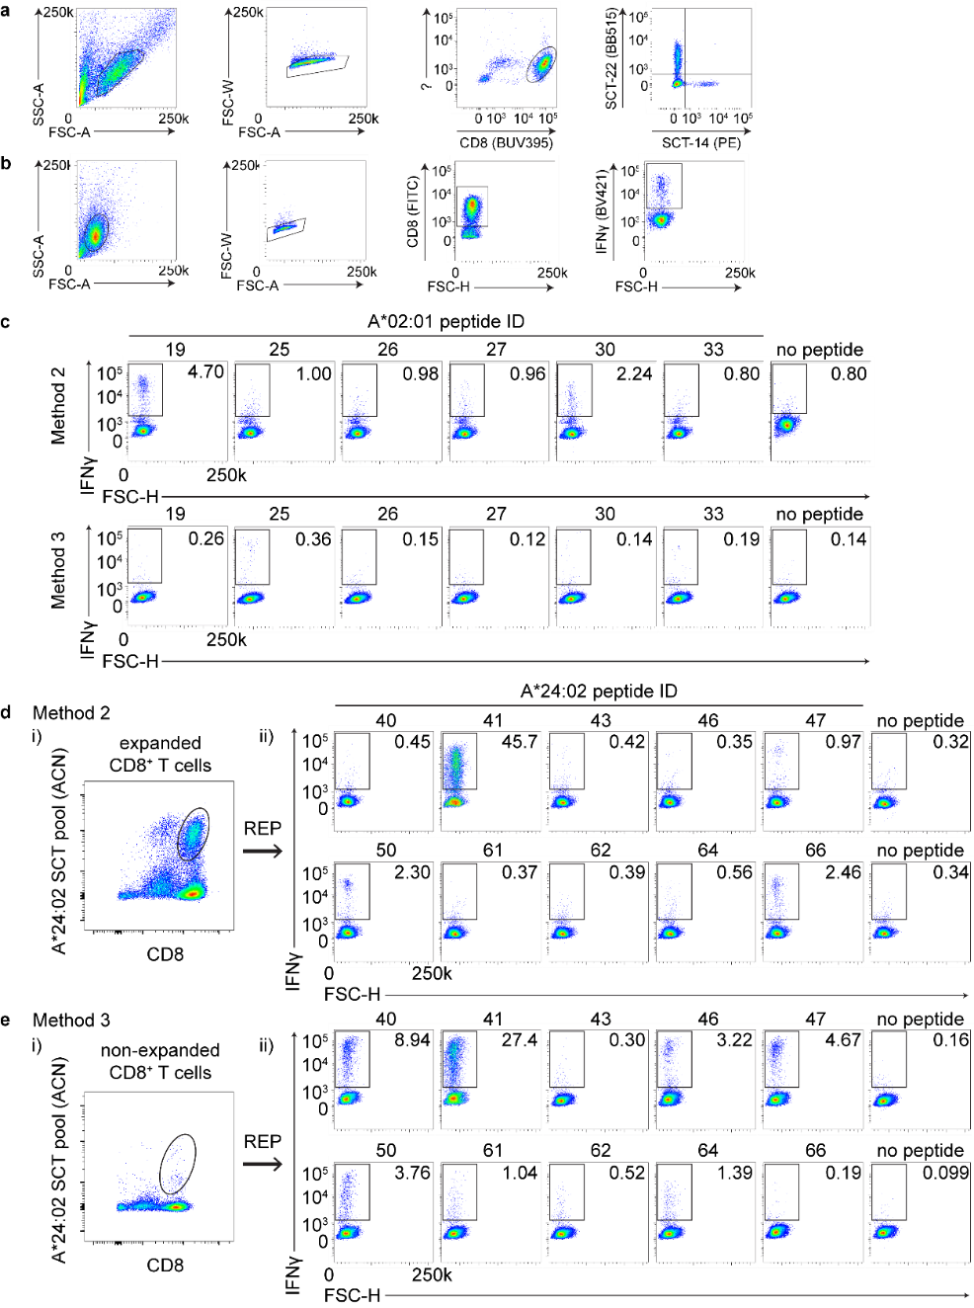
Supplementary Figure 3. Flow cytometric analysis of antigen specific CD8⁺ T cell response against commonly reported viral epitopes a. Gating strategies for flow cytometry plots of CD8+ T cells captured by 5-color pooled SCT tetramers from peptide-stimulated and expanded CD8+ T cells. Lymphocytes, single cells, CD8+ T cells and tetramer positive populations were sequentially gated. b. Gating strategies for flow cytometry plots of IFNγ+ CD8+ cells after peptide stimulation. c. Representative flow cytometry plots of IFNγ+ A*02:01-restricted CD8+ T cells after peptide stimulation. These cells were initially obtained by single-color pooled SCT tetramer binding and REP expansion (see Fig. 3 c.i andd.i). d,e. Representative flow cytometry plots of A*24:02-restricted CD8+ T cells initially captured by single-color pooled SCT tetramers from peptide-stimulated and expanded CD8+ T cells (d.i) (Method #2) or from non-stimulated, non-expanded CD8+ T cells (e.i) (Method #3). Subsequent flow plots represent IFNγ+ cells after peptide stimulation of expanded cells from the previously captured tetramer-positive subset (d.ii, e.ii). Peptide sequences found in Supplementary Table 2. Values in flow cytometry plots indicate the percentage of total cell population captured within outlined box. FSC, forward scatter; SSC, side scatter; A, area; W, width; H, height; SCT; single chain trimer; IFNγ, interferon γ; REP, rapid expansion protocol.
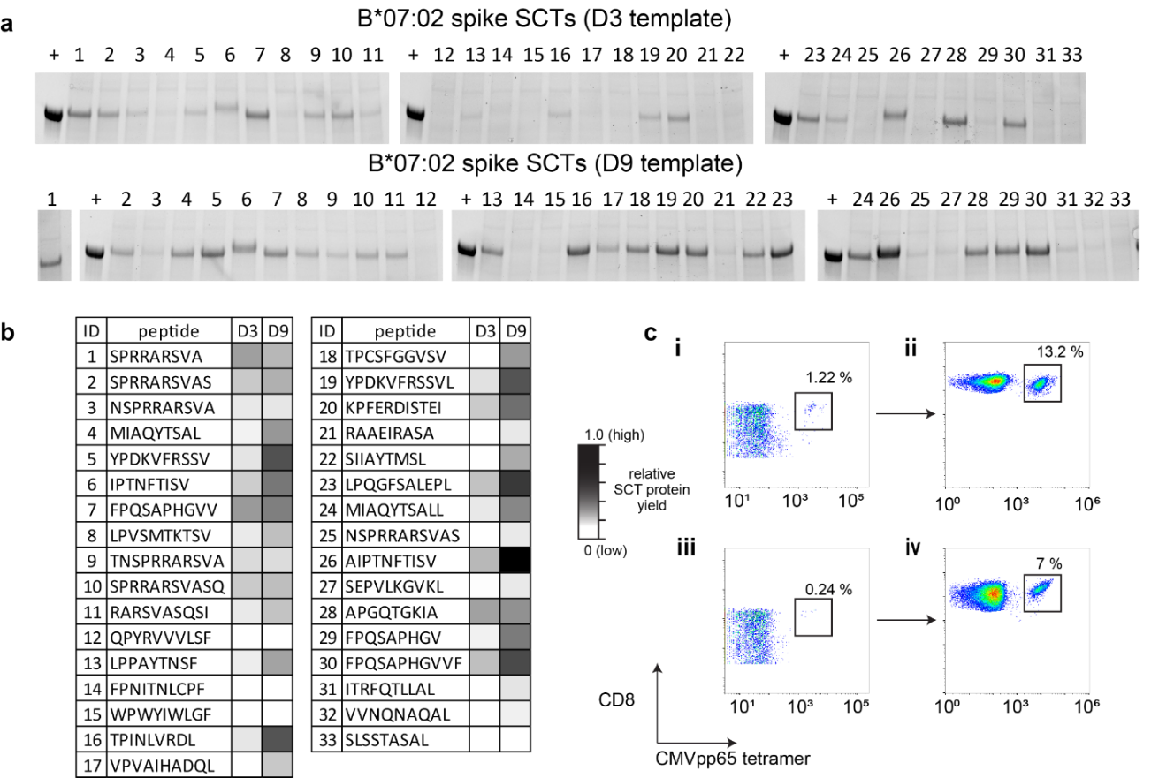

Supplementary Figure 4. Expression and characterization of B*07:02 spike SCTs and the use of SCT to capture and expand antigen specific CD8⁺ T cell population
a. Reduced SDS-PAGE of B*07:02 spike epitope SCTs using two templates (B_Y84C corresponds to template D3 and A_Y84C_A139C corresponds to template D9 (DS-SCT) of table in Figure 2.B). +, purified WT1 SCT. b. SCT yield heatmap comparing relative expression results for the two templates. c. Flow cytometry plots of CMVpp65 specific CD8⁺ T cell populations before (i and iii) and after (ii and iv) tetramer-guided sorting and expansion in the two A*02:01 COVID-19 patients. The inset box in each plot shows the frequency of CMVpp65 specific CD8⁺ T cell population.

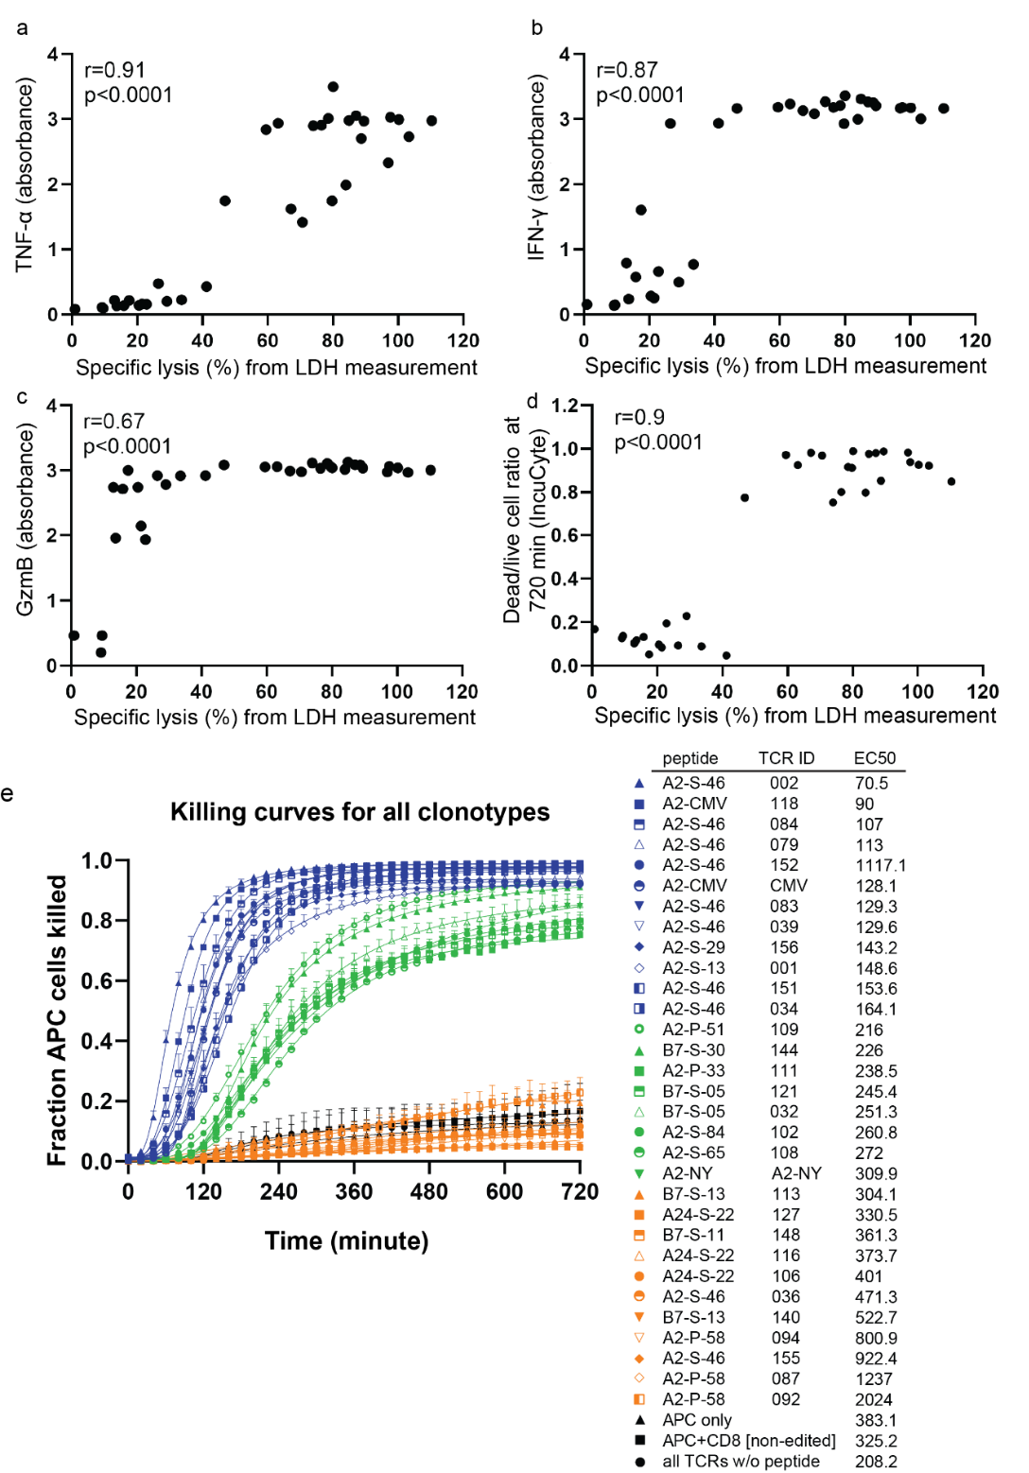
Supplementary Figure 5. Linear regression analysis of T cell functional data and curve fitting for time course killing curves.
a-c. Scatter plots showing positive correlations between all three functional cytokines (TNFα, IFNγ, and GzmB) and the assayed LDH levels. d. A scatter plot of data obtained from the two cytotoxic assays (incuCyte killing assay and non-radioactive cytotoxicity assay for LDH measurement). e. Nonlinear regression curve fitting and analysis of EC50 from IncuCyte kinetic curves. The list of peptide, internal TCR ID, and calculated EC50 values are in table. LDH, lactate dehydrogenase; TNFα, tumor necrosis factor α; IFNγ, interferon γ; GzmB, granzyme B; NY, SLLMWITQC (NY-ESO-1); CMV, NLVPMVATV; A2, A*02:01; B7, B*07:02; APC, antigen-presenting cell; P, PLpro; S, spike.
Supplementary Table 1. Tumor-associated peptides and sources.
peptide ID | peptide | protein | PubMed ref ID
1 | YMLDLQPET | E7 (PPV-9) | 29669936
2 | YMLDLQPETTDL | E7 (PPV-9) | 27693214
3 | LLMGTLGIV | E7 (PPV-9) | 26418056
4 | TLGIVCPI | E7 (PPV-9) | 8617954
5 | SLLQHLIGL | MART | 22424782
6 | VLQELNVTV | Myeloblastin | PMC1534319
7 | SVAPALALFPA | LB-ADIR-1F | 17234742
8 | FLKANLPLL | MTG8b | 11122105
9 | KLSAMQAHL | Foxp3 | 23812418
10 | LQLPTLPLV | Foxp3 | 19456276
11 | VLHDDLLEA | HA-1/A2 | 18698046
12 | VFEEPEDFL | Foxp3 | 23812418
13 | AIQDLCLAV | nucleophosmin | 31291378
14 | AIQDLCVAV | nucleophosmin | 31291378
15 | ALYVDSLFFL | PRAME | PMC2195886
16 | RMFPNAPYL | WT1 | PMC5722674
17 | SLLMWITQV | NY-ESO-1 | PMC5941317
18 | ELAGIGILTV | MART-1 | 16860654

Supplementary Table 2. Viral/bacterial A*02:01 and A*24:02 peptides used for SCT production
ID | peptide | antigen | HLA | yield
1 | LLFGYPVYV | HTLV-1 Tax | A*02:01 | 0.35
2 | KLVALGINAV | HCV | A*02:01 | 0.50
3 | GLCTLVAML | EBV-BLMF1 | A*02:01 | 0.00
4 | WLSLLVPFV | HBV-SAg | A*02:01 | 0.03
5 | YVLDHLIVV | EBV-BRLF1 | A*02:01 | 0.45
6 | SITEVECFL | Human polyomavirus 2 protein | A*02:01 | 0.29
7 | FLLSLGIHL | HBV | A*02:01 | 0.36
8 | GILGFVFTL | Flu-M1 | A*02:01 | 0.05
9 | SLFNTVATL | HIV gag | A*02:01 | 0.52
10 | YLLFEVFDV | AdV 11 Hexon | A*02:01 | 0.45
11 | LLFEVFDVV | AdV 11 Hexon | A*02:01 | 0.79
12 | YVLFEVFDV | AdV 11 Hexon | A*02:01 | 0.43
13 | FLDKGTYTL | EBV BALF4 | A*02:01 | 0.12
14 | YLQQNWWTL | EBV-LMP1-2 | A*02:01 | 0.48
15 | YLLEMLWRL | EBV-LMP1-1 | A*02:01 | 0.12
16 | FLYALALLL | EBV-LMP1-2 | A*02:01 | 0.10
17 | VLEETSVML | CMV-IE1 | A*02:01 | 0.00
18 | TLNAWVKVV | HIV-gag | A*02:01 | 0.08
19 | AIMDKNIIL | Influenza NS1 | A*02:01 | 0.33
20 | KLIANNTRV | M. tuberculosis Ag85A | A*02:01 | 0.38
21 | ALWALPHAA | varicella-zoster IE62 593-601 | A*02:01 | 0.05
22 | NLVPMVATV | CMV-pp65 | A*02:01 | 0.70
23 | FMYSDFHFI | Influenza A | A*02:01 | 0.56
24 | YLLPGWKL | Rota-VP3 | A*02:01 | 0.00
25 | NMLSTVLGV | Flu-PB1 | A*02:01 | 0.61
26 | SLMDPAILTSL | Rota-VP1 | A*02:01 | 1.42
27 | TLLANVTAV | Rota-VP6 | A*02:01 | 0.85
28 | FMDILTTCVET | CMV-IE1-2 | A*02:01 | 0.23
29 | QMWQARLTV | CMV-pp65-2 | A*02:01 | 0.07
30 | SLISGMWLL | Rota-VP2-1 | A*02:01 | 0.26
31 | LLNYILKSV | Rota-VP7-1 | A*02:01 | 0.14
32 | LMNGQQIFL | CMV-pp65-3 | A*02:01 | 0.26
33 | FLDSEPHLL | Rota-NSP1 | A*02:01 | 0.15
34 | ALWGPDPAAA | Proinsulin precursor 15-24 | A*02:01 | 0.23
35 | TLDYKPLSV | EBV BMRF1 | A*02:01 | 0.07
36 | CLGGLLTMV | EBV-LMP2A | A*02:01 | 0.04
37 | TYFNLGNKF | AdV 11 Hexon (37-45) | A*24:02 | 0.80
38 | VYSGSIPYL | AdV 11 Hexon (696-704) | A*24:02 | 0.18
39 | TYFSLNNKF | AdV 5 Hexon (37-45) | A*24:02 | 0.93
40 | DYNFVKQLF | EBV BMLF1 (320-328) | A*24:02 | 0.84
41 | TYPVLEEMF | EBV BRLF1 (198-206) | A*24:02 | 1.39
42 | RYSIFFDYM | EBV EBNA3A (246-254) | A*24:02 | 0.05
43 | TYSAGIVQI | EBV EBNA3B (217-225) | A*24:02 | 0.84
44 | IYVLVMLVL | EBV LMP2 (222-230) | A*24:02 | 0.00
45 | PYLFWLAAI | EBV LMP2 (131-139) | A*24:02 | 0.00
46 | TYGPVFMSL | EBV LMP2 (419-427) | A*24:02 | 1.13
47 | TYGPVFMCL | EBV LMP2 (419-427) | A*24:02 | 0.64
48 | EYLVSFGVW | HBV core (117-125) | A*24:02 | 0.59
49 | KYTSFPWLL | HBV pol (756-764) | A*24:02 | 0.23
50 | QYDPVAALF | HCMV pp65 (341-349) | A*24:02 | 0.51
51 | EYVLLLFLL | HCV E2 (717-725) | A*24:02 | 0.00
52 | PFHCSFHTI | HHV-6B U54 (267-275) | A*24:02 | 0.00
53 | RYLRDQQLL | HIV env gp160 (584-592) | A*24:02 | 0.19
54 | RYLKDQQLL | HIV env (67-75) | A*24:02 | 0.20
55 | RYPLTFGW | HIV nef (134-141) | A*24:02 | 0.26
56 | VYDFAFRDL | HPV16 E6 (49-57) | A*24:02 | 0.13
57 | FFQFCPLIF | HTLV-1 Env (43788) | A*24:02 | 0.63
58 | LFGYPVYVF | HTLV-1 Tax (43819) | A*24:02 | 0.51
59 | PYKRIEELL | HTLV-1 Tax (187-195) | A*24:02 | 0.00
60 | SFHSLHLLF | HTLV-1 Tax (301-309) | A*24:02 | 0.83
61 | YYLEKANKI | Influenza PA (130-138) | A*24:02 | 0.99
62 | SYLIRALTL | Influenza PB1 (216-224) | A*24:02 | 0.39
63 | RYTKTTYWW | Influenza PB1 (430-438) | A*24:02 | 0.11
64 | SYINRTGTF | Influenza PB1 (482-490) | A*24:02 | 1.02
65 | RYGFVANF | Influenza PB1 (498-505) | A*24:02 | 0.00
66 | TYQWIIRNW | Influenza PB2 (549-557) | A*24:02 | 0.90

Supplementary Table 3. A*02:01 spike peptides used for SCT production
ID | peptide | domain | span | length | predicted nM affinity | yield |  | ID
01 | YLQPRTFLL | NTD | 269-277 | 9 | 5.4 | 0.33 |  | 01
02 | FQFCNDPFL | NTD | 133-141 | 9 | 9.2 | 1.19 |  | 02
03 | FIAGLIAIV | TM | 1220-1228 | 9 | 10.3 | 0.09 |  | 03
04 | FVSNGTHWFV | CD | 1095-1104 | 10 | 13.1 | 0.53 |  | 04
05 | SIIAYTMSL | S2 | 691-699 | 9 | 13.5 | 0.88 |  | 05
06 | KLNDLCFTNV | RBD | 386-395 | 10 | 15.3 | 0.21 |  | 06
07 | RLQSLQTYV | CH | 1000-1008 | 9 | 16.7 | 0.18 |  | 07
08 | YHLMSFPQSA | S2 | 1047-1056 | 10 | 17.9 | 0.08 |  | 08
09 | YIKWPWYIWL | S2/TM | 1209-1218 | 10 | 18.8 | 0.00 |  | 09
10 | YIWLGFIAGL | TM | 1215-1224 | 10 | 20.5 | 0.09 |  | 10
11 | FELLHAPATV | RBD/S1 | 515-524 | 10 | 21 | 0.16 |  | 11
12 | FTISVTTEI | S2 | 718-726 | 9 | 25.4 | 1.74 |  | 12
13 | LLFNKVTLA | FP | 821-829 | 9 | 25.4 | 1.74 |  | 13
14 | HLMSFPQSA | S2 | 1048-1056 | 9 | 26.4 | 1.24 |  | 14
15 | FVFLVLLPLV | S | 2-11 | 10 | 32.6 | 0.00 |  | 15
16 | VLNDILSRL | HR1 | 976-984 | 9 | 33.6 | 0.11 |  | 16
17 | FIEDLLFNKV | FP | 817-826 | 10 | 36 | 0.11 |  | 17
18 | GYLQPRTFLL | NTD | 268-277 | 10 | 36.1 | 0.13 |  | 18
19 | KIADYNYKL | RBD | 417-425 | 9 | 36.1 | 0.50 |  | 19
20 | VVFLHVTYV | S2 | 1060-1068 | 9 | 36.6 | 0.08 |  | 20
21 | RLDKVEAEV | HR1/CH | 983-991 | 9 | 39 | 0.23 |  | 21
22 | FVFLVLLPL | S | 2-10 | 9 | 41.7 | 0.00 |  | 22
23 | GFIAGLIAIV | TM | 1219-1228 | 10 | 56.9 | 0.15 |  | 23
24 | YQDVNCTEV | S1 | 612-620 | 9 | 57.8 | 0.83 |  | 24
25 | FLHVTYVPA | S2 | 1062-1070 | 9 | 65.2 | 0.73 |  | 25
26 | MIAQYTSAL | S2 | 869-877 | 9 | 69 | 0.92 |  | 26
27 | KLPDDFTGCV | RBD | 424-433 | 10 | 77.1 | 0.26 |  | 27
28 | GLIAIVMVTI | TM | 1223-1232 | 10 | 80.8 | 0.00 |  | 28
29 | KQIYKTPPI | S2 | 786-794 | 9 | 85.6 | 0.61 |  | 29
30 | EFQFCNDPFL | NTD | 132-141 | 10 | 87.8 | 0.00 |  | 30
31 | TKLNDLCFTNV | RBD | 385-395 | 11 | 91.2 | 0.00 |  | 31
32 | SVTTEILPV | S2 | 721-729 | 9 | 113.1 | 0.90 |  | 32
33 | YLQPRTFLLK | NTD | 269-278 | 10 | 118.8 | 0.54 |  | 33
34 | MQMAYRFNGI | S2/HR1 | 900-909 | 10 | 120.9 | 0.39 |  | 34
35 | FQFCNDPFLGV | NTD | 133-143 | 11 | 126.8 | 1.09 |  | 35
36 | GRLQSLQTYV | CH | 999-1008 | 10 | 128.4 | 0.13 |  | 36
37 | GLTVLPPLL | S2 | 857-865 | 9 | 130.4 | 0.13 |  | 37
38 | FIAGLIAIVMV | TM | 1220-1230 | 11 | 136.3 | 0.09 |  | 38
39 | VFVSNGTHWFV | CD | 1094-1104 | 11 | 137.7 | 0.00 |  | 39
40 | WYIWLGFIAGL | TM | 1214-1224 | 11 | 140.1 | 0.00 |  | 40
41 | SFELLHAPATV | RBD/S1 | 514-524 | 11 | 140.8 | 0.10 |  | 41
42 | KQLSSNFGA | HR1 | 964-972 | 9 | 141.2 | 0.22 |  | 42
43 | FIAGLIAIVM | TM | 1220-1229 | 10 | 143 | 0.10 |  | 43
44 | TLDSKTQSL | NTD | 109-117 | 9 | 153.6 | 0.12 |  | 44
45 | MFVFLVLLPL | S | 1-10 | 10 | 157.8 | 0.00 |  | 45
46 | RLITGRLQSL | CH | 995-1004 | 10 | 167 | 1.06 |  | 46
47 | GYHLMSFPQSA | S2 | 1046-1056 | 11 | 172.6 | 0.09 |  | 47
48 | NLNESLIDL | HR2 | 1192-1200 | 9 | 177.3 | 0.24 |  | 48
49 | VLYENQKLI | HR1 | 915-923 | 9 | 194.4 | 0.16 |  | 49
50 | KLIANQFNSA | HR1 | 921-930 | 10 | 195.6 | 1.09 |  | 50
51 | VTWFHAIHV | NTD | 62-70 | 9 | 202 | 0.17 |  | 51
52 | DLLFNKVTLA | FP | 820-829 | 10 | 202 | 0.08 |  | 52
53 | QSIIAYTMSL | S2 | 690-699 | 10 | 207.4 | 0.00 |  | 53
54 | SRLDKVEAEV | HR1/CH | 982-991 | 10 | 221.2 | 0.08 |  | 54
55 | QYIKWPWYIWL | S2/TM | 1208-1218 | 11 | 223.4 | 0.00 |  | 55
56 | TLLALHRSYL | NTD | 240-249 | 10 | 227.8 | 0.33 |  | 56
57 | MFVFLVLLPLV | S | 1-11 | 11 | 229 | 0.00 |  | 57
58 | GLIAIVMVT | TM | 1223-1231 | 9 | 242 | 0.06 |  | 58
59 | YTNSFTRGV | NTD | 28-36 | 9 | 245.1 | 0.18 |  | 59
60 | ITSGWTFGA | S2 | 882-890 | 9 | 265.1 | 0.11 |  | 60
61 | KNLNESLIDL | HR2 | 1191-1200 | 10 | 268.8 | 0.07 |  | 61
62 | GVVFLHVTYV | S2 | 1059-1068 | 10 | 272.4 | 0.12 |  | 62
63 | LLIVNNATNV | NTD | 117-126 | 10 | 272.8 | 0.16 |  | 63
64 | SLSSTASAL | HR1 | 937-945 | 9 | 273.3 | 0.22 |  | 64
65 | KIYSKHTPI | NTD | 202-210 | 9 | 288.5 | 0.36 |  | 65
66 | FVSGNCDVV | CD | 1121-1129 | 9 | 290.4 | 0.12 |  | 66
67 | FQFCNDPFLG | NTD | 133-142 | 10 | 296.2 | 1.17 |  | 67
68 | KLNDLCFTNVY | RBD | 386-396 | 11 | 302.6 | 0.16 |  | 68
69 | VLSFELLHA | RBD | 512-520 | 9 | 302.6 | 0.11 |  | 69
70 | AIPTNFTISV | S2 | 713-722 | 10 | 324.5 | 0.11 |  | 70
71 | VLLPLVSSQCV | S/NTD | 16-Jun | 11 | 325.3 | 0.49 |  | 71
72 | LLALHRSYL | NTD | 241-249 | 9 | 329.1 | 0.23 |  | 72
73 | IITTDNTFV | CD | 1114-1122 | 9 | 338.8 | 0.10 |  | 73
74 | IMLCCMTSC | TM/CT | 1232-1240 | 9 | 349 | 0.13 |  | 74
75 | VFLHVTYVPA | S2 | 1061-1070 | 10 | 377.3 | 0.00 |  | 75
76 | ELLHAPATV | RBD/S1 | 516-524 | 9 | 380.7 | 0.99 |  | 76
77 | VLHSTQDLFL | NTD | 47-56 | 10 | 382.2 | 0.00 |  | 77
78 | VLYNSASFST | RBD | 367-376 | 10 | 388.9 | 0.29 |  | 78
79 | YRVVVLSFEL | RBD | 508-517 | 10 | 391.5 | 0.00 |  | 79
80 | SFIEDLLFNKV | FP | 816-826 | 11 | 394.6 | 0.05 |  | 80
81 | FLPFFSNVT | NTD | 55-63 | 9 | 398.9 | 0.15 |  | 81
82 | SVLNDILSRL | HR1 | 975-984 | 10 | 399.3 | 0.22 |  | 82
83 | ALEPLVDLPI | NTD | 222-231 | 10 | 405.6 | 0.07 |  | 83
84 | ALQIPFAMQM | S2 | 893-902 | 10 | 415.7 | 1.76 |  | 84
85 | RVVVLSFEL | RBD | 509-517 | 9 | 419.8 | 0.12 |  | 85
86 | FTISVTTEIL | S2 | 718-727 | 10 | 419.8 | 1.66 |  | 86
87 | FELLHAPATVC | RBD/S1 | 515-525 | 11 | 435.6 | 0.09 |  | 87
88 | YIWLGFIAGLI | TM | 1215-1225 | 11 | 436.3 | 0.00 |  | 88
89 | KTSVDCTMYI | S2 | 733-742 | 10 | 438.1 | 0.00 |  | 89
90 | GIYQTSNFRV | S1 | 311-320 | 10 | 449 | 0.09 |  | 90
91 | MIAQYTSALL | S2 | 869-878 | 10 | 453 | 1.10 |  | 91
92 | LGFIAGLIAIV | TM | 1218-1228 | 11 | 457.3 | 0.08 |  | 92
93 | VGYLQPRTFLL | NTD | 267-277 | 11 | 461.4 | 0.06 |  | 93
94 | WTAGAAAYYV | NTD | 258-267 | 10 | 463.3 | 0.08 |  | 94
95 | SWMESEFRV | NTD | 151-159 | 9 | 475.3 | 0.09 |  | 95
96 | NFTISVTTEI | S2 | 717-726 | 10 | 501.6 | 0.13 |  | 96

Supplementary Table 4. A*24:02 spike peptides used for SCT production
ID | peptide | domain | span | length | predicted nM affinity | yield |  | ID
01 | KWPWYIWLGF | TM | 1211-1220 | 10 | 9 | 0.16 |  | 01
02 | LYNSASFSTF | RBD | 368-377 | 10 | 12.3 | 0.31 |  | 02
03 | QYIKWPWYI | TM | 1208-1216 | 9 | 13.2 | 0.32 |  | 03
04 | QYIKWPWYIW | TM | 1208-1217 | 10 | 14.9 | 0.00 |  | 04
05 | VYSTGSNVF | S1 | 635-643 | 9 | 19 | 0.46 |  | 05
06 | VYSSANNCTF | NTD | 159-168 | 10 | 21.9 | 0.55 |  | 06
07 | CYFPLQSYGF | RBD | 488-497 | 10 | 26.6 | 0.00 |  | 07
08 | NYNYLYRLF | RBD | 448-456 | 9 | 28.9 | 0.49 |  | 08
09 | RVYSTGSNVF | S1 | 634-643 | 10 | 36.3 | 0.16 |  | 09
10 | IKWPWYIWLGF | TM | 1210-1220 | 11 | 36.3 | 0.00 |  | 10
11 | PFAMQMAYRF | S2 | 897-906 | 10 | 38.9 | 0.00 |  | 11
12 | YFPLQSYGF | RBD | 489-497 | 9 | 41.5 | 0.00 |  | 12
13 | KWPWYIWLGFI | TM | 1211-1221 | 11 | 42.1 | 0.78 |  | 13
14 | EQYIKWPWYI | TM | 1207-1216 | 10 | 45.3 | 0.33 |  | 14
15 | YEQYIKWPWYI | TM | 1206-1216 | 11 | 55.8 | 0.31 |  | 15
16 | VLYNSASFSTF | RBD | 367-377 | 11 | 64.3 | 0.00 |  | 16
17 | YYVGYLQPRTF | NTD | 265-275 | 11 | 73.3 | 0.26 |  | 17
18 | LYNSASFSTFK | RBD | 368-378 | 11 | 76.3 | 0.73 |  | 18
19 | VYSTGSNVFQ | S1 | 635-644 | 10 | 93.3 | 0.21 |  | 19
20 | EQYIKWPWYIW | TM | 1207-1217 | 11 | 96.2 | 0.38 |  | 20
21 | KYEQYIKWPW | TM | 1205-1214 | 10 | 110.2 | 0.53 |  | 21
22 | FAMQMAYRF | S2 | 898-906 | 9 | 111.5 | 0.54 |  | 22
23 | QYIKWPWYIWL | TM | 1208-1218 | 11 | 115.5 | 0.40 |  | 23
24 | IYQTSNFRV | S1 | 312-320 | 9 | 124.6 | 0.00 |  | 24
25 | TYVPAQEKNF | S2 | 1066-1075 | 10 | 137.3 | 0.68 |  | 25
26 | GYLQPRTFLL | NTD | 268-277 | 10 | 138.1 | 0.35 |  | 26
27 | RVYSSANNCTF | NTD | 158-168 | 11 | 143.7 | 0.17 |  | 27
28 | RFPNITNLCPF | RBD | 328-338 | 11 | 149.3 | 0.13 |  | 28
29 | KWPWYIWLG | TM | 1211-1219 | 9 | 152 | 0.00 |  | 29
30 | PYRVVVLSF | RBD | 507-515 | 9 | 152.4 | 0.00 |  | 30
31 | VYAWNRKRI | RBD | 350-358 | 9 | 160.3 | 0.00 |  | 31
32 | VYSSANNCTFE | NTD | 159-169 | 11 | 172.5 | 0.31 |  | 32
33 | GNYNYLYRLF | RBD | 447-456 | 10 | 174.6 | 0.22 |  | 33
34 | YYHKNNKSW | NTD | 144-152 | 9 | 223.5 | 0.32 |  | 34
35 | NYNYLYRLFR | RBD | 448-457 | 10 | 233.2 | 0.20 |  | 35
36 | IYSKHTPINL | NTD | 203-212 | 10 | 233.7 | 0.00 |  | 36
37 | IWLGFIAGLI | TM | 1216-1225 | 10 | 239 | 0.00 |  | 37
38 | NCYFPLQSYGF | RBD | 487-497 | 11 | 243.2 | 0.16 |  | 38
39 | IYKTPPIKDF | S2 | 788-797 | 10 | 252.1 | 0.24 |  | 39
40 | YNSASFSTF | RBD | 369-377 | 9 | 252.4 | 0.61 |  | 40
41 | WRVYSTGSNVF | S1 | 633-643 | 11 | 274.1 | 0.00 |  | 41
42 | CYFPLQSYGFQ | RBD | 488-498 | 11 | 299.8 | 0.53 |  | 42
43 | TFEYVSQPF | NTD | 167-175 | 9 | 337.1 | 0.58 |  | 43
44 | YFPLQSYGFQ | RBD | 489-498 | 10 | 349.3 | 0.78 |  | 44
45 | RVYSTGSNVFQ | S1 | 634-644 | 11 | 371.1 | 0.32 |  | 45
46 | CFTNVYADSF | RBD | 391-400 | 10 | 371.3 | 0.43 |  | 46
47 | EYVSQPFLM | NTD | 169-177 | 9 | 373.2 | 0.53 |  | 47
48 | VFVSNGTHWF | CD | 1094-1103 | 10 | 377.5 | 0.45 |  | 48
49 | YLQPRTFLL | NTD | 269-277 | 9 | 406.7 | 0.25 |  | 49
50 | IPFAMQMAYRF | S2 | 896-906 | 11 | 427.8 | 0.30 |  | 50
51 | VYYHKNNKSW | NTD | 143-152 | 10 | 488.9 | 0.00 |  | 51

Supplementary Table 5. B*07:02 spike peptides used for SCT production
ID | peptide | domain | span | length | predicted nM affinity | yield |  | ID
01 | SPRRARSVA | S1/S2 | 680-688 | 9 | 4.2 | 0.25 |  | 01
02 | SPRRARSVAS | S1/S2 | 680-689 | 10 | 18.4 | 0.27 |  | 02
03 | NSPRRARSVA | S1/S2 | 679-688 | 10 | 20.1 | 0.09 |  | 03
04 | MIAQYTSAL | S2 | 869-877 | 9 | 28.9 | 0.36 |  | 04
05 | YPDKVFRSSV | NTD | 38-47 | 10 | 50.2 | 0.60 |  | 05
06 | IPTNFTISV | S2 | 714-722 | 9 | 95.1 | 0.47 |  | 06
07 | FPQSAPHGVV | S2 | 1052-1061 | 10 | 99.6 | 0.44 |  | 07
08 | LPVSMTKTSV | S2 | 727-736 | 10 | 100 | 0.22 |  | 08
09 | TNSPRRARSVA | S1/S2 | 678-688 | 11 | 104.1 | 0.12 |  | 09
10 | SPRRARSVASQ | S1/S2 | 680-690 | 11 | 136.2 | 0.23 |  | 10
11 | RARSVASQSI | S1/S2 | 683-692 | 10 | 147 | 0.21 |  | 11
12 | QPYRVVVLSF | RBD | 506-515 | 10 | 163.1 | 0.00 |  | 12
13 | LPPAYTNSF | NTD | 24-32 | 9 | 168 | 0.32 |  | 13
14 | FPNITNLCPF | RBD | 329-338 | 10 | 175.2 | 0.00 |  | 14
15 | WPWYIWLGF | TM | 1212-1220 | 9 | 193.4 | 0.00 |  | 15
16 | TPINLVRDL | NTD | 208-216 | 9 | 202.5 | 0.59 |  | 16
17 | VPVAIHADQL | S1 | 620-629 | 10 | 210.8 | 0.19 |  | 17
18 | TPCSFGGVSV | S1 | 588-597 | 10 | 249.9 | 0.35 |  | 18
19 | YPDKVFRSSVL | NTD | 38-48 | 11 | 255.4 | 0.59 |  | 19
20 | KPFERDISTEI | RBD | 462-472 | 11 | 286 | 0.50 |  | 20
21 | RAAEIRASA | CH | 1014-1022 | 9 | 317.7 | 0.08 |  | 21
22 | SIIAYTMSL | S2 | 691-699 | 9 | 328 | 0.29 |  | 22
23 | LPQGFSALEPL | NTD | 216-226 | 11 | 337.2 | 0.68 |  | 23
24 | MIAQYTSALL | S2 | 869-878 | 10 | 350.9 | 0.41 |  | 24
25 | NSPRRARSVAS | S1/S2 | 679-689 | 11 | 361.2 | 0.08 |  | 25
26 | AIPTNFTISV | S2 | 713-722 | 10 | 381 | 0.88 |  | 26
27 | SEPVLKGVKL | CP | 1261-1270 | 10 | 388.2 | 0.08 |  | 27
28 | APGQTGKIA | RBD | 411-419 | 9 | 407.8 | 0.38 |  | 28
29 | FPQSAPHGV | S2 | 1052-1060 | 9 | 409.9 | 0.45 |  | 29
30 | FPQSAPHGVVF | S2 | 1052-1062 | 11 | 413.7 | 0.62 |  | 30
31 | ITRFQTLLAL | NTD | 235-244 | 10 | 444.5 | 0.10 |  | 31
32 | VVNQNAQAL | HR1 | 951-959 | 9 | 472.6 | 0.05 |  | 32
33 | SLSSTASAL | HR1 | 937-945 | 9 | 492.4 | 0.00 |  | 33

Supplementary Table 6. A*02:01 PLpro peptides used for SCT production
ID | peptide | span | length | predicted nM affinity | yield |  | ID
01 | ILFTRFFYV | 1514-1522 | 9 | 3.2 | 0.23 |  | 01
02 | YILFTRFFYV | 1513-1522 | 10 | 3.8 | 0.21 |  | 02
03 | YIFFASFYYV | 1566-1575 | 10 | 5 | 0.13 |  | 03
04 | YLATALLTL | 857-865 | 9 | 5.1 | 0.17 |  | 04
05 | WLMWLIINL | 1545-1553 | 9 | 6.6 | 0.00 |  | 05
06 | YMPYFFTLL | 1350-1358 | 9 | 7.1 | 0.21 |  | 06
07 | FLTENLLLYI | 430-439 | 10 | 7.2 | 0.92 |  | 07
08 | KLINIIIWFL | 1407-1416 | 10 | 7.3 | 0.00 |  | 08
09 | QLFFSYFAV | 1530-1538 | 9 | 10 | 0.09 |  | 09
10 | LLSAGIFGA | 330-338 | 9 | 10.1 | 0.48 |  | 10
11 | AYILFTRFFYV | 1512-1522 | 11 | 10.5 | 0.17 |  | 11
12 | MQLFFSYFAV | 1529-1538 | 10 | 10.7 | 0.32 |  | 12
13 | WLMWLIINLV | 1545-1554 | 10 | 11 | 0.11 |  | 13
14 | YLKLTDNVYI | 213-222 | 10 | 12.5 | 0.24 |  | 14
15 | LMWLIINLV | 1546-1554 | 9 | 13.3 | 0.00 |  | 15
16 | YMPYFFTLLL | 1350-1359 | 10 | 13.9 | 0.10 |  | 16
17 | FLGRYMSAL | 824-832 | 9 | 14.9 | 0.32 |  | 17
18 | KLMPVCVET | 569-577 | 9 | 15.1 | 0.90 |  | 18
19 | FVMMSAPPA | 986-994 | 9 | 15.1 | 1.32 |  | 19
20 | YVWKSYVHV | 1574-1582 | 9 | 15.2 | 0.85 |  | 20
21 | ILFTRFFYVL | 1514-1523 | 10 | 16 | 0.10 |  | 21
22 | QLEMELTPVV | 193-202 | 10 | 17 | 0.22 |  | 22
23 | YLNSTNVTI | 1452-1460 | 9 | 17.2 | 0.10 |  | 23
24 | IIWFLLLSV | 1412-1420 | 9 | 19 | 0.00 |  | 24
25 | QLMCQPILL | 1745-1753 | 9 | 19 | 0.41 |  | 25
26 | YLVQQESPFV | 978-987 | 10 | 19.3 | 1.31 |  | 26
27 | QMAPISAMV | 1555-1563 | 9 | 19.6 | 0.00 |  | 27
28 | CYLATALLTL | 856-865 | 10 | 19.8 | 0.08 |  | 28
29 | KLLHKPIVWHV | 1166-1176 | 11 | 20.5 | 0.79 |  | 29
30 | YLFDESGEFKL | 88-98 | 11 | 22.2 | 0.74 |  | 30
31 | YILFTRFFYVL | 1513-1523 | 11 | 22.3 | 0.11 |  | 31
32 | MYIFFASFYYV | 1565-1575 | 11 | 22.7 | 0.09 |  | 32
33 | MQLFFSYFA | 1529-1537 | 9 | 23.1 | 0.47 |  | 33
34 | ILGTVSWNL | 549-557 | 9 | 23.6 | 0.00 |  | 34
35 | SWLMWLIINL | 1544-1553 | 10 | 24.9 | 0.00 |  | 35
36 | LLHKPIVWHV | 1167-1176 | 10 | 27 | 0.26 |  | 36
37 | ILLLDQALV | 1751-1759 | 9 | 27.1 | 0.87 |  | 37
38 | FISNSWLMWL | 1540-1549 | 10 | 29 | 0.00 |  | 38
39 | KMFDAYVNT | 1771-1779 | 9 | 30.2 | 0.88 |  | 39
40 | SLIYSTAAL | 1424-1432 | 9 | 30.8 | 0.93 |  | 40
41 | YVWKSYVHVV | 1574-1583 | 10 | 32.5 | 0.55 |  | 41
42 | FELDERIDKV | 25-34 | 10 | 34.8 | 0.09 |  | 42
43 | KFLTENLLLYI | 429-439 | 11 | 36.4 | 0.22 |  | 43
44 | SKLINIIIWFL | 1406-1416 | 11 | 38.4 | 0.09 |  | 44
45 | VLLAPLLSA | 325-333 | 9 | 40.8 | 0.93 |  | 45
46 | SQLMCQPILL | 1744-1753 | 10 | 42.1 | 0.34 |  | 46
47 | FLKKDAPYI | 460-468 | 9 | 42.2 | 0.18 |  | 47
48 | TLVTMPLGYV | 626-635 | 10 | 43.5 | 0.75 |  | 48
49 | NTFSSTFNV | 1778-1786 | 9 | 43.6 | 0.28 |  | 49
50 | YSQLMCQPILL | 1743-1753 | 11 | 45.4 | 0.12 |  | 50
51 | TLATHGLAAV | 1303-1312 | 10 | 47.6 | 0.34 |  | 51
52 | NYMPYFFTLL | 1349-1358 | 10 | 48.7 | 0.12 |  | 52
53 | AMVRMYIFFA | 1561-1570 | 10 | 49 | 0.10 |  | 53
54 | IMQLFFSYFA | 1528-1537 | 10 | 51.3 | 0.10 |  | 54
55 | KLVSSFLEM | 367-375 | 9 | 52.5 | 0.40 |  | 55
56 | SLDNVLSTFI | 1807-1816 | 10 | 52.8 | 0.29 |  | 56
57 | YTVELGTEV | 42-50 | 9 | 53.7 | 0.64 |  | 57
58 | MLAKALRKV | 494-502 | 9 | 54.2 | 0.50 |  | 58
59 | VLSTFISAA | 1811-1819 | 9 | 55.3 | 0.13 |  | 59
60 | YLATALLTLQ | 857-866 | 10 | 56.4 | 0.18 |  | 60
61 | FITESKPSV | 396-404 | 9 | 57.5 | 0.48 |  | 61
62 | LVAEWFLAYI | 1505-1514 | 10 | 59.3 | 0.13 |  | 62
63 | IIIWFLLLSV | 1411-1420 | 10 | 59.9 | 0.00 |  | 63
64 | SWLMWLIINLV | 1544-1554 | 11 | 61.5 | 0.08 |  | 64
65 | VQMAPISAMV | 1554-1563 | 10 | 61.8 | 0.32 |  | 65
66 | IMQLFFSYFAV | 1528-1538 | 11 | 67.1 | 0.07 |  | 66
67 | QLMCQPILLL | 1745-1754 | 10 | 67.6 | 0.43 |  | 67
68 | FGLVAEWFLA | 1503-1512 | 10 | 67.7 | 0.49 |  | 68
69 | YLDGADVTKI | 780-789 | 10 | 67.8 | 0.21 |  | 69
70 | NLAKHCLHV | 291-299 | 9 | 68 | 0.14 |  | 70
71 | YIFFASFYYVW | 1566-1576 | 11 | 68.1 | 0.09 |  | 71
72 | ILAYCNKTV | 896-904 | 9 | 68.7 | 0.17 |  | 72
73 | LLLSVCLGSL | 1416-1425 | 10 | 71.4 | 0.36 |  | 73
74 | LLDQALVSDV | 1753-1762 | 10 | 80.1 | 0.27 |  | 74
75 | FLKKDAPYIV | 460-469 | 10 | 80.8 | 0.21 |  | 75
76 | LLAPLLSAGI | 326-335 | 10 | 80.9 | 0.58 |  | 76
77 | KLINIIIWFLL | 1407-1417 | 11 | 81 | 0.17 |  | 77
78 | SLKVPATVSV | 650-659 | 10 | 85.2 | 0.11 |  | 78
79 | KLDGVVCTEI | 1065-1074 | 10 | 87.1 | 0.18 |  | 79
80 | IFFASFYYV | 1567-1575 | 9 | 87.8 | 0.07 |  | 80
81 | YLAVFDKNL | 356-364 | 9 | 89 | 0.42 |  | 81
82 | YMRSLKVPATV | 647-657 | 11 | 89.2 | 0.13 |  | 82
83 | AVIKTLQPV | 60-68 | 9 | 89.6 | 0.61 |  | 83
84 | ALLTLQQIEL | 861-870 | 10 | 91.7 | 1.06 |  | 84
85 | FCLEASFNYL | 1391-1400 | 10 | 93.3 | 0.49 |  | 85
86 | TLNDLNETL | 619-627 | 9 | 95.6 | 0.14 |  | 86
87 | ALQDAYYRA | 876-884 | 9 | 100.3 | 0.08 |  | 87
88 | NYMPYFFTLLL | 1349-1359 | 11 | 101.3 | 0.10 |  | 88
89 | FLTENLLLYID | 430-440 | 11 | 102 | 1.00 |  | 89
90 | GLVAEWFLA | 1504-1512 | 9 | 105.3 | 0.24 |  | 90
91 | YVNTFSSTFNV | 1776-1786 | 11 | 110.1 | 0.46 |  | 91
92 | VLGLAAIMQL | 1522-1531 | 10 | 111.3 | 0.09 |  | 92
93 | PLLSAGIFGA | 329-338 | 10 | 111.6 | 0.13 |  | 93
94 | YVDNSSLTI | 1281-1289 | 9 | 115.3 | 0.41 |  | 94
95 | RKLMPVCVET | 568-577 | 10 | 121.6 | 0.08 |  | 95
96 | WLDDDSQQTV | 161-170 | 10 | 124.2 | 0.30 |  | 96
97 | ILFTRFFYVLG | 1514-1525 | 11 | 125.3 | 0.14 |  | 97
98 | LINIIIWFL | 1408-1417 | 9 | 126.6 | 0.08 |  | 98
99 | NLACEDLKPV | 1220-1230 | 10 | 128.4 | 0.22 |  | 99
100 | KLSHQSDIEV | 1838-1848 | 10 | 128.5 | 0.40 |  | 100
101 | LMWLIINLVQ | 1546-1556 | 10 | 131.1 | 0.13 |  | 101
102 | YYVWKSYVHV | 1573-1583 | 10 | 131.2 | 0.15 |  | 102
103 | SLINTLNDL | 615-624 | 9 | 133 | 1.49 |  | 103
104 | GYLKLTDNVYI | 212-223 | 11 | 135.4 | 0.10 |  | 104
105 | NLAKHCLHVV | 291-301 | 10 | 137.4 | 0.19 |  | 105
106 | TLNDLNETLV | 619-629 | 10 | 139.8 | 0.22 |  | 106
107 | FTRFFYVLGL | 1516-1526 | 10 | 142.2 | 0.28 |  | 107
108 | NSWLMWLIINL | 1543-1554 | 11 | 149.1 | 0.00 |  | 108
109 | WLMWLIINLVQ | 1545-1556 | 11 | 154.2 | 0.09 |  | 109
110 | QLFFSYFAVH | 1530-1540 | 10 | 156.8 | 0.00 |  | 110
111 | FLNKVVSTT | 1327-1336 | 9 | 157 | 0.32 |  | 111
112 | GYLNSTNVTI | 1451-1461 | 10 | 164.2 | 0.09 |  | 112
113 | VLTAVVIPT | 477-486 | 9 | 168.2 | 0.16 |  | 113
114 | LLLQLCTFT | 1357-1366 | 9 | 169.2 | 0.32 |  | 114
115 | PQLEMELTPVV | 192-203 | 11 | 170.5 | 0.21 |  | 115
116 | VLPNDDTLRV | 802-812 | 10 | 172.5 | 0.08 |  | 116
117 | NCYLATALLTL | 855-866 | 11 | 173.3 | 0.13 |  | 117
118 | SAFYILPSI | 533-542 | 9 | 179.7 | 0.13 |  | 118
119 | TLYCIDGALL | 1026-1036 | 10 | 180.9 | 0.10 |  | 119
120 | LMCQPILLL | 1746-1755 | 9 | 184.2 | 0.35 |  | 120
121 | IIWFLLLSVC | 1412-1422 | 10 | 188 | 0.00 |  | 121
122 | FSYFAVHFI | 1533-1542 | 9 | 195.1 | 0.13 |  | 122
123 | SFLGRYMSAL | 823-833 | 10 | 196.9 | 0.07 |  | 123
124 | MPLGYVTHGL | 630-640 | 10 | 197.4 | 0.10 |  | 124
125 | LILAYCNKTV | 895-905 | 10 | 199.2 | 0.15 |  | 125
126 | MQLFFSYFAVH | 1529-1540 | 11 | 214.2 | 0.12 |  | 126
127 | QLEMELTPV | 193-202 | 9 | 215.1 | 0.23 |  | 127
128 | EILGTVSWNL | 548-558 | 10 | 217.3 | 0.13 |  | 128
129 | PILLLDQALV | 1750-1760 | 10 | 222.8 | 0.17 |  | 129
130 | FLAYILFTRF | 1510-1520 | 10 | 226.9 | 0.00 |  | 130
131 | KYLVQQESPFV | 977-988 | 11 | 230.2 | 0.09 |  | 131
132 | LLTLQQIEL | 862-871 | 9 | 239.6 | 0.77 |  | 132
133 | FISNSWLMWLI | 1540-1551 | 11 | 240.2 | 0.00 |  | 133
134 | TTIQTIVEV | 182-191 | 9 | 241.3 | 0.69 |  | 134
135 | KIAEIPKEEV | 384-394 | 10 | 247.7 | 0.19 |  | 135
136 | YLKSPNFSKL | 1399-1409 | 10 | 248.8 | 0.07 |  | 136
137 | KLMPVCVETKA | 569-580 | 11 | 249.5 | 0.82 |  | 137
138 | YIATNGPLKV | 272-282 | 10 | 250.5 | 0.09 |  | 138
139 | YMRSLKVPA | 647-656 | 9 | 251.4 | 0.10 |  | 139
140 | MELTPVVQTI | 196-206 | 10 | 255.7 | 0.11 |  | 140
141 | TLYCIDGAL | 1026-1035 | 9 | 267.7 | 0.08 |  | 141
142 | IDLDEWSMAT | 77-87 | 10 | 281.2 | 0.09 |  | 142
143 | YLNSTNVTIA | 1452-1462 | 10 | 289.4 | 0.09 |  | 143
144 | MQVESDDYI | 265-274 | 9 | 294 | 0.24 |  | 144
145 | EVLLAPLLSA | 324-334 | 10 | 296.2 | 0.07 |  | 145
146 | SLETIQITI | 1485-1494 | 9 | 297.5 | 0.25 |  | 146
147 | GLVAEWFLAYI | 1504-1515 | 11 | 300.4 | 0.20 |  | 147
148 | FLLLSVCLGS | 1415-1425 | 10 | 300.8 | 0.00 |  | 148
149 | YYVWKSYVHVV | 1573-1584 | 11 | 302.2 | 0.00 |  | 149
150 | LLSVCLGSL | 1417-1426 | 9 | 305.3 | 0.11 |  | 150
151 | VNTFSSTFNV | 1777-1787 | 10 | 308.6 | 0.09 |  | 151
152 | YMPYFFTLLLQ | 1350-1361 | 11 | 309 | 0.09 |  | 152
153 | TLQPVSELL | 64-73 | 9 | 315 | 0.32 |  | 153
154 | FLLLSVCLGSL | 1415-1426 | 11 | 324.7 | 0.06 |  | 154
155 | NLYDKLVSSFL | 363-374 | 11 | 325.4 | 0.28 |  | 155
156 | LLYIDINGNL | 436-446 | 10 | 327.3 | 0.28 |  | 156
157 | FGDDTVIEV | 7-16 | 9 | 328.5 | 0.30 |  | 157
158 | RTIKVFTTV | 748-757 | 9 | 330.4 | 0.75 |  | 158
159 | LIYSTAALGV | 1425-1435 | 10 | 330.8 | 0.14 |  | 159
160 | FLEMKSEKQV | 372-382 | 10 | 334.8 | 0.09 |  | 160
161 | LLSAGIFGAD | 330-340 | 10 | 351.2 | 0.32 |  | 161
162 | GSLIYSTAAL | 1423-1433 | 10 | 358.6 | 0.94 |  | 162
163 | YLFDESGEF | 88-97 | 9 | 360 | 0.68 |  | 163
164 | PFVMMSAPPA | 985-995 | 10 | 363.4 | 0.20 |  | 164
165 | TFELDERIDKV | 24-35 | 11 | 368.3 | 0.08 |  | 165
166 | CLGSLIYST | 1421-1430 | 9 | 375.2 | 0.07 |  | 166
167 | KLINIIIWF | 1407-1416 | 9 | 382.9 | 0.10 |  | 167
168 | WLIINLVQMA | 1548-1558 | 10 | 395.1 | 0.00 |  | 168
169 | LVQMAPISAMV | 1553-1564 | 11 | 402.1 | 0.49 |  | 169
170 | MVRMYIFFA | 1562-1571 | 9 | 404 | 0.00 |  | 170
171 | KLMPVCVETK | 569-579 | 10 | 404.3 | 0.94 |  | 171
172 | NLHPDSATL | 444-453 | 9 | 411.9 | 0.12 |  | 172
173 | HFISNSWLMWL | 1539-1550 | 11 | 415.1 | 0.00 |  | 173
174 | VLMSNLGMPS | 1434-1444 | 10 | 417.1 | 0.45 |  | 174
175 | LVQQESPFV | 979-988 | 9 | 419.2 | 0.19 |  | 175
176 | KLTCATTRQV | 1923-1933 | 10 | 430.8 | 0.08 |  | 176
177 | FVCDNIKFA | 1112-1121 | 9 | 432.8 | 0.63 |  | 177
178 | DKLVSSFLEM | 366-376 | 10 | 447 | 0.00 |  | 178
179 | TIVEVQPQL | 186-195 | 9 | 447.8 | 0.58 |  | 179
180 | KSVNITFEL | 19-28 | 9 | 453.2 | 0.82 |  | 180
181 | VLNEKCSAYTV | 34-45 | 11 | 457.4 | 0.10 |  | 181
182 | FLAYILFTR | 1510-1519 | 9 | 460.6 | 0.05 |  | 182
183 | TNYMPYFFTLL | 1348-1359 | 11 | 467.8 | 0.00 |  | 183
184 | NIIIWFLLLSV | 1410-1421 | 11 | 470.4 | 0.00 |  | 184
185 | TMSYLFQHA | 913-922 | 9 | 481.5 | 0.00 |  | 185
186 | FPDLNGDVVAI | 1142-1153 | 11 | 489.5 | 0.10 |  | 186
187 | LLLDQALVSDV | 1752-1763 | 11 | 491.8 | 1.24 |  | 187
188 | YPQVNGLTSI | 840-850 | 10 | 491.9 | 0.00 |  | 188
189 | KLASHMYCS | 97-106 | 9 | 493.4 | 0.38 |  | 189
190 | HNLAKHCLHV | 290-300 | 10 | 494.6 | 0.00 |  | 190
191 | YLVQQESPFVM | 978-989 | 11 | 497.2 | 1.48 |  | 191

Supplementary Table 7. A list of TCRs, cognate antigens, and their groupings
