Supplementary Materials

Supplementary Materials S1: Similarity Features in Train and Test Data
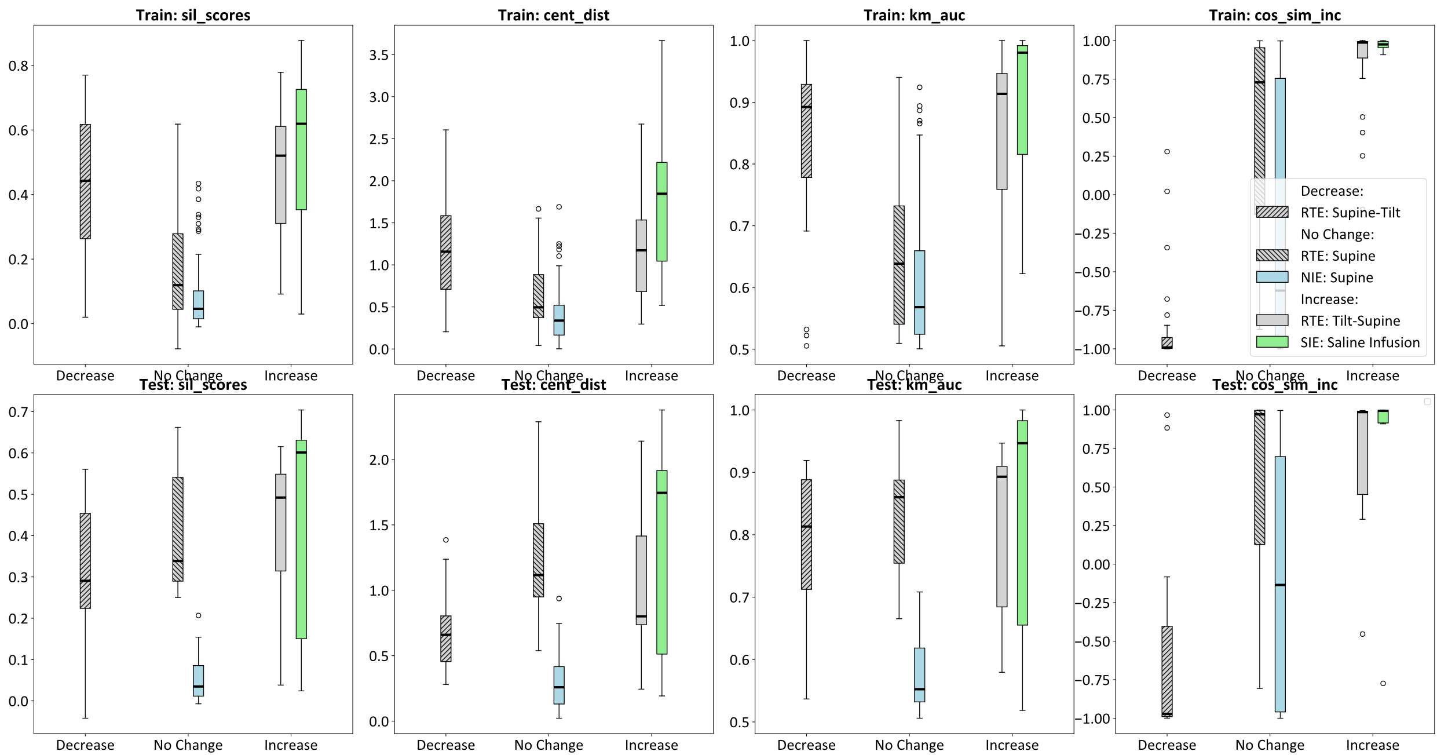
Figure S1: The similarity measures in train data in first row and test data in second row for expected decrease, no change, and increase in preload across the three different experiments.

