Supplementary Material:
S1. Visual depiction of averaged SCR for each trial and CS type for each study, and summary of the evidence for CS type, Trial effects, and their interaction on SCR in each study, separately.
S2. Representational similarity matrices (RSMs) of skin conductance response (SCR) for each study, and summary of the evidence for a correspondence between SCR and learning strategies across studies and participants.
S3. Time-series representation exemplifying forward and backward models of threat learning and uncertainty reduction in different CS-US contingency rates.
S4. RSMs of the forward threat strategy for each study.
S5. RSMs of the backward threat strategy for each study.
S6. RSMs of the forward uncertainty strategy for each study.
S7. RSMs of the backward uncertainty learning strategy for each study.
S8. Unsupervised cluster analysis.
S9. Cluster differences based on categorical anxiety levels.
S10. Comparison between clusters based on similarities with backward threat learning and uncertainty reduction strategies on anxiety scores after leaving one study out at a time.

S1. Visual depiction of averaged SCR for each trial and CS type for each study.
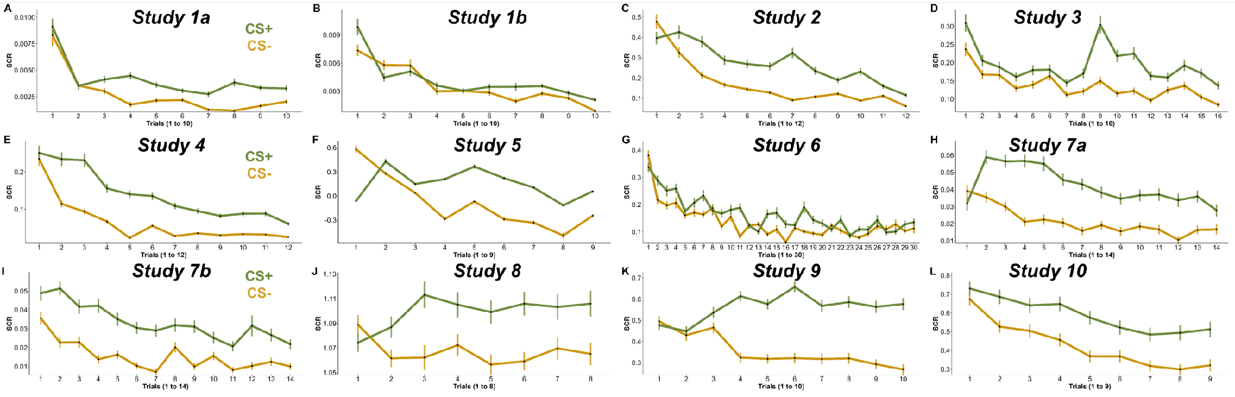
Figure S1. Averaged SCR for each trial and CS type of each study.

Table S1. Summary of the evidence for CS type, Trial effects, and their interaction on SCR in each study, separately. In bold, results showing evidence in favor of the tested effects.
 | CS type | Trial | CS x Trials interaction
Study 1a | β = 7.4 x 10³, t₇₁₉= 1.021, logBF₁₀= 4.75 | β= -4.8 x10⁴, t₇₁₉= -5.72, logBF₁₀= 19.66 | β= 1.17 x10⁴, t₇₁₉= 0.97, logBF₁₀=-1.87
Study 1b | β= 1.96 x10⁴, t₇₁₉= 0.25, logBF₁₀= -1.45 | β= -6.12 x10⁴, t₇₁₉= -6.94, logBF₁₀=31.13 | β= 7.08 x10⁵, t₇₁₉= 0.56, logBF₁₀==-2.20
Study 2 | β= 8.59 x10², t₂₅₁₃=3.13, logBF₁₀=21.44 | β= -2.71 x10², t₂₅₁₃=-10.26, logBF₁₀=69.61 | β= 2.61 x10³, t₂₅₁₃= 0.70, logBF₁₀=-2.68
Study 3 | β= 4.13 x10², t₃₆₂₄= 3.19, logBF₁₀=23.36 | β= -5.76 x10³, t₃₆₂₄= -6.1, logBF₁₀=11.93 | β= 2.05 x10³, t₃₆₂₄= 1.53, logBF₁₀=-2.21
Study 4 | β= 0.10, t₃₆₀₆= 8.62, logBF₁₀=61.40 | β= -1.27 x10², t₃₆₀₆= -10.96, logBF₁₀=118.62 | β= -4.51 x10², t₃₆₀₆= -2.74, logBF₁₀=-0.21
Study 5 | β= -0.18, t₁₀₉₄= -1.08, logBF₁₀=1.88 | β= -0.11, t₁₀₉₄= -4.89, logBF₁₀=6.17 | β= 0.86, t₁₀₉₄= 2.79, logBF₁₀=1.56
Study6 | β= 4.37 x10², t₁₅₉₀= 2.70, logBF₁₀=0.22 | β= -3.73 x10³, t₁₅₉₀= -2.58, logBF₁₀=.004 | β= -9.12 x10⁴, T₁₅₉₀= -1.00, logBF₁₀=-2.03
Study7a | β= 2.22 x10², t₂₉₂₀= 8.69, logBF₁₀=87.15 | β= -1.64 x10³, t₂₉₁₈= -7.77, logBF₁₀=35.10 | β= -1.16 x10⁴, t₂₉₁₉= -0.38, logBF₁₀=-2.82
Study7b | β= 2.33 x10², t₁₉₀₉= 8.19, logBF₁₀=50.03 | β= -1.31 x10³, t₁₉₀₉= -5.56, logBF₁₀=26.62 | β= -6.92 x10⁴, t₁₉₀₉= -2.09, logBF₁₀=-1.23
Study 8 | β= 9.96 x10³, t₁₇₉₇= 1.14, logBF₁₀=15.21 | β= -1.78 x10³, ₁₇₉₇= -1.53, logBF₁₀=-2.34 | β= 5.06 x10³, t₁₇₉₇= 3.04, logBF₁₀=-0.20
Study 9 | β= 1.71 x10², t₁₂₅₁= 0.53, logBF₁₀=60.61 | β= -2.27 x10², t₁₂₅₁= -6.20, logBF₁₀=-0.80 | β= 3.42 x10², t₁₂₅₁= 6.61, logBF₁₀=12.64
Study 10 | β= 0.12, t₁₄₉₃= 2.77, logBF₁₀=21.40 | β= -4.26 x10², t₁₄₉₃= -8.85, logBF₁₀=31.03 | β= 1.11 x10², t₁₄₉₃= 1.64, logBF₁₀=-1.77

S2. Representational similarity matrices (RSMs) of skin conductance response (SCR) for each study, and summary of the evidence for a correspondence between SCR and learning strategies across studies and participants.
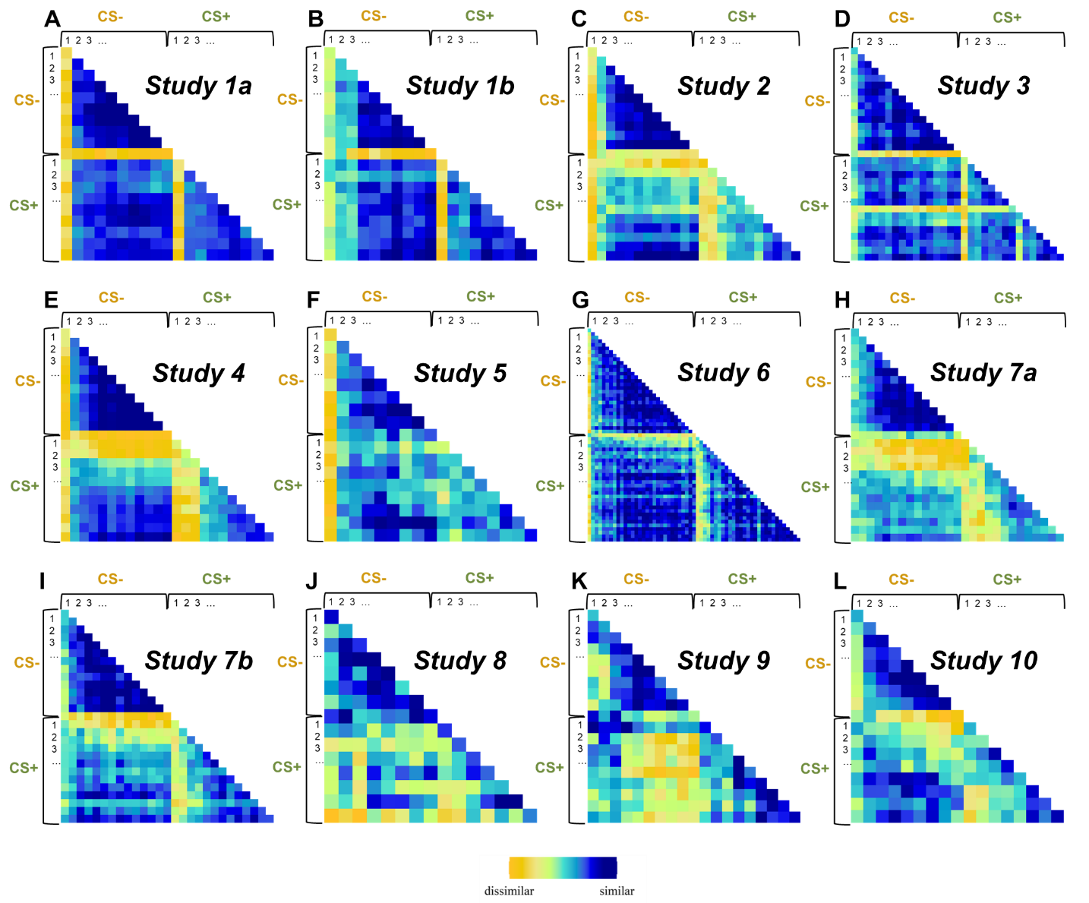
Figure S2. Representational similarity matrices (RSMs) illustrating the similarity across trials based on the SCR for each study.

Table S2. Summary of the evidence for a correspondence between SCR and backward (P_{CS|US}) and forward models (P_{US|CS}) of threat learning and uncertainty reduction learning (UncP_{US|CS}, UncP_{CS|US}), in each study, separately. In bold, results demonstrating evidence in favor of correspondence.
 | P_{CS|US} | P_{US|CS} | UncP_{CS|US} | UncP_{US|CS}
Study 1a | logBF₁₀=-4.41 | logBF₁₀=-4.49 | logBF₁₀=111.59 | logBF₁₀=112.87
Study 1b | logBF₁₀=-5.57 | logBF₁₀=-5.13 | logBF₁₀=88.87 | logBF₁₀=-1.75
Study 2 | logBF₁₀=-1.93 | logBF₁₀=-0.28 | logBF₁₀=72.35 | logBF₁₀=9.79
Study 3 | logBF₁₀=0.45 | logBF₁₀=0.61 | logBF₁₀= 65.85 | logBF₁₀=2.57
Study 4 | logBF₁₀=-1.5 | logBF₁₀=-1.39 | logBF₁₀=77.32 | logBF₁₀=71.16
Study 5 | logBF₁₀=-3.33 | logBF₁₀=-4.12 | logBF₁₀=4.64 | logBF₁₀=27.37
Study6 | logBF₁₀=-5.4 | logBF₁₀=3.35 | logBF₁₀=120 | logBF₁₀=-0.17
Study7a | logBF₁₀=1.8 | logBF₁₀=1.32 | logBF₁₀=22.36 | logBF₁₀=2.71
Study7b | logBF₁₀=-1.48 | logBF₁₀=-1.59 | logBF₁₀=105.11 | logBF₁₀=56
Study 8 | logBF₁₀=6.15 | logBF₁₀=2.17 | logBF₁₀=0.69 | logBF₁₀=-0.58
Study 9 | logBF₁₀=16.31 | logBF₁₀=27.72 | logBF₁₀=-2.14 | logBF₁₀=30.68
Study 10 | logBF₁₀=-1.04 | logBF₁₀=1.25 | logBF₁₀=35.93 | logBF₁₀=5.56
M_{Evidence} (SD_{Evidence}) | 0.004 (6.08) | 1.61 (8.65) | 58.54 (44.75) | 26.35 (36.23)

Table S3. pair-wise comparison of the correspondence between SCR and forward and backward models of threat learning and uncertainty reduction across studies. In bold, results indicating evidence in favor of differences between models.
 | P_{CS|US} | P_{US|CS} | UncP_{CS|US} | UncP_{US|CS}
P_{CS|US} | —
P_{US|CS} | t22=-0.52, p = .60, d = 0.21, BF10 = 0.57. | —
UncP_{CS|US} | t22=-4.48, p <.001, d = 1.83, BF10 = 25.84; | t22=-4.33, p <.001, d = 1.77, BF10 = 21.52 | —
UncP_{US|CS} | t22=-2.48, p = .059, d = 1.01, BF10 = 2.28 | t22=-2.29, p = .060, d = 0.94, BF10 = 1.73 | t22=-1.93, p =.08, d = 0.79, BF10 = 2.21 | —

Table S4. pair-wise comparison of the correspondence between SCR and forward and backward models of threat learning and uncertainty reduction across participants. In bold, results indicating evidence in favor of differences between models.
 | P_{CS|US} | P_{US|CS} | UncP_{CS|US} | UncP_{US|CS}
P_{CS|US} | —
P_{US|CS} | t931=-1.11, p = .26, d = 0.01, BF10 = 0.06. | —
UncP_{CS|US} | t931=--11.87, p <.001, d = 0.63, BF10 >100; | t931=-11.90, p <.001, d = 0.61, BF10 >100 | —
UncP_{US|CS} | t931=--10.44, p < .001, d = 0.46, BF10 >100 | t931=-10.06, p <.001, d = 0.44, BF10 >100 | t931=-.646, p <.001, d = 0.19, BF10 >100 | —
Mean (SD) | .047 (0.12) | .049 (0.13) | .157 (0.21) | .119(0.18)

S3. Time-series representation exemplifying forward and backward models of threat learning and uncertainty reduction in different CS-US contingency rates.
Table S5. Example of Pavlovian Conditioning paradigm with different CS-US contingencies. CS type: 1= CS+, 0 = CS-. US: 1= US presented, 0= No US presented.
Trial | CS type | US 50% | US 60% | US 70% | US 100%
1 | 1 | 1 | 1 | 1 | 1
2 | 0 | 0 | 0 | 0 | 0
3 | 0 | 0 | 0 | 0 | 0
4 | 1 | 0 | 0 | 1 | 1
5 | 1 | 1 | 1 | 0 | 1
6 | 0 | 0 | 0 | 0 | 0
7 | 1 | 0 | 0 | 1 | 1
8 | 0 | 0 | 0 | 0 | 0
9 | 0 | 0 | 0 | 0 | 0
10 | 1 | 1 | 1 | 1 | 1
11 | 0 | 0 | 0 | 0 | 0
12 | 1 | 1 | 1 | 1 | 1
13 | 1 | 0 | 0 | 0 | 1
14 | 0 | 0 | 0 | 0 | 0
15 | 1 | 0 | 1 | 1 | 1
16 | 0 | 0 | 0 | 0 | 0
17 | 0 | 0 | 0 | 0 | 0
18 | 1 | 1 | 1 | 1 | 1
19 | 1 | 0 | 0 | 0 | 1
20 | 0 | 0 | 0 | 0 | 0

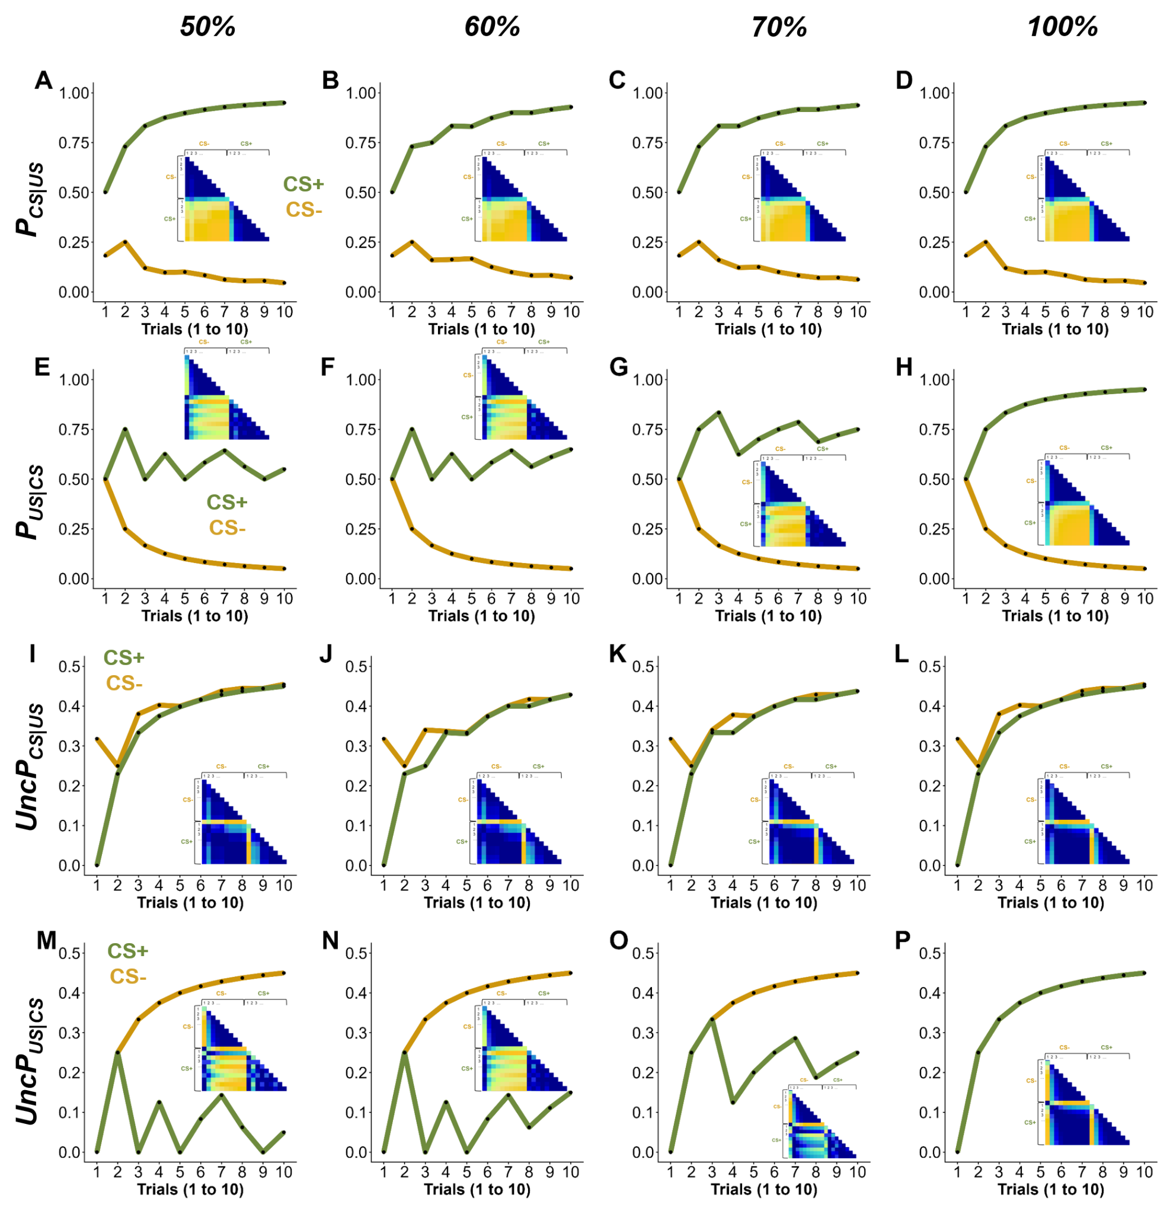
Figure S3. Time series representation of backward (A-D) and forward (E-H) models of threat learning, and backward (I-L) and forward (M-P) models of uncertainty reduction across different CS/US contingencies. Insets depict the representational similarity matrices (RSMs) of the model estimates.
S4. RSMs of the forward threat learning strategy (P_{US|CS}) for each study.
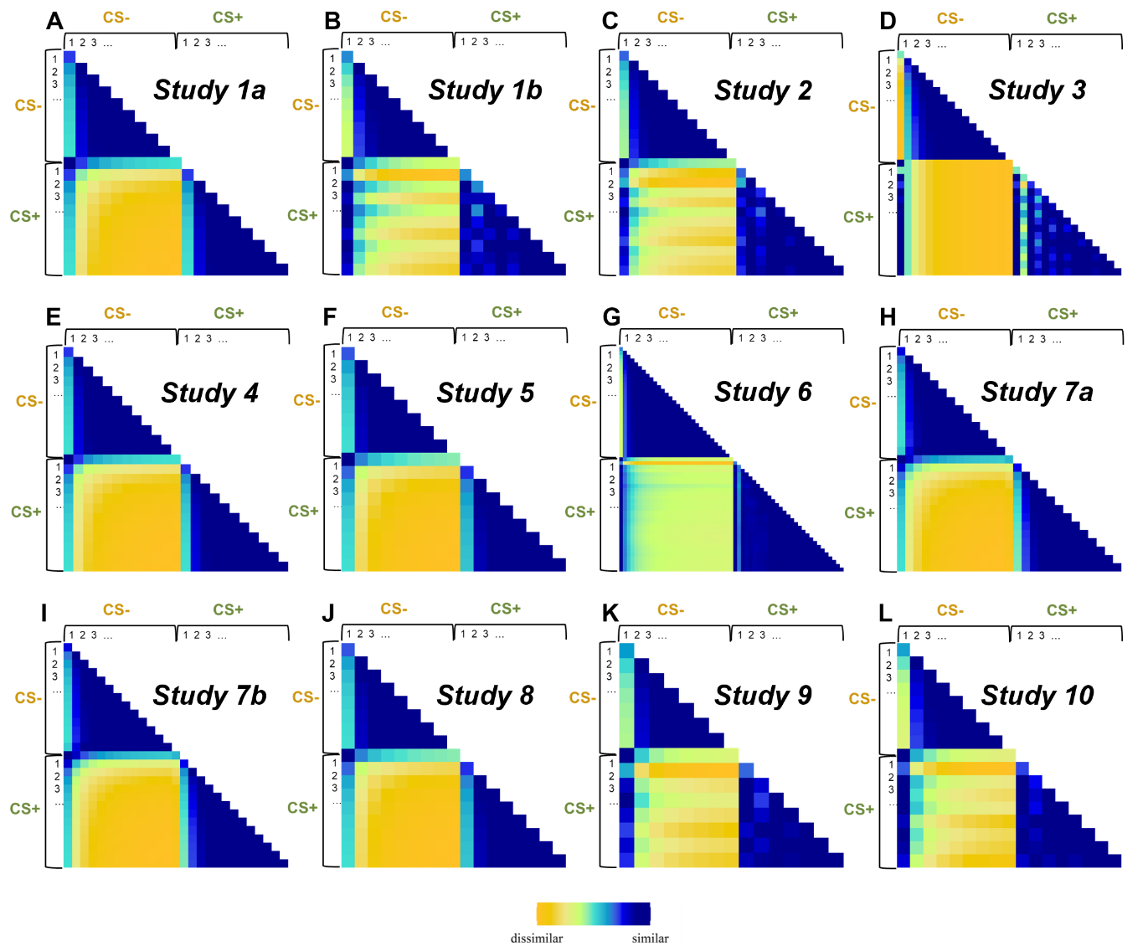
Figure S4. RSMs illustrate the similarity across trials based on the forward threat learning model for each study.

S5. RSMs of the backward threat learning strategy (P_{CS|US}) for each study.
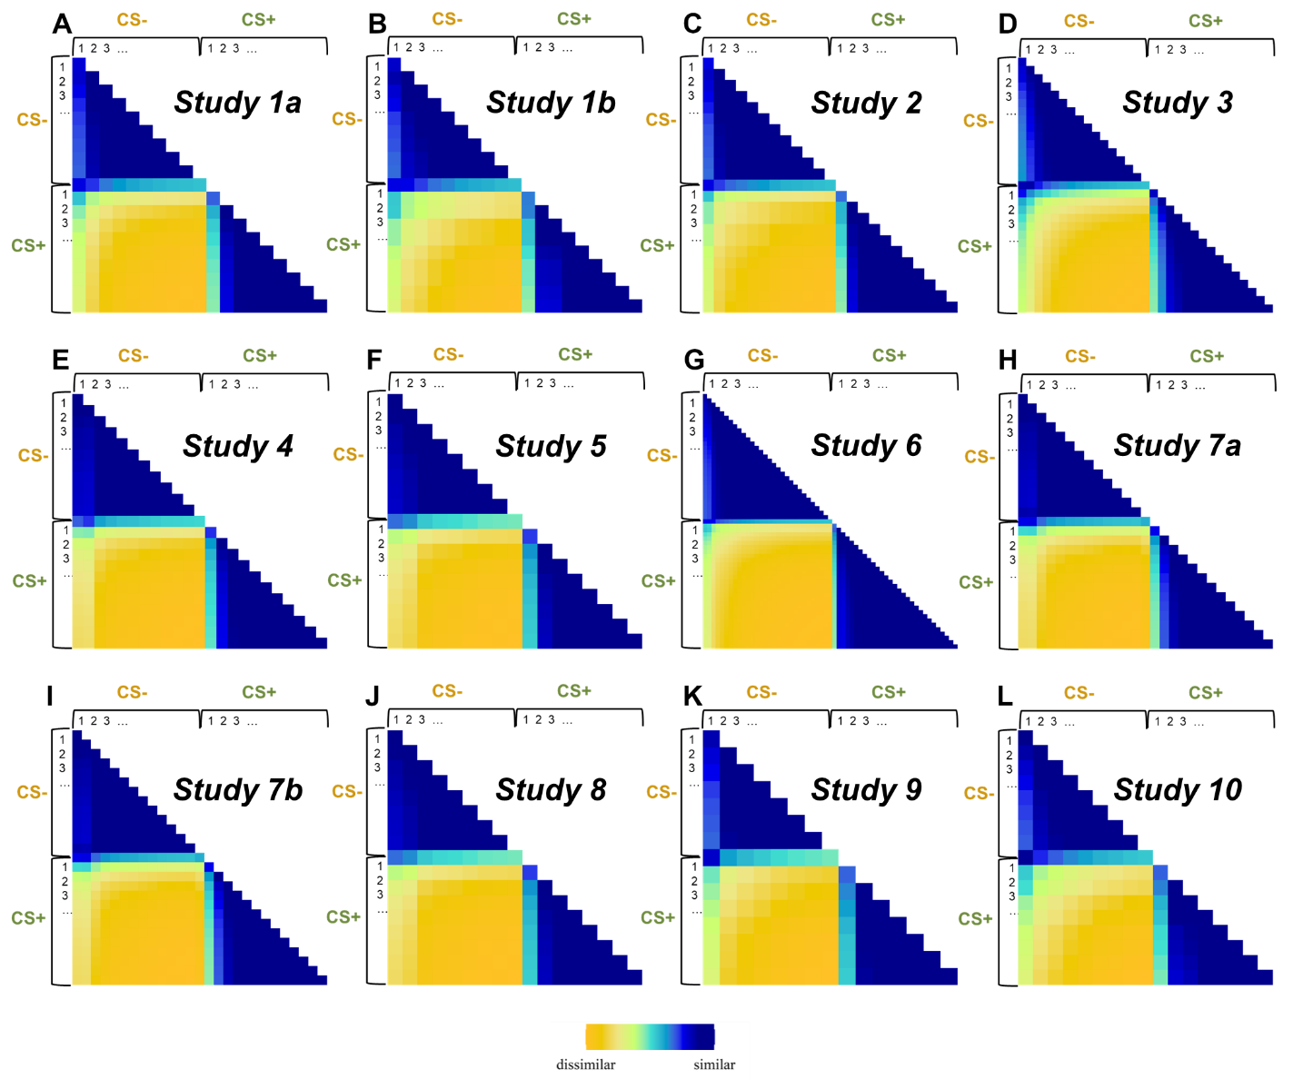
Figure S5. RSMs illustrate the similarity across trials based on the backward threat learning model for each study.

S6. RSMs of the forward uncertainty learning strategy (UncP_{US|CS}) for each study.
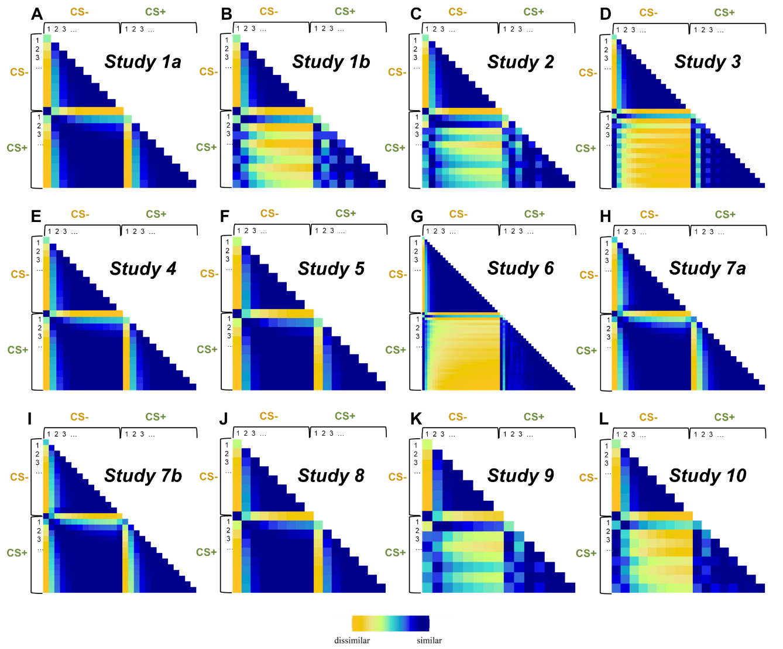
Figure S6. RSMs illustrate the similarity across trials based on the forward uncertainty learning model for each study.

S7. RSMs of the backward uncertainty learning strategy (UncP_{CS|US}) for each study.
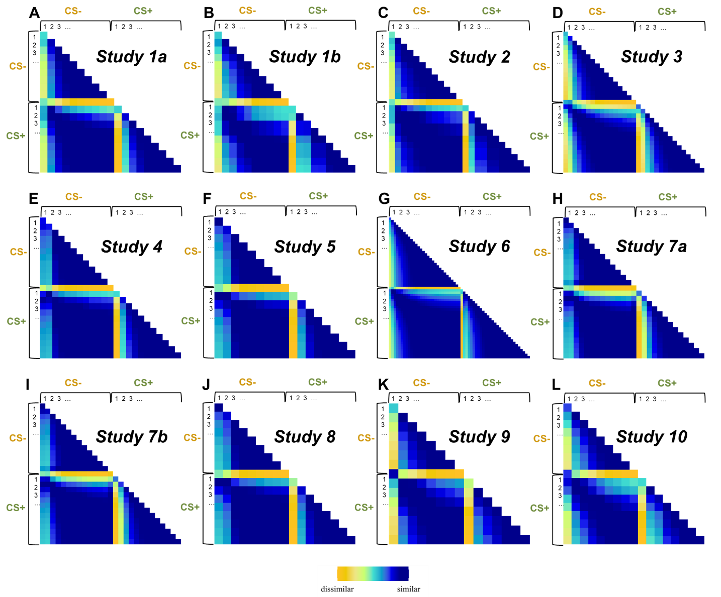
Figure S7. RSMs illustrate the similarity across trials based on the backward uncertainty learning model for each study.

S8. Unsupervised cluster analysis.
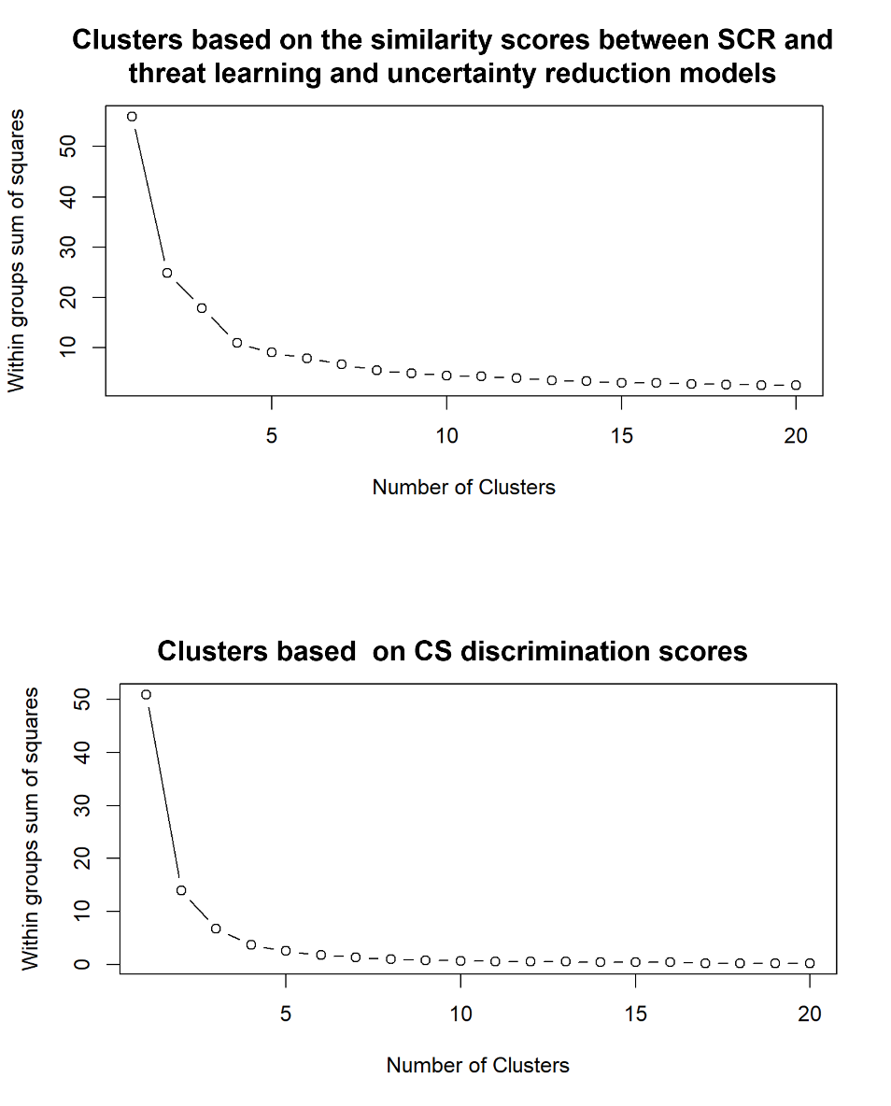
To select optimal number of clusters, we used the elbow criterion. Specifically, the clustering algorithm was run across a range of 20 potential cluster solutions, and the within-cluster sum of squares (WCSS) was computed for each solution. WCSS values were plotted as a function of cluster number, and the optimal solution was identified at the point where the reduction in WCSS began to plateau, indicating diminishing returns from additional clusters. Here below, the visual depiction of the 20 clusters for the similarity scores (Figure S7 upper part) and CS discrimination scores (Figure S7 lower part) are depicted. In both cases, three clusters were selected.

Figure S8. Visual depiction of potential clusters for each unsupervised cluster analysis.
S9. Cluster differences based on categorical anxiety levels.
Differences in anxiety scores between clusters based on the correspondence between SCR and backward models of threat learning and uncertainty reduction was further confirmed by analysis of categorical anxiety levels. The proportion of participants with moderate (STAI-T > 38¹) versus low anxiety differed across clusters using χ² tests. Nearly half of the participants in Cluster 2 (48.1%) fell within the moderate anxiety range, whereas lower proportions were observed in Cluster 1 (36.1%) and Cluster 3 (30.8%). Statistical comparisons confirmed that Cluster 2 contained significantly more individuals with at least moderate trait anxiety than Cluster 1 (χ² = 8.51, p = 0.003, ω = 0.12) and Cluster 3 (χ² = 9.41, p = 0.002, ω = 0.14), whereas Clusters 1 and 3 did not differ from each other (χ² = 0.69, p = 0.40, ω = 0.05).

S10. Comparison between clusters based on similarities with backward threat learning and uncertainty reduction strategies on anxiety scores after leaving one study out at a time.
To assess the consistency of the cluster differences on anxiety scores, we repeated the analyses as many times as studies included, leaving one study out each time. In most of the cases, cluster differences remain. Two exceptions were, however, observed. Removing Study 2 led to a lack of evidence for differences between Cluster 1 and 2 while removing Study 9, led to a lack of evidence for differences between Clusters 2 and 3.

Table S6. Comparison between clusters, leaving one study out. Cluster 1: higher correspondence with uncertainty reduction strategy. Cluster 2: lower correspondence with both uncertainty reduction and threat learning strategy. Cluster 3. Higher correspondence with threat learning strategy. Boldened results indicate the replicated findings from the main results.
Removed Study | Study 1 | Study 2 | Study 3 | Study 4 | Study 5 | Study 8 | Study 9
Cluster 1 | M = 36.27 | M = 37.60 | M = 36.37 | M = 37.01 | M = 36.82 | M = 36.40 | M = 37
Cluster 2 | M =38.32 | M = 38.67 | M = 38.66 | M = 39.23 | M = 38.73 | M = 38.11 | M = 39.27
Cluster 3 | M = 35.74 | M = 36.07 | M = 35.58 | M = 36.09 | M = 35.69 | M = 34.98 | M = 37.51
Cluster 1 vs. Cluster 2 | t_{519.67} = -3.05, p = .002, d = 0.22, BF₁₀ =8.31 | t ₄₃₄ = -1.61, = .11, d = 0.12, BF₁₀ =0.33 | t₅₀₈ = -3.45, p < .001, d = 0.26, BF₁₀ =26 | t_{409.1} = -3.08, p = .002, d = 0.25, BF₁₀ =8.59 | t_{524.48} = -2.79, p = .006, d = 0.21, BF₁₀ =4.11 | t_{509.12} = -2.31, p = .02, d = 0.18, BF₁₀ =1.22 | t₅₃₄ = -3.36, p < .001, d = 0.25, BF₁₀ =21.41
Cluster 3 vs. Cluster 2 | t_{178.92} = -3.00, p = .003, d = 0.30, BF₁₀ =6.81 | t₂₀₃ = -3.02, p = .002, d = 0.32, BF₁₀ =7.47 | t_{179.34} = -3.64, p < .001, d = 0.39, BF₁₀ =33.59 | t_{167.68} = -3.51, p < .001, d = 0.37, BF₁₀ =28.90 | t₁₉₁ = -3.61, p < .001, d = 0.37, BF₁₀ =29.85 | t_{140.14} = -3.04, p = 0.003, d = 0.38, BF₁₀ =7.56 | t_{128.32} = 1.87, p < = .06, d = 0.21, BF₁₀ =0.58
Cluster 1 vs Cluster 3 | t_{206.7} = 0.58, p = 0.55, d = 0.06, BF₁₀ =0.15 | t₂₀₃ = 1.58, p = .11, d = 0.17, BF₁₀ =0.41 | t_{192.26} = 0.90, p = .36, d = 0.1, BF₁₀ =0.19 | t_{201.26} = 0.95, p = 0.34, d = 0.11, BF₁₀ =0.21 | t_{210.15} = 1.28, p = 0.20, d = 0.13, BF₁₀ =0.26 | t_{149.61} = 1.34, p = 0.18, d = 0.15, BF₁₀ =0.32 | t_{146.62} = -0.52, p = 0.59, d = 0.04, BF₁₀ =0.15

References
1. Kayikcioglu, O., Bilgin, S., Seymenoglu, G. & Deveci, A. State and Trait Anxiety Scores of Patients Receiving Intravitreal Injections. Biomed. Hub 2, 1–5 (2017).

