Preparation and characterization of novel polymer-based heterogeneous MPg-C₃N₄ catalyst and its application in multi-component reactions
Hossein Ghafuri, Ensiye Zare-Bakheir, Peyman Hanifehnejad
Maryam Talebi, Nastaran Ghanbari
Catalysts and Organic Synthesis Research Laboratory, Department of Chemistry, Iran University of Science and Technology, Tehran 16846‑13114, Iran
* E-mail: ghafuri@iust.ac.ir

The general procedure of g-C₃N₄ nanosheets
Bulk g-C₃N₄ (2 g) was added to a 600 mL beaker with 40 mL H₂SO₄ and stirred at 90 $℃$. After 5 h, 400 mL ethanol was added to the mixture at room temperature. A white mixture is obtained and stirred for 2 h. Then, the beaker has rested for a day to settle the mixture. The upper liquid has overflowed, and the rest of it has ultrasounded for 6 h. The mixture was washed by centrifuge with ethanol and water and dried at 70$℃$, and then the powder g-C₃N₄ nanosheets have obtained.
The procedure for the synthesis of polymer-based heterogeneous MPg-C₃N₄
For the synthesis of MPg-C₃N₄, (0.2 g) polyvinyl alcohol (72000 g/mol) and 7 mL H₂O have poured in a round bottom flask and stirred at 80$℃$. After 3 h, g-C₃N₄ nanosheets (0.1 g) were added to the mixture and stirred for 5 h. The Co-precipitation method has been used for the deposition of magnetic ferrites over the layers of MPg-C₃N₄ composite. Therefore, FeCL₂.3H₂O and FeCl₃.2H₂O (2 : 1) were solved in water and poured in a round bottom flask in an inert atmosphere. Then, drop by drop, ammonia was added to the mixture until pH reached approximately 12 and stirred for 2 h. After that, the obtained polymer-based heterogeneous MPg-C₃N₄ was washed with water and ethanol several times and dried in an oven at 70 $℃$.
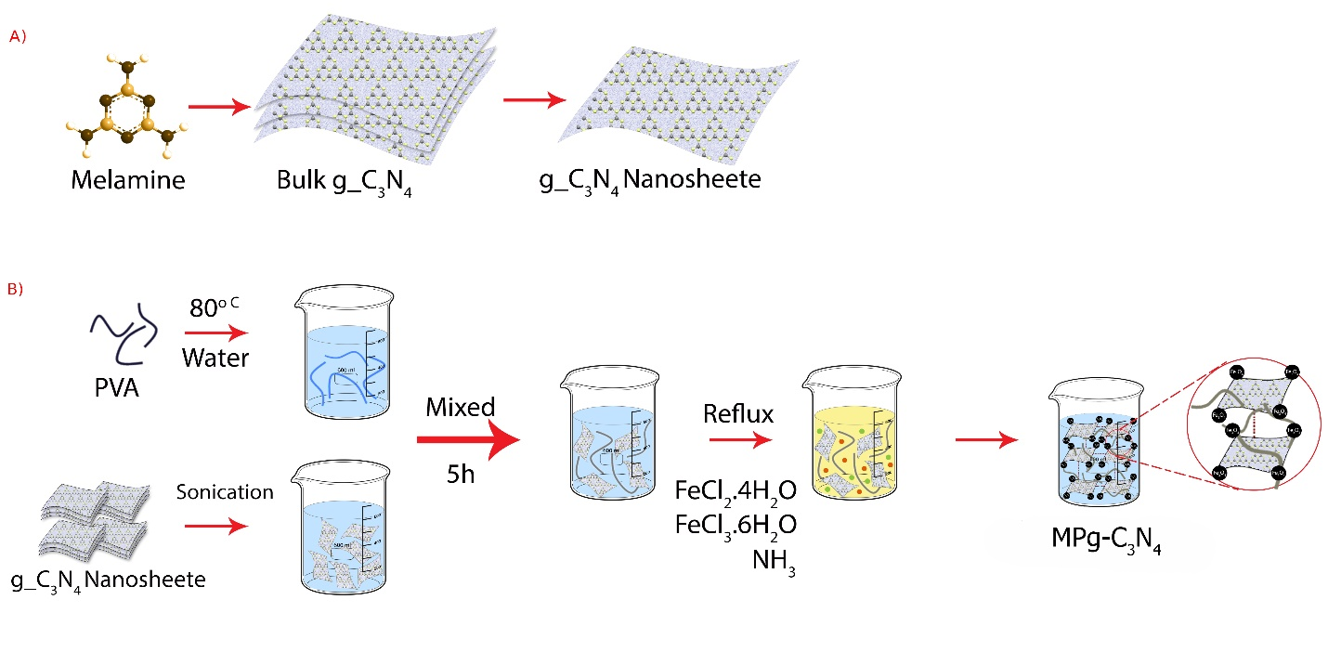
Scheme S1. The schematic synthesis of MPg-C₃N₄.

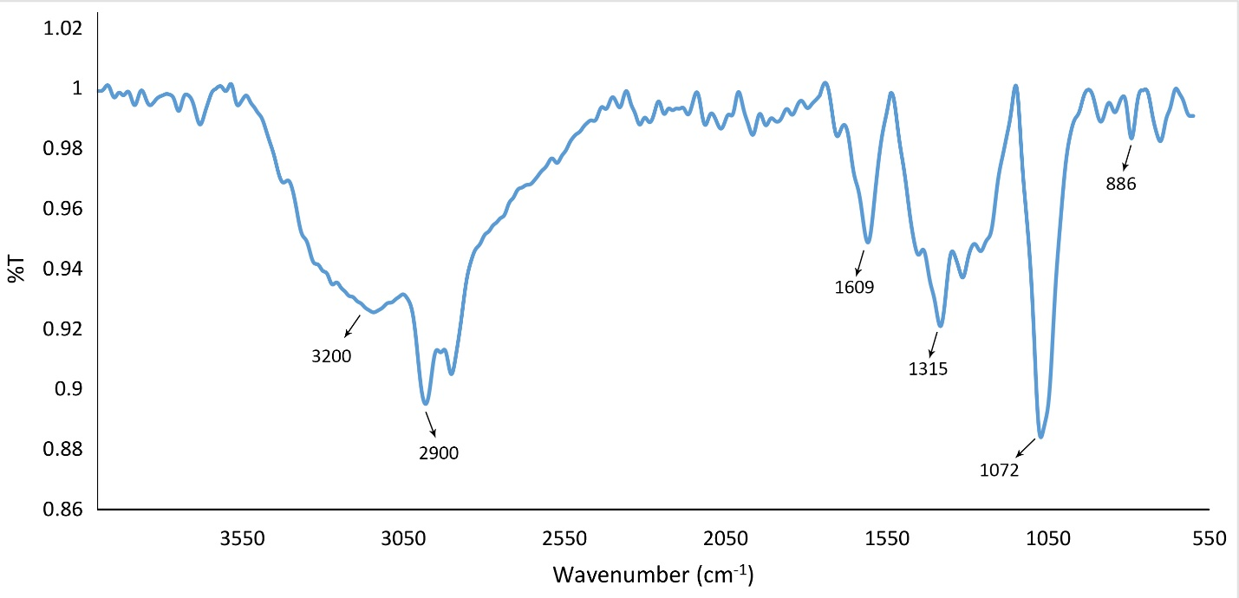
Figure S1. The FT-IR spectra of MPg-C₃N₄.

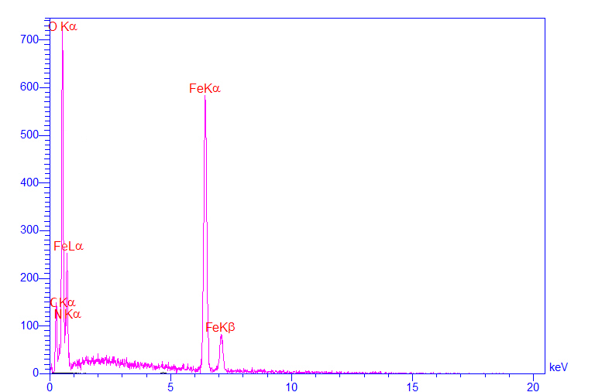
 | %W | %A
C | 18.38 | 23.94
N | 12.21 | 13.64
O | 61.57 | 60.22
Fe | 7.84 | 2.20
 | 100 | 100

Figure S2. The EDS spectra of MPg-C₃N₄.

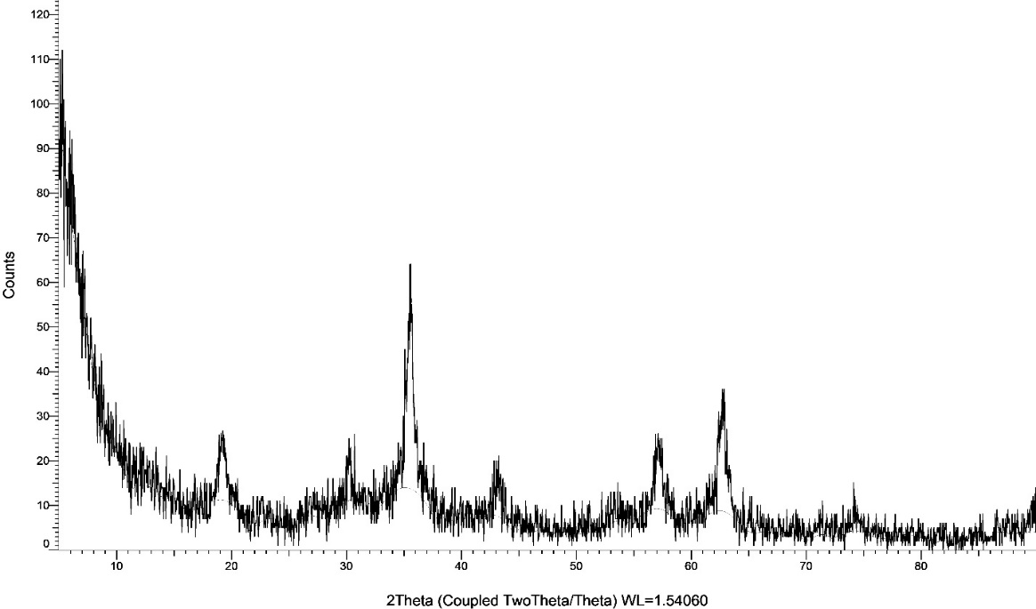
Figure S3. The XRD pattern of MPg-C₃N₄.
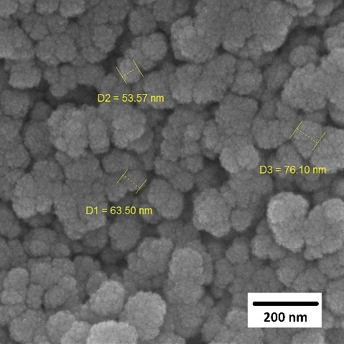
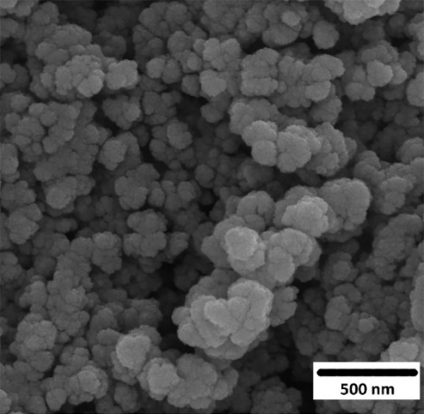
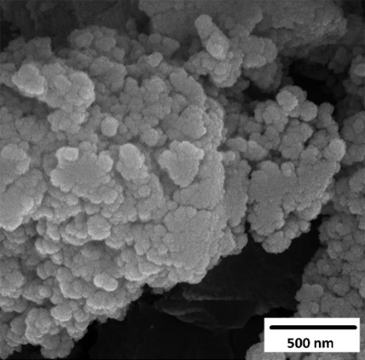
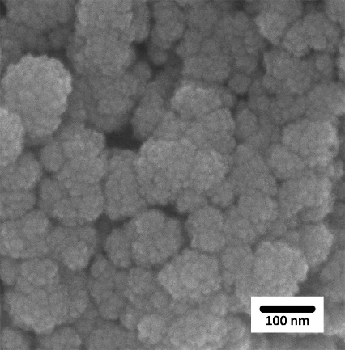
d)
c)
b)
a)
Figure S4. The FE-SEM images of MPg-C₃N₄ a) 100 nm b) 200 nm c , d) 500 nm.

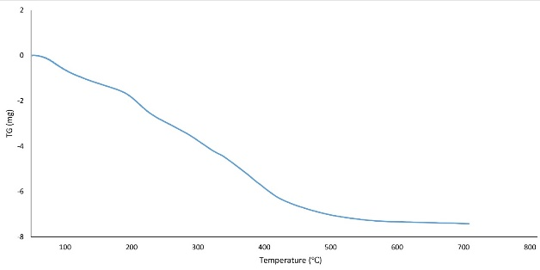
Figure S5. The TGA spectra of MPg-C₃N₄

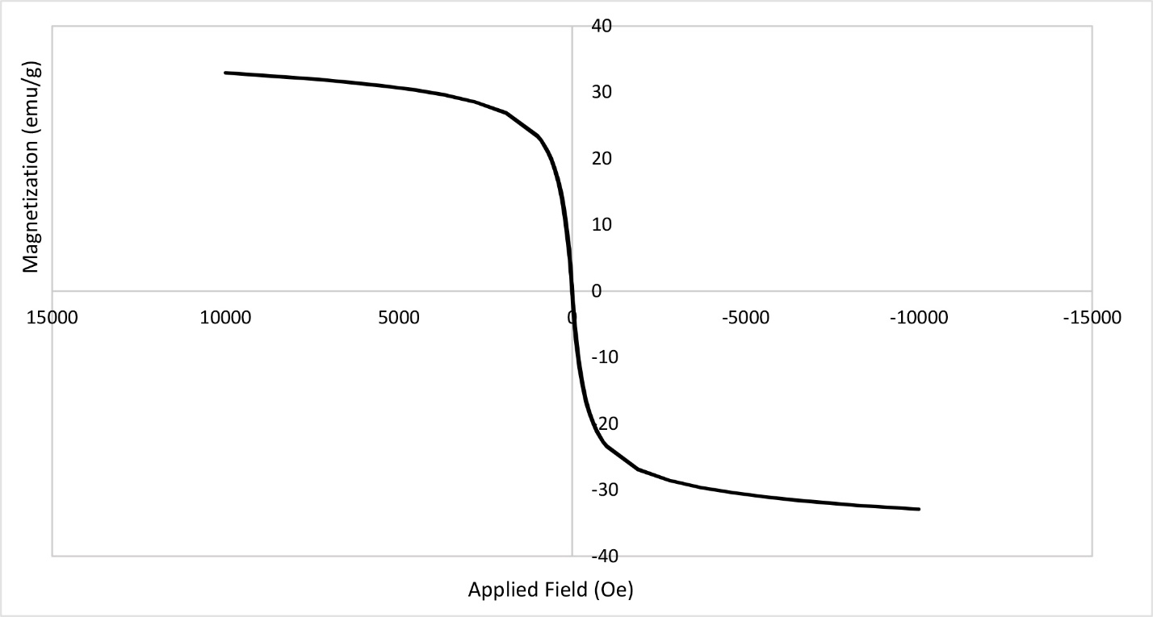
Figure S6. The VSM spectra of MPg-C₃N₄

3,3,6,6-tetramethyl-9-(4-chlorophenyl)-10-phenyl-1,8-dioxodecahydroacridine (7a)
FTIR (KBr, cm⁻¹): 3035, 2954, 2882, 1630, 1579, 1487, 1361, 1265, 1221, 1142, 1087, 1013, 839, 704 cm⁻¹. ¹H NMR (500 MHz, DMSO): δ H (ppm)= 0.69(s, 6H, 2 CH₃), 0.86(s, 6H, 2 CH₃), 1.74(d, 2H, 2 CH), 1,99(d, 2H, 2 CH), 2.17(d, 2H, 2 CH), 2.20(d, 2H, 2 CH), 5.01(s, 1H, CH), 7.16-7.34(m, 4H, Ar-H), 7.41(b, 2H, Ar-H), 7.55-7.62(m, 3H, Ar-H).
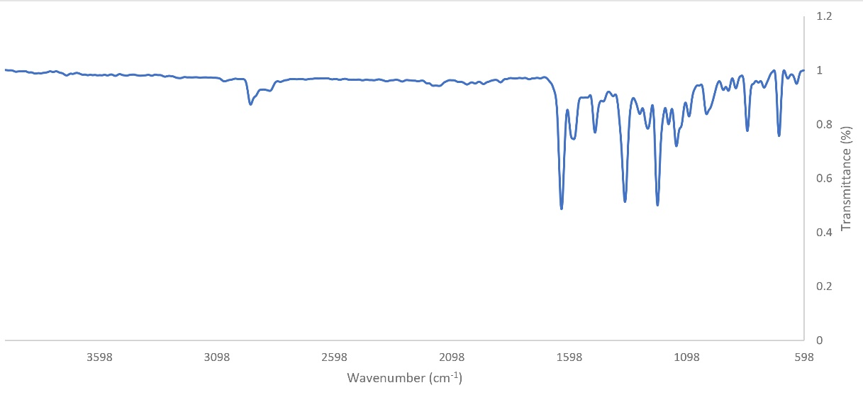

Figure S7. FTIR of the 3,3,6,6-tetramethyl-9-(4-chlorophenyl)-10-phenyl-1,8-dioxodecahydroacridine (7a).

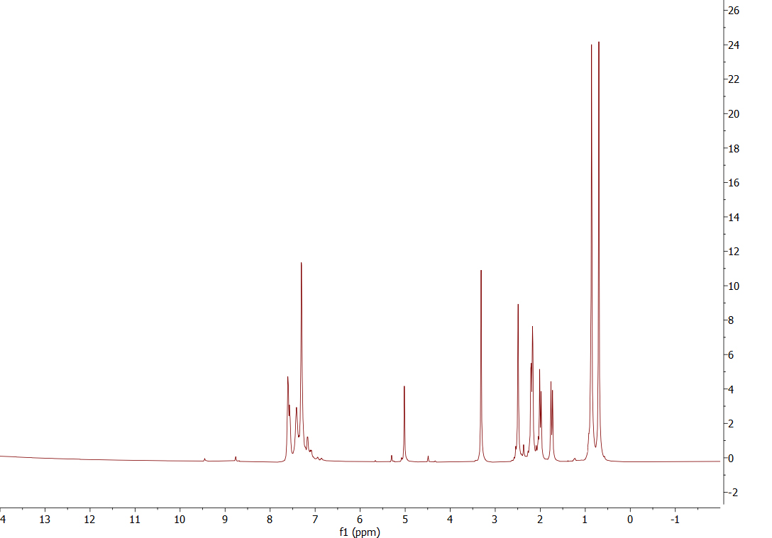
Figure S8. HNMR of the 3,3,6,6-tetramethyl-9-(4-chlorophenyl)-10-phenyl-1,8-dioxodecahydroacridine (7a).

2-amino-7,7-dimethyl-5-oxo-4-phenyl-5,6,7,8-tetrahydro-4H-chromene-3-carbonitrile (1c)
FTIR (KBr, cm⁻¹): 3396, 3326, 3214, 2961, 2889, 2200, 1680, 1661, 1605, 1371, 1214, 1037, 696 cm⁻¹. ¹H NMR (500 MHz, DMSO): δ H (ppm)= 0.96(s, 3H, CH₃), 1.05(s, 3H, CH₃), 2.09-2.57(m, 4H, 2CH₂), 4,17(s, 1H, CH), 7.01(s, 2H, NH₂), 7.13-7.32 (m, 4H, Ar-H)
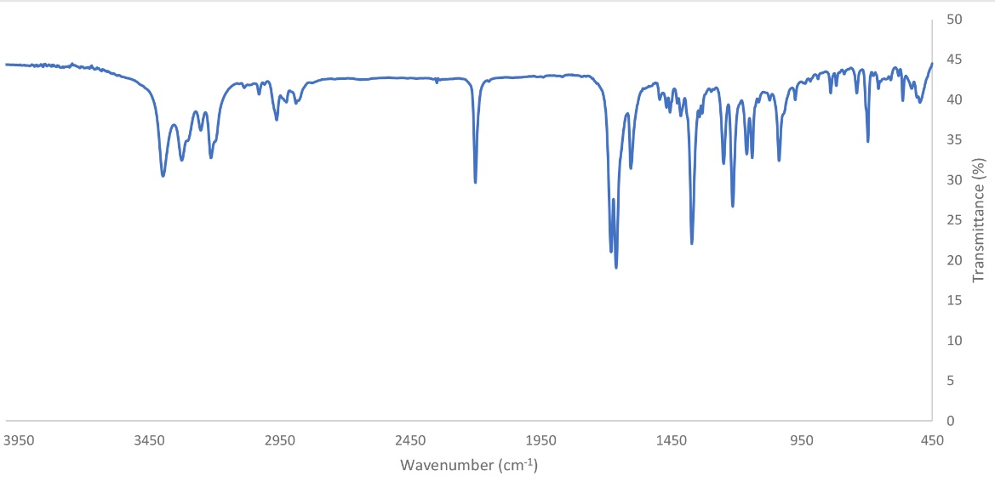
Figure S9. FTIR of the 2-amino-7,7-dimethyl-5-oxo-4-phenyl-5,6,7,8-tetrahydro-4H-chromene-3-carbonitrile (1c).
Figure S10. HNMR of the 2-amino-7,7-dimethyl-5-oxo-4-phenyl-5,6,7,8-tetrahydro-4H-chromene-3-carbonitrile (1c).

