A Microbial Pathway for Methanesulfonic Acid Biosynthesis from DMSP Expands the Marine Sulfur Cycle

Authors:
Anuj K. Chhalodia^{1,2}, Julius Bartels,^{1,2} Maïa M.N. Henry,^{1,2} Georg Pohnert*^{1,2}
Affiliations:
¹ Institute for Inorganic and Analytical Chemistry, Bioorganic Analytics, Friedrich Schiller University Jena, Rosalind-Franklin-Str. 5, D-07745 Jena, Germany
² Friedrich Schiller Univ Jena, Cluster Excellence Balance Microverse, Jena, Germany
*to whom correspondence should be addressed: Georg.Pohnert@uni-jena.de

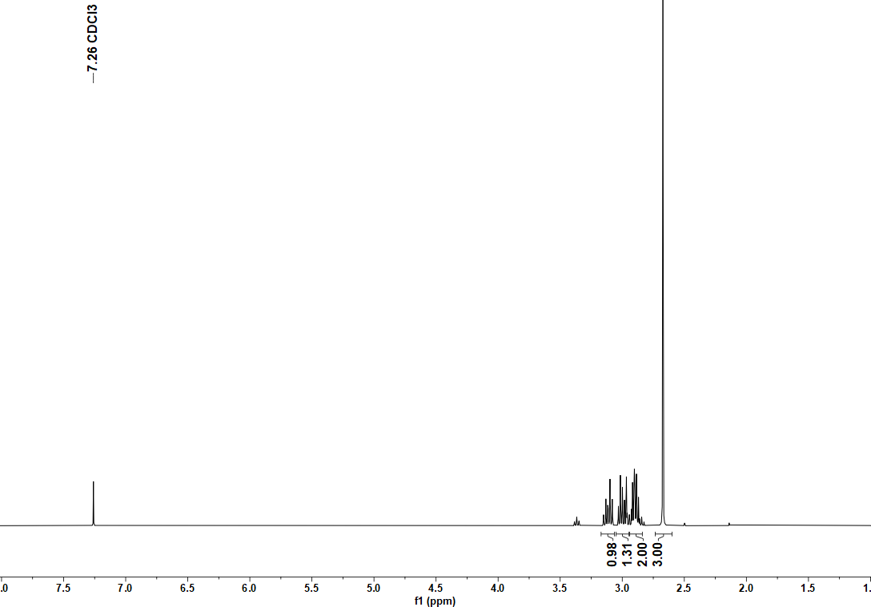
Figure S8. ¹H-NMR spectrum (CDCl₃, 400 MHz) of compound 2.
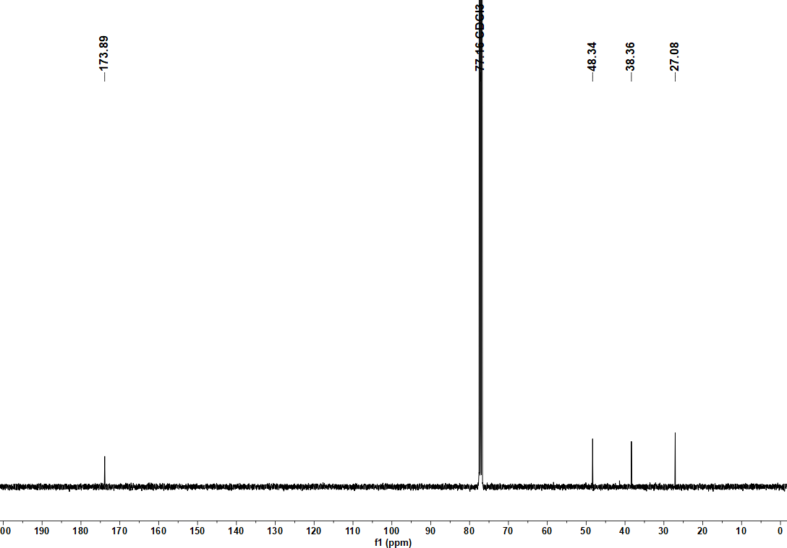
Figure S9. ¹³C-NMR spectrum (CDCl₃, 100 MHz) of compound 2.
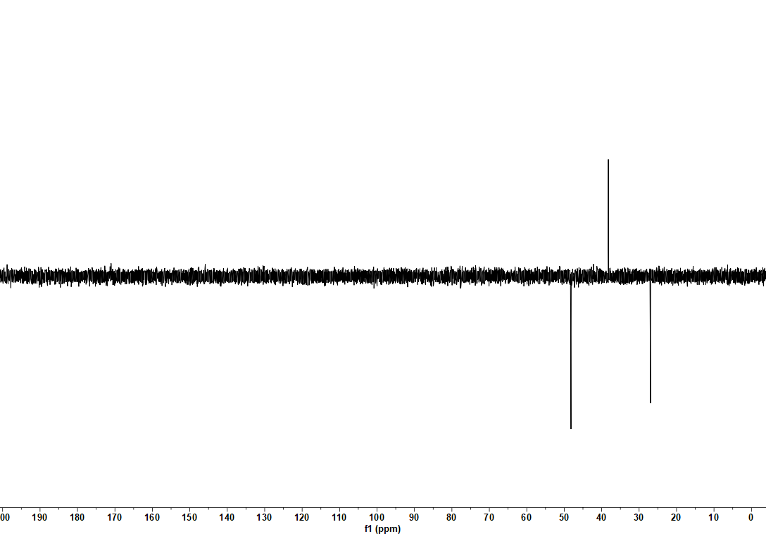
Figure S10. ¹³C-DEPT135 spectrum (CDCl₃, 400 MHz) of compound 2.
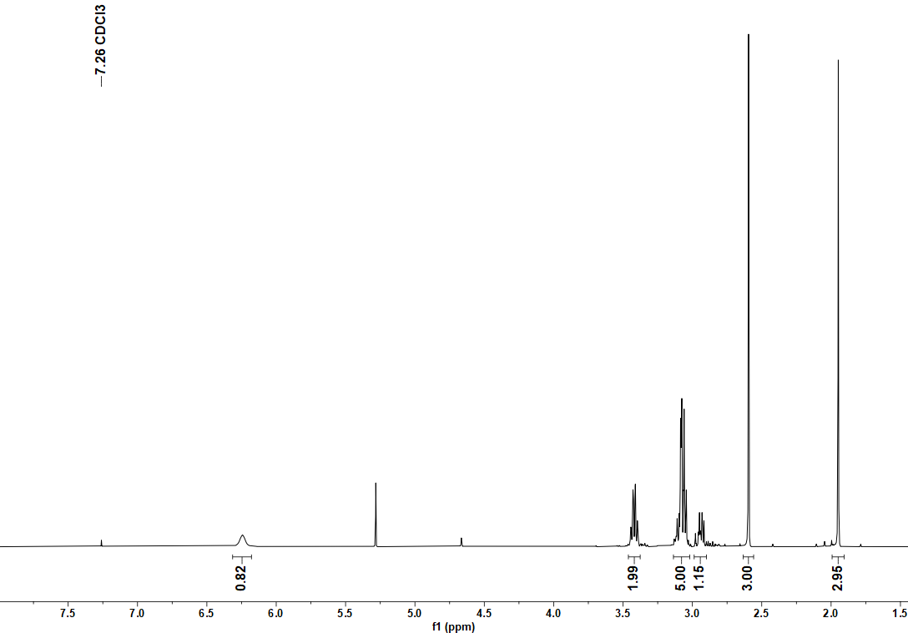
Figure S11. ¹H-NMR spectrum (CDCl₃, 400 MHz) of compound 3.
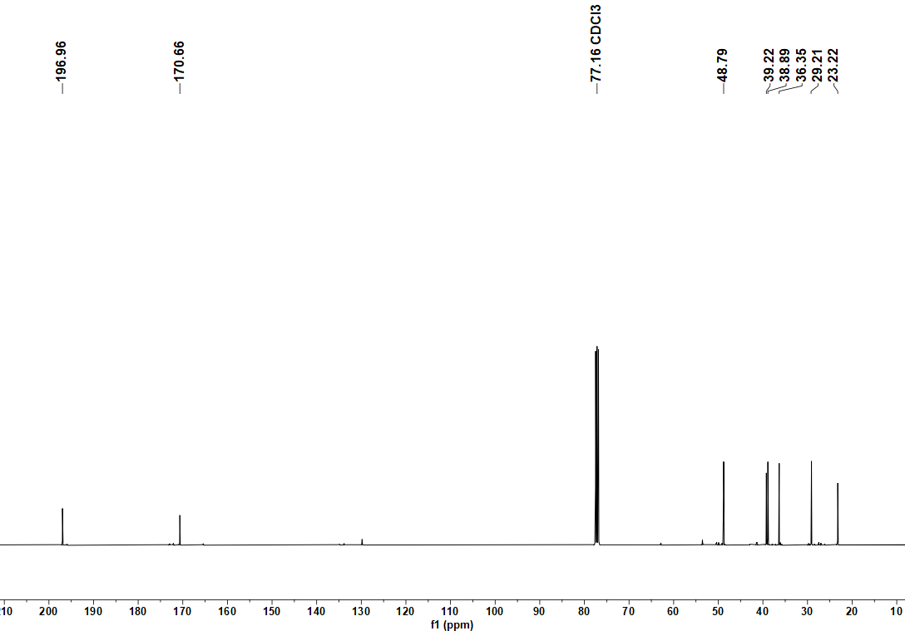
Figure S12. ¹³C-NMR spectrum (CDCl₃, 100 MHz) of compound 3.
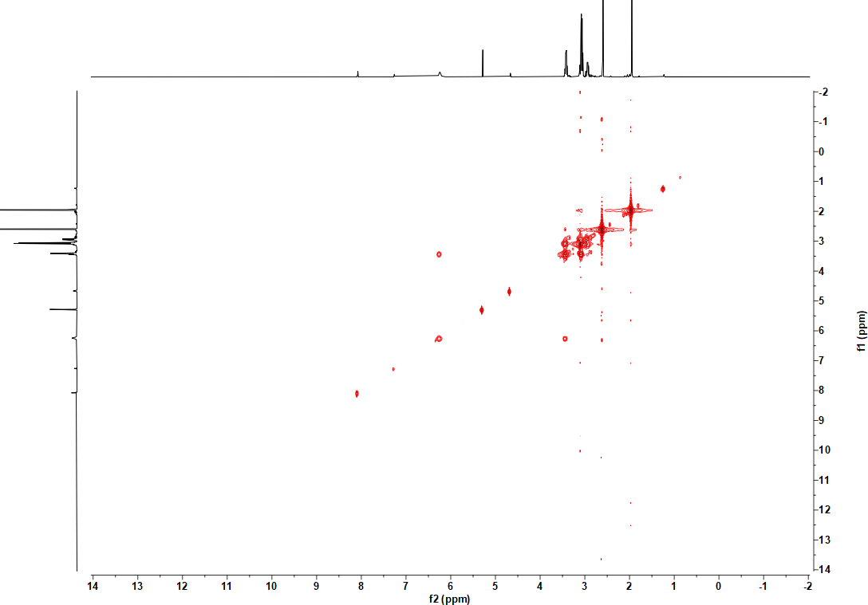
Figure S13. ¹H-¹H-COSY (CDCl₃) spectrum of compound 3.
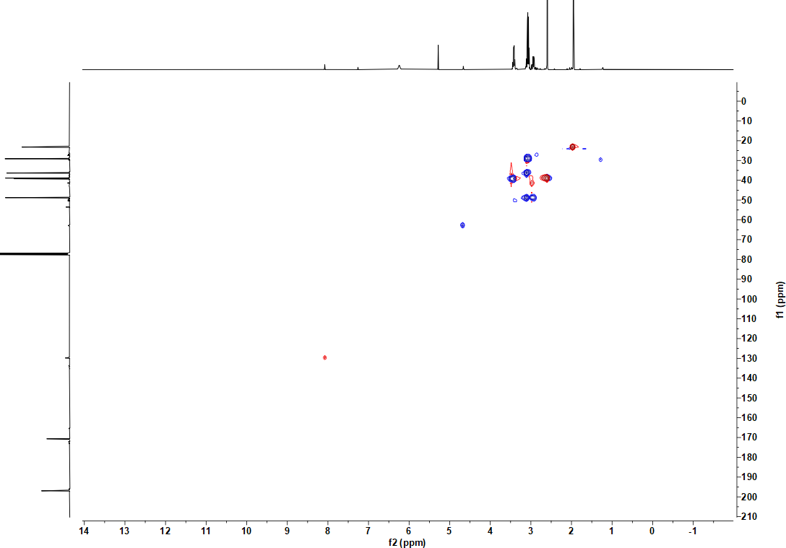
Figure S14. HSQC spectrum (CDCl₃) of compound 3.
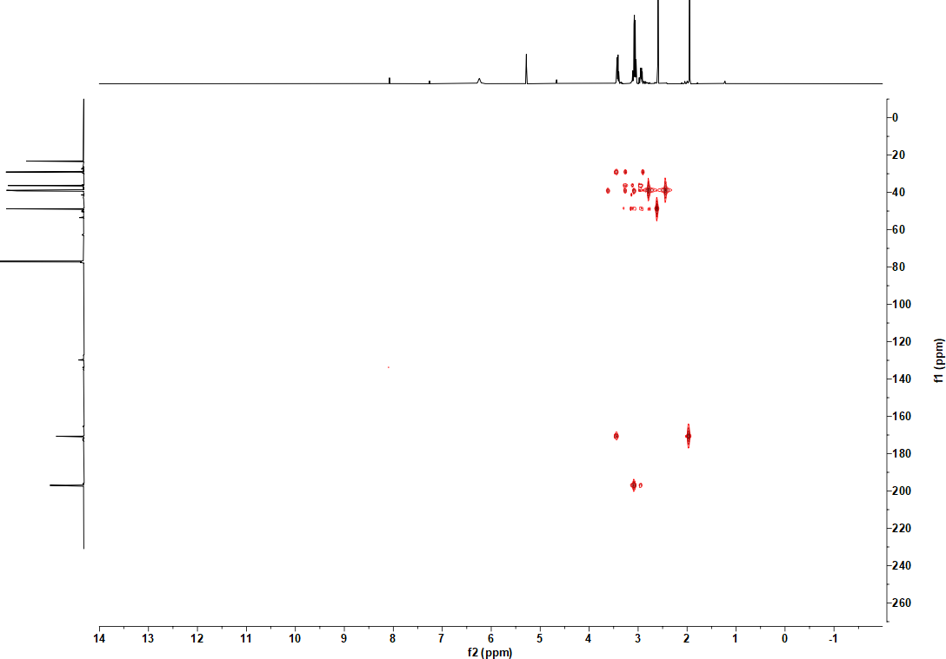
Figure S15. HMBC spectrum (CDCl₃) of compound 3.
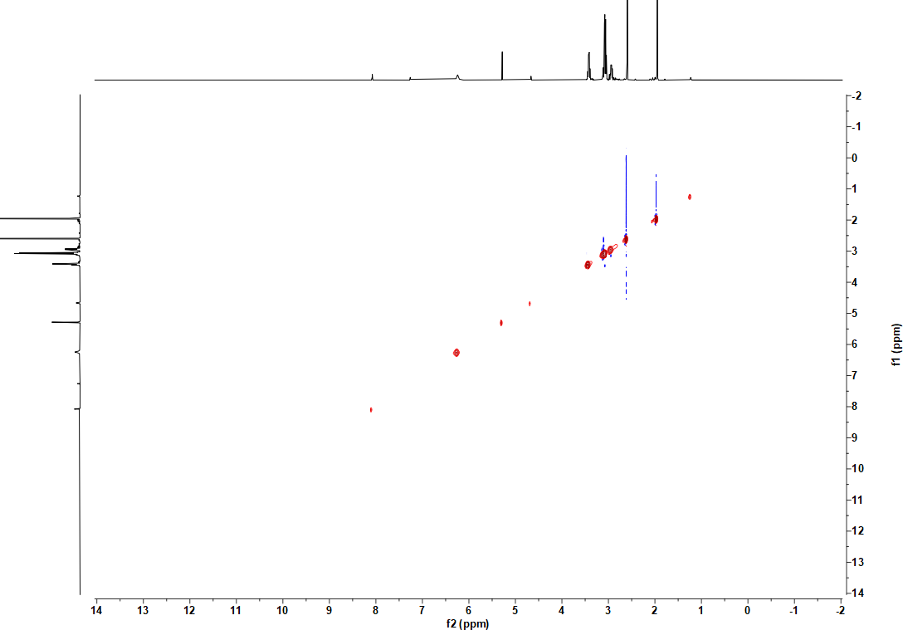
Figure S16. NOESY spectrum (CDCl₃) of compound 3.

