Supplement

Supplementary Table 1.

Demographic and additional information for all three groups.

 | Characteristic | PRG₁ | PRG₂ | CTR
 | Age at PRE (M ± SD) | 29.35 ± 3.51 | 32.03 ± 2.33 | 29.33 ± 3.57
 | Education (M Verhage score ± SD) | 6.43 ± 0.78 | 6.33 ± 0.76 | 6.65 ± 0.53
 | Secondary school | - | 2 | -
 | College | 19 | 13 | 12
 | University | 21 | 14 | 28
 | Unknown | - | 1 | -
 | Days PRE – POST (M ± SD) | 509.78 ± 158.91 | 502.7 ± 125.02 | 457.95 ± 81.95
 | Days parturition – POST (M ± SD) | 100.6 ± 70.8 | 95.4 ± 70.2 | -
 | Days parturition – POST+1 (M ± SD) | 402.6 ± 64.8 | - | -
 | Medical History
ADHD |  | 1 | - | -
 | Burn-out | - | - | 1
Depression/anxiety |  | 3 | 3 | 5
 | Eating disorder | 1 | 2 | -
 | Harlequin syndrome | 1 | - | -
 | Meningitis | 1 | - | -
Neuralgic amyotrophy |  | - | 1 | -
Personality disorder |  | - | 1 | -
 | Trigeminal neuralgia | - | - | 1
 | Natural Conception | 37 | 29 | -
 | Assisted Conception | 3 | 1 | -
 | Vaginal Birth | 31 | 28 | -
 | Caesarean section | 9 | 2 | -
 | Twins | 1 | - | -
 | Daughters | 23 | 15 | -
 | Sons | 17 | 13 | -
 | Sex baby unknown | 1 | 2 | -
 | Feeding method at POST session |  |  | -
 | Breastfeeding | 30 | 21 | -
 | Formula | 10 | 7 | -
 | NA | - | 2 | -

Supplementary Table 2

Results POST min PRE contrast during mentalizing condition minus the control condition for first mothers with extra strict motion correction (participants removed that moved more than 1.5 mm³ degrees).

Contrasts | Regions | MNI coordinates |  |  | T | P (FWE cluster corrected) | Cluster size (mm³)
Contrasts | Regions | x | y | z | T | P (FWE cluster corrected) | Cluster size (mm³)
PRG₁>CTR | Left Precuneus, Right Precuneus | 0 | -54 | 54 | 4.44 | <0.010 | 177
 | Right Cuneus, Left Cuneus, Right Precuneus, Left Precuneus, Left Superior Occipital Lobule, Left Calcarine | 15 | -72 | 33 | 4.34 | <0.001 | 299
CTR>PRG₁ | -
PRG₁: POST>PRE | Right Precuneus, Left Precuneus, Right Cuneus, Left Cuneus, Middle Right Cingulate Cortex, Right Paracentral Lobule | 15 | -66 | 33 | 5.28 | <0.001 | 722
 | Middle Frontal Gyrus, Superior Frontal Gyrus | 36 | 39 | 21 | 4.67 | 0.009 | 153
PRG₁: PRE>POST,  CTR: POST>PRE,  CTR: PRE>POST,  PRG₁>PRG₂,  PRG₂>PRG₁ | - | - | - | - | -

Supplementary Table 3

Means and standard deviations per group for mentalizing performance, self-reported mentalizing, and self-reported and observed maternal behavior.

Behavioral measure | Group | PRE |  | PRG |  | POST |  | POST+1
 |  | Mean | SD | Mean | SD | Mean | SD | Mean | SD
Mentalizing performance | PRG₁ | 46.65 | 3.33 | - | - | 47.40 | 3.57 | 48.24 | 3.81
 | CTR | 46.98 | 2.69 | - | - | 47.37 | 3.24 | - | -
 | PRG₂ | 46.53 | 7.58 | - | - | 47.63 | 3.06 | 47.14 | 3.35
BES: Cognitive Empathy | PRG₁ | 36.20 | 4.50 | 36.66 | 5.04 | 36.85 | 5.31 | 36.79 | 5.05
 | CTR | 36.75 | 4.62 | 38.58 | 4.17 | 37.78 | 4.12 | - | -
 | PRG₂ | 37.48 | 3.73 | 37.60 | 3.60 | 38.36 | 3.67 | 39.75 | 3.65
WLEIS: Self-Emotion Appraisal | PRG₁ | 15.60 | 3.17 | 15.34 | 2.95 | 15.49 | 3.30 | 15.89 | 2.71
 | CTR | 15.68 | 2.92 | 14.88 | 3.00 | 15.42 | 2.97 | - | -
 | PRG₂ | 16.31 | 2.49 | 15.71 | 3.16 | 16.25 | 2.66 | 16.92 | 2.23
WLEIS: Others-Emotion Appraisal | PRG₁ | 14.78 | 3.06 | 14.66 | 2.75 | 15.05 | 2.72 | 15.10 | 3.24
 | CTR | 15.33 | 2.88 | 15.64 | 2.12 | 14.96 | 2.26 | - | -
 | PRG₂ | 14.97 | 2.90 | 15.04 | 2.53 | 15.89 | 2.40 | 16.08 | 2.35
WLEIS: Regulation of Emotion | PRG₁ | 13.30 | 3.33 | 12.60 | 3.82 | 13.23 | 2.74 | 13.25 | 3.40
 | CTR | 12.40 | 3.55 | 12.24 | 3.42 | 12.38 | 3.17 | - | -
 | PRG₂ | 12.90 | 3.14 | 13.00 | 3.88 | 13.36 | 4.00 | 13.17 | 3.86
WLEIS: Use of Emotion | PRG₁ | 14.70 | 3.54 | 14.69 | 3.08 | 14.74 | 3.15 | 14.89 | 2.38
 | CTR | 13.90 | 3.69 | 13.97 | 3.82 | 13.58 | 2.78 | - | -
 | PRG₂ | 13.72 | 3.00 | 14.00 | 2.78 | 14.18 | 3.76 | 15.00 | 2.13
MPAS: Absence of Hostility | PRG₁ | - | - | - | - | 20.05 | 2.13 | - | -
MPAS: Pleasure in Interaction | PRG₁ | - | - | - | - | 20.61 | 2.73 | - | -
MPAS: Quality of Attachment | PRG₁ | - | - | - | - | 40.39 | 3.81 | - | -
Observed maternal behavior | PRG₁ | - | - | - | - | - | - | 0.62 | 0.25
Supplementary Table 4

Results of the ANOVA between PRG₁ and CTR group for the PRE, PRG, and POST sessions for self-reported mentalizing and for PRE and POST for mentalizing performance.

Measure |  | F-statistic | d | p-value
Mentalizing performance | Group | 0.004 | (1, 78) | 0.948
 | Timepoint | 0.89 | (1, 78) | 0.348
 | Timepoint*Group | 0.001 | (1, 78) | 0.974
BES: Cognitive Empathy | Group | 0.51 | (1, 77) | 0.477
 | Timepoint | 4.32 | (1, 77) | 0.041*
 | Timepoint*Group | 0.36 | (1, 77) | 0.550
WLEIS: Self Emotion Appraisal | Group | 0.008 | (1, 77) | 0.930
 | Timepoint | 1.12 | (1, 77) | 0.293
 | Timepoint*Group | 1.29 | (1, 77) | 0.260
WLEIS: Others Emotion Appraisal | Group | 0.02 | (1, 77) | 0.899
 | Timepoint | 0.76 | (1, 77) | 0.386
 | Timepoint*Group | 0.65 | (1, 77) | 0.424
WLEIS: Regulation of Emotion | Group | 1.97 | (1, 77) | 0.165
 | Timepoint | 0.03 | (1, 77) | 0.855
 | Timepoint*Group | 0.01 | (1, 77) | 0.911
WLEIS: Use of Emotion | Group | 2.09 | (1, 77) | 0.152
 | Timepoint | 0.27 | (1, 77) | 0.606
 | Timepoint*Group | 0.36 | (1, 77) | 0.552

Supplementary Table 5

Results of the t-test or Wilcox test of POST-PRE mentalizing performance and self-reported mentalizing between first- and second-time mothers.

Measure | Test | P-value | W/t | Df | 95% CI
Mentalizing performance | Parametric | 0.87 | 0.17 | 68 | -1.64 1.94
BES: Cognitive Empathy | Parametric | 0.85 | -0.18 | 65 | -1.76 1.49
WLEIS: Self Emotion Appraisal | Parametric | 0.98 | -0.028 | 65 | -1.52 1.48
WLEIS: Others Emotion Appraisal | Non-parametric | 0.33 | 469.5 | - | -
WLEIS: Regulation of Emotion | Parametric | 0.48 | -0.71 | 65 | -2.17 1.03
WLEIS: Use of Emotion | Parametric | 0.71 | -0.37 | 65 | -1.88 1.29

Supplementary Table 6

Paired t-test or Wilcox test between POST and POST+1 in first-time mothers for mentalizing performance and self-reported mentalizing.

Measure | Test | P-value | V/t-value | df | 95% CI
Mentalizing performance | Non-parametric | 0.38 | 410 | - | -
BES: Cognitive Empathy | Non-parametric | 0.14 | 225 | - | -
WLEIS: Self Emotion Appraisal | Non-parametric | 0.98 | 219 | - | -
WLEIS: Others Emotion Appraisal | Parametric | 0.41 | 192.5 | - | -
WLEIS: Regulation of Emotion | Non-parametric | 0.98 | 219 | - | -
WLEIS: Use of Emotion | Parametric | 0.95 | -0.061 | 38 | -0.88 0.82

Supplementary Figure 1

Recruitment overview of all three groups.
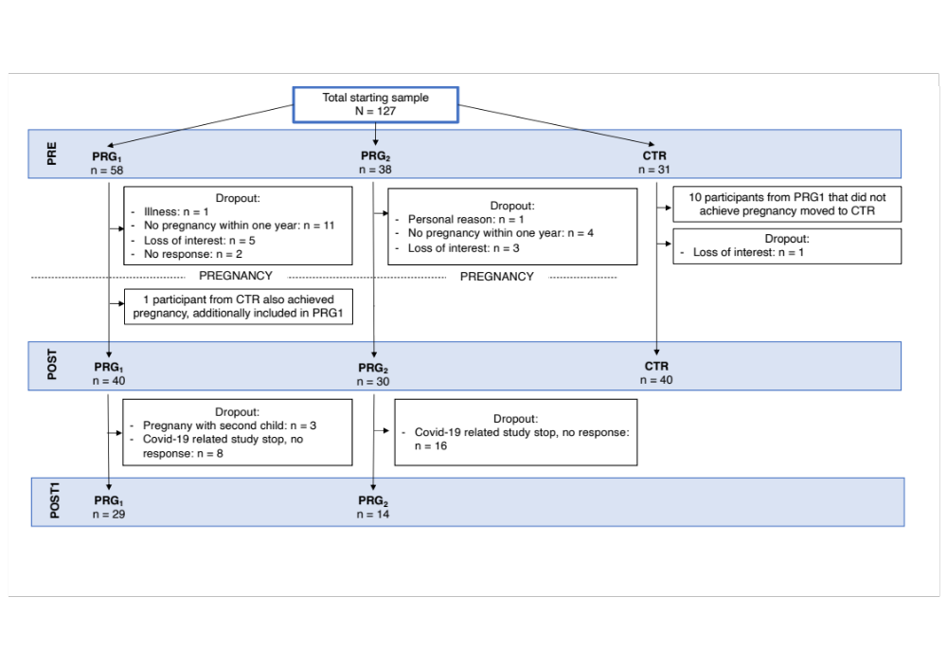
Supplementary Figure 2

Set-up of the DCM model showing the fixed connections, the driving input and the modulatory input.

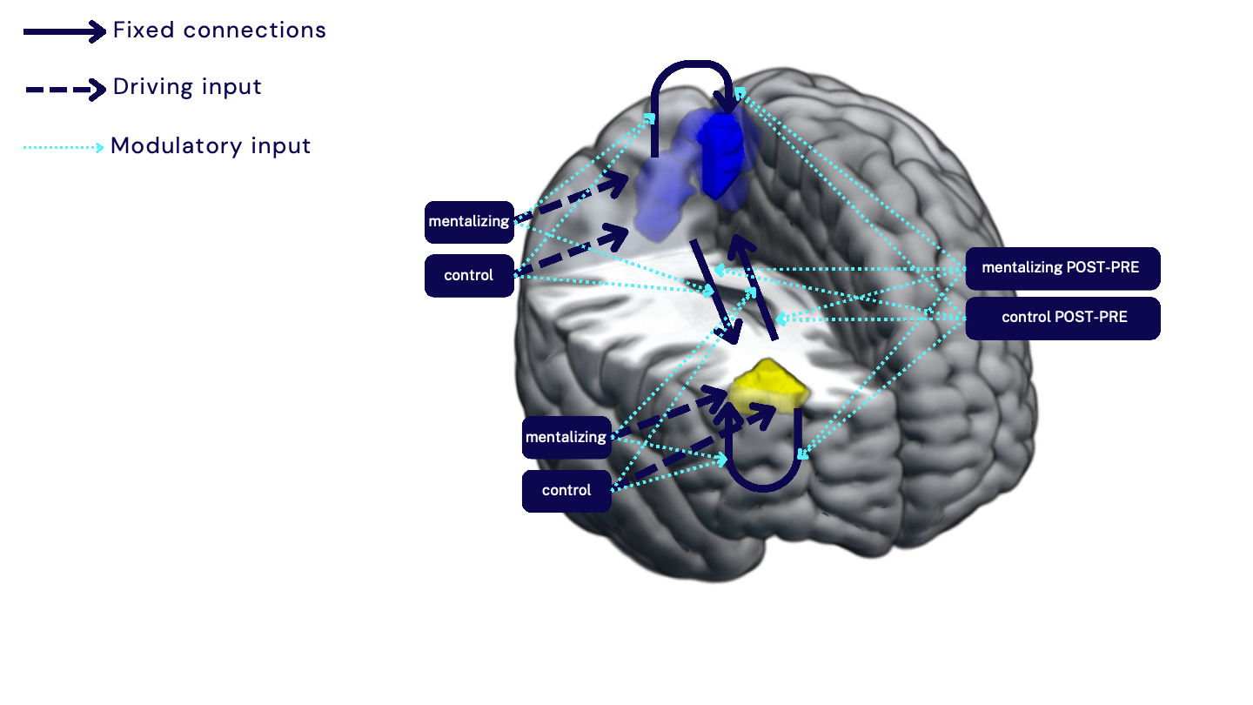
Supplementary Figure 3

Precuneus/cuneus activity with standard deviation pre-conception (PRE), early postpartum (POST), and one year postpartum (POST+1) for first-time mothers during mentalizing task.
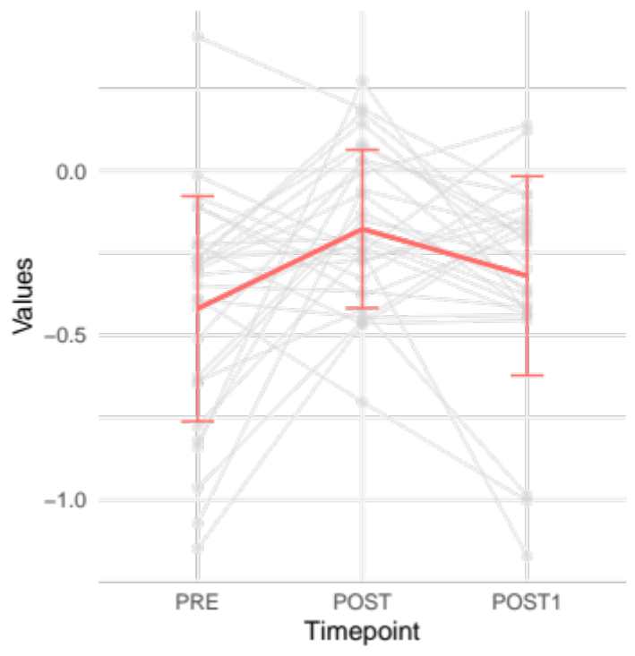
0.0
-0.05
-1.0
Precuneu/cuneus activity

PRE POST POST+1

Supplementary Figure 4

Hormone levels divided by creatine levels across pregnancy in week 16, 20, 24, 28, 32, and 36 in first-time mothers in pg/ml with standard deviation for A. Estradiol, B. Estriol, C. Cortisol, D. Progesterone.

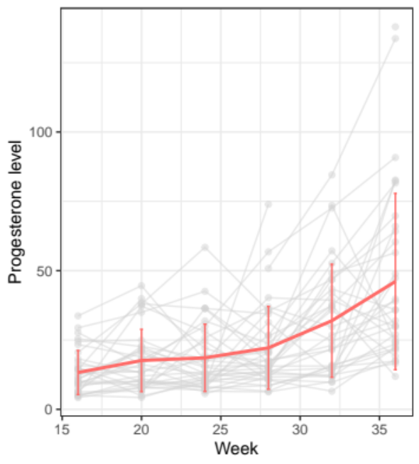
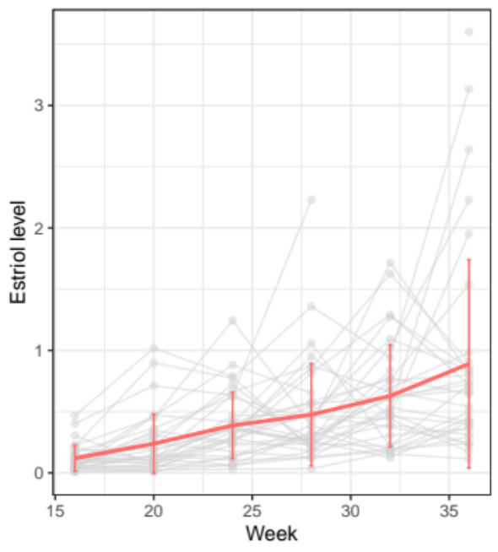
Week
Week
Week
Week
C
D
B
D
Progesterone level
Cortisol level
Estradiol level
Estriol level
A
A
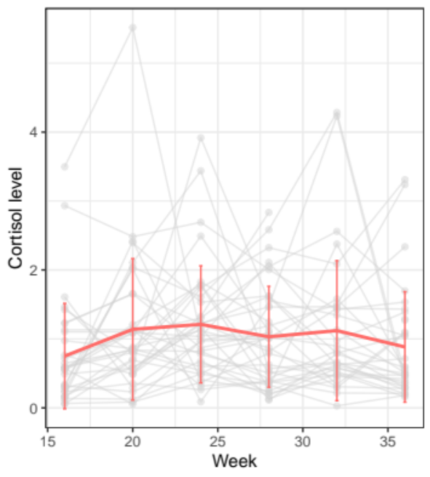
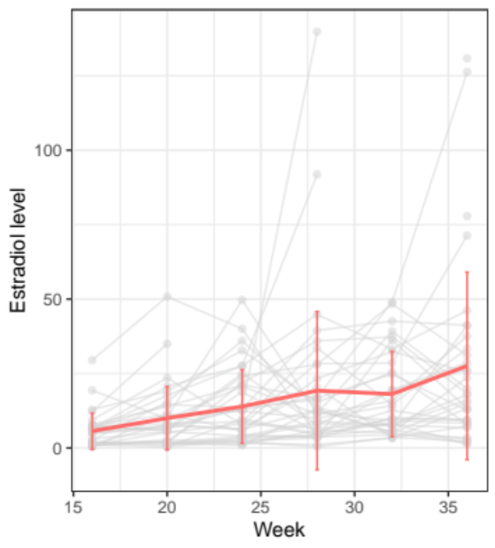
Estradiol levels
Week
Week
Supplementary Figure 5

Oxytocin level in mg/dl in first time mothers measured during pregnancy, at week 12, week 28, and 36 with standard error.

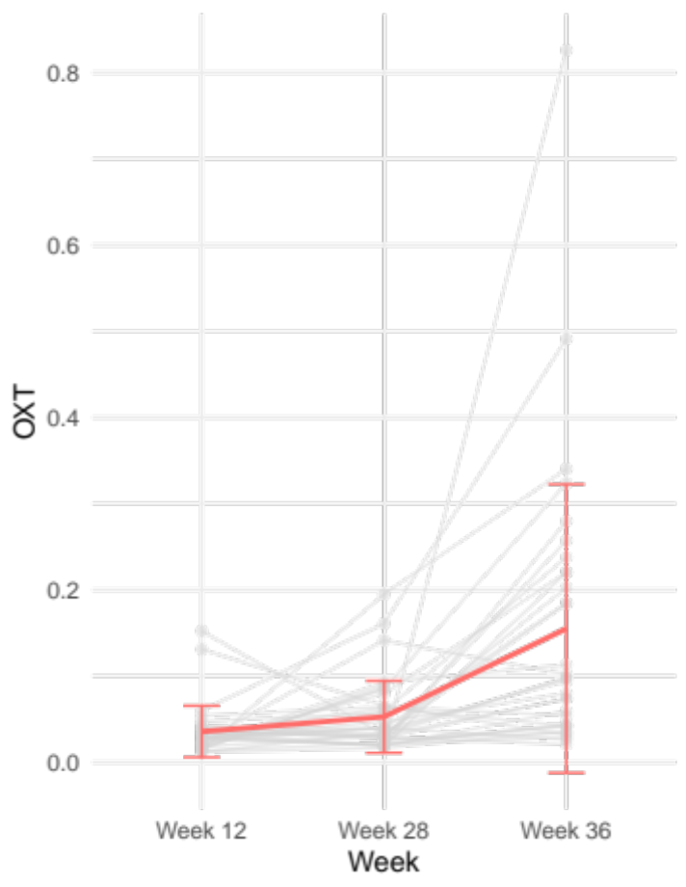
Oxytocin level
Week 28
Week 12
Week 36
Supplementary Figure 6

Correlations between precuneus/cuneus activity (POST-PRE session) in first-time mothers and the area under the curve of hormones divided by creatine: A. Cortisol (pg/dl), B. Estradiol (pg/dl), C. Oxytocin (mg/dl).

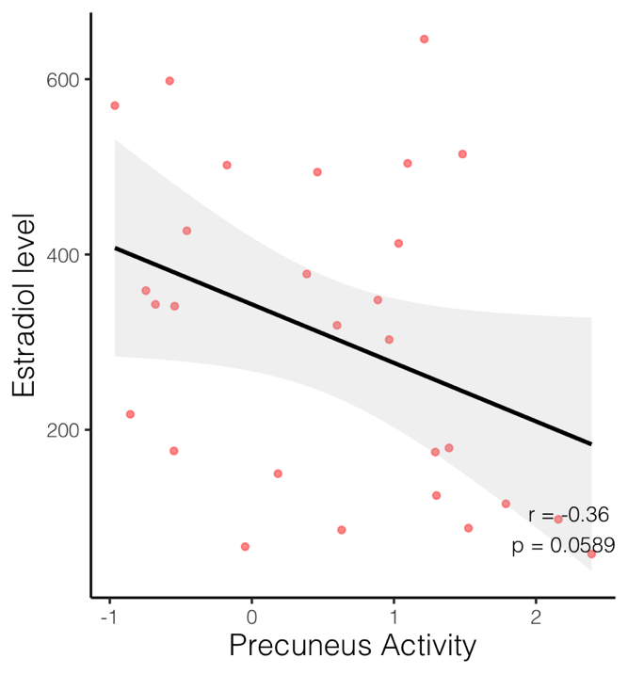
B
A
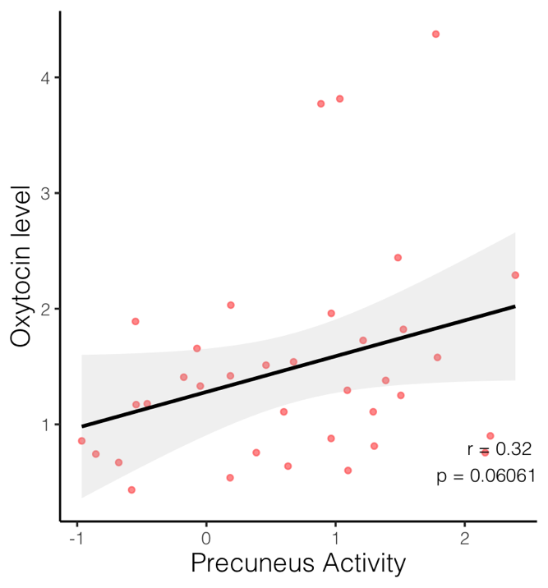
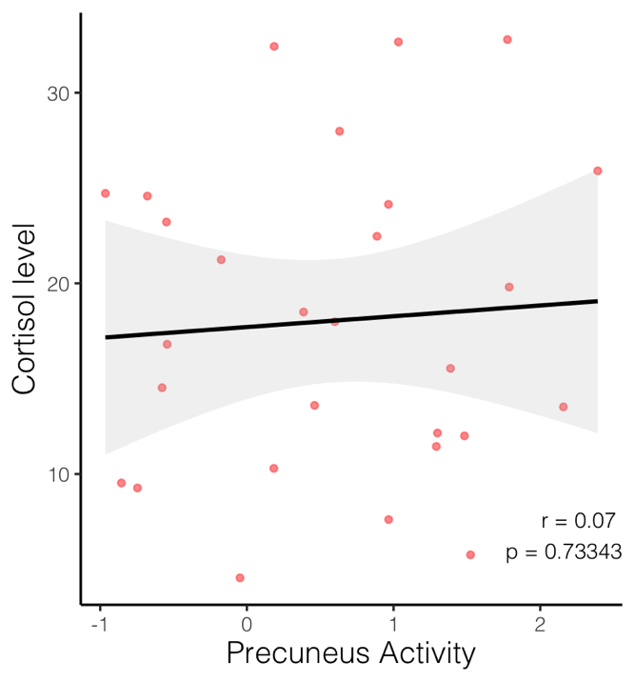
C

