Hierarchically Porous ZnTiO₃/Zeolite Composites with Optimised Charge-Storage Kinetics for Alkaline Supercapattery Applications
P. Ram Kumar∗, A. Nichelson^{b}, E. Mothi Paul^{c}, S. Alwin^{d}, S. Karthicprabhu^{e}, K. Tamilarasan^{f}
ªAdvanced Materials Lab-Centre of Excellence in Hydrogen Energy Research, Department of Chemistry, Thiagarajar College of Engineering, Madurai-625 015, Tamil Nadu, India.
^{b}Department of Physics, Kalaignarkarunanidhi Institute of Technology, Coimbatore, 641402, Tamil Nadu, India.
^{c}Department of Chemistry, School of Basic Engineering and Sciences, PSN College of Engineering and Technology, Melathediyoor, Tirunelveli 627 152, Tamil Nadu, India.
^{d}Department of Chemistry, The American College, Madurai-625 002, Tamil Nadu, India.
^{e}Centre of Excellence in Materials Research and Energy Solutions, Department of Physics, Thiagarajar College of Engineering, Madurai-625 015, Tamil Nadu, India.
^{f}Advanced Materials and Thin Film Lab, Department of Physics, Alagappa University, Karaikudi-630003, India.
Corresponding author E-mail: dr.ramchem93@gmail.com

Supporting Information

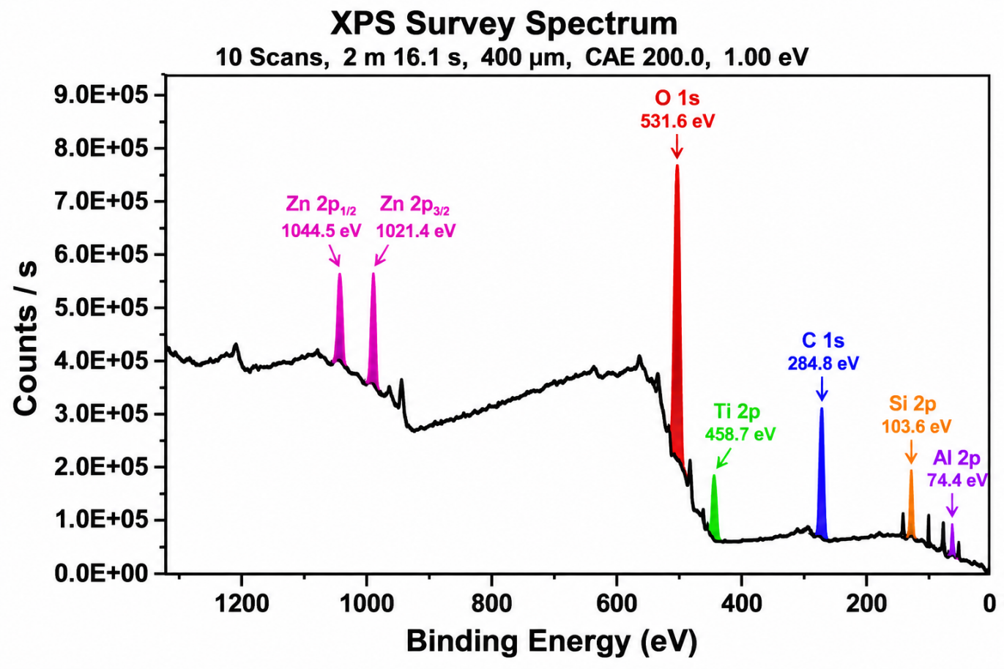
Fig. S1. X-ray photoelectron spectroscopy (XPS) survey spectrum of the ZT-40 (40 wt% zeolite) composite. The survey spectrum confirms the presence of Zn, Ti, O, Si, Al, and adventitious C on the sample surface.

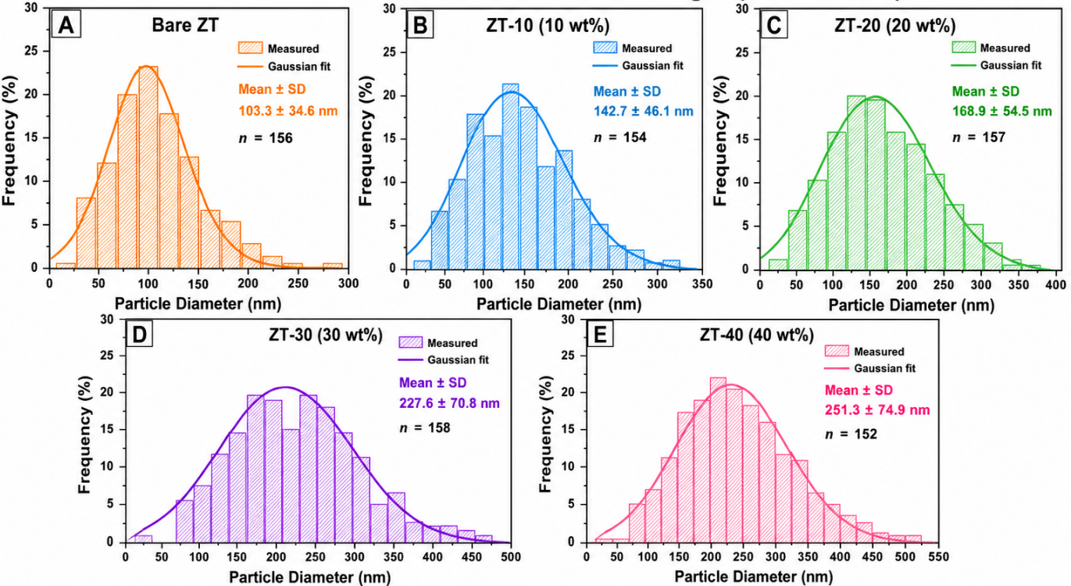
Fig. S2. Particle-size distribution histograms of (A) bare ZT, (B) ZT-10, (C) ZT-20, (D) ZT-30, and (E) ZT-40, derived from FESEM micrographs. The solid curves represent the corresponding Gaussian fits to the measured particle-size distributions, with the mean particle diameter (± standard deviation) and number of measured particles (n) indicated for each sample.
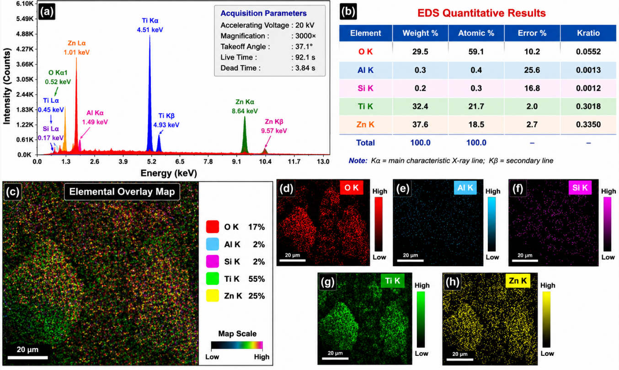

Fig. S3. EDS characterization of the bare ZT: (a) EDS spectrum with characteristic X-ray peak assignments, (b) quantitative elemental composition, (c) elemental overlay map, and corresponding elemental distribution maps of (d) O, (e) Al, (f) Si, (g) Ti, and (h) Zn, confirming the homogeneous distribution of the constituent elements throughout the material.

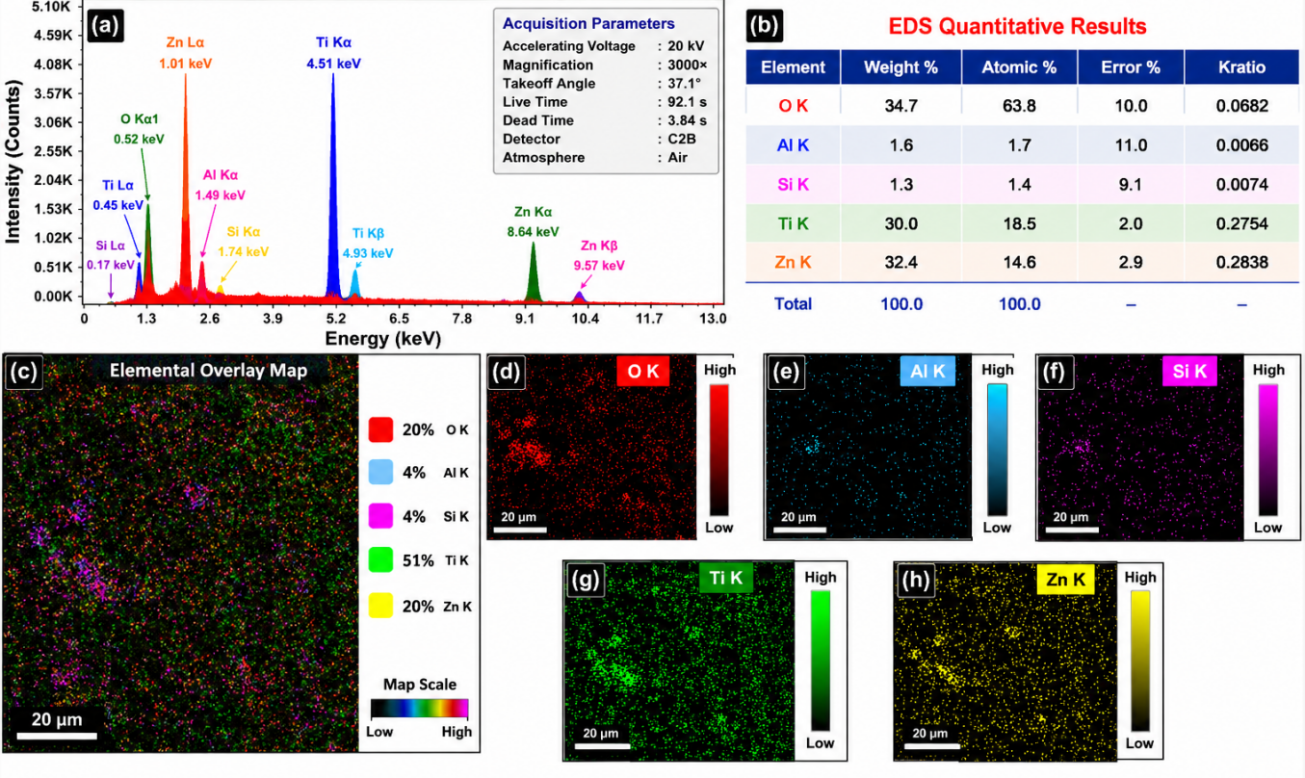
Fig. S4. EDS characterization of the ZT-10 composite: (a) EDS spectrum with characteristic X-ray peak assignments, (b) quantitative elemental composition, (c) elemental overlay map, and corresponding elemental distribution maps of (d) O, (e) Al, (f) Si, (g) Ti, and (h) Zn, confirming the homogeneous distribution of the constituent elements throughout the ZnTiO₃/zeolite composite.

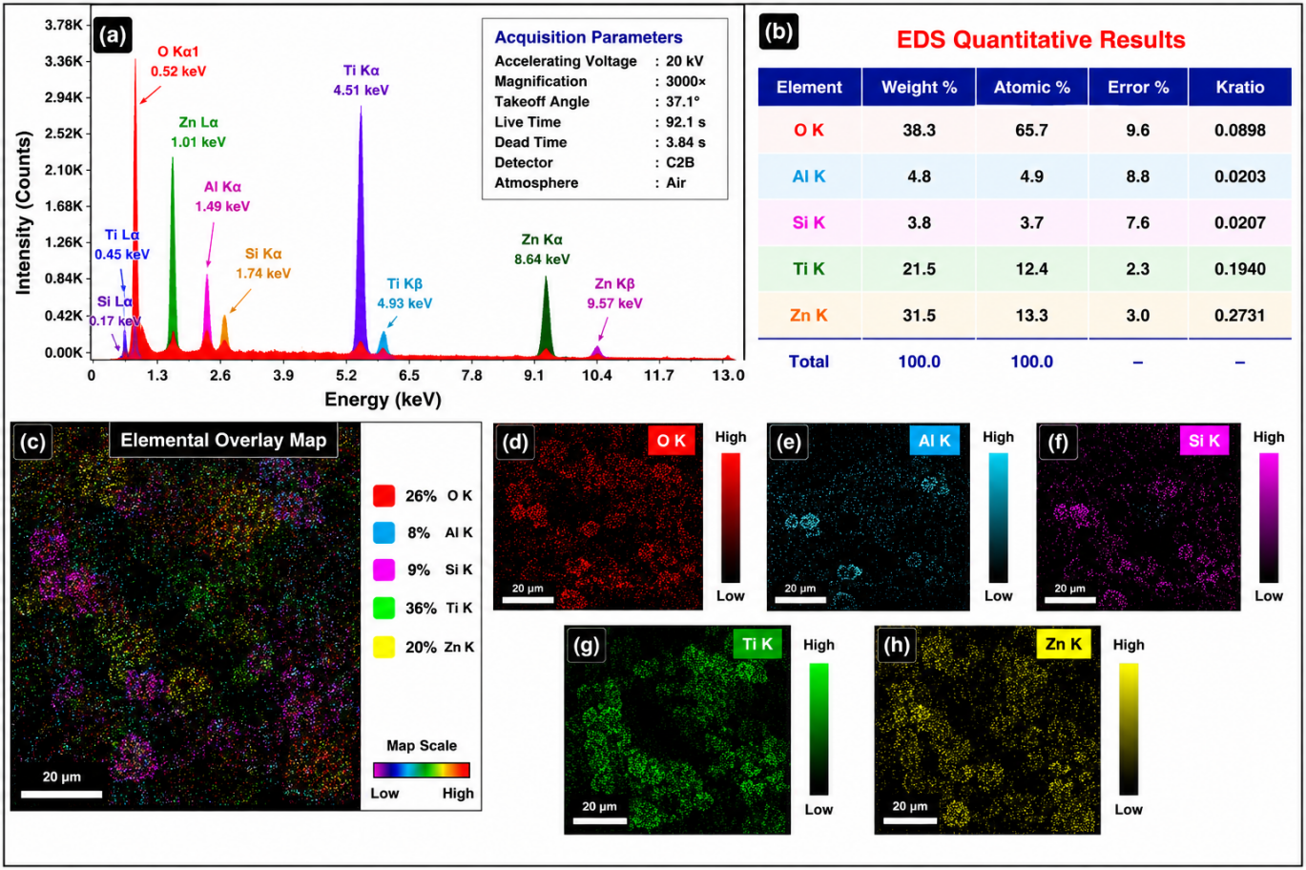
Fig. S5. EDS characterization of the ZT-20 composite: (a) EDS spectrum with characteristic X-ray peak assignments, (b) quantitative elemental composition, (c) elemental overlay map, and corresponding elemental distribution maps of (d) O, (e) Al, (f) Si, (g) Ti, and (h) Zn, confirming the homogeneous distribution of the constituent elements throughout the ZnTiO₃/zeolite composite.

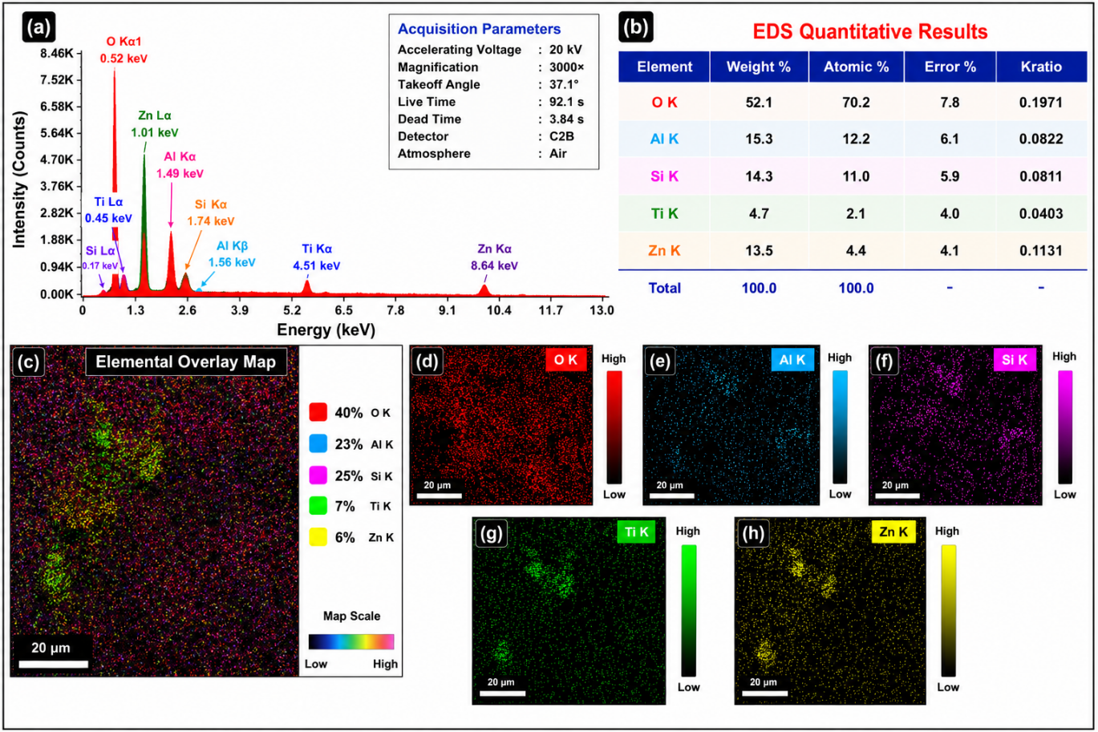
Fig. S6. EDS characterization of the ZT-30 composite: (a) EDS spectrum with characteristic X-ray peak assignments, (b) quantitative elemental composition, (c) elemental overlay map, and corresponding elemental distribution maps of (d) O, (e) Al, (f) Si, (g) Ti, and (h) Zn, confirming the homogeneous distribution of the constituent elements throughout the ZnTiO₃/zeolite composite.
Table S1 Reconstruction statistics obtained from Dunn's kinetic analysis of ZnTiO₃ (ZT) and ZnTiO₃/zeolite composite electrodes.
Sample | Mean R² | RMSE (100 mV s⁻¹) | MAE (100 mV s⁻¹) | Maximum Deviation
ZT | 0.503 | 0.0030 | 0.0018 | 0.0126
ZT-20 | 0.681 | 0.0032 | 0.0019 | 0.0132

Table S2 Quantitative separation of surface-controlled (capacitive) and diffusion-controlled current contributions of ZnTiO₃ (ZT) and ZnTiO₃/zeolite composite electrodes determined by Dunn's analysis.

Scan Rate (mV s⁻¹) | ZT Capacitive (%) | ZT Diffusion (%) | ZT-20 Capacitive (%) | ZT-20 Diffusion (%)
1 | 3.91 | 96.09 | 5.40 | 94.60
3 | 6.58 | 93.42 | 9.13 | 90.87
5 | 8.34 | 91.66 | 11.65 | 88.35
7 | 9.72 | 90.28 | 13.62 | 86.38
10 | 11.40 | 88.60 | 16.03 | 83.97
20 | 15.40 | 84.60 | 21.97 | 78.03
30 | 18.23 | 81.77 | 26.19 | 73.81
40 | 20.47 | 79.53 | 29.54 | 70.46
50 | 22.35 | 77.65 | 32.34 | 67.66
60 | 23.97 | 76.03 | 34.76 | 65.24
70 | 25.40 | 74.60 | 36.89 | 63.11
80 | 26.69 | 73.31 | 38.82 | 61.18
90 | 27.85 | 72.15 | 40.48 | 59.52
100 | 28.93 | 71.07 | 35.98 | 64.02

