Supplementary Table 1. Characteristics of the study municipalities
Characteristic | City A (Intervention) | City B (Control)
Area, km² | 70 | 80
Population (2016), n | 200000 | 190000
Population aged <15 years (2016), n | 27000 | 28000
Public assistance rate (2016), % | 3.1 | 2.3
Junior high school lunch program | Introduced in September 2016 | Implemented since 1956

Supplementary Table 2. Difference-in-differences estimates for outpatient healthcare utilization
 | Difference-in-differences  estimate (95% CI) | p value
Outpatient visits (visits per person-month) | 0.13 (0.02, 0.25) | 0.02
Any outpatient visit (percentage points) | 5.55 (0.30, 10.81) | 0.04

Note: Estimates were obtained using difference-in-differences models with individual and month fixed effects. Values are presented as regression coefficients with 95% confidence intervals (CI). The estimate for any outpatient visit represents the absolute change in the probability of having at least one outpatient visit per month, expressed in percentage points.
Supplementary Figure 1
Monthly medical use days per person-month in the intervention group (City A), control group (City B), and City C before and after the introduction of the school lunch program.

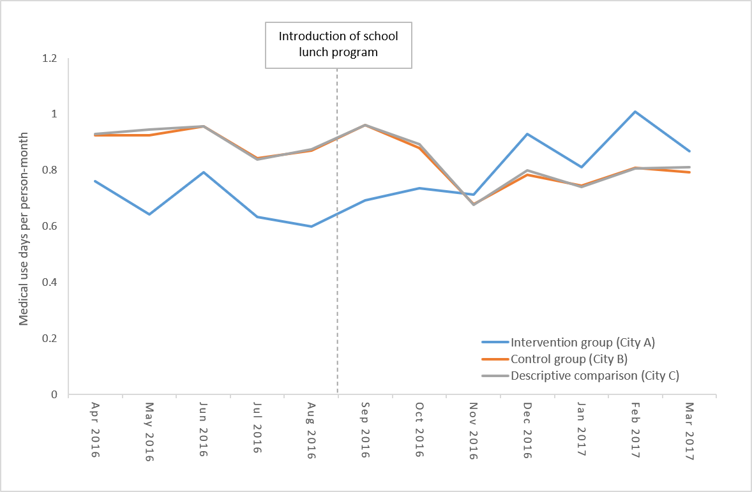

Note: Data from City C are presented only for descriptive comparison; City C was not included in the difference-in-differences analysis.
Supplementary Figure 2
Monthly medical expenditures (medical fee points per person-month) in the intervention group (City A), control group (City B), and City C before and after the introduction of the school lunch program.

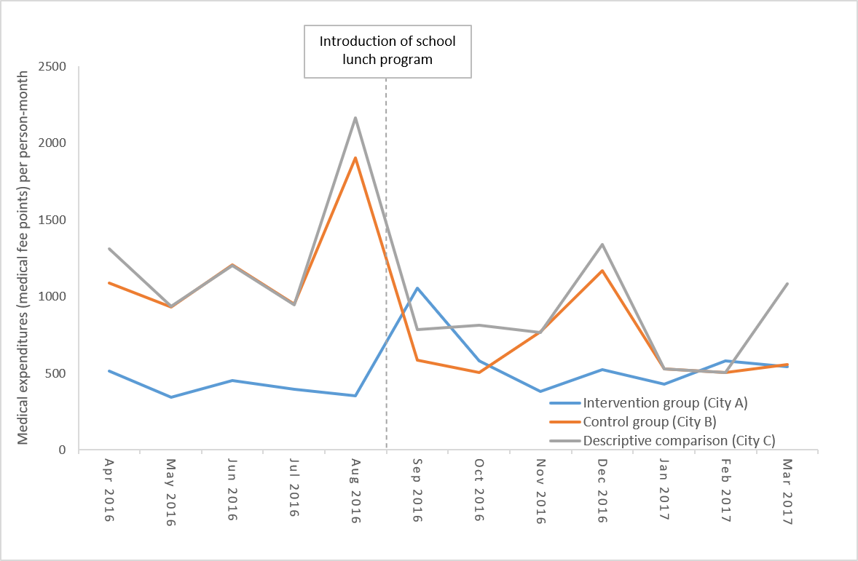

Note: Data from City C are presented only for descriptive comparison; City C was not included in the difference-in-differences analysis.

