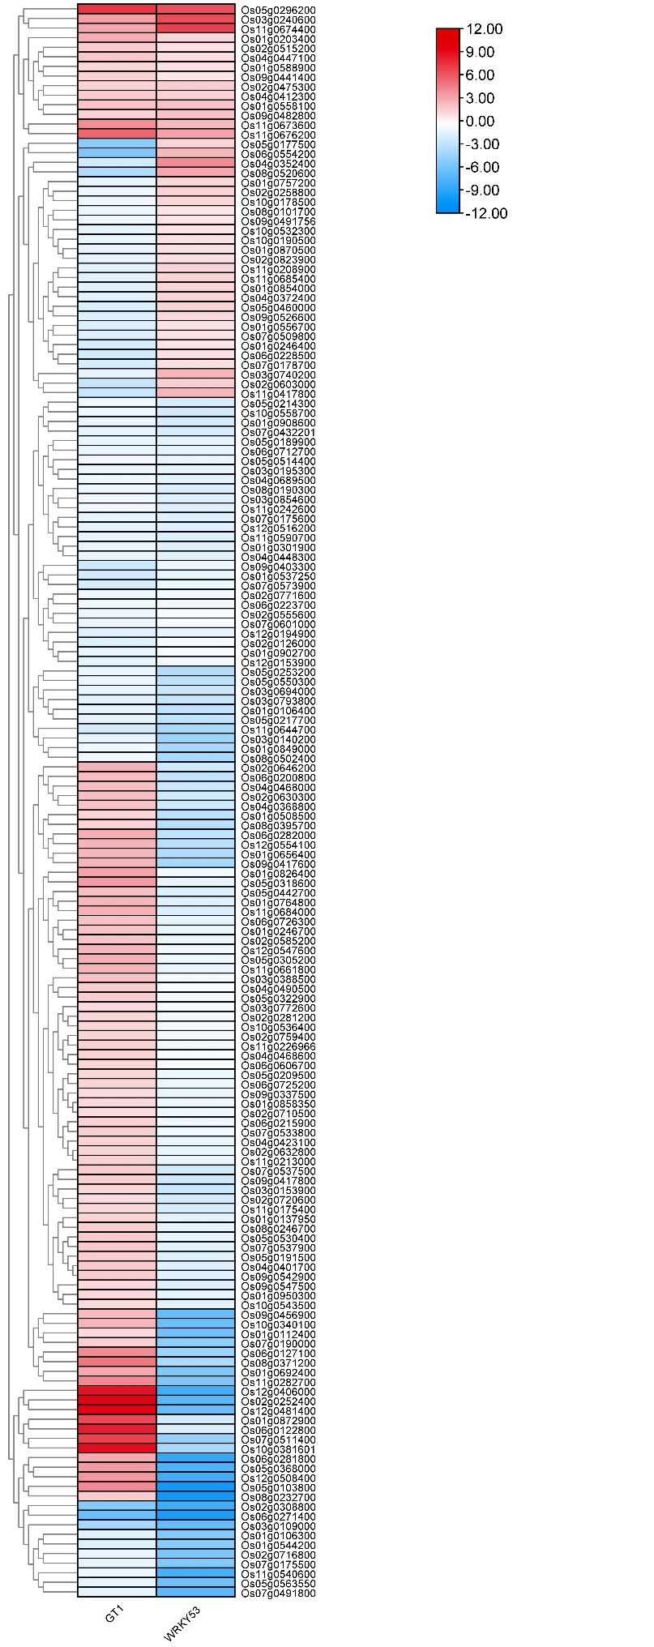
Figure S1 Heatmap of gene expression levels regulated by both GT1and WRKY53.

