Supplementary material
Supplementary Figure 1: The stability of network structure by case dropping bootstrap
Supplementary Figure 2: Bootstrapped confidence intervals of edge weights
Supplementary Figure 3: Estimation of node bridge expected influence difference by bootstrapped difference test

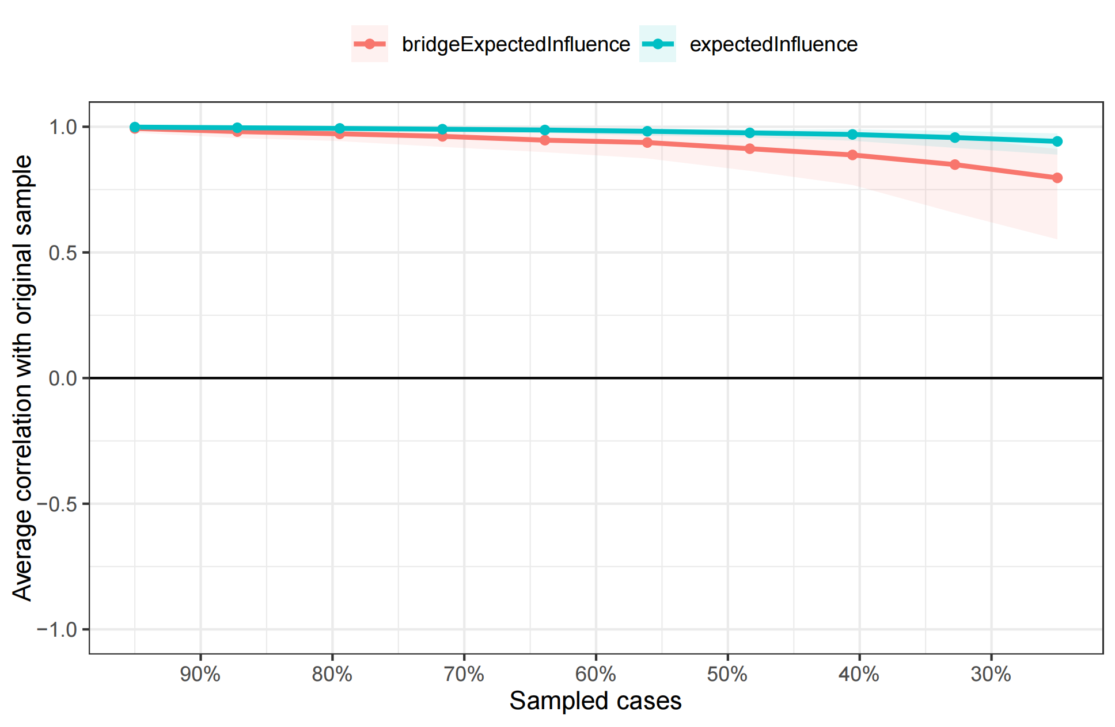
a. low comorbid network
b. moderate comorbid network
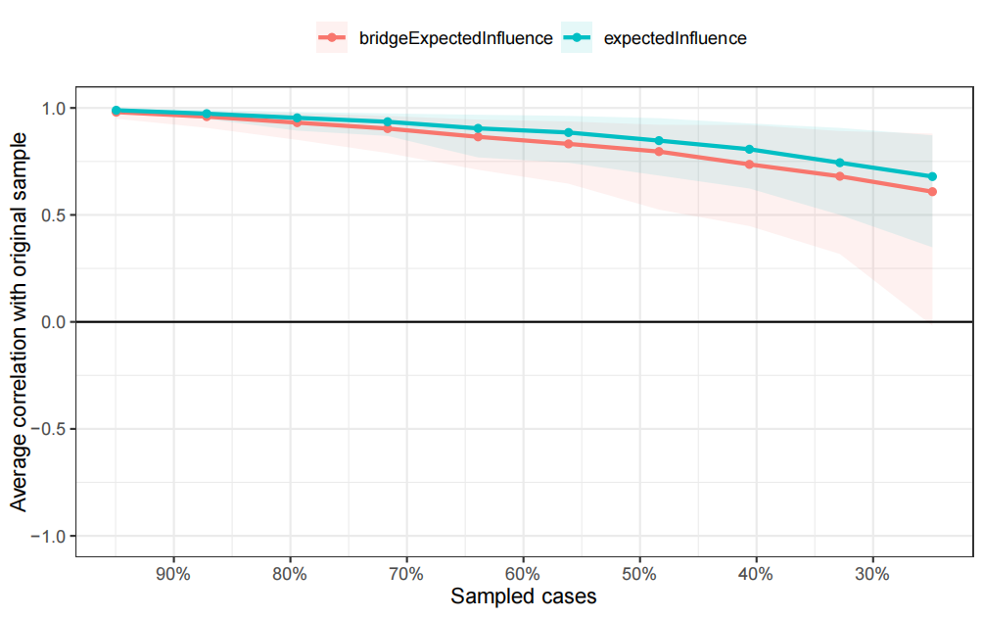
c. high comorbid network
Supplementary Figure 1: The stability of network structure by case dropping bootstrap.
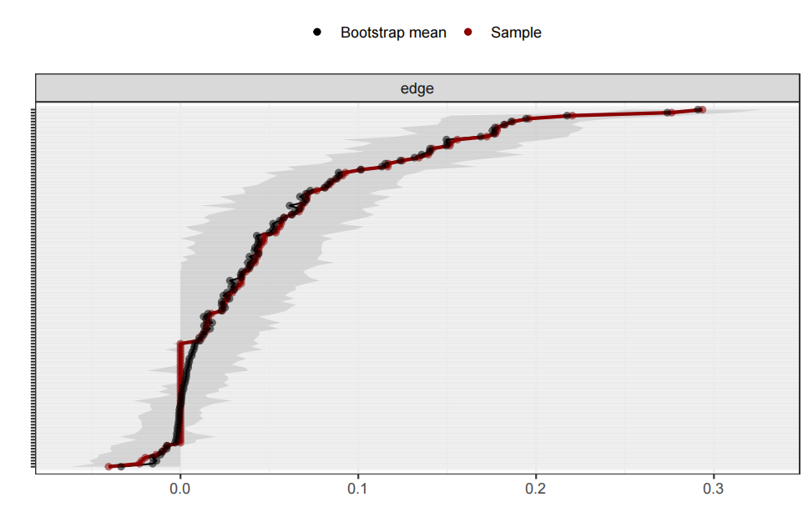
a. low comorbid network
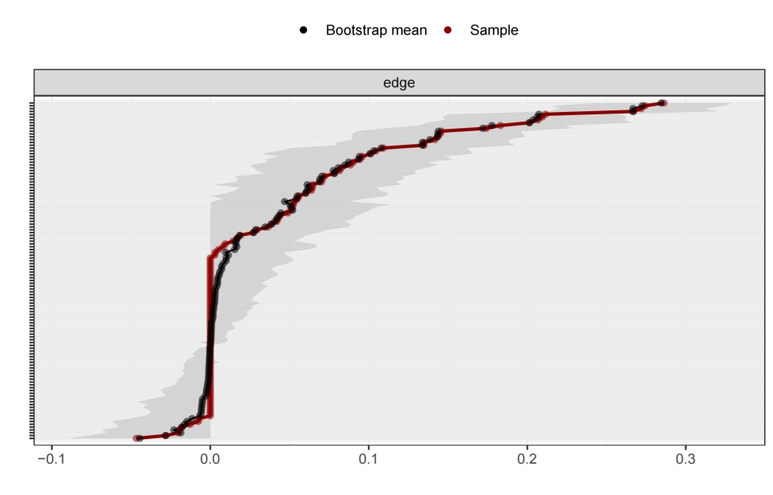
b. moderate comorbid network
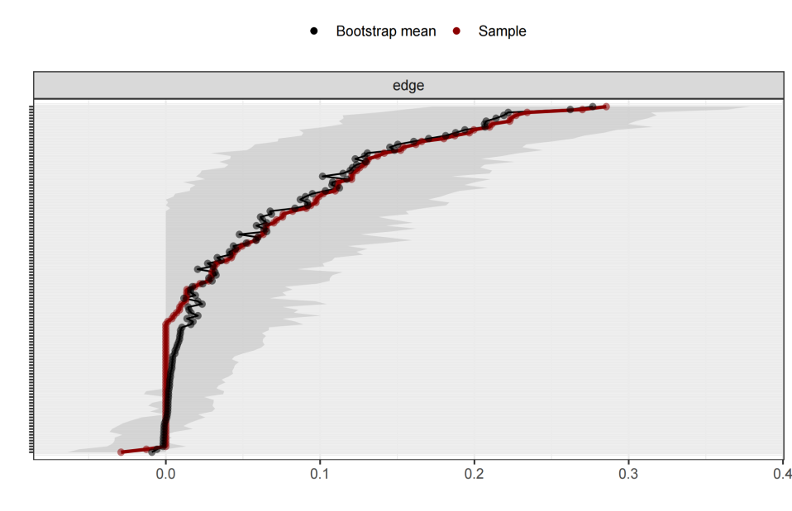
c. high comorbid network
Supplementary Figure 2: Bootstrapped confidence intervals of edge weights.
The black dots represent the edge weight values, which are arranged from highest to lowest. The gray region shows the edge weights' 95 percent Confidence Intervals. Wide intervals indicate less stability, whereas tight intervals denote more stability.
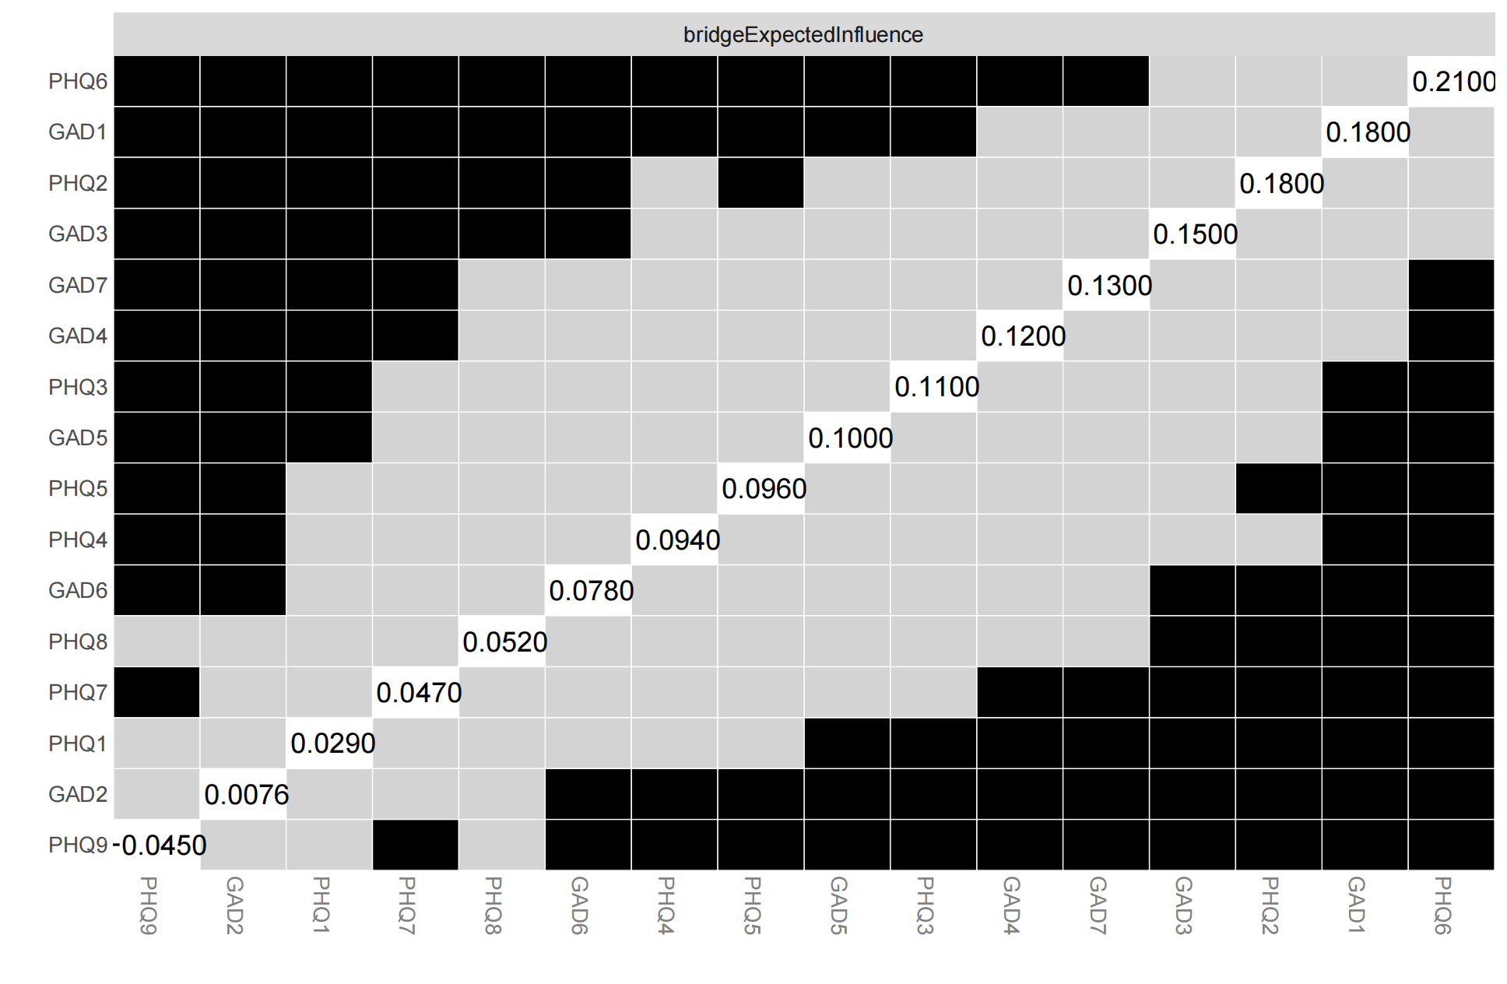
- low comorbid network
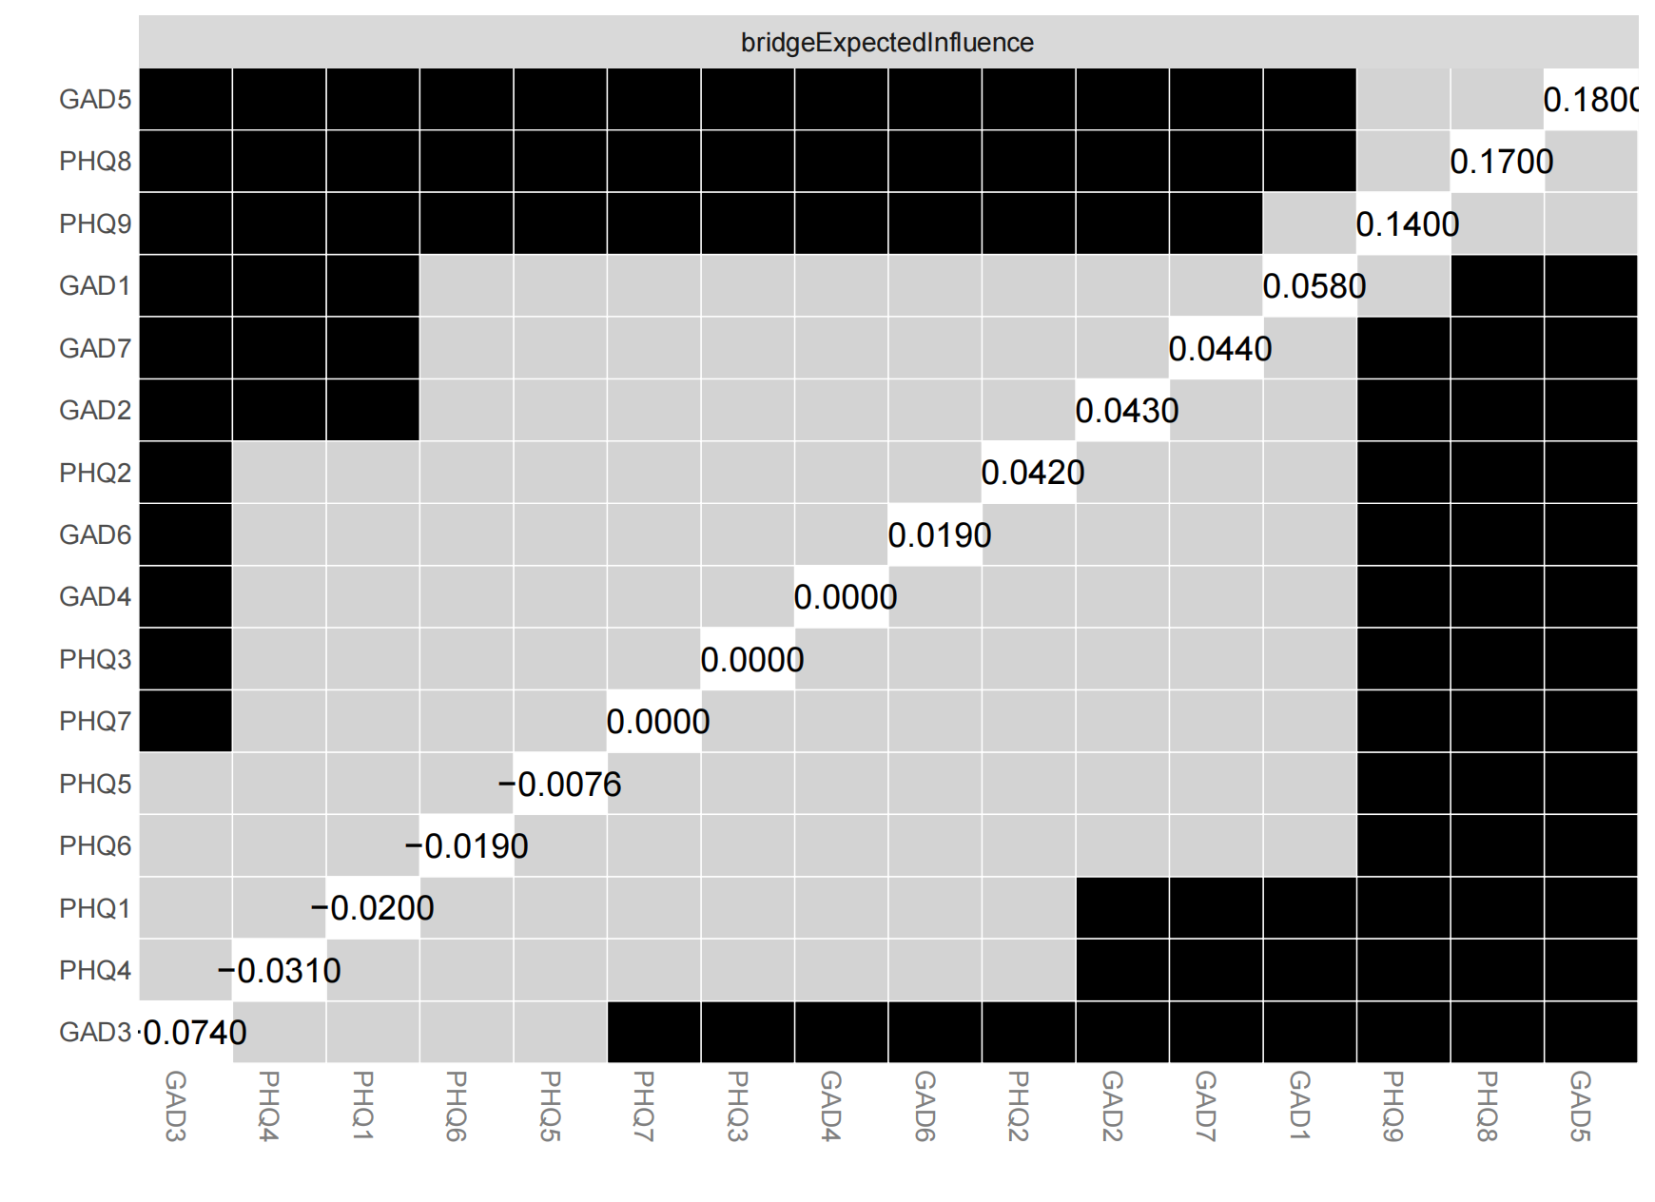
b. moderate comorbid network
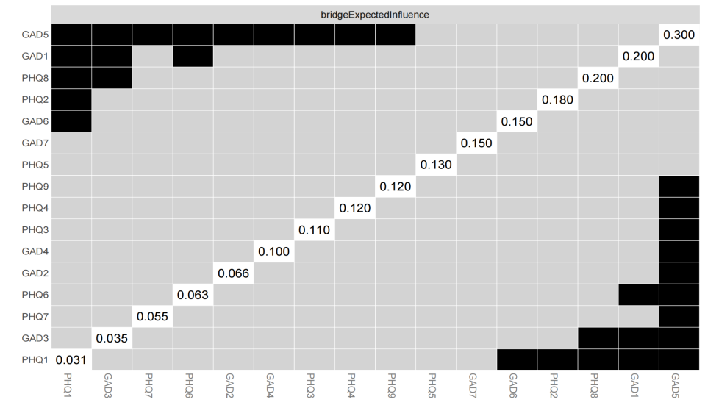
c.high comorbid network
Supplementary Figure 3: Estimation of nodes centrality difference by bootstrapped difference test.
Bootstrapped difference tests between nodes centrality within the network. Gray boxes indicate that are not significantly different from each other. Black boxes represent that are significantly different from each other (α = 0.05).

