Urinary metal exposure and type 2 diabetes mellitus: the potential mediating role of biological aging in older adults
Table S1 LOD for heavy metal in urine
Metals | LOD(μg/L)
Pb | 0.0071
Zn | 0.0447
Mn | 0.0395
Cr | 0.0395
As | 0.0081
Co | 0.8939
Note: abbreviation: LOD, Limit of detection. Pb, lead; Zn, zinc; Mn, manganese; Cr, chromium; As, arsenic; Co, cobalt.
Table S2 Sample Size Estimation Based on the Clopper-Pearson Method
Confidence Level | Sample Size | Target Proportion | Target Width | Actual Width | 95% Confidence Interval
0.95 | 248 | 15.88% | 0.1 | 0.0994 | (0.1103,0.2097)
0.95 | 843 | – | – | 0.0558 | (0.1821,0.2379)
Note: The sample sizes were estimated using the exact binomial confidence interval method (Clopper-Pearson). The Target Proportion was based on the diabetes prevalence reported by Zhou et al. The Target Width = 2* the allowable margin of error (0.05), resulting in an actual interval width of 0.0994 (≈0.10). The 95% Confidence Interval is presented in the format (lower bound, upper bound). The final sample size of this study (N = 843) exceeded the minimum effective sample size (n = 248) estimated by this method.
Table S3 Distribution of Metal Concentrations in Urine among Participants
Metals | Media (μg/L) | Interquartile range (μg/L) | Detection rate (%)
Pb | 2.38 | 0.71–6.70 | 100.00
Zn | 7.98 | 4.16–14.43 | 100.00
Mn | 0.46 | 0.26–0.77 | 99.88
Cr | 0.71 | 0.38–1.27 | 99.88
As | 0.62 | 0.32–1.24 | 98.57
Co | 0.89 | 0.55–1.47 | 99.88
Note: Detection rate (%), calculated as (number of samples with detectable metal / total samples) × 100%. Pb, lead; Zn, zinc; Mn, manganese; Cr, chromium; As, arsenic; Co, cobalt.
Table S4 VIF for Individual Metal Concentrations
Metal | Pb | Zn | Mn | Cr | As | Co
VIF | 1.715 | 3.779 | 4.145 | 4.195 | 1.473 | 4.462
Note: VIF value exceeding 5 indicates the presence of notable multicollinearity among the independent variables. Abbreviation: VIF, variance inflation factor. Pb, lead; Zn, zinc; Mn, manganese; Cr, chromium; As, arsenic; Co, cobalt.
Table S5 Metal levels (μg/L) among participants
Metal | Total (n=843) | Non-T2DM (n=667) | T2DM (n=176) | P
Pb | 2.38 (0.71,6.70) | 2.15 (0.66,6.07) | 3.33 (0.97,9.90) | 0.001
Zn | 7.98 (4.16,14.43) | 7.69 (3.90,13.31) | 10.30 (5.06,17.26) | <0.001
Mn | 0.46 (0.26,0.77) | 0.44 (0.25,0.74) | 0.50 (0.29,0.92) | 0.030
Cr | 0.71 (0.38,1.27) | 0.69 (0.36,1.23) | 0.83 (0.42,1.39) | 0.016
As | 0.62 (0.32,1.24) | 0.61 (0.30,1.24) | 0.67 (0.38,1.20) | 0.150
Co | 0.89 (0.55,1.47) | 0.88 (0.53,1.46) | 0.96 (0.64,1.51) | 0.020
Note: Metal levels were continuous variables presented by M (P25, P75). Group comparisons were performed using the Mann-Whitney test. P<0.05 was considered statistically significant.

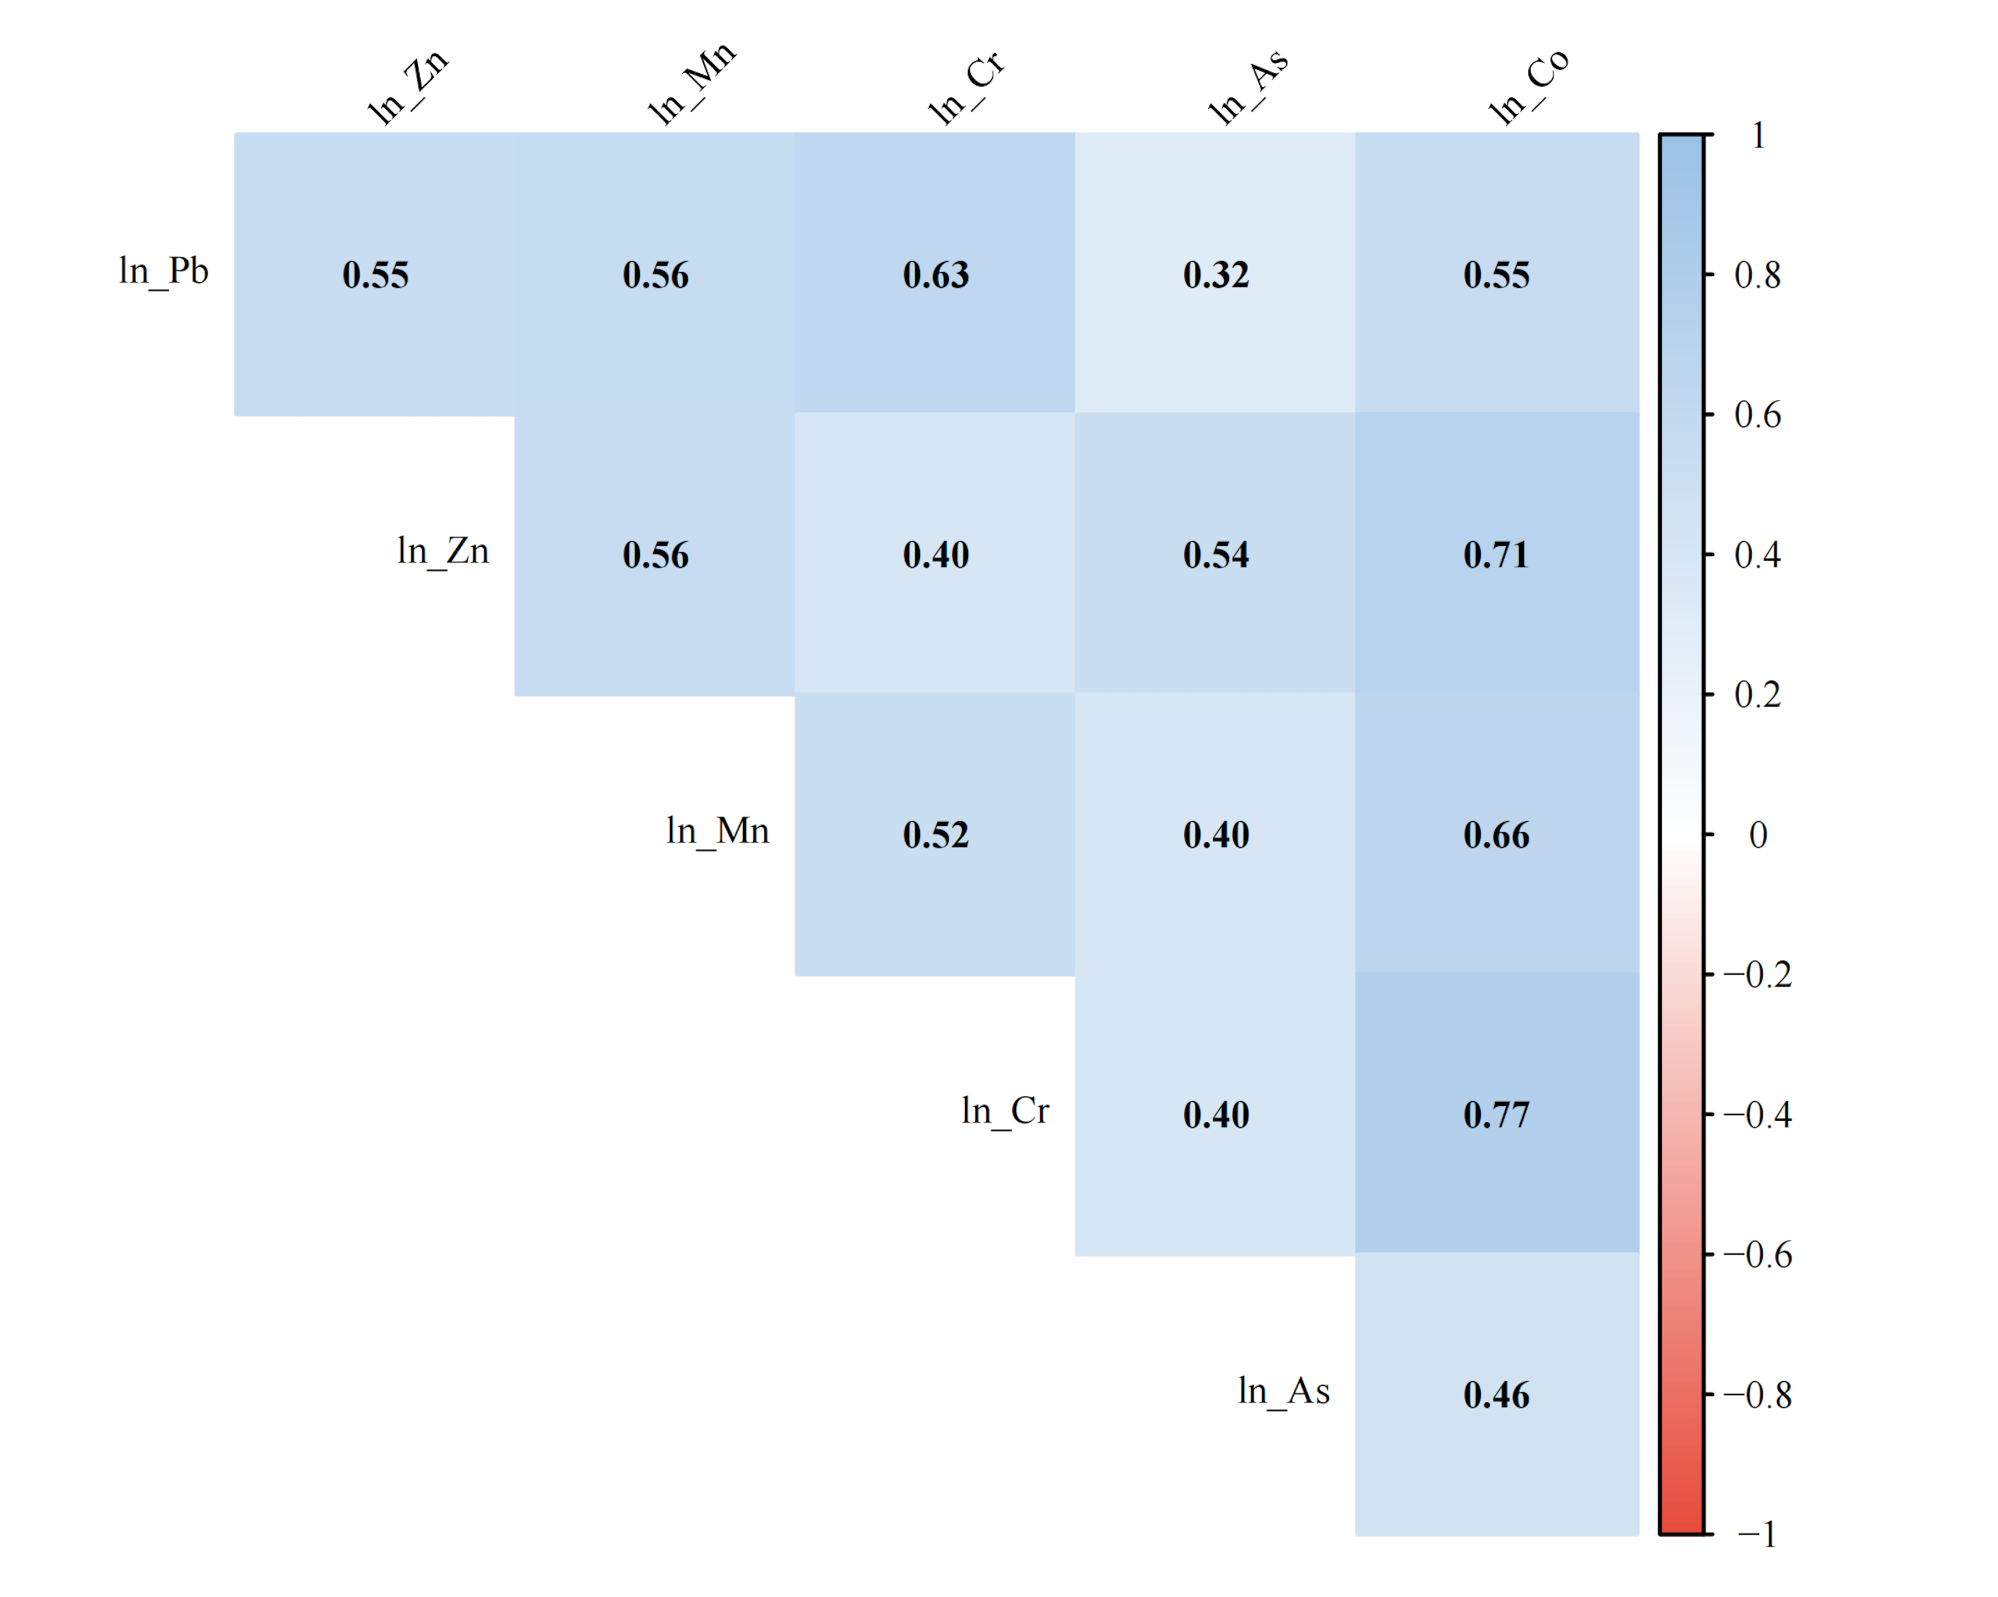
Figure S1 Pearson correlation matrix of metal
Note: Numbers represent correlation coefficients, with all P values<0.05. Blue indicates a positive correlation; red indicates a negative correlation. Color intensity corresponds to the magnitude of the correlation coefficient.

Figure S2 Association between metal and type 2 diabetes mellitus
Note: Models were adjusted for gender, age, marital status, educational level, income level, BMI, smoking and drinking status, and hypertension. Abbreviation: Pb, lead; Zn, zinc; Mn, manganese; Cr, chromium; As, arsenic; Co, cobalt.
Table S6 Logistic regression analysis of metals with type 2 diabetes mellitus
Metals | Q2 |  | Q3 |  | Q4 |  | P_trend
Metals | OR (95%CI) | P | OR (95%CI) | P | OR (95%CI) | P | P_trend
Pb | 1.050(0.620,1.780) | 0.857 | 1.240(0.744,2.075) | 0.412 | 1.805(1.105,2.978) | 0.019 | 0.033
Zn | 1.282(0.756,2.186) | 0.358 | 1.557(0.924,2.651) | 0.099 | 2.045(1.239,3.424) | 0.006 | 0.028
Mn | 1.327(0.807,2.205) | 0.218 | 1.589(0.971,2.638) | 0.076 | 1.853(1.136,3.075) | 0.022 | 0.050
Cr | 1.202(0.725,2.001) | 0.475 | 1.421(0.861,2.368) | 0.188 | 1.786(1.091,2.954) | 0.031 | 0.055
As | 1.610(1.000,2.680) | 0.093 | 1.270(0.780,2.130) | 0.480 | 1.820(1.140,3.050) | 0.030 | 0.070
Co | 1.878(1.119,3.203) | 0.018 | 1.851(1.090,3.187) | 0.024 | 1.796(1.058,3.091) | 0.032 | 0.070
Mixed | 1.467(0.886,2.453) | 0.139 | 1.197(0.706,2.040) | 0.504 | 2.060(1.267,3.398) | 0.004 | 0.035
Note: P_ trend: P value for trend test after adjustment for the false discovery rate (FDR). Models were adjusted for gender, age, marital status, educational level, income level, BMI, smoking and drinking status, and hypertension. Abbreviation: Pb, lead; Zn, zinc; Mn, manganese; Cr, chromium; As, arsenic; Co, cobalt.
Figure S3 Weights of individual metals in the WQS model
Note: Models were adjusted for gender, age, marital status, educational level, income level, BMI, smoking and drinking status, and hypertension. Larger weights indicate greater contributions of the respective metal to the overall effect of the metal mixture. Abbreviation: Pb, lead; Zn, zinc; Mn, manganese; Cr, chromium; As, arsenic; Co, cobalt.

Figure S4 Association between metal and phenotypic age
Note: Models were adjusted for gender, age, marital status, educational level, income level, BMI, smoking and drinking status, and hypertension. Abbreviation: Pb, lead; Zn, zinc; Mn, manganese; Cr, chromium; As, arsenic; Co, cobalt.
Table S7 Linear regression analysis of metals with phenotypic age
Metals | Q2 |  | Q3 |  | Q4 |  | P_trend
Metals | β(95%CI) | P | β(95%CI) | P | β(95%CI) | P | P_trend
Pb | 0.375(-1.380,2.131) | 0.675 | 0.911(-0.846,2.667) | 0.309 | 2.648(0.888,4.407) | 0.003 | 0.007
Zn | 0.062(-1.813,1.689) | 0.944 | 0.287(-1.488,2.062) | 0.751 | 2.492(0.720,4.263) | 0.006 | 0.007
Mn | 0.901(-0.868,2.670) | 0.318 | 1.071(-0.706,2.849) | 0.237 | 2.087(0.312,3.863) | 0.021 | 0.025
Cr | 0.923(-0.837,2.684) | 0.303 | 0.576(-1.189,2.340) | 0.522 | 2.619(0.842,4.396) | 0.004 | 0.007
As | 2.200(-0.094,4.495) | 0.060 | 3.854(1.537,6.172) | 0.001 | 1.553(-0.772,3.878) | 0.190 | 0.092
Co | 1.381(-0.993,3.756) | 0.254 | 1.128(-1.282,3.537) | 0.359 | 2.364(-0.042,4.770) | 0.054 | 0.092
Mixed | 1.520(0.921,2.534) | 0.001 | 1.228(0.728,2.082) | 0.001 | 2.086(1.286,3.432) | 0.001 | 0.007
Note: P_trend: P value for trend test after adjustment for the false discovery rate (FDR). Models were adjusted for gender, age, marital status, educational level, income level, BMI, smoking and drinking status, and hypertension. Abbreviation: Pb, lead; Zn, zinc; Mn, manganese; Cr, chromium; As, arsenic; Co, cobalt.
Figure S5 Dose–response associations between metals and phenotypic age
Note: Panels A–G correspond to the associations of Pb, Zn, Mn, Cr, As, Co, and mixed metals with phenotypic age, respectively. Models were adjusted for gender, age, marital status, educational level, income level, BMI, smoking and drinking status, and hypertension.

Table S8 Results of mediation analysis
Metal | Indirect effect (95%CI) | P | Direct effect(95%CI) | P | Total effect (95%CI) | P | Mediation effect (%)
Pb | 0.005(0.002,0.009) | 0.012 | 0.023(0.008,0.036) | <0.001 | 0.028(0.013,0.038) | <0.001 | 17.9
Zn | 0.007(0.002,0.011) | 0.004 | 0.057(0.025,0.088) | <0.001 | 0.064(0.034,0.094) | <0.001 | 10.9
Mn | 0.008(0.003,0.014) | 0.004 | 0.028(0.003,0.066) | 0.021 | 0.036(0.009,0.073) | 0.003 | 22.2
Cr | 0.006(0.002,0.012) | 0.019 | 0.029(0.001,0.063) | 0.023 | 0.035(0.009,0.068) | <0.001 | 17.1
Mixed | 0.093(0.048,0.145) | <0.001 | 0.514(0.231,0.804) | <0.001 | 0.607(0.341,0.918) | <0.001 | 15.3
Note: Total effect = direct effect + indirect effect. Models were adjusted for gender, age, marital status, educational level, income level, BMI, smoking and drinking status, and hypertension. Abbreviation: Pb, lead; Zn, zinc; Mn, manganese; Cr, chromium; As, arsenic; Co, cobalt.
Figure S6 Stratified logistic regression analysis of metals and type 2 diabetes mellitus
Note: Stratification variables included age and gender. Models were adjusted for gender, age, marital status, educational level, income level, BMI, smoking and drinking status, and hypertension. P value represented the significance of the associations within each subgroup; P_interaction represented the P value of the interaction between each metal and subgroup variable (gender or age). Abbreviation: Pb, lead; Zn, zinc; Mn, manganese; Cr, chromium.

Figure S7 Stratified linear regression analysis of metals and phenotypic age
Note: Stratification variables included age and gender. Models were adjusted for gender, age, marital status, educational level, income level, BMI, smoking and drinking status, and hypertension. P value represented the significance of the associations within each subgroup; P_interaction represented the P value of the interaction between each metal and subgroup variable (gender or age). Abbreviation: Pb, lead; Zn, zinc; Mn, manganese; Cr, chromium.

Figure S8 Joint effects of mixed metal exposure
Note：The x-axis denotes the combined quantiles of mixed heavy metal exposure, the y-axis represents the mean differences in diabetes risk, the red dashed line indicates a mean difference of 0, and the error bars stand for the 95% confidence intervals.
Table S9 Logistic regression analysis of metals with type 2 diabetes mellitus
Metals | Q2 |  | Q3 |  | Q4 |  | P_trend
Metals | OR (95%CI) | P | OR (95%CI) | P | OR (95%CI) | P | P_trend
Pb | 1.046(0.627,1.749) | 0.863 | 1.252 (0.759, 2.076) | 0.381 | 1.787(1.106,2.917) | 0.019 | 0.030
Zn | 1.231(0.734,2.077) | 0.431 | 1.463(0.879,2.457) | 0.146 | 1.945(1.192,3.214) | 0.008 | 0.030
Mn | 1.315(0.785,2.198) | 0.221 | 1.487(0.901,2.465) | 0.128 | 1.851(1.126,3.047) | 0.017 | 0.039
Cr | 1.205(0.718,2.029) | 0.475 | 1.450(0.920,2.285) | 0.159 | 1.642(1.068,2.524) | 0.023 | 0.050
As | 1.350(0.815,2.240) | 0.095 | 1.280(0.770,2.125) | 0.431 | 1.820(1.095,3.020) | 0.029 | 0.071
Co | 1.880(1.082,3.260) | 0.019 | 1.853(1.065,3.198) | 0.025 | 1.798(1.031,3.130) | 0.035 | 0.071
Mixed | 1.452(0.873,2.448) | 0.135 | 1.185(0.625,2.258) | 0.332 | 2.149(1.301,3.603) | 0.003 | 0.025
Note: P_trend: P value for trend test after adjustment for the false discovery rate (FDR). Models were adjusted for gender, age, marital status, educational level, income level, BMI, smoking and drinking status, hypertension, physical activity, sleep quality, and some blood-related indicators. Abbreviation: Pb, lead; Zn, zinc; Mn, manganese; Cr, chromium; As, arsenic; Co, cobalt.
Table S10 Linear Regression Analysis of Metals with phenotypic age
Metals | Q2 |  | Q3 |  | Q4 |  | P_trend
Metals | β(95%CI) | P | β(95%CI) | P | β(95%CI) | P | P_trend
Pb | 0.568(-1.166,2.303) | 0.520 | 0.740(-0.99,2.471) | 0.401 | 2.649(0.919,4.378) | 0.003 | 0.008
Zn | 0.091(-1.627,1.81) | 0.917 | 0.298(-1.446,2.042) | 0.737 | 2.628(0.892,4.365) | 0.003 | 0.008
Mn | 0.914(-0.825,2.653) | 0.303 | 1.229(-0.522,2.981) | 0.169 | 2.327(0.589,4.073) | 0.009 | 0.025
Cr | 0.932(-0.810,2.664) | 0.291 | 0.546(-1.131,2.041) | 0.325 | 2.697(0.956,4.438) | 0.002 | 0.008
As | 2.251(-0.041,4.532) | 0.058 | 3.824(1.521,6.115) | 0.001 | 1.433(-0.868,3.728) | 0.195 | 0.078
Co | 1.238(-0.991,3.732) | 0.241 | 1.114(-1.267,3.523) | 0.339 | 2.493(0.001,4.688) | 0.049 | 0.078
Mixed | 1.453(0.854,2.048) | 0.001 | 1.254(0.653,1.854) | 0.001 | 2.108(1.324,3.022) | 0.001 | 0.008
Note: P_trend: P value for trend test after adjustment for the false discovery rate (FDR). Models were adjusted for gender, age, marital status, educational level, income level, BMI, smoking and drinking status, hypertension, physical activity, sleep quality, and some blood-related indicators. Abbreviation: Pb, lead; Zn, zinc; Mn, manganese; Cr, chromium; As, arsenic; Co, cobalt.
Table S11 Results of mediation analysis
Metal | indirect effect (95%CI) | P | direct effect(95%CI) | P | total effect (95%CI) | P | Mediation  effect (%)
Pb | 0.004(0.001,0.008) | 0.031 | 0.022(0.009,0.038) | <0.001 | 0.026(0.015,0.038) | <0.001 | 15.3
Zn | 0.005(0.002,0.012) | 0.022 | 0.058(0.033,0.101) | <0.001 | 0.063(0.037,0.0105) | <0.001 | 7.9
Mn | 0.007(0.002,0.011) | 0.004 | 0.031(0.001,0.063) | 0.025 | 0.038(0.007,0.069) | 0.011 | 18.4
Cr | 0.005(0.001,0.008) | 0.008 | 0.032(0.009,0.065) | 0.018 | 0.036(0.0013,0.068) | 0.003 | 13.9
Mixed | 0.089(0.045,0.139) | <0.001 | 0.510(0.228,0.802) | <0.001 | 0.599(0.335,0.912) | <0.001 | 14.8
Note: Total effect = direct effect + indirect effect. Models were adjusted for gender, age, marital status, educational level, income level, BMI, smoking and drinking status, hypertension, physical activity, sleep quality, and some blood-related indicators. Abbreviation: Pb, lead; Zn, zinc; Mn, manganese; Cr, chromium; As, arsenic; Co, cobalt.

