SUPPLEMENTAL INFORMATION

Rapid offline integration of learned experiences is shaped by valence and biases future decisions

Ting Xu^{1,2,3,4}*, Zhiyi Chen^{1,2,5}, Lei Zhang^{6,7}, Xianyang Gan^{3,4}, Feng Zhou^{1,2}, Ran Zhang^{1,2}, Weihua Zhao^{3,4}, Kun Fu^{3,4}, Lan Wang^{3,4}, Dezhong Yao^{3,4}, Tingyong Feng^{1,2}*, Benjamin Becker^{8,9}*

¹ Faculty of Psychology, Southwest University, Chongqing, China
² Key Laboratory of Cognition and Personality, Ministry of Education, Chongqing, China
³ The Center of Psychosomatic Medicine, Sichuan Provincial Center for Mental Health, Sichuan Provincial
People’s Hospital, University of Electronic Science and Technology of China, Chengdu, China
⁴ MOE Key Laboratory for Neuroinformation, School of Life Science and Technology, University of Electronic
Science and Technology of China, Chengdu, China
⁵ Experimental Research Center for Medical and Psychological Science (ERC-MPS), School of Psychology, Third
Military Medical University, Chongqing, China
⁶ Centre for Human Brain Healthy, School of Psychology, University of Birmingham, Birmingham, UK
⁷ Institute for Mental Health, School of Psychology, University of Birmingham, Birmingham, UK
⁸ Department of Psychology, The University of Hong Kong, Hong Kong, China
⁹ SRT AI, Society & Social Dynamics, The University of Hong Kong, Hong Kong SAR, China

*Correspondence to
Ting Xu
Faculty of Psychology, Southwest University, Chongqing, China
E-mail: tingxu.uestc@outlook.com

Tingyong Feng
Faculty of Psychology, Southwest University, Chongqing, China
E-mail: fengty0@swu.edu.cn

Benjamin Becker
Department of Psychology, The University of Hong Kong, Hong Kong, China
E-mail: ben_becker@gmx.de

Supplemental Methods
Computational model
An immense revolution in the psychology and neuroscience is the application of sophisticated computational models which allows the instantiation of complex mathematical algorithms to make quantitative predictions about dynamic features of how choice behaviors are generated [1-3], instead solely concentrating on choice accuracy and response time and omitting the discernment of speed-accuracy trade-offs [4-5]. We thus derived four computational models (M1: Recorla-Wagner (RW) model with single learning rate; M2: RW model with dual learning rate; M3: Reinforcement Learning Drift Diffusion model (RL-DDM) with single learning rate; M4: RL-DDM with dual learning rate) to explore how participants encode and predict value information to facilitate rewarding choices in learning stage (See Table. S1). The RW model elucidates error-driven learning process in which the choices are updated by evaluating the discrepancy between actual outcome and expected outcome value [6-7], whereas the RLDDM quantifies the learning of subjective values towards options over time and how this skews specific decisions via inspecting both choices and response times [8]. To abstain from repeated redundant procedures of model evaluation, simulation and parameter recovery and select one model reaching goodness-of-fit criterion directly, we firstly compared the two RW models according to Leave-One-Out Information Criterion (LOOIC) [9] using the loo package in R and evaluated the two RLDDMs performance based on the Deviance Information Criterion (DIC) using the hddm package in python. The LOOIC was a highly recommended method for estimating pointwise out-of-sample prediction accuracy from hierarchical Bayesian models, with lower LOOIC score suggesting better prediction accuracy out of sample. Although the DIC with lower value also indicated better hierarchical model, it was only effective when the posterior distributions of the model is approximately multivariate normal [10].
Our initial analysis revealed that the fitting data from the first fMRI run of the learning stage exhibited lower Bayesian information criterion (BIC), leave-one-out cross-validation information criterion (LOOIC), and deviance information criterion (DIC) values compared to those from the two fMRI runs (Table. S2-S3). This suggested that the four models performed better in capturing participants’ actual learning trajectory in the first fMRI run, but not in both two fMRI runs of the learning stage (Fig. S1-S5), which supported our pre-determined analysis plan of focusing solely on the first fMRI run. Given that, we conducted model comparison between M1 and M2, M3 and M4, separately, revealing that M2 and M4 with dual learning rate were the best-fitting models (Table. S2-S3). However the M4 was excluded due to its poor simulation performance in posterior predictive checks for choice accuracy (Fig. S4) in the comparison with M2 which captures better representation of overall learning trends (the trial-wise observed data significantly correlates with simulated data with high correlation coefficients that ranging from 0.94 to 0.99, all ps < 0.001).
As such we preserved the M2 which was defined with a hierarchical Bayesian parameter estimation framework in which group and individual parameter distributions were fitted simultaneously and constrained each other. In this model, the expected value of the chosen object (Q_{cs}) on the trial t+1 was updated based on the disparity (r(t) – Q_{cs}(t) denoted as the prediction error (PE)) between the reward obtained for choosing that object (r = 1 for reward, r = 0 for loss) and the prior expected value of that object:

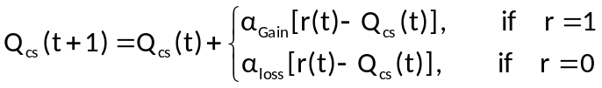

Following that equation, choices followed by positive outcome (r = 1) were weighted by the α_{Gain} learning rate parameter and choices followed by negative outcome (r = 0) were weighted by the α_{Loss} learning rate parameter (0 < α_{Gain}, α_{Loss} < 1). The Q-value for the first trial and for each participant was set at 0.5 to prevent any initial bias in the expected value. Participants’ choice behaviors were then estimated via the use of a ‘Softmax’ logistic function, in which an inverse gain parameter β reflecting the probability of choosing one object over another (e.g., A over B) was computed as:

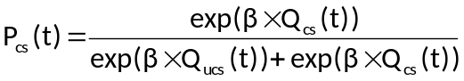

The parameter β ranging from 1 to 15 revealed the exploratory or exploitatory choice behavior, with higher value describing consistent choices on the object of higher expected value, but lower value reflecting random choices irrespective of the expected value of the object. Accordingly, participants’ trial-wise choices were fit with three free parameters α_{Gain}, α_{Loss} and β, which were modified to maximize the likelihood of the actual choices under the model.
In addition, to check the validity of model parameter estimation, we deployed participant-specific posterior means for each true free parameter from the M2 as ground truth and used them to simulate 50 new choice datasets per participant. The M2 was fitted again to those 50 simulated data in which each participant would be reported with 50 × 3 recovered parameters. We then averaged the recovered parameters for α_{Gain}, α_{Loss} and β for each participant and associated those averaged recovered parameters with true parameters to indicate the degree to which they are correlated and whether there was a bias. Finally, we evaluated the ability of M2 in capturing the trial-wise expected value and PEs based on the rewarding probability by plotting the change of final Q values across each object alongside with rewarding probability and comparing PEs, updated Q value and PEs in different stimulus pairs.

Supplemental Results
Table S1. Free parameters of all models
Models | Free parameters
Model 1 | α, β
Model 2 | α_{Gain}, α_{Loss}, β
Model 3 | a, v, t , α
Model 4 | a, v, t, α_{Gain}, α_{Loss}
α - learning rate; β - inverse temperature; α_{Gain}, α_{Loss} - learning rate for gain and loss outcomes, separately; a - decision threshold; v - drift rate; t - non-decision time

Table S2. Model1-2 comparison indices between first and second fmri run dataset
Group-level | LOOIC±SE | Mean_AIC | Mean_BIC
Model 1_{(1st run)} | 1570.0(105.1) | 37.21 | 49.06
Model 1_{(2 runs)} | 2442.2(200.3) | 55.68 | 68.91
Model 2_{(1st run)} | 1385.6(94.6) | 34.48 | 52.25
Model 2_{(2 runs)} | 2222.8(195.6) | 52.24 | 72.09
LOOIC - leave-one-out information criterion; AIC - Akaike information criterion; BIC - Bayesian information criterion

Table S3. Model3-4 comparison indices between first and second fmri run dataset
Group-level | DIC | Gelman-statistic value
Model 3_{(1st run)} | 2519.96 | 1.02
Model 3_{(2 runs)} | 3957.18 | 1.01
Model 4_{(1st run)} | 2000.58 | 1.03
Model 4_{(2 runs)} | 2946.13 | 1.01
DIC - Deviance information criterion

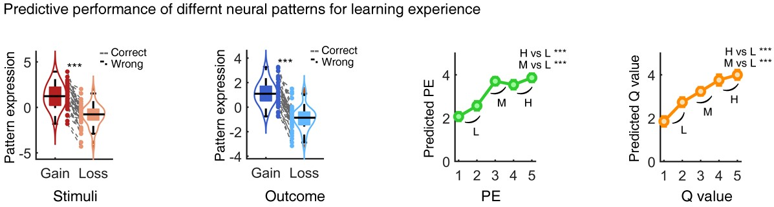
Fig. S1 Predictive performance of different neural patterns for learning experiences, including gain- and loss-related stimuli and outcomes, as well as various levels of prediction errors and expected value.

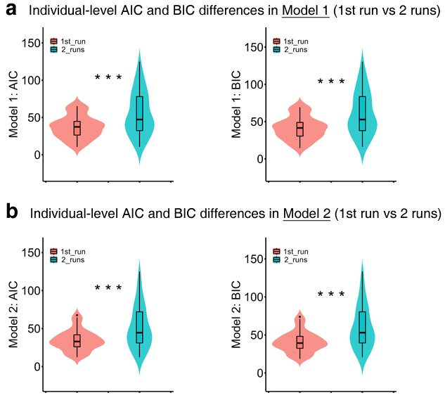
Fig.S2 Individual-level differences in AIC and BIC between models using data from only the first fMRI run and models using data from both fMRI runs.M1: Recorla-Wagner model with single learning rate; M2: RW model with dual learning rate.

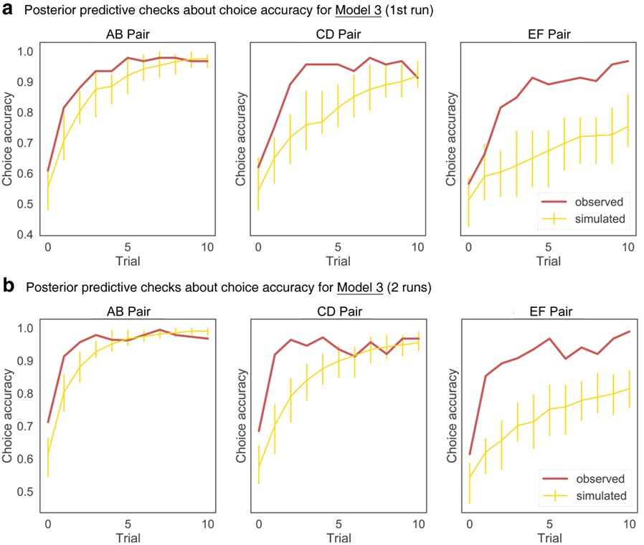
Fig. S3 Posterior predictive checks assessing trial-wise choice accuracy for Model 3 fitted to data from only the first fMRI run (a) and to data from both fMRI runs (b).

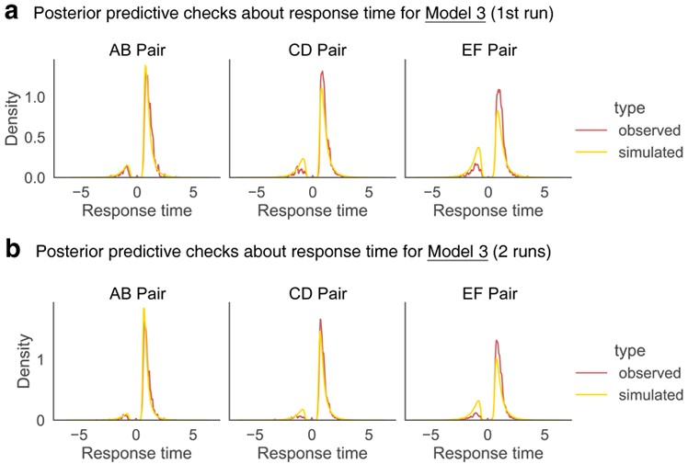
Fig. S4 Posterior predictive checks assessing trial-wise response time for Model 3 fitted to data from only the first fMRI run (a) and to data from both fMRI runs (b).

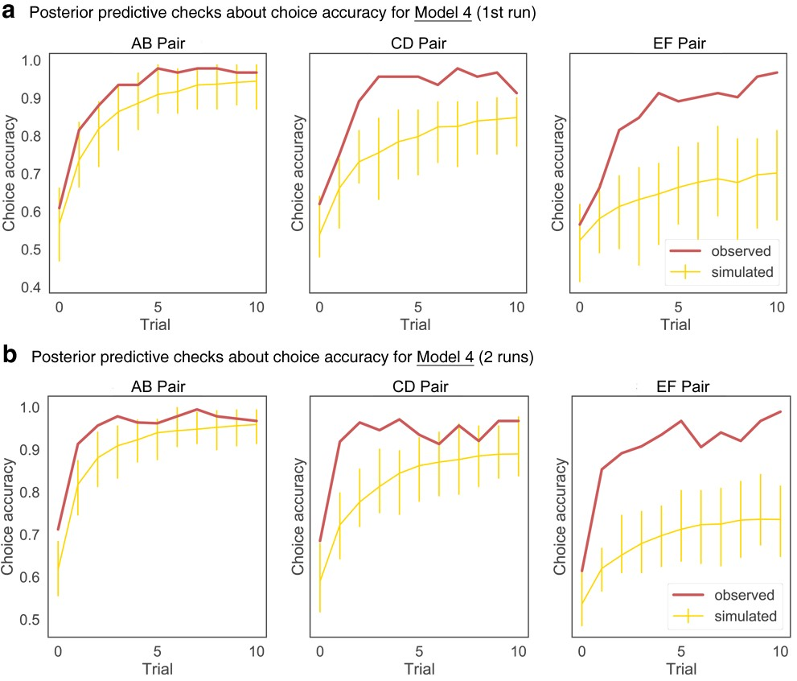
Fig. S5 Posterior predictive checks assessing trial-wise choice accuracy for Model 4 fitted to data from only the first fMRI run (a) and to data from both fMRI runs (b).

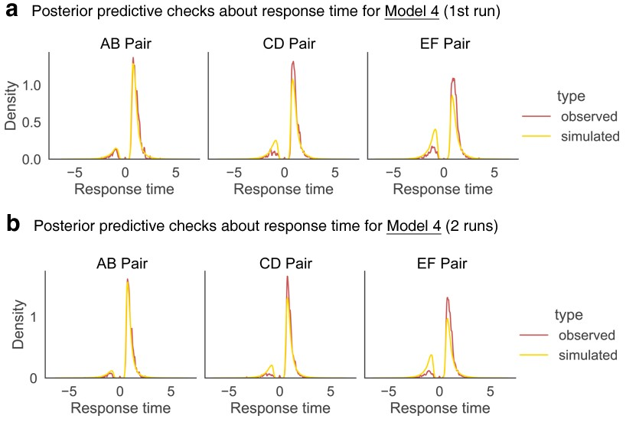
Fig. S6 Posterior predictive checks assessing trial-wise response time for Model 4 fitted to data from only the first fMRI run (a) and to data from both fMRI runs (b).

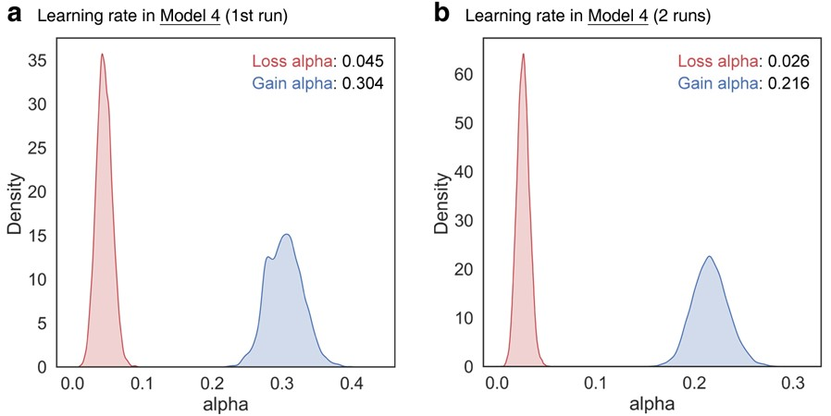
Fig. S7 The “Optimism bias” was observed in learning rates for Model 4 fitted to data from only the first fMRI run (a) and from both fMRI runs (b).

Reference
- R. S. Sutton, A. G. Barto, Reinforcement learning: An introduction (MIT press, 2018).
- R. C. Wilson, A. G. Collins, Ten simple rules for the computational modeling of behavioral data. Elife 8, e49547 (2019).
- D. Roberts, C. A. Hutcherson, Affect and decision making: Insights and predictions from computational models. Trends in cognitive sciences 23, 602-614 (2019).
- T. Stafford, A. Pirrone, M. Croucher, A. Krystalli, Quantifying the benefits of using decision models with response time and accuracy data. Behavior Research Methods 52, 2142-2155 (2020).
- R. P. Heitz, The speed-accuracy tradeoff: history, physiology, methodology, and behavior. Frontiers in neuroscience 8, 150 (2014).
- J. O.-Y. Yau, G. P. McNally, The Rescorla-Wagner model, prediction error, and fear learning. Neurobiology of learning and memory 203, 107799 (2023).
- L. Zhang, L. Lengersdorff, N. Mikus, J. Gläscher, C. Lamm, Using reinforcement learning models in social neuroscience: frameworks, pitfalls and suggestions of best practices. Social Cognitive and Affective Neuroscience 15, 695-707 (2020).
- L. Fontanesi, S. Gluth, M. S. Spektor, J. Rieskamp, A reinforcement learning diffusion decision model for value-based decisions. Psychonomic bulletin & review 26, 1099-1121 (2019).
- Vehtari, A. Gelman, J. Gabry, Practical Bayesian model evaluation using leave-one-out cross-validation and WAIC. Statistics and computing 27, 1413-1432 (2017).
- D. J. Spiegelhalter, N. G. Best, B. P. Carlin, A. Linde, The deviance information criterion: 12 years on. Journal of the Royal Statistical Society Series B: Statistical Methodology 76, 485-493 (2014).

