Table 2 Frequency of Inappropriate Sitting Posture (ISP) Types (n=500)
ISP Type |  |  | Response | n | %
Computer work  postures | Sitting on the edge of the chair | 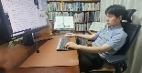 | No | 310 | 62
Computer work  postures | Sitting on the edge of the chair |  | Yes | 190 | 38
Computer work  postures | Chin up | 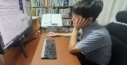 | No | 414 | 82.8
Computer work  postures | Chin up |  | Yes | 89 | 17.2
Computer work  postures | Forward head posture | 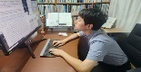 | No | 310 | 62
Computer work  postures | Forward head posture |  | Yes | 190 | 38
Computer work  postures | One arm forward | 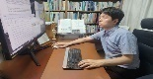 | No | 415 | 83
Computer work  postures | One arm forward |  | Yes | 85 | 17
Types of crossed-leg sitting postures | Crossing legs at the knee | 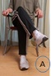  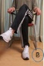 | No | 284 | 56.8
Types of crossed-leg sitting postures | Crossing legs at the knee |  | Yes | 216 | 43.2
Types of crossed-leg sitting postures | Resting one ankle on the  opposite knee | 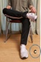  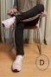 | No | 395 | 79
Types of crossed-leg sitting postures | Resting one ankle on the  opposite knee |  | Yes | 105 | 21
Types of crossed-leg sitting postures | Crossing legs at the ankles | 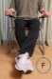  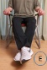 | No | 375 | 75
Types of crossed-leg sitting postures | Crossing legs at the ankles |  | Yes | 125 | 25
Slouching  postures | Position of the back when  sitting in a chair 1 |  | No | 318 | 63.6
Slouching  postures | Position of the back when  sitting in a chair 1 |  | Yes | 182 | 36.4
Slouching  postures | Position of the back when  sitting in a chair 3 |  | No | 293 | 58.6
Slouching  postures | Position of the back when  sitting in a chair 3 |  | Yes | 207 | 41.4
Slouching  postures | Position of the back when  sitting in a chair 4 |  | No | 409 | 81.8
Slouching  postures | Position of the back when  sitting in a chair 4 |  | Yes | 91 | 18.2
Daily life  postures | Cross-legged floor sitting |  | No | 151 | 30.2
Daily life  postures | Cross-legged floor sitting |  | Yes | 349 | 69.8
Daily life  postures | Full Lotus position |  | No | 467 | 93.4
Daily life  postures | Full Lotus position |  | Yes | 33 | 6.6
Daily life  postures | Butterfly sitting |  | No | 472 | 94.4
Daily life  postures | Butterfly sitting |  | Yes | 28 | 5.6
Daily life  postures | Asymmetrical  floor sitting with one knee raised | 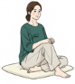 | No | 384 | 76.8
Daily life  postures | Asymmetrical  floor sitting with one knee raised |  | Yes | 116 | 23.2
Daily life  postures | Unilateral  side-sitting on the floor | 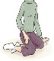 | No | 481 | 96.2
Daily life  postures | Unilateral  side-sitting on the floor |  | Yes | 19 | 3.8
Daily life  postures | Sitting with one leg tucked  under opposite thigh |  | No | 293 | 58.6
Daily life  postures | Sitting with one leg tucked  under opposite thigh |  | Yes | 207 | 41.4
Cradling phone between neck and shoulder |  |  | No | 405 | 81
 |  |  | Yes | 95 | 19

