Alleviation of Oxidative Stress Upregulates Protective Autophagy to Mediate PTX3-Induced Anoikis Resistance and Metastasis in HNSCC

Ting-Wei, Chang et al.

Supplementary figures

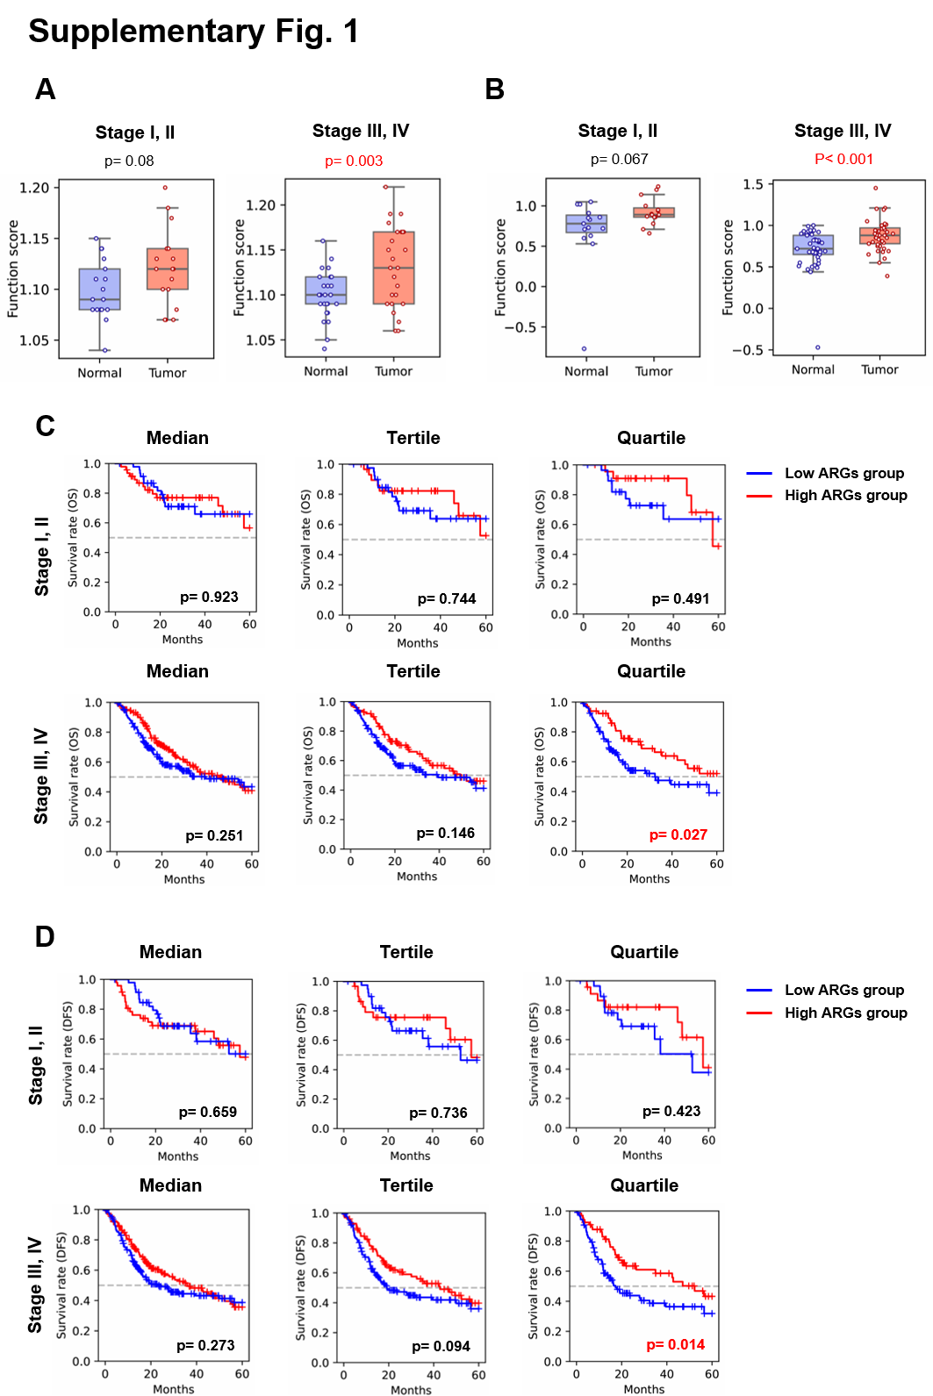
Supplementary figure 1. The expression of anoikis-related gene (ARGs) signature in HNSCC. (A) The box plots showed the transcriptional expression of ARGs from the cohort of TCGA-HNSC (n=84, including 34 patients within stage I, II and 50 patients within stage III and IV). (B) The box plots showed the mass-spectroscopy-based protein expression of ARGs from the cohort of CPTAC-HNSCC (n=120, including 30 patients within stage I, II and 90 patients within stage III and IV). Clinical data were analyzed by Q-omics data mining platform [ref]. (C-D) Kaplan-Meier curves showed HNSCC patient overall and disease-free survival that was retrieved from the TCGA database (n=430, including 94 patients within stage I, II and 336 patients within stage III and IV by cut-off ARGs expression with median, tertile and quartile). The p-value of the Log-rank test compared patients with high (red) and low (blue) expression of ARGs that were shown in the figures.

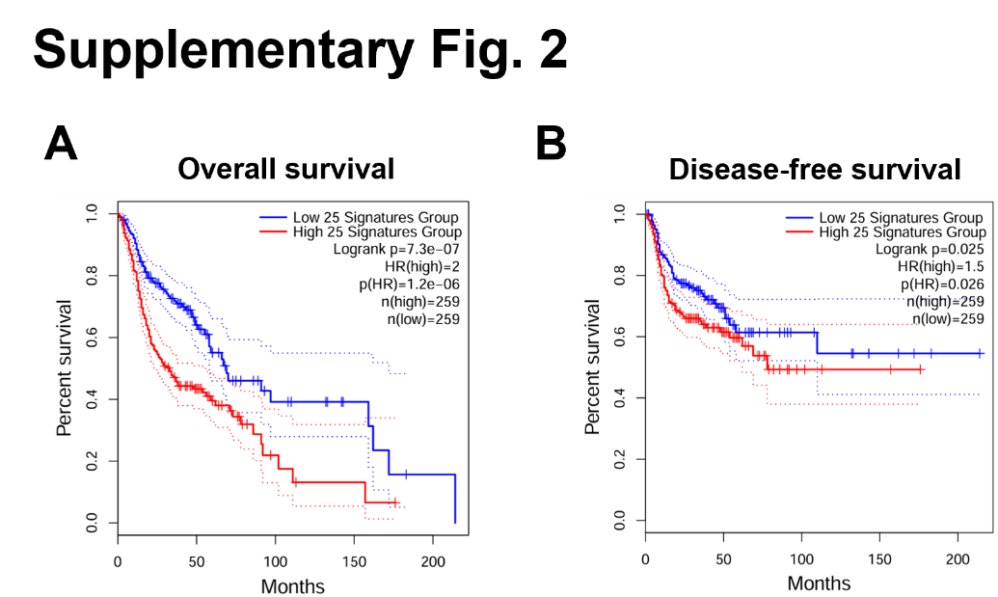
Supplementary figure 2. The expression and correlation of anoikis resistance and EMT signature in HNSCC. (A-B) The 25 ANRGs were retrieved from HNSC-GSE65858 cohort [12]. Kaplan-Meier curves showed HNSCC patient overall and disease-free survival that was retrieved from the TCGA database. The p-value of the Log-rank test compared patients with high (red) and low (blue) expressions of ANRGs that were shown in the figures.

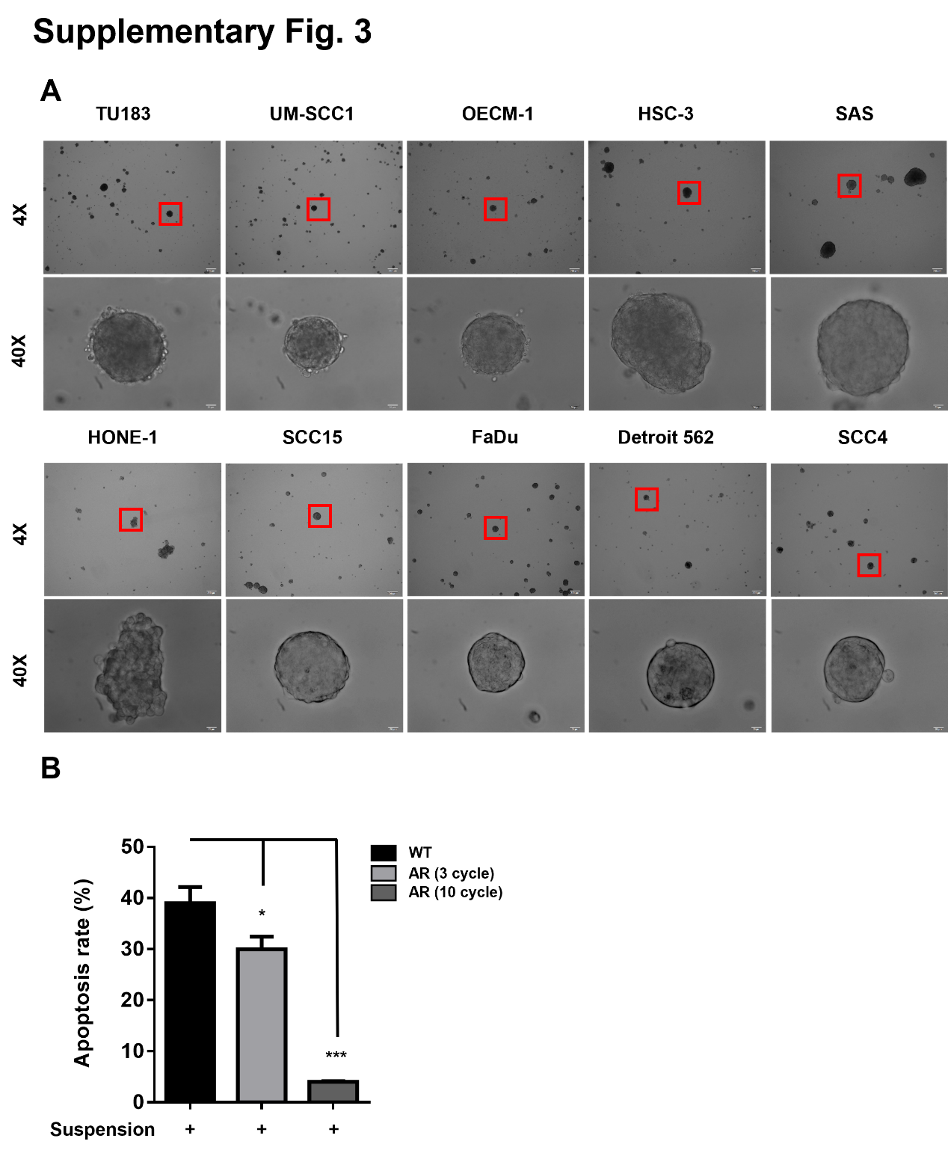
Supplementary figure 3. (A) Morphology of tumor spheroids from various HNSCC cell lines. HNSCC cells were cultured in Ultra-low attachment culture dish for 2 days. Tumor spheroids were taken pictures with brightfield as indicated magnification. (B) WT and AR spheroids with different selected cycles were cultured in suspension conditions for 3 days. Tumor spheroids were harvest and dissociated into single cells by accumax reagent. Cells were then stained with annexin V and Propidium Iodide (PI) to measure apoptosis by flow cytometry.

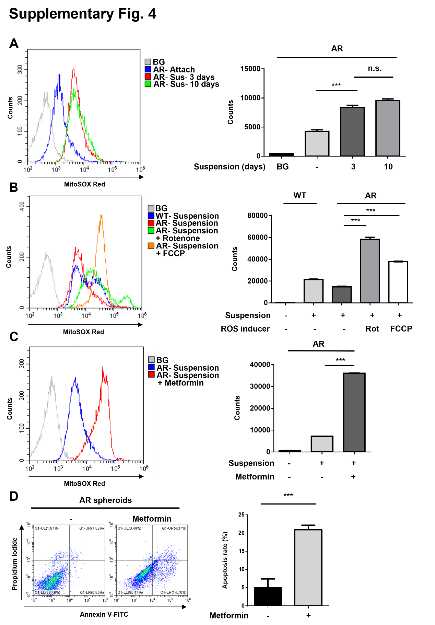
Supplementary figure 4. Induction of mitochondrial ROS in AR spheroids reduced survival. (A) AR attached cells and spheroids were cultured under suspension as indicated time point. Tumor spheroids were harvest and dissociated into single cells by accumax reagent. Cells were then stained with mitoSOX red to measure mitochondrial ROS by flow cytometry. (B) Adherent WT cells, WT spheroids and AR spheroids were cultured with or without FCCP (10 µM) or Rotenone (1 µM) for 2 days. Tumor spheroids were harvest and dissociated into single cells by accumax reagent. Cells were then stained with MitoSOX to measure mitochondrial ROS by flow cytometry. (C-D) AR spheroids treated with or without 20mM metformin were cultured under suspension for 7 days. Tumor spheroids were harvest and dissociated into single cells by accumax reagent. Cells were then stained with mitoSOX to measure mitochondrial ROS or stained with annexin V and Propidium Iodide (PI) to measure apoptosis by flow cytometry (left panel). The percentage of apoptotic cells were statistically analyzed by Prism 6.0 software (right panel).

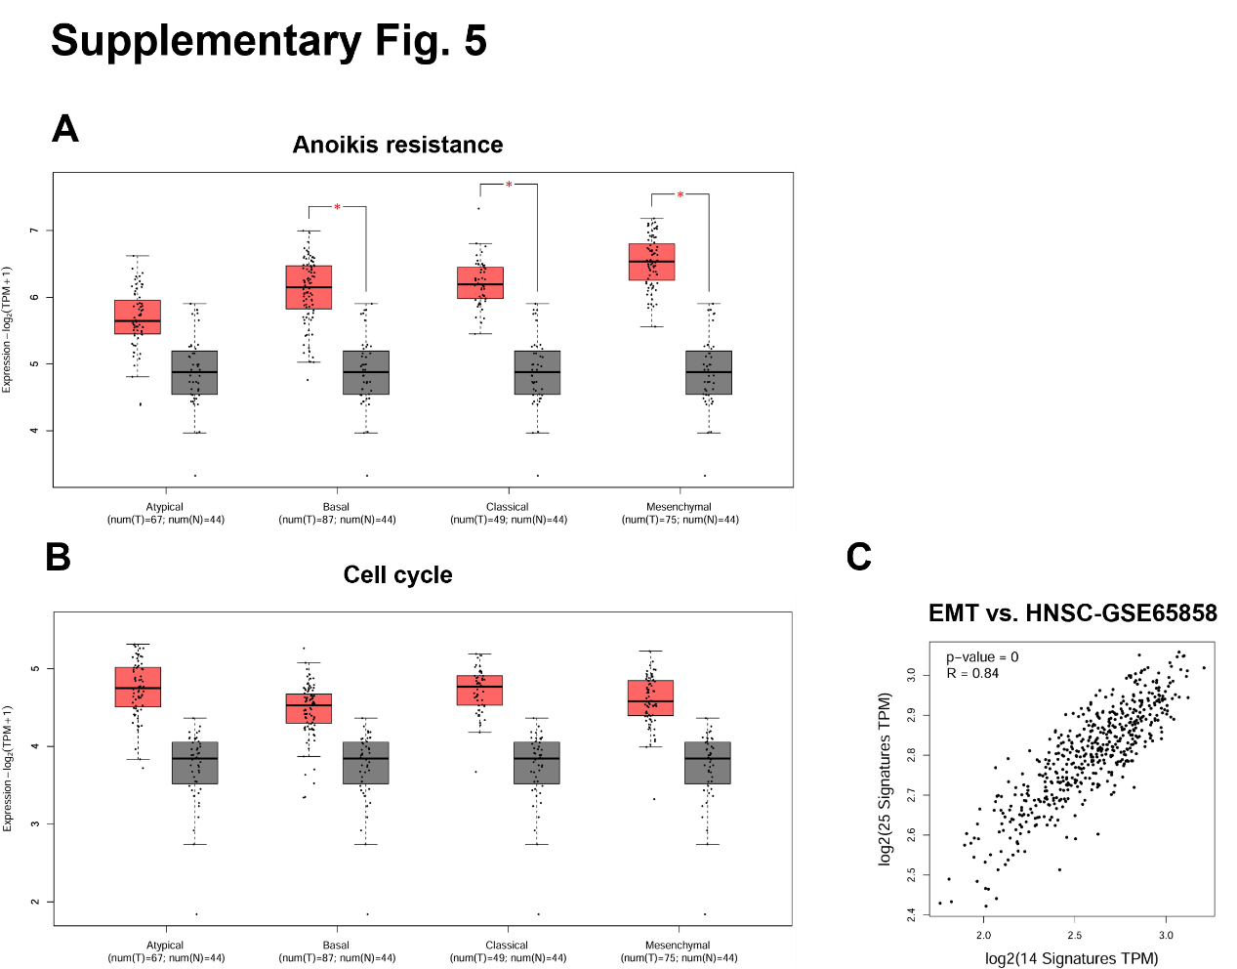
Supplementary figure 5. The association between anoikis resistance genes, cell cycle regulators, and EMT markers in TCGA-HNSC dataset. (A) The expression of anoikis resistance genes (HNSC-GSE65858 dataset) was determined in subtypes of atypical (n = 67), basal (n = 87), classical (n = 49), and mesenchymal (n = 75) HNSCC in the TCGA database. (B) The expression of cell cycle regulators was determined in subtypes of atypical (n = 67), basal (n = 87), classical (n = 49), and mesenchymal (n = 75) HNSCC in the TCGA database. (C) Concurrent expression of global EMT signatures and anoikis resistance genes (HNSC-GSE65858 dataset) was determined in the HNSCC tumor tissues (n = 518) from the TCGA database and analyzed by GEPIA2.
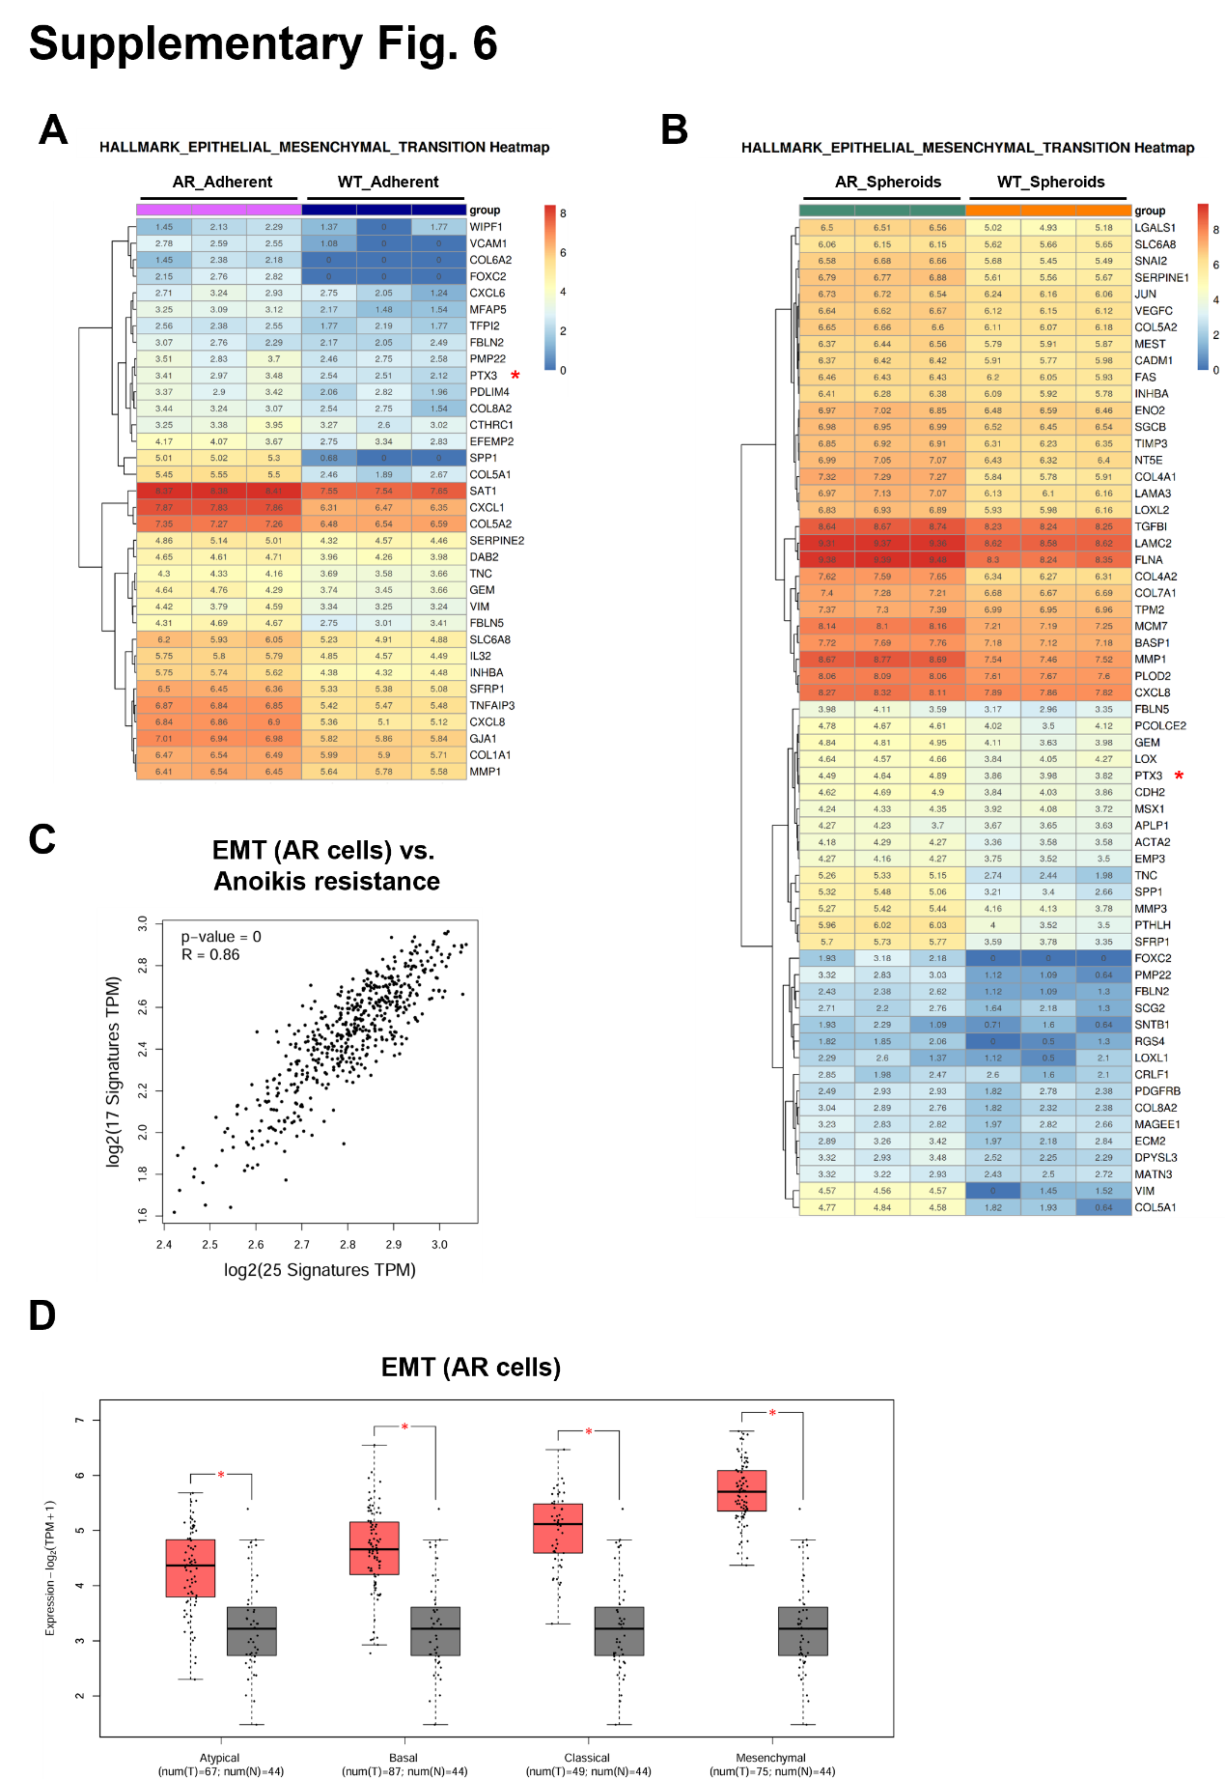
Supplementary figure 6. Enrichment of the EMT signature in both AR attached cells and spheroids compared with WT cells. (A-B) Total RNA was harvested from WT and AR attached cells and spheroids. The heat maps show the normalized count of differential gene expression of EMT signature. (C) Concurrent expression of EMT signature enriched in AR cells and anoikis resistance genes (HNSC-GSE65858 dataset) was determined in the HNSCC tumor tissues (n = 518) from the TCGA database and analyzed by GEPIA2. (D) The expression of EMT signature enriched in AR cells was determined in subtypes of atypical (n = 67), basal (n = 87), classical (n = 49), and mesenchymal (n = 75) HNSCC in the TCGA database.
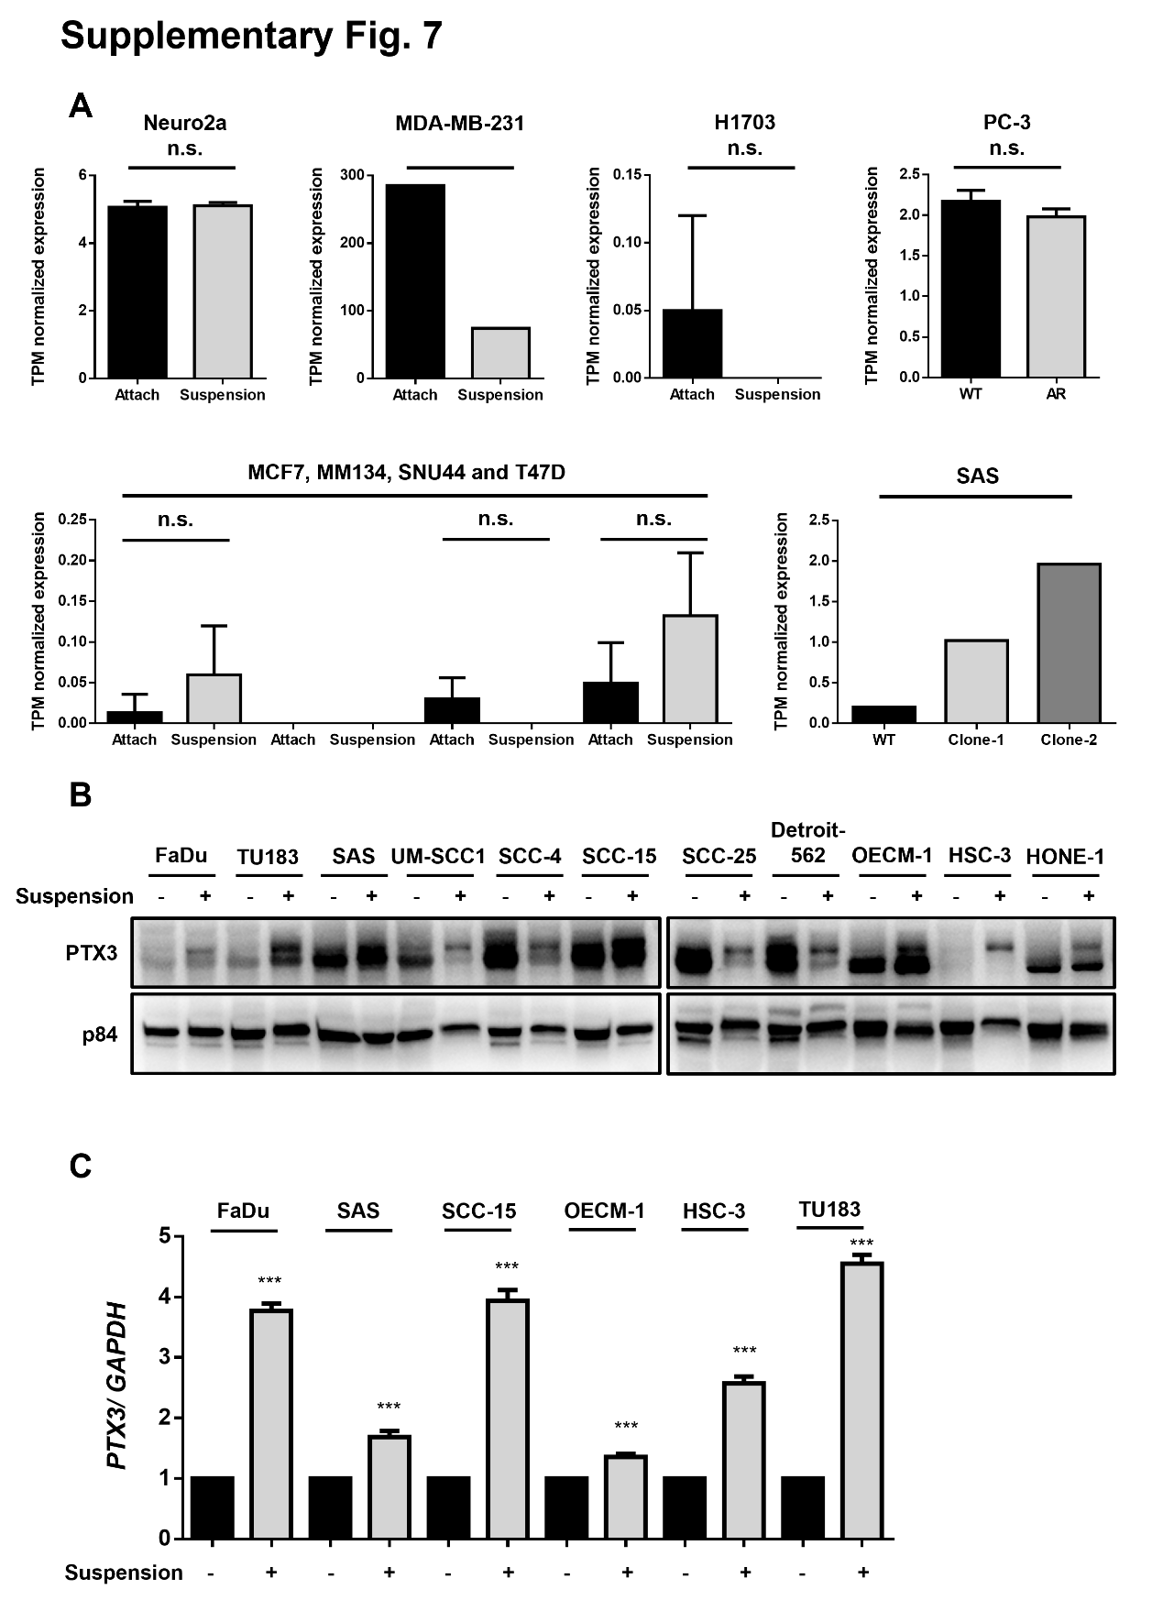
Supplementary figure 7. The expression of PTX3 under attachment or suspension culture condition in various cancer tissue and cell lines. (A) PTX3 mRNA expression was quantitated from the Gene Expression Omnibus (GEO) with different types of cancer cell lines including GSE45160-Neuro2a cells, GSE234460-MDA-MB-231 cells, GSE106592-H1703 cells, GSE100629-PC-3 cells, GSE130650-MCF7, MM134, SUM-44 and T47D cells and GSE158933-SAS cells. (B) HNSCC cells from different anatomy tissues were cultured under attachment or suspension for 2 days. Attached cells and tumor spheroids were harvested and detected protein expression of PTX3 and GAPDH by using and western blotting. (C) FaDu, SAS, SCC-15, OECM-1, HSC-3 and TU183 attached cells and spheroids were cultured for 2 days. Cells and tumor spheroids were harvested and detected mRNA expression of PTX3 and GAPDH by using RT-qPCR.

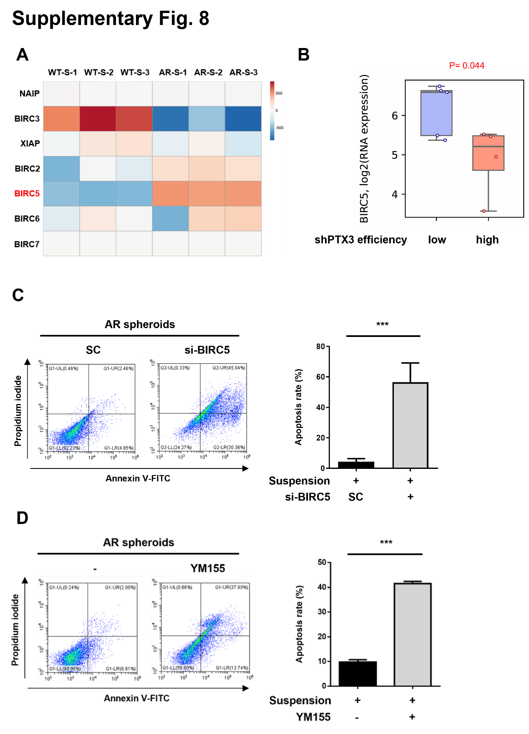
Supplementary figure 8. Expression of survivin in AR cells determined spheroids survival.(A) The heatmap of the IAP family members from the raw-read sequence data among adherent WT/ AR spheroids. (B) The shRNA knockdown HNSCC cells were retrieved from Depmap database. The mRNA expression of BIRC5 (survivin) was compared between low or high PTX3 knockdown efficiency groups. (C) AR cells were transfected with 40 nM BIRC5 (survivin) siRNA or scrambled (SC) oligonucleotides for 24 h. Cells were then cultured under suspesion for 7 days. Tumor spheroids were harvest and dissociated into single cells by accumax reagent. Cells were then stained with annexin V and Propidium Iodide (PI) to measure apoptosis by flow cytometry. (left panel). The percentage of apoptotic cells were statistically analyzed by Prism 6.0 software (right panel). (D) AR cells were treated with 100 nM selective survivin inhibitor (YM155). Cells were then cultured in suspesion for 7 days. Tumor spheroids were harvest and dissociated into single cells by accumax reagent. Cells were then stained with annexin V and Propidium Iodide (PI) to measure apoptosis by flow cytometry (left panel). The percentage of apoptotic cells were statistically analyzed by Prism 6.0 software (right panel).

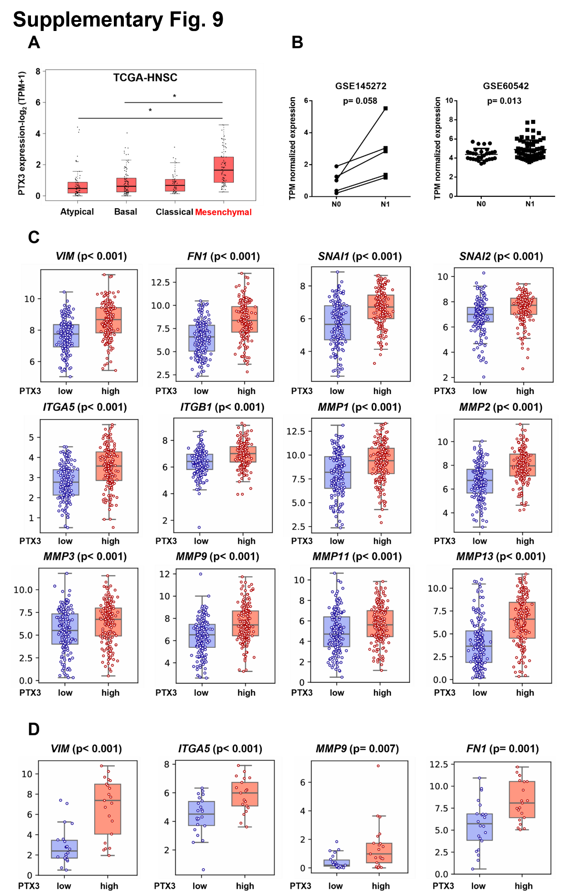
Supplementary figure 9. The expression of PTX3 is associated with HNSCC metastasis in clinical specimen. (A) Gene expression of PTX3 was determined in subtypes of atypical (n = 67), basal (n = 87), classical (n = 49), and mesenchymal (n = 75) HNSCC in the TCGA database. (B) PTX3 mRNA expression was quantitated from the Gene Expression Omnibus (GEO) with different stages of HNSCC. N1 indicated tumor events in lymph node. (C) The box plots showed the transcriptional expression of EMT markers from the cohort of TCGA-HNSC with high expression level of PTX3 (red) or low expression level of PTX3 (blue). (D) The box plots showed the transcriptional expression of EMT markers in HNSCC cell lines retrieved from DepMap project with high expression level of PTX3 (red) or low expression level of PTX3 (blue).

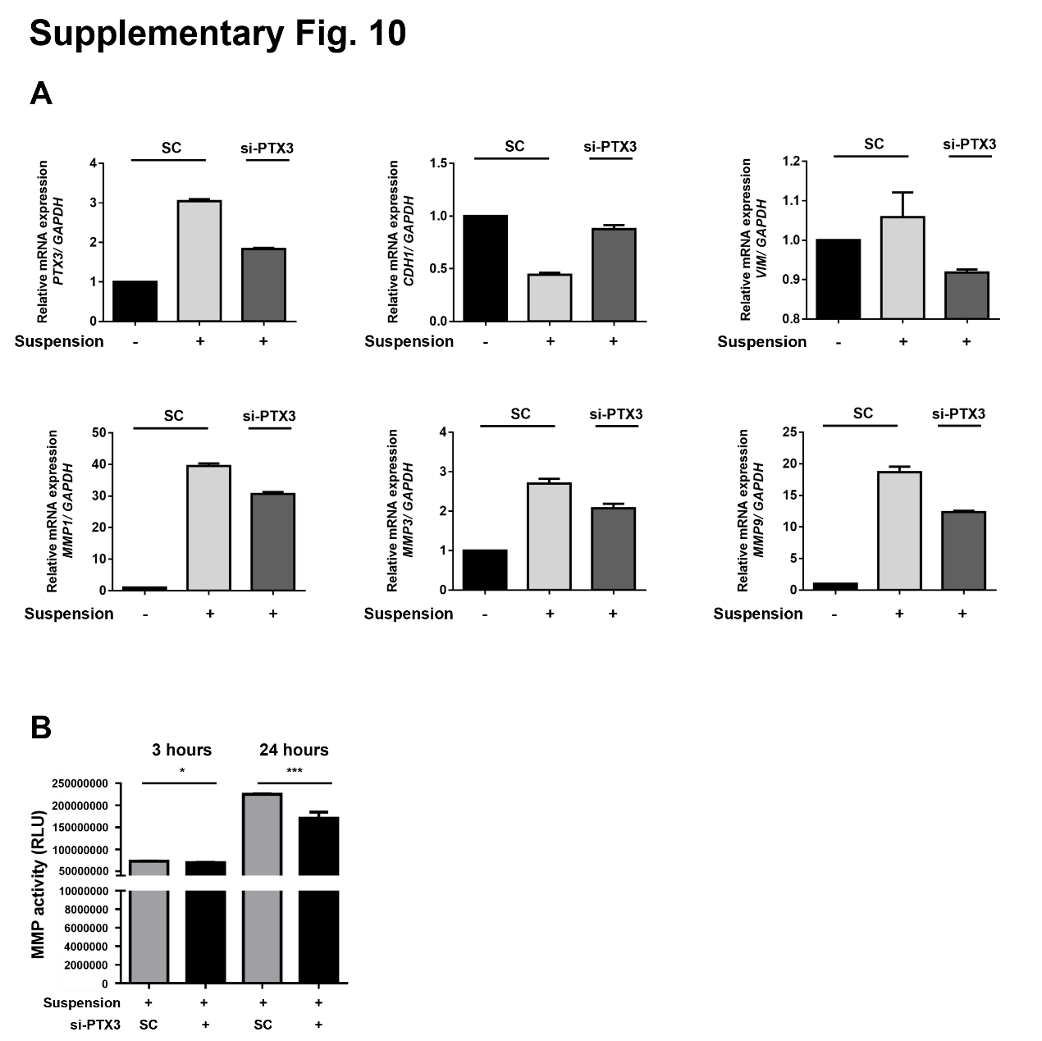
Supplementary figure 10. Depletion of PTX3 reduced the acquired EMT in AR spheroids. (A) AR cells were transfected with 40 nM PTX3 siRNA or scrambled (SC) oligonucleotides for 24 h. Cells were then cultured under suspension for 2 days. Tumor spheroids were harvested and the expressions of PTX3, CDH1, VIM, MMP1, MMP3, MMP9 and GAPDH were examined by using qRT-PCR. (B) AR cells were transfected with 40 nM PTX3 siRNA or scrambled (SC) oligonucleotides for 24 h. Cells were then cultured under suspension for 2 days. The condition medium was harvested for analyzing MMP activity as described in the materials and methods.

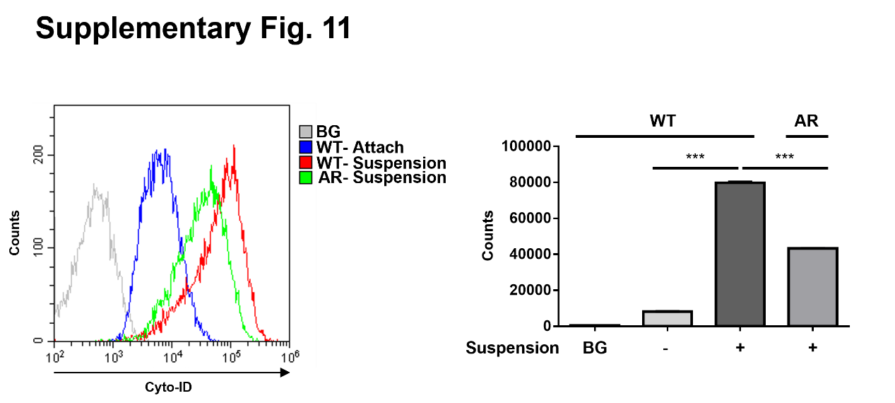
Supplementary figure 11. The autophagic activation in WT/ AR spheroids. Adherent WT cells and WT/ AR spheroids were cultured for 7 days. Tumor spheroids were harvest and dissociated into single cells by accumax reagent. Cells were then stained with CYTO-ID to measure autophagy flux by flow cytometry.

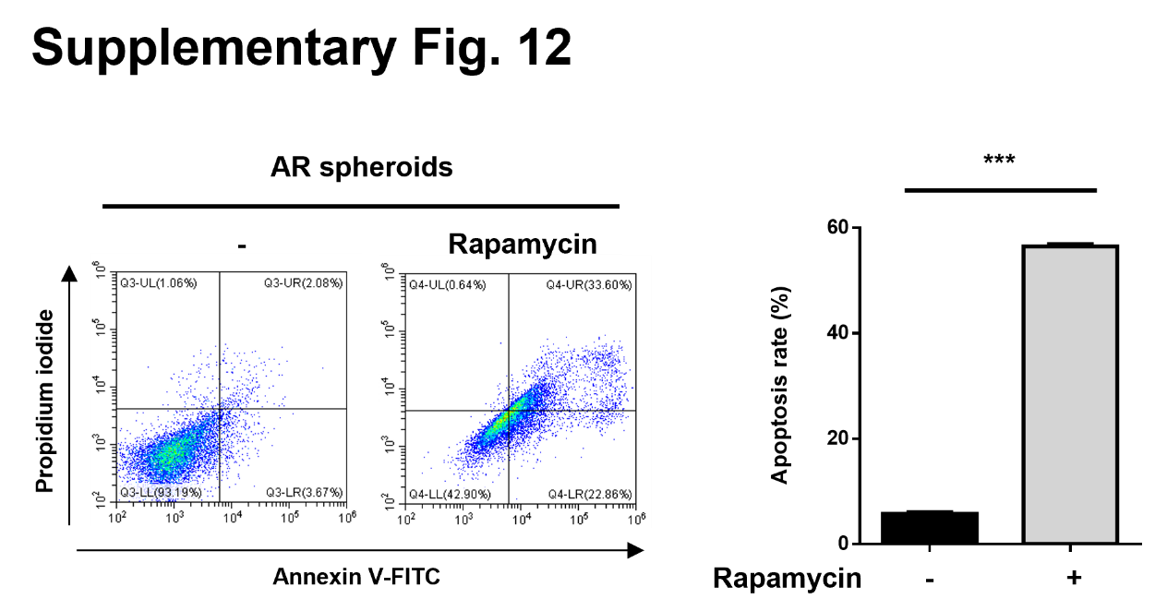
Supplementary figure 12. Rapamycin reduced spheroids survival in AR cells. AR cells were treated with or without 10 µM rapamycin under suspension for 7 days. Tumor spheroids were harvest and dissociated into single cells by accumax reagent. Cells were then stained with annexin V and Propidium Iodide (PI) to measure apoptosis by flow cytometry (left panel). The percentage of apoptotic cells were statistically analyzed by Prism 6.0 software (right panel).

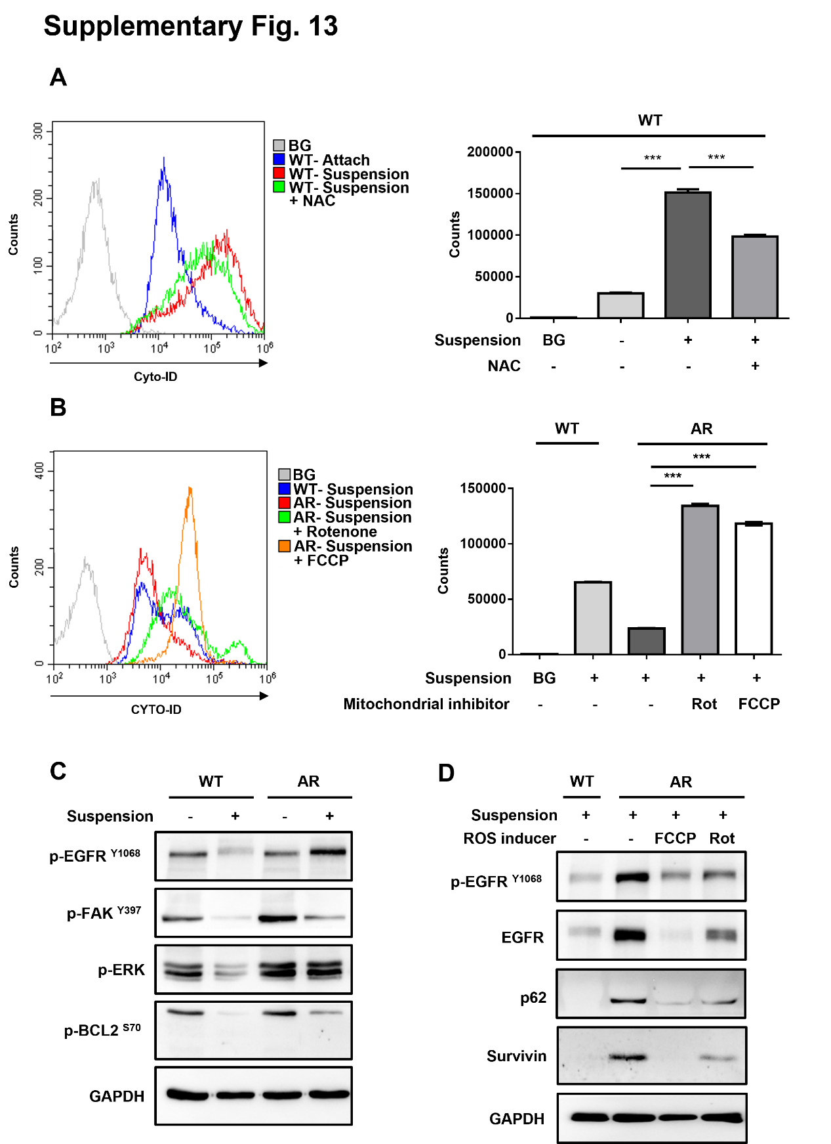
Supplementary figure 13. Manipulation of ROS regulates autophagy homeostasis and EGFR activity. (A) Adherent WT cells and WT spheroids with/ without NAC and rapamycin were cultured for 2 days. Tumor spheroids were harvest and dissociated into single cells by accumax reagent. Cells were then stained with Cyto-ID to measure autophagy flux by flow cytometry. (B) Adherent WT cells, WT spheroids and AR spheroids were cultured with or without FCCP (10 µM) or Rotenone (1 µM) for 2 days. Tumor spheroids were harvest and dissociated into single cells by accumax reagent. Cells were then stained with CYTO-ID to measure autophagy flux by flow cytometry. (C) Adherent WT/ AR cells and WT/ AR spheroids were cultured for 2 days. Tumor spheroids were harvested and the protein expressions of phosphorylated EGFR, FAK, ERK, BCL-2 and GAPDH were examined by using western blotting. (D) WT/ AR spheroids were treated with FCCP or Rotenone for 2 days. Tumor spheroids were harvested and the protein expressions of phosphorylated EGFR, total EGFR, p62, survivin and GAPDH were examined by using western blotting.

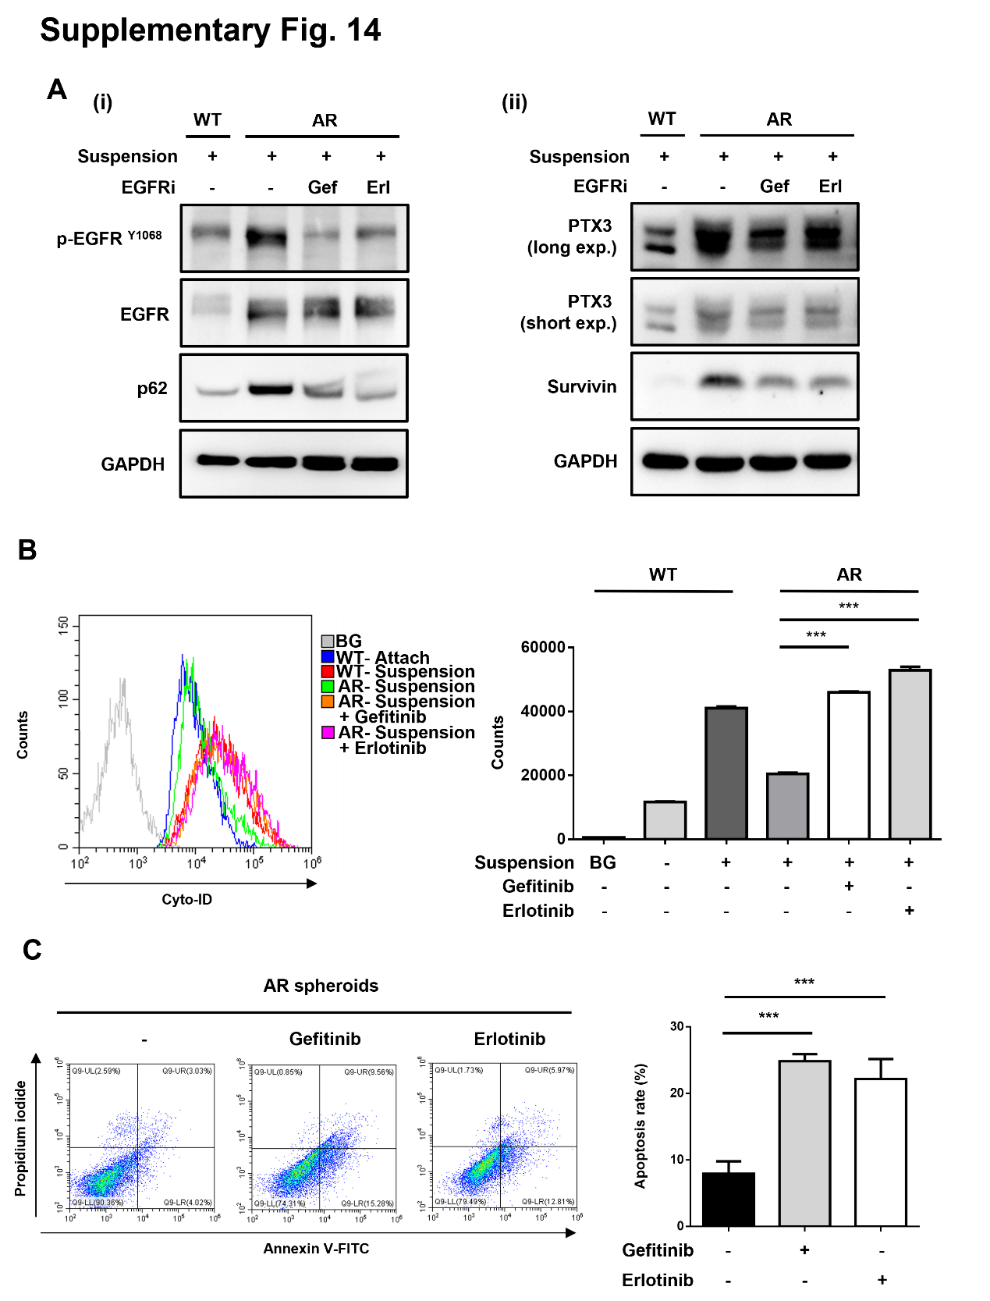
Supplementary figure 14. Targeting EGFR signaling disrupted autophagy homeostasis in AR cells and decreased spheroid survival. (A) WT/ AR spheroids were treated with Gefitinib or Erlotinib for 2 days. Tumor spheroids were harvested and the protein expressions of phosphorylated EGFR, total EGFR, p62 and GAPDH were examined by using western blotting. (i) WT/ AR spheroids were treated with Gefitinib or Erlotinib for 2 days. Tumor spheroids were harvested and the protein expressions of PTX3, survivin and GAPDH were examined by using western blotting. (ii) (B) WT attached cells and WT/ AR spheroids were treated with or without Gefitinib or Erlotinib for 2 days. Cells and spheroids were then stained with Cyto-ID to measure autophagy flux by flow cytometry. (C) AR spheroids were treated with or without Gefitinib or Erlotinib for 2 days. Tumor spheroids were harvest and dissociated into single cells by accumax reagent. Cells were then stained with annexin V and Propidium Iodide (PI) to measure apoptosis by flow cytometry (left panel). The percentage of apoptotic cells were statistically analyzed by Prism 6.0 software (right panel).

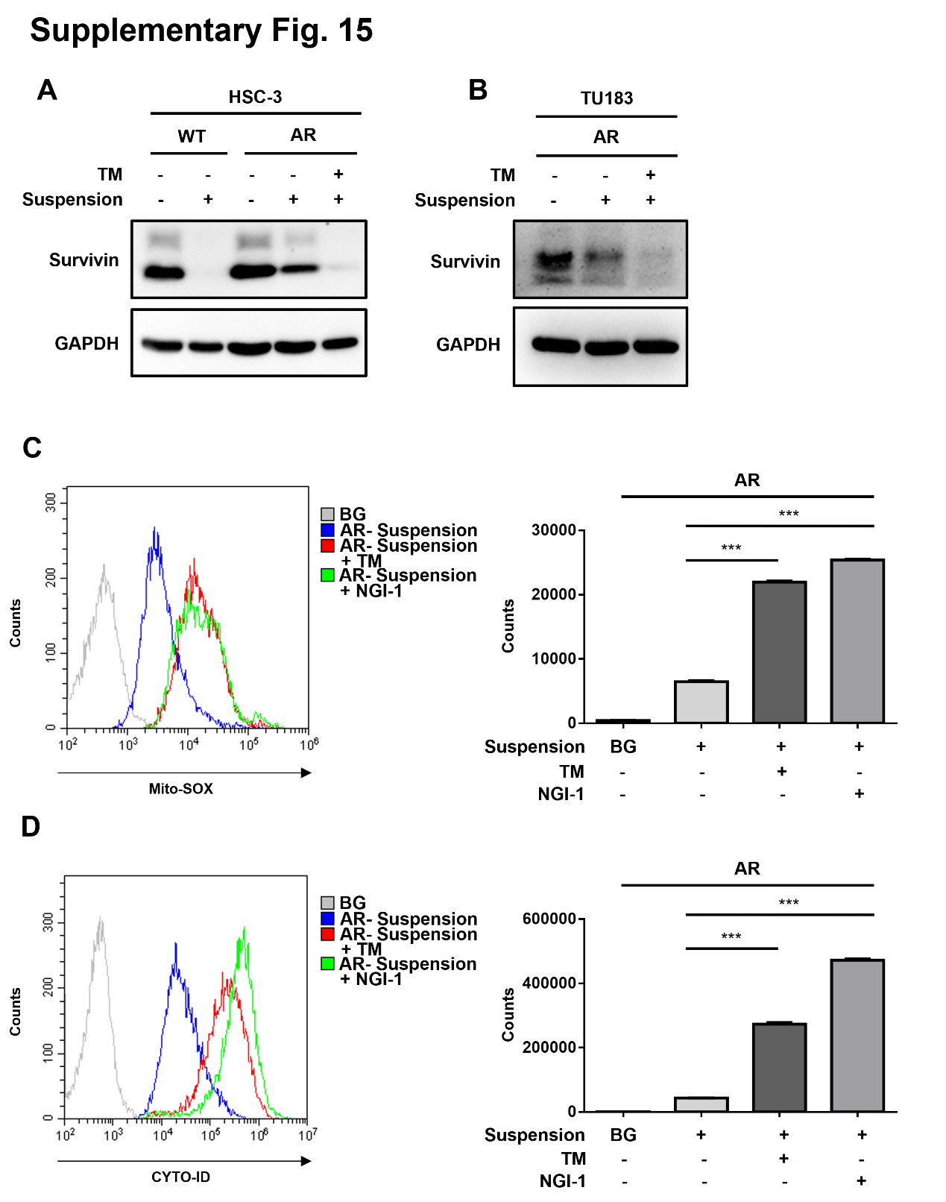
Supplementary figure 15. Targeting glycosylation reduced survival signal and disrupted homeostasis of ROS and autophagy in AR cells. (A) HSC-3 adherent WT/ AR cell and WT/ AR spheroids were cultured with or without TM for 2 days. Tumor spheroids were harvested and the protein expressions of survivin and GAPDH were examined by using western blotting. (B) TU183 adherent AR cells and AR spheroids were cultured with or without TM for 2 days. Tumor spheroids were harvested and the protein expressions of survivin and GAPDH were examined by using western blotting. (C-D) TU183 AR spheroids were cultured with or without TM or NGI-1 for 2 days. Tumor spheroids were harvest and dissociated into single cells by accumax reagent. Cells were then stained with MitoSOX to measure mitochondrial ROS or stained with CYTO-ID to measure autophagy flux by flow cytometry.

