Tables
Table 1. The correlation between ARGs expression and patient survival among
different types of cancer.
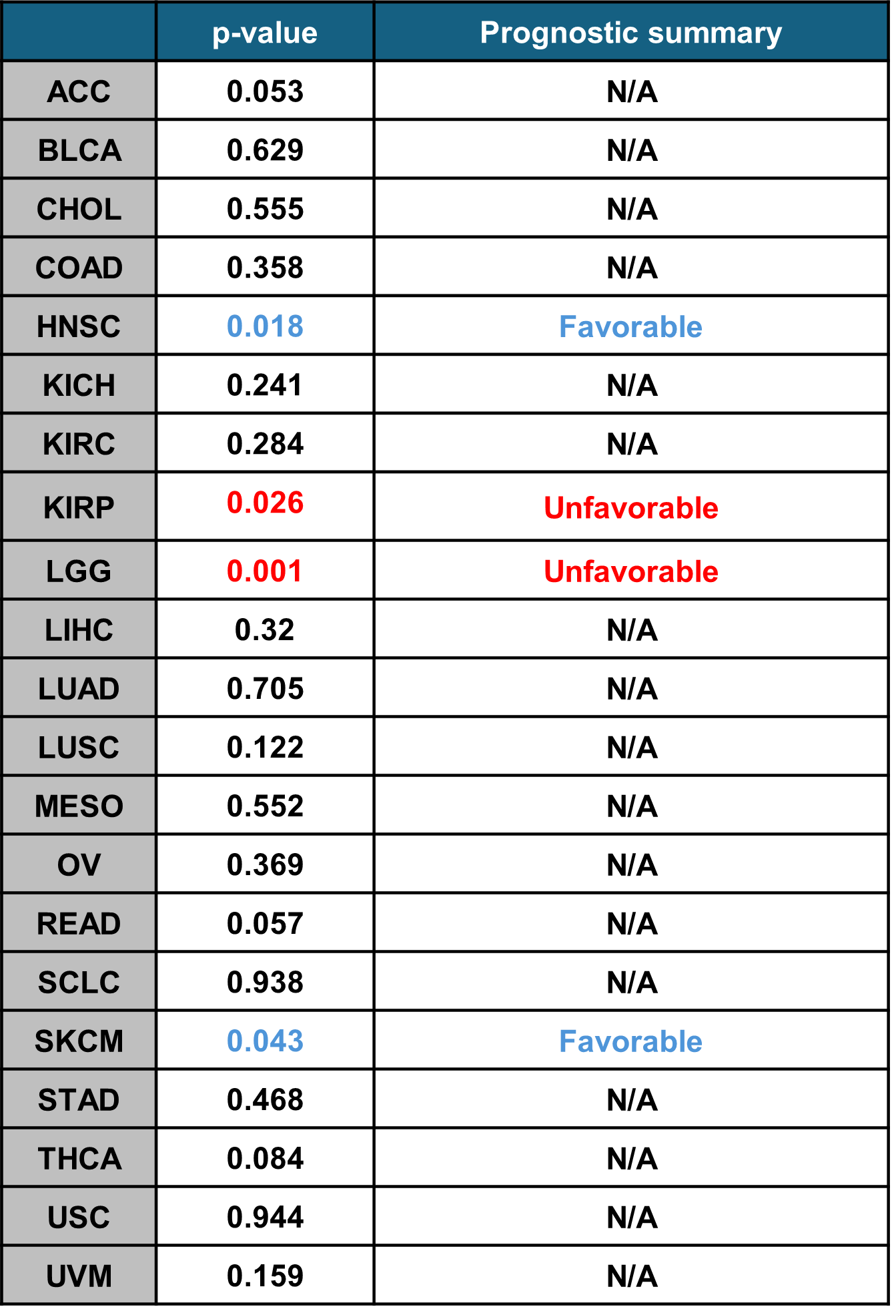

Table 2. Correlation between anoikis-related genes and patient overall/disease-free survival in stage I–II HNSCC.
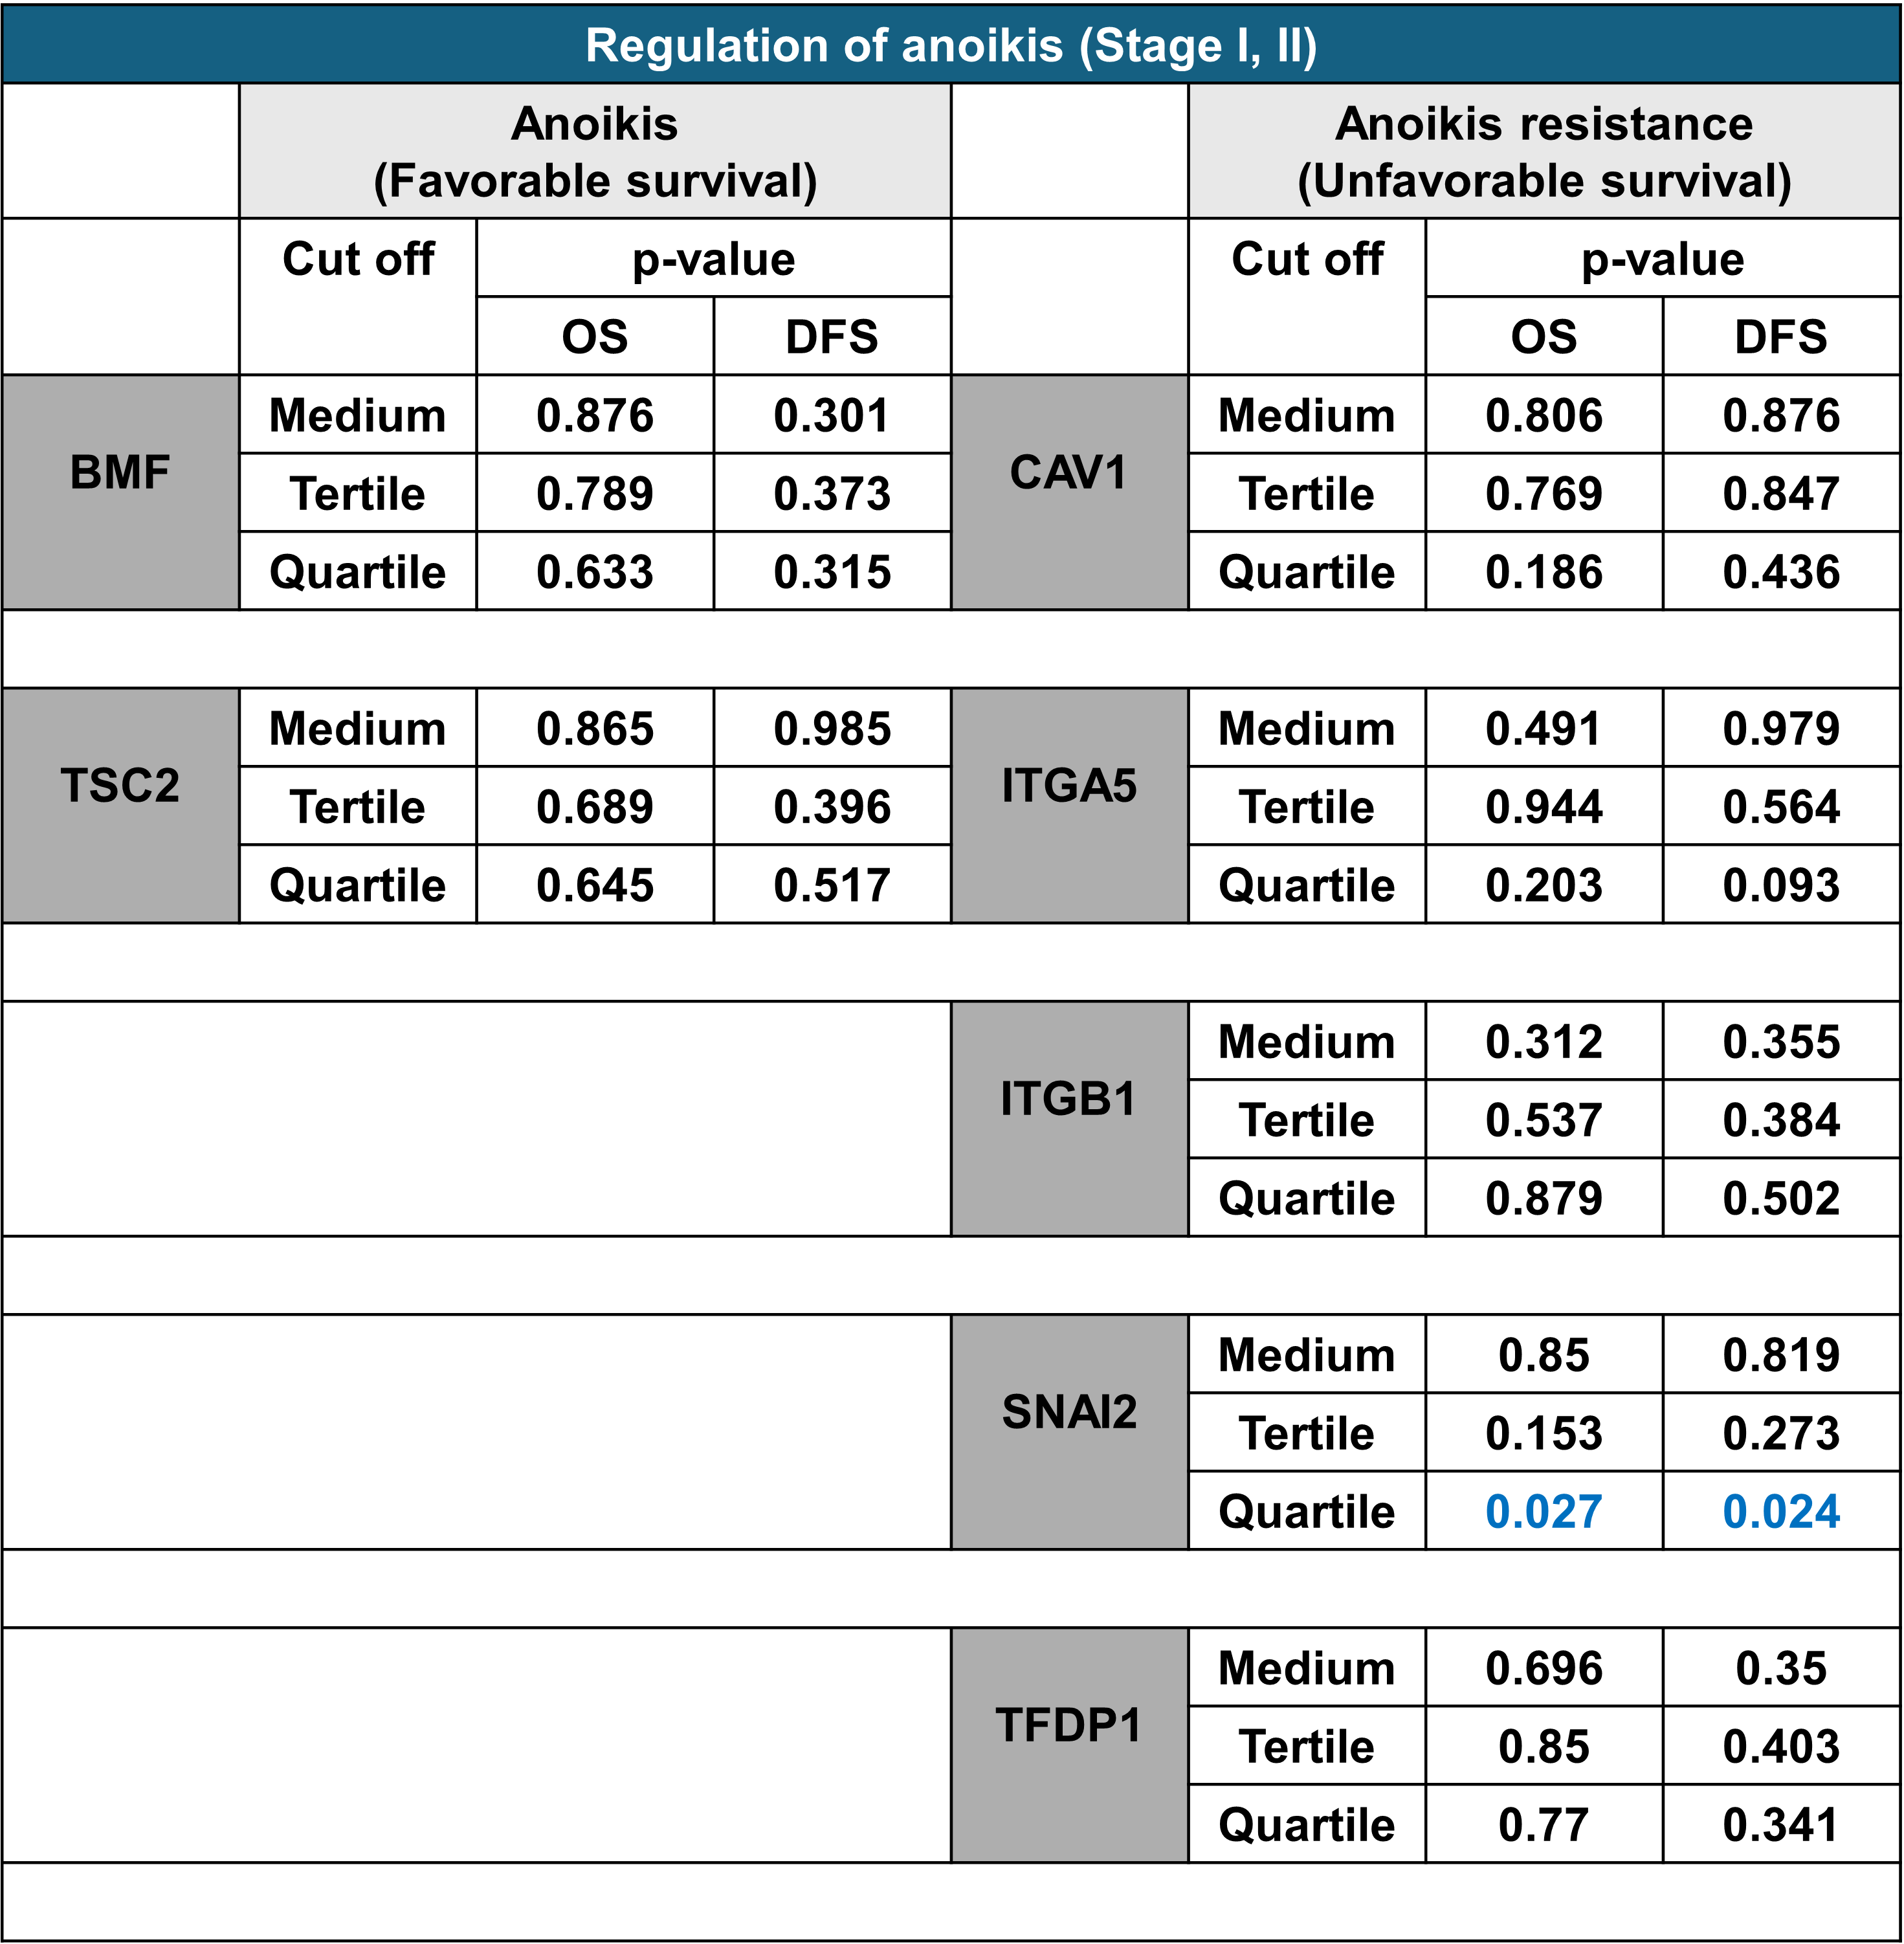

Table 3. Correlation between anoikis-related genes and patient overall/disease-free survival in stage III–IV HNSCC.
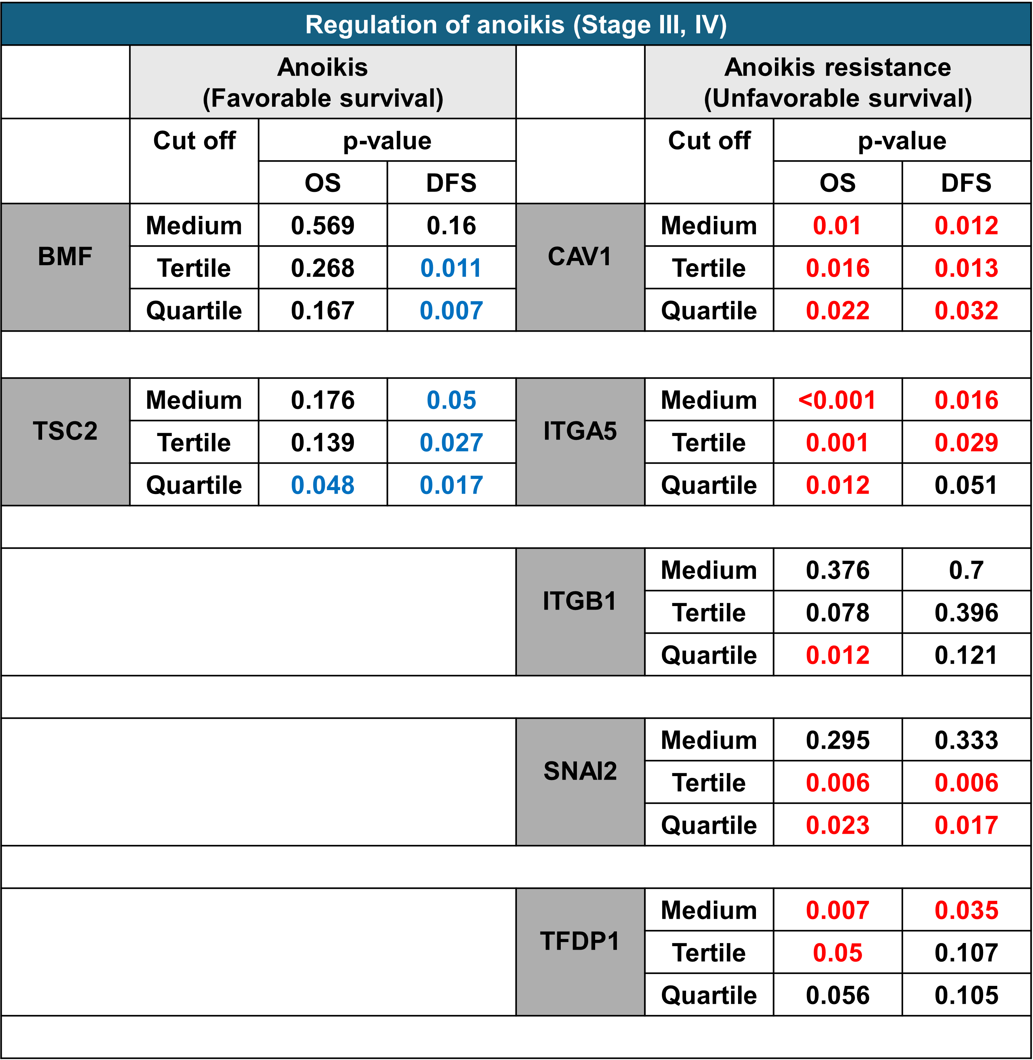

Table 4. The original site and HPV status among various HNSCC cell lines in this study.
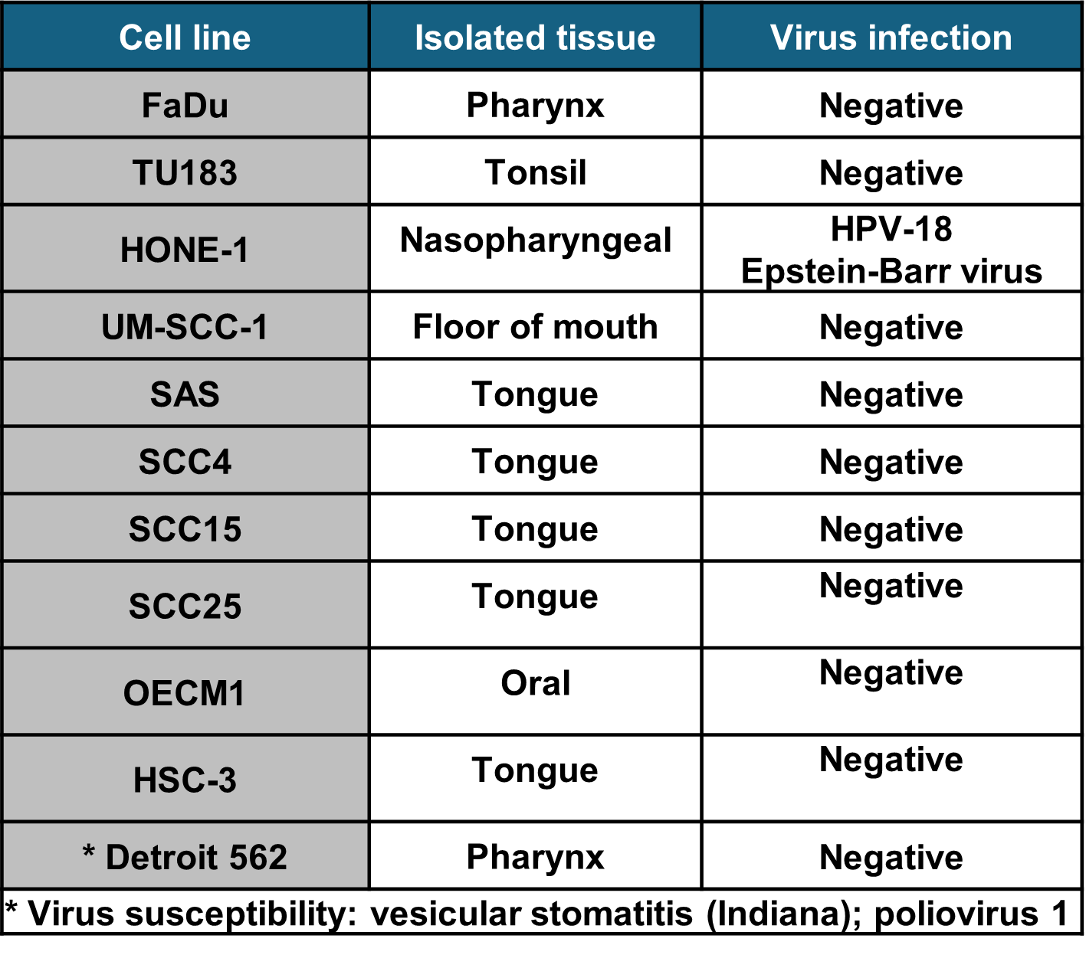

Table 5. The differential gene expression and prognostic value of the overlapped gene list from WT/ AR spheroids.
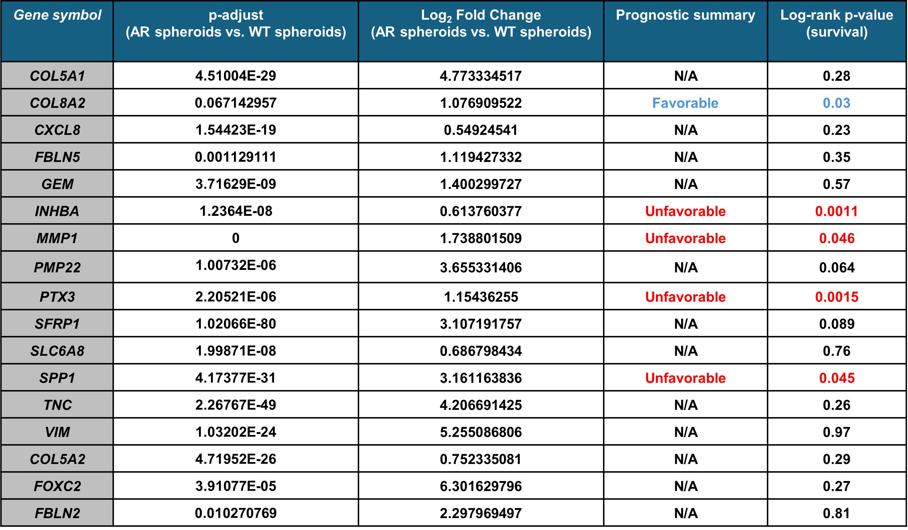

Table 6. KEGG pathway analysis of the top 100 genes that positively correlates with PTX3 in TCGA-HNSC dataset.
