Additional File 1: Search Strategy on Databases

Database | Searched date | Search strategy
PubMed | 8 September, 2021 | (((((((((((((((smart health[All Fields] OR smart healthcare[All Fields]) AND ("1999/01/01"[PDAT] : "2020/12/31"[PDAT]) AND "humans"[MeSH Terms]) OR (("internet of things"[MeSH Terms] OR ("internet"[All Fields] AND "things"[All Fields]) OR "internet of things"[All Fields]) AND ("1999/01/01"[PDAT] : "2020/12/31"[PDAT]) AND "humans"[MeSH Terms])) OR (IoT[All Fields] AND ("1999/01/01"[PDAT] : "2020/12/31"[PDAT]) AND "humans"[MeSH Terms])) OR ((digital health[All Fields] OR digital healthcare[All Fields]) AND ("1999/01/01"[PDAT] : "2020/12/31"[PDAT]) AND "humans"[MeSH Terms])) OR ((remote health[All Fields] OR remote healthcare[All Fields]) AND ("1999/01/01"[PDAT] : "2020/12/31"[PDAT]) AND "humans"[MeSH Terms])) OR (("telemedicine"[MeSH Terms] OR "telemedicine"[All Fields]) AND ("1999/01/01"[PDAT] : "2020/12/31"[PDAT]) AND "humans"[MeSH Terms])) OR (("telemedicine"[MeSH Terms] OR "telemedicine"[All Fields] OR "ehealth"[All Fields]) AND ("1999/01/01"[PDAT] : "2020/12/31"[PDAT]) AND "humans"[MeSH Terms])) OR ((mobile health[All Fields] OR mobile healthcare[All Fields]) AND ("1999/01/01"[PDAT] : "2020/12/31"[PDAT]) AND "humans"[MeSH Terms])) OR (("telemedicine"[MeSH Terms] OR "telemedicine"[All Fields] OR "mhealth"[All Fields]) AND ("1999/01/01"[PDAT] : "2020/12/31"[PDAT]) AND "humans"[MeSH Terms])) OR (("point-of-care systems"[MeSH Terms] OR ("point-of-care"[All Fields] AND "systems"[All Fields]) OR "point-of-care systems"[All Fields] OR ("point"[All Fields] AND "care"[All Fields]) OR "point of care"[All Fields]) AND ("1999/01/01"[PDAT] : "2020/12/31"[PDAT]) AND "humans"[MeSH Terms])) OR ((wireless[All Fields] AND ("Sensors (Basel)"[Journal] OR "sensor"[All Fields]) AND ("Network"[Journal] OR "Netw Res Triangle Park N C"[Journal] OR "IEEE Netw"[Journal] OR "network"[All Fields])) AND ("1999/01/01"[PDAT] : "2020/12/31"[PDAT]) AND "humans"[MeSH Terms])) OR (("artificial intelligence"[MeSH Terms] OR ("artificial"[All Fields] AND "intelligence"[All Fields]) OR "artificial intelligence"[All Fields]) AND ("1999/01/01"[PDAT] : "2020/12/31"[PDAT]) AND "humans"[MeSH Terms])) OR ((ubiquitous[All Fields] AND ("delivery of health care"[MeSH Terms] OR ("delivery"[All Fields] AND "health"[All Fields] AND "care"[All Fields]) OR "delivery of health care"[All Fields] OR "healthcare"[All Fields])) AND ("1999/01/01"[PDAT] : "2020/12/31"[PDAT]) AND "humans"[MeSH Terms])) AND ("1999/01/01"[PDAT] : "2020/12/31"[PDAT]) AND "humans"[MeSH Terms]) AND (((((((smart[All Fields] AND ("nursing homes"[MeSH Terms] OR ("nursing"[All Fields] AND "homes"[All Fields]) OR "nursing homes"[All Fields] OR ("nursing"[All Fields] AND "home"[All Fields]) OR "nursing home"[All Fields])) AND (("1999/01/01"[PDAT] : "2020/12/31"[PDAT]) AND "humans"[MeSH Terms])) OR ("nursing home"[All Fields] AND (("1999/01/01"[PDAT] : "2020/12/31"[PDAT]) AND "humans"[MeSH Terms]))) OR ((("veterans"[MeSH Terms] OR "veterans"[All Fields] OR "veteran"[All Fields]) AND ("nursing homes"[MeSH Terms] OR ("nursing"[All Fields] AND "homes"[All Fields]) OR "nursing homes"[All Fields] OR ("nursing"[All Fields] AND "home"[All Fields]) OR "nursing home"[All Fields])) AND (("1999/01/01"[PDAT] : "2020/12/31"[PDAT]) AND "humans"[MeSH Terms]))) OR ("old-age home"[All Fields] AND (("1999/01/01"[PDAT] : "2020/12/31"[PDAT]) AND "humans"[MeSH Terms]))) OR ("retirement home"[All Fields] AND (("1999/01/01"[PDAT] : "2020/12/31"[PDAT]) AND "humans"[MeSH Terms]))) OR ((Australian[All Fields] AND residential[All Fields] AND ("aged"[MeSH Terms] OR "aged"[All Fields]) AND care[All Fields] AND home[All Fields]) AND ("1999/01/01"[PDAT] : "2020/12/31"[PDAT]) AND "humans"[MeSH Terms])) AND (("1999/01/01"[PDAT] : "2020/12/31"[PDAT]) AND "humans"[MeSH Terms])  Updated search applied the filters: from 2020 - 2021
CINAHL | 10 September, 2021 | ((((((smart health OR internet of things OR iot OR ( digital health or digital medicine or ehealth or mhealth ) OR remote health care OR telemedicine OR ( mobile health or mhealth or telehealth ) OR point of care OR wireless sensor networks OR artificial intelligence OR ubiquitous healthcare) AND (S3)) AND (S1 OR S2)) AND (S2 AND S3)) AND (S2 AND S3)) AND (S1 AND S2 AND S3)) AND (S4 AND S5)  Updated search applied the filters: from Jan 2020 – Sept 2021
Health Systems Evidence | 8 September, 2021 | smart nursing home NOT child  mobile health* AND nursing home NOT child  Date range for updated search: 2020-2021
Social Systems Evidence | 8 September, 2021 | smart nursing home NOT child  mobile health* AND nursing home NOT child  Date range for updated search: 2020-2021
Cochrane Library | 9 September, 2021 | 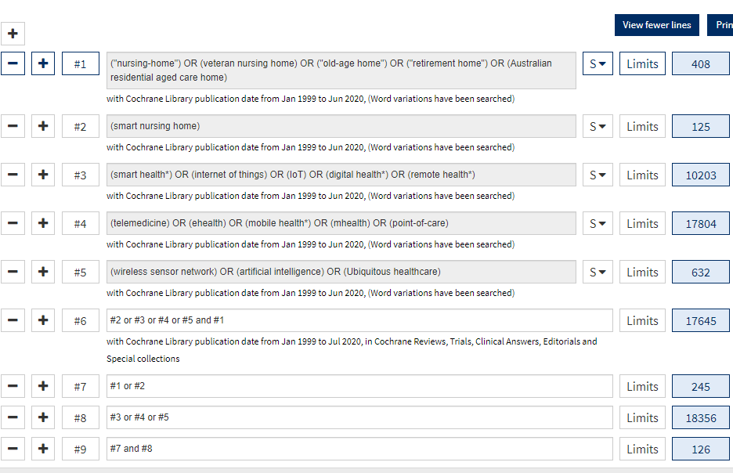  Updated search applied the filters: May 2020 to Sept 2021
万方 Wanfang Data | 9 September, 2021 | 智慧养老院 或智能养老院 或医疗康养养老院  Updated search applied the filters: 9 May 2020 to 9 Sept 2021
知网 CNKI | 9 September, 2021 | 智慧养老院 或者 智能养老院 或者医疗康养 并含 养老院  Updated search applied the filters: 2020 to Sept 2021
ProQuest Dissertations | 9 September, 2021 | ((("smart health" OR "internet of things" OR "IoT" OR "digital health*" OR "remote health" OR "telemedicine" OR "ehealth" OR "mobile health" OR "mhealth" OR "point-of-care") OR ("wireless sensor network" OR "artificial intelligence" OR "ubiquitous healthcare")) AND ("smart nursing home" OR "nursing home" OR "veteran nursing home" OR "old-age home" OR "retirement home" OR "Australian residential aged care home")) NOT child  Updated search applied the filters: 11 May 2020 to 9 Sept 2021
IEEE | 9 September, 2021 | ((((((((((("Abstract":“smart health”) OR "Abstract":“internet of things”) OR "Abstract":“digital health*”) OR "Abstract":“remote health care”) OR "Abstract":“mobile health”) OR "Abstract":“telehealth”) OR "Abstract":“wireless sensor networks”) OR "Abstract":“artificial intelligence”) OR "Authors":“ubiquitous healthcare”) AND "Full Text & Metadata":“Nursing home”) AND "Full Text & Metadata":elderly)  Date range for updated search: 2020-2021
Psychology and Behavioral Sciences Collection | 9 September, 2021 | 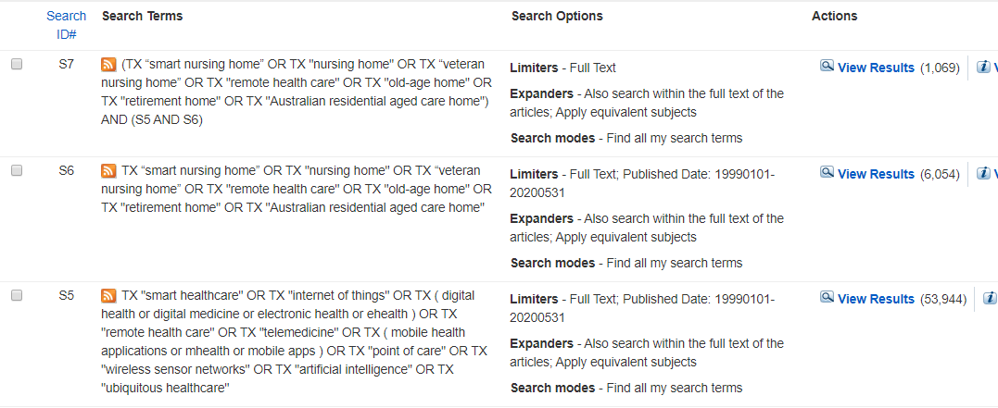  Date range for updated search: 2020-2021
Scopus | 9 September, 2021 | ( TITLE-ABS-KEY ( "smart health" ) OR TITLE-ABS-KEY ( "internet of things" ) OR TITLE-ABS-KEY ( "IoT" ) OR TITLE-ABS-KEY ( "digital health" ) OR TITLE-ABS-KEY ( "remote health" ) OR TITLE-ABS-KEY ( "telemedicine" ) OR TITLE-ABS-KEY ( "ehealth" ) OR TITLE-ABS-KEY ( "mobile health" ) OR TITLE-ABS-KEY ( "mhealth" ) OR TITLE-ABS-KEY ( "point-of-care" ) OR TITLE-ABS-KEY ( "wireless sensor network" ) OR TITLE-ABS-KEY ( "artificial intelligence" ) OR TITLE-ABS-KEY ( "ubiquitous healthcare" ) OR ALL ( "smart nursing home" ) AND ALL ( "nursing home" ) AND ALL ( "elderly" ) ) AND PUBYEAR > 1998  Date updated search to: December 2019 (UPM license)

