column chromatography to obtain pure bromoketones (3) with 90% yield.
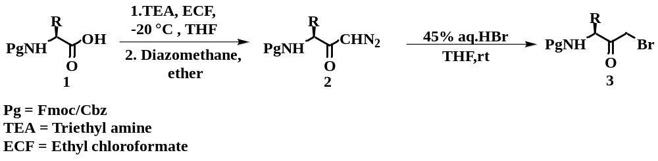Scheme 1. Synthesis of amino acid derived bromoketones.
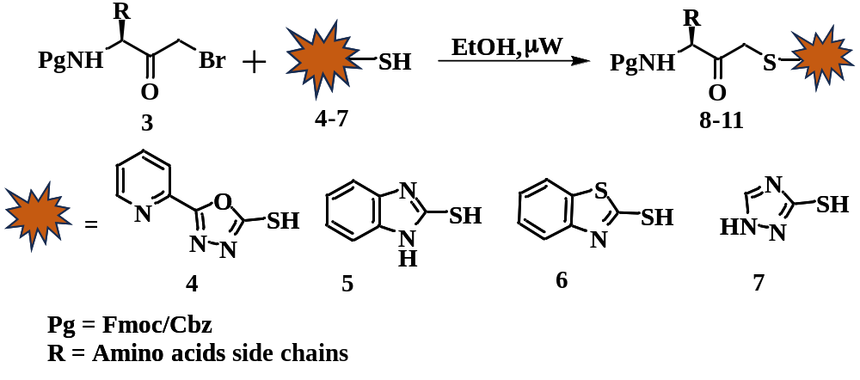
Scheme 2. Synthesis of heterocycle conjugates of amino acid derived thio methylene ketones.
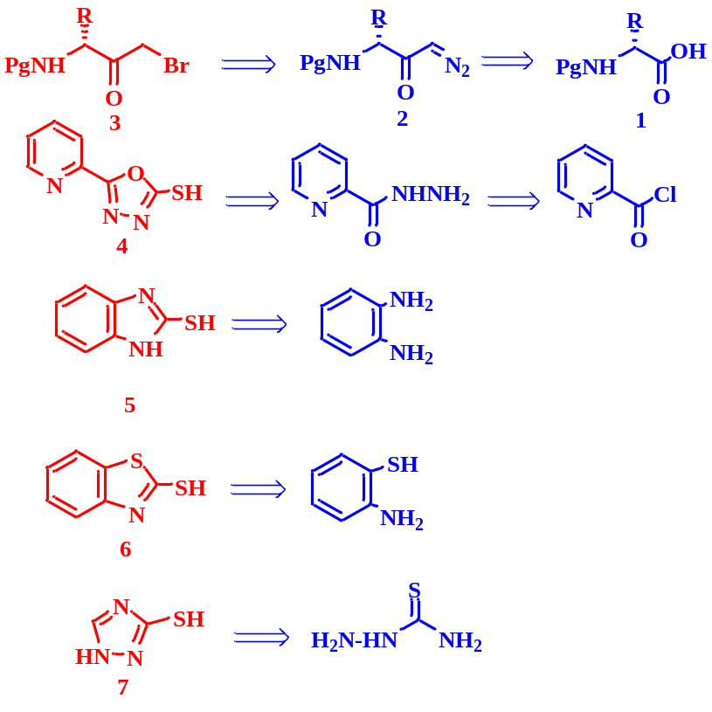
Scheme 3. Retrosynthetic route for the synthesis of amino acid derived thio methylene ketones.

Scheme 4. Optimization reaction for the synthesis of thio methylene ketones.
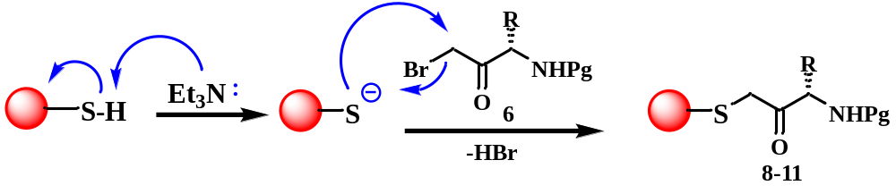
Scheme 5. Plausible mechanism for the synthesis of thio methylene ketones.

