Synthesis and insilico investigations of amino acid derived ketomethylene derivatives of S-linked heterocycles
Ramya M^{a,b}, Nitin^{a,b}, Kuruvalli Gouthami^{c}, Vaddi Damodara Reddy^{d}, Nagendra G^{a,b}*
ª Department of Chemistry, REVA University, Rukmini Knowledge Park, Kattigenahalli, Yelahanka, Bangalore-560064, Karnataka, India.
^{b} Centre for Bio-Organic Chemistry, REVA Research Centre, REVA University, Rukmini Knowledge Park, Kattigenahalli, Yelahanka, Bangalore-560 064, Karnataka, India.
^{c} Department of Biochemistry, REVA University, Rukmini Knowledge Park, Kattigenahalli, Yelahanka, Bangalore-560064, Karnataka, India.
^{d} Department of Biotechnology, REVA University, Rukmini Knowledge Park, Kattigenahalli, Yelahanka, Bangalore-560064, Karnataka, India.
*Corresponding author: E-mail address: gnagendrachem@gmail.com (Nagendra G).

Docking images of Protein 1 (Escherichia coli Topoisomerase IV)
8a

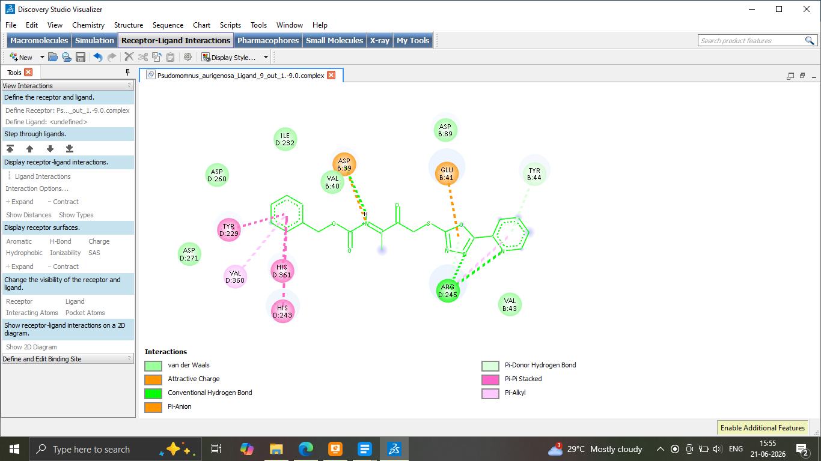
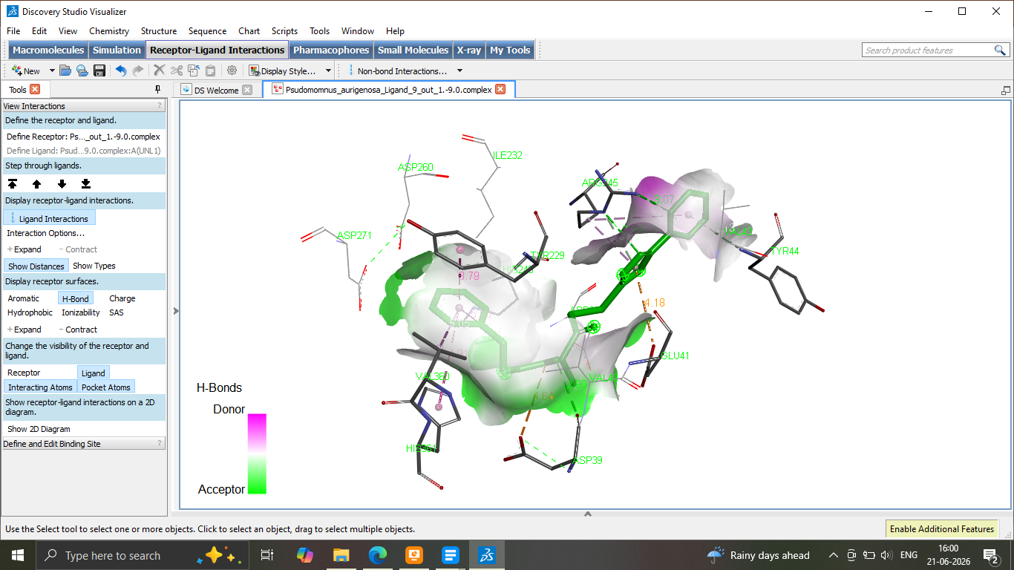
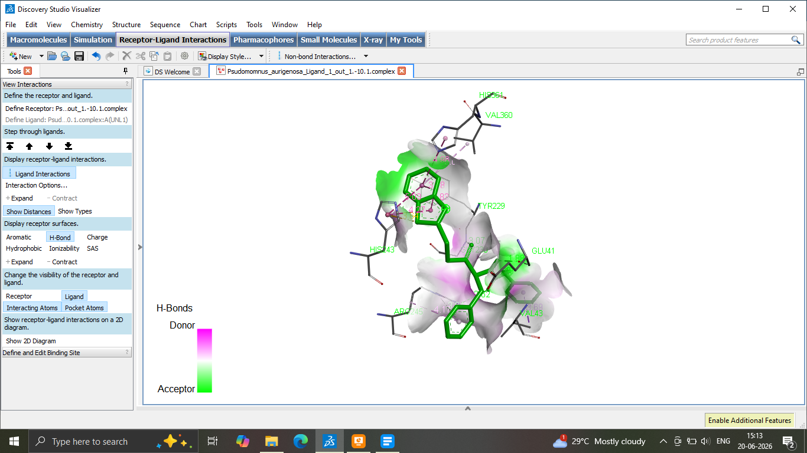

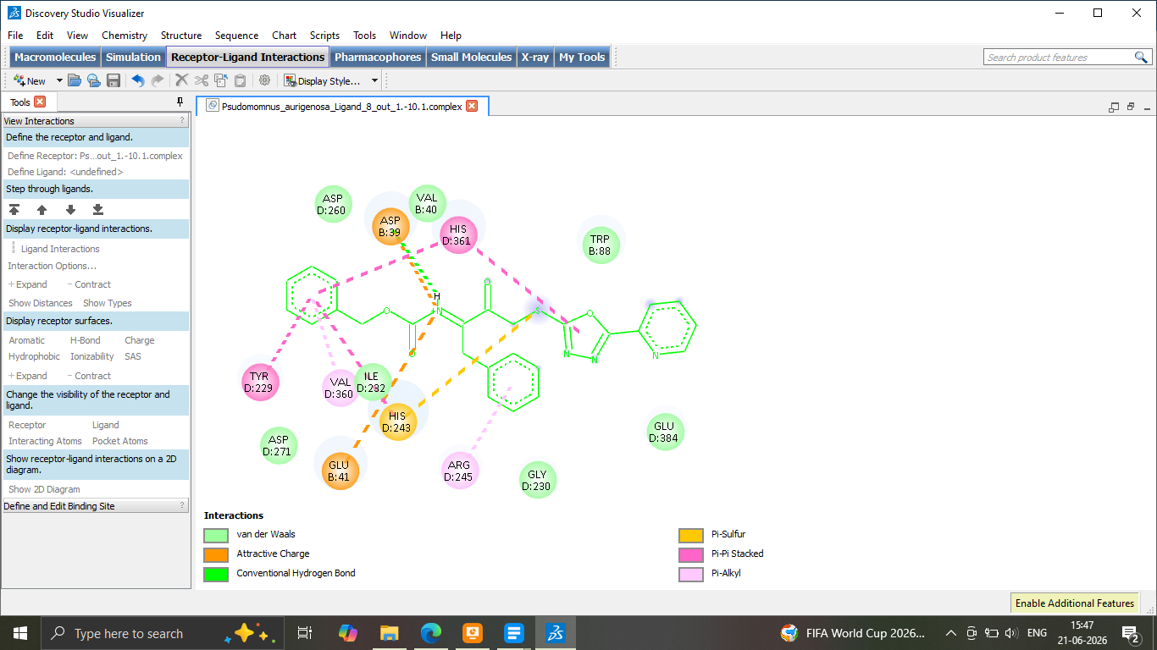
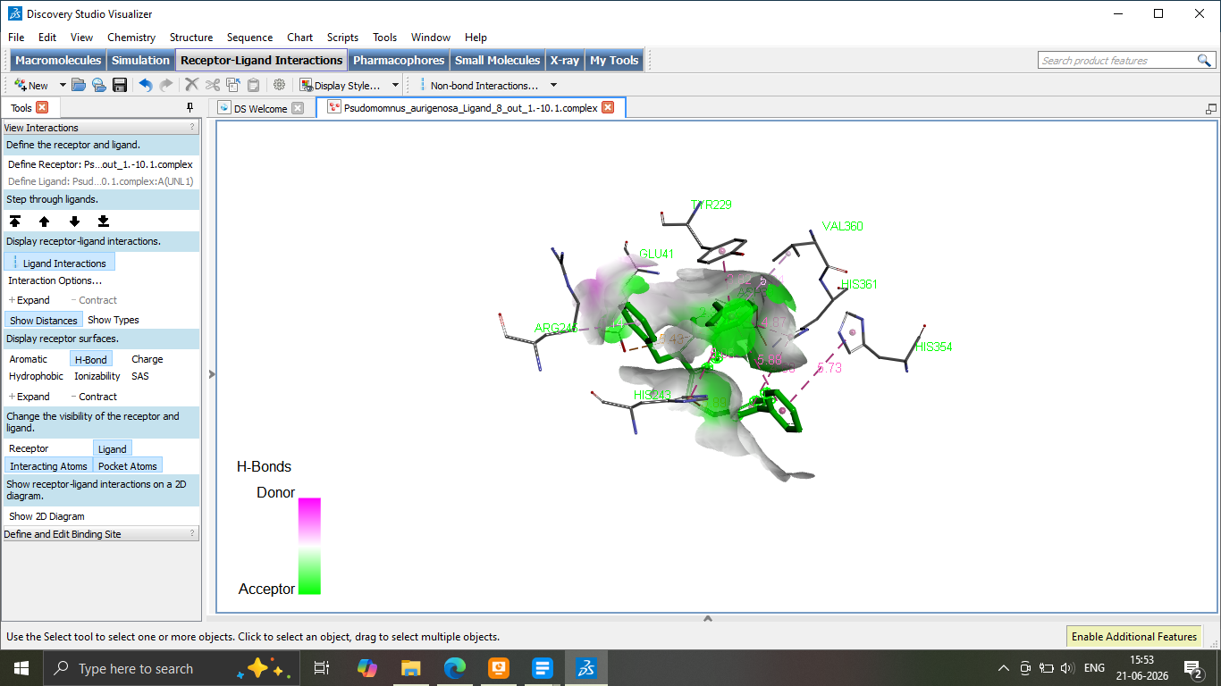
8b

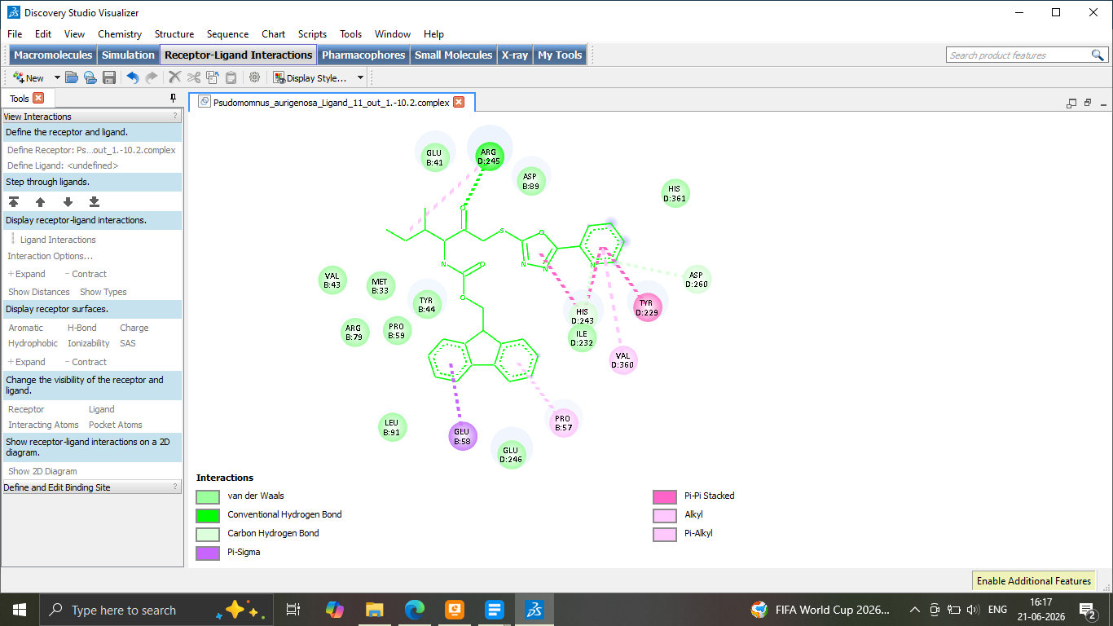
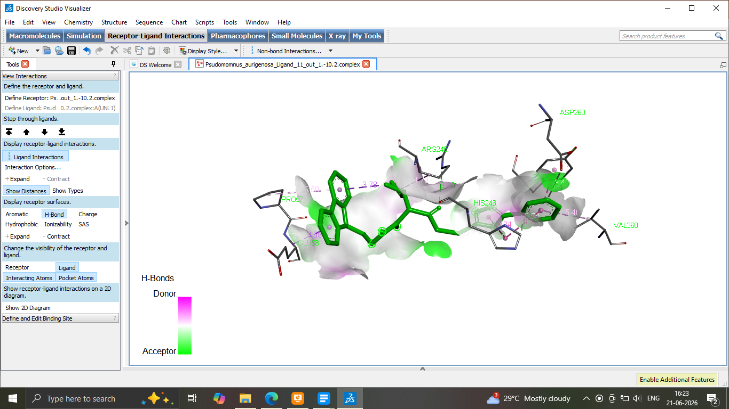
8c

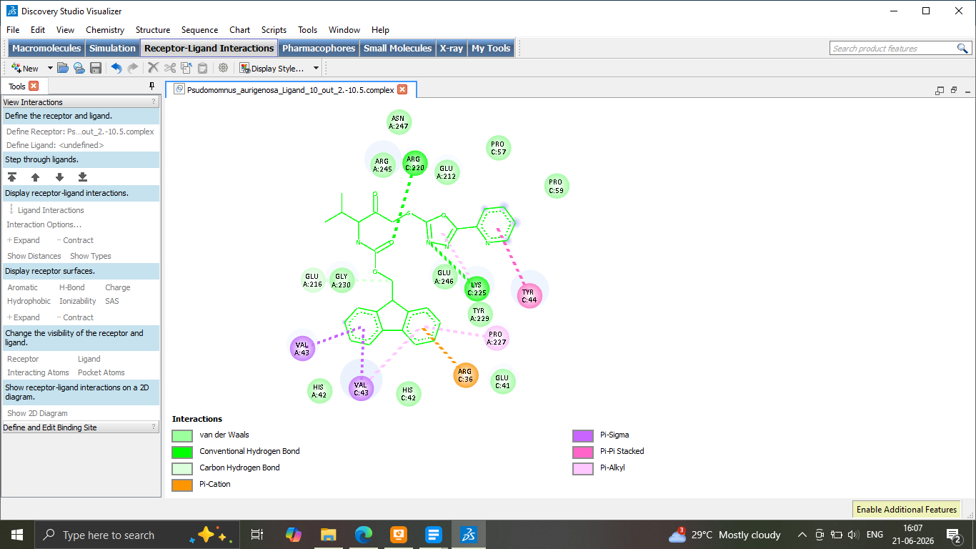
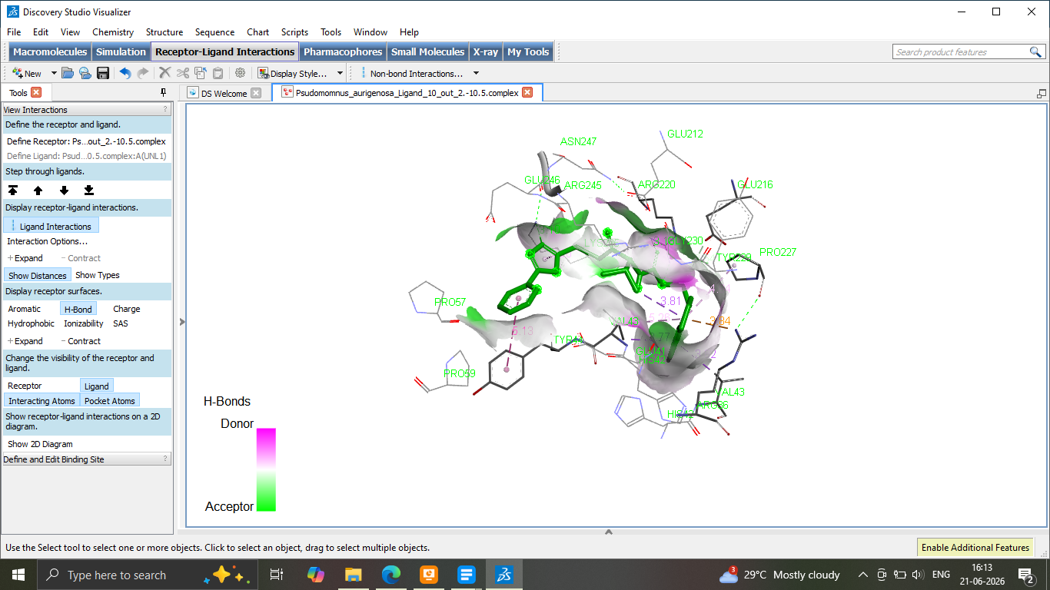
8d

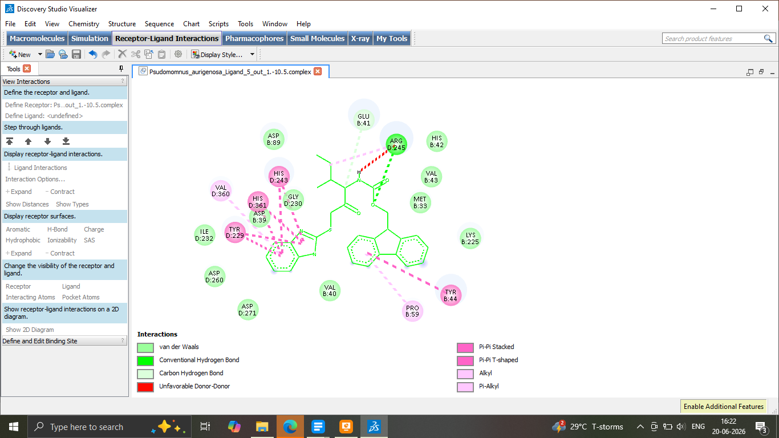
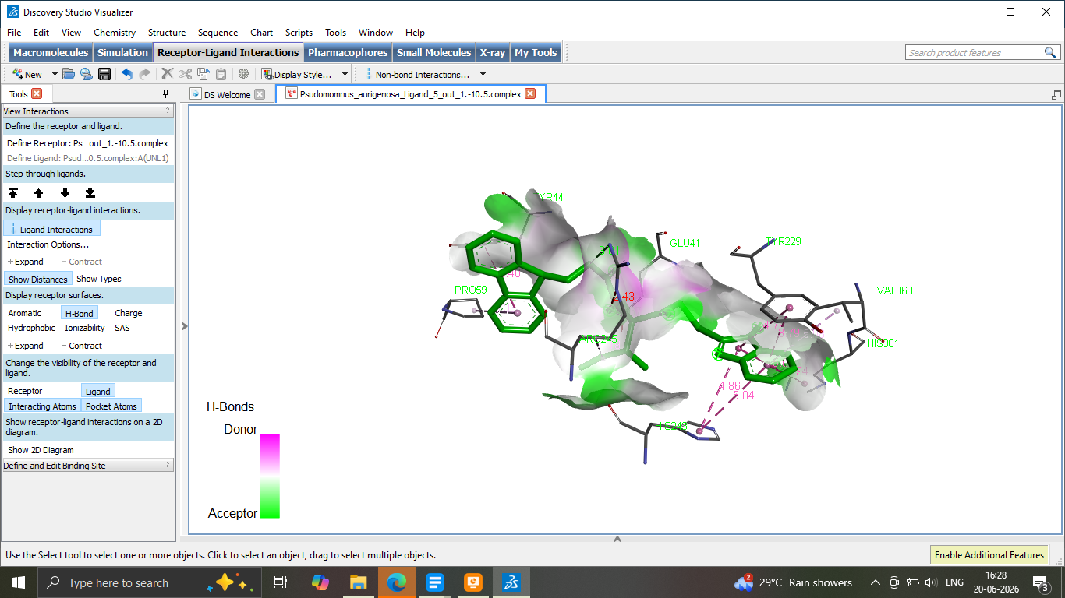

9a

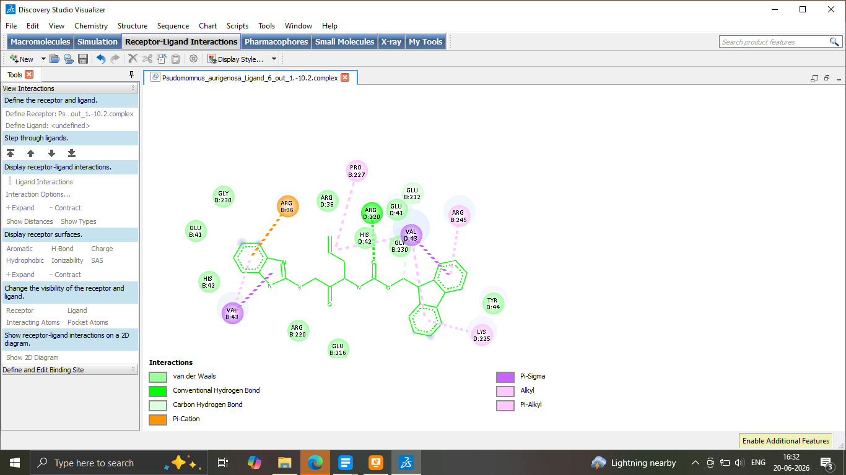
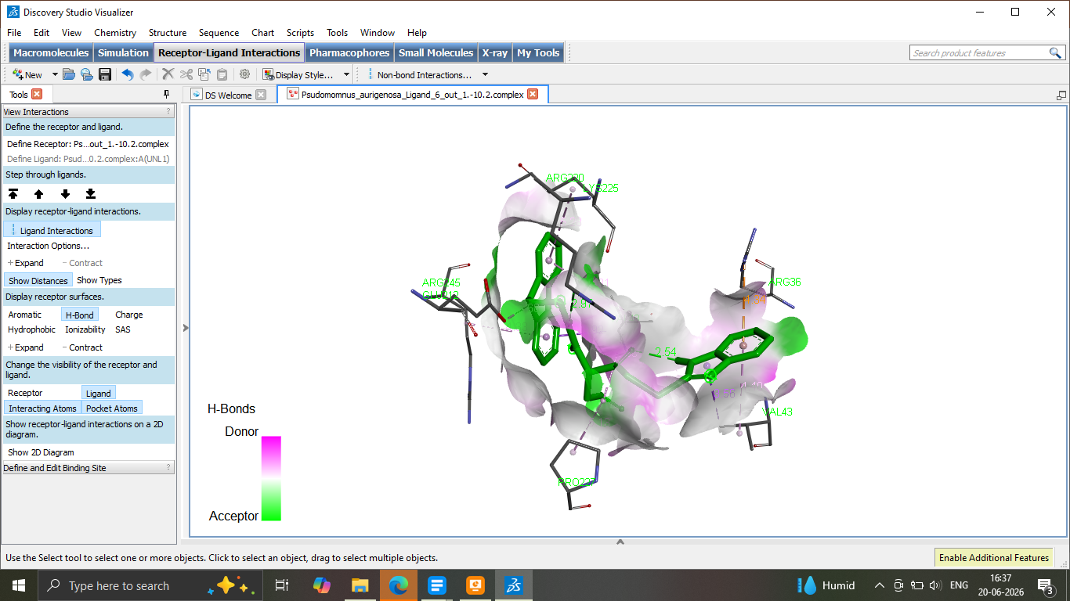
9c

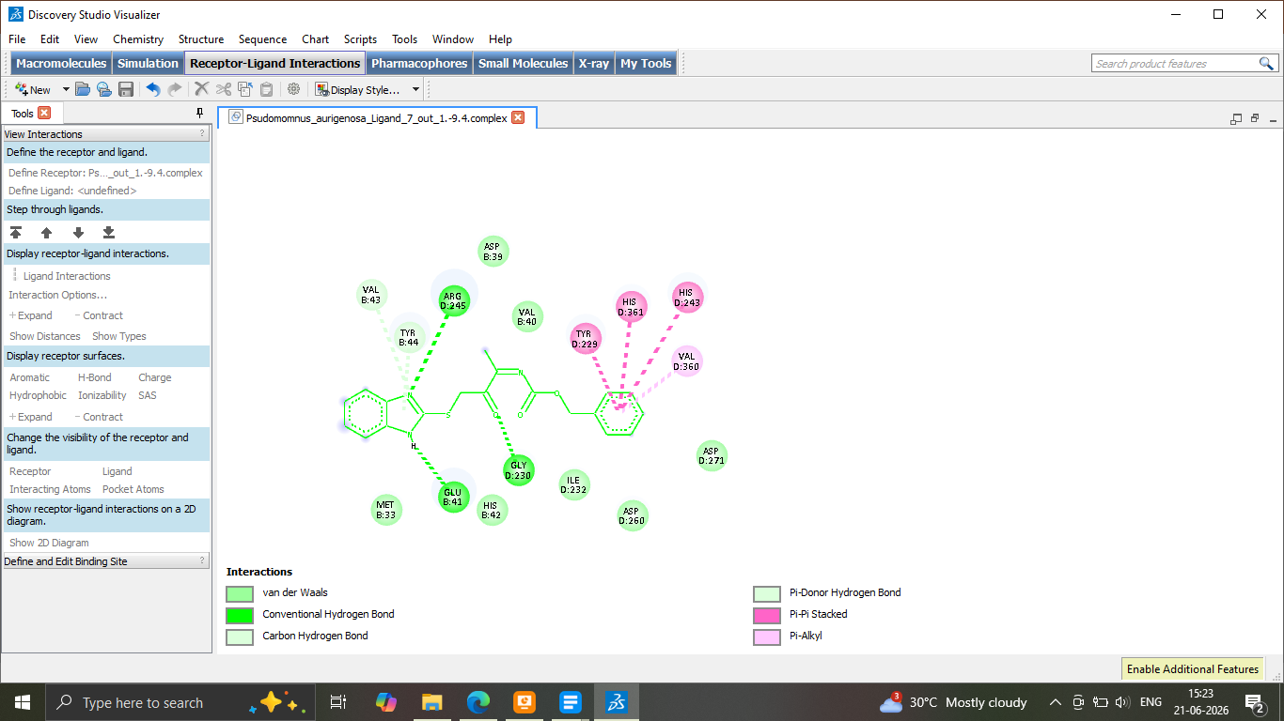
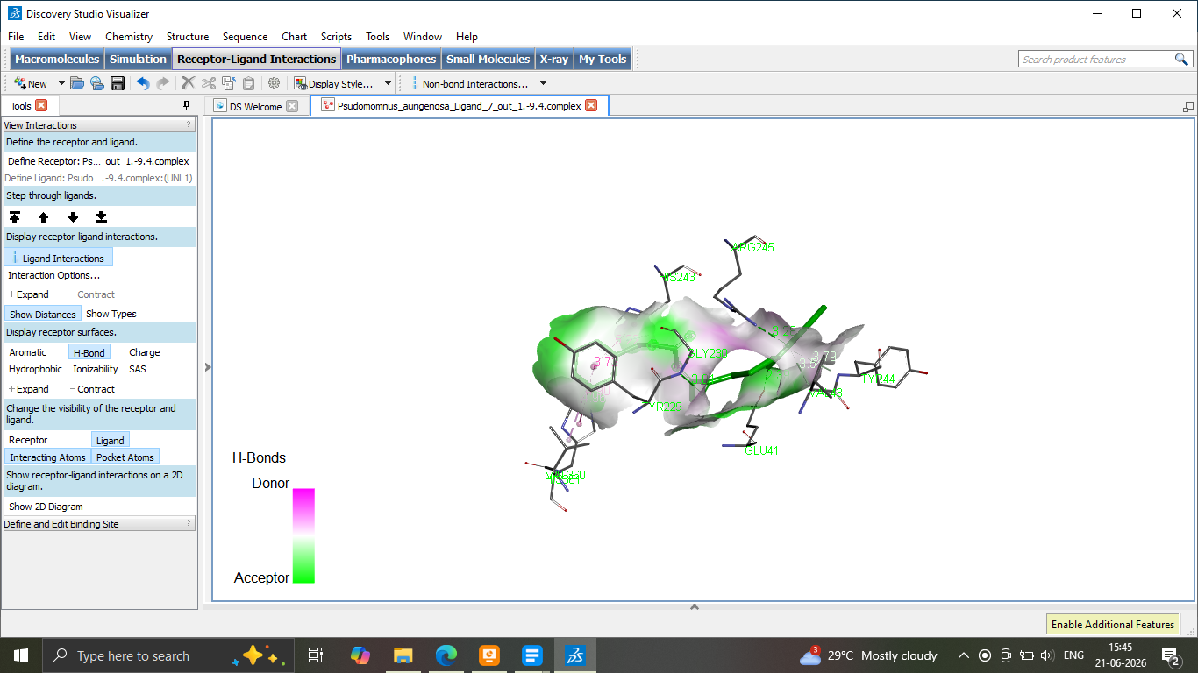
9b

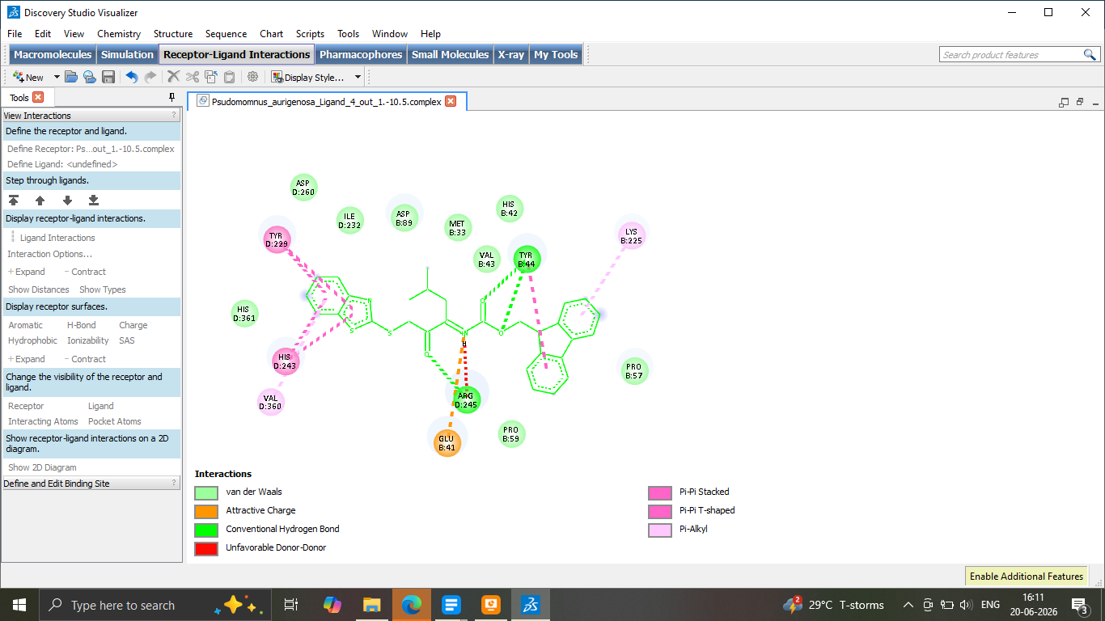
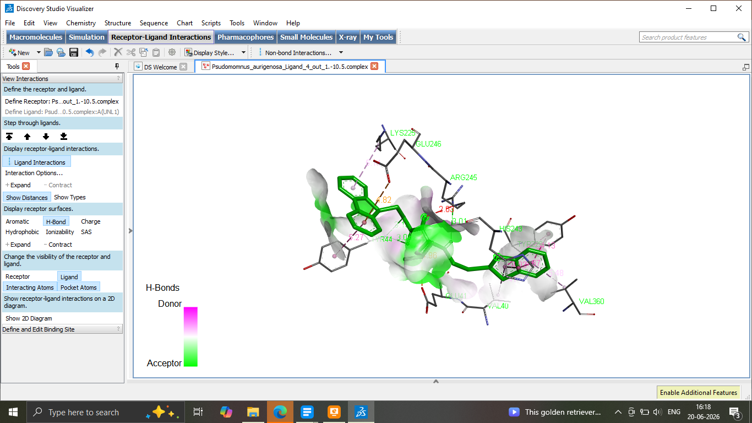
10a

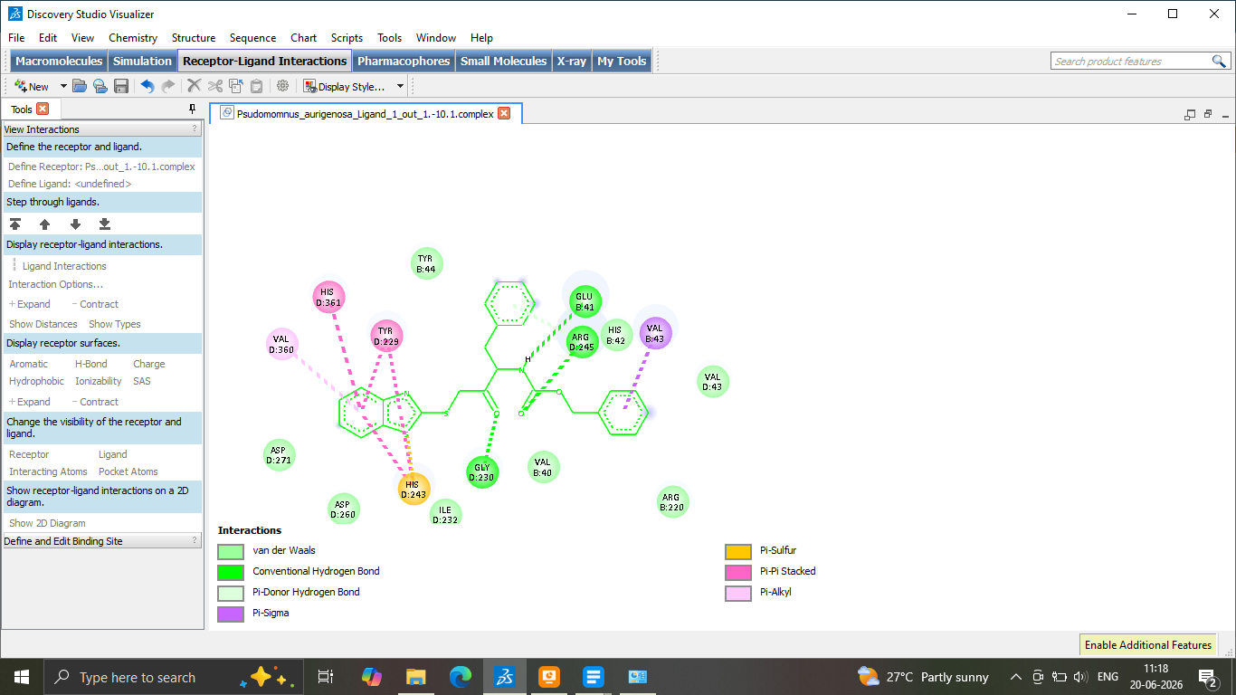
10b

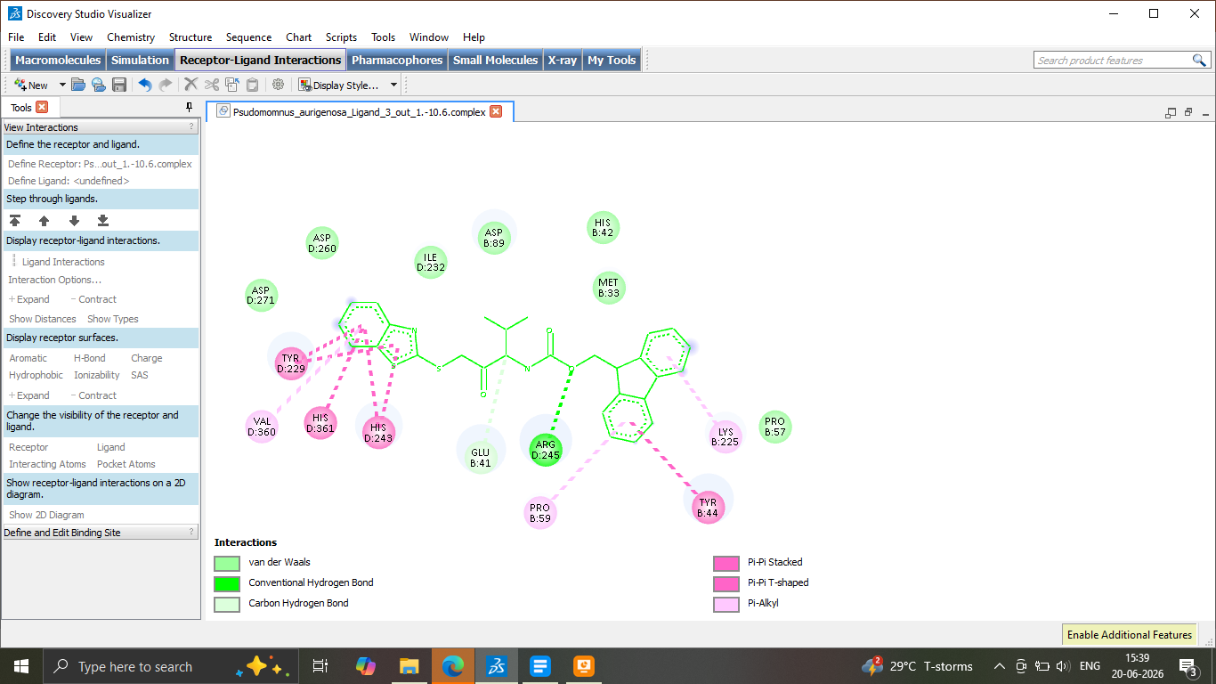
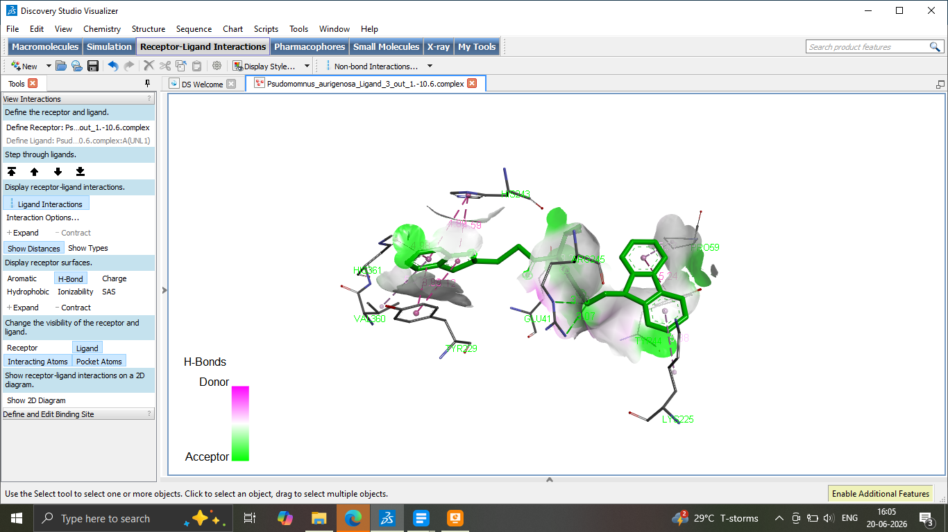
10c

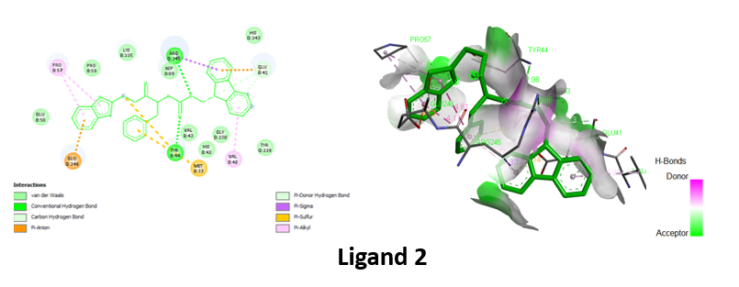
10d

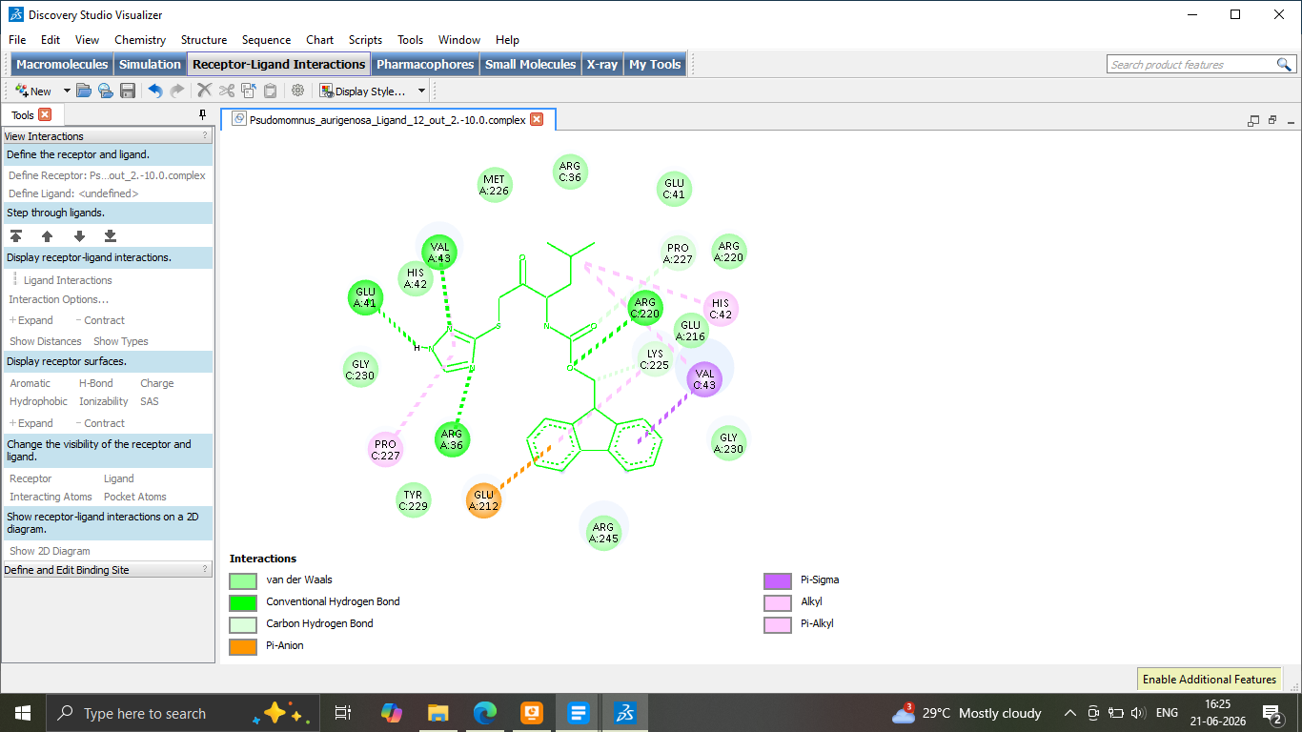
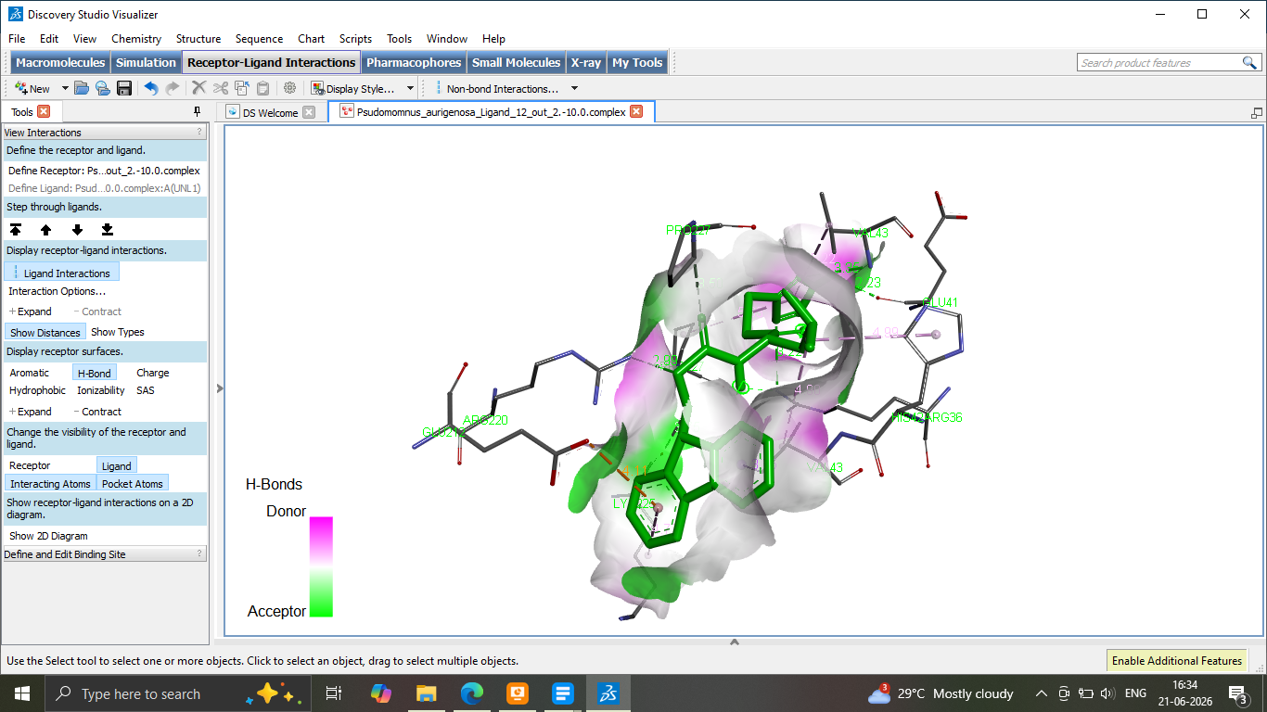
11a

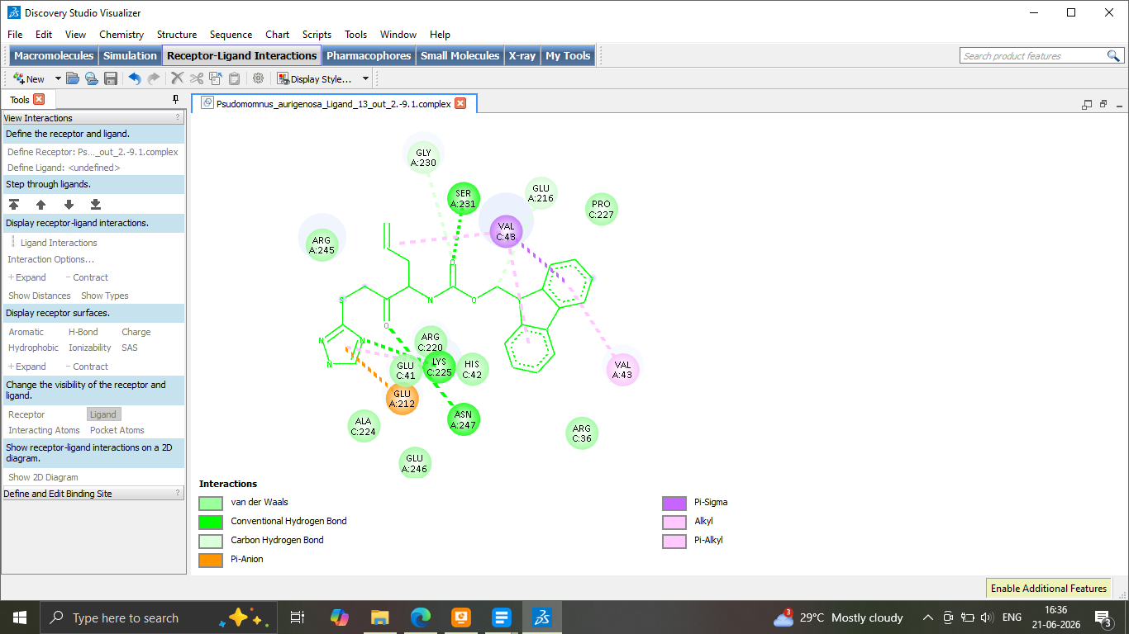
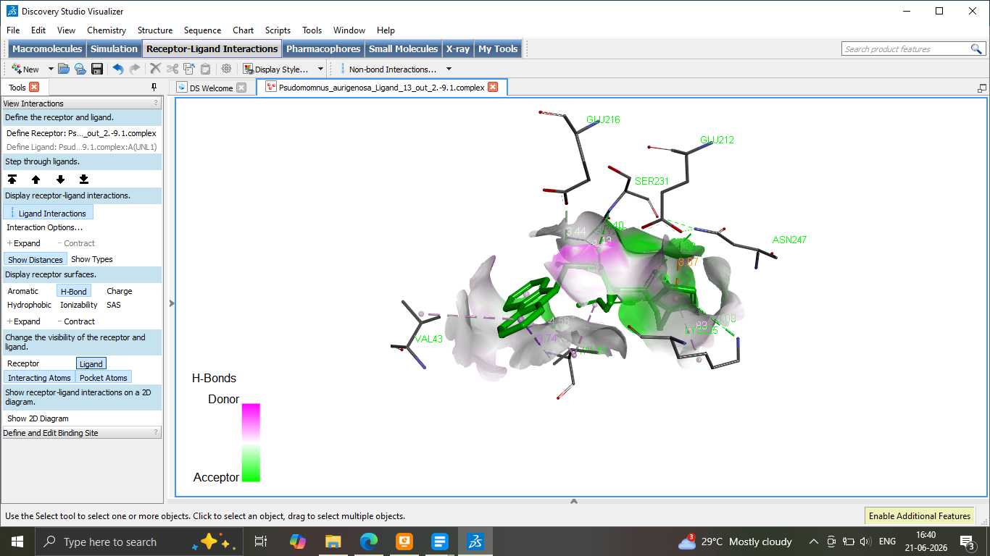
11b

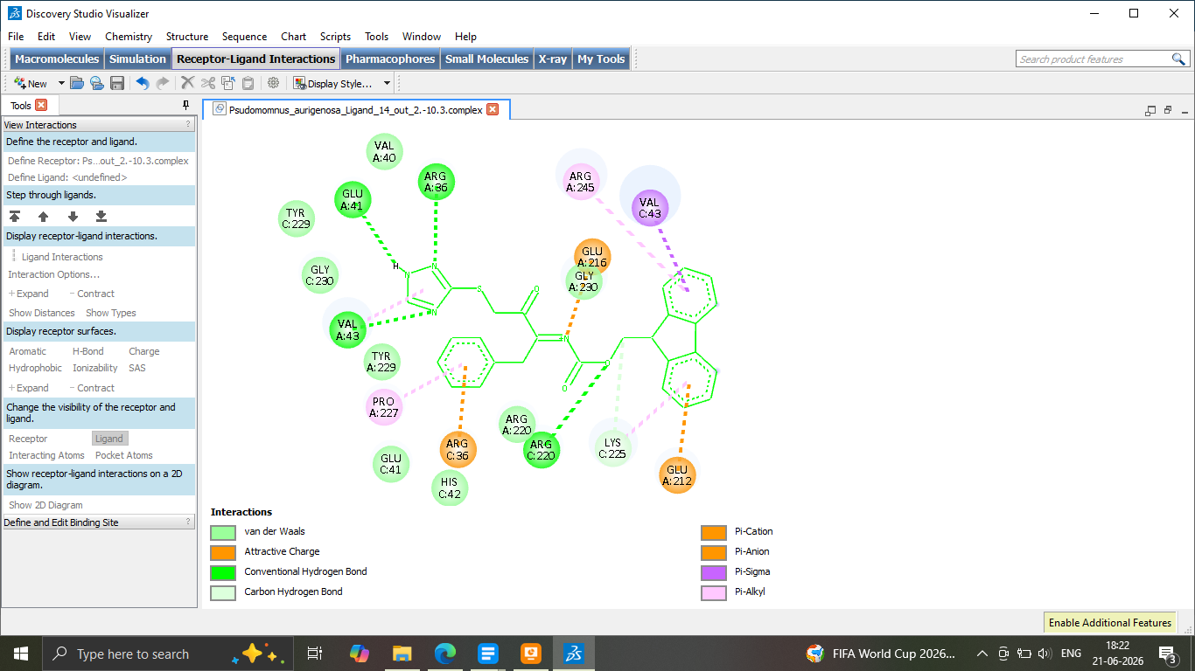
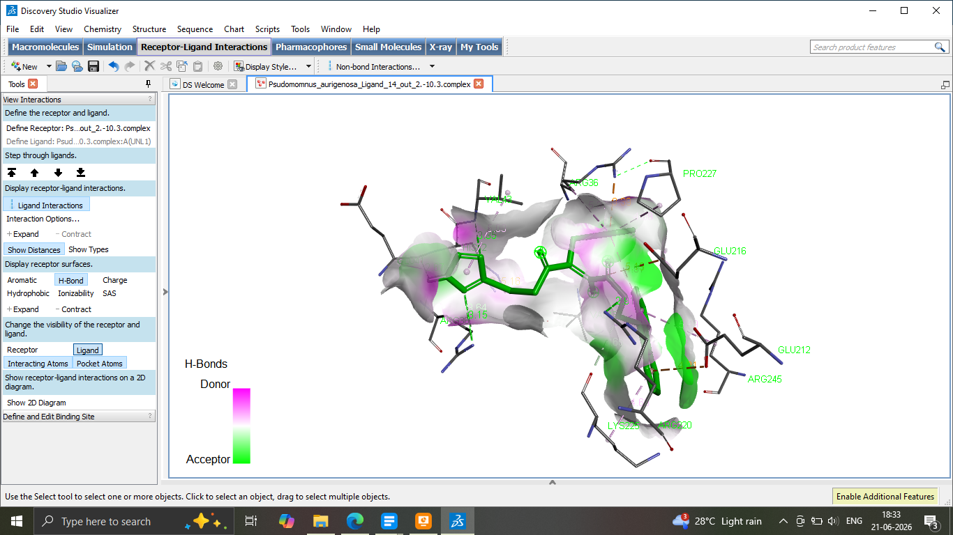
11c

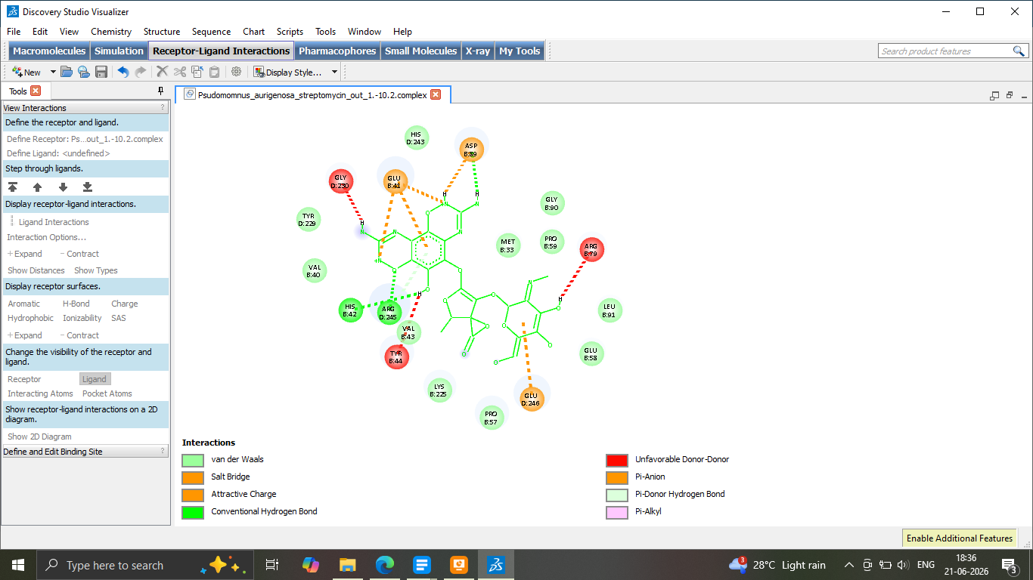
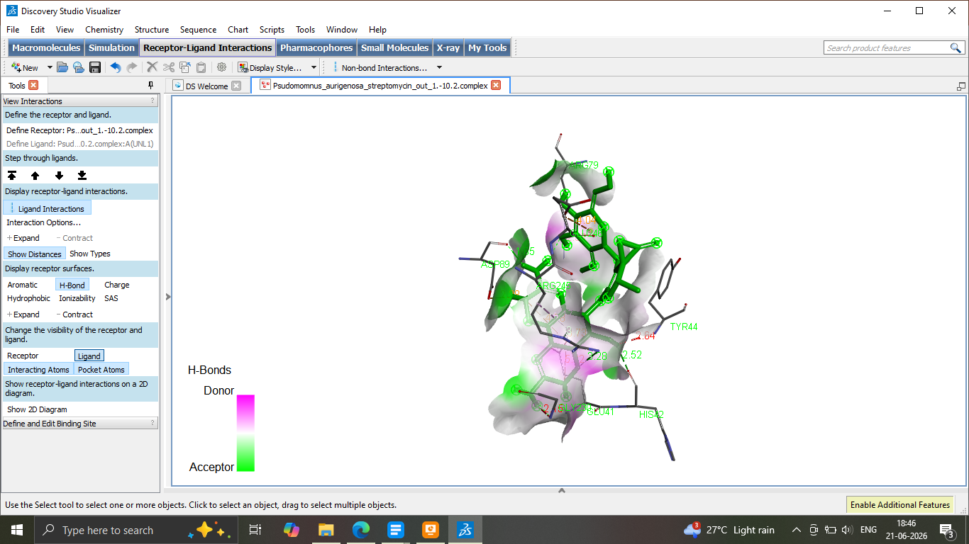
Streptomycin

Docking images of Protein 2 (Aspergillus niger EstA)
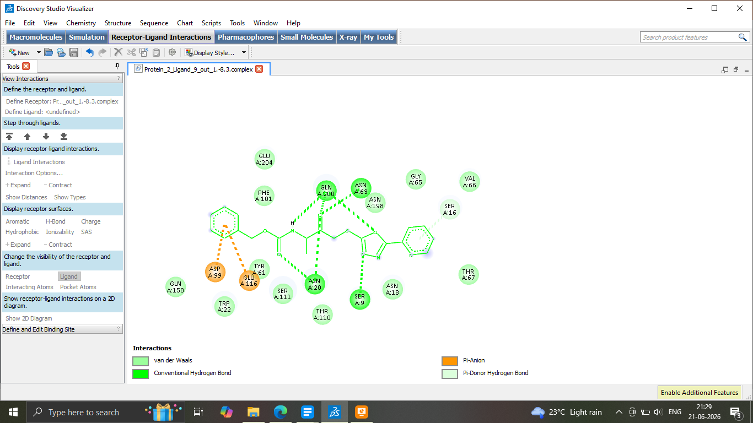
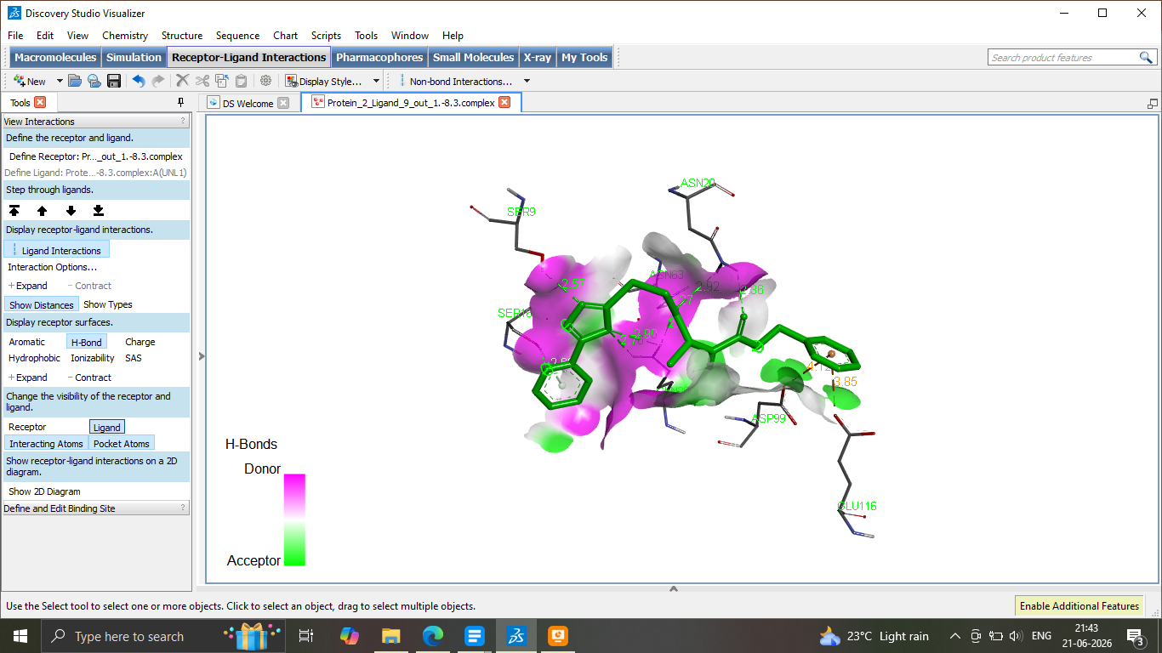
8a

8b
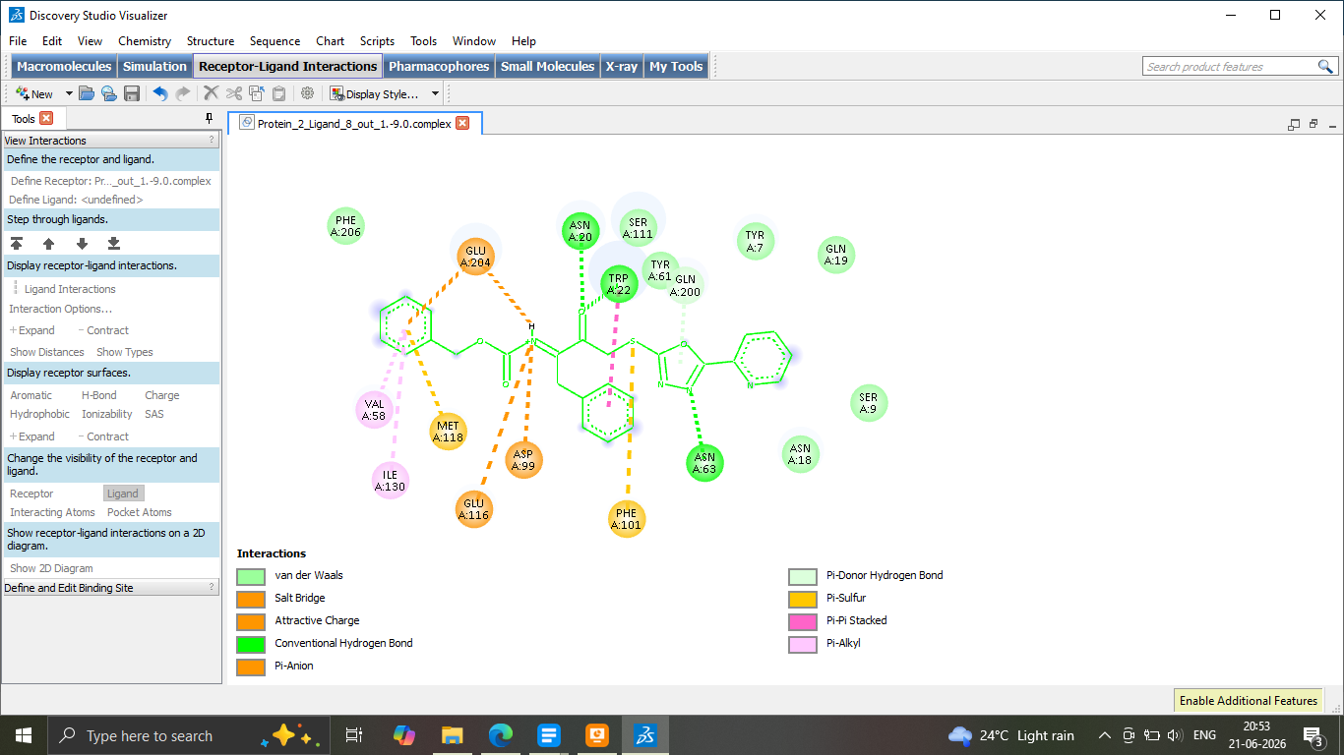
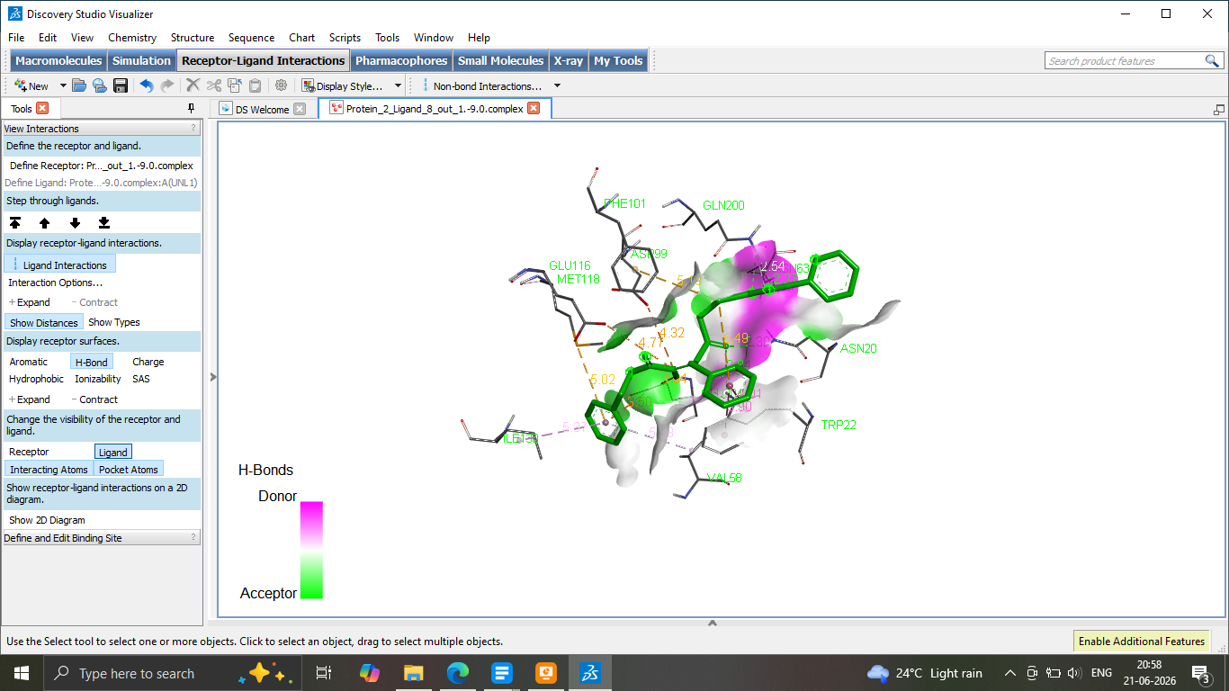

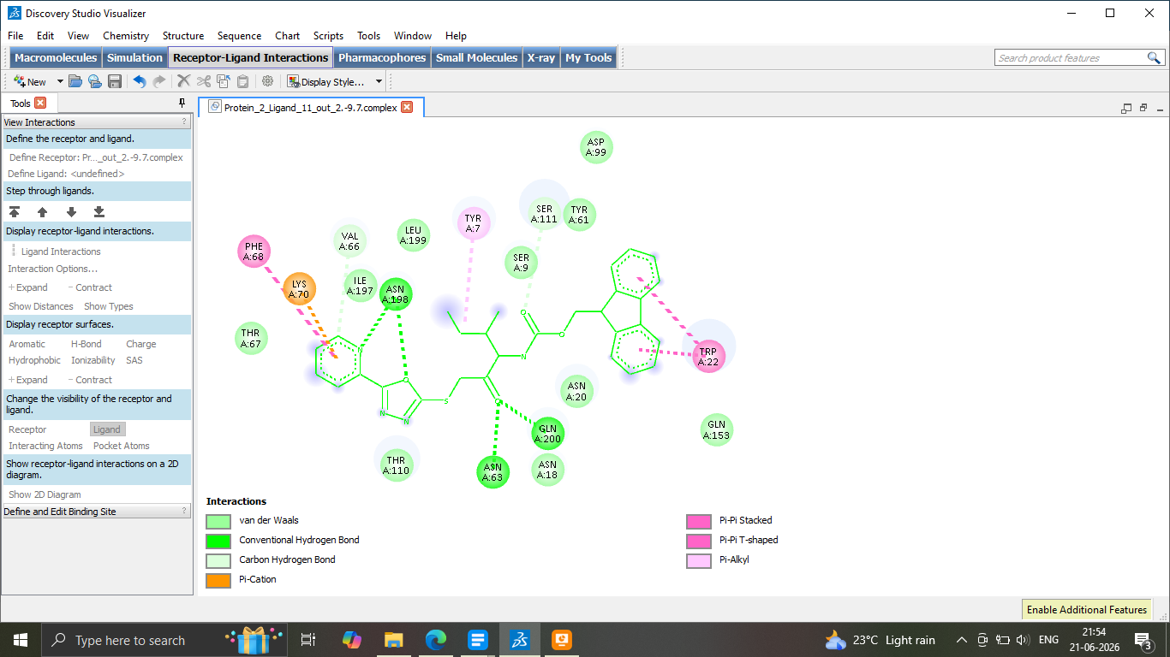
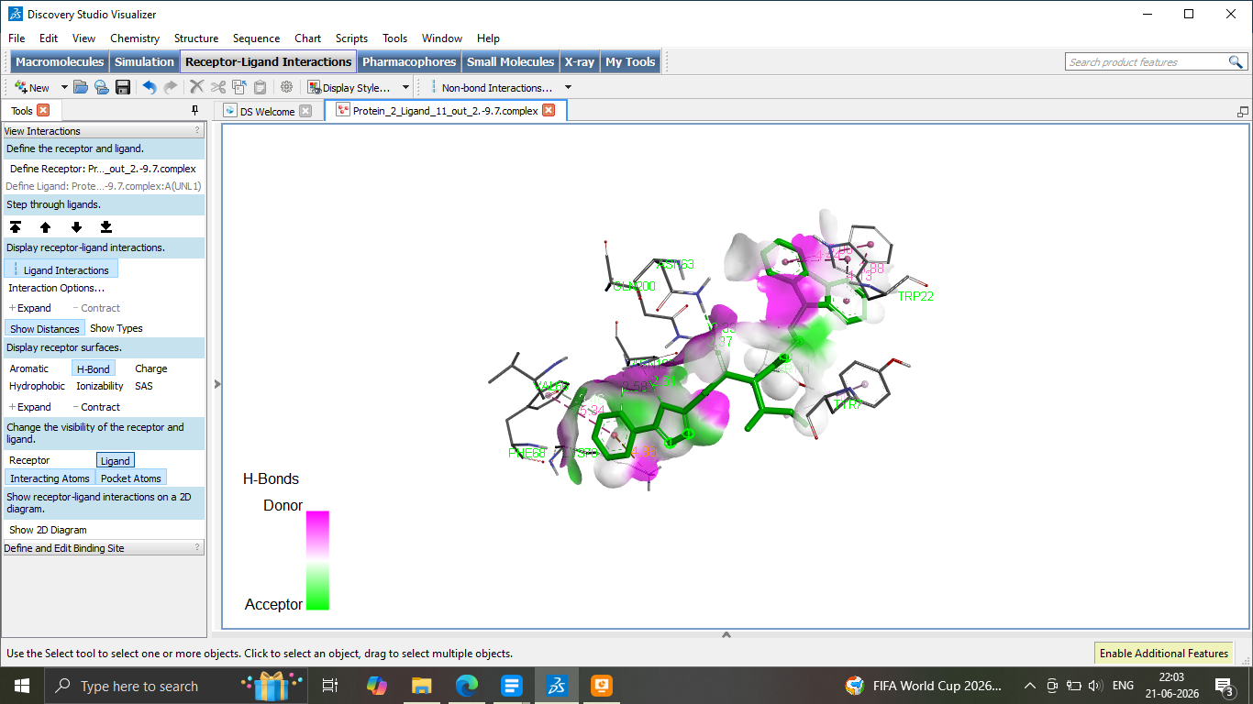
8c

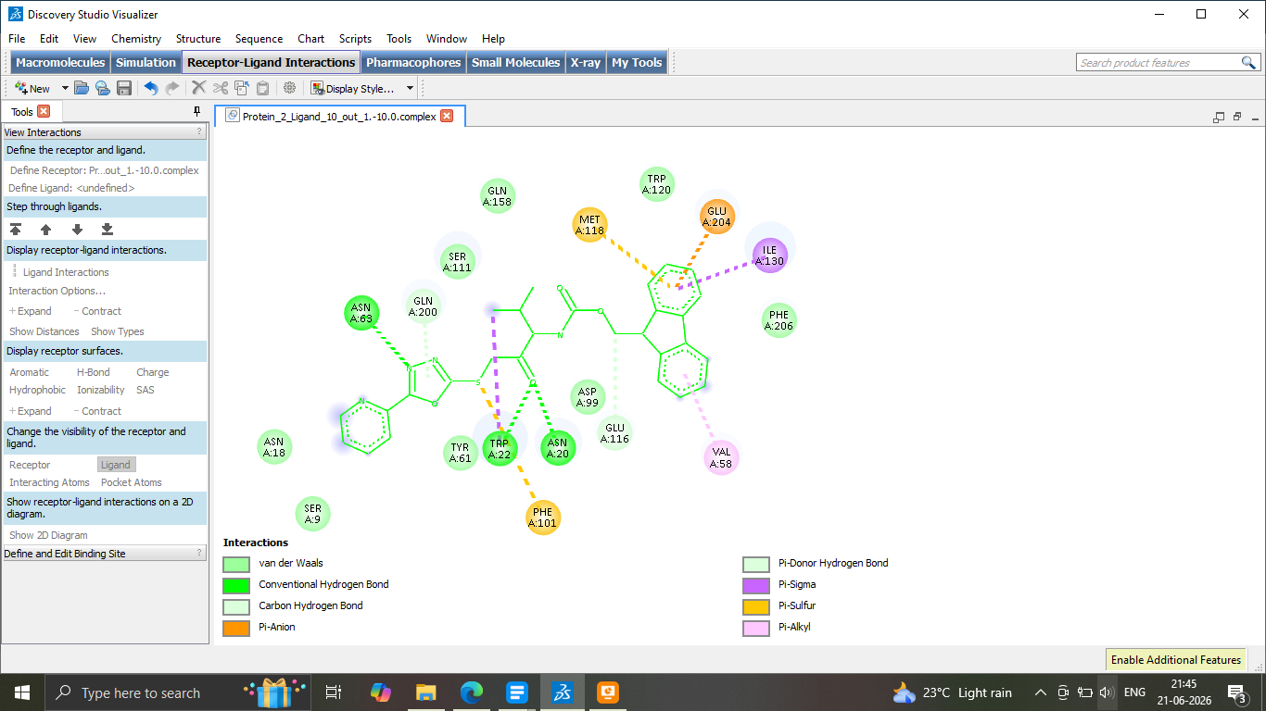
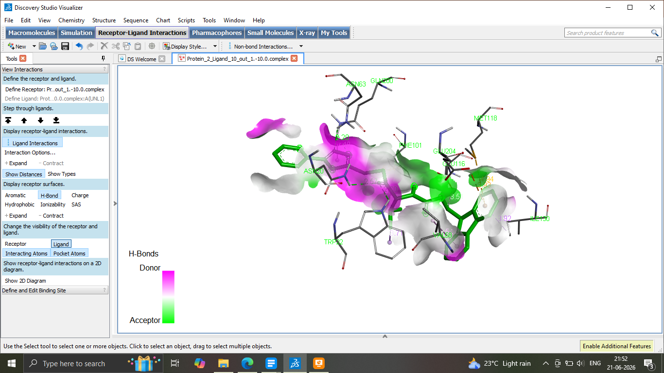
8d

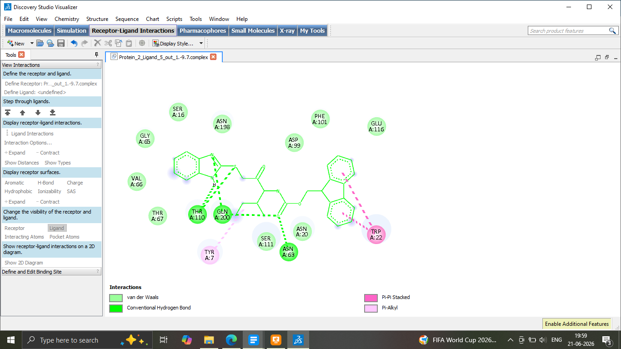
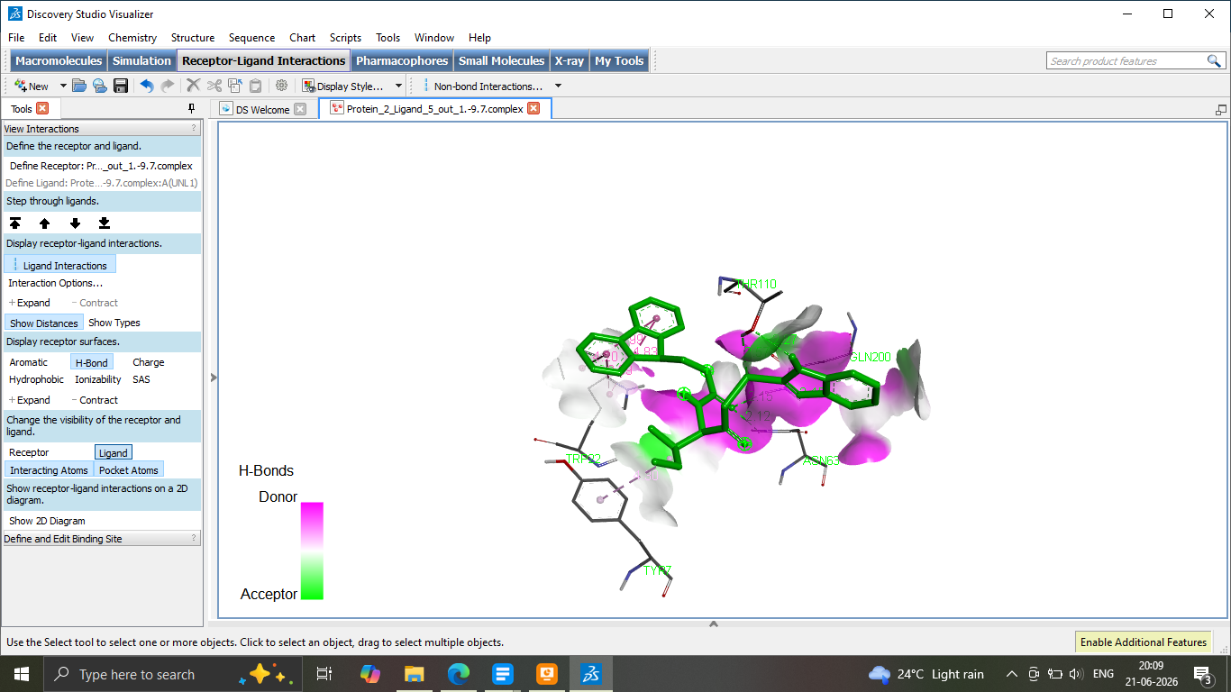
9a

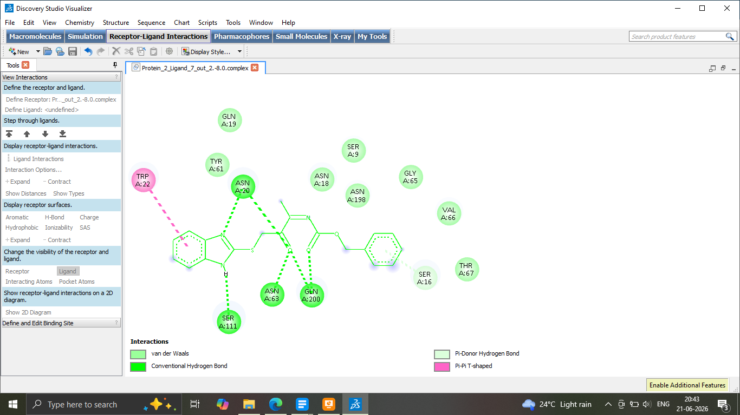
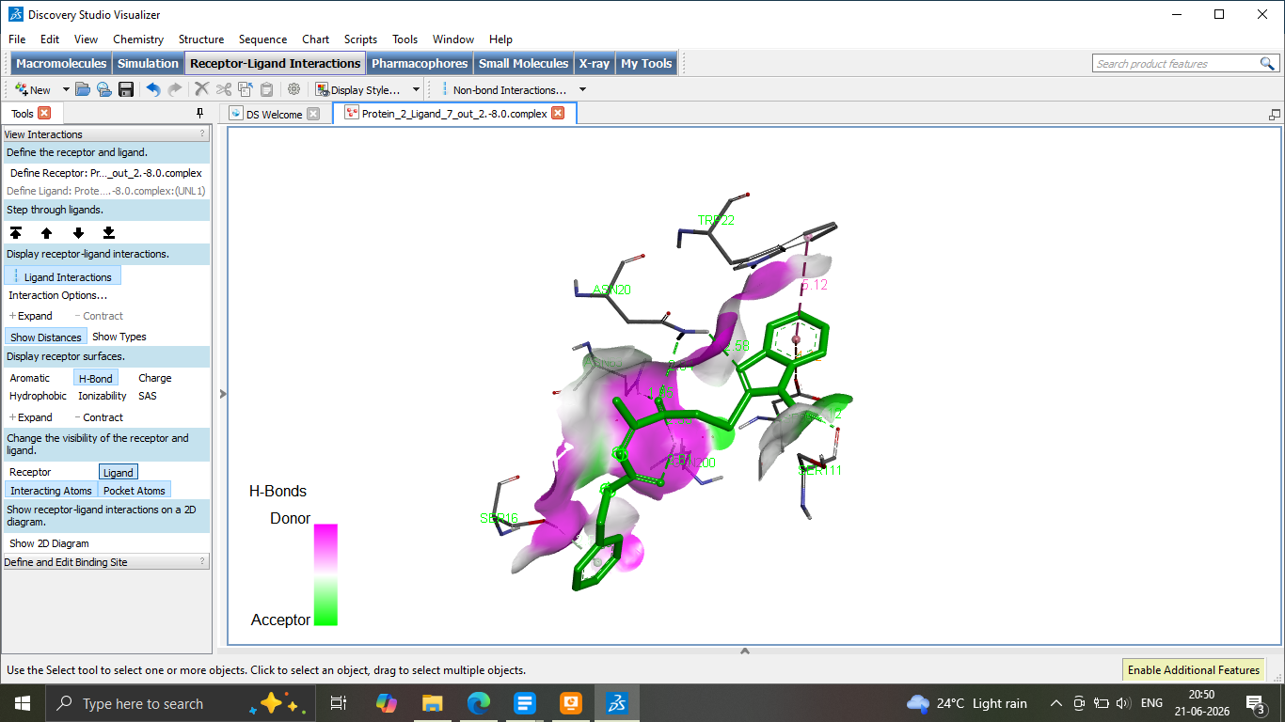
9b

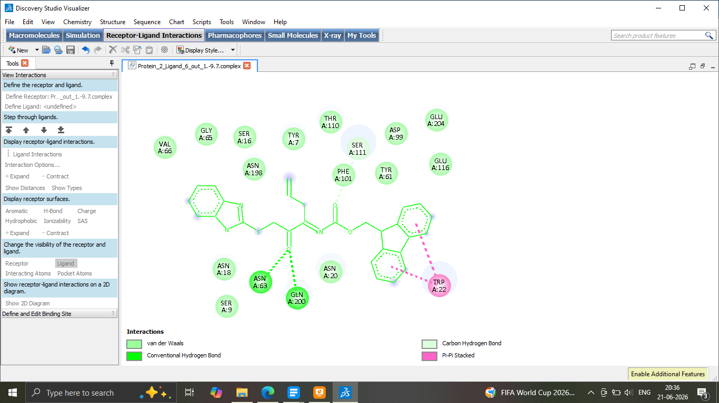
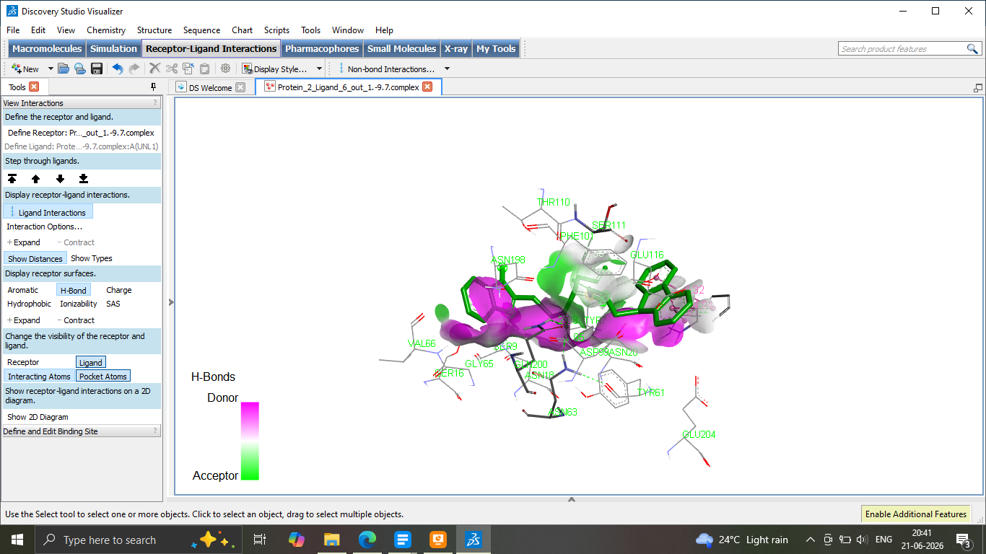
9c

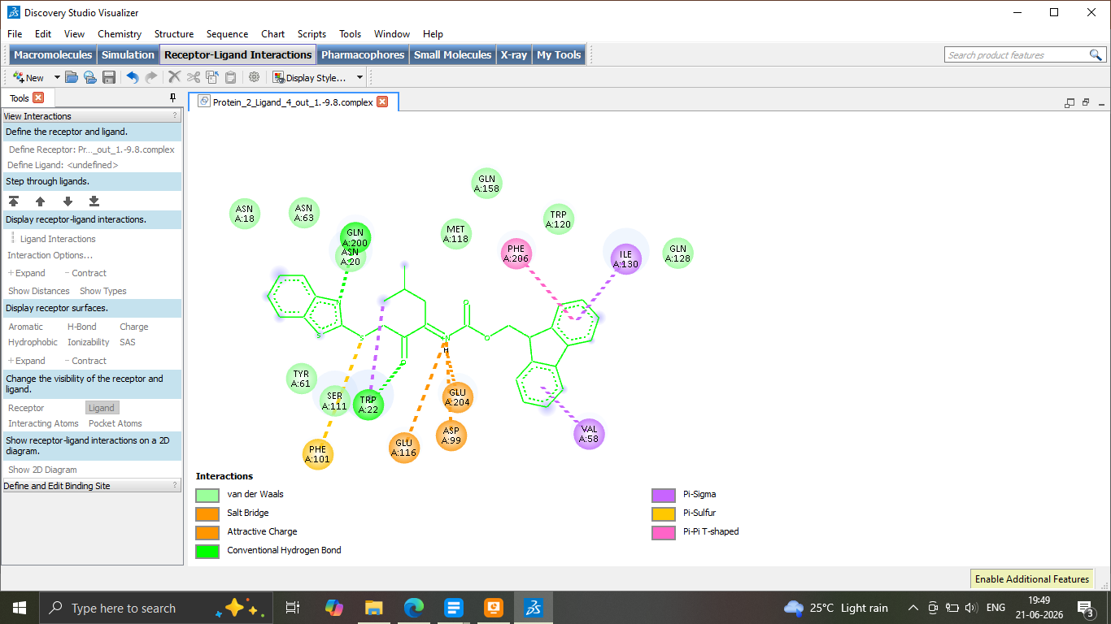
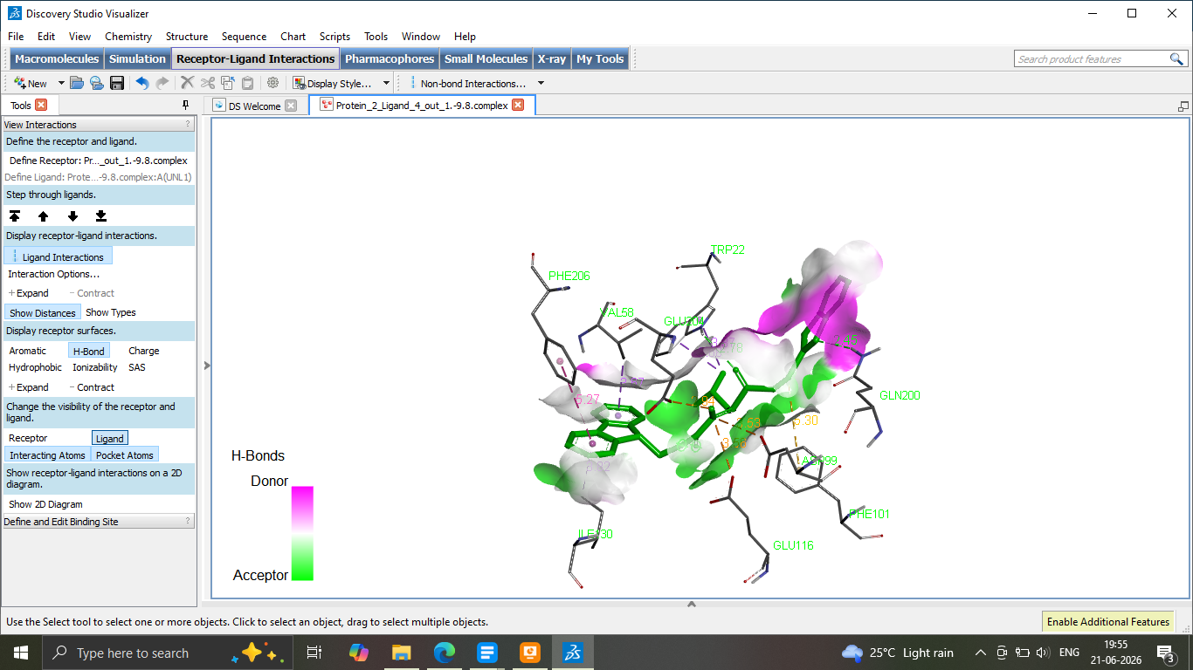
10a

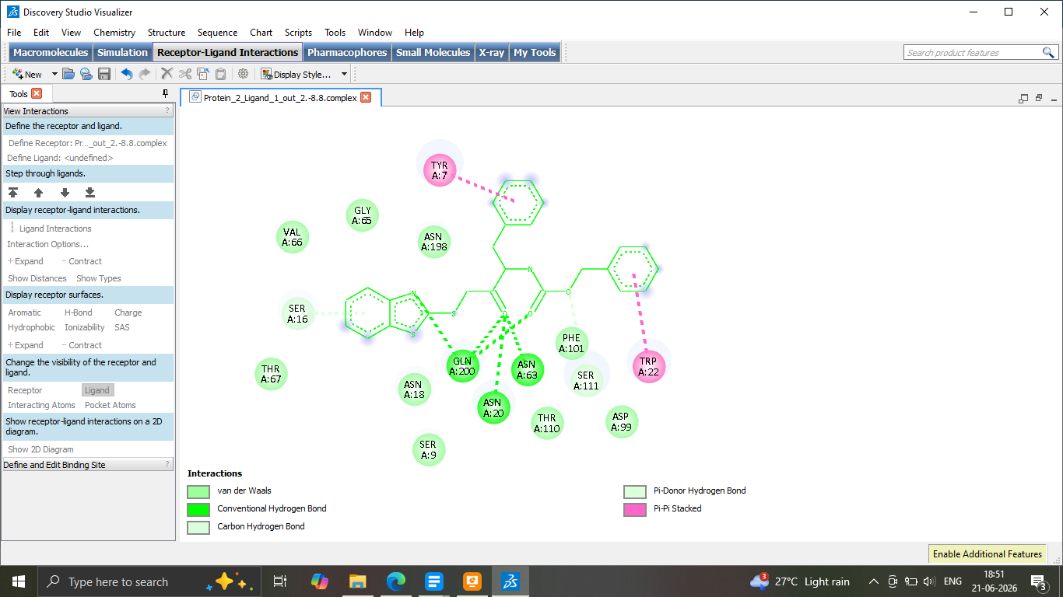
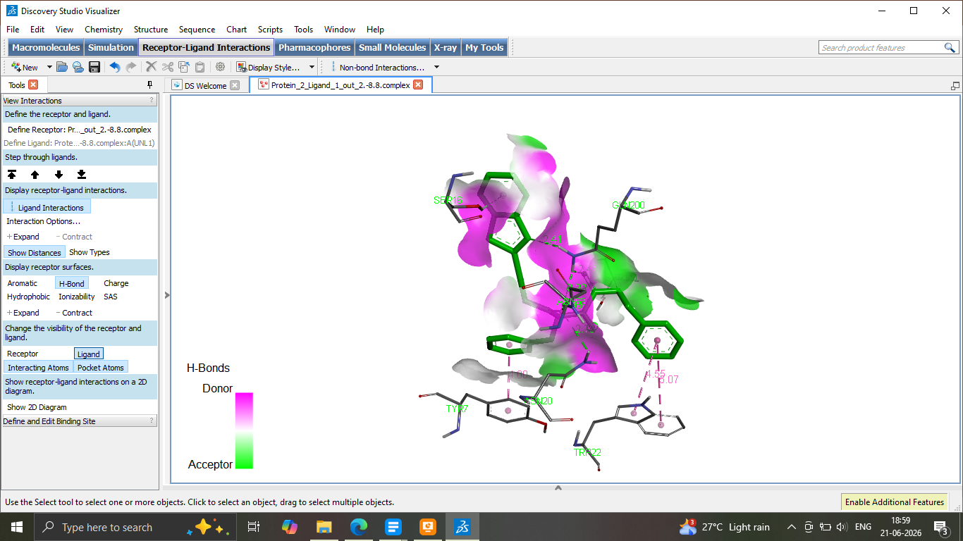
10b

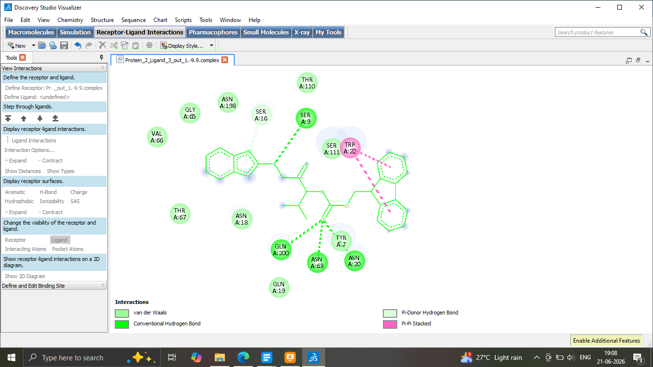
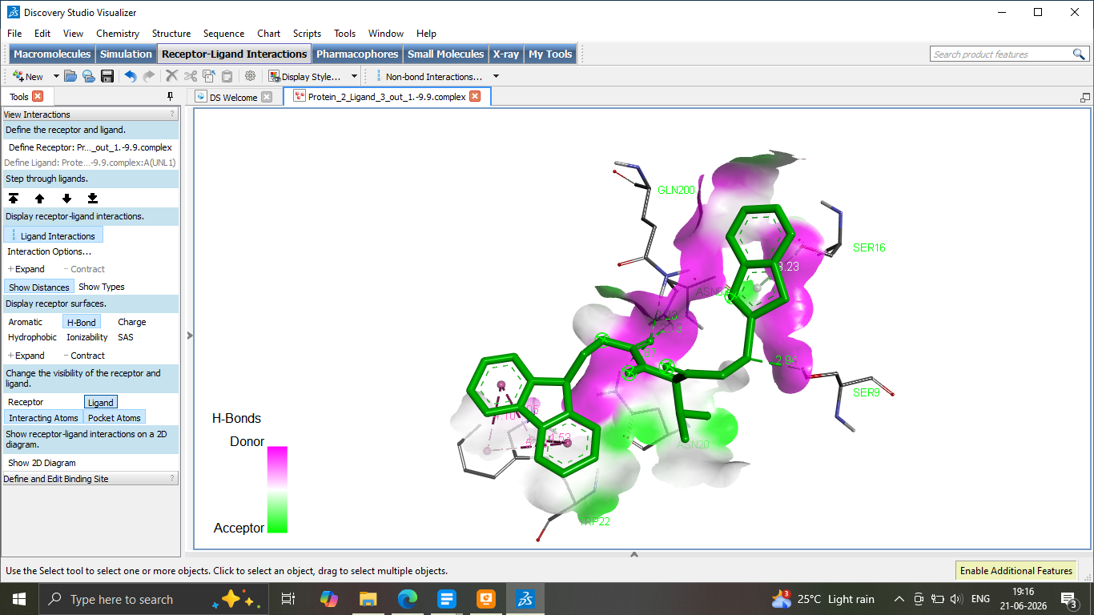
10c

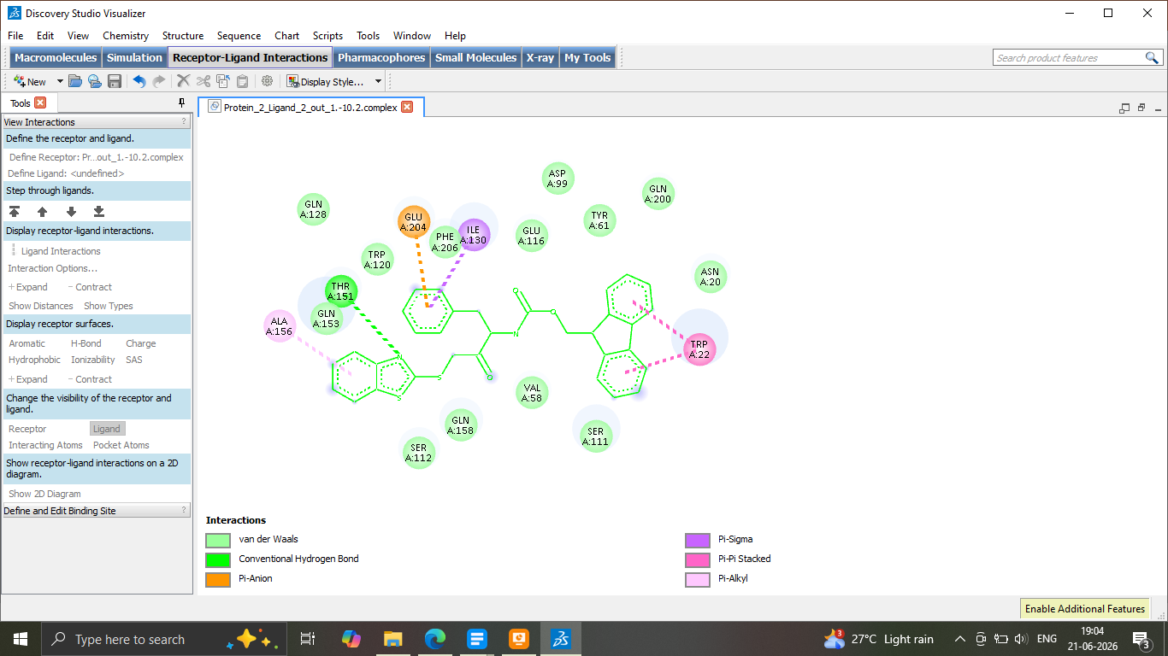
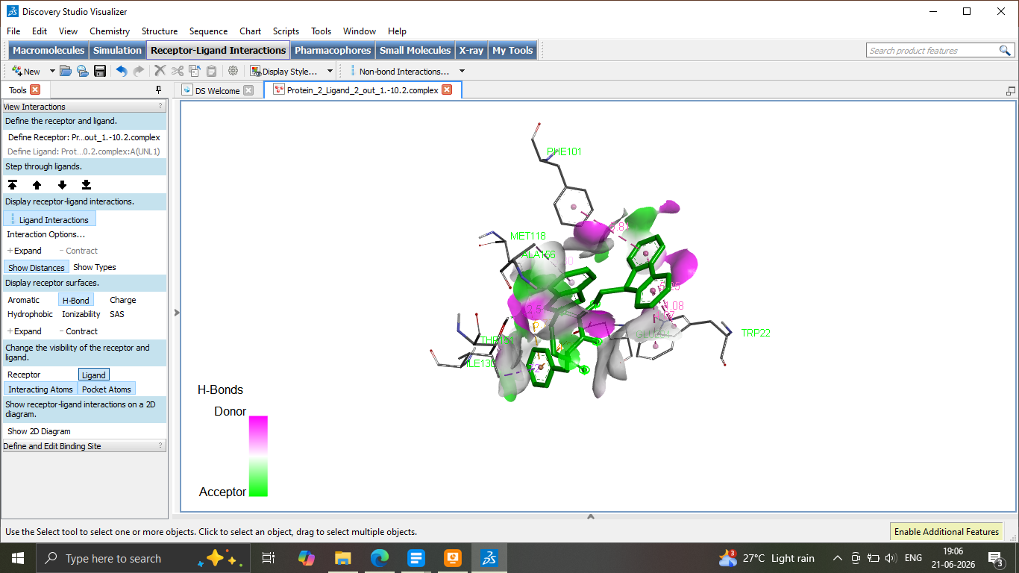
10d

11a
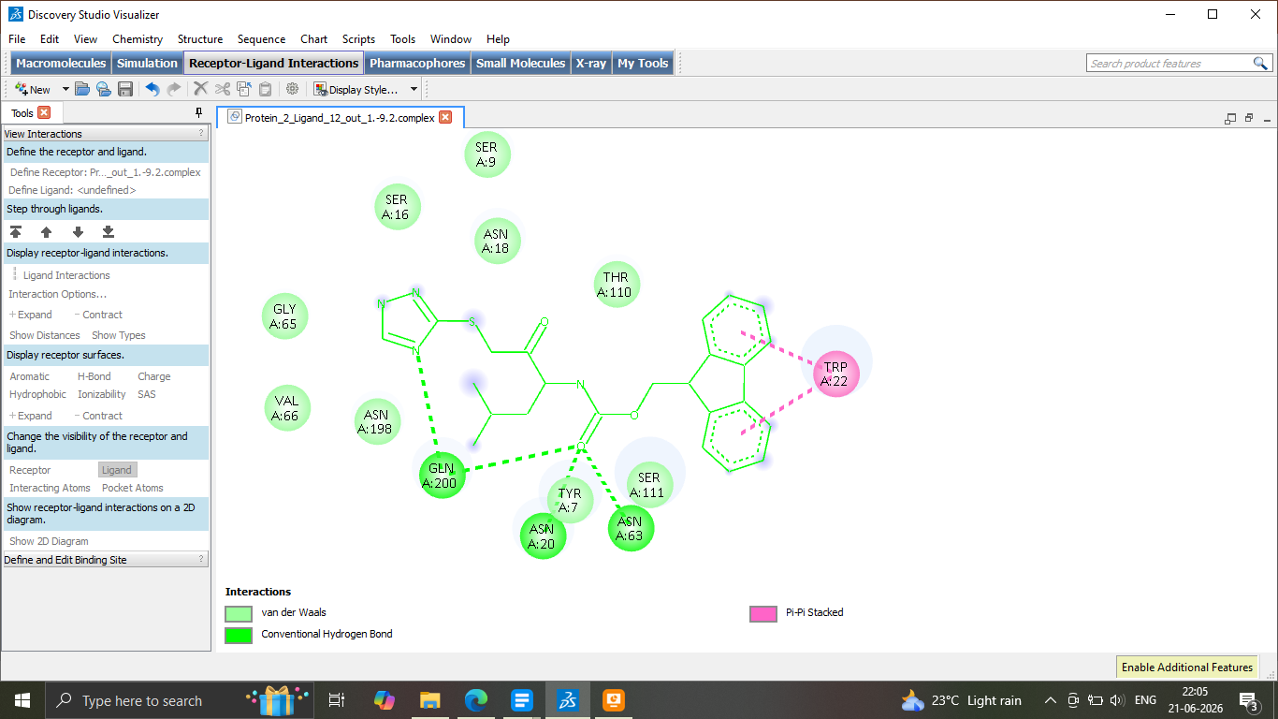
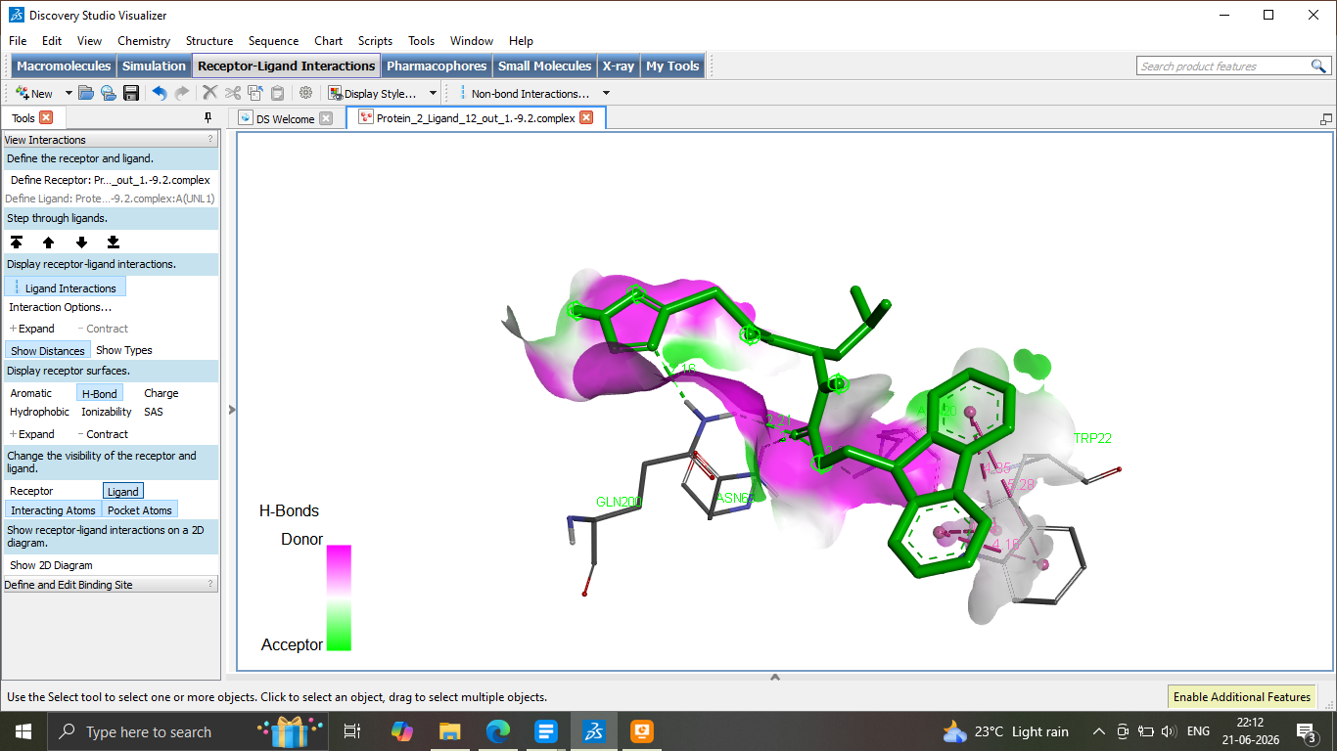

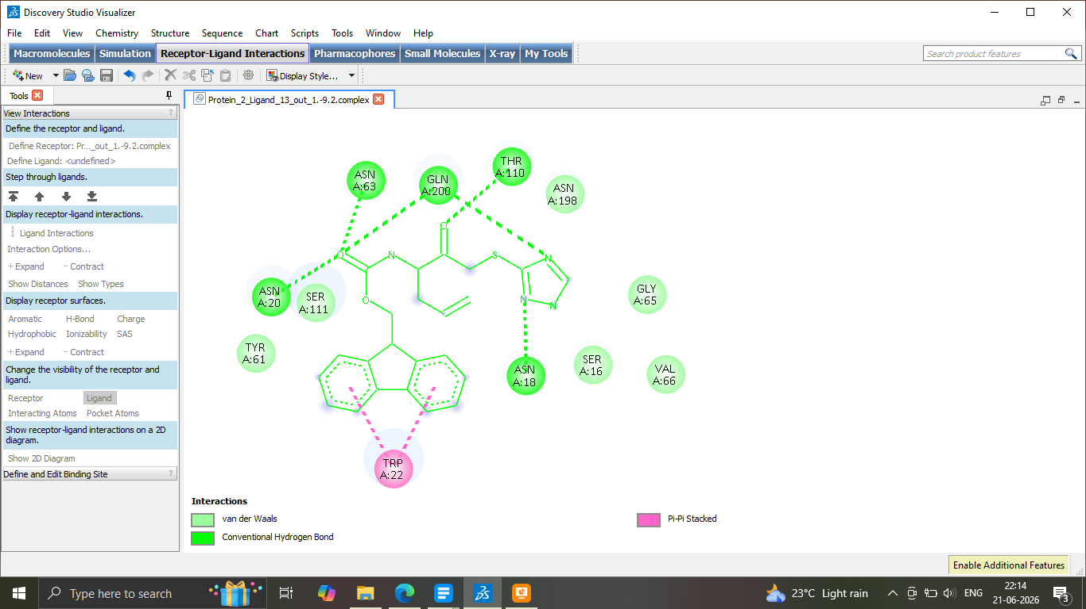
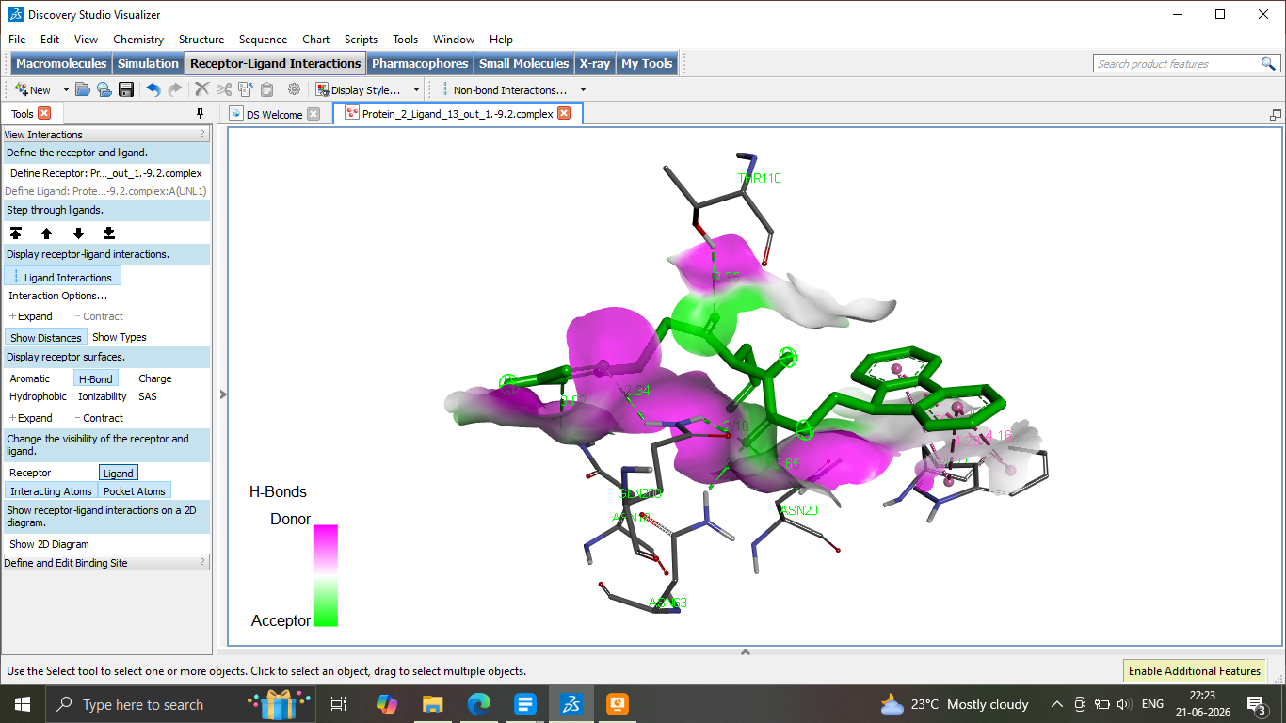
11b

11c
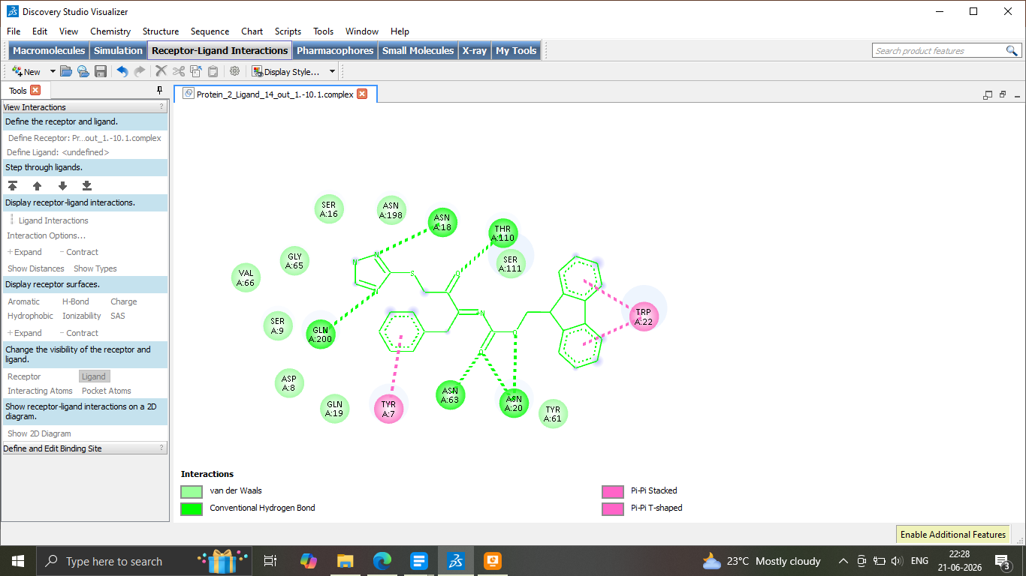
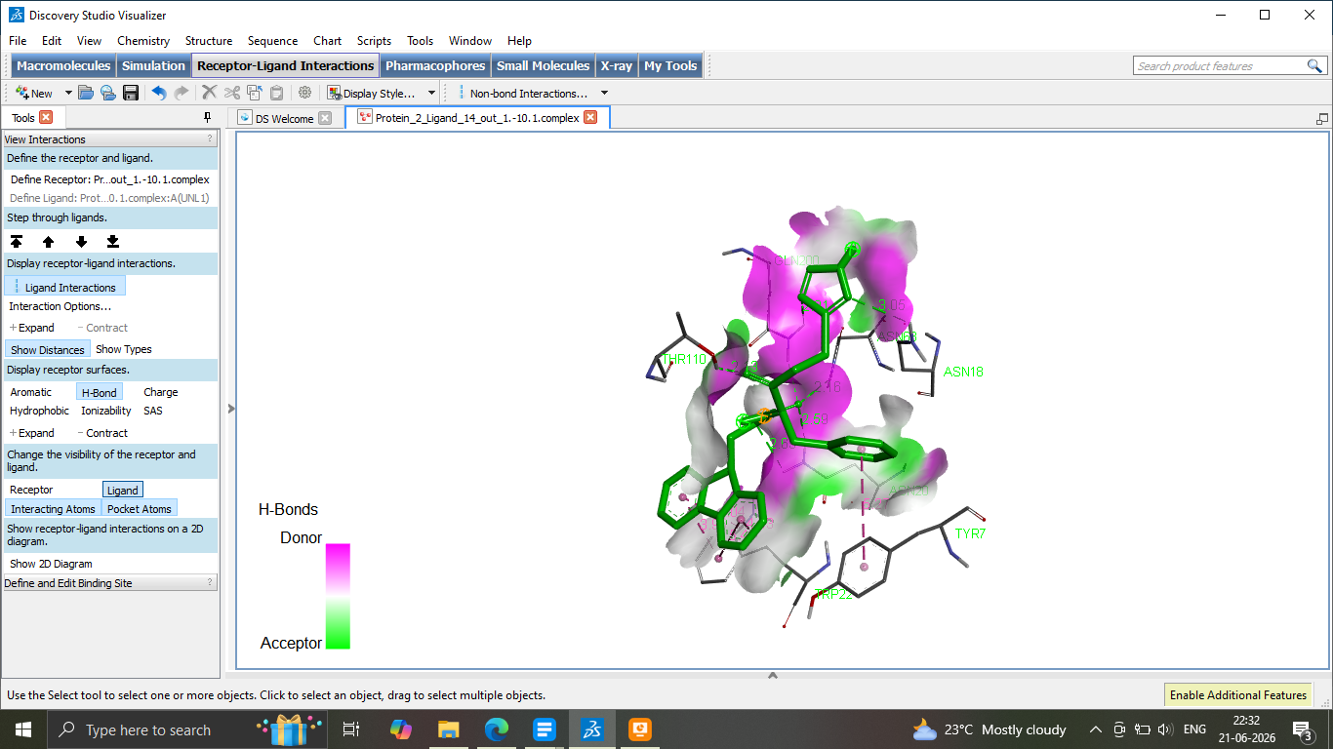

Fluconazole
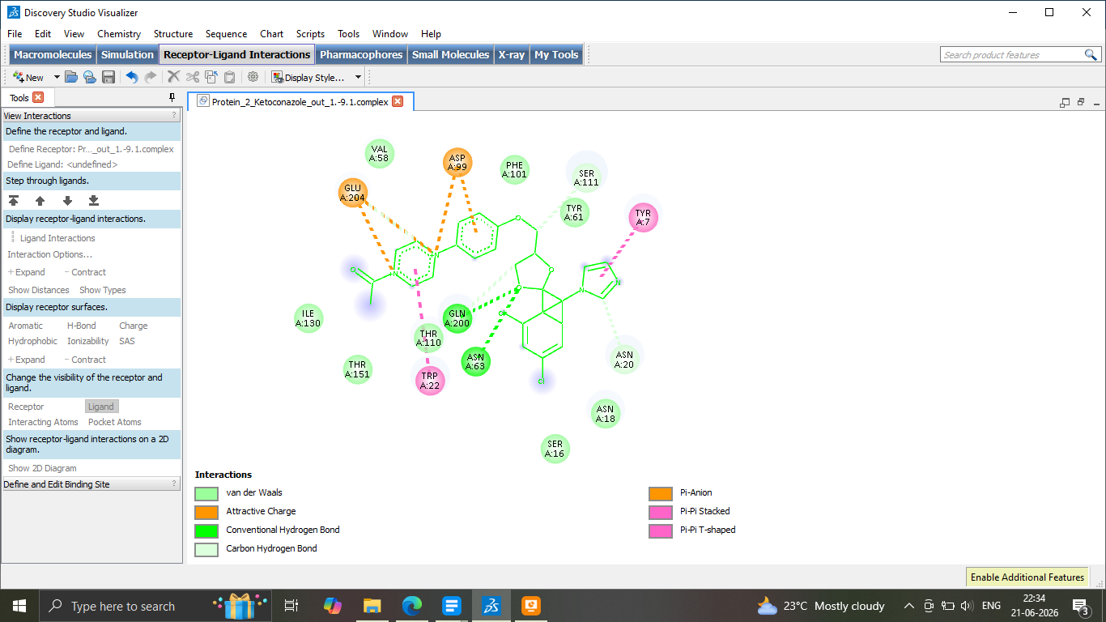
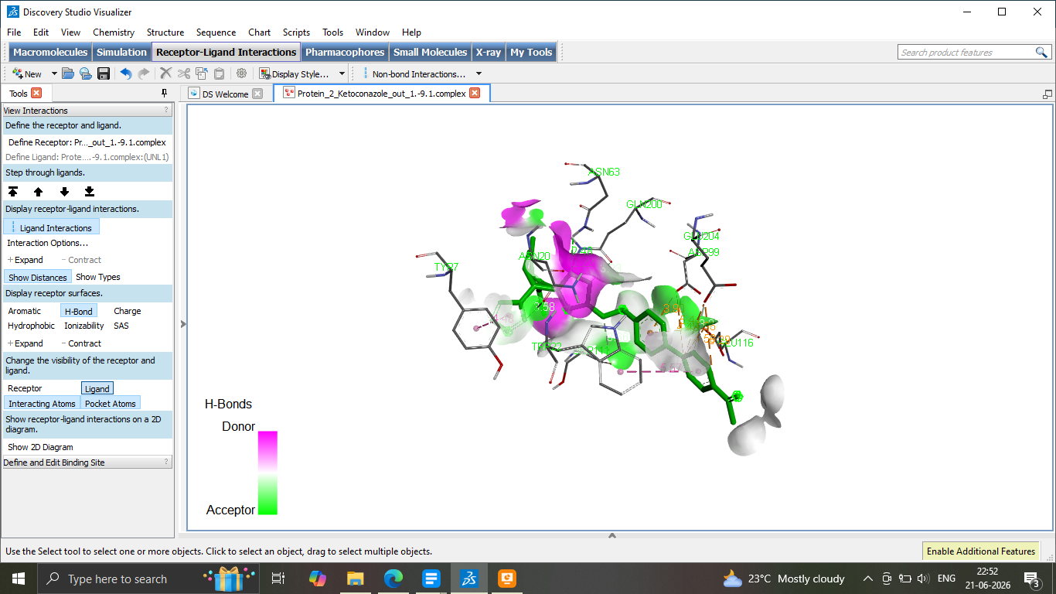

Cbz-Ala-oxadiazole-thiomethylene ketone (8a)
White solid;¹H NMR (400 MHz, DMSO-d₆): δ 1.29 (3H, d), 3.75-3.90 (2H, 3.80 (s), 3.80 (s)), 4.15 (1H, q), 4.74-4.84 (2H, 4.79 (s), 5.09 (s)), 7.21-7.44 (6H, 7.28 (m), 7.30 (m), 7.33 (tt), 7.37 (m), 7.76 (2H, m), 7.98 (1H, m), 8.89 (1H, m).¹³C NMR(100 MHz, DMSO-d₆): δ 18.1, 52.3, 65.5, 119.0, 126.3, 127.2, 128.1, 128.5, 136.5, 136.6, 151.9, 151.9, 154.4, 162.7, 163.0, 200.7. MS: Cald. for C₁₉H₁₉N₄O₄S m/z: 399.11 [M+H]⁺, Found: 398.91.
Cbz-Phe-oxadiazole-thiomethylene ketone (8b)
White solid;¹H NMR (400 MHz, CDCl₃): δ 3.01-3.13 (2H, 3.07 (d), 3.07 (d)), 4.18-4.28 (2H, 4.19 (s), 4.19 (s)), 4.94 (1H, d), 5.07-5.37 (2H, 5.12 (s), 5.32 (s)), 7.13-7.43 (11H, 7.20 (t), 7.28 (m), 7.29 (m), 7.30 (m), 7.30 (m), 7.33 (t), 7.36 (m), 7.76 (1H, m), 8.08 (1H, m), 8.59 (1H, m). ¹³C NMR (100 MHz, CDCl₃): δ 37.5, 40.7, 60.2, 67.5, 119.0, 122.3, 127.2, 127.2, 128.1, 128.5, 128.6, 129.1, 136.5, 136.6, 136.8, 149.2, 151.9, 155.7, 162.7, 163.0, 200.7. MS: Cald. for C₂₅H₂₃N₄O₄S m/z: 475.14 [M+H]⁺, Found: 475.62.
Fmoc-Val-oxadiazole-thiomethylene ketone (8c)
White solid;¹H NMR (400 MHz, DMSO-d₆): δ 0.82-0.94 (6H, 0.88 (d), 0.88 (d), 2.11 (1H, m), 4.17-4.31 (2H, 4.19 (s), 4.21 (s)), 4.34 (1H, d), 4.50-4.66 (3H, 4.56 (d), 4.60 (d), 4.60 (d), 7.23-7.43 (5H, 7.30 (m), 7.34 (m), 7.34 (m), 7.36 (m), 7.36 (m), 7.60-7.86 (5H, 7.67 (m), 7.67 (m), 7.76 (m), 7.80 (m), 7.80 (m)), 7.98 (1H, m), 8.89 (1H, m). ¹³C NMR (100 MHz, DMSO-d₆): δ 18.4, 19.6, 29.0, 47.1, 67.6, 68.1, 120.0, 120.0, 120.0, 122.3, 125.0, 125.0, 127.0 (s), 127.0, 127.7, 136.6, 141.3, 141.3, 143.7, 143.7, 149.2, 150.9, 156.4, 162.7, 163.0, 200.7.MS: Cald. for C₂₈H₂₆N₄O₄S m/z: 515.10 [M+H]⁺, Found: 514.97.
Fmoc-Ileu-oxadiazole-thiomethylene ketone (8d)
White solid;¹H NMR (400 MHz, DMSO-d⁶): δ 0.77-0.91 (6H, 0.83 (d), 0.85 (d), 1.11-1.28 (2H, 1.20 (m), 1.20 (m), 1.83 (1H, m), 4.17-4.37 (2H, 3.92 (s), 4.18 (s)), 4.18 (1H, d), 4.50-4.66 (3H, 4.56 (d), 4.61 (d), 4.61 (d), 7.23-7.43 (5H), 7.34 (m), 7.34 (m), 7.36 (m), 7.36 (m), 7.60-7.86 (5H, 7.67 (m), 7.67 (m), 7.76 (m), 7.80 (m), 7.80 (m), 8.08 (1H, m), 8.59 (1H, m). ¹³C NMR (100 MHz, DMSO-d⁶): δ 10.8, 15.2, 24.5, 35.5, 35.8, 47.1, 57.6, 67.1, 119.0, 120.0 (s), 120.0 (s)), 122.3, 125.0 (s), 125.0 (s)), 127.0 (s), 127.0 (s), 127.7 (s), 127.7 (s), 136.6, 141.3 (s), 141.3 (s), 143.7 (s), 143.7 (s), 149.2 (s), 151.9 (s), 156.4 (s), 162.7 (s), 163.0 (s), 200.7 (s). MS: Cald. forC₂₉H₂₉N₄O₄S m/z: 529.17 [M-H]⁺, Found: 529.68.
Fmoc-Ileu-benzimidazole-thiomethylene ketone (9a)
White solid;¹H NMR (400 MHz, DMSO-d⁶): δ 0.77-0.91 (6H, 0.83 (dd), 0.85 (d), 1.11-1.28 (2H, 1.20 (m), 1.20 (dq), 1.83 (1H, dqdd), 4.16-4.29 (2H, 4.18 (s), 4.18 (s)), 4.42 (1H, d), 4.60-4.86 (3H, 4.66 (m), 4.81 (d), 4.81 (d), 7.15 (1H, m), 7.27-7.43 (4H, 7.34 (m), 7.34 (m), 7.36 (m), 7.36 (m), 7.49-7.86 (6H, 7.56 (m), 7.67 (m), 7.67 (m), 7.73 (m), 7.80 (m), 7.80 (m). ¹³C NMR(100 MHz, DMSO-d⁶) : δ 10.8, 15.2, 24.5, 35.5, 35.8, 47.1, 50.6, 67.1, 111.1, 118.1, 120.0, 120.0, 122.5, 122.5, 125.0, 125.0, 127.0, 127.0, 127.7, 127.7, 141.2, 141.3, 141.3, 143.7, 143.7, 144.6, 149.3, 156.4, 210.7. MS: Cald. for C₂₉H₂₉N₃O₃S m/z: 500.20 [M+H]⁺, Found: 500.59.
Fmoc-Ala-benzimidazole-thiomethylene ketone (9b)
White solid;¹H NMR (400 MHz, DMSO-d₆): δ 1.32 (3H, d), 3.85-3.95 (2H, 3.90 (s), 3.90 (s)), 4.46 (1H, q), 5.04-5.14 (2H, 5.09 (s), 5.09 (s)), 6.93 (1H, m), 7.08-7.44 (6H, 7.15 (m), 7.28 (m), 7.33 (t), 7.37 (m), 7.56 (1H, m), 7.73 (1H, m). ¹³C NMR(100 MHz, DMSO-d₆): δ 18.1, 35.5, 48.3, 65.5, 111.1, 118.1,122.5, 122.5, 127.2, 128.1, 128.5, 136.5, 141.2, 144.6,149.3, 154.4, 200.7. MS: Cald. for C₁₉H₂₀N₃O₃S m/z: 370.12 [M+H]⁺, Found: 370.37.
Fmoc-Allyl Gly-benzimidazole-thiomethylene ketone (9c)
White solid;¹H NMR (300 MHz, DMSO-d⁶): δ 2.37-2.50 (2H, 2.44), 2.44 (d), 3.86-3.96 (2H, 3.91 (s), 3.91 (s)), 4.50-4.66 (3H, 4.56 (d), 4.60 (d), 4.60 (d), 4.78-4.95 (3H, 4.85 (d), 4.85 (d), 4.88 (d), 5.61 (1H, m),5.93 (1H, m), 7.15 (1H, m), 7.27-7.43 (4H, 7.34 (m), 7.34 (m), 7.36 (m), 7.36 (m), 7.49-7.86 (6H, 7.56 (m) 7.67 (m), 7.67 (m), 7.73 (m), 7.80 (m), 7.80 (m). ¹³C NMR(100 MHz, DMSO-d⁶): δ 35.5, 37.0, 47.1, 53.2, 67.1, 111.1, 118.1, 119.2, 120.0, 120.0, 122.5, 122.5, 125.0, 125.0, 127.0, 127.0, 127.7, 127.7, 133.4, 141.2, 141.3, 141.3, 143.7, 143.7, 144.6, 149.3, 155.9, 200.7. MS: Cald. for C₂₈H₂₅N₃O₃S m/z: 483.16 [M+H]⁺, Found: 483.30.
Fmoc-Leu-benzothiazole-thiomethylene ketone (10a)
Off-white solid;¹H NMR (400 MHz, DMSO-d₆): δ 0.84-0.96 (6H, 0.90 (d), 0.90 (d), 1.47-1.71 (3H, 1.59 (m), 1.55 (m), 1.55 (m), 4.19-4.31 (2H, 4.22 (s), 4.22 (s)), 4.35 (1H, m), 4.50-4.66 (3H, 4.56 (m), 4.60 (d), 4.60 (d), 7.23-7.43 (6H, 7.30 (m), 7.34 (m), 7.34 (m), 7.35 (m), 7.36 (m), 7.36 (m), 7.60-7.88 (6H, 7.67 (m), 7.67 (m), 7.86 (m), 7.90 (m), 8.01 (m), 8.01 (m). ¹³C NMR(100 MHz, DMSO): δ 22.1, 23.3, 24.3, 47.1, 58.2, 67.1, 119.9-120.0, 120.0, 120.9, 121.4, 124.6, 125.0, 125.0, 126.2, 127.0, 127.0, 127.7, 127.7, 135.2, 141.3, 141.3, 143.7, 143.7, 152.8, 155.9, 166.9, 200.7. MS: Cald. for C₂₉H₂₉N₂O₃S₂ m/z: 516.14 [M+H]⁺, Found: 516.97.
Cbz-Phe-benzothiazole-thiomethylene ketone (10b)
White solid;¹H NMR (400 MHz, CDCl₃): δ 3.00-3.12 (2H, 3.06 (d), 3.06 (d), 4.19-4.29 (2H, 4.19 (s), 4.19 (s)), 4.65 (1H, d), 5.07-5.17 (2H, 5.12 (s), 5.12 (s)), 7.13-7.46 (12H, 7.20 (tt), 7.28 (m), 7.29 (m), 7.30 (m), 7.30 (m), 7.33 (t), 7.35 (m), 7.39 (m), 7.71-7.88 (2H, 7.77 (m), 7.81 (m). ¹³C NMR (100 MHz, CDCl₃): δ 32.5, 47.7, 53.2, 65.5, 120.9, 121.4, 124.6, 126.2, 127.2, 127.2, 128.1, 128.5, 128.6, 129.1, 135.2, 136.5, 136.8, 152.8, 155.7, 166.9, 200.7. Cald. for C₃₂H₂₆N₂O₃S₂ m/z: 463.10 [M+H]⁺, Found: 463.61.
Fmoc-Val-benzothiazole-thiomethylene ketone (10c)
Off-white solid;¹H NMR (400 MHz, DMSO-d₆): δ 0.82-0.94 (6H, 0.88 (d), 0.88 (d)), 2.15 (1H, m), 4.12-4.29 (2H, 4.12 (s), 4.12 (s)), 4.40 (1H, d), 4.50-4.66 (3H, 4.56 (d), 4.61 (d), 4.61 (d)), 7.23-7.43 (6H, 7.30 (m), 7.34 (m), 7.34 (m), 7.35 (m), 7.36 (m), 7.36 (m)), 7.60-7.88 (6H, 7.67 (m), 7.67 (m), 7.87 (m), 7.90 (m), 8.81 (m), 8.81 (m)). ¹³C NMR (100 MHz, DMSO-d₆) δ 18.4, 19.6, 29.0, 47.1, 65.1,67.3, 120.0, 120.9, 121.4, 124.6, 125.0, 125.0, 126.2, 127.0, 127.0,127.7, 127.7, 141.3, 141.3, 143.7, 143.7, 152.8, 156.4, 166.9, 200.7. Cald. for C₂₈H₂₆N₂O₃S₂ m/z: 503.14 [M+H]⁺, Found: 502.93.
Fmoc-Phe-benzothiazole-thiomethylene ketone (10d)
Off-white solid;¹H NMR (400 MHz, DMSO-d₆): δ 3.00-3.19 (2H, 3.16 (d), 3.16 (d), 4.10-4.29 (2H, 4.14 (s), 4.14 (s)), 4.50-4.66 (3H, 4.56 (d), 4.61 (d), 4.61 (d), 4.95 (1H, d), 7.13-7.43 (11H, 7.20 (t), 7.28 (m), 7.30 (m), 7.30 (m), 7.34 (m), 7.34 (m), 7.35 (m), 7.36 (m), 7.36 (m), 7.60-7.88 (6H, 7.67 (m), 7.67 (m), 7.77 (m), 7.80 (m), 7.80 (m), 7.81 (m). ¹³C NMR (100 MHz, DMSO-d₆): δ 35.5, 37.7, 47.1, 53.2, 67.1,120.0, 120.0, 120.9, 121.4, 124.6, 125.0, 125.0, 126.2, 127.0, 127.0, 127.2, 127.7, 127.7, 128.6, 129.1, 135.2, 136.8, 141.3, 141.3, 143.7, 143.7, 152.8 , 155.9, 166.9, 200.7. Cald. For C₃₂H₂₆N₂O₃S₂ m/z: 551.14 [M+H]⁺, Found: 551.17.
Fmoc-Ileu-triazole-thiomethylene ketone (11a)
White solid;¹H NMR (400 MHz, DMSO-d⁶): δ 0.84-0.96 (6H, 0.90 (d), 0.90 (d), 1.47-1.71 (3H, 1.59 (m), 1.55 (dd), 1.55 (d), 3.65-3.75 (2H, 3.70 (s), 3.70 (s)), 4.30 (1H, dd), 4.50-4.66 (3H, 4.56 (d), 4.60 (d), 4.60 (d), 7.27-7.43 (4H, 7.34 (m), 7.34 (m), 7.36 (m), 7.36 (m), 7.60-7.73 (2H, 7.67 (m), 7.67 (m), 7.74-7.86 (2H, 7.80 (m), 7.80 (m), 8.55 (1H, s).¹³C NMR(100 MHz, DMSO-d⁶): δ 22.1, 22.3, 24.3, 35.5, 40.9, 47.1, 53.2, 67.1, 120.0, 120.0, 125.0, 125.0, 127.0, 127.0, 127.7, 127.7, 140.4, 141.3, 141.3,143.7, 143.7, 155.9, 159.0, 200.7.MS: Cald. For C₂₄H₂₆N₄O₃S m/z: 449.17 [M-H]⁺, Found: 449.57.
Fmoc-Allyl Gly-triazole-thiomethylene ketone (11b)
White solid;¹H NMR (300 MHz, DMSO-d⁶): δ 2.37-2.50 (2H, 2.44 (dd), 2.44 (d), 4.24-4.36 (2H, 4.26 (s), 4.26 (s)), 4.50-4.66 (3H, 4.56 (d), 4.60 (d), 4.60 (d), 5.18-5.24 (3H, 5.20 (d), 5.20 (d), 5.20 (d), 5.81 (1H, m), 7.27-7.43 (4H, 7.34 (m), 7.34 (m), 7.36 (m), 7.36 (m), 7.60-7.73 (2H, 7.67 (m), 7.67 (m), 7.74-7.86 (2H, 7.80 (m), 7.80 (m)), 8.56 (1H, s). ¹³C NMR (100 MHz, DMSO-d⁶): δ 35.5, 37.0, 47.1, 58.2, 67.1, 119.2, 120.0, 120.0), 125.0, 125.0, 127.0, 127.0, 127.7, 127.7, 133.4, 140.4, 141.3, 141.3, 143.7, 143.7, 155.9, 159.0, 200.7. MS: Cald. For C₂₃H₂₂N₄O₃S m/z: 435.10 [M⁺+H], Found: 435.64.
Fmoc-Phe-triazole-thiomethylene ketone (11c)
White solid;¹H NMR (300 MHz, DMSO-d⁶): δ 3.01-3.13 (2H, 3.07 (d), 3.07 (d), 3.62-3.72 (2H, 3.67 (s), 3.67 (s)), 4.50-4.66 (3H, 4.56 (d), 4.61 (d), 4.61 (d), 4.94 (1H, dd), 7.13-7.43 (9H, 7.20 (t), 7.28 (m), 7.30 (m), 7.34 (m), 7.34 (m), 7.36 (m), 7.36 (m), 7.60-7.73 (2H, 7.67 (m), 7.67 (m), 7.74-7.86 (2H, 7.80 (m), 7.80 (m), 8.55 (1H, s). ¹³C NMR (100 MHz, DMSO-d⁶): δ 35.5, 37.7, 47.1, 53.2, 67.1, 120.0, 120.0, 125.0 (s), 125.0, 127.0, 127.0, 127.2, 127.7, 127.7, 128.6 , 129.1, 136.8, 140.4, 41.3, 141.3, 143.7, 143.7, 155.9, 159.0, 200.7. MS: Cald. For C₂₇H₂₄N₄O₃S m/z: 485.16 [M⁺+H], Found: 485.27.

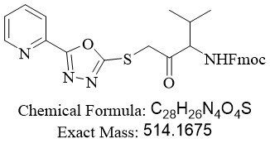
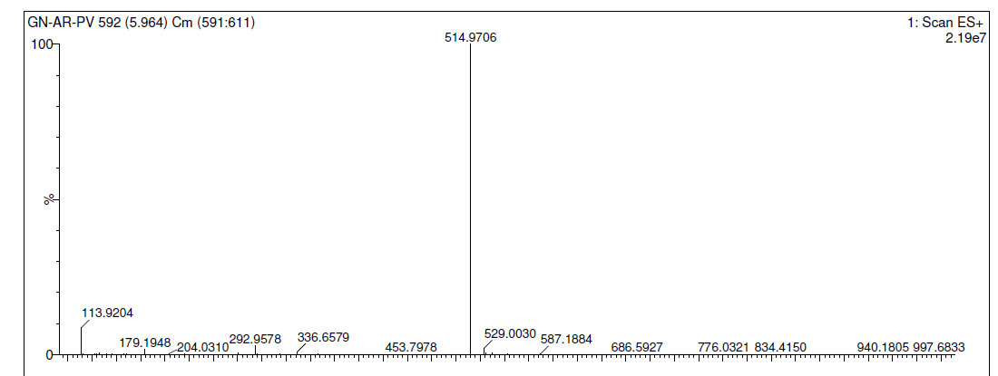
Spectra 1: Mass data for (9H-fluoren-9-yl)methyl (4-methyl-2-oxo-1-((5-(pyridin-2-yl)-1,3,4-oxadiazol-2-yl)thio)pentan-3-yl)carbamate.
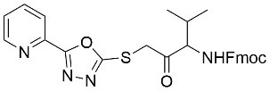
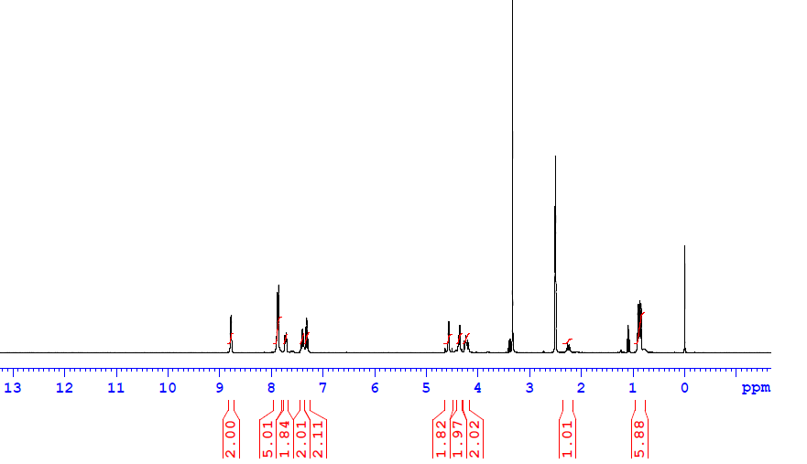
Spectra 2: H¹ data for (9H-fluoren-9-yl)methyl (4-methyl-2-oxo-1-((5-(pyridin-2-yl)-1,3,4-oxadiazol-2-yl)thio)pentan-3-yl)carbamate. (ether peak)
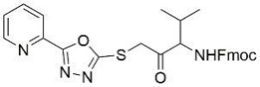
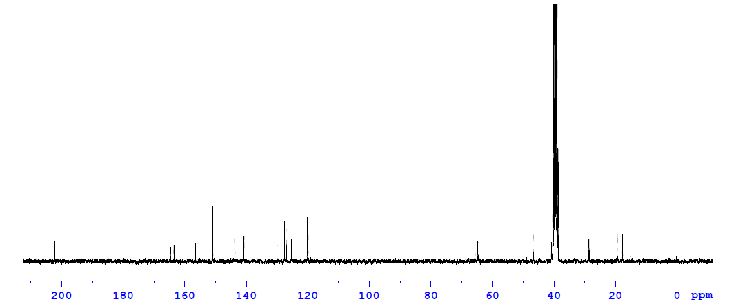
Spectra 3: C¹³ data for (9H-fluoren-9-yl)methyl (4-methyl-2-oxo-1-((5-(pyridin-2-yl)-1,3,4-oxadiazol-2-yl)thio)pentan-3-yl)carbamate
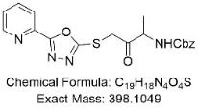
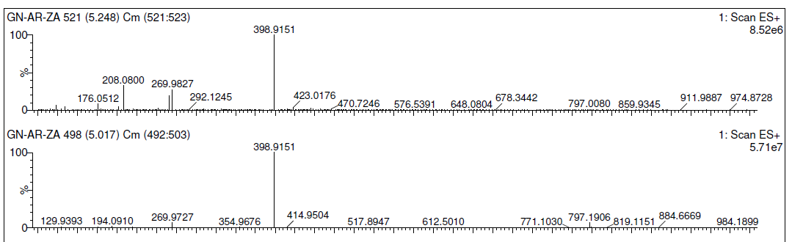
Spectra 4: Mass for Benzyl (3-oxo-4-((5-(pyridin-2-yl)-1,3,4-oxadiazol-2-yl)thio)butan-2-yl)carbamate (1H nmr)

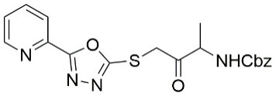
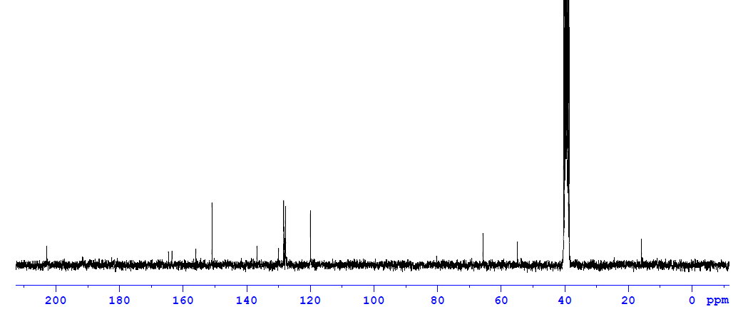
Spectra 6: C¹³ NMR for Benzyl (3-oxo-4-((5-(pyridin-2-yl)-1,3,4-oxadiazol-2-yl)thio)butan-2-yl)carbamate
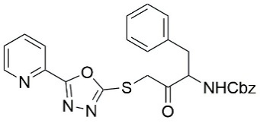
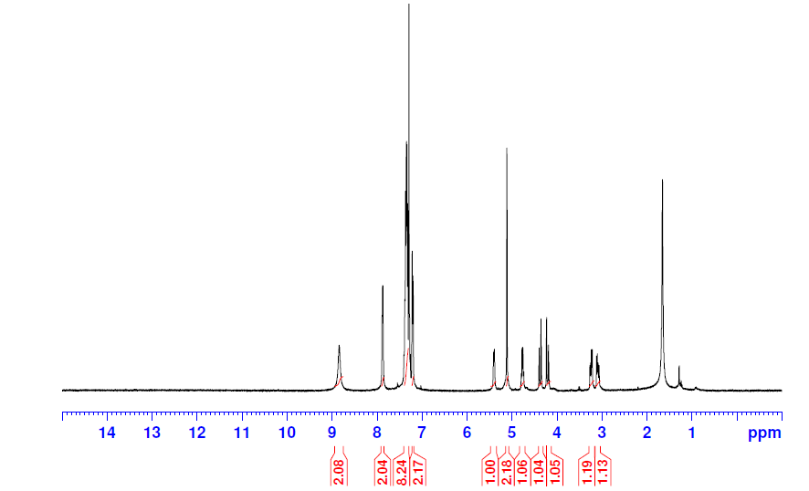
Spectra 7: H¹ NMR for Benzyl (3-oxo-4-((5-(pyridin-2-yl)-1,3,4-oxadiazol-2-yl)thio)butan-2-yl)carbamate

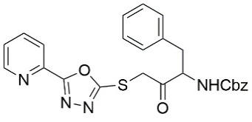
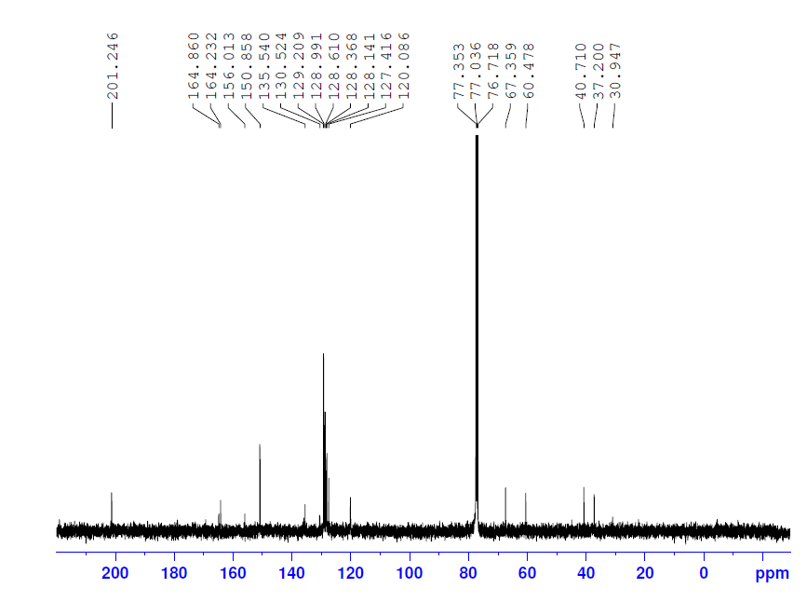
Spectra 8: C¹³ NMR for Benzyl (3-oxo-4-((5-(pyridin-2-yl)-1,3,4-oxadiazol-2-yl)thio)butan-2-yl)carbamate
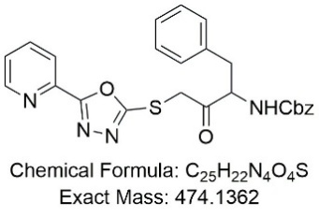
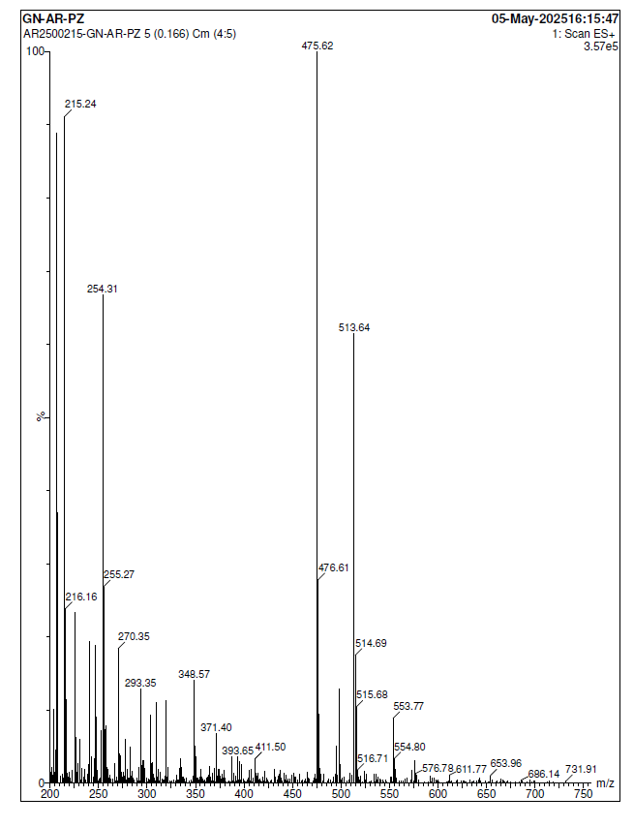
Spectra 9: Mass for Benzyl (3-oxo-4-((5-(pyridin-2-yl)-1,3,4-oxadiazol-2-yl)thio)butan-2-yl)carbamate
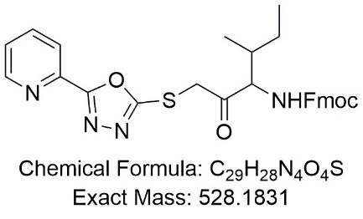
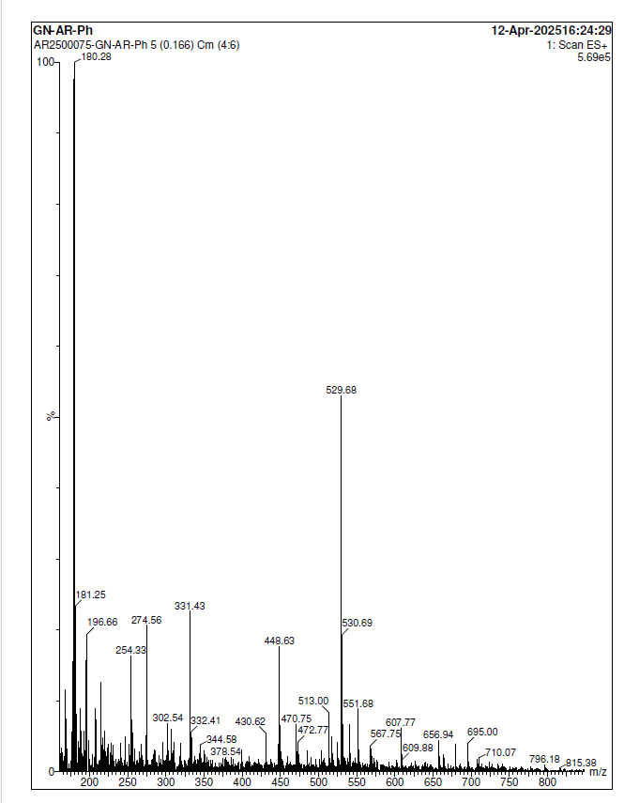
Spectra 10: Mass for (9H-fluoren-9-yl)methyl (4-methyl-2-oxo-1-((5-(pyridin-2-yl)-1,3,4-oxadiazol-2-yl)thio)hexan-3-yl)carbamate

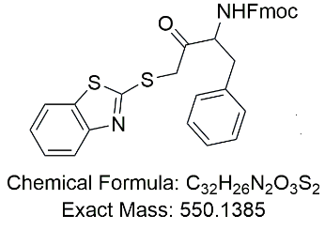
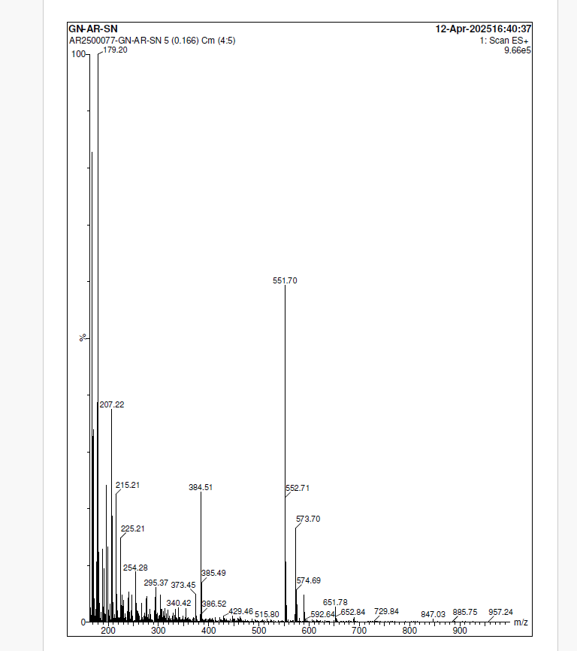
Spectra 11: Mass for (9H-fluoren-9-yl)methyl (4-(benzo[d]thiazol-2-ylthio)-3-oxo-1-phenylbutan-2-yl)carbamate

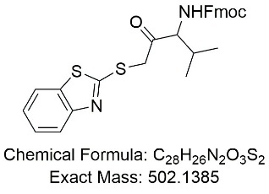
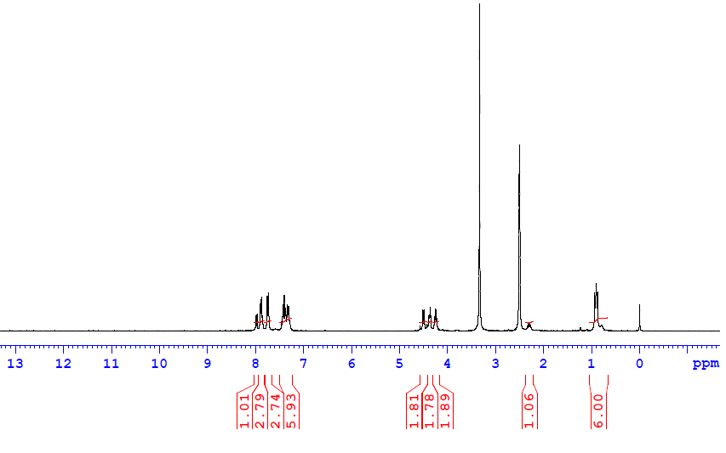
Spectra 12: H¹ NMR for (9H-fluoren-9-yl)methyl (1-(benzo[d]thiazol-2-ylthio)-4-methyl-2-oxopentan-3-yl)carbamate
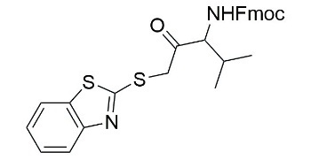
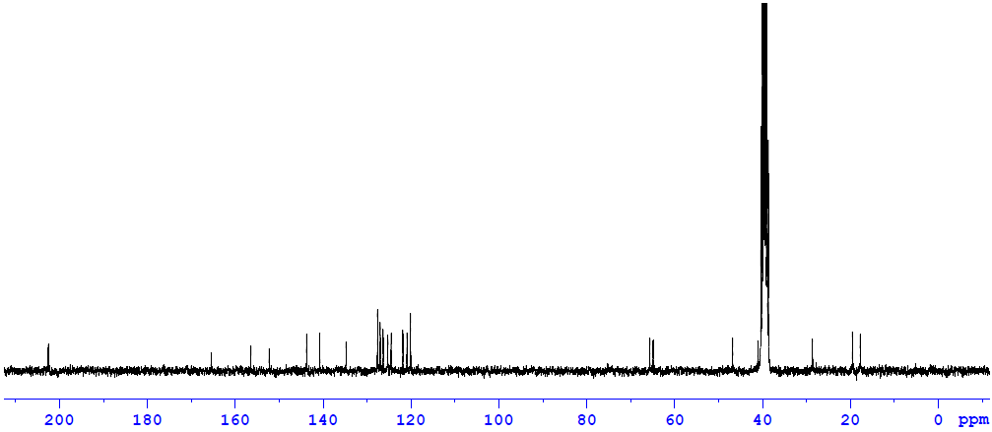
Spectra 13: C¹³ NMR for (9H-fluoren-9-yl)methyl (1-(benzo[d]thiazol-2-ylthio)-4-methyl-2-oxopentan-3-yl)carbamate
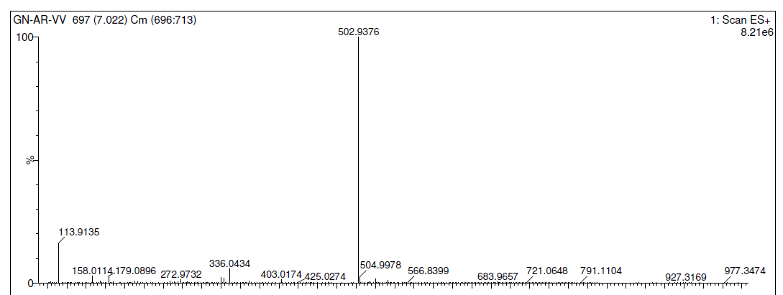Spectra 14: Mass data for (9H-fluoren-9-yl)methyl (1-(benzo[d]thiazol-2-ylthio)-4-methyl-2-oxopentan-3-yl)carbamate
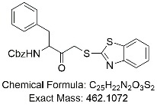
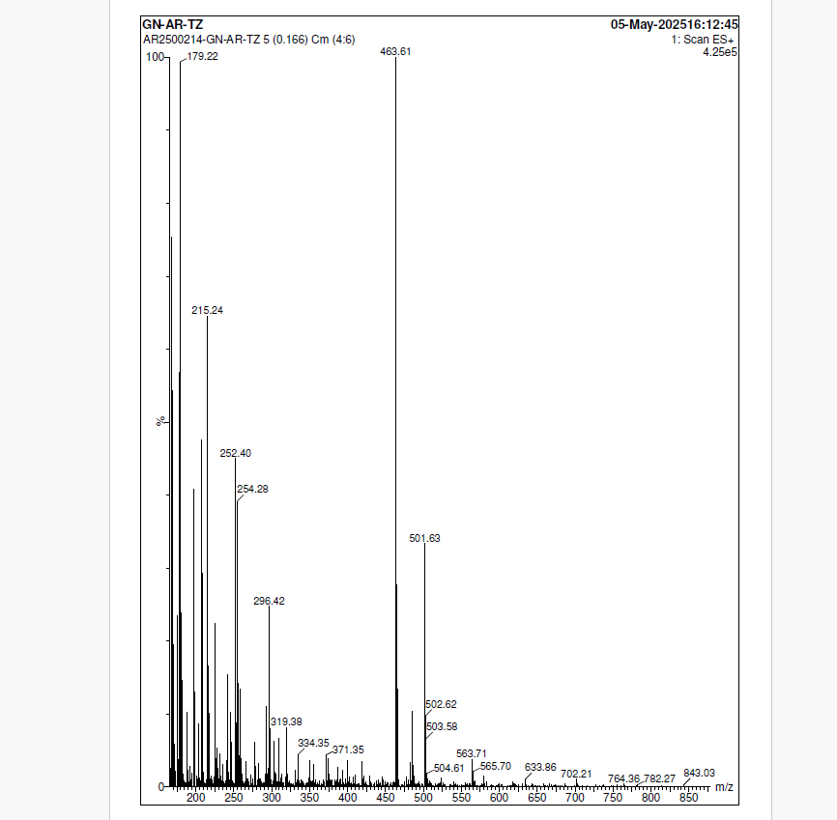
Spectra 15: Mass data for benzyl (4-(benzo[d]thiazol-2-ylthio)-3-oxo-1-phenylbutan-2-yl)carbamate
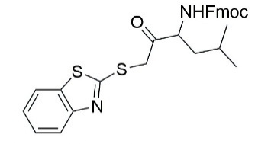
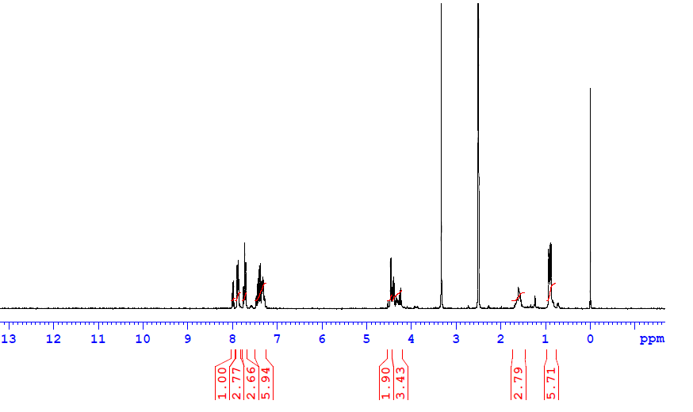
Spectra 16: H¹ NMR for 9H-fluoren-9-yl)methyl (1-(benzo[d]thiazol-2-ylthio)-5-methyl-2-oxohexan-3-yl)carbamate

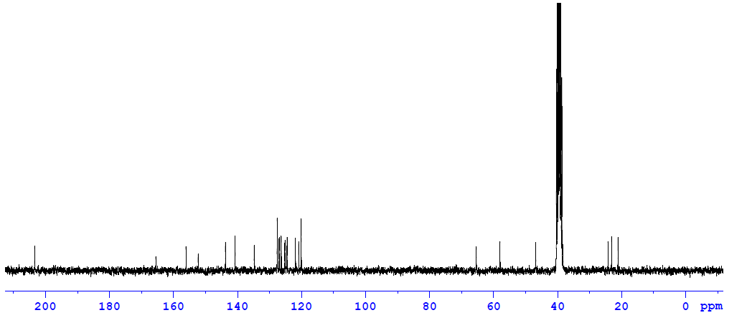
Spectra 17: C¹³ NMR for 9H-fluoren-9-yl)methyl (1-(benzo[d]thiazol-2-ylthio)-5-methyl-2-oxohexan-3-yl)carbamate

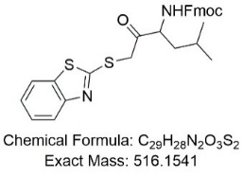
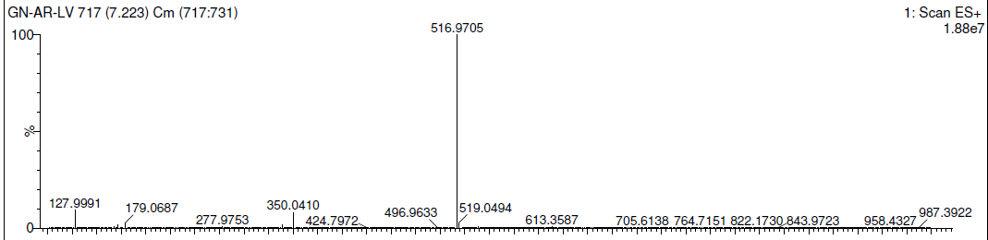
Spectra 18: Mass data for 9H-fluoren-9-yl)methyl (1-(benzo[d]thiazol-2-ylthio)-5-methyl-2-oxohexan-3-yl)carbamate.
Spectra 19: Mass for (9H-fluoren-9-yl)methyl (4-(benzo[d]thiazol-2-ylthio)-3-oxo-1-phenylbutan-2-yl)carbamate
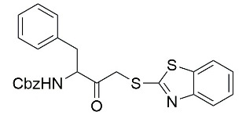
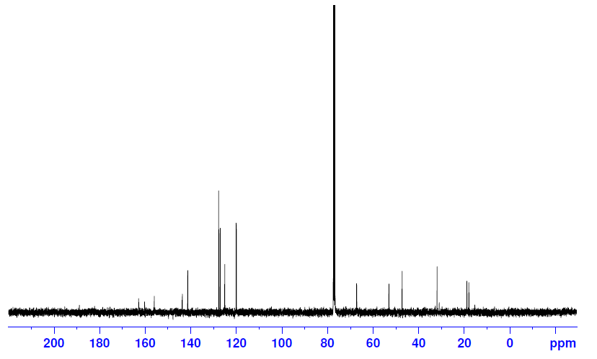
Spectra 20: C¹³ NMR for benzyl (4-(benzo[d]thiazol-2-ylthio)-3-oxo-1-phenylbutan-2-yl)carbamate
Spectra 21: Mass data for benzyl (4-(benzo[d]thiazol-2-ylthio)-3-oxo-1-phenylbutan-2-yl)carbamate
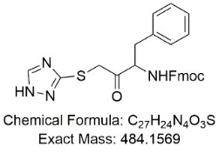
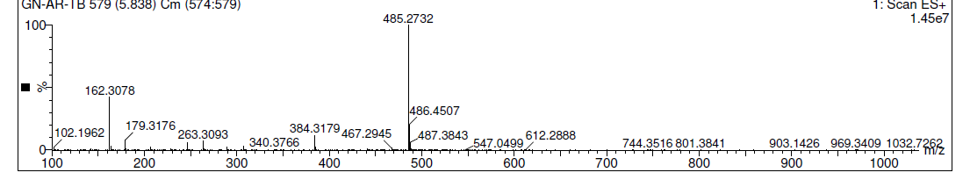
Spectra 22: Mass data for (9H-fluoren-9-yl)methyl (4-((1H-1,2,4-triazol-3-yl)thio)-3-oxo-1-phenylbutan-2-yl)carbamate
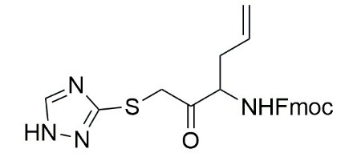
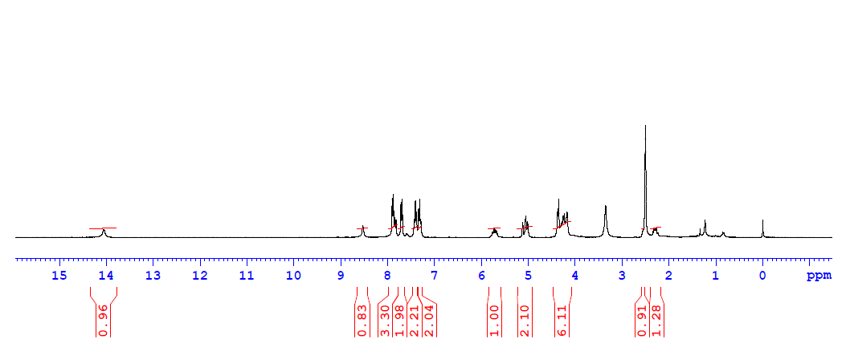
Spectra 23 : H¹for (9H-fluoren-9-yl)methyl (1-((1H-1,2,4-triazol-3-yl)thio)-2-oxohex-5-en-3-yl)carbamate

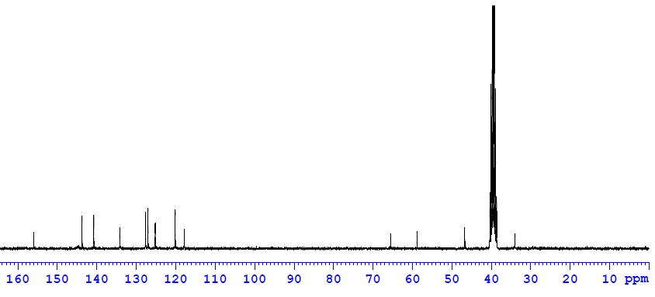
Spectra 24 : H¹for (9H-fluoren-9-yl)methyl (1-((1H-1,2,4-triazol-3-yl)thio)-2-oxohex-5-en-3-yl)carbamate
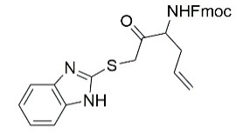
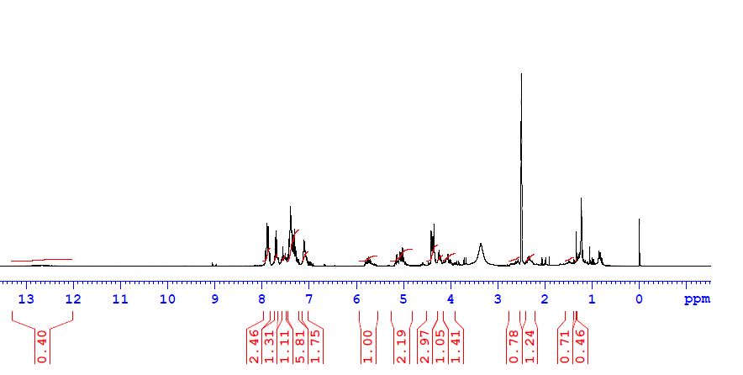
Spectra 25: H¹for(9H-fluoren-9-yl)methyl (1-((1H-1,2,4-triazol-3-yl)thio)-2-oxohex-5-en-3-yl)carbamate
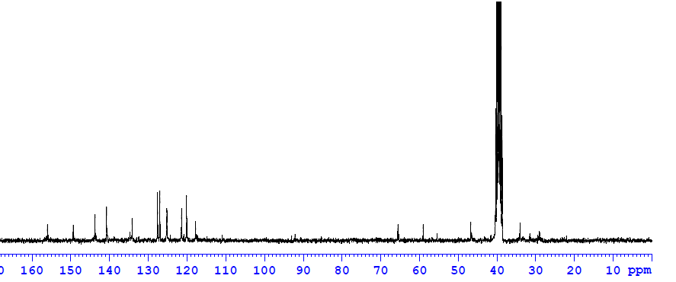
Spectra 26: (9H-fluoren-9-yl)methyl (1-((1H-1,2,4-triazol-3-yl)thio)-2-oxohex-5-en-3-yl)carbamate
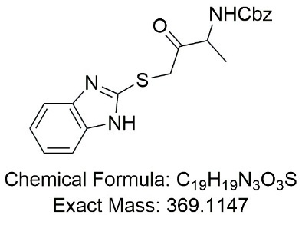
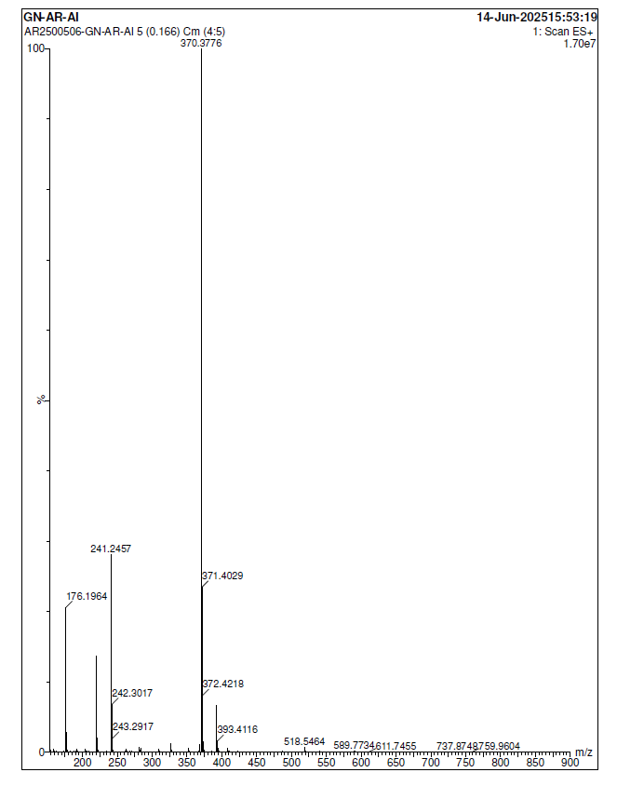
Spectra 27: Mass for benzyl (4-((1H-benzo[d]imidazol-2-yl)thio)-3-oxobutan-2-yl)carbamate
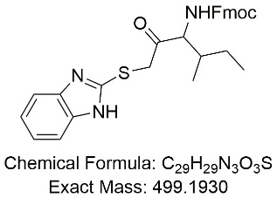
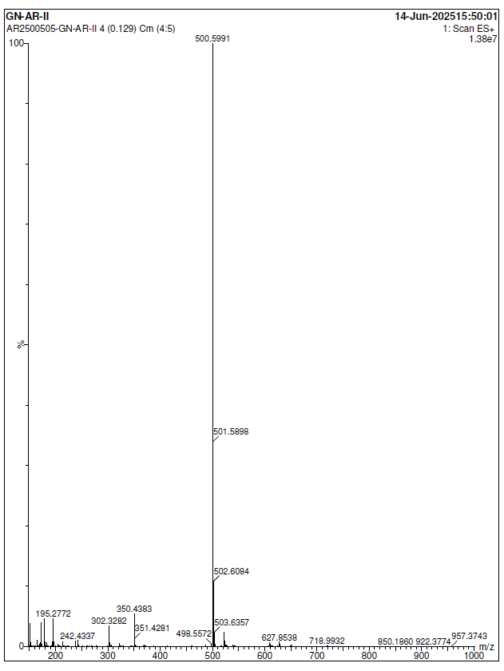
Spectra 28: Mass data for (9H-fluoren-9-yl)methyl (1-((1H-benzo[d]midazole-2-yl)thio)-4-methyl-2-oxohexan-3-yl)carbamate

