Supporting information
Synthesis and characterization of CuO nanoparticles and CuO/PVA-PVP nanocomposites: adsorption activity for malachite green (MG) dye and antibacterial property in wastewater treatment
Nikita Ghosh¹, Subhadeep Sen² , Goutam Biswas², L. Robindro Singh³, Prabir Kumar Haldar*¹
¹Department of Physics, Cooch Behar Panchanan Barma University, Vivekananda Street,
CoochBehar736101, West Bengal, India; prabirkrhaldar@gmail.com; nikitaghosh1994@gmail.com
² Department of Chemistry, Cooch Behar Panchanan Barma University, Vivekananda Street,
Cooch Behar 736101, West Bengal, India; goutam@cbpbu.ac.in; sensubhadeep07@gmail.com
³ Department of Nanotechnology, North-Eastern Hill University, 793002, India; robindro001@yahoo.co.in
*Corresponding author: prabirkrhaldar@gmail.com

Table of contents:
- Supporting Figures…………………………………………….2-5

Figure S1: DLS curve of (a) CuO NPs; (b) CuO/PVA-PVP NCs
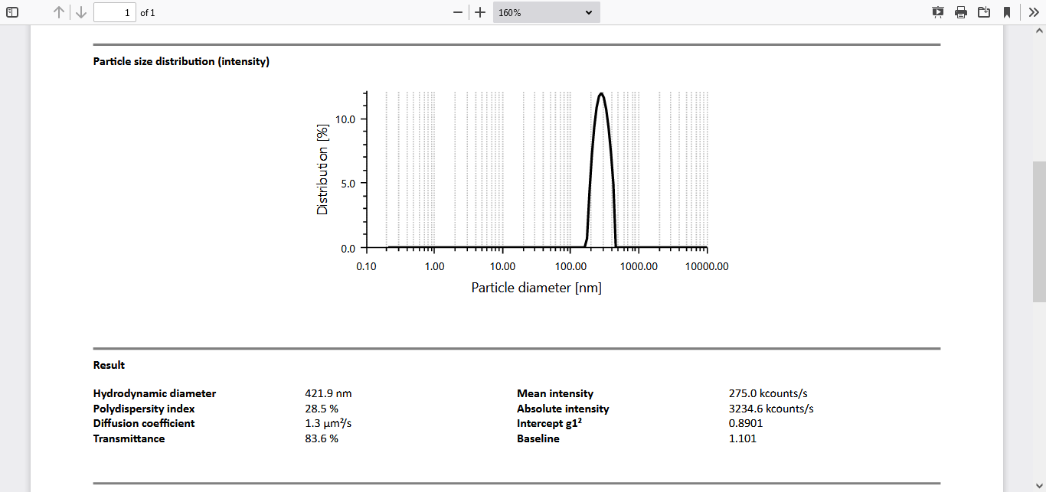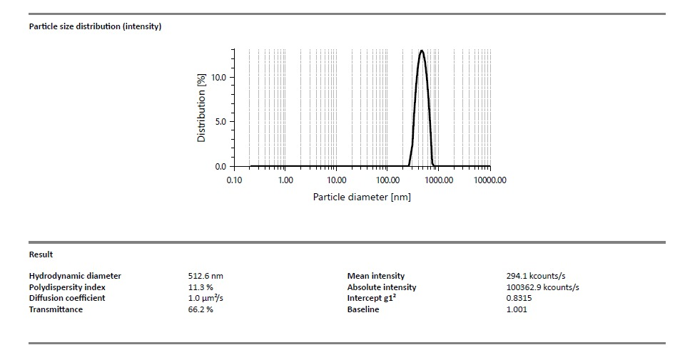
- (b)

Figure S2: Particle size analysis of TEM micrograph (Histogram plot) of (a) CuO NPs. and (b) CuO/PVA-PVP NCs.
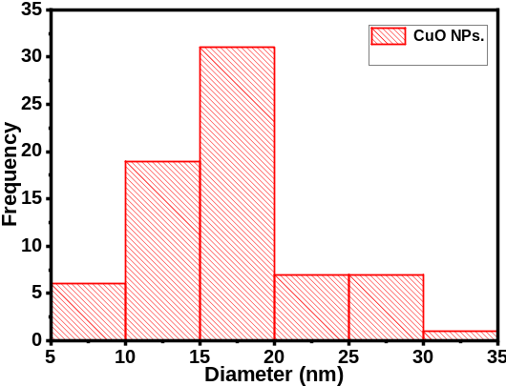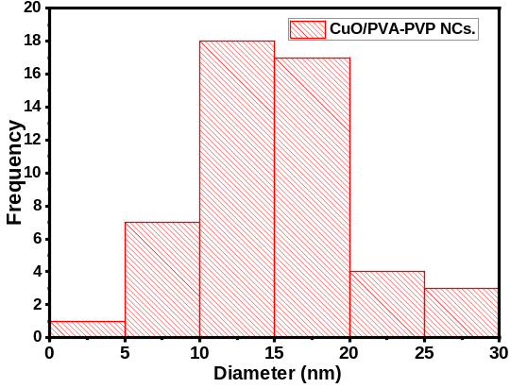
(b)

Figure S3: EDS map with elemental composition of (a) CuO/PVA-PVP NCs and (b) CuONPs
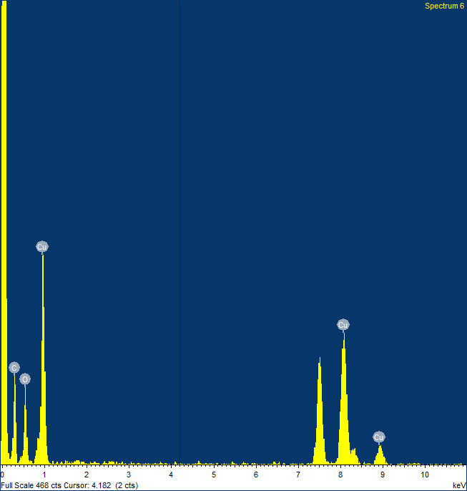
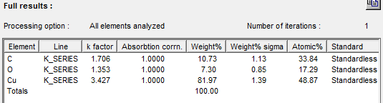
(a)

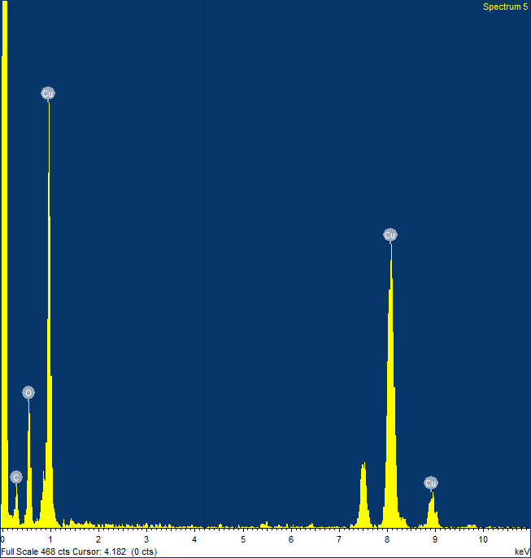
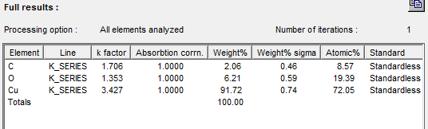
(b)

Figure S4: Antibacterial activity of CuO NPs against (a) E.coli and (b) S.aurious, and that of CuO/PVA-PVP NCs against (c)E.coli and (d) S.aurious respectively.
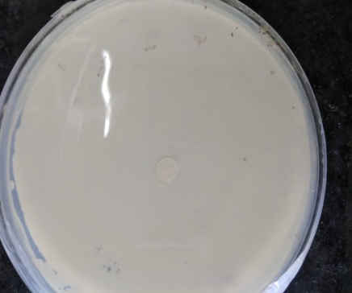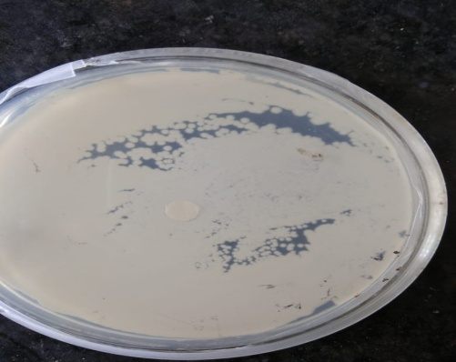
(a) (b)
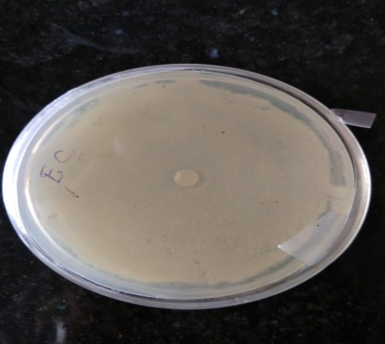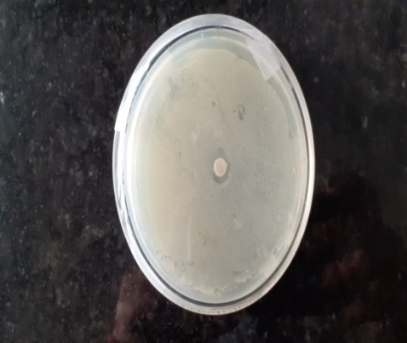
(c) (d)

