 |  | THP-1 MP |  |  | L. donovani mCherry
Compound | Structure | MP CC₅₀ (µM) | Pro IC₅₀ (µM) | SI |  | AxAm IC₅₀ (µM) | SI | Int Am IC₅₀ (µM) | SI
Miltefosine | 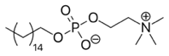 | 39.16 $±$ 1.29 | 6.75 $±$ 2.26 | 5.80 |  | 4.19 $±$0.56 | 9.35 | 3.09 $±$ 0.11 | 12.66
1,4-DAPP Compounds
9279817 | 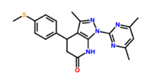 | 50 | 6.64 $±$ 0.78 | 7.53 |  | 4.54 $±$0.10 | 11.01 | 3.50 $±$ 0.07 | 14.29
9277093 | 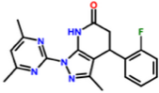 | 50 | 48.44 $±$ 2.71 | 1.03 |  | 31.47 $±$ 0.20 | 1.59 | ND | ND
9227165 | 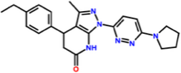 | 50 | 25.15 $±$ 5.35 | 1.99 |  | 5.92 $±$ 1.37 | 8.45 | ND | ND
9284204 | 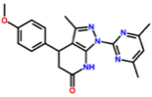 | 50 | 32.85 $±$ 5.29 | 1.52 |  | 17.55 $±$ 3.13 | 2.85 | ND | ND
PTZ Compounds
9234527 | 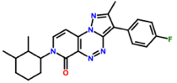 | 50 | 6.13 $±$3.07 | 8.15 |  | 5.49 $±$0.18 | 9.11 | 3.12 $±$ 0.07 | 16.03
9269861 | 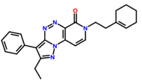 | 50 | 4.67 $±$1.64 | 10.71 |  | 3.16 $±$0.40 | 14.12 | 6.71 $±$1.77 | 7.45
9284493 | 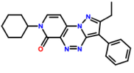 | 50 | 8.27 $±$1.19 | 6.05 |  | 3.99 $±$0.40 | 6.46 | 2.48 $±$0.28 | 20.16
9234966 | 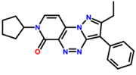 | 50 | 9.70 $±$0.79 | 5.15 |  | 4.16 $±$0.26 | 5.81 | 2.81 $±$0.23 | 17.79
Singleton Compounds
9292300 | 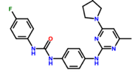 | 4.27 $±$0.23 | 0.77 $±$ 0.38 | 5.55 |  | 4.16 $±$1.04 | 1.03 | ND | ND
9272957 | 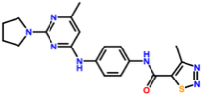 | 4.85 $±$1.13 | 1.43 $±$ 0.58 | 3.39 |  | 48.68 $±$1.75 | 0.10 | ND | ND
9206712 | 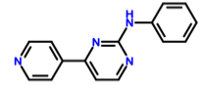 | 15.06 $±$2.87 | 15.35 $±$ 3.09 | 0.98 |  | 50 | 0.30 | ND | ND
9217119 | 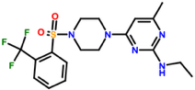 | 50 | 2.82 $±$ 1.36 | 17.93 |  | 50 | 1 | ND | ND
9213529 | 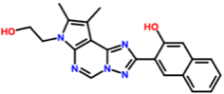 | 50 | 50 | 1 |  | 7.58 $±$0.22 | 6.60 | ND | ND
9283571 | 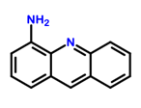 | 25.30 $±$3.95 | 1.02 $±$ 0.34 | 24.80 |  | 50 | 1 | ND | ND
9257177 | 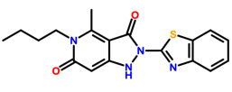 | ND | 13.36 $±$2.08 | ND |  | 24.23 $±$1.72 | ND | ND | ND
9231273 | 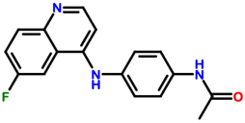 | ND | 22.41 $±$ 4.28 | ND |  | 50 | ND | ND | ND
Table 1. In vitro antileishmanial activity and host-cell cytotoxicity of enriched scaffolds and singleton compounds against L. donovani parasite life stages and THP-1 macrophages. Antileishmanial activity was evaluated against L. donovani promastigotes (Pro), axenic amastigotes (AxAm), and intracellular amastigotes (Int Am) and is reported as the half-maximal inhibitory concentration (IC₅₀) at 48 h post-drug addition. Cytotoxicity against THP-1 macrophages (MP) is reported as the half-maximal cytotoxic concentration (CC₅₀) at 48 h post-drug addition. Selectivity indices (SI) were calculated as the ratio of macrophage CC₅₀ to the corresponding parasite IC₅₀. Miltefosine was included as a reference antileishmanial compound. Values are presented as mean $±$ SD from at least three independent experiments. ND: not determined.

 | THP-1 MP CC₅₀ (µM) | Promastigote IC₅₀ (µM)
Compound | THP-1 MP | L.  major mCherry | SI | L.  infantum | SI | L.  tropica | SI
Miltefosine | 39.16 $±$ 1.29 | 10.94 $±$2.99 | 3.58 | 7.79 $±$ 1.77 | 5.03 | 14.58 $±$ 4.76 | 3.43
1,4-DAPP Compounds
9279817 | 50 | 10.11 $±$2.01 | 5.32 | 14.74 $±$ 2.17 | 3.39 | 4.78 $±$ 2.31 | 10.46
9277093 | 50 | 30.53 $±$ 5.59 | 1.64 | 47.72 $±$ 3.95 | 1.04 | 41.42 $±$ 6.85 | 1.21
9227165 | 50 | 50 | 1 | 50 | 1 | 15.23 $±$ 3.84 | 3.28
9284204 | 50 | 28.24 $±$ 1.92 | 1.84 | 32.76 $±$ 2.94 | 1.53 | 21.96 $±$ 6.36 | 2.28
PTZ Compounds
9234527 | 50 | 6.18 $±$ 1.44 | 8.09 | 23.50 $±$ 2.13 | 2.36 | 3.73 $±$ 2.16 | 13.40
9269861 | 50 | 11.68 $±$ 2.36 | 4.28 | 18.00 $±$ 4.37 | 2.78 | 4.00 $±$ 3.63 | 12.5
9284493 | 50 | 18.33 $±$ 2.33 | 2.73 | 15.64 $±$ 2.69 | 3.20 | 6.46 $±$ 4.10 | 7.74
9234966 | 50 | 16.19 $±$ 3.35 | 3.09 | 14.79 $±$ 3.45 | 3.38 | 4.48 $±$ 2.42 | 11.16
Singleton Compounds
9292300 | 4.27 $±$0.23 | 2.60 $±$ 1.32 | 1.64 | 4.72 $±$ 0.92 | 0.90 | 4.77 $±$ 1.50 | 0.90
9272957 | 4.85 $±$1.13 | 1.51 $±$ 1.92 | 3.21 | 1.74 $±$ 0.12 | 2.79 | 2.36 $±$ 1.33 | 2.06
9206712 | 15.06 $±$2.87 | 50 | 0.30 | 10.77 $±$ 1.99 | 1.40 | 6.05 $±$ 2.09 | 2.49
9217119 | 50 | 4.39 $±$ 1.99 | 11.39 | 31.80 $±$ 3.63 | 1.57 | 8.3 $±$ 0.62 | 6.02
9213529 | 50 | 50 | 1 | ND | ND | ND | ND
9283571 | 25.30 $±$3.95 | 0.961 $±$ 0.71 | 26.35 | 3.56 $±$ 0.46 | 7.11 | 1.36 $±$ 1.03 | 18.60
9257177 | ND | 25.55 $±$ 5.11 | ND | 28.19 $±$ 8.85 | ND | ND | ND
9231273 | ND | 34.42 $±$ 3.17 | ND | ND | ND | ND | ND
Table 2. Cross-species antileishmanial activity and host-cell cytotoxicity of enriched scaffolds and singleton compounds against multiple Leishmania species. Antileishmanial activity was evaluated against L. major, L. infantum, and L. tropica promastigotes (Pro) and is reported as the half-maximal inhibitory concentration (IC₅₀) at 48 h post-drug addition. Cytotoxicity against THP-1 macrophages (MP) is reported as the half-maximal cytotoxic concentration (CC₅₀) at 48 h post-drug addition. Selectivity indices (SI) were calculated as the ratio of macrophage CC₅₀ to the corresponding parasite IC₅₀. Miltefosine was included as a reference antileishmanial compound. Values are presented as mean $±$ SD from at least three independent experiments. ND: not determined.

