Supplementary Information (SI)

Sea cucumbers influence coral growth and alter sediment-associated prokaryotic communities on a Caribbean reef.
Leon R. Schlenger^{1, 2}, Leah Harper³, Sarah A. Gignoux-Wolfsohn⁴, Cara A. Gallagher^{2, 5}, Caroline C. DeSouza⁴, Julia G. McDonough⁴, Victoria E. Mann^{1, 6}, Matthew L. Doherty^{1, 6}

- Reef Ecology and Evolution, Central Caribbean Marine Institute, Little Cayman, Cayman Islands
- Plant Ecology and Nature Conservation, University of Potsdam, Potsdam, Germany
- Tennenbaum Marine Observatories Network, MarineGEO, Smithsonian Environmental Research Center, Edgewater, Maryland, United States of America
- Biological Sciences, University of Massachusetts at Lowell, Lowell, MA, United States
- Department of Ecoscience, Aarhus University, Roskilde, Denmark
- School of Biological and Marine Sciences, University of Plymouth, Plymouth, United Kingdom

Corresponding author(s):
- Leon R. Schlenger, leon.schlenger@web.de ORCID: 0009-0003-8724-9246
- Matthew L. Doherty, dohertym@protonmail.com ORCID: 0009-0000-6259-3006
Table S1 The 15 most enriched and depleted prokaryotic families in H. mexicana egesta relative to sediment. Mean relative abundances were calculated from total ASV counts. Log2 fold changes (log2FC) and adjusted p-values were obtained from negative binomial generalized linear models implemented in DESeq2 (v1.44.0, Love et al., 2014), with normalization for differences in library size. Statistical significance was assessed using Wald tests, and p-values were adjusted for multiple testing using the Benjamini–Hochberg procedure to control the false discovery rate (FDR < 0.05).
Family | Direction | Share Sediment (%) | Share Egesta (%) | Log₂ FC | padj
Caulobacteraceae | Enriched | 0,00 | 0,55 | 11,41 | 2,12E-04
Comamonadaceae | Enriched | 0,00 | 0,27 | 10,10 | 1,23E-03
Xanthobacteraceae | Enriched | 0,00 | 0,07 | 8,62 | 6,62E-03
Reyranellaceae | Enriched | 0,00 | 0,15 | 8,22 | 9,53E-14
Flammeovirgaceae | Enriched | 0,05 | 1,59 | 6,70 | 4,39E-16
Desulfolunaceae | Enriched | 0,00 | 0,03 | 5,69 | 1,57E-04
Psychromonadaceae | Enriched | 0,02 | 0,41 | 5,09 | 1,27E-05
Colwelliaceae | Enriched | 0,83 | 7,96 | 4,58 | 2,81E-08
Halobacteroidaceae | Enriched | 0,01 | 0,05 | 4,34 | 5,57E-03
Acholeplasmataceae | Enriched | 0,01 | 0,99 | 4,29 | 2,26E-03
Moritellaceae | Enriched | 0,46 | 2,57 | 4,25 | 4,39E-16
Vibrionaceae | Enriched | 10,60 | 53,70 | 4,17 | 1,68E-09
Propionibacteriaceae | Enriched | 0,09 | 0,38 | 4,13 | 6,20E-08
Lentisphaeraceae | Enriched | 0,50 | 3,66 | 3,99 | 5,42E-06
Anaeromicrobium | Enriched | 0,29 | 0,13 | 3,36 | 2,43E-02
Puniceicoccaceae | Reduced | 0,95 | 0,00 | -5,32 | 1,50E-06
Terasakiellaceae | Reduced | 0,87 | 0,01 | -5,42 | 2,53E-05
Nitrincolaceae | Reduced | 2,24 | 0,03 | -5,42 | 1,14E-06
Omnitrophaceae | Reduced | 0,26 | 0,00 | -5,43 | 1,53E-05
Nitrosopumilaceae | Reduced | 1,44 | 0,02 | -5,45 | 2,53E-05
Parvularculaceae | Reduced | 0,26 | 0,00 | -5,55 | 8,27E-06
Magnetospiraceae | Reduced | 0,32 | 0,00 | -5,72 | 4,69E-06
Thiomicrospiraceae | Reduced | 0,79 | 0,00 | -5,78 | 2,09E-06
Microtrichaceae | Reduced | 0,65 | 0,01 | -5,82 | 5,42E-06
Desulfatiglandaceae | Reduced | 0,37 | 0,00 | -5,83 | 3,27E-06
Hyphomonadaceae | Reduced | 0,74 | 0,01 | -5,95 | 2,03E-06
BD2-7 | Reduced | 0,36 | 0,00 | -5,99 | 1,50E-06
Rickettsiaceae | Reduced | 0,39 | 0,00 | -6,09 | 1,13E-06
Balneolaceae | Reduced | 0,52 | 0,00 | -6,53 | 1,90E-07
Woeseiaceae | Reduced | 2,26 | 0,03 | -7,09 | 1,90E-07

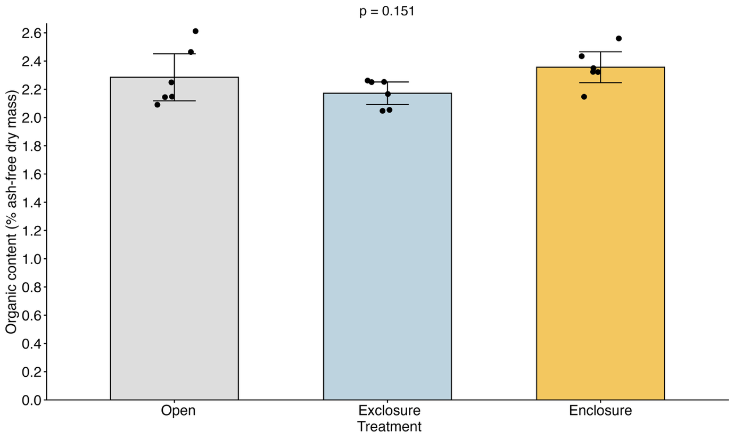 Fig. S1 Sediment organic content across open-frame control (n = 5), H. mexicana exclosure (n = 4), and H. mexicana enclosure (n = 5) treatments on the final day of the experiment (day 43, 27 March 2024). Points represent replicates, and bars show means ± SE. Organic content did not differ significantly among treatments (one-way ANOVA, F₂,₁₁ = 0.48, p = 0.63).

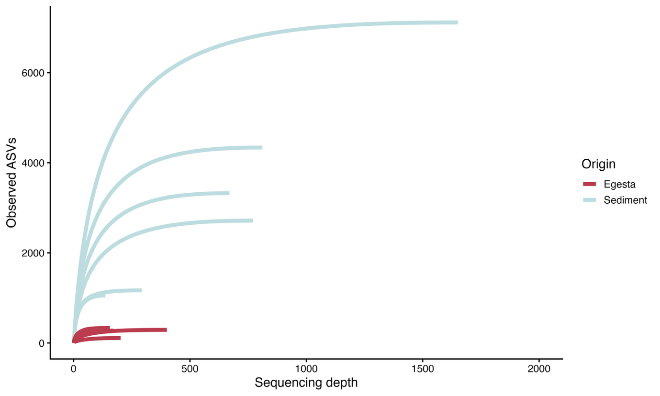

Fig. S2 Rarefaction curves of amplicon sequence variants (ASVs) in sediment and H. mexicana egesta samples. Curves show the relationship between sequencing depth and observed ASV richness, with each line representing an individual sample.
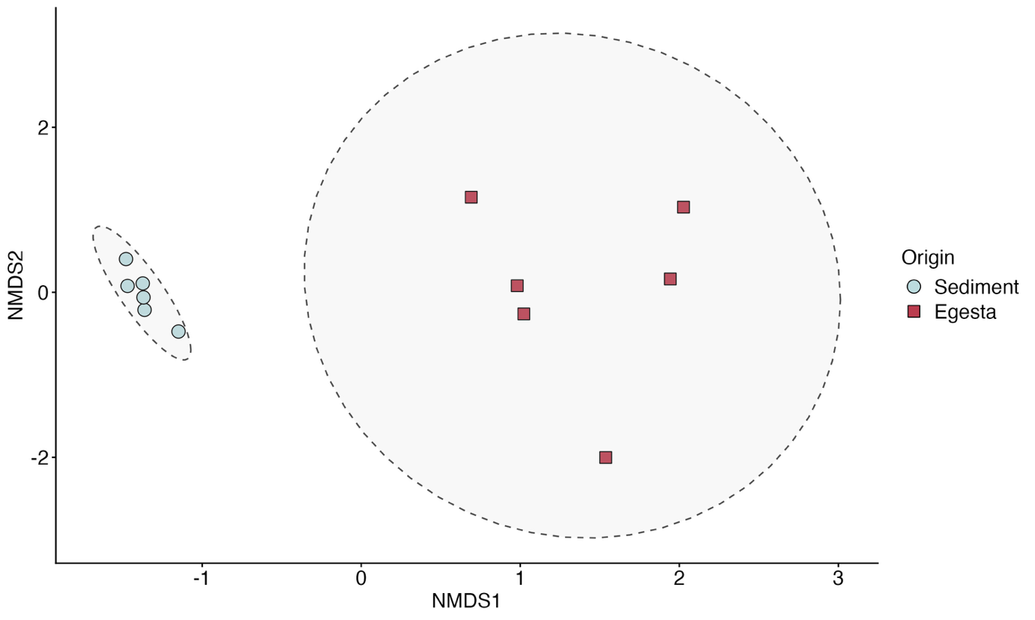
Fig. S3 Non-metric multidimensional scaling (NMDS) ordination of prokaryotic community composition in sediment and egesta samples based on Bray–Curtis dissimilarities calculated from relative abundances. Points represent individual samples, and shaded ellipses indicate 95% confidence regions for each sample origin. NMDS stress = 0.035

References

Love, M. I., Huber, W., & Anders, S. (2014). Moderated estimation of fold change and dispersion for RNA-seq data with DESeq2. Genome Biology, 15(12), 550. https://doi.org/10.1186/s13059-014-0550-8

