Oscillatory motion of viscoelastic drops on slippery lubricated surfaces

Paolo Sartori, Davide Ferraro, Marco Dassie, Alessio Meggiolaro, Daniele Filippi, Annamaria Zaltron, Matteo Pierno and Giampaolo Mistura*

Dipartimento di Fisica e Astronomia “G. Galilei”, Università di Padova, via Marzolo 8, 35131 Padova (Italy)

E-mail: giampaolo.mistura@unipd.it

1. Motion of Newtonian drops on silicone lubricated surfaces.
To test the performance of our silicone lubricated surfaces we have analyzed the motion of Newtonian drops deposited onto them. Figure S1 reports the average speed U of water drops with viscosity μ_{drop} much lower than the viscosity μ_{oil} of the impregnating oil plotted as a function of sin(α). We compare our data (red triangles) regarding 20 μL water drops on silicone lubricated surfaces (μ_{drop} = 1 mPa s, μ_{oil} ≈ 100 mPa s) to data from Keiser et al. [1] (blue diamonds) corresponding to 20 μL water/glycerol drops on a microfabricated array of square pillars impregnated with silicone oil (μ_{drop} = 2 mPa s, μ_{oil} = 100 mPa s). The dashed line represents the universal scaling law with exponent 3/2, which is the result of multiple causes of dissipation ascribed to the oil meniscus surrounding the moving drop [1].

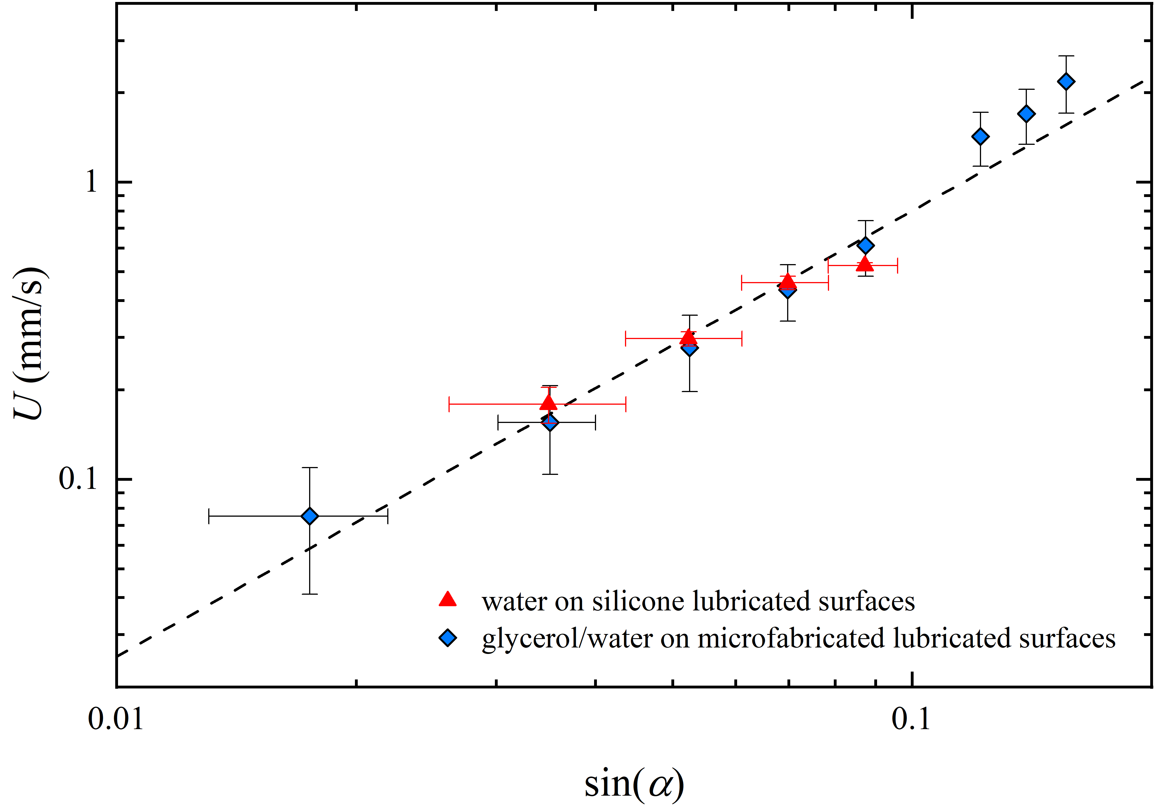
FIG. S1. Average speed U as a function of the sine of the inclination angle α for Newtonian drops having volume Ω=30 μL deposited on silicon lubricated surfaces. The drops have viscosity μ_{drop} much lower than the viscosity μ_{oil} of the impregnating oil. The blue data are taken from [1]. The dashed line represents the universal scaling law with exponent 3/2.

2. Motion of poly(acrylamide) drop on Fomblin lubricated surfaces.
Figure S2 shows a representative time evolution of a PAA₁₀/water drop with concentration of 2500 ppm (wt) and volume Ω=30 𝜇L deposited on a Fomblin lubricated surface inclined by an angle α=30°. The top graph indicates the position of the front contact point. It corresponds to an overall travelled distance of about 4 cm. The periodic oscillations with respect to a uniform motion are clearly seen in the bottom graph. Amplitude and frequency of the oscillations are comparable to the ones reported in Fig.3 (e) of the Article confirming that the observed dynamics is mainly determined by the rheology of the drop and not by the preparation of the slippery lubricated surface. Notably, the data reported in the Article are obtained on lubricated surfaces prepared using silicone oil.
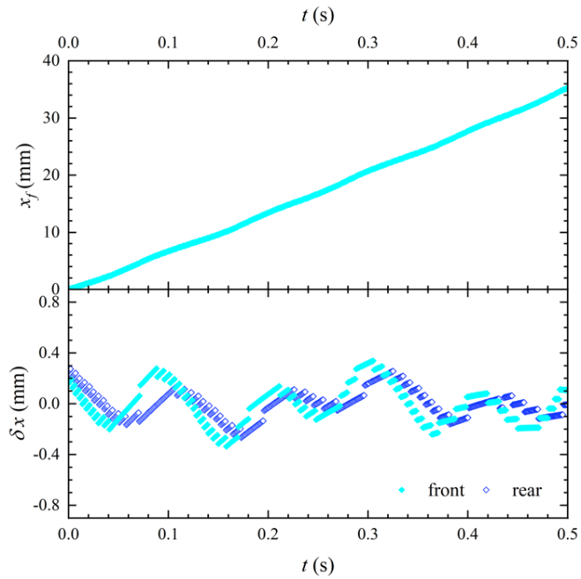
FIG. S2. Top: time evolution of the contact line front position x_{f} of a PAA₁₀/water 2500 ppm drop having volume Ω=30 μL deposited on a fluorinated lubricated surface inclined by α=30°. Bottom: time evolution of the instantaneous variation of the contact line front (filled diamonds) and rear (open diamonds) position of the drop with respect to the average uniform motion.

3. Motion of poly(acrylamide) drops on long silicone lubricated surfaces
In the measurements, drops are typically gently placed on the already tilted surface by a micropipette. To verify that the initial drop dosing does not affect the oscillatory regime, we have also tried to place the drop on a horizontal surface, which is then quickly tilted to the desired angle α. The results are reported in Fig. S3 that shows two representative time laws of PAA₁₀/water drops with concentration of 2500 ppm and volume Ω=30 𝜇L deposited on silicone lubricated surfaces, taken over a distance slightly longer than that of the data reported in Fig. 3 of the Article. More precisely, the data span an overall displacement of about 5 cm placed at the end of the 30 cm × 3 cm coated glass plate. The drop is deposited at the opposite end of the substrate. The top graph indicates the positions of the front contact point of a drop deposited on the lubricated surfaces inclined by 20° and of another drop deposited on the lubricated surfaces kept initially in the horizontal position and then quickly inclined to α=20°. The corresponding periodic oscillations with respect to the uniform motion are clearly seen in the bottom graphs, confirming that the observed dynamics is not affected by the initial conditions.
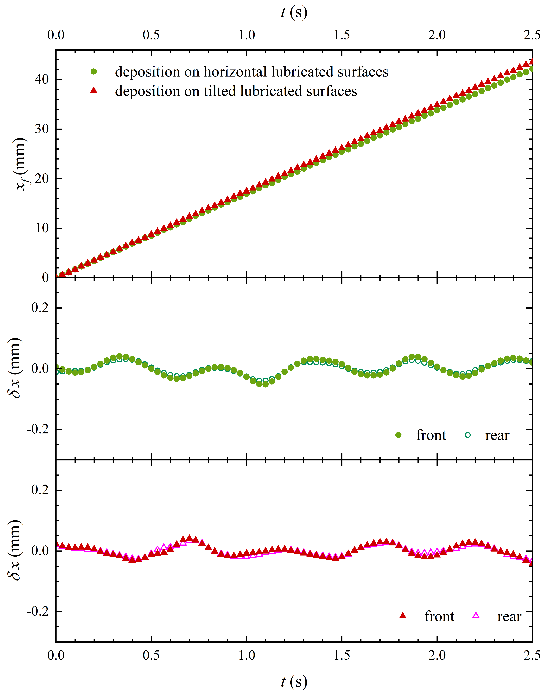
FIG. S3. Top: time evolution of the contact line front position x_{f} of PAA₁₀/water 2500 ppm drops having volume Ω=20 μL deposited on long silicone lubricated surfaces either inclined by α=20° or kept initially in the horizontal position and then tilted to the same final angle α=30°. Middle: time evolution of the instantaneous variation of the contact line front and rear positions from its average uniform motion of a drop deposited on the lubricated surfaces kept initially in the horizontal position and then tilted to α=30°. Bottom: as in the middle panel but now the drop is deposited on the 20° tilted lubricated surfaces.

4. Motion of poly(acrylamide) drop on solid Teflon
To assess the role played by the nature of the surface, we show in Figure S4 a representative time evolution of a PAA₁₀/water drop with concentration of 2500 ppm and volume Ω=30 𝜇L deposited on a solid Teflon (PTFE) tape inclined by an angle α=40°. The top graph indicates the position of the front contact point x_{f}, the bottom one the instantaneous difference δx of the front and rear contact points with respect to the average straight line displayed in the top graph. The resulting data exhibit some oscillations, although there is no clear evidence of the periodic oscillations observed on lubricated surfaces because of the pinning of the drops to the unavoidable defects present on the solid tape. The enhanced friction exerted by this surface is also evinced by the much lower average speed: the downhill speed, which is about 7 cm/sec (see Fig. S2) on the fluorinated lubricated surface, decreases to 0.3 cm/sec on the more inclined Teflon tape.
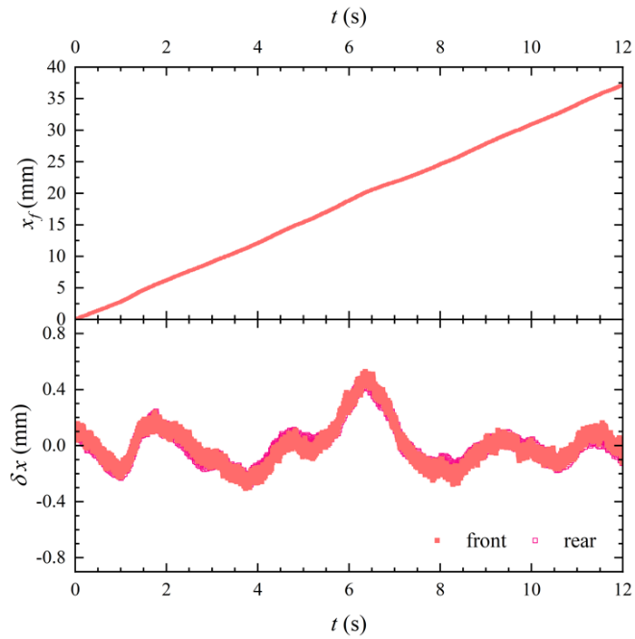
FIG. S4. Top: time evolution of the contact line front position x_{f} of a PAA₁₀/water 2500 ppm drop having volume Ω=30 μL deposited on a solid Teflon (PTFE) tape inclined by α=40°. Bottom: time evolution of the instantaneous variation of the contact line front and rear positions of the drop from the average linear trend.

5. Motion of poly(acrylamide) drops on different slippery surfaces
Figure S5 extends the data shown in Fig. 4 of the Article to all slippery surfaces investigated in our study. It plots the frequency of the observed periodic oscillations as a function of the mean drop speed. The data points refer to drops of PAA₁₀/water solution with a concentration of 2500 ppm having different volumes and deposited on silicone and fluorinated lubricated surfaces as well as (solid) Teflon surfaces tilted at different inclination angles. The inset shows an enlargement of the initial region. The linear behavior between the oscillation frequency f and the average drop speed U reported in Fig. 4 is confirmed in Fig. S5, by plotting all data in the same graph. In particular, it can be noticed that data points referring to the same drop volume but different kind of substrate lie on the same straight line.

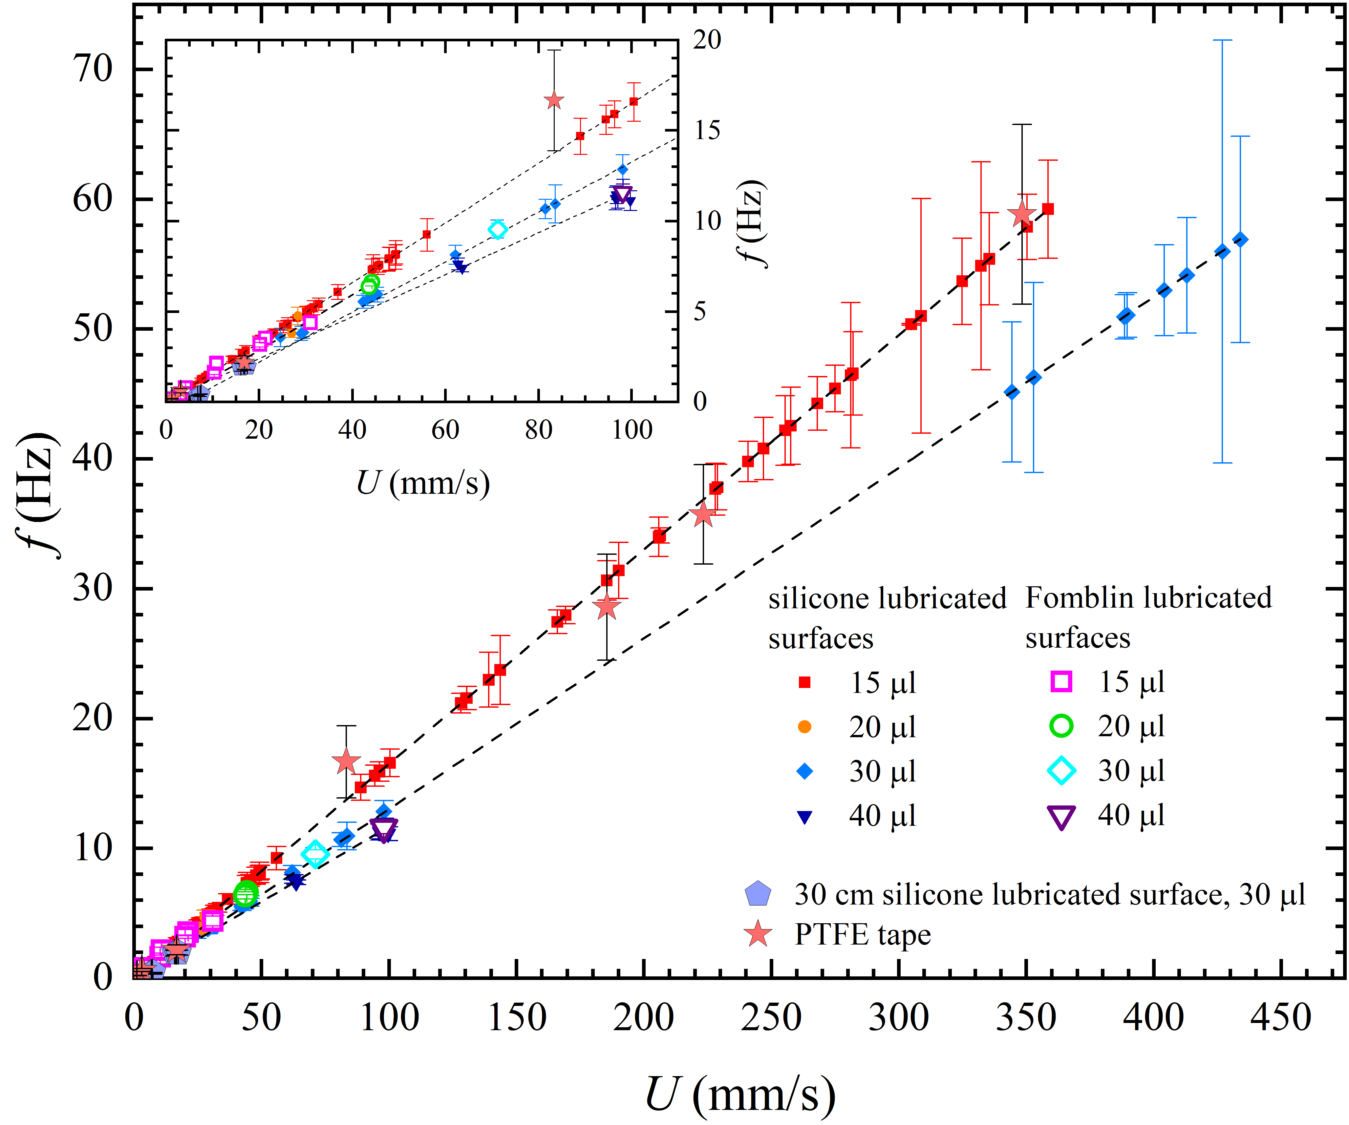
FIG. S5. Oscillation frequency f as a function of the average drop speed U for PAA₁₀/water drops at a concentration of 2500 ppm with different volumes and deposited on lubricated and solid slippery surfaces. The inset displays an enlargement of the data at low average speed U. The dashed lines are linear fits to the data, plotted over the corresponding data range.
6. Motion of more concentrated poly(acrylamide) drops on silicone lubricated surfaces.
Figure S6 extends the data shown in Fig. 4 of the Article to a more concentrated PAA₁₀ solution, characterized by larger amplitude of the observed periodic oscillations. It plots the frequency of the oscillations as a function of the mean drop speed. The data points refer to drops of PAA₁₀/water solution with a concentration of 5000 ppm having different volumes and deposited on silicone lubricated surfaces tilted at different inclination angles. The characteristic speeds are now much smaller due to the higher viscosity of this more concentrated solution. For instance, PAA₁₀ drops of 30 µL on a lubricated surface inclined by 30° degrees have U=16±1 mm/s to be compared to the speed U=45±1 mm/s of PAA₁₀ drops of similar volume but with a concentration of 2500 ppm reported in Fig. 4. As in Fig. 4, the inset of Fig. S6 rescales all data in terms of the product fp versus U, where p is the length of the drop free contour. Again, the data nicely collapse on a straight-line having slope equal to 1.

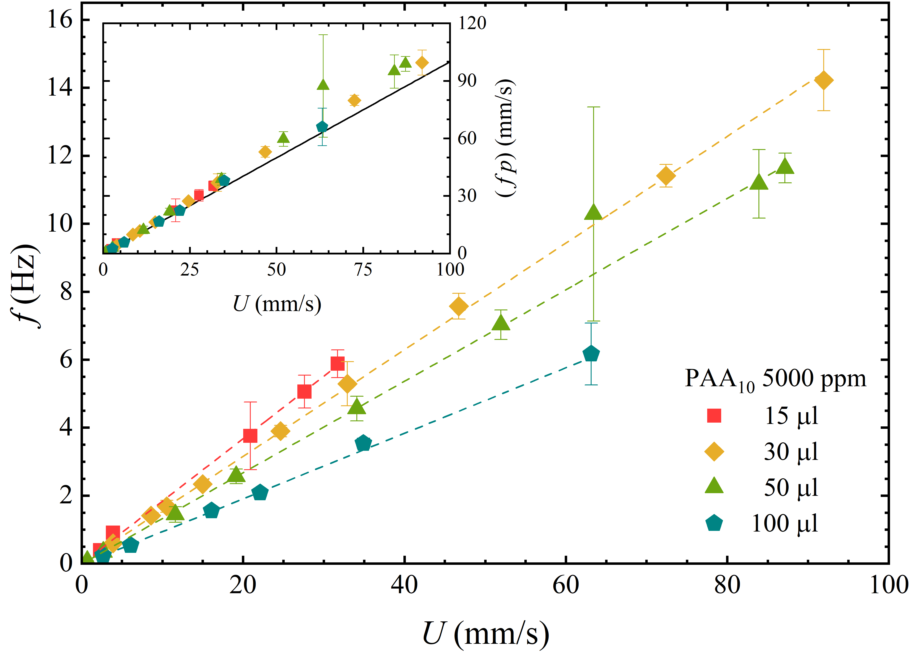
FIG. S6. Oscillation frequency f as a function of the average drop speed U for PAA₁₀/water drops at a concentration of 5000 ppm and different volumes deposited on silicone lubricated surfaces. The inset displays all the data in terms of the product $fp$ versus U, where p is the length of the drop free contour. The straight line has a slope equal to 1.

7. Oscillatory amplitudes of poly(acrylamide) drops on silicone lubricated surfaces
We have also analyzed the amplitude A of the oscillatory motions of PAA drops by varying either the size or the mean speed of the drops. We have considered drops of 5000 ppm PAA₁₀/water, the same polymer solution addressed in the previous section, for which we registered the largest observed amplitude of oscillation (see Fig. 3f in the Article). Nevertheless, at variance with the frequency data, the amplitudes are much noisier as reported in Figure S7, which summarizes the data acquired. The error bars represent the standard deviation calculated over about 4 or 5 consecutive peaks. Clearly, the amplitude seems to get larger with the drop volume. Apart from this, no precise trend with the oscillatory frequency can be derived due to the scatter in the data.
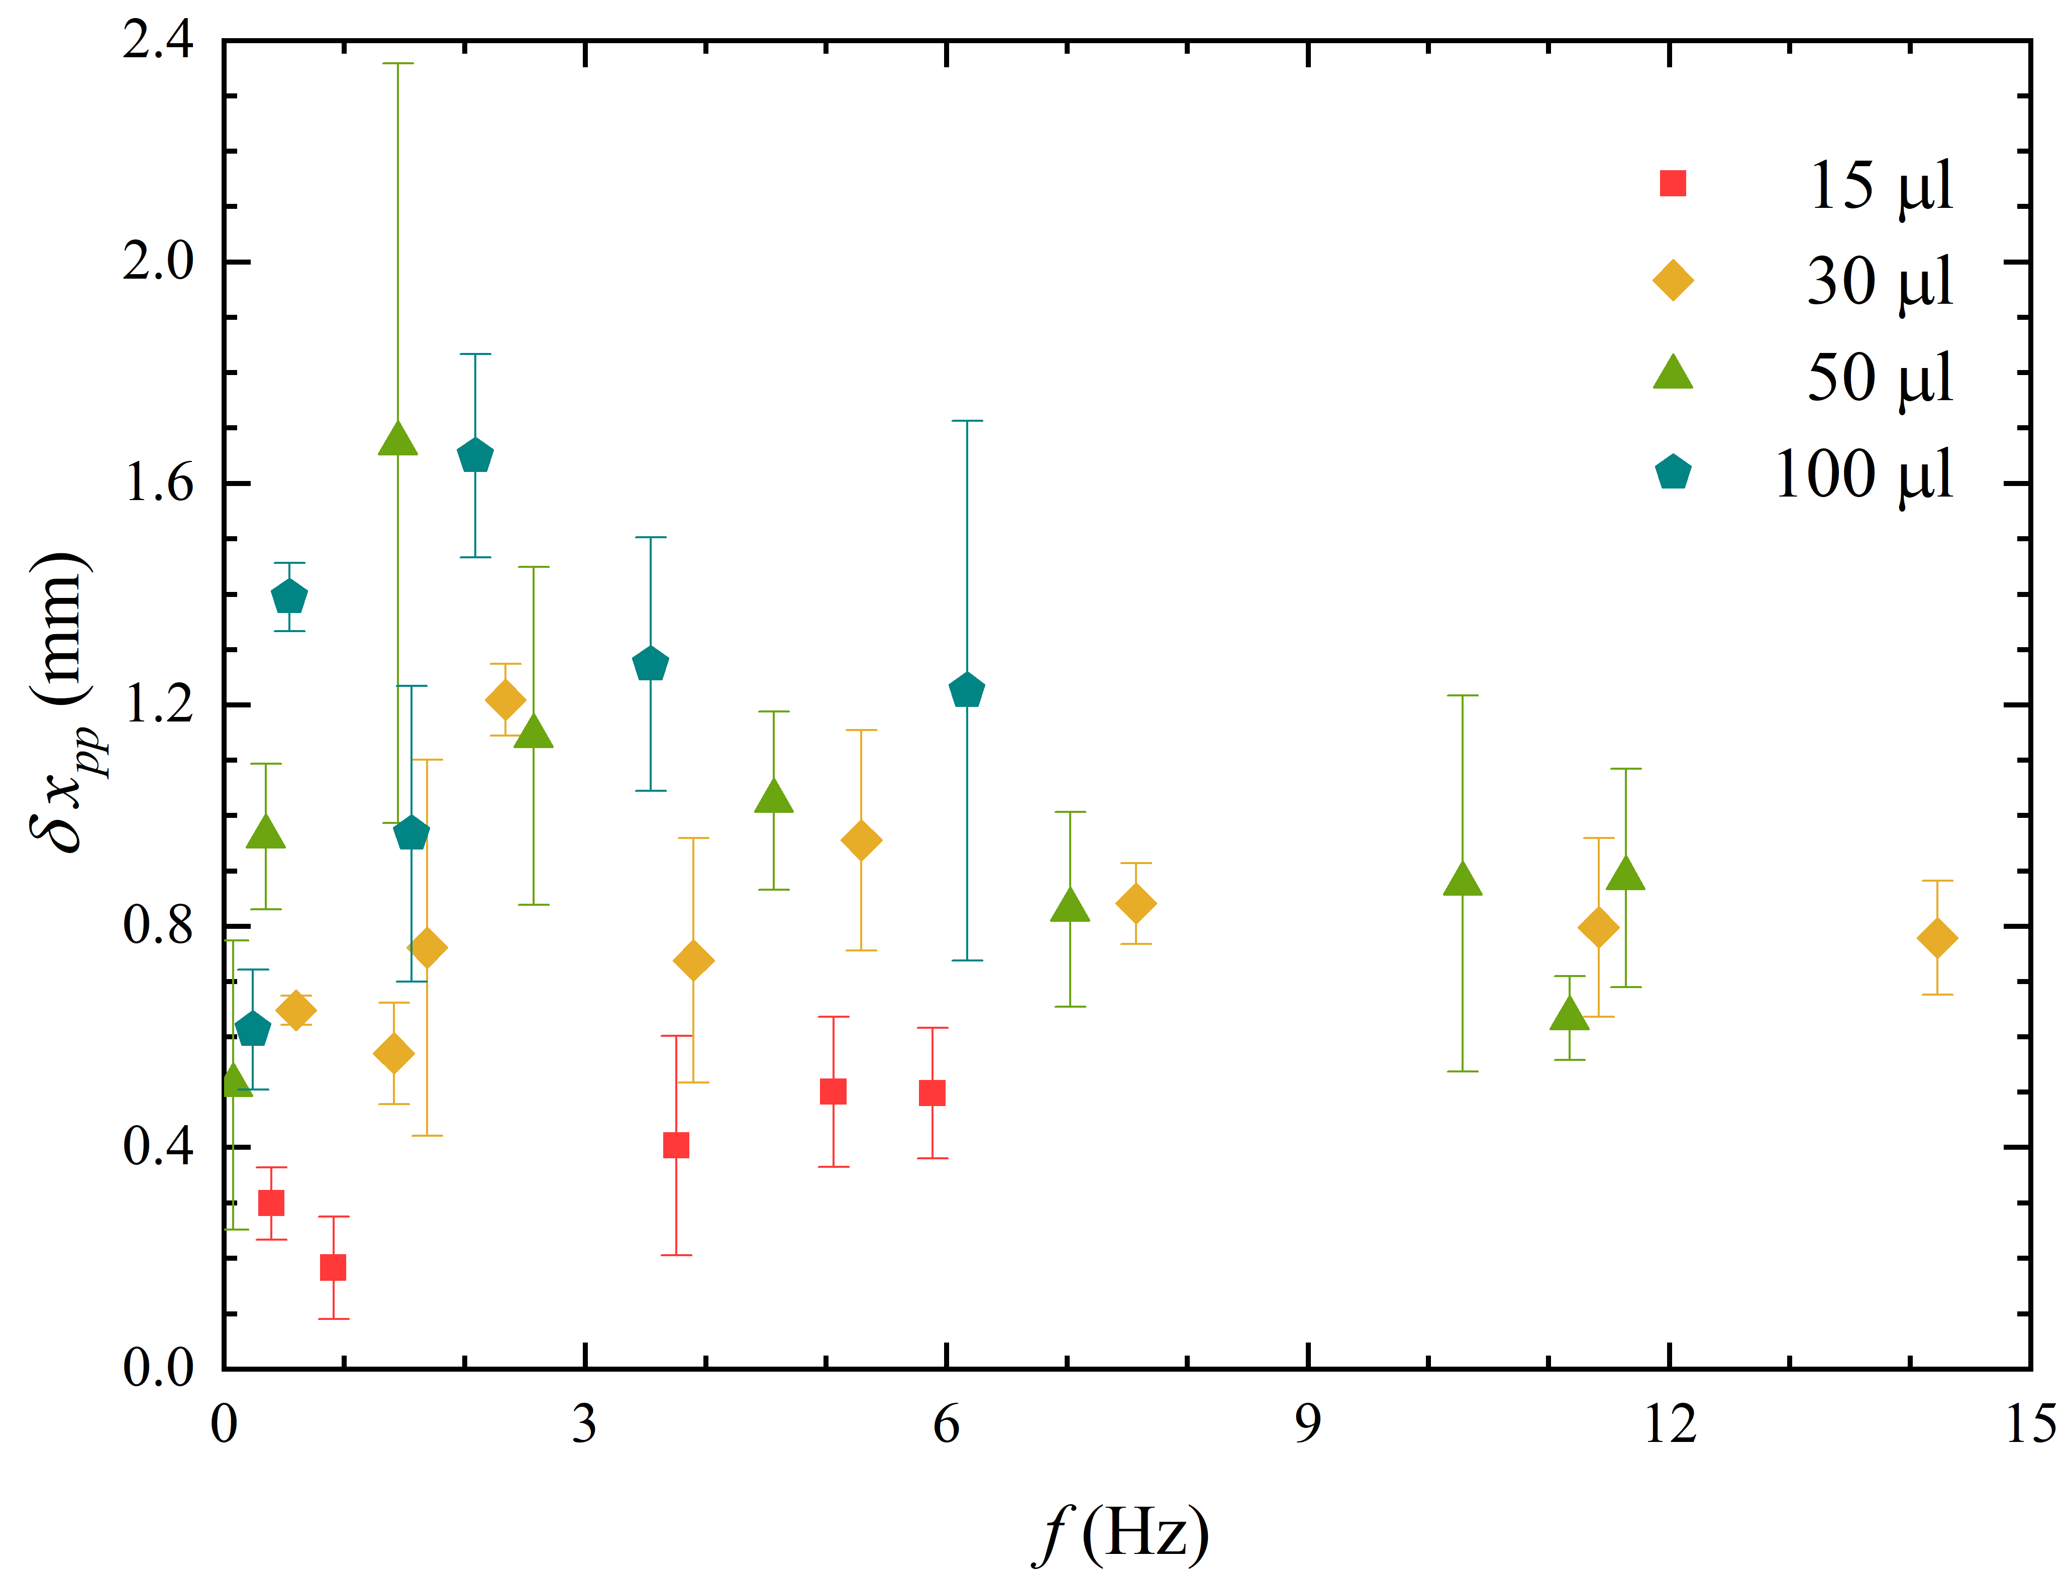
FIG. S7. Peak-to-peak amplitude versus frequency of the oscillatory motions of PAA₁₀/water drops at a concentration of 5000 ppm and different volumes.

8. Mechanical analogy
To shed more light on the novel drop motion presented in the Article, we consider a simple mechanical system commonly investigated in classical mechanics for its asymmetric distribution of mass. It consists of a homogeneous rigid cylinder (a wheel) of mass M and radius R rolling over a flat surface. A point mass m < M is fixed on the cylinder at a distance d, being 0<d≤R (Fig. S8). By neglecting capillary forces and viscous dissipation, this can be thought as the simplest representation of a drop moving on a lubricated surface with a bulge rolling around it.
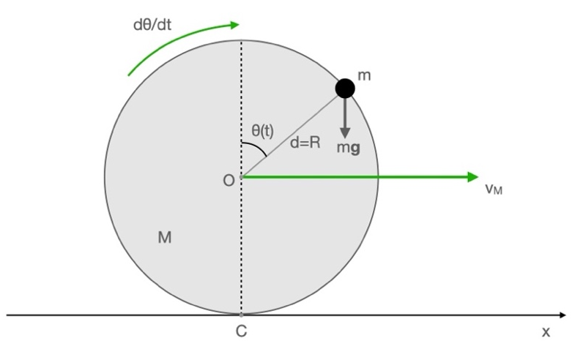
FIG. S8. Homogeneous wheel M and a point mass m fixed on its boundary in rolling without slipping over a flat surface with velocity $v_{M}$ and angular velocity dθ/dt.

Under the assumption of pure rolling of M and perfectly sticking of m to M, by denoting mg as the weight of m, I_{C} the inertia momentum of the cylinder with respect to the rotation axis passing through the contact point C with the plane, θ(t) the angular position of m with respect to the vertical direction and $\dot{θ}\left(t\right)=dθ/dt$ its time derivative, for the motion of M and m we have:
$x_{M}(t)=R θ(t)$, (1)
$v_{M}(t)=R \dot{θ}(t$), (2)
$r_{m}(t)=\left[d sinθ(t), d cosθ(t)\right]$, (3)
$v_{m}(t)=v_{M}(t) + {\dot{r}}_{m}(t)$. (4)

The kinetic and potential energy of the system are therefore:
${T = \frac{1}{2}I}_{C} {\dot{θ}}^{2}+\frac{1}{2}m v_{m}^{2}$, (5)
$V=mg\left[1+d cosθ\right]$, (6)
V being defined apart the constant energy of M independent from $t, θ,\dot{θ}$. The Lagrangian mechanics L=T-V has been solved analytically by using Wolfram Mathematica (version 12.3) given an initial value of the angular velocity $\dot{θ}\left(t=0\right)$at the starting point x = 0 corresponding to 𝜃 = 0.
From classical mechanics, it is well known that the system composed by the wheel and the point mass rigidly bound on it cannot be considered as a single rigid body. This is because the total inertia momentum with respect to the contact point C is depending on the distance of m from C. At variance with the case of a homogeneous wheel, the center of mass of the system does not follow a linear motion (see Movie M3 and Fig. S9).
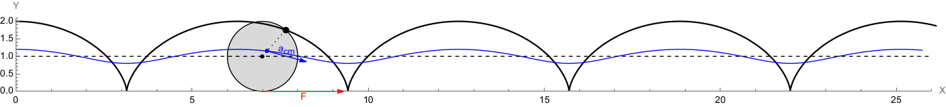
FIG. S9. Snapshot of the movie M3 taken at an arbitrary time, for the motion of the system showed in Fig. S5: red vector F is the instantaneous friction between the wheel contact point and the plane. Blue vector a_{cm} is the instantaneous acceleration of the system center of mass whose trajectory is showed by the blue line. Dashed line is the trajectory of the center of the wheel. Black line is the trajectory of the point mass m for d=R. The vertical coordinate y is the position of m on the vertical plane in units of R with respect to the rolling plane, the horizontal coordinate x is in units of R.

As a consequence, the time law given by Eq. (1) for the center O of the rolling wheel is oscillating in time as shown in Fig. S10. It resembles the experimental time laws of the front and rear contact points of PAA drops reported in Figs. 3 and 4 of the Article, as the bulge is rolling around the drop boundary during its motion.

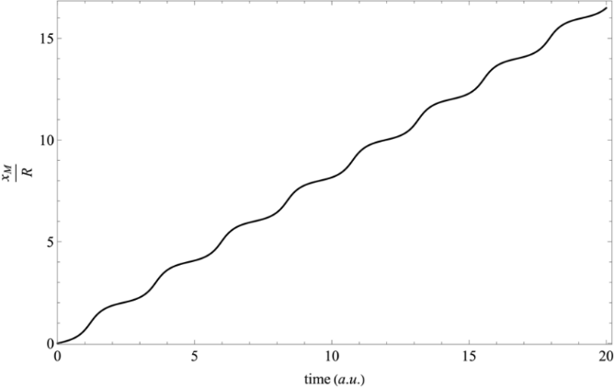
FIG. S10. Oscillatory time law of the center of the wheel for the mechanical system showed in Fig. S5, resulting from the solution of the Lagrangian mechanics. The advancement of the system is in units of R, starting from the initial position x=0.

References
[1] A. Keiser, P. Baumli, D. Vollmer, and D. Quere, Physical Review Fluids 5, 014005 (2020).

Movie captions
Movie M1. Motion of a PAA₁₀/water 5000 ppm drop with 30 µL volume on a 96.5 mPa s silicone oil lubricated surface inclined by an angle α= 30°. The movie, played at 0.1x speed, clearly shows the oscillatory behavior of the instantaneous speed and the periodical motion of the bulge along the semi-circular profile.
Movie M2. Motion of a PAA₁₀/water 2500 ppm drop with 30 µL volume on a 96.5 mPa s silicone oil lubricated surface tilted by α= 30°. The ground coffee particles added to the PAA/water solution highlight the internal rolling motion of the drop. Images have been acquired by high-speed camera and are played at 0.1x speed.
Movie M3. Motion of the homogeneous wheel of mass M and radius R in rolling without slipping over a flat surface, with a point mass m < M fixed on its boundary. Red vector F is the instantaneous friction between the wheel contact point and the plane. Blue vector a_{cm} is the instantaneous acceleration of the system center of mass whose trajectory is showed by the blue line. Dashed line is the trajectory of the center of the wheel. Black line is the trajectory of the point mass m. Time evolution is given in arbitrary units. The vertical coordinate y is the position of m on the vertical plane, expressed in units of R with respect to the rolling plane, the horizontal coordinate x shows the advancement of the wheel in units of R.

