SUPPLEMENTARY MATERIAL

Supplementary Experiment.

We conducted an experiment to test our hypothesis that participants believe that when submitting “How to” and “How do” search queries, people are primarily motivated to find information that can guide action and when submitting “What” and “Why” questions they are primarily motivated to increase their general understanding.

Participants. Twenty participants (age = 37.69, SD = 9.18; females = 46.3%) completed the task on Prolifics’ online system. Participants received £7.50 per hour for their participation. Ethical approval was provided by the Research Ethics Committee at University College London and all participants gave their informed consent to participate.

Procedure. Participants (N = 20) were shown 20 of the most popular search queries submitted to Google during 2020, which included the words “How to” and “How do” (E.g., “How to make scones?”; “How do I scan a QR code?”) and 20 of the most popular search queries for the terms “What” and “Why” (E.g., “What is a recession?”; “Why can’t I sleep?”). For each search query, participants were asked to indicate from three options why they think the person asked this question on Google. The three options were: (a) to get information that will help guide their actions and/or help them make a decision, (b) to get information that will increase their understanding about the topic, or (c) other (see Supplementary Figure 1). Search queries were presented in a randomized order and were self-paced. We grouped separately participants’ responses on (i) “How to” and “How do” queries and (ii) “What” and “Why” queries.

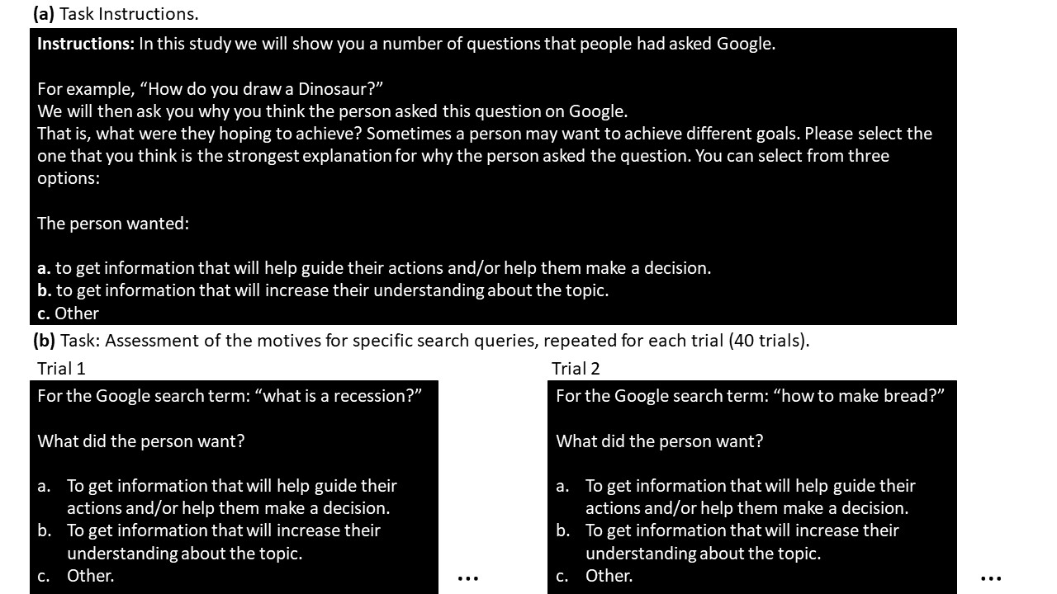

Supplementary Figure 1. Assessing search query motives. (a) Participants were asked to indicate from three options why they thought a person asked a question on Google. The three options were: (i) to get information that will help guide their actions and/or help them make a decision, (ii) to get information that will increase their understanding about the topic, or (iii) other. (b) They were shown 40 search queries in a random order , half began with “What” or “Why” and half with “How to” or “How do”.

Analysis & Results. A 2 (condition: How to, How do/ What, Why) by 3 (response type: guide action/increase understanding/other) ANOVA revealed a significant interaction (F (2, 239) = 325.13, p = .0001). Follow up paired-sample t-tests revealed that the interaction was due to participants indicating that when submitting “How to” and “How do” searches, a person was more likely seeking information to help guide their actions and/or make a decision (“How to” and “How do” mean response % = 76.25, SE = 3.07) compared to increasing their understanding about a topic (“How to” and “How do” mean response % = 18.50, SE = 2.52, comparing the two: t(39) = 10.601, p = 0.0001) or an alternative reason (“How to” and “How do” mean response % = 5.25, SE = 1.39, comparing the two: t(39) = 17.540, p = 0.0001; see Supplementary Figure 2). In contrast, participants indicated that when submitting “What” and “Why” searches, a person was more likely seeking information to increase their understanding of a topic (“What” and “Why” mean response % = 75.52, SE = 2.44) than gain information that can help guide their actions and/or make a decision (“What” and “Why” mean response % = 17.71, SE = 1.91, comparing the two: t(39) = -14.570 , p = 0.0001) or an alternative reason (“How to” and “How do” mean response % = 6.77, SE = 1.87, comparing the two: t(39) = 3.783, p = 0.001; see Supplementary Figure 2).

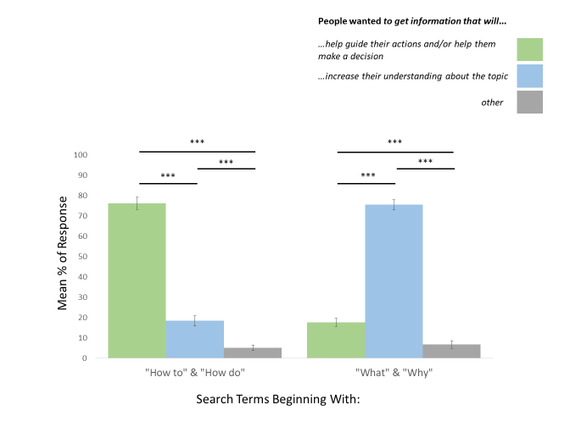
Supplementary Figure 2. Perceived motives for asking how do, how to, what and why. Participants indicated that when submitting a “How to” or "How do” search, a person was more likely seeking information to help guide their actions and/or make a decision than increase their understanding about a topic. In contrast, participants indicated that when submitting a “Why” or "What” search, a person was more likely seeking to increase their understanding of a topic rather than gain information that can help guide their actions and/or make a decision. Error bars = standard error (SE). *** = P < 0.001 (two-sided).

The results support the assumption that people believe that (i) when submitting “How to” and “How do” search queries people are primarily motivated to find information that can guide action and (ii) when submit “What” and “Why” questions they are primarily motivated to increase their general understanding.

Supplementary Analysis: Linear results remain when detrending is not employed.

Here we repeat all the linear regressions presented in the main article, but without detrending the dependent and predictor variables. The dependent and predictor variables in this present analysis are only Z-scored prior to being submitted to a linear model. As can be observed in the Supplementary Table below, the results presented in the main article are observed when detrending is not employed.

Supplementary Table. Results for all linear models without detrending the dependent and predictive variables.

Region | Dependent Variable | Model Results
UK | "How to" & "How do" questions | Stress levels β = 0.489 ± 0.087 (SE), t(49) = 5.608, p = 0.0001, COVID-19 related confinement β = 0.580 ± 0.087 (SE), t(49) = 6.650, p = 0.0001, R2 = 0.616
UK | “What” and “Why” questions | Stress levels β = 0.008 ± 0.096 (SE), t(49) = 0.085, p = 0.933, COVID-19 related confinement β = 0.743 ± 0.096 (SE), t(49) = 7.735, p = 0.0001, R2 = 0.553
UK | Valence Index | Stress levels β = 0.124 ± 0.142 (SE), t(49) = 0.870, p = 0.388, COVID-19 related confinement β = 0.061 ± 0.142 (SE), t(49) = 0.429, p = 0.670, R2 = - 0.019
UK | Stress levels | "How to" & "How do" questions β = 0.520 ± 0.124 (SE), t(47) = 4.201, p = 0.0001, "Stress" term β = -0.055 ± 0.143 (SE), t(47) = -0.381, p = 0.705, "Anxiety" term β = -0.107 ± 0.140 (SE), t(47) = -0.766, p = 0.448, "Mental health” term β = -0.081 ± 135 (SE), t(47) = -0.604, p = 0.549, R2 = 0.334

