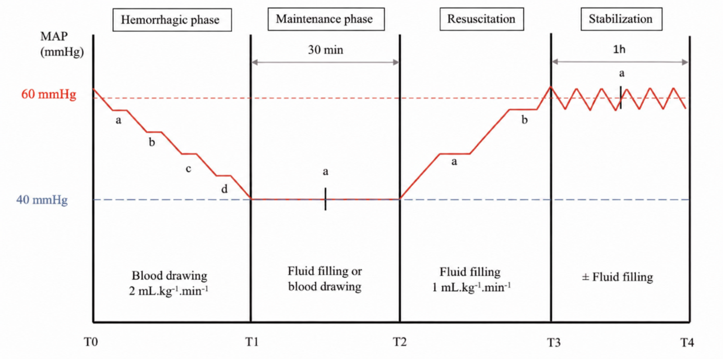

Supplementary Fig. 1. Study Design

