Supplementary Information
Multiparametric CEST MRI–Guided Intranasal Theranostic Liposomes for Quantitative Biodistribution and Response Prediction in Glioblastoma
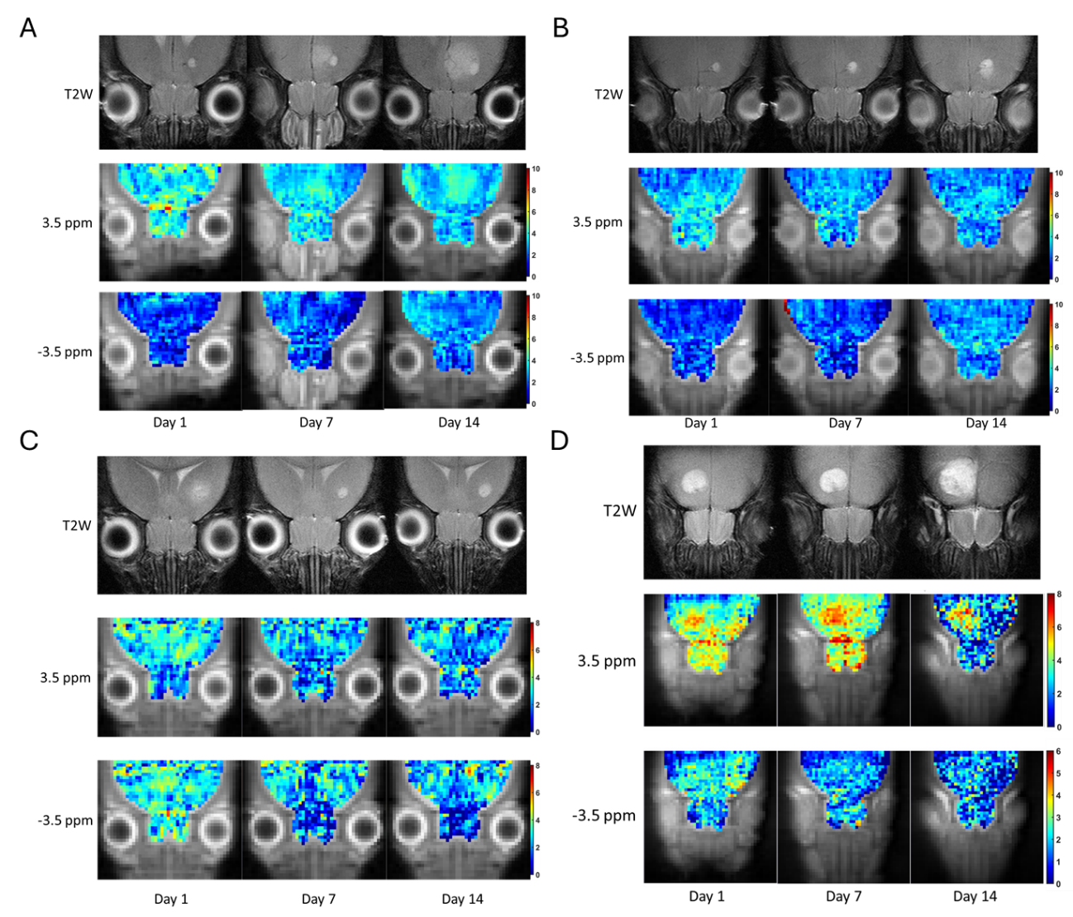
Lok Hin Law^{a,b}, Haoyun Su^{a,b}, Yang Liu^{a,b}, Liyan Wang^{a,b}, Seweon Park^{a,b}, Huabing Liu^{a,b}, Wai Po Chong^{c,d*}, Kannie W.Y. Chan^{a,b,e-h*}
Supp Fig. 1. In vivo tumor CEST MRI of treatment group using APTw contrast. T2w image, CEST map at 3.5 ppm, and -3.5 ppm of (A) mice 2, (B) mice 3, (C) mice 4, and (D) mice 5.
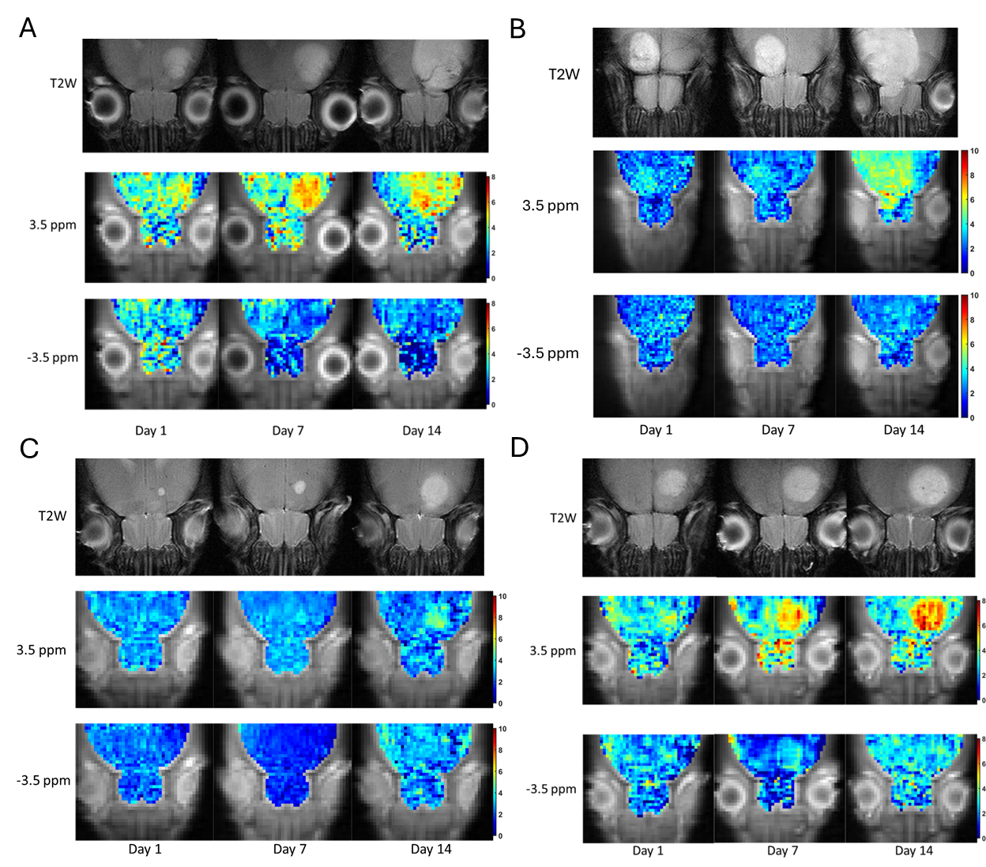
Supp Fig. 2. In vivo tumor CEST MRI of control group using APTw contrast. T2w image, CEST map at 3.5 ppm, and -3.5 ppm of (A) mice 2, (B) mice 3, (C) mice 4, and (D) mice 5.

