Supporting Information
of
Embedded 3D-Printed Magnetic Shape-Memory Robots with Frequency-Separated Control for Wireless Luminal Support

Wenrui Zhang†¹, Shiqi Hu^{†2,3}, Yijie Bian¹, Mei Zhou¹, Kai Zhuang¹, Zeji Sun¹, Xiao Xiao¹, Hao Jiang¹, Shuaiqi Liu¹, Xiong Zhou¹, Jizhuang Wang⁶, Li Liu^{5*}, Han Yu^{4*}, Mojun Chen¹*
¹Smart Manufacturing Thrust, Systems Hub, The Hong Kong University of Science and Technology (Guangzhou), Guangzhou 511453, China
²Department of Mechanical Engineering, Pohang University of Science and Technology (POSTECH), Pohang 37673, Korea
³Platform for Real-world Innovation in Smart Manufacturing and AI, Korea Advanced Institute of Science and Technology (KAIST), Daejeon, Republic of Korea
⁴Academy of Medical Engineering and Translational Medicine, Tianjin University, Tianjin 300072, China
⁵School of Materials Science and Engineering, Harbin Institute of Technology (Shenzhen), Shenzhen 518055, China
⁶College of Chemistry and Materials Science, Jinan University, Guangzhou 510632, China

† These authors contributed equally to this work.
*Correspondence: Mojun Chen, mjchen@hkust-gz.edu.cn; Han Yu, han.yu@tju.edu.cn; Li Liu, liuli20@hit.edu.cn
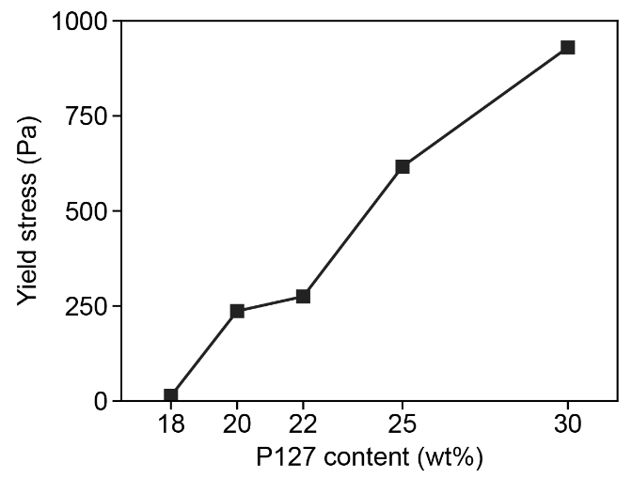
Figure S1. The yield stress (σ_{y}) increases monotonically with increasing Pluronic F-127 concentration.
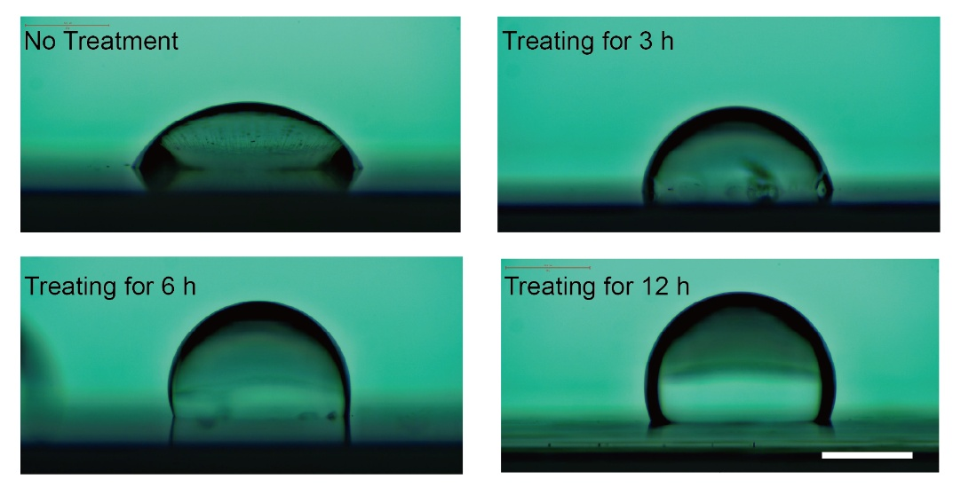
Figure S2. Effect of the nozzle hydrophobic treatment. Static contact angles measured on untreated and vapour-phase silanized nozzle surfaces. Scale bar, 0.5 mm.
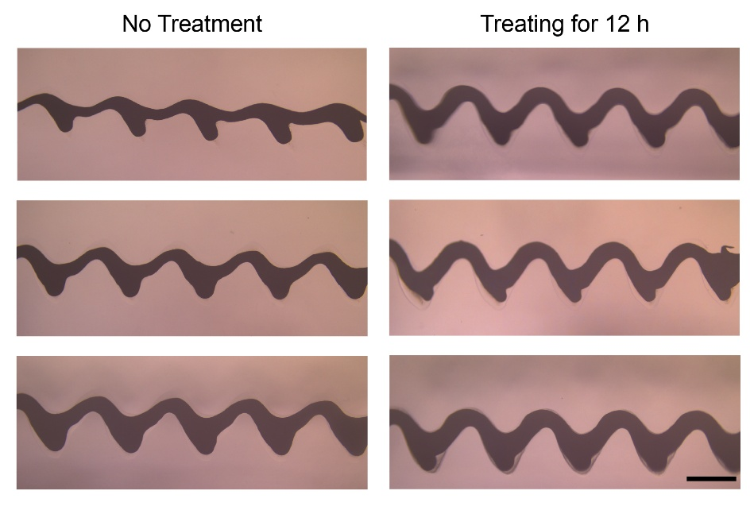
Figure S3. Optical micrographs show printed filaments obtained using treated and untreated nozzles. The treated nozzle enables uniform and continuous filament deposition, while the untreated nozzle suffers from severe outer-wall wetting, resulting in discontinuous, bead-like printed tracks. Scale bar, 0.5 mm.
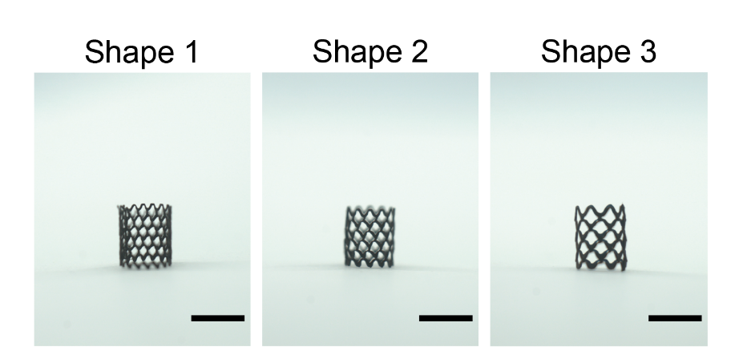
Figure S4. Different morphologies of printed lattice robots. Scale bar, 4 mm.

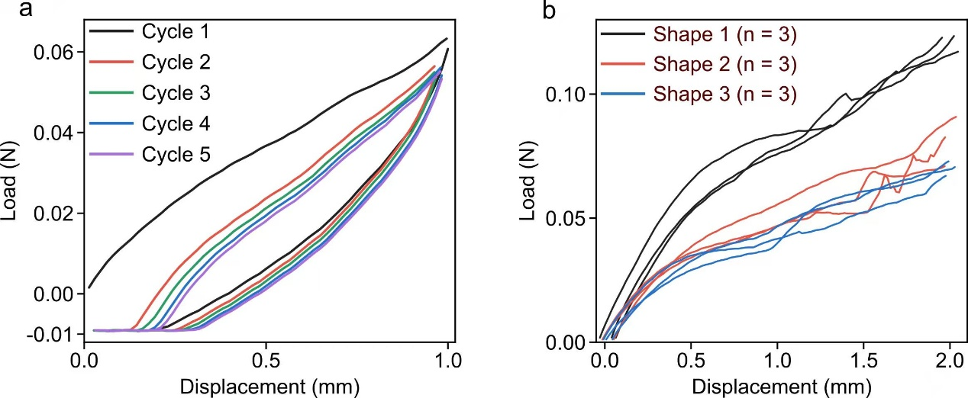
Figure S5. Compressive response of the printed lattice robots. Load–displacement curves recorded under uniaxial compression for lattices of different architecture, and the corresponding response over five successive compression cycles.

