Additional File 1
Supplementary Figure S1. Twelve-lead electrocardiogram obtained on admission.
The initial 12-lead electrocardiogram demonstrated sinus rhythm with narrow QRS complexes and no apparent baseline QT-interval prolongation, diagnostic repolarization abnormality, or acute ST-segment changes.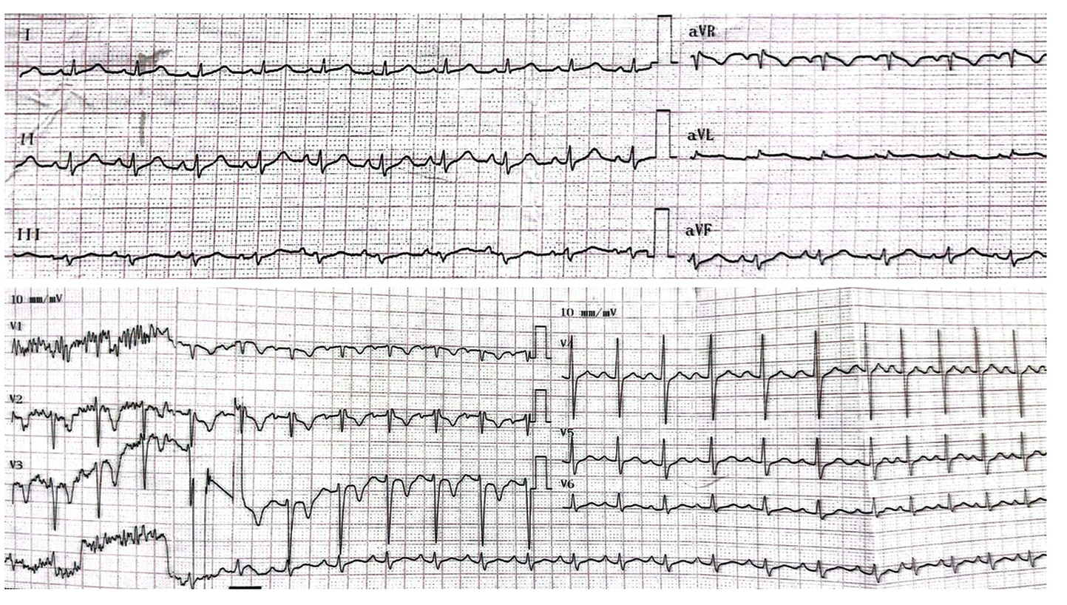

Supplementary Figure S2. Ventricular tachyarrhythmia documented on continuous electrocardiographic monitoring. The continuous ECG monitoring demonstrated frequent ventricular ectopy and episodes of rapid wide-complex tachycardia with beat-to-beat variation in QRS morphology and axis, compatible with bidirectional and polymorphic ventricular tachycardia.
