Green Wavelength Femtosecond Laser Ablated Copper Surface

Yi-Hsien Liu^{1,2} and Chung-Wei Cheng^{1,2*}

¹Department of Mechanical Engineering, National Yang Ming Chiao Tung University, No. 1001, Ta Hsueh Road, Hsinchu 300, Taiwan
²Department of Mechanical Engineering, National Chiao Tung University, No. 1001, Ta Hsueh Road, Hsinchu 300, Taiwan
E-mail: weicheng@nctu.edu.tw

Two temperature model
To simulate the ultrashort laser-metal interaction, the two-temperature model (TTM) should always be adopted because the amount of time for laser interaction with the material is less than the electron-lattice coupling time. Also, in general, the one-dimensional (1D) heating problem can be used to analyze the ultrashort laser-metal interaction because the heating spot size is much larger than the heat-affected zone.
Considering that a bulk copper is irradiated normally by a femtosecond laser pulse on the front surface (z = 0), the governing equations for 1D-TTM are given by:

$$C_{e}\frac{∂T_{e}}{∂t}=\frac{∂}{∂z}\left(K_{e}\frac{∂T_{e}}{∂z}\right)-G\left(T_{e}-T_{l}\right)+S(z,t)$$ | (1)
$$C_{l}\frac{∂T_{l}}{∂t}=\frac{∂}{∂z}\left(K_{l}\frac{∂T_{l}}{∂z}\right)+G(T_{e}-T_{l})$$ | (2)
where t is the time, T is the temperature, and $C$ and $K$ are the heat capacity and thermal conductivity, respectively. $G$ is the electron-lattice coupling factor, and $S(z,t)$ is the laser heat source. The subscript $e$ and $l$ correspond to the electron and lattice, respectively. The thermophysical parameters ($C_{e},K_{e},G$) are varied with the electron temperature, and the values used in this paper can be found in [1].

The AFM profile of copper with different fluences
The AFM data of a copper surface irradiated by a single-shot femtosecond green wavelength laser with laser fluences of 0.7, 7, and 63 J/cm² are shown in Figure S1. The depth of the crater increased as the fluence increased.

Figure S1 Cross-sectional profile of craters with laser fluences of 0.7, 7, and 63 J/cm²

The electron and lattice temperature calculated by TTM
Figure S2 shows the time evolution of electrons and lattice temperatures obtained by non-linear model on the surface of the sample for different fluences. The results show that the electron transfers the heat to lattice after few ps and after few ps or ns, depending on the fluence, the system will reach an equilibrium state, and these two temperatures decrease together until the computing finish.
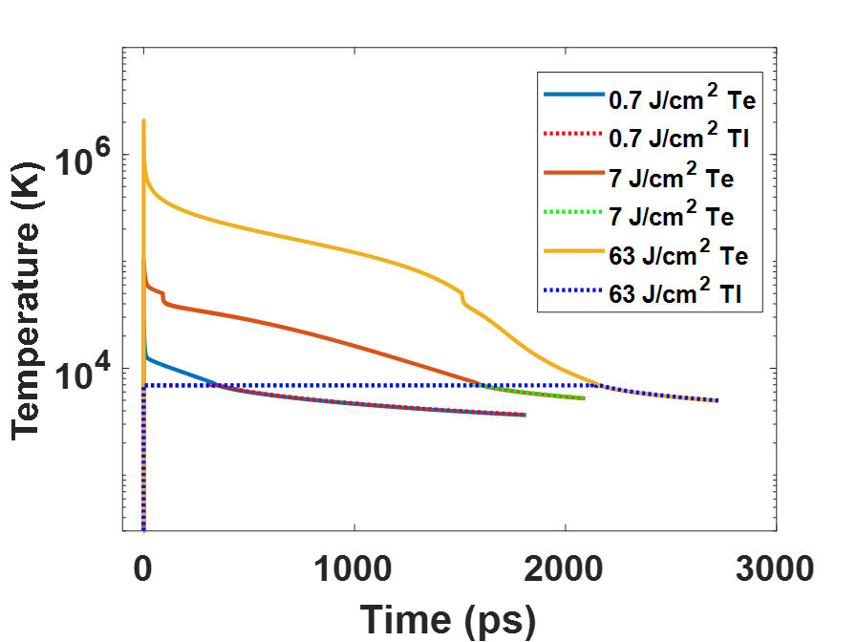
Figure S3 Time-dependence of the calculated electron and lattice temperature by non-linear model

[1] C.W. Cheng, S.Y. Wang, K.P. Chang, and J.K. Chen, "Femtosecond laser ablation of copper at high laser fluence: Modeling and experimental comparison," Applied Surface Science, vol. 361. 2016, 41-48

