SUPPLEMENTARY MATERIAL
MetaLFM: Metalens-array-enabled High-Density Optical Sampling for High-Resolution Volumetric Bioimaging by Light Field Microscopy
Tien Nhat Nguyen^{1 †} , Doyoon Lee^{2,†} , Huu Lam Phan^{3,4}, Akm Ashiquzzaman¹, Yesl Jun^{5,6}, Minkyung Kim^{2,*}, Euiheon Chung^{1,7,*}
¹Department of Biomedical Science and Engineering, Gwangju Institute of Science and Technology, 61005 Gwangju, Republic of Korea.
²Department of Mechanical and Robotics Engineering, Gwangju Institute of Science and Technology, 61005 Gwangju, Republic of Korea
³GIST InnoCORE AI-Nano Convergence Institute for Early Detection of Neurodegenerative Diseases, Gwangju Institute of Science and Technology, 61005 Gwangju, Republic of Korea
⁴ Mechatronics and Robotics Research Group, Faculty of Engineering and Technology, Nguyen Tat Thanh University, Ho Chi Minh City 754000, Vietnam
⁵Therapeutics & Biotechnology Division, Korea Research Institute of Chemical Technology, Daejeon 34114, Republic of Korea
⁶Department of Medicinal Chemistry and Pharmacology, University of Science and Technology, Daejeon 34113, Republic of Korea
⁷AI Graduate School, Gwangju Institute of Science and Technology, 61005 Gwangju, Republic of Korea
† These authors contributed equally to this work
*Corresponding author: m.kim@gist.ac.kr, ogong50@gist.ac.kr
Supplementary Contents:
Supplementary Note 1: Defining light field microscopy structure and performance parameters
Supplementary Note 2: Additional details on the design method of the metalens array
Supplementary Figure S1: Design considerations for the metalens array
Supplementary Figure S2: Polarization independence of the metalens array
Supplementary Figure S3: Schematic of the experimental setup used to measure the focusing properties of the metalens array
Supplementary Figure S4: Focal shift of the metalens array
Supplementary Figure S5: Spatial uniformity characterization of the metalens array
Supplementary Figure S6: Focal-shift characterization and preservation of f# -matched LFM operation
Supplementary Figure S7: Fluorescent bead distribution across the imaging volume
Supplementary Figure S8: USAF target resolution test
Supplementary Figure S9: Dendritic structure cross-sectional profiles
Supplementary Figure S10: Intestinal organoid structural cross-sectional profiles
Supplementary Figure S11: Grid-like artifacts at and around NIP
Supplementary Table 1: Quantitative analysis of focal-spot uniformity across nine representative regions of the metalens array
Supplementary Table 2: Spatial resolution improvement across DOF
Supplementary Table 3: Comparison of MetaLFM and other LFM techniques
Supplementary Table 4: List of main equipment
References
Supplementary Note 1: Defining light field microscopy structure and performance parameters.
Light field microscopy can be integrated into a wide range of conventional optical microscopy systems. However, not every microlens array (MLA) is suitable for use in an LFM setup. In particular, the f-number (f#) of the MLA must be matched to that of the objective lens, assuming the tube lens matches the objective’s design specification ¹:
$$f^{\#}= \frac{f_{MLA}}{d}= \frac{M}{2NA}$$
where f_{mla} and d are the focal length and lens size of the microlens, M and NA are the magnification and NA of the objective lens. Proper f# matching prevents overlapping of the sub-images, which would otherwise cause crosstalk between neighboring views, or separation, which would reduce the effective angular sampling. In addition, the MLA pitch is typically chosen to be close to odd multiples (e.g., 11, 13, or 15) of the camera pixel size to achieve a balanced trade-off between spatial and angular sampling ². In this work, we selected a commonly used objective for bioimaging applications (20×/0.5 NA), corresponding to an f# of 20. We designed the metalens to span 11 camera pixels using a Hamamatsu ORCA-Flash 4.0 camera with a pixel size of 6.5 μm. Based on these parameters, the metalens array was designed with a lens diameter of 71.5 μm and a focal length of 1430 μm. To prevent crosstalk between adjacent lenslets, the gap was set to 3.5 µm, resulting in a total pitch of 75 µm.
The theoretical evaluation of LFM performance considers three main metrics: lateral resolution (R_{x}), axial resolution (R_{z}) and depth of field (DOF). These parameters were modified from ³. The total resolvable spots (N) per microlens can be determined by:
$$N= \frac{pNA}{0.47λM}$$
The axial resolution and DOF shown in Fig. 1b can be expressed as follows ³:
$$R_{z} (μm)≈\frac{(2+N)λn}{2{NA}^{2}}=\frac{λn}{{NA}^{2}}+\frac{pn}{0.94NA}×\frac{1}{M}$$
$$DOF (μm)≈\frac{(2+N^{2})λn}{2{NA}^{2}}≈\frac{λn}{{NA}^{2}}+\frac{p^{2}n}{0.44NA}×\frac{1}{M^{2}}$$
where λ is the emission wavelength and n is the refractive index. Due to deconvolution recovering diffracted information beyond the Rayleigh range, the depth of view (DOV) extends beyond the conventional depth of field and is approximated as twice the depth of field ^{4,5}:
$$DOV(μm)=2DOF$$
In light field microscopy, the sensor is divided into many sub-images by the MLA. Each microlens acts like a small camera, so the final lateral resolution depends on how many spatial samples are available under each microlens ³:
$$R_{x} (μm)=\frac{p}{M}$$
In Fig. 1b, showing the relationship between spatial resolution, depth of field (DOF), and objective magnification, the calculations are based on our experimental setup using a conventional microlens array (MLA). The representative objective lenses were selected to match the f# of the MLA. For the analysis of spatial resolution and DOF as a function of MLA pitch size, a 20×/0.5 NA objective lens was used (Supplementary Table 4), assuming that the representative MLAs have an f# matched to that of the objective lens.
Supplementary Note 2: Additional details on the design method of the metalens array.
Fig. S1a and S1b show the transmission and phase maps obtained by sweeping the nanopost diameter from 100 to 220 nm over a wavelength range of 400–700 nm. Geometries producing an inter-post spacing below 70 nm were excluded to maintain fabrication feasibility. At the target wavelength of 525 nm (Fig. S1c), diameters above 206 nm also exhibited transmission below the threshold of 0.8; therefore, the final phase library was restricted to diameters of 100–206 nm.
Fig. S1d and S1e show the phase maps of single metalenses with diameters of 50 µm and 100 µm, respectively, using the same unit-cell parameters (period, height and diameter). The insets in Figs. S1d and S1e present the one-dimensional cross-sections of the phase profiles near the center of each single lens. Likewise, at each position, the nanopost diameter is chosen from the unit-cell phase library such that the phase matches the required hyperbolic phase profile. When the single-lens diameter is reduced to 50 µm, the pitch size decreases, which potentially improves spatial resolution. However, as shown in Fig. S1d, not all elements of the phase-library are utilized, leading to incomplete 2π phase coverage. In contrast, when the diameter of the lens is 100 µm, all elements of the unit-cell phase library are effectively used, achieving a full 2π phase span. Nevertheless, increasing the lens diameter leads to a larger pitch size, which degrades the overall spatial resolution of the array.
In addition, simulations with different pitch sizes were conducted to compare the resolution of the lateral intensity distributions for pitch sizes of 75 µm and 100 µm. In both cases, the lens array consists of 3 × 3 lenses, and the gap size between adjacent lenses is fixed at 3.5 µm. The lateral intensity distribution is evaluated at the axial point where the maximum intensity occurs for each lens. The propagation field is also calculated using a convolution-based Rayleigh–Sommerfeld diffraction equation. As shown in Fig. S1f, the FWHM of the lateral intensity distribution is 8.78 µm for the pitch size of 75 µm and 9.25 µm for the pitch size of 100 µm. These results show that a smaller pitch size leads to improved resolution.
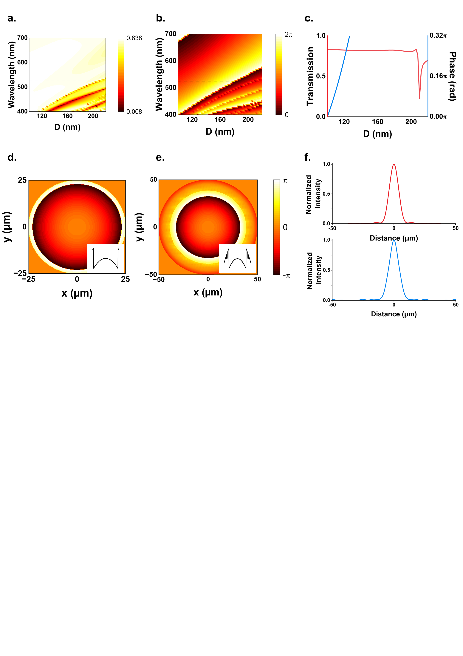
Supplementary Figure S1: Design considerations for the metalens array. (a) Transmission and (b) phase maps as functions of nanopost diameter (100–220 nm) over the wavelength range of 400–700 nm. In each map, the blue and black dashed lines indicate the wavelength of 525 nm. (c) Transmission (left, red solid line) and phase profiles (right, blue solid line) at 525 nm with the nanopost diameter range of 100–220 nm. The phase is normalized with respect to the reference value at D = 50 nm, and subsequently unwrapped. (d-e) Phase distributions of single metalenses with diameters of 50 and 100 µm, respectively, implemented with the same phase library and unit-cell parameters. Insets present one-dimensional phase cross-sections near the lens center. (f) Cross-sectional profiles of the intensity distribution along the x-direction with pitch sizes of 75 μm (top) and 100 μm (bottom).
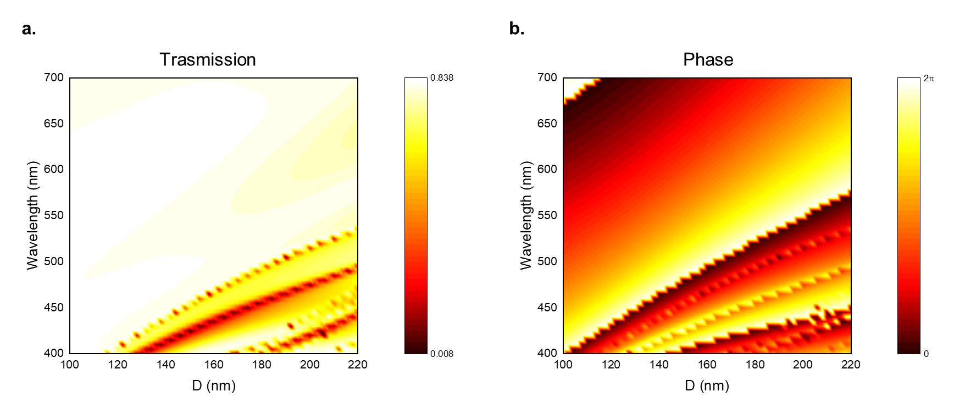
Supplementary Figure S2: Polarization independence of the metalens array. (a) Simulated transmission map under y-polarized (TE) illumination for nanopost diameters ranging from 100 to 220 nm over the wavelength range of 400–700 nm. (b) Corresponding simulated phase response under the same conditions. All other simulation parameters were kept identical to those used for the x-polarized (TM) case shown in Figs. S1a and S1b. The transmission and phase responses under y-polarized illumination closely match those obtained for x-polarization, confirming the polarization-independent optical response of the designed metalens array.

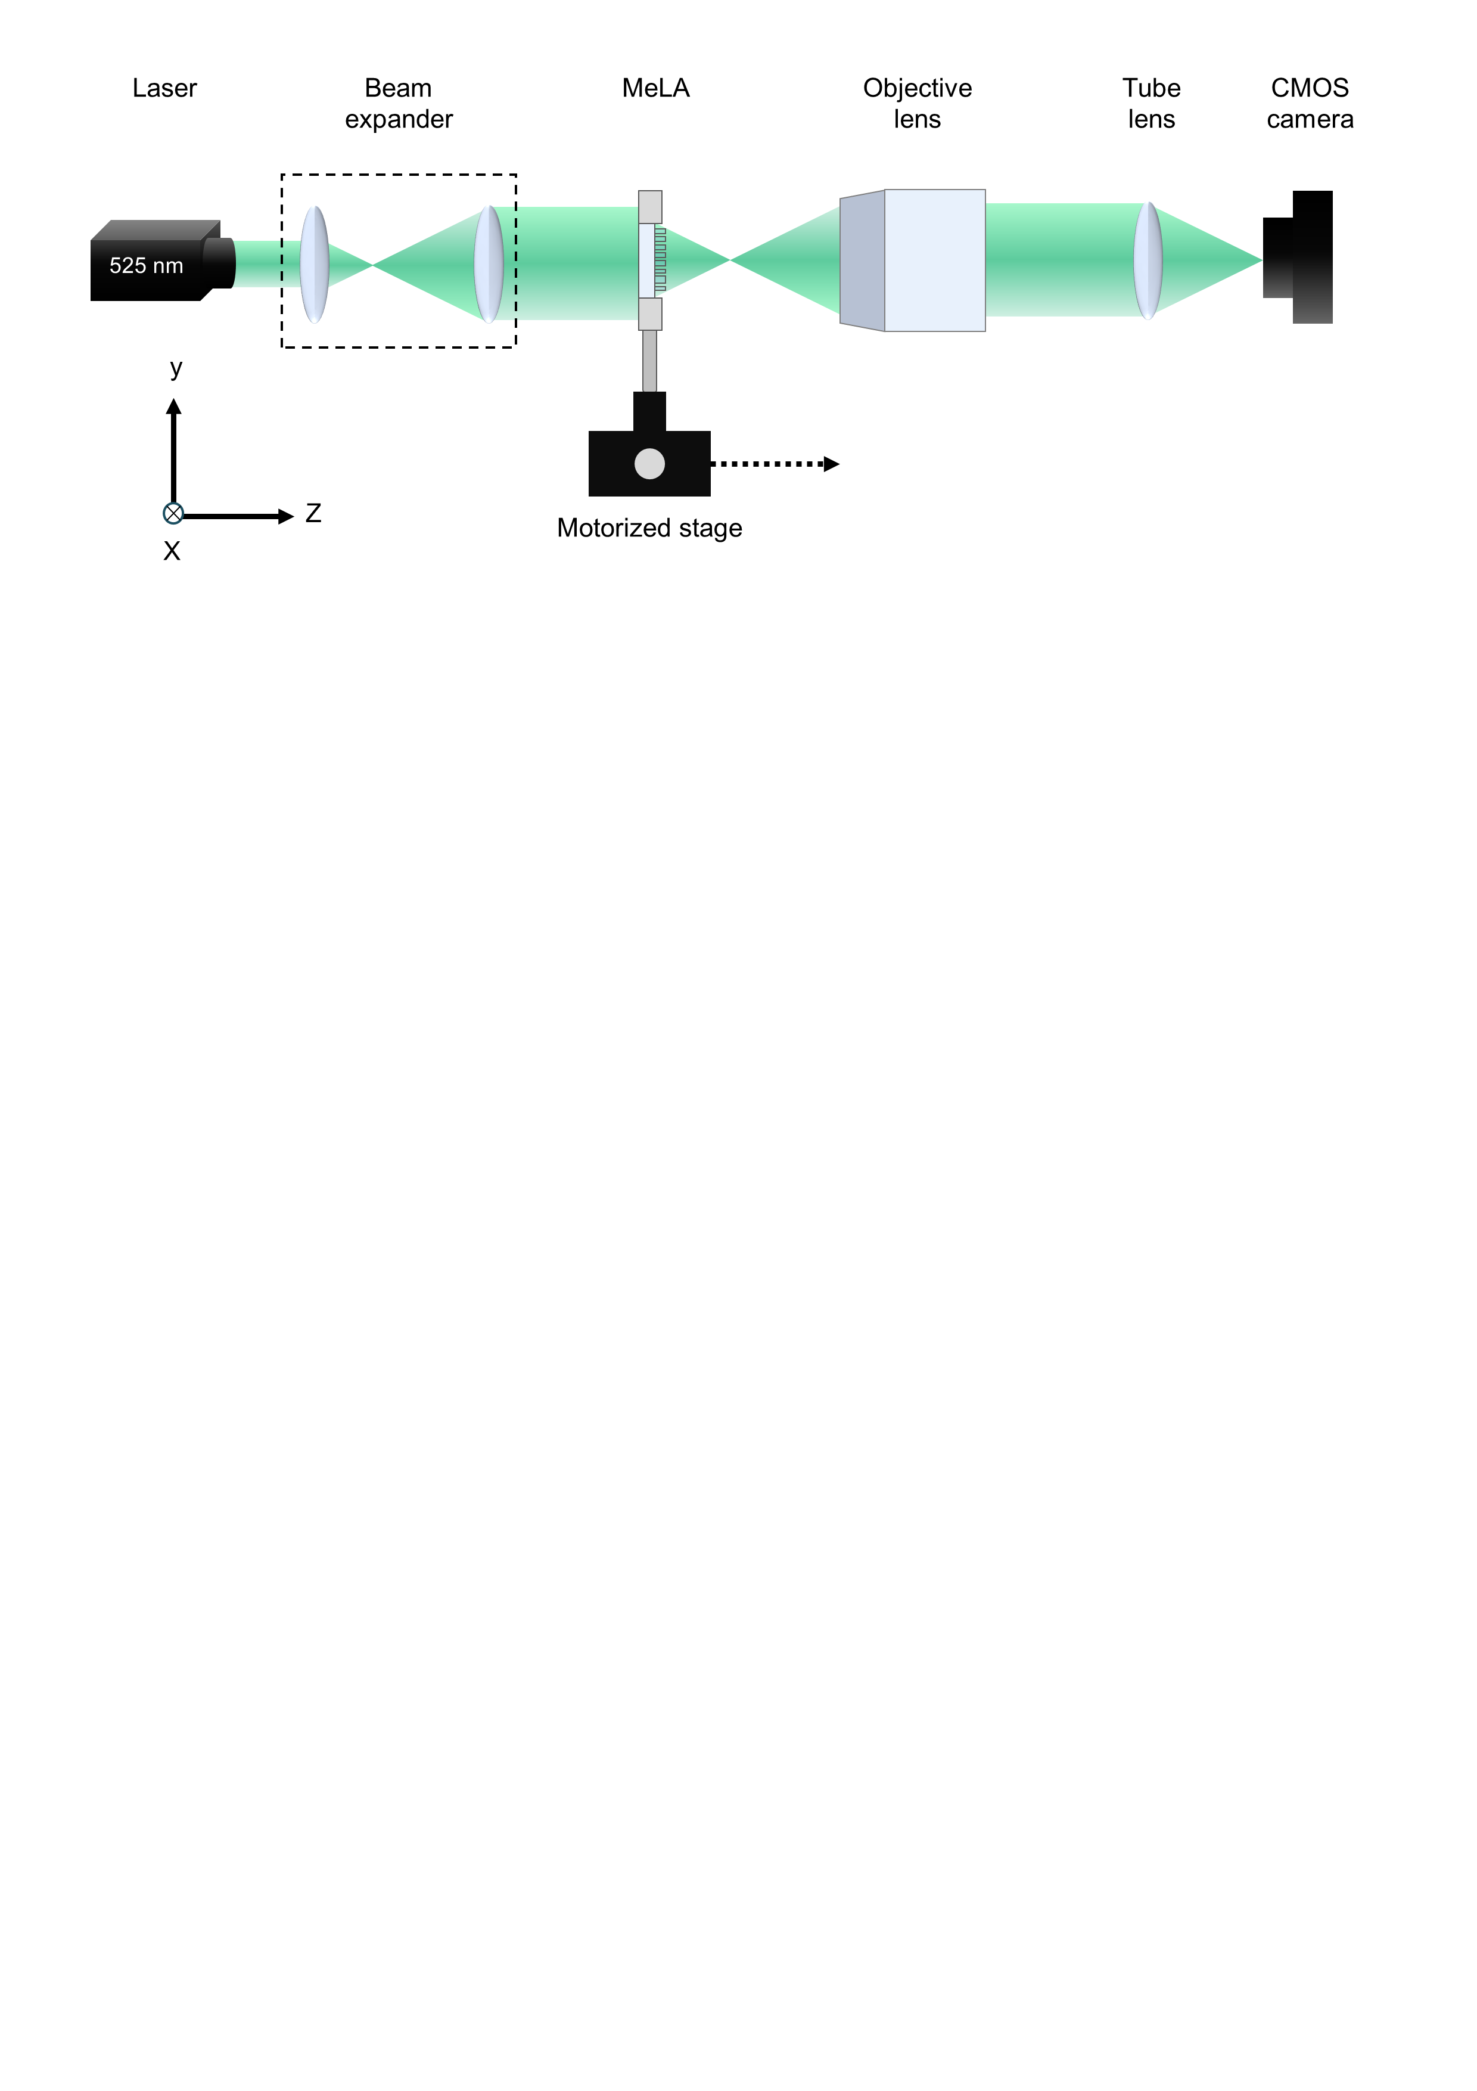
Supplementary Figure S3: Schematic of the experimental setup used to measure the focusing properties of the metalens array. The focusing test in Fig. 2a was performed with the shown optical setup. A 525-nm laser beam was expanded by two lenses … and directed onto the metalens array mounted on a motorized translation stage. The array was translated along the z-axis, and the transmitted light was imaged through an infinity-corrected system comprising a 4×/0.1 NA objective, tube lens, and CMOS camera.
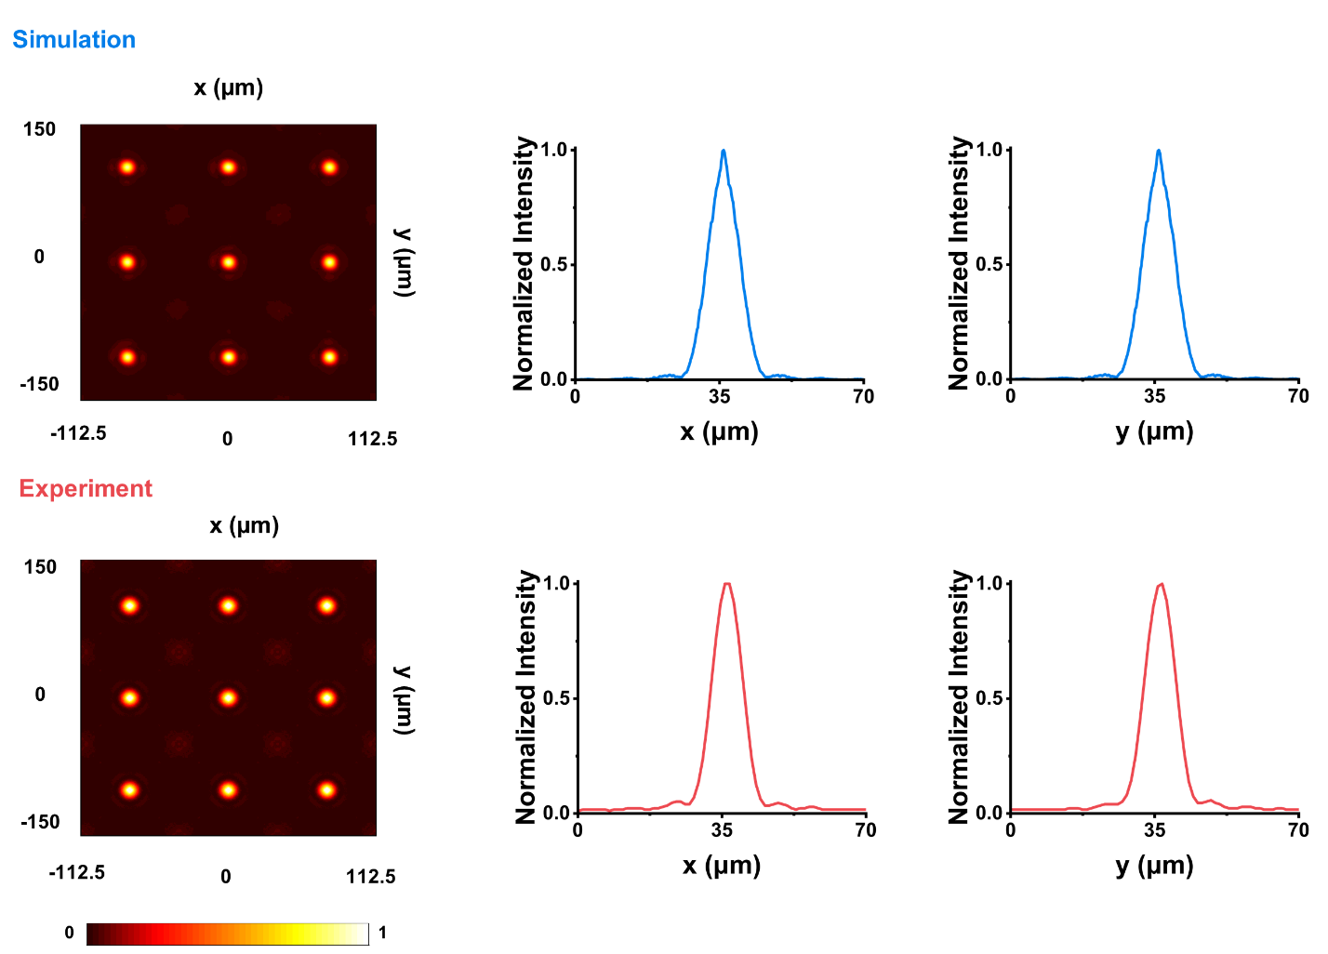
Supplementary Figure S4: Focal shift of the metalens array. (a) Simulated focal intensity distribution of the designed metalens array evaluated at the axial position of maximum intensity, z ≈ 1241 μm. Although the metalens was designed with a focal length of approximately 1430 μm, corresponding to f# = 20 and NA = 0.025, the simulated intensity maximum occurs at a shorter axial distance of approximately 1241 μm. This focal shift corresponds to an effective f# ≈ 17 and an effective NA ≈ 0.03. The corresponding normalized intensity profiles along the x- and y-directions are shown on the right and were used to extract the lateral FWHM. The focal shift is attributed primarily to deviations from the ideal continuous phase profile introduced by the discrete unit-cell implementation, together with the local periodic approximation used in the metalens design and the relatively low numerical aperture of the lens. (b) Experimental focal intensity distribution measured at the corresponding shifted focal position of approximately 1240 μm, together with the normalized intensity profiles along the x- and y-directions. The measured lateral FWHM values were 9.0 ± 0.3 μm and 9.0 ± 0.2 μm along the x- and y-directions, respectively (Supplementary Table 1), consistent with the reduced focal-spot size observed at the shifted focal plane. Although the shifted focal plane provides a smaller lateral FWHM, it does not satisfy the required f#-matching condition, resulting in inappropriate separation or overlap of neighboring elemental patterns (Fig. S6). Consequently, the imaging experiments were performed near the designed focal length of approximately 1430 μm, where the required f# matching is maintained. Under this operating condition, MetaLFM achieved measured lateral and axial resolutions of 3.6 ± 0.5 μm and 15.1 ± 0.4 μm (n = 7), respectively, in close agreement with the theoretically predicted spatial resolution.
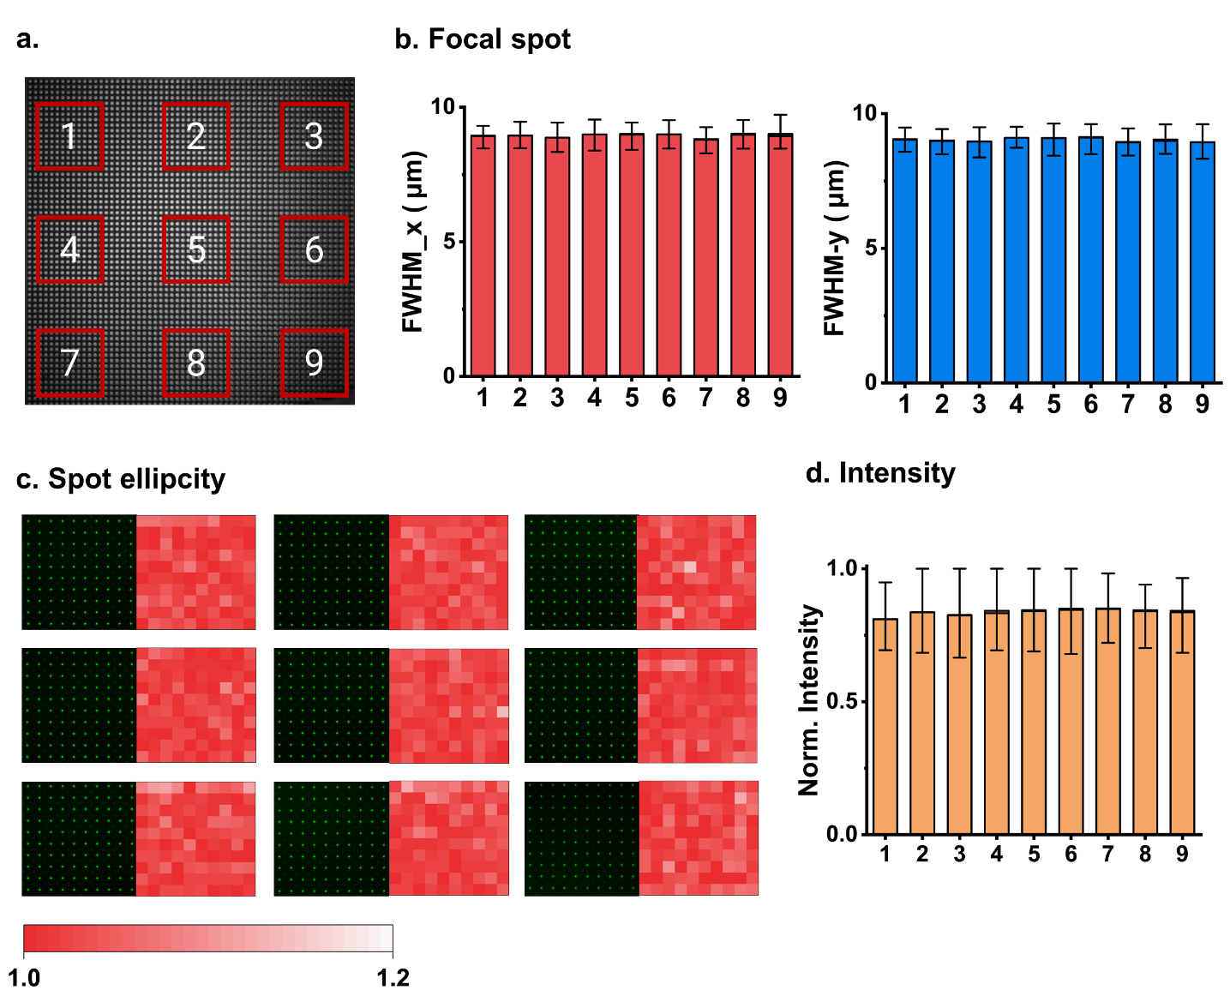
Supplementary Figure S5: Spatial uniformity characterization of the metalens array. (a) Light microscopy image of the full 60 × 60 metalens array with 9 representative regions (1–9) selected across the array. Because the CMOS sensor field of view was insufficient to capture the entire focal-spot array in a single acquisition, focusing measurements were performed separately at these nine positions using the setup detailed in Fig. S3, whereas the full 60 × 60 array image was acquired by light microscopy. For each region, a 10 × 10 subset of metalenses was analyzed. (b) Mean lateral focal-spot widths, FWHM_{x} and FWHM_{y}, measured for the 9 selected regions. Error bars indicate the variation among focal spots within each region. (c) Corresponding focal-spot images and ellipticity heatmaps for the 9 regions. Ellipticity was calculated for individual focal spots, with values displayed over a range of 1.0 to 1.2, where values closer to 1 indicate more circular focal spots. (d) Normalized focal intensity for the 9 regions. Within each region, the intensity of each focal spot was normalized to the maximum focal intensity measured in that same region. For each region, 100 metalenses (10 × 10) were analyzed (n = 100 per region), corresponding to a total of 900 metalenses across the 9 regions (n = 900 for the overall analysis). Detailed quantitative results are summarized in Supplementary Table 1.
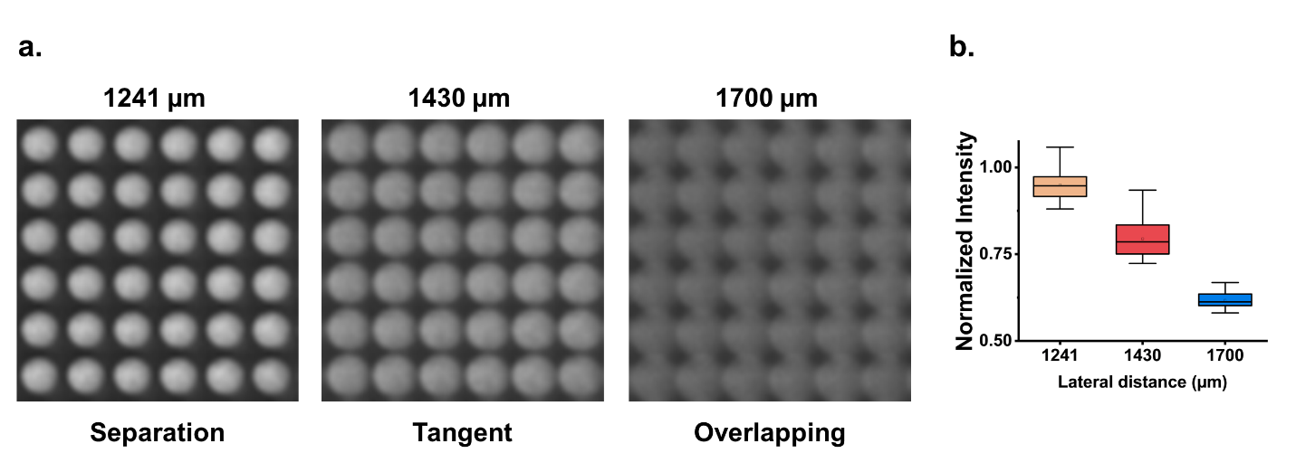
Supplementary Figure S6: Focal-shift characterization and preservation of f# -matched LFM operation. (a) Focal-pattern distributions of the fabricated metalens array measured at axial distances of 1241, 1430, and 1700 µm. The 1241-µm plane corresponds to the experimentally observed position of highest focal intensity, whereas 1430 µm is the designed focal length of the metalens array. At 1241 µm, neighboring focal patterns remain spatially separated; at the designed focal plane of 1430 µm, adjacent patterns become approximately tangent, satisfying the intended f#-matching condition; and at 1700 µm, substantial overlap occurs between neighboring patterns. (b) Corresponding normalized intensity distributions measured from the same 36 metalenses shown in (a) at each axial position. Although the highest focal intensity was observed at 1241 µm due to the experimentally measured focal shift, the normalized intensity at the designed focal plane of 1430 µm remained above 0.8, indicating that sufficient focal intensity was retained for image formation. More importantly, the 1430-µm plane satisfies the required f# matching condition, providing approximately tangential packing of neighboring focal patterns while avoiding both spatial separation and inter-lenslet overlap. Therefore, the designed focal plane was retained as the operating plane for LFM.
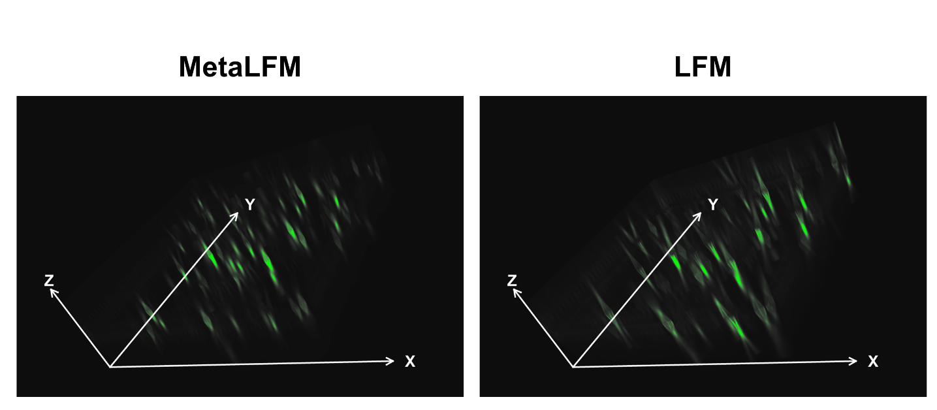
Supplementary Figure S7: Fluorescent bead distribution across the imaging volume. In addition to PSF analysis using fluorescent beads, reconstructed images were extracted at axial positions of −40 to +40 µm. At different depths, distinct beads appear in focus for both MetaLFM and conventional LFM, confirming similar bead distributions throughout the volume for both techniques. However, MetaLFM exhibits sharper bead reconstruction across depth, consistent with the resolution improvements quantified in Fig. 3c.
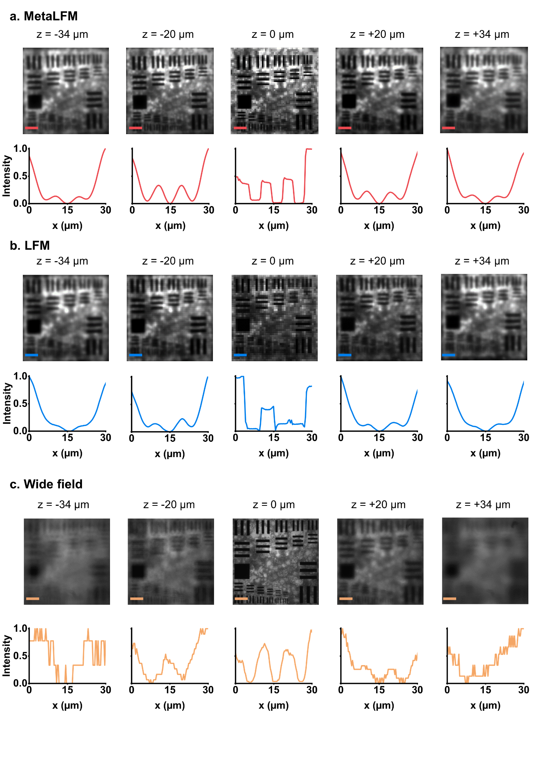
Supplementary Figure S8: Depth-dependent USAF resolution comparison among MetaLFM, conventional LFM, and wide field microscopy. (a-c) The USAF resolution target was imaged over the same axial range using (a) MetaLFM, (b) conventional LFM, and (c) wide-field microscopy, with representative planes shown at z = -34, -20, 0, +20, and +34 μm, under the same illumination and detection. For quantitative comparison, intensity profiles were extracted across USAF group 7-1, corresponding to a line width of 3.91 μm, which is close to the theoretically expected resolution of the system and is also representative of biologically relevant structures with characteristic dimensions of approximately 4-5 μm, such as dendritic features in the mouse spinal cord slice shown in Fig. 4. MetaLFM maintains a clearly recognizable group 7-1 pattern across depth, with the extracted profiles preserving the characteristic symmetric M-shaped modulation. Conventional LFM still produces measurable modulation at z = -20 and +20 μm, but the corresponding profiles become asymmetric and less representative of the original USAF pattern, indicating reduced reconstruction fidelity. At z = 0 μm, both light field techniques exhibit grid-like reconstruction artifacts; however, MetaLFM retains sufficient reconstruction fidelity for the underlying USAF pattern to remain identifiable despite the artifact. In contrast, wide-field microscopy provides the best resolving performance at z = 0 μm, but its image quality and pattern visibility deteriorate rapidly away from the focal plane. Overall, MetaLFM provides more consistent depth-dependent resolvability than conventional LFM while maintaining a substantially broader usable axial range than wide-field microscopy.
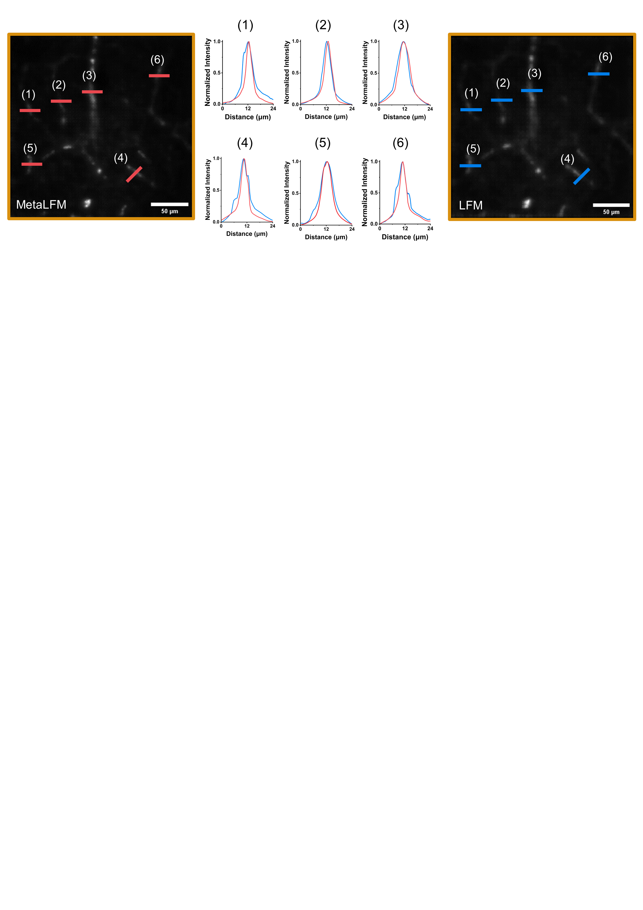
Supplementary Figure S9: Dendritic structure cross-sectional profiles. We analyzed dendritic structures within the mouse spinal cord section to compare the structural resolving capability of MetaLFM and conventional LFM (Fig. 4b). Six representative positions along the same dendrite were selected for direct comparison between the two techniques. Intensity profiles were extracted along the marked lines at each position. Across all measured positions, MetaLFM produced narrower intensity profiles than conventional LFM, consistent with the quantitative FWHM improvement shown in Fig. 4c. The improvement (%) was measured by $\frac{{FWHM}_{LFM} -{ FWHM}_{MetaLFM}}{{FWHM}_{LFM}}$.
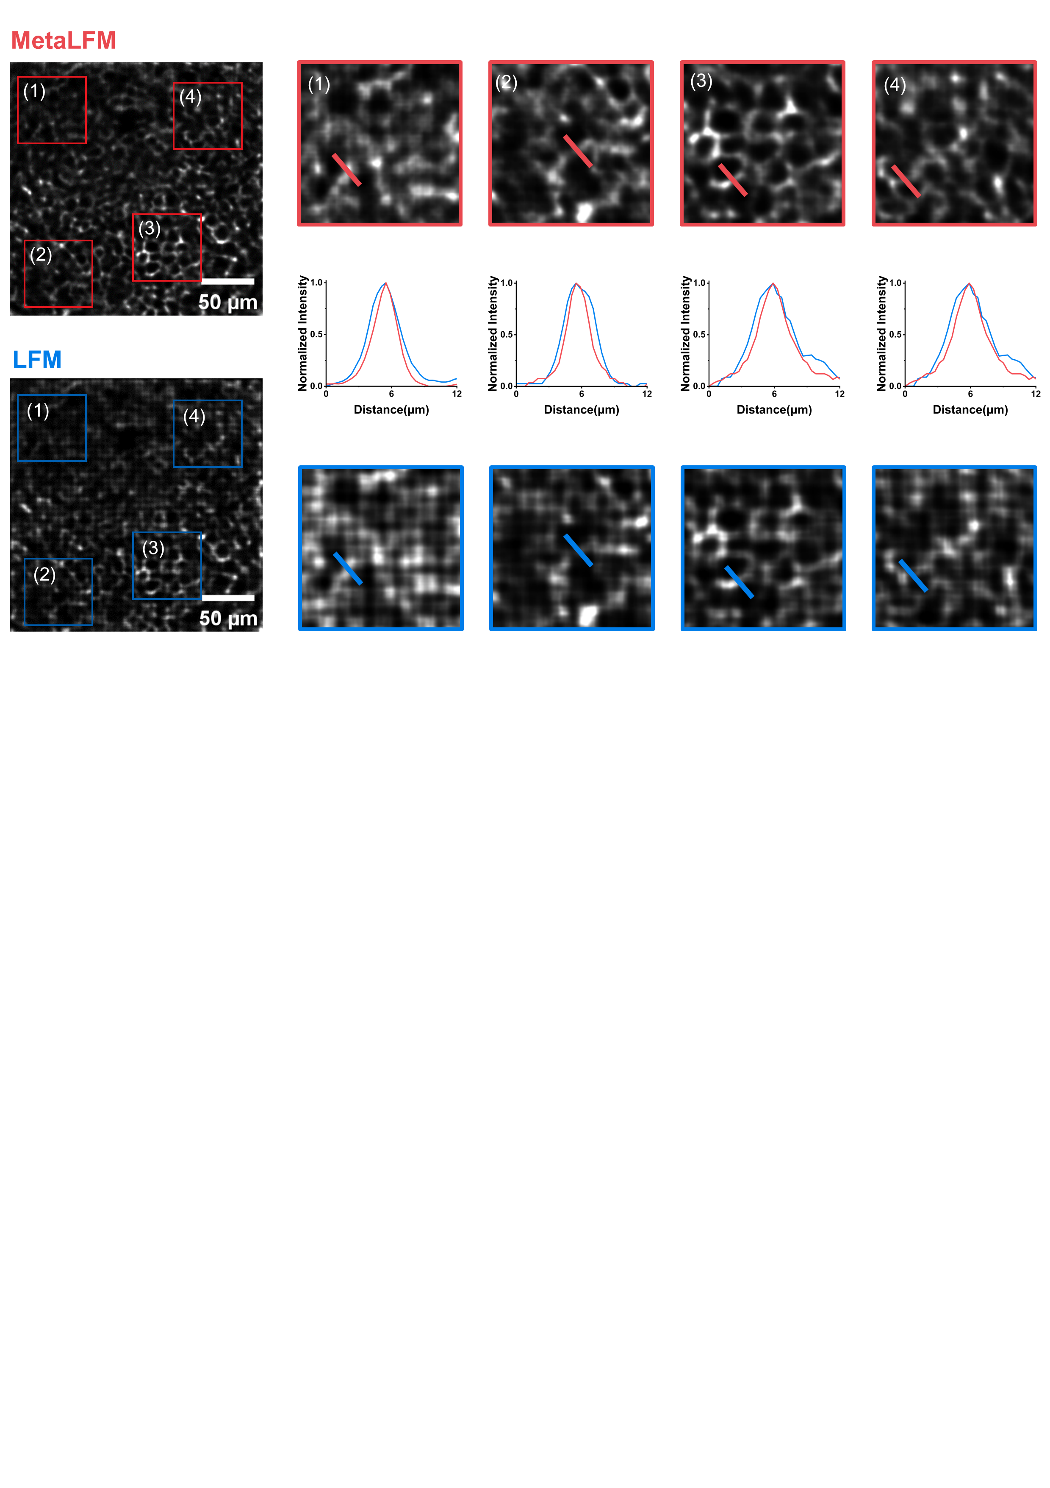
Supplementary Figure S10: Intestinal organoid structural cross-sectional profiles. To further compare the structural resolving capability of MetaLFM and conventional LFM in the intestinal organoid sample, we examined the characteristic honeycomb-like structures within the reconstructed volume (Fig. 5b). Four representative regions of interest (ROIs) were selected from the same reconstructed slice for both techniques. Enlarged views of these ROIs reveal that MetaLFM preserves clearer structural boundaries and finer features compared with LFM. For each ROI, intensity profiles were extracted along the marked structures (red lines for MetaLFM and blue lines for LFM). The resulting profiles consistently show narrower peaks for MetaLFM, indicating improved structural resolution. To obtain a more robust evaluation, we further analyzed a total of 15 structural positions across the organoid volume. Statistical analysis across 15 structural positions confirmed the FWHM reduction observed in the representative ROIs, consistent with Fig. 1e. P-values were calculated using a two-sided paired t-test for Fig. 1e.
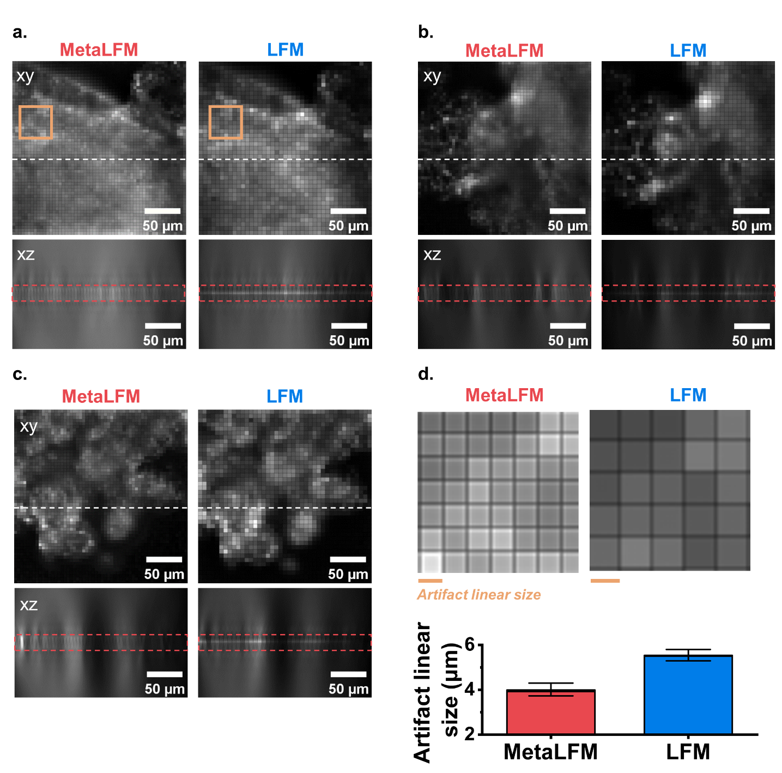
Supplementary Figure S11: Grid-like artifacts at and around NIP. (a-c) Intestinal organoids were used to illustrate the reconstruction artifacts due to their structural complexity and thickness. Panels present 3 representative examples of organoids, showing reconstructed images in the XY plane at z = 0 and at nearby planes close to the native image plane (NIP, marked by red boxes). The corresponding XZ cross-sectional views extracted along the white dashed lines are shown, highlighting the artifact patterns along the axial direction. In the LFM reconstructions, a brighter line appears near the NIP, where the artifacts are more pronounced than in MetaLFM reconstructions. (d) Quantitative analysis of the artifact linear size shows an approximately 1.4-fold reduction with MetaLFM compared with conventional LFM. The relative reduction in artifact size was calculated as $\frac{Average artifact linear size of MetaLFM}{Average artifact linear size of LFM}$ , illustrates that the artifact size was reduced by 1.4-fold. Linear dimensions were measured along both the x and y directions (n = 10 for each direction).
Supplementary Table 1. Quantitative analysis of focal-spot uniformity across nine representative regions of the metalens array.
The FWHM_{x} and FWHM_{y} values were measured from intensity line profiles extracted along the x- and y-directions through each focal spot, respectively. Spot ellipticity was calculated as the ratio of the larger to the smaller lateral FWHM: $E= \frac{max⁡({FWHM}_{x}, { FWHM}_{y})}{min⁡({FWHM}_{x}, { FWHM}_{y})}$, with E = 1 corresponding to a circular focal spot. For the intensity analysis, the focal intensity of each spot within a given region was normalized to the maximum focal intensity measured within that same region. For each region, 100 metalenses (10 × 10) were analyzed (n = 100 per region), corresponding to a total of 900 metalenses across the 9 regions (n = 900 for the overall analysis).
Parameters | Region
Parameters | 1 | 2 | 3 | 4 | 5
FWHM_{x} | 8.93 ± 0.25 | 8.94 ± 0.22 | 8.87 ± 0.23 | 8.99 ± 0.29 | 8.98 ± 0.24
FWHM_{y} | 9.05 ± 0.21 | 9.01 ± 0.24 | 8.96 ± 0.25 | 9.10 ± 0.23 | 9.09 ± 0.27
Spot ellipticity | 1.03 ± 0.03 | 1.03 ± 0.02 | 1.03 ± 0.02 | 1.03 ± 0.02 | 1.03 ± 0.02
Normalized intensity | 0.81 ± 0.06 | 0.84 ± 0.07 | 0.82 ± 0.07 | 0.84 ± 0.06 | 0.84 ± 0.06
Parameters | Region
Parameters | 6 | 7 | 8 | 9 | Overall
FWHM_{x} | 8.99 ± 0.25 | 8.81 ± 0.22 | 9.01 ± 0.24 | 8.93 ± 0.28 | 8.95 ± 0.27
FWHM_{y} | 9.12 ± 0.24 | 8.95 ± 0.23 | 9.03 ± 0.30 | 9.10 ± 0.29 | 9.03 ± 0.26
Spot ellipticity | 1.03 ± 0.03 | 1.03 ± 0.02 | 1.03 ± 0.02 | 1.03 ± 0.02 | 1.03 ± 0.02
Normalized intensity | 0.85 ± 0.07 | 0.85 ± 0.06 | 0.83 ± 0.07 | 0.80 ± 0.08 | 0.83 ± 0.07

Supplementary Table 2: Spatial resolution improvement across DOF.
The improvement (%) was measured by $\frac{{FWHM}_{LFM} -{ FWHM}_{MetaLFM}}{{FWHM}_{LFM}}$.
Depth (μm) | Average lateral resolution (μm) |  |  | Average axial resolution (μm)
Depth (μm) | MetaLFM | LFM | Improvement | MetaLFM | LFM | Improvement
+40 | 5.45 | 6.58 | 17% | 20.14 | 28.05 | 28%
+30 | 4.33 | 5.66 | 24% | 16.49 | 21.69 | 24%
+20 | 3.10 | 3.42 | 9% | 12.95 | 15.08 | 14%
+10 | 2.13 | 2.58 | 17% | 9.36 | 10.38 | 10%
-10 | 2.45 | 3.10 | 21% | 11.05 | 12.22 | 10%
-20 | 2.72 | 4.84 | 44% | 11.27 | 15.37 | 27%
-30 | 4.02 | 7.18 | 44% | 14.62 | 20.84 | 30%
-40 | 5.26 | 8.55 | 39% | 16.12 | 26.26 | 39%

Supplementary Table 3: Comparison of MetaLFM with other LFM techniques (Fig. 3d).
Ref. in main text | Lateral resolution (μm)* | Axial resolution  (μm)* | Reported depth range (μm)**
MetaLFM | 2.1 | 9.4 | 150
[9] | 7.8 | 24.1 | 262
[10] | 3.4 | 11.3 | 200
[12] | 2.0 | 10 | 80
[14] | 5.1 | 6.1 | 32
[15] | 6.0 | 30 | 360
[16] | 4.0 | 7.0 | 80
[28] | 3.0 | 6.0 | 100
[29] | 3.5 | 9.0 | 260
[30] | 3.2 | 2.8 | 300
[31] | 2.4 | 5.7 | 100
[32] | 3.5 | 6.0 | 200
[33] | 1.8 | 15 | 100
[34] | 1.9 | 9.5 | 200
[35] | 3.0 | 5.0 | 80
[36] | 5.0 | 14.0 | 100
* For references without reported resolution values, the resolution was estimated from the PSF plots provided in the original publications.
** The reported depth range corresponds to the maximum axial extent described in each reference, regardless of whether it is defined as DOF, DOV, or a representative imaging depth selected in the original study. Values are taken directly from the original publications. In this work, the reported value corresponds to the depth of view (DOV).
Supplementary Table 4: List of main equipment
Item | Acronym | Description | Part number | Manufacturer/Vendor
Excitation laser  (for MetaLFM/LFM) | Laser | 475 nm laser | MBL-III-473-100mW | Changchun New Industries Optoelectronics Technology Co., Ltd., China
Laser  (for focusing test) | Laser | Set at 525 nm | SLM70 | Spectrolight
Lens | L1 | Lens diameter = Ø1"  Focal length = 150 mm | AC254-150-A-ML | Thorlabs
Dichroic mirror | DM | Long-pass DM  Edge wavelength = 500 nm | FITC-Di01-Clin-25x36 | Semrock
Objective lens  (for MetaLFM/LFM) | OBJ | 20×/0.5 NA  Water immersion, | UMPLFLN20XW | Olympus
Objective lens  (for focusing test) | OBJ | 4×/0.1 NA  Air immersion | Plan 4X/0.10 | Nikon
Tube lens | TL | Lens diameter = Ø2"  Focal length = 180 mm | TTL180-A | Thorlabs
Relay lens | Relay 1:1 | Macro lens  Canon EF 100 mm 1:2.8 USM |  | Canon
sCMOS camera  (for MetaLFM/LFM) | sCMOS | Pixel size = 6.5 µm  2048 x 2040 pixels | ORCA-Flash 4.0 | Hamamatsu
sCMOS camera  (for wide field imaging) |  | Pixel size = 6.5 µm  2048 x 2040 pixels | Dhyana 400DC | Tucsen
CMOS camera  (for focusing test) | CMOS camera | Pixel size = 5.04 µm  1920 x 1080 pixels | CS2100M-USB | Thorlabs
Metalens array | MeLA | Pitch = 75 µm  Lenslet linear size = 71.5 µm  Focal length = 1430 µm |  | Henan OMEDA Technologies
Microlens array  (for LFM) | MLA | Pitch = 100 µm  Focal length = 2100 µm | MLA-S100-f21 | RPC Photonics

References
1. Kim, J. et al. F-number matching method in light field microscopy using an elastic micro lens array. Opt. Lett. 41, 2751–2754 (2016).
2. Lu, Z. et al. A practical guide to scanning light-field microscopy with digital adaptive optics. Nat. Protoc. 17, 1953–1979 (2022).
3. Levoy, M., Ng, R., Adams, A., Footer, M. & Horowitz, M. Light Field Microscopy. ACM Trans. Graph 25, 924–934 (2006).
4. Guo, C., Liu, W., Hua, X., Li, H. & Jia, S. Fourier light-field microscopy. Opt. Express 27, 25573–25594 (2019).
5. Bai, Y. et al. Multiscale Light Field Microscopy Platform for Multi-purpose Dynamic Volumetric Bioimaging. bioRxiv 2024.09.30.615205 (2024) doi:10.1101/2024.09.30.615205.

