Construct Validity of C-QDQ-P
An exploratory factor analysis using principal component analysis with Kaiser-normalized varimax rotation extracted two factors, and the factor loadings of all items on their respective factors exceeded 0.50 (Table S1).
Table S1 Rotated factor loadings from the exploratory factor analysis of C-QDQ-P
Item | Factor loading
Item | Delay aversion | Delay discounting
Q1 | 0.020 | 0.514
Q2 | 0.816 | 0.090
Q3 | 0.421 | 0.536
Q4 | 0.765 | -0.036
Q5 | -0.029 | 0.699
Q6 | 0.755 | 0.273
Q7 | 0.222 | 0.690
Q8 | 0.619 | 0.170
Q9 | 0.721 | -0.035
Q10 | 0.027 | 0.562
Confirmatory factor analysis modeled the 10 items of the C-QDQ-P as observed variables and the two factors (delay aversion and delay discounting) as latent variables. The model fit indices (χ²/df, CFI, SRMR, RMSEA, and PClose) were shown in Table S2. The initial model showed suboptimal fit. After modification based on modification indices, the fit improved to an acceptable level (Table S2); the modified model is shown in Figure S1. The factor loadings of all 10 items on their respective factors ranged from 0.596 to 0.885, all exceeding the 0.50 criterion. The average variance extracted (AVE) and composite reliability (CR) were 0.55 and 0.86 for delay aversion, and 0.52 and 0.84 for delay discounting, respectively (Table S3).
Table S2 Model fit indices of C-QDQ-P
 | χ2/df | CFI | SRMR | RMSEA | PClose
Pre-modification Model | 2.926 | 0.864 | 0.091 | 0.133 | 0.000
Post-modification Model | 1.642 | 0.964 | 0.071 | 0.077 | 0.138
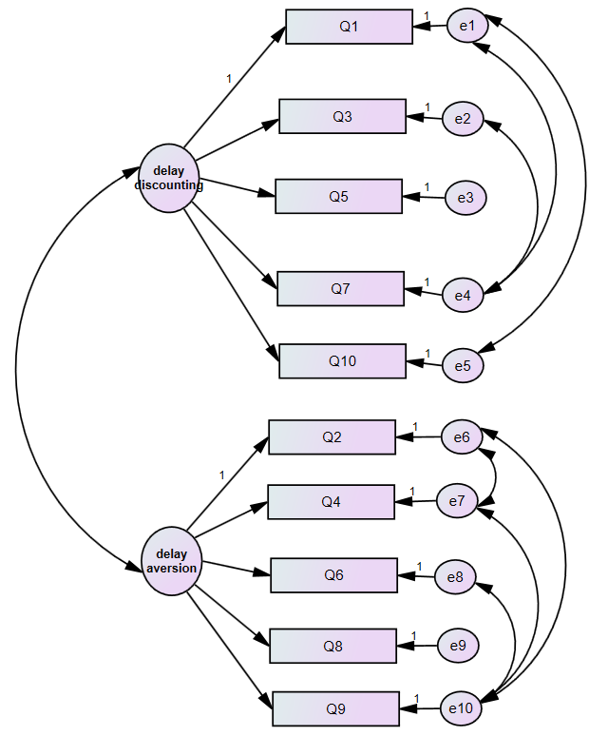
Figure S1 Modified factor model of C-QDQ-P

Table S3 Convergent validity of C-QDQ-P
 |  |  | Factor loading | AVE | CR
Q2 | ⬅ | Delay aversion | 0.606 | 0.55 | 0.86
Q4 | ⬅ | Delay aversion | 0.626 | 0.55 | 0.86
Q6 | ⬅ | Delay aversion | 0.811 | 0.55 | 0.86
Q8 | ⬅ | Delay aversion | 0.885 | 0.55 | 0.86
Q9 | ⬅ | Delay aversion | 0.751 | 0.55 | 0.86
Q1 | ⬅ | Delay discounting | 0.682 | 0.52 | 0.84
Q3 | ⬅ | Delay discounting | 0.763 | 0.52 | 0.84
Q5 | ⬅ | Delay discounting | 0.596 | 0.52 | 0.84
Q7 | ⬅ | Delay discounting | 0.858 | 0.52 | 0.84
Q10 | ⬅ | Delay discounting | 0.680 | 0.52 | 0.84

Network Analysis
Among the 41 nonzero edges, the strongest connection was HI–Inhibit (r = 0.523, 95% CI [0.390, 0.574]), followed by Shift–Emotional Control (r = 0.482, 95% CI [0.355, 0.553]), Inhibit–Monitor (r = 0.372, 95% CI [0.266, 0.436]), and Initiate–Plan/Organize (r = 0.342, 95% CI [0.229, 0.424]). Thirty-five of the 41 edges had bootstrap 95% CIs excluding zero, whereas six edges—all negative—showed CIs including zero and were therefore not reliably estimated. Among cross-community edges, DA–Inhibit (r = 0.137, 95% CI [0.029, 0.220]) was stable, whereas the IA–DD connection was weak and borderline (r = 0.133, 95% CI [0.000, 0.234]). In addition, the lower CI bounds of many weak positive edges approached zero (Figure S2).
The correlation-stability (CS) coefficient was 0.71 for node strength and 0.68 for bridge expected influence, both exceeding the recommended threshold of 0.50, indicating that the centrality ordering remained stable when up to approximately 68%–71% of the sample was dropped. Table S4 reports bridge centrality, including bridge expected influence with 95% bootstrap confidence intervals and bridge betweenness, and Table S5 reports node centrality, including strength, betweenness, closeness, and expected influence.

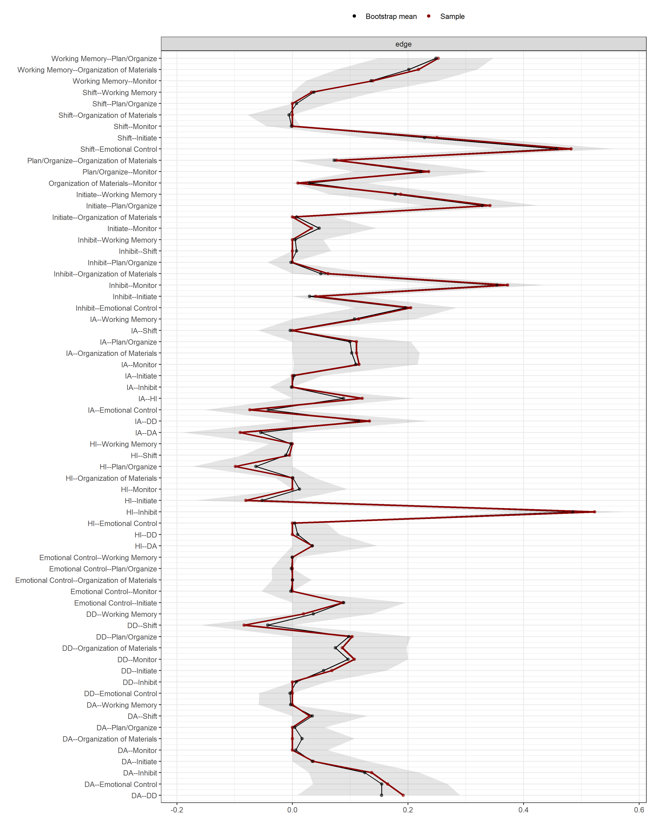
Figure S2 Nonzero edge weights with 95% bootstrap confidence intervals (dashed line = 0).
IA: Inattentive; HI: Hyperactive-Impulsive; DA: Delay Aversion; DD: Delay Discounting
Table S4 Bridge centrality: bridge expected influence with 95% bootstrap confidence intervals and bridge betweenness.
Node | Bridge Expected Influence | BEI Bootstrap CI |  | Bridge betweenness
Node | Bridge Expected Influence | 2.5% | 97.5% | Bridge betweenness
Inhibit | 0.660 | 0.481 | 0.747 | 13
DD | 0.433 | 0.231 | 0.657 | 2
IA | 0.421 | 0.221 | 0.635 | 0
HI | 0.372 | 0.261 | 0.568 | 2
DA | 0.311 | 0.167 | 0.525 | 2
Monitor | 0.222 | 0.073 | 0.389 | 8
Organization of Materials | 0.197 | 0.036 | 0.371 | 0
Working Memory | 0.134 | 0.003 | 0.286 | 1
Plan/Organize | 0.115 | -0.045 | 0.313 | 5
Emotional Control | 0.091 | -0.049 | 0.259 | 4
Initiate | 0.024 | -0.126 | 0.210 | 1
Shift | -0.060 | -0.168 | 0.100 | 1
IA: Inattentive; HI: Hyperactive-Impulsive; DA: Delay Aversion; DD: Delay Discounting

Table S5 Node centrality: strength, betweenness, closeness, and expected influence.
Node | Strength | Betweenness | Closeness | Expected Influence
IA | 0.8700 | 0 | 0.0088 | 0.5411
HI | 0.8627 | 1 | 0.0098 | 0.4930
DA | 0.6838 | 1 | 0.0085 | 0.5028
DD | 0.7927 | 1 | 0.0084 | 0.6249
Inhibit | 1.3388 | 14 | 0.0115 | 1.3388
Shift | 0.8839 | 5 | 0.0103 | 0.7054
Emotional Control | 1.0125 | 6 | 0.0106 | 0.8646
Initiate | 1.1242 | 6 | 0.0107 | 0.9631
Working Memory | 0.9630 | 7 | 0.0097 | 0.9630
Plan/Organize | 1.2188 | 6 | 0.0119 | 1.0210
Organization of Materials | 0.5621 | 0 | 0.0075 | 0.5621
Monitor | 1.0119 | 12 | 0.0121 | 1.0119
IA: Inattentive; HI: Hyperactive-Impulsive; DA: Delay Aversion; DD: Delay Discounting

