Supplementary Materials

Low-Cost Gold Nanoparticle-Coated Aluminium Foil for SERS Detection of Chlorpyrifos in Honey

James Tate¹, Udit Pant¹, Xiaotong Liu¹, Anastasios Koidis¹, and Cuong Cao^{1,2*}
Institute for Global Food Security, School of Biological Sciences, Queen’s University of Belfast, Chlorine Gardens, Belfast, BT9 5DL, United Kingdom
Material and Advanced Technologies for Healthcare, Queen’s University of Belfast – 18-30 Malone Road Belfast, BT9 5DL, United Kingdom
*Corresponding author: c.cao@qub.ac.uk

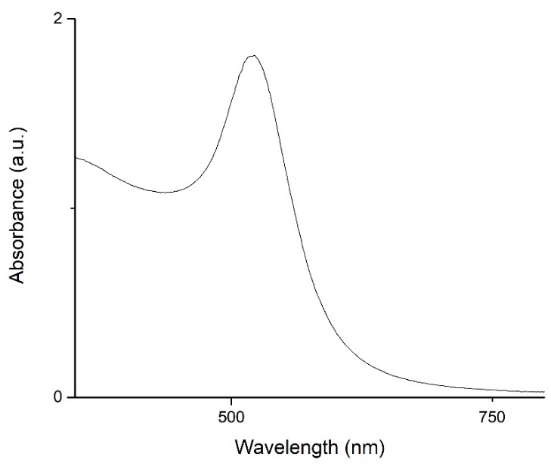

Fig. S1 The measured absorbance of synthesised AuNPs using a U/V visible-spectrometer.
Calculation of the concentration of the synthesised AuNP solution:
The highest absorbance peak, expected to be in proximity of 520 nm (1.80) and the absorbance value at 450 nm (1.09) are taken. The diameter of the AuNPs can then be calculated using the following ratio:
$$r=\frac{maximum absorbance}{absorbance at 450 nm}$$
$$r=\frac{1.80}{1.09}=1.65$$
The calculated ratio was then input into a data table to equate the ɛ value¹. An ɛ value of 2.67x108 M⁻¹cm⁻¹ and an AuNP diameter of 16 nm was subsequently calculated:
$$c=\frac{A_{450}}{ɛ_{450}}= \frac{1.09}{2.67x{10}^{8}}=8.19 nM$$

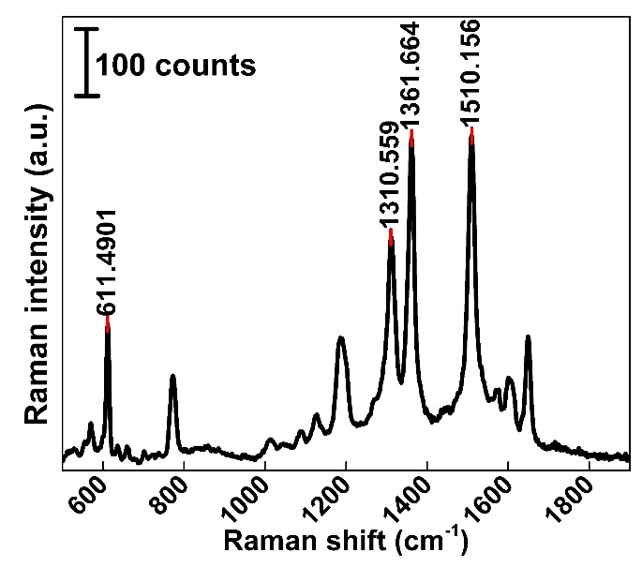

Fig. S2 Characteristic Raman bands of 10⁻³ M R6G on ALF@AuNPs substrate

Table S.1 Band assignments for R6G
Raman shift (cm⁻¹) | Band assignment | Raman shift in literature (cm⁻¹) | Reference
611.5 | C-C-C bending mode | 611 | ²
1310.6 | C-H in-plane bending | 1318 | ²
1361.7 | C-C stretching | 1366 | ²
1510.2 | C-N stretching | 1512 | ²

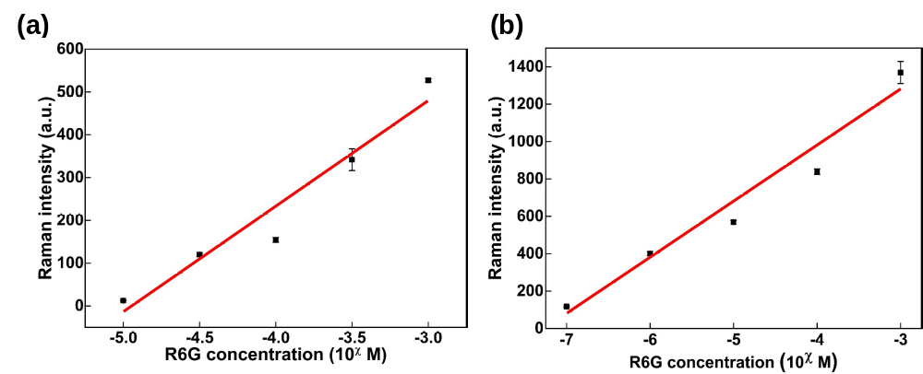
Fig. S3 Raman intensity at 1362 cm⁻¹ as a function of R6G concentration on (a) Si@AuNPs and (b) ALF@AuNPs. Error bars represent standard deviation (σ, n = 3).

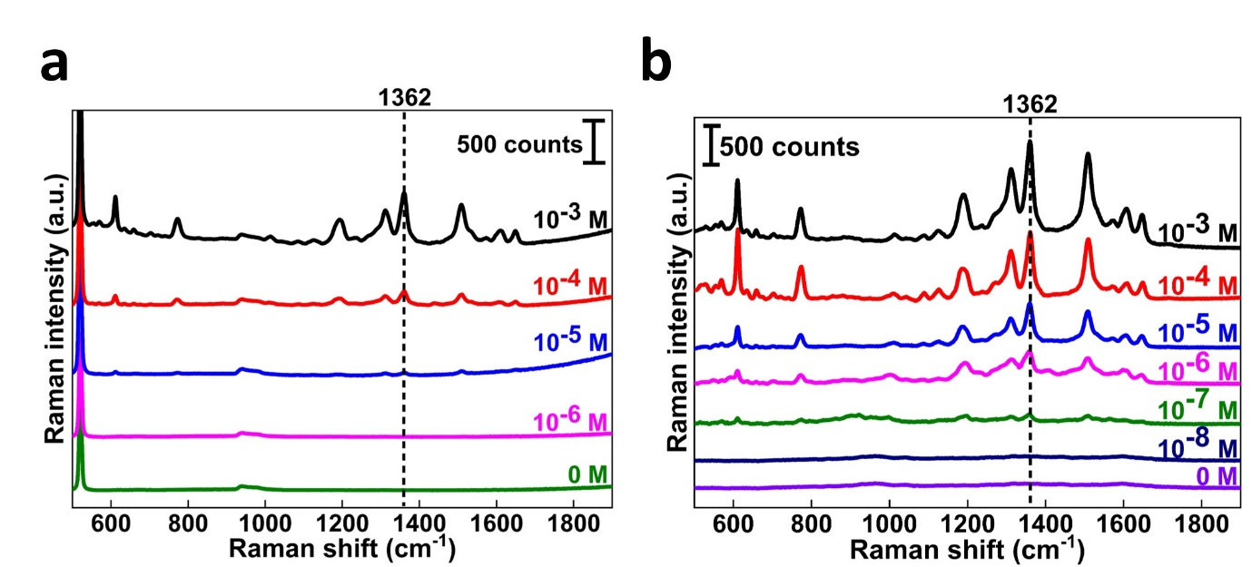
Fig. S4 (a) SERS spectra of Si@AuNPs with decreasing concentrations of R6G (10⁻³M to 10⁻⁶M, black line to green line, respectively). (b) SERS spectra of ALF@AuNPs with decreasing concentrations of R6G (10⁻³ M to 10⁻⁸ M, black line to lilac line, respectively).

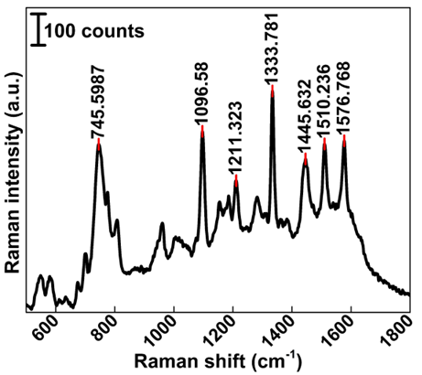

Fig. S5 Characterisation of 10⁻⁵ M CPY on ALF enhanced with AuNPs
Table S.2 full band assignments for CPY
Raman shift (cm⁻¹) | Band assignment | Raman shift in literature (cm⁻¹) | Reference
1096.7 | v(P-O-C) | 1097 | ³
1211.3 | Cl-ring, σ(C-H), | 1209 | ³
1333.8 | Cl-ring, σ(C-H), Vas (C=C) | 1333 | ³
1445.6 | Cl-ring, v(C-N), σ(C-H) | 1440 | ³
1510.2 | Cl-ring, v(C=C) | 1509 | ³
1576.8 | pyridine ring stretching | 1575 | ³

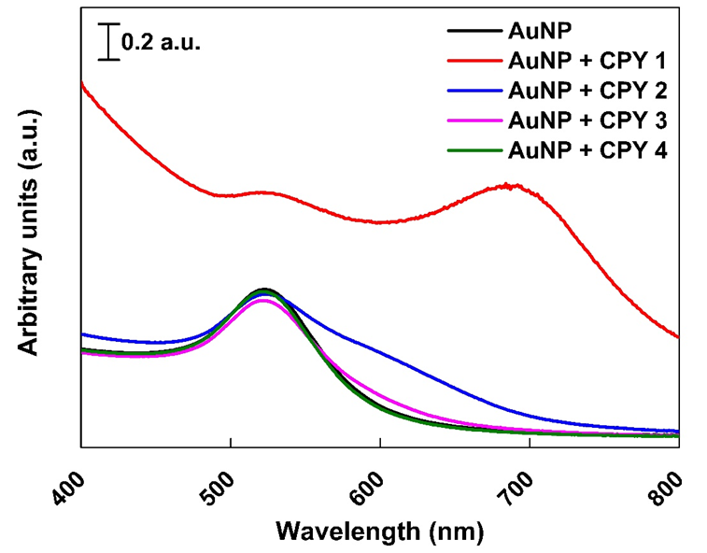

Fig. S6 UV-vis spectrum of colloidal AuNPs mixed at a 1:1 ratio with decreasing concentrations of CPY (10⁻³M, 10⁻⁴ M, 10⁻⁵ M and 10⁻⁶ M correspond to CPY 1, 2, 3, & 4, respectively).

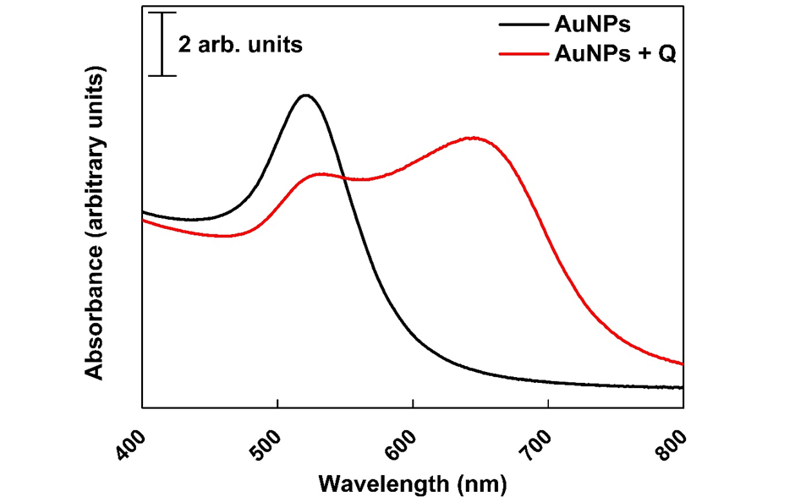

Fig. S7 UV-vis spectrum of colloidal AuNPs mixed at a 1:1 ratio with water (black line) and at a 1:1 ratio with QuEChERS extract (red line).

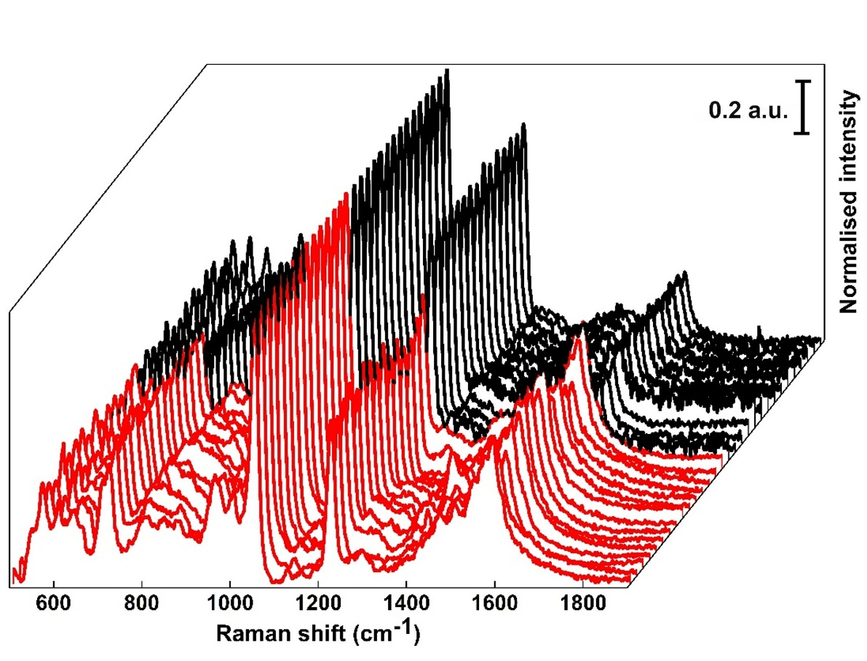
Fig. S8 SERS Spectra (n = 30) collected for honey spiked with 10⁻⁵ M CPY, 10⁻⁵ M fenthion, 10⁻⁵ M of profenofos and 10⁻⁵ M diazinon (OGP + CPY) (black lines) after QuEChERS extraction and SERS spectra collected for honey spiked with 10⁻⁵ M fenthion, 10⁻⁵ M of profenofos and 10⁻⁵ M diazinon (OGP) (red lines) after QuEChERS extraction on ALF@AuNPs.

References
1 Haiss, W., Thanh, N. T. K., Aveyard, J. & Fernig, D. G. Determination of Size and Concentration of Gold Nanoparticles from UV−Vis Spectra. Analytical Chemistry 79, 4215-4221 (2007). https://doi.org/10.1021/ac0702084
2 Kulakovich, O. S. et al. Nanoplasmonic Raman detection of bromate in water. Opt. Express 24, A174-A179 (2016). https://doi.org/10.1364/OE.24.00A174
3 Xu, Q. et al. Template-free synthesis of SERS-active gold nanopopcorn for rapid detection of chlorpyrifos residues. Sensors and Actuators B: Chemical 241, 1008-1013 (2017). https://doi.org/https://doi.org/10.1016/j.snb.2016.11.021

