Supplementary Material
Intraoperative Inspired Oxygen Exposure and Mechanical Ventilation Recorded 24–48 Hours After Intracranial Neurosurgery: An INSPIRE Cohort Study
Shikun Li, Xu Chen, Rudong Chen, Zhuo Yang, Yuyang Hou, Jiasheng Yu

Supplementary methods

Supplementary Methods S1. Formal-analysis amendment and outcome-selection sequence
The feasibility phase was designed to establish whether the INSPIRE variables could support a reproducible continuous oxygen exposure and clinically interpretable postoperative outcomes. Ninety-day mortality was initially evaluated as the principal outcome. Feasibility models did not show a clear adjusted association with 90-day mortality, whereas postoperative ventilation records showed a graded association across the fixed exposure categories used for data checking. This observation prompted a formal amendment that designated at least one vent=1 record during postoperative hours 24–48 as the primary outcome.
The amended outcome and its cautious terminology were fixed before the formal MICE analysis, restricted cubic-spline modelling, and protocol-defined sensitivity analyses. The temporal outcome-audit rules were then applied uniformly to all primary events. Exposure was analysed continuously per 10 TWAEO percentage points; the fixed quartiles were retained only for descriptive presentation. No oxygen threshold was selected by inspecting the primary-outcome curve, and the spline analysis was used to test the overall association and departure from linearity rather than to derive a treatment cut-off. This sequence should be considered when interpreting the findings and reinforces the need for independent validation.

Supplementary tables

Supplementary Table S1. Primary MICE model coefficients
Term | Adjusted OR | 95% CI | P value
TWAEO per 10 points | 1.54 | 1.18–2.02 | .0017
Age per 10 years | 1.23 | 1.04–1.45 | .015
Male sex | 1.69 | 1.06–2.70 | .027
ASA per class | 1.30 | 0.96–1.76 | .093
Emergency surgery | 5.26 | 2.30–12.00 | <.001
Haemorrhage/decompression | 2.35 | 1.02–5.40 | .045
Operation duration per hour | 1.64 | 1.45–1.86 | <.001
BMI per 5 kg/m² | 0.58 | 0.41–0.82 | .002
SpO₂ <92% burden per 1% time | 1.15 | 0.46–2.88 | .763

Supplementary Table S2. Missingness before imputation
Variable | Missing, n (%)
ASA class | 59 (3.7)
BMI | 42 (2.6)
Median PEEP | 280 (17.5)
Median VT/PBW | 20 (1.2)
Dynamic driving pressure | 280 (17.5)
Estimated blood loss | 47 (2.9)
Fluid rate | 34 (2.1)

Supplementary Table S3. Comparison of TWAEO and mean FiO₂ in the complete-case sample
Model | AIC | C-statistic
Adjusted covariates only | 478.33 | 0.846
Covariates + TWAEO | 468.19 | 0.859
Covariates + mean FiO₂ | 468.12 | 0.859
Complete-case n=1,504 with 70 events. Pearson correlation between TWAEO and mean FiO₂ was 0.99994. A joint model was not fitted because of near-perfect collinearity.

Supplementary Table S4. Operational definition of major intracranial neurosurgery
Operational category | Included five-character ICD-10-PCS codes or groups | Applied rule
Tumor/skull-base | 00B00, 00B0X, 00B0D, 00B60, 00B64, 0GQ0* | The five listed 00B codes exactly, or any code beginning with 0GQ0
Cerebrovascular | 03LG*, 03VG* | First three characters 03L or 03V, with G as the fourth character
Haemorrhage/decompression | 00900, 0090D, 00907, 00910, 00913, 00940, 00D0X, 0NB00 | The eight listed five-character codes exactly
Other intracranial | 00L00, 00Q00, 00Q10, 00Q60, 00T60 | The five listed five-character codes exactly
An asterisk denotes any fifth character following the specified four-character prefix. All codes without an asterisk were matched exactly at five characters. Candidate operations additionally required age ≥18 years, general anaesthesia, neurosurgery department attribution, and a positive recorded operation duration. Diagnostic inspection and ventricular-shunt procedures were not included in the curated code set.
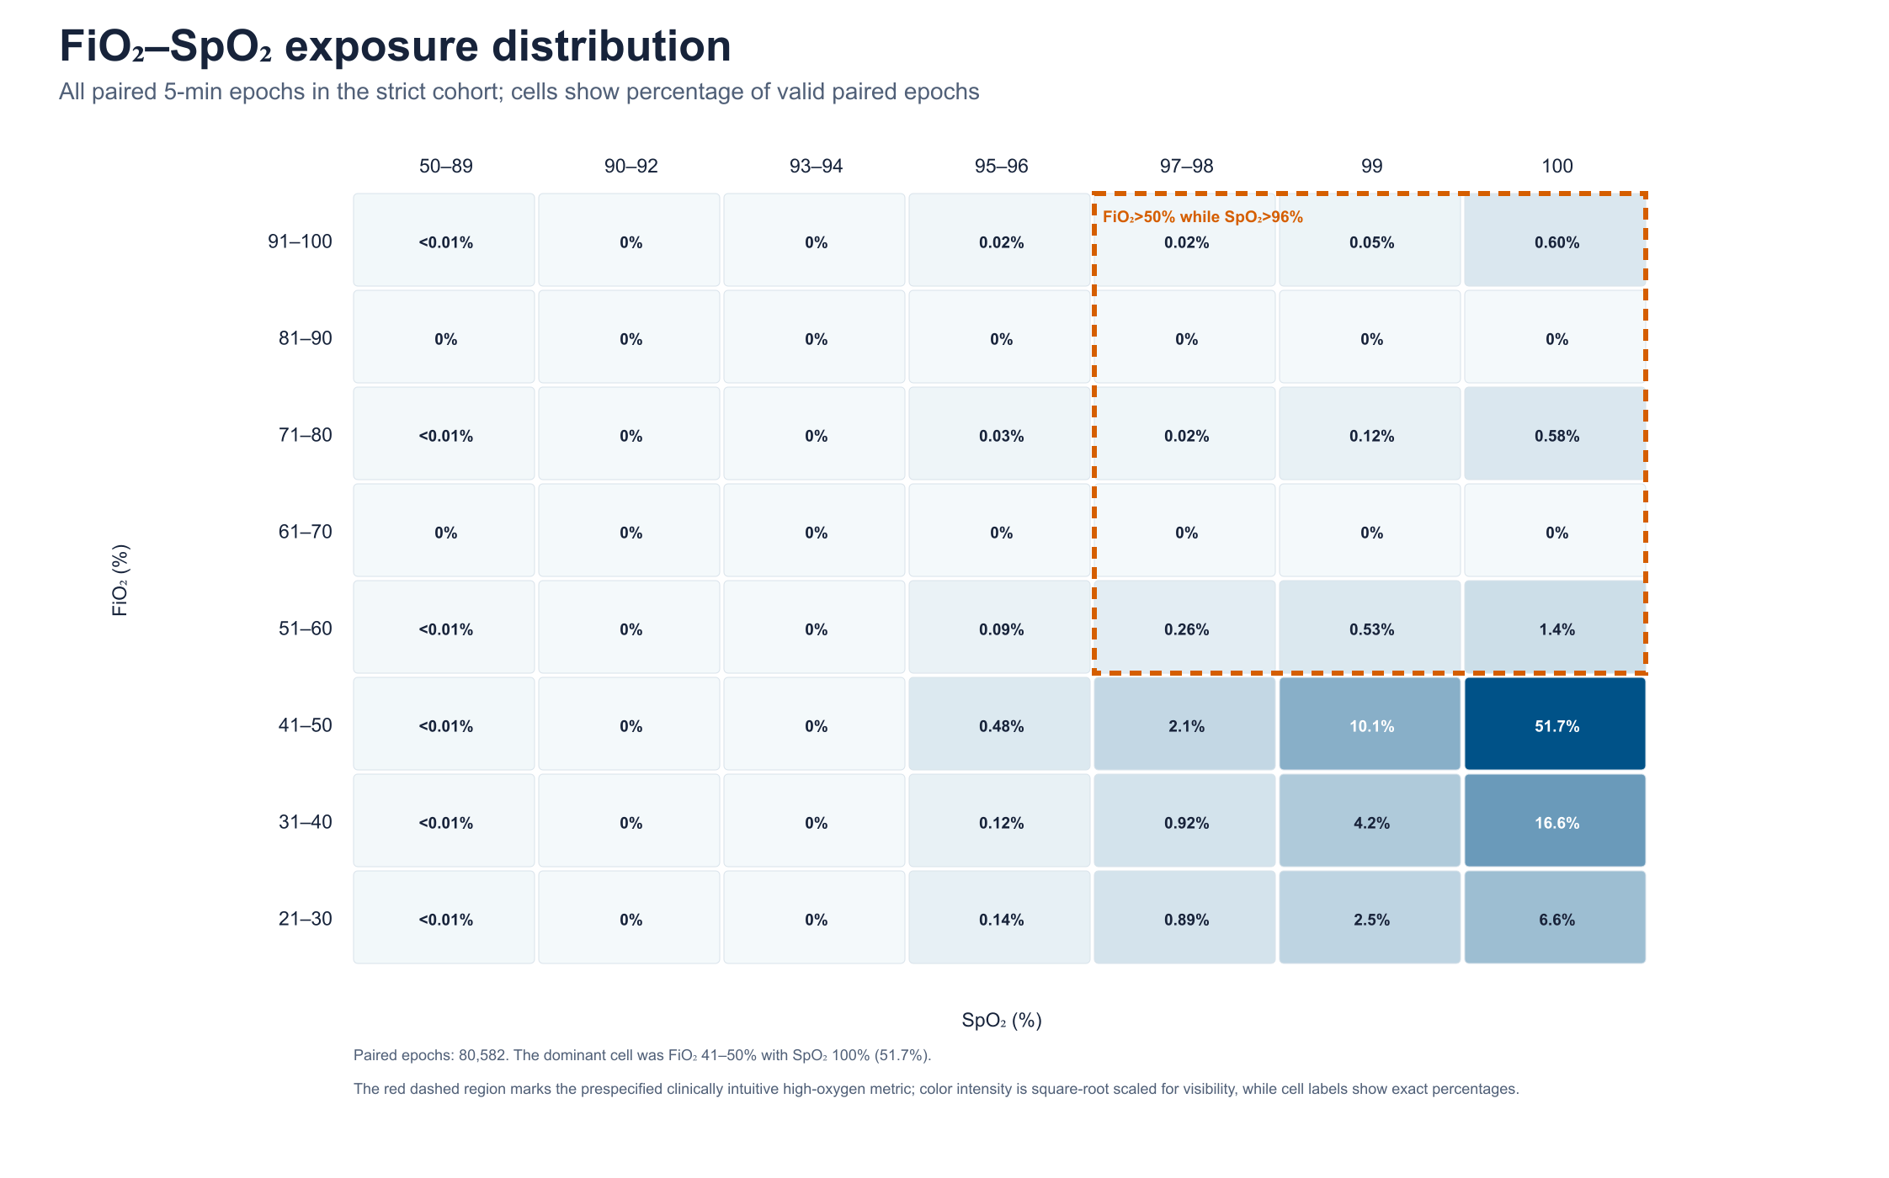
Supplementary Figure S1. Joint FiO₂–SpO₂ distribution. The heat map displays paired intraoperative FiO₂ and SpO₂ observations, illustrating near-uniform adequate saturation and explaining the near-perfect correlation between TWAEO and mean FiO₂.

