Supplementary Figures and Legends
Supplementary Figure S1. The flowchart of this study.
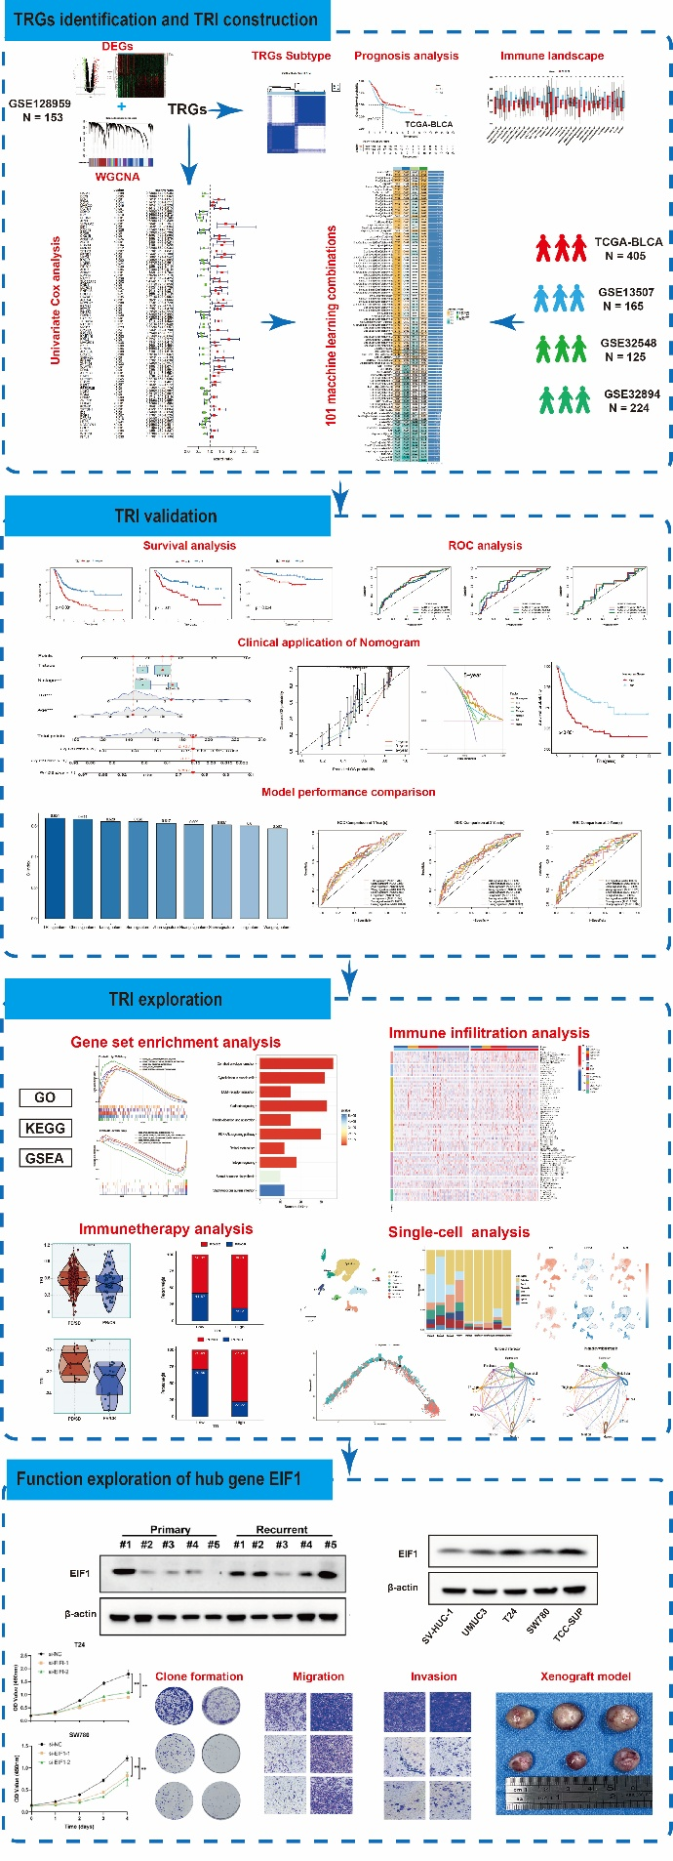
Supplementary Figure S2. Functional enrichment analysis of TRGs. (A) GO enrichment analysis of TRGs. (B) KEGG enrichment analysis of TRGs.
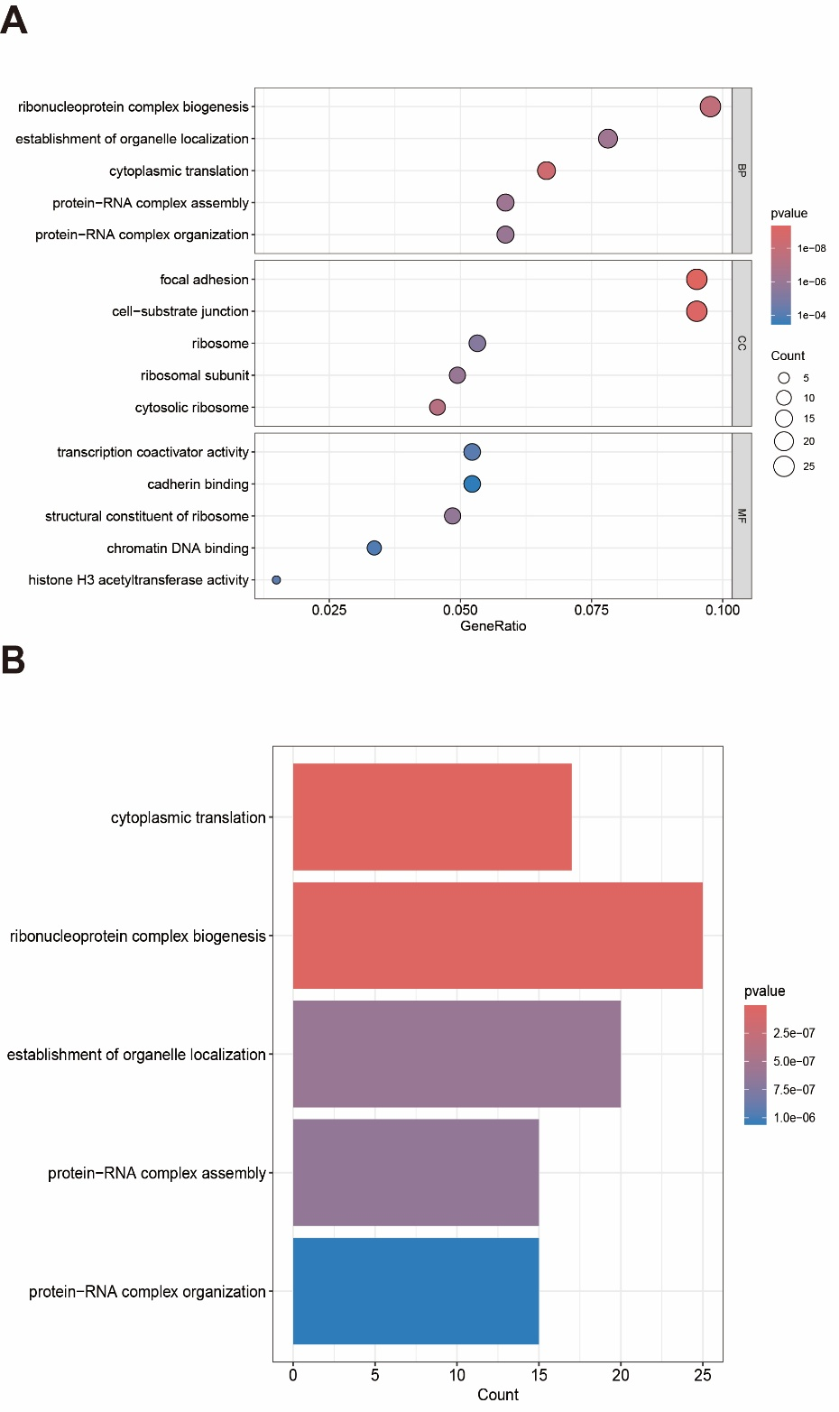

Supplementary Figure S3. Clinical features and Hallmark pathway activity profiles between R1 and R2 cluster. (A) Complex heatmap showing the distribution of clinical characteristics (Age, Gender, Stage, and T stage) across the two identified subtypes. (B) The heatmap illustrating the single-sample gene set enrichment analysis (ssGSEA/GSVA) scores of 50 canonical Hallmark pathways in individual samples grouped by R1 and R2 cluster. (C) Box plots comparing the Hallmark pathway scores between R1 (red) and R2 (blue) subcluster.

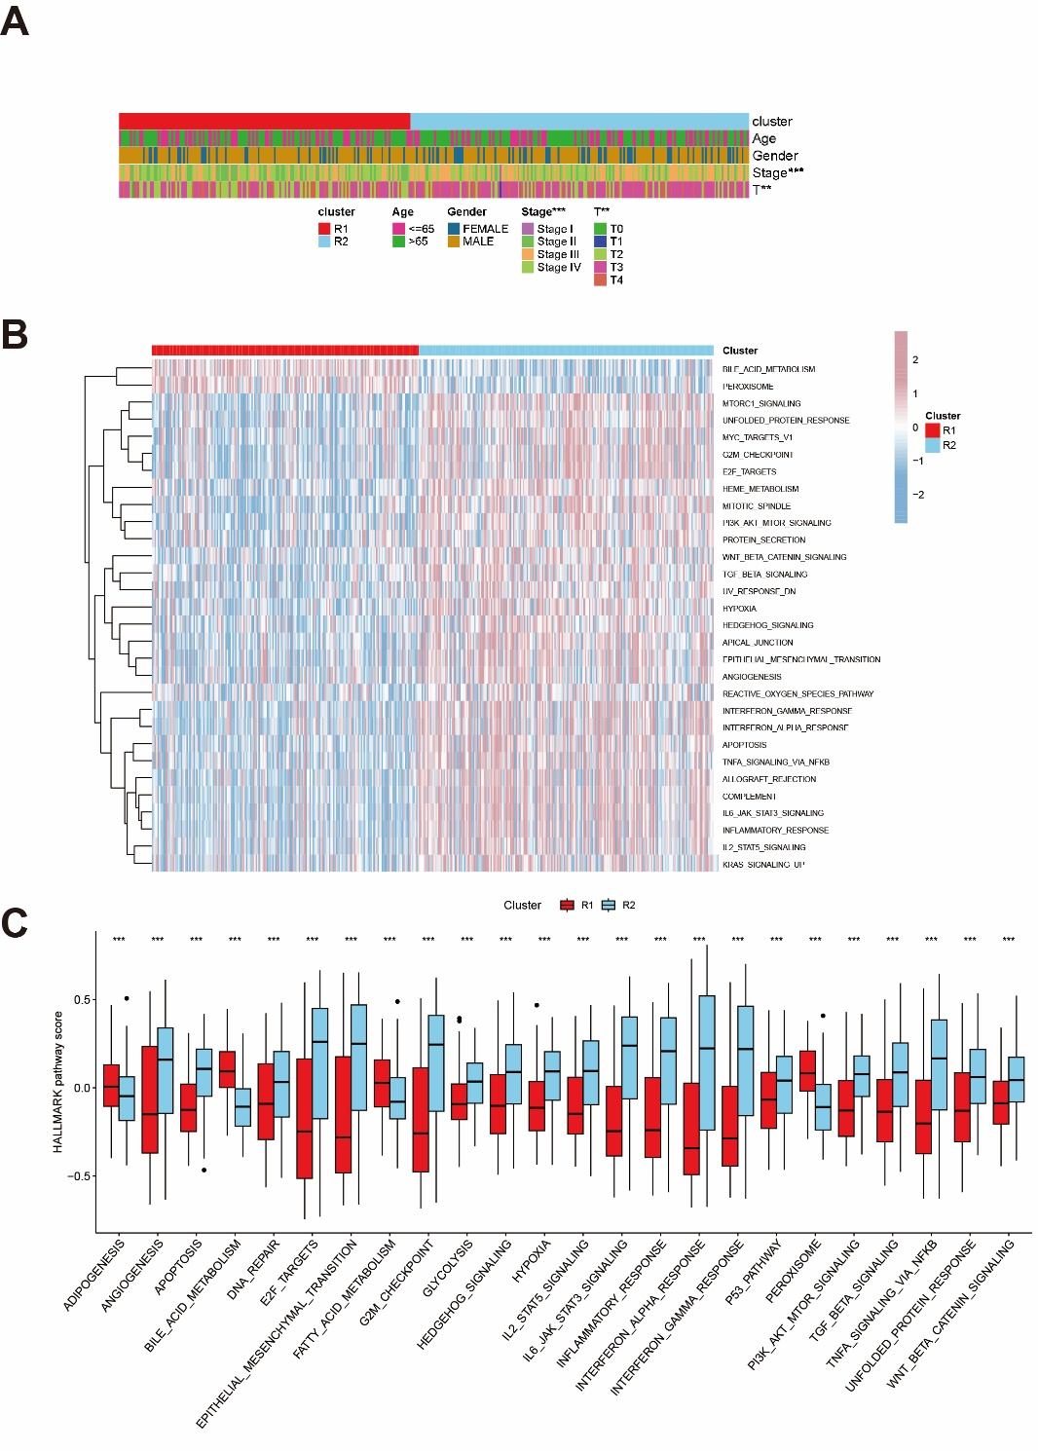

Supplementary Figure S4. Identification of prognosis related TRGs and performance comparison of TRI with previous published prognostic models. (A) Univariant-cox regression analysis was conducted to select prognostic TRGs. (B, C) Time-dependent ROC curve comparisons predicting 1-, 3-, and 5-year overall survival between TRI and previously published prognostic signatures in the TCGA-BLCA cohort (B) and GSE13507 cohort (C).
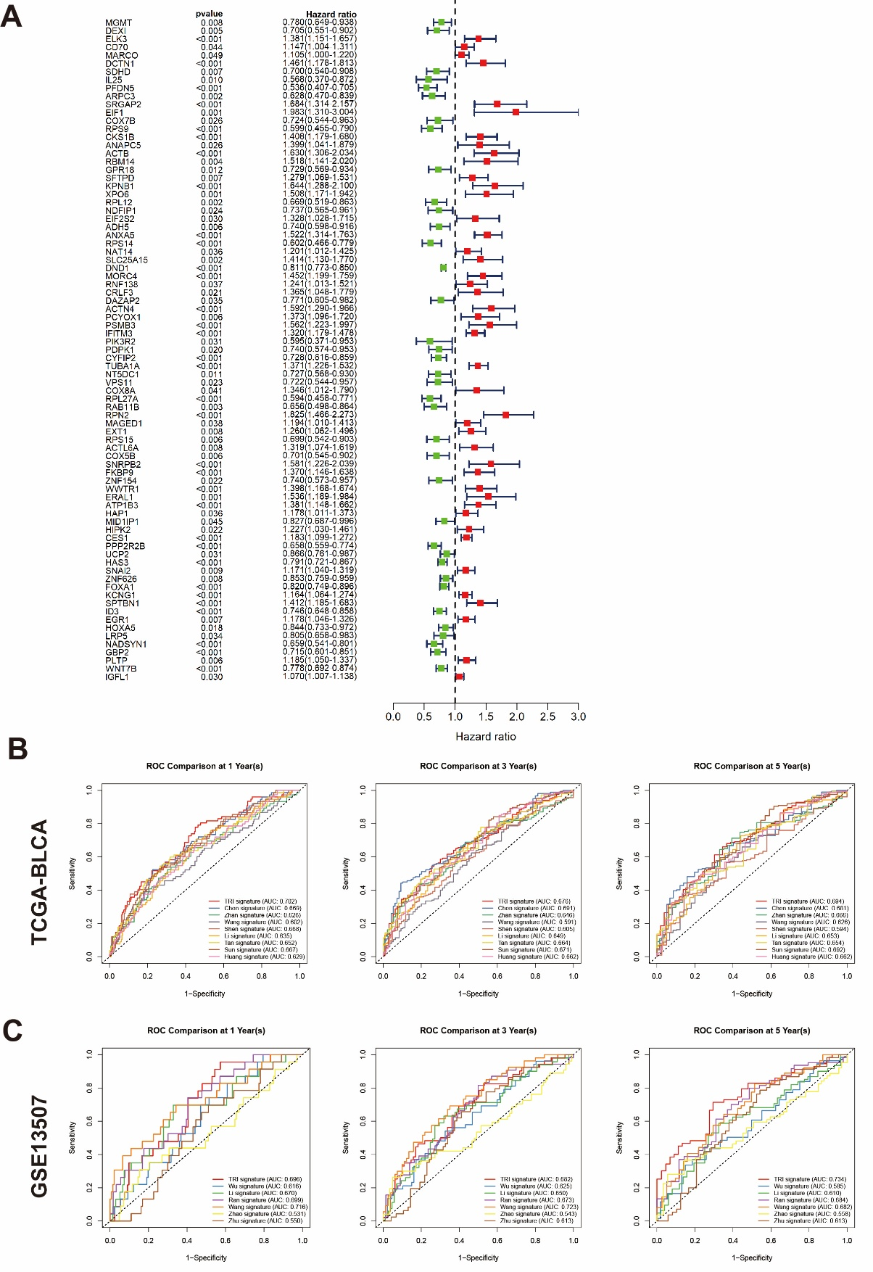
Supplementary Figure S5. Clinical Significance of the TRI-based nomogram model across multiple validation cohort. (A-C) Construction and validation of the TRI-based nomogram model in GSE13507 (A), GSE32894 (B), GSE32548 (C).
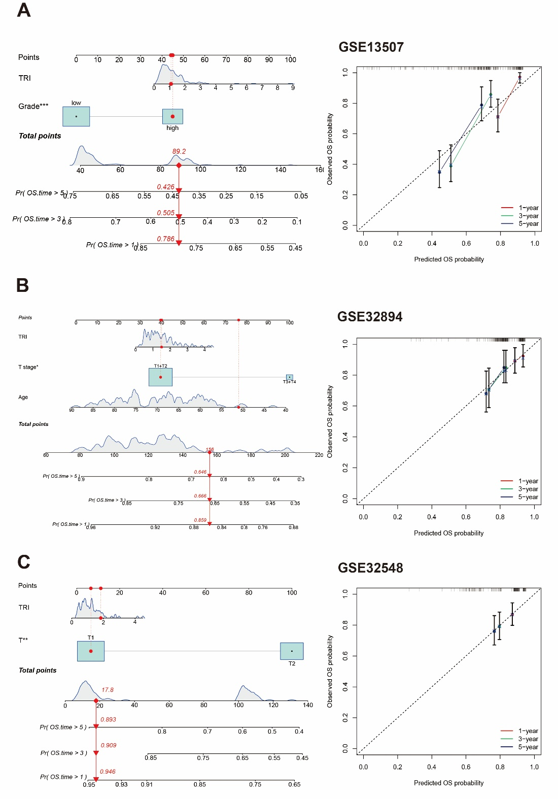

Supplementary Figure S6. Identification of prognosis-associated immune cells in BLCA based on CIBERSORT and survival analysis. (A) The UMAP visualization of all single cells by unsupervised clustering. (B) Violin plot of representative cluster marker genes across the identified clusters. (C) UMAP plot showing the distribution of cell types in primary and recurrent bladder cancer samples. (D) CopyKAT-predicted copy number variations (CNVs) in epithelial cells.

