Corresponding to Fig. 8A
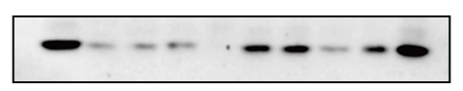
Anti-EIF1

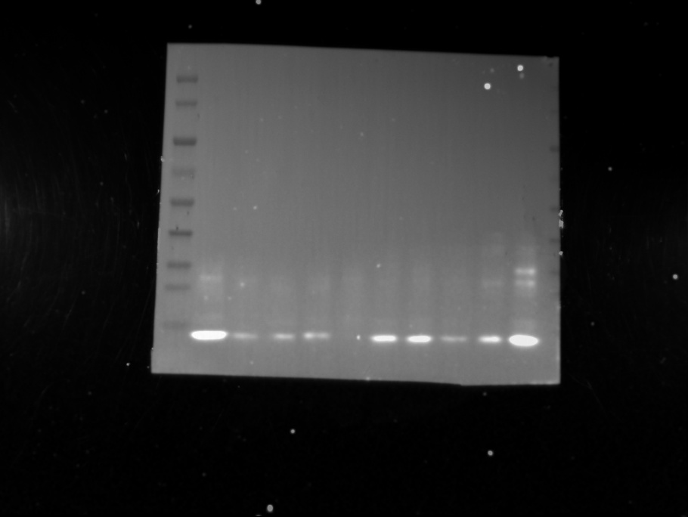
kDa
170
130
100
70
55
40
35
25
15

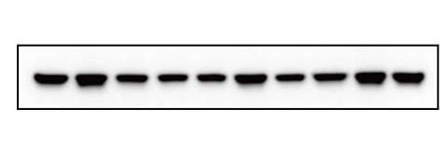
Anti-β-actin

kDa
170
130
100
70
55
40
35
25
15

Corresponding to Fig. 8B
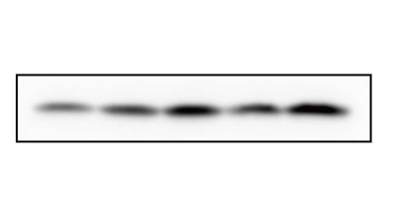
Anti-EIF1

kDa
170
130
100
70
55
40
35
25
15

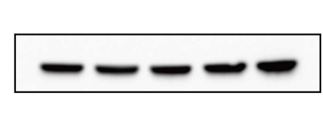
Anti-β-actin

kDa
170
130
100
70
55
40
35
25
15

Corresponding to Fig. 8H
Full membrane
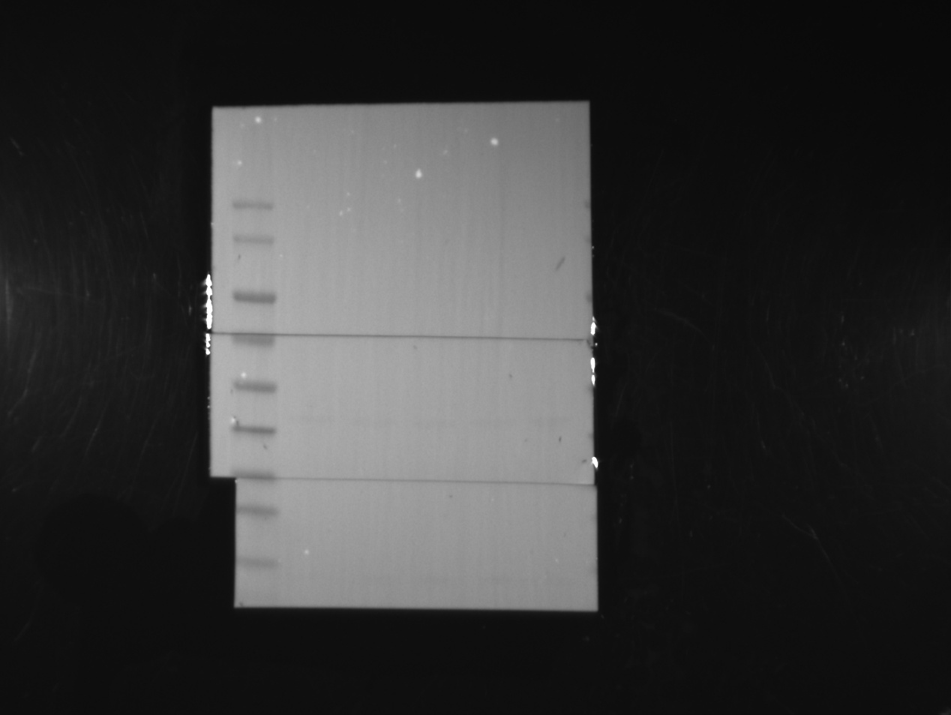
kDa
170
130
100
70
55
40
35
25
15

Corresponding to Fig. 9B
T24
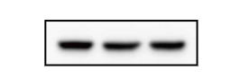
Anti-EIF1 Anti-β-actin
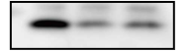
kDa
170
130
100
70
55
40
35
25
15
kDa
170
130
100
70
55
40
35
25
15

SW780
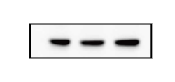
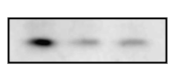
Anti-EIF1 Anti-β-actin

kDa
170
130
100
70
55
40
35
25
15
kDa
170
130
100
70
55
40
35
25
15

Corresponding to Fig. 9G
Anti-Ncadherin
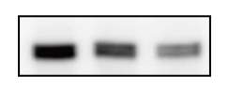
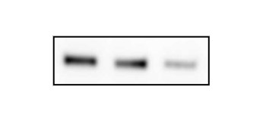
T24 SW780

kDa
170
130
100
70
55
40
35
25
15

kDa
170
130
100
70
55
40
35
25
15

Anti-β-actin

kDa
170
130
100
70
55
40
35
25
15

kDa
170
130
100
70
55
40
35
25
15

Anti-Vimentin
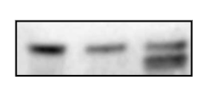
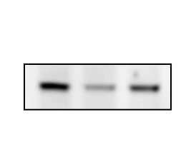
T24 SW780

kDa
170
130
100
70
55
40
35
25
15
kDa
170
130
100
70
55
40
35
25
15

Anti-β-actin
kDa
170
130
100
70
55
40
35
25
15
kDa
170
130
100
70
55
40
35
25
15

Anti-Slug
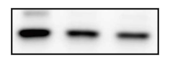
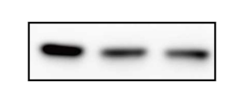
T24 SW780

kDa
170
130
100
70
55
40
35
25
15
kDa
170
130
100
70
55
40
35
25
15

Anti-β-actin
kDa
170
130
100
70
55
40
35
25
15
kDa
170
130
100
70
55
40
35
25
15

Anti-Snail1
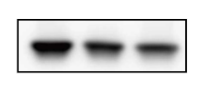
T24 SW780
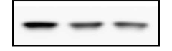
kDa
170
130
100
70
55
40
35
25
15
kDa
170
130
100
70
55
40
35
25
15

Anti-β-actin

kDa
170
130
100
70
55
40
35
25
15

kDa
170
130
100
70
55
40
35
25
15

Anti-EIF1
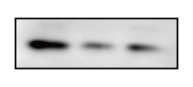
T24 SW780
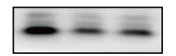

kDa
170
130
100
70
55
40
35
25
15
kDa
170
130
100
70
55
40
35
25
15

Anti-β-actin

kDa
170
130
100
70
55
40
35
25
15
kDa
170
130
100
70
55
40
35
25
15

Anti-β-actin
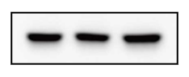
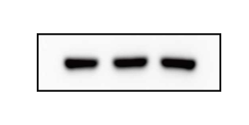
T24 SW780

kDa
170
130
100
70
55
40
35
25
15

kDa
170
130
100
70
55
40
35
25
15

