Acronym | Meaning
RADIANT-Net | Resilient Adaptive Disaster Intelligence with Agentic Neural Twins Network
SAR | Synthetic Aperture Radar
ROC | Receiver Operating Characteristic
AUC | Area Under the Curve
RMSE | Root Mean Square Error
mTCN | Multi-scale Temporal Convolutional Network
LSTM | Long Short-Term Memory
ViT | Vision Transformer
GNN | Graph Neural Network
PINN | Physics-Informed Neural Network
PIML | Physics-Informed Machine Learning
IMD | India Meteorological Department
NOAA | National Oceanic and Atmospheric Administration
IMERG | Integrated Multi-satellitE Retrievals for GPM
FIRMS | Fire Information for Resource Management System
NDVI | Normalized Difference Vegetation Index
NDWI | Normalized Difference Water Index
ReLU | Rectified Linear Unit
GRU | Gated Recurrent Unit
GPU | Graphics Processing Unit
FLOPs | Floating-Point Operations

Supplementary Table S1. Glossary of Acronyms

Supplementary Figure S2. Study Area Map
The study area comprises geographically diverse locations exposed to multiple natural hazards, including floods, cyclones, landslides, wildfires, and earthquakes. Georeferenced observations from Sentinel-1/2 imagery, meteorological records, seismic data, FIRMS, and GIS/OSM sources were integrated to characterize spatial variations in hazard occurrence and intensity. These multimodal observations provide a representative setting for evaluating the ability of RADIANT-Net to learn complex multi-hazard patterns and generalize predictions to previously unseen locations.

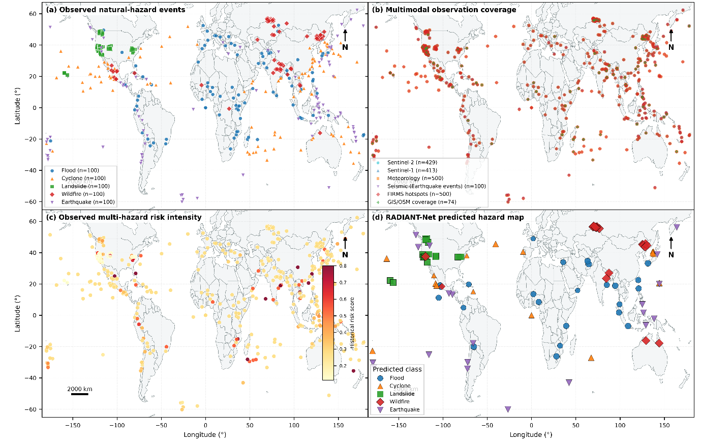
Figure S12 Spatial distribution of multi-hazard observations and RADIANT-Net predictions across geographically distributed study locations
The Figure S1 presents the spatial characteristics of multi-hazard observations and the corresponding predictions generated by RADIANT-Net. Panel (a) depicts the geographic distribution of documented flood, cyclone, landslide, wildfire, and earthquake events. Panel (b) illustrates the spatial availability of multimodal information obtained from Sentinel-1/2, meteorological, seismic, FIRMS, and GIS/OSM sources. Panel (c) represents the spatial variability of historical multi-hazard intensity, whereas panel (d) shows the hazard classes estimated by RADIANT-Net for geographically held-out test locations, with marker size reflecting prediction confidence. All spatial observations are represented in the EPSG:4326 geographic coordinate system.

